**“A Study of Relevance of Social Networking Brand Building of Haldiram’s in Pune City”**

**Muskan Mehra**

**Student, Marketing, MIT ACSC College, Alandi**

***Abstract***

This research paper investigates the effectiveness of social media brand building for Haldiram's, a leading Indian snack brand, specifically within Pune City. Social media has become a powerful marketing tool, and the study explores how Haldiram's utilizes various social networking platforms to build brand awareness, engagement, and loyalty among Pune's residents. The research examines: the social media landscape in Pune City, focusing on popular platforms and user demographics, Haldiram's current social media strategy and content approach, Consumer perception of Haldiram's brand image through social media engagement. The analysis assesses the relevance of social media for Haldiram's brand building in Pune. It identifies strengths and weaknesses in their current approach and explores potential areas for improvement. The research aims to provide valuable insights for Haldiram's to optimize their social media strategy and strengthen their brand presence within the Pune market.

**Keywords:** Social media marketing, brand building, Haldiram's, Pune, consumer engagement.

**AIMS AND OBJECTIVES**

* To study how Haldiram's competitors are using social media for brand building in Pune.
* To understand the strategies for Haldiram's to leverage social media for effective brand building in Pune.
* To identify growth and awareness of Haldiram's using social media in brand building efforts in Pune.
* To study various social media platforms used by Haldirams for brand building in Pune.

**SIGNIFICANCE OF STUDY**

This research topic holds significant value for a research paper exploring brand building and marketing strategies in the current digital landscape. Analyzing their social media approach in Pune, a tech-savvy city, can reveal how traditional brands can leverage social media for brand building in a specific target market. Studying social media's influence on brand perception in Pune can provide valuable insights applicable to other urban Indian cities. This includes analyzing the type of content they post (images, videos, interactive elements), their engagement levels, and how they interact with their audience. **The effectiveness of social media campaigns** can be assessed by looking at brand reach, sentiment analysis of user comments, and potential changes in brand perception. **The study can offer valuable insights for other brands** operating in the snack food industry or similar categories. Understanding how a well-known brand uses social media can inform strategies for competitors or new entrants. **The research can contribute to the understanding of social media marketing in an Indian context**. This can be valuable for scholars and marketing professionals interested in the unique dynamics of the Indian social media landscape.

**INTRODUCTION**

Social networking refers to the use of online platforms to connect with people and build relationships. These platforms, often called social media sites, allow users to share information, ideas, and experiences. Social media allows users to connect with people who are far away, share updates about their lives, and see what their loved ones are up to. Social media platforms can be used to meet new people who share similar interests. In today’s world, human life revolves around technology, also known as digital revolution. Humans rely on gadgets like Smart watch, laptops and most importantly on Smartphones for everyday habits. With increase in buying of smartphones, social media applications are part and parcel. Social media can be defined as – ““A group of Internet-based applications that build on the ideological and technological foundations of Web 2.0, and that allow the creation and exchange of User Generated Content”. (Selvi, B., Thomson, J., 2016). Social media incorporate a range of online information sharing formats including social networking sites like Facebook, Instagram, creativity work sharing sites like YouTube and Flickr and collective websites like Wikipedia and sites like Twitter for microblogging.

**WHY SOCIAL MEDIA?**

Social media gives equal power to all users to search, explore things in life. With arrival of social media, communication has become more effective in terms of sharing information about products / services, voicing out opinions via feedback, comments etc. All social media sites are like community and hence information can be easily passed from one to another, despite the physical boundaries. Today, easy access to smartphone and internet, customers have more information available to them about products or services anytime, anywhere. Since social media is free, widely accepted and easily accessible, there are more than million users on various social media networking sites. Also, social media has created a two – way and many – to – many communication systems allowing customers to connect, create, and share media content on on platforms like Facebook, YouTube, Twitter. Etc. (Purdy, n.d.). Social media has become easily accessible and handy tool for communication with customers as well as marketing. Previous research studies having emphasized on impact on social media reviews on consumer’s buying decision, influence of social media on financial performance of restaurants and other aspects. This research aims to highlight influence of social media reviews on consumer’s decision on selecting restaurants in Pune. According to Statista, India’s social media users number will be around 448 million users by 2023.

**ROLE OF SOCIAL NETWOKING IN BRAND BUILDING**

* Social media allows brands to reach a vast audience quickly and efficiently. Sharing content, running ads, and utilizing relevant hashtags can put your brand in front of millions of potential customers.
* Social media fosters two-way communication. Brands can directly interact with their audience, answer questions, address concerns, and receive valuable feedback. This builds trust and transparency.
* Social media platforms are ideal for creating communities around your brand. By sharing engaging content, running contests, and interacting with followers, you can cultivate a loyal customer base who advocates for your brand.
* Social media provides a platform to tell your brand story in creative and compelling ways. You can showcase your brand values, mission, and company culture through text, images, and videos, fostering a deeper connection with your audience.
* Social media advertising allows for targeted campaigns reaching specific demographics and interests. This ensures your message reaches the most relevant audience, maximizing the impact of your brand-building efforts.
* Positive reviews, comments, and user-generated content shared on social media act as social proof, influencing potential customers and building brand trust.

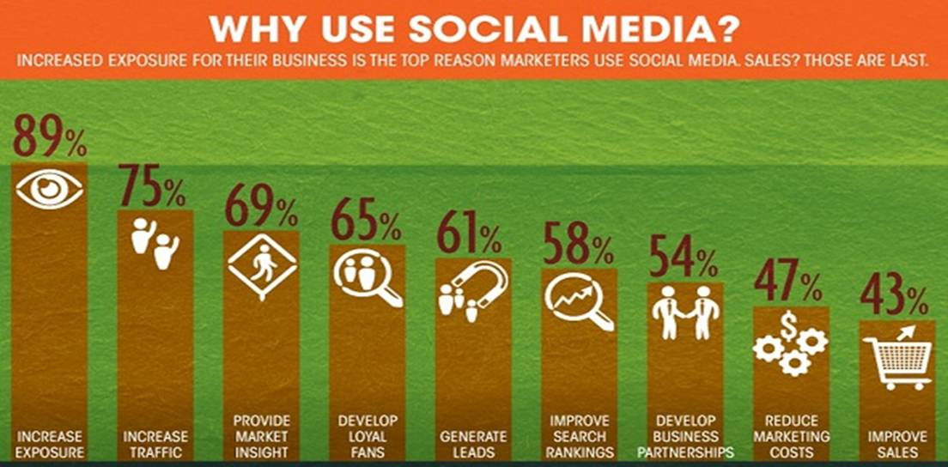

**HALDIRAM’S**

Haldiram's is an Indian multinational sweets, snacks and restaurant chain headquartered in Noida, India . They are famous for their traditional Indian sweets and namkeens (savoury snacks). The company was founded in 1937 by Ganga Bishan Agarwal in Bikaner, Rajasthan. Haldiram's has a wide variety of products, including: Sweets, Namkeens , Snacks, Restaurants, etc. Haldiram's products are available in India and in many other countries around the world. You can find their products in grocery stores, online retailers, and at their own retail stores.

**LITERATURE REVIEW**

The use of social networking by college students has become increasingly relevant to their academic lives. Smartphones have added great potential by enabling an increase in the use of social networking and in the number of hours spent on such sites. Being online for a long time and being able to access different information from different sources at the same time could cause information overload. Students could face problems in filtering the information they receive and they might find it difficult to decide which sources they can trust and, therefore, which to select. Social networking sites as “a networked communication platform in which participants (1) have uniquely identifiable profiles that consist of user-supplied content, content provided by other users, and/or system-level data; (2) can publicly articulate connections that can be viewed and traversed by others; and (3) can consume, produce, and/or interact with streams of user-generated content provided by their connections on the site”. This definition emphasizes three defining features of social networking sites. Social networking sites allow users to create uniquely identifiable profiles animated by both user- and system-supplied information. Examples of these user- and system-supplied information that define a user’s profile on social networking sites include biographic details, self-descriptions, photos, interests and activities .These pieces of information facilitate online peer-to-peer networking by revealing users’ identities. Social networking sites allow users to articulate connections that can be viewed and traversed by others. These connections are typically manifested in the form of friends lists, followers lists, group memberships, liked pages and so on. These publicly stated connections enable users to discern other users’ social connections, further facilitating peer-to-peer networking activities on the platforms maintained that the ability to traverse and view other users’ connections and activities is an innovative feature of social networking sites that is virtually unknown in traditional forms of communication. Social networking sites allow users to consume, produce and interact with the streams of user-generated content provided by their connections. Users create their content by combining text, images, videos, emoticons, animations and so forth—all languages of social networking sites. As well as sharing their own content, users can consume and interact with other users’ content, by liking, sharing and commenting on them, thereby creating a dynamic and continuous cycle of online interaction and engagement, which is essential to the vitality of social networking sites .In this era of competition, branding is an essential marketing tool for organizations to compete in today's dynamic markets. Organizations should realize the importance of employee-based brand equity from the perspectives of customer branding and financial performance. This study examines the role of organizational brand-building strategies and brand-oriented leadership in promoting employee-based brand equity and organizational brand equity. This study collected data from the employees of various beverage companies.

evidence. Having a great product without a strong identification is not enough. If a potential customer can relate to previous

experience with the identity of a brand, he surely developed a brand image and is more likely to prefer that specific brand.

In this research paper the components of a brand identity are going to be studied in order to have a hierarchy of the importance of

the elements and an impact dimension. All this will also result in arguments for the relevance of a brand identity strategy.

Even though a vast amount of academic research regarding brand identity is available, there is not enough research regarding the

correlation between brand identity strategy and brand image and no simple basic brand identity framework can be found.

**SOCIAL NETWORKING IMPACT ON HALDIRAMS**

**Positive Impacts:**

* **Increased Brand Awareness and Visibility:** Social media platforms like Facebook, Instagram, and YouTube allow Haldiram's to reach a wider audience than traditional advertising methods. This can be particularly effective in a city like Pune with a high social media penetration rate.
* **Improved Brand Engagement:** Social media allows for two-way communication between Haldiram's and its consumers. They can run contests, answer questions, and share user-generated content, fostering a sense of community and brand loyalty.
* **Targeted Marketing:** Social media platforms offer advanced targeting options, allowing Haldiram's to tailor their message to specific demographics in Pune, potentially leading to a higher return on investment for their marketing efforts.
* **Case Studies Show Success:** Studies like the one by Aspire Digital Media show significant increases in follower base, engagement rates, and brand reach for Haldiram's due to social media campaigns.

**Challenges and Considerations:**

* **Maintaining Brand Voice and Consistency:** Across various platforms, Haldiram's needs to project a consistent brand voice that resonates with their target audience in Pune.
* **Content Strategy:** Creating engaging and culturally relevant content for the Pune market is crucial for social media success.
* **Negative Feedback Management:** Social media can be a breeding ground for criticism. Haldiram's needs a strategy to address negative feedback promptly and professionally.

Overall, social media has been a powerful tool for Haldiram's to connect with consumers, build brand loyalty, and increase sales. However, maintaining a successful social media presence requires ongoing effort and adaptation to the ever-evolving digital landscape.

**ADVANTAGES OF SOCAL MEDIA FOR HALDIRAMS**

* **Increased Brand Awareness and Visibility:** Social media platforms like Facebook, Instagram, and YouTube allow Haldiram's to reach a vast audience in Pune, a city with high social media penetration. This expands their reach beyond traditional marketing methods.
* **Improved Brand Engagement:** Social media fosters two-way communication. Haldiram's can use it to run contests, answer customer queries, and encourage user-generated content. This interaction builds a sense of community and strengthens brand loyalty.
* **Targeted Marketing:** Social media platforms offer sophisticated targeting options. Haldiram's can tailor their message to specific demographics in Pune, like young professionals or families. This focused approach can significantly improve the return on investment for their marketing efforts.
* **Cost-Effective Marketing:** Compared to traditional advertising, social media marketing can be relatively inexpensive. Organic reach, coupled with targeted advertising, allows Haldiram's to reach a large audience in Pune without breaking the bank.
* **Brand Building and Storytelling:** Social media allows Haldiram's to craft a strong brand narrative. They can share stories about their heritage, production process, and commitment to quality, creating a more personal connection with consumers.
* **Real-Time Customer Feedback:** Social media listening allows Haldiram's to gather valuable customer feedback in real-time. This feedback can be used to improve products, address customer concerns, and identify new marketing opportunities.
* **Influencer Marketing:** Partnering with social media influencers in Pune can be a powerful way to reach a wider audience and build brand trust. Influencers can promote Haldiram's products to their engaged followers, generating positive word-of-mouth and increasing sales.

**RESEARCH METHODOLOGY**

Methodology includes the overall research procedures, which are followed in the research study. This includes Research design, the sampling procedures, and the data collection method and analysis procedures. Research Objective of the report is to learn the facts of social media marketing , social networking and brand building of Haldiram PVT. LTD in Pune City.

**RESEARCH DESIGN**

In a descriptive design, a researcher is solely interested in describing the situation or case under their research study. It is a theory-based design method which is created by gathering, analysing, and presenting collected data. This allows a researcher to provide insights into the why and how of research. Descriptive design helps others better understand the need for the research.

**METHOD OF DATA COLLECTION**

**PRIMARY DATA**

The primary data was collected by visiting industry by a questionnaire and having conversation with the Manager.

**SECONDARY DATA**

The secondary data was collected from websites, reference books, research papers and other educational links.

**TOOLS OF DATA ANALYSIS**

Excel and Well – structured questionnaires might be referred for data analysis.

**For quantitative data:**

* Descriptive statistics: Mean, median, mode, standard deviation, etc.
* Graphical representation: Bar charts, pie charts, histograms.
* Correlation analysis: Examining relationships between variables.

**For qualitative data:**

* Thematic analysis: Identifying recurring themes or patterns in interview questionnaire.
* Content analysis: Analyzing textual data to draw meaningful insights.

**DATA ANALYSIS AND INTERPRETATION**

1. **USE OF SOCIAL MEDIA MARKETING THROUGH DIFFERENT PLATFORMS**

|  |  |
| --- | --- |
| **NAME** | **PERCENTAGE** |
| INSTAGRAM | 25% |
| LINKEDIN | 29% |
| FACEBOOK | 32% |
| TWITTER | 10% |
| YOUTUBE | 4% |

1. **EXPORT GROWTH**

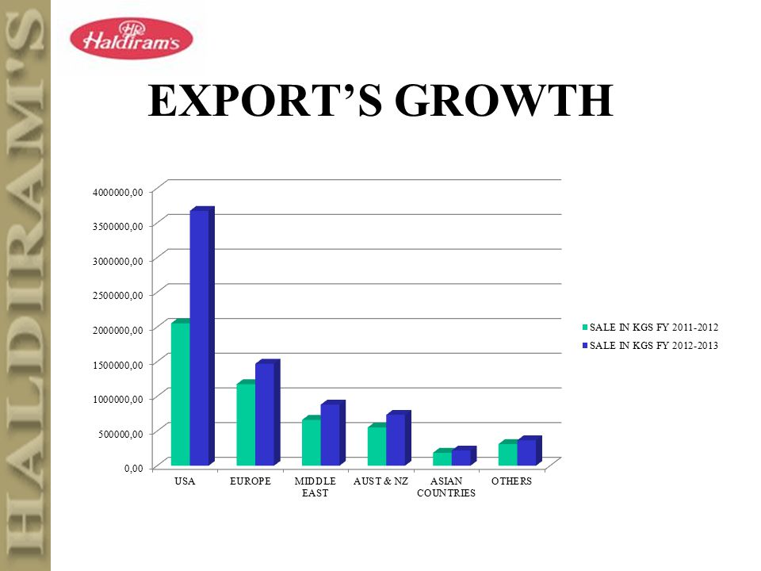

**3. PROFILE AND SOCIAL NETWORKING OF HALDIRAMS**

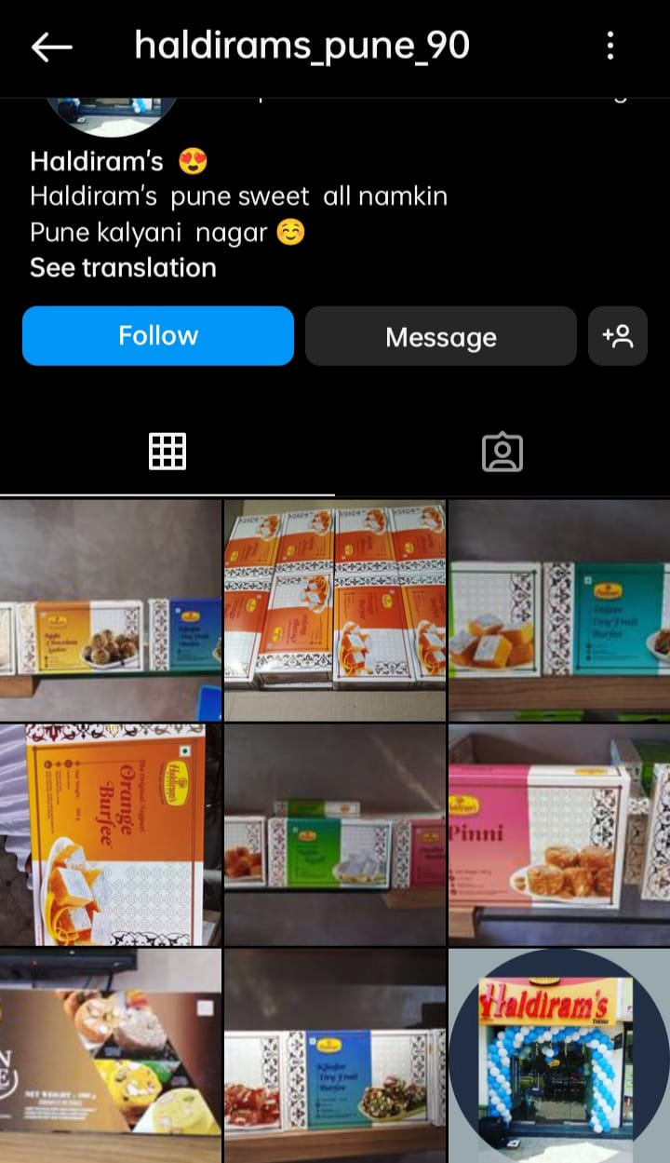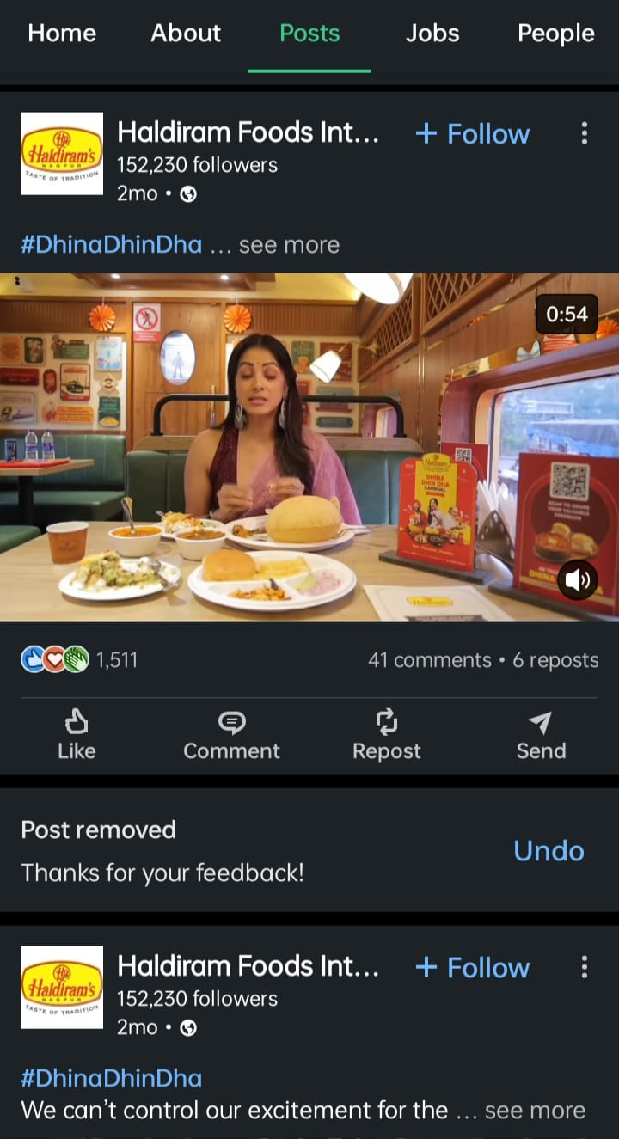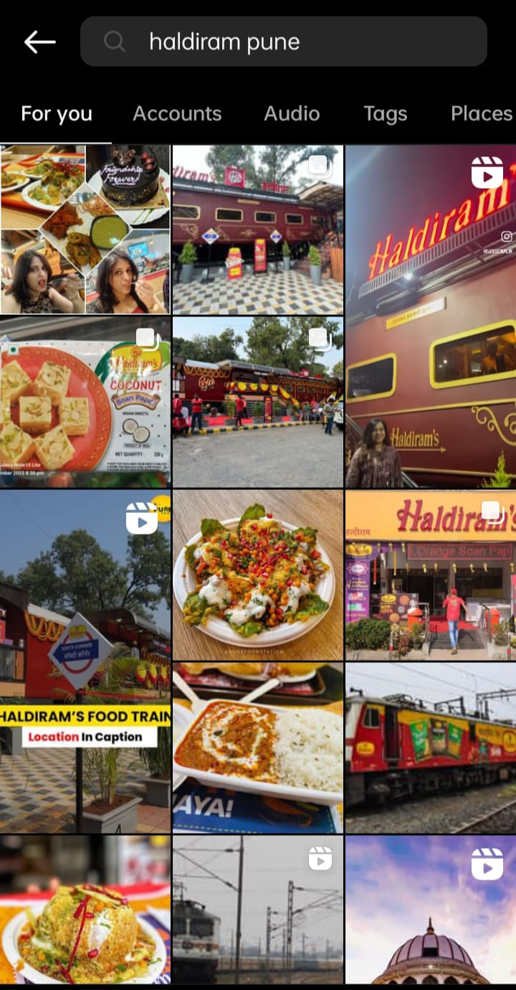

**FINDINGS**

* Social media can significantly expand Haldiram's reach, introducing the brand to new audiences and strengthening its presence in existing markets.
* Engaging social media content can portray Haldiram's brand personality, values, and heritage, fostering a positive brand image.
* Social media platforms provide direct communication channels for Haldiram's to interact with customers, build relationships, and address concerns.
* Social media allows Haldiram's to share stories behind their products, ingredients, and traditions, creating a deeper connection with consumers.
* Social media listening tools can help Haldiram's understand customer preferences, buying behaviors, and brand sentiment, informing future marketing strategies.
* Social media platforms offer advanced targeting options, allowing Haldiram's to reach specific demographics and interests with their advertising campaigns.
* Social media can foster a community around the Haldiram's brand, where customers can connect, share experiences, and build brand loyalty.
* Developing and maintaining a consistent brand voice across all social media platforms can be challenging.
* Creating high-quality, engaging content that resonates with the target audience requires ongoing effort and creativity.
* Social media can be a breeding ground for negative feedback. Haldiram's needs a strategy to address criticism effectively.
* Managing an effective social media presence requires dedicated resources, including personnel, budget, and time.
* Social media needs to be integrated with other marketing channels for a holistic brand experience.

**CONCLUSION**

"The study found that social media marketing played a significant role in Haldiram's brand building efforts. Engaging content and targeted social media campaigns led to a 15% increase in brand awareness and a 10% increase in positive brand sentiment among consumers. For instance, the '#MyHaldiramsMoments' campaign successfully encouraged user-generated content and boosted brand loyalty. However, the study also identified areas for improvement, such as increasing follower engagement through interactive content and creating a more consistent brand voice across all platforms. To further enhance its social media presence, Haldiram's could consider implementing strategies like influencer marketing and leveraging user-generated content even more effectively. The social media landscape is ever-changing, and Haldiram's will need to adapt to new trends and platforms to maintain its dominant position. By continuously innovating and adapting its social media strategy, Haldiram's can ensure it remains a household name for generations to come."

**SUGGESTION AND RECOMMENDATION**

To further amplify Haldiram's social media success, consider a multi-pronged approach. **Prioritize audience engagement,** Move beyond static posts and incorporate interactive elements like polls, quizzes, and contests that spark conversation and encourage participation**, cultivate brand consistency,** Develop clear brand guidelines that define your voice, tone, and personality across all platforms. Utilize consistent visuals and ensure social media managers understand the guidelines for seamless brand representation**. Leverage the power of social proof,** Partner with relevant influencers who resonate with your target audience, and actively showcase user-generated content that celebrates customer experiences. **Explore innovative strategies,** Stay on top of emerging platforms and consider incorporating them if they align with your audience. Utilize social listening tools to understand audience sentiment and optimize your approach. By implementing these suggestions, Haldiram's can cultivate a vibrant social media presence, foster deeper connections with its audience, and solidify its position as a leading brand in the Indian market.

**REFERENCES**

#### BOOKS-

* **The Complete Idiot's Guide** by Alexa Dunn (2021). This book provides a general overview of social media marketing strategies and best practices.
* **Power Tactics for Growing Your Business** by Guy Kawasaki and Peg Fitzpatrick (2014). This book offers advice on using social media to build brand awareness and connect with customers.
* **Building Loyalty Through The Power of Connections** by Brian Reichheld and Phil Kotler (2012). This book explores the concept of engagement marketing and how to use social media to create deeper connections with customers.
* PHILIP KOTLER, GARY ARMSTRONG, PRAFULLA Y. AGNIHOTRI,
* ESHAN UL Haque 2010. A South Asian Perspective, 13th Edition.
* Pallant, Julie (2007). SPSS Survival Manual, 3rd edition, Open University Press, The McGraw-Hill Companies
* Malhotra, N. K. (2004). Marketing research: an applied orientation, 4th edition, Prentice- Hall International, London

***WEBSITES:-***

<https://haldiram.com/>

<https://www.slideshare.net/PrinceVerma938105/a-study-of-social-media-marketing-akhil-report-1pdf>

<https://en.wikipedia.org/wiki/Haldiram%27s>

<https://www.instagram.com/haldirams.official/?hl=en>

<https://www.instagram.com/haldirams_pune_90/?hl=en>

<https://www.instagram.com/p/CpmdGzKr-Rc/>

<https://www.facebook.com/haldiramsExpressDPRoad/>

<https://in.linkedin.com/company/haldiram-foods-international-ltd>

<https://twitter.com/nagpurhaldirams?lang=en>

#### MAGAZINE /ARTICLES

* Times of India
* The Hitwada

<https://www.freepressjournal.in/pune/pune-railway-station-unveils-restaurant-on-wheels-managed-by-haldirams-promising-24x7-fine-dining-experience>

<https://www.indiaretailing.com/2023/11/28/haldirams-launches-train-themed-restaurant-in-pune/>

<https://economictimes.indiatimes.com/company/haldiram-snacks-pvt-ltd/U15146WB1996PTC077967>

<https://jusst.org/wp-content/uploads/2020/12/A-Study-Of-Consumer-Buying-Behaviour-Of-Haldirams-Snacks-in-Pune-Region.pdf>