“Design And Production Of Agricultural Equipment Solar Based Pesticide Duster”

Sahil Thakur1, Ritesh Bhamare 2, Harshad Hadpe 3, Vidhan Alai 4

Students, Maratha Vidya Prasarak Samaj's, Karmaveer Baburao Ganpatrao Thakare College Of Engineering, Udoji Maratha Boarding Campus, Gangapur Road, Nashik, Maharashtra, India. ***

**Abstract**: Agriculture has a predominant role in our day to day life. Spraying of pesticides is an important task in agriculture for protecting the crops from pests. The conventional methods were person carrying a sprayer and manually actuating a lever to generate and pump the pesticide through a tube or a mobile vehicle carrying an inbuilt compressor and sprayer unit. Another major drawback in human operated systems is that the operator is exposed to the harmful chemicals while spraying which is extremely detrimental to operator’s health.The tractors compress the soil, as they are heavier in weight. They cannot move in terrain environment..In this paper we are trying to make unique equipment for cultivation users. Finding solution to meet the energy demand is a great challenge for scientists and engineers. Now-a-days pesticide sprayer is operated based on fuel engine. This operation is more economical. To overcome this, we found out a new concept known as “solar pesticide sprayer”. Here, operation of pesticide sprayer is based on solar energy and hence there is no need of any kind of alternative energy source. It has many advantages such as cost of spraying and saving on Fuel/Petrol. There is less vibration as compared to the petrol sprayer. Hence, the system can easily be operated and there is no need of labors which increase the efficiency of farmland.

***Keywords***: Conventional Energy, Solar Energy, Solar Cells, Solar Pesticide Sprayer, Solar Panel.

**PROBLEM STATEMENT**

The existing products for pesticide sprayers are either hand operated (manpowered) or fuel operated (fossil power) which requires high human effort and needs regular maintenance like refilling of fuel which are quite expensive also traditional agricultural sprayers are in the form of backpack which on continuous usage creates back pain or becomes stressful for the users.

**INTRODUCTION**

Duster is very much important in the application of agricultural practices like spraying pesticides to get uniform distribution of chemicals throughout the crop foliage. Duster not only ensures uniform distribution but also limits use of it. We are particularly using a duster which is empowered by a renewable resource i.e solar energy. This signifies the which creates no harm to the environment. The existing products for pesticide sprayers are either hand operated (manpowered) or fuel operated (fossil power) which requires high human effort and needs regular maintenance like refilling of fuel which are quite expensive. Traditional agricultural sprayers are in the form of backpack which on continuous usage creates back pain or becomes stressful for the users and also can only carry maximum of 10 liters. Our product which is basically a trolley based that eliminates these problems and restrictions. It can be easily movable with very less human effort and can carry sufficient amount of pesticide. The solar panel mounted on the top can be tilted to required angle according to the sunlight. This panel consisting of photovoltaic cells which converts solar energy into electrical energy which is supplied to the battery via controller. The battery runs DC motor with sufficient speed for effective spraying through duster.

Farmers mainly use hand operated or fuel operated spray pump for this task. This conventional sprayer causes user fatigue due to excessive bulky and heavy construction. In our design, we can eliminate the back mounting of sprayer. Ergonomically, it is not good for farmers’ health point of view. There will be elimination of engine of fuel operated spray pump by which there will be reduction in vibrations and noise. The elimination of fuel will make our spraying system eco-friendly. So, with this background, we are trying to design and construct a solar powered spray pump system. Now-a-days, there are non-conventional energy sources which are widely used i.e. the energy which is available from the sun is in nature at free of cost. In India Solar Energy is available around 8 months in year. So, it can be used in spraying operation. Solar pesticide sprayer can give less tariff or price in effective spraying. Solar energy is absorbed by the solar panel which contains photovoltaic cells. The conversion of the solar energy into electrical energy is done by these cells. This converted energy utilizes to store the voltage in the DC battery and that battery further used for driving the spray pump.

**METHODOLOGY**

Design and fabrication of solar powered pesticide sprayer has following steps, Selection of components. The selection of component has been done according to the requirements. Solar energy obtained by the sun is converted into electrical energy using solar panel by photovoltaic effect. The output of the energy conversion is given to charge a deep cycle lead acid battery through a charge controller. The charge controller limits the rate at which electric current is added to the battery.

**Design and Features of the Solar Based Pesticide Duster**

**A. Solar-Powered Operation:** The duster is equipped with a high-efficiency solar panel, allowing it to operate without the need for external power sources, reducing operational costs. Additionally, the solar power feature makes it eco-friendly by minimizing carbon emissions.

**B. Adjustable Spray Nozzles**:It is designed with adjustable spray nozzles, providing flexibility in pesticide application according to varying crop types and sizes. This ensures uniform coverage and effective pest control.

**C. Lightweight and Portable**:Its lightweight design and portability allow for easy maneuverability across different agricultural terrains, enhancing efficiency and reducing labor fatigue. The compact size makes it easy to transport and store when not in use

**Selection of Components**

The selection of component has been done according to the requirements. Following are the list of components with specification.

**Solar panel** :Each panel is rated by its DC output power under standard test conditions, and typically ranges from 100 to 320 watts. The efficiency of a panel determines the area of a panel given the same rated output - an 8% efficient 230 watt panel will have twice the area of a 16% efficient 230 watt panel.

**Nozzle** :A nozzle is a device designed to control the direction or characteristics of a fluid flow as it exits an enclosed chamber or pipe.

**DC Motor** :A DC motor is any of a class of rotary electrical machines that converts direct current electrical energy into mechanical energy.

**Tank:**Storage tanks are containers that hold liquids, compressed gases or mediums used for the short or longterm storage of fluids or gases. Large tanks tend to be vertical cylindrical, or to have rounded corners transition from vertical side wall to bottom profile, to easier withstand hydraulic hydrostatically induced pressure of contained liquid.

**Battery:** An electric battery is a device consist of one or more electrochemical cells with external connections provided to power electrical devices. When a battery is connected to an external circuit, electrolytes are able to move as ions within, allowing the chemical reactions to be completed at the separate terminals and so deliver energy to the external circuit.

**DESIGN AND ANALYSIS OF MODEL**

**There are different conditions as follows:**

**Model**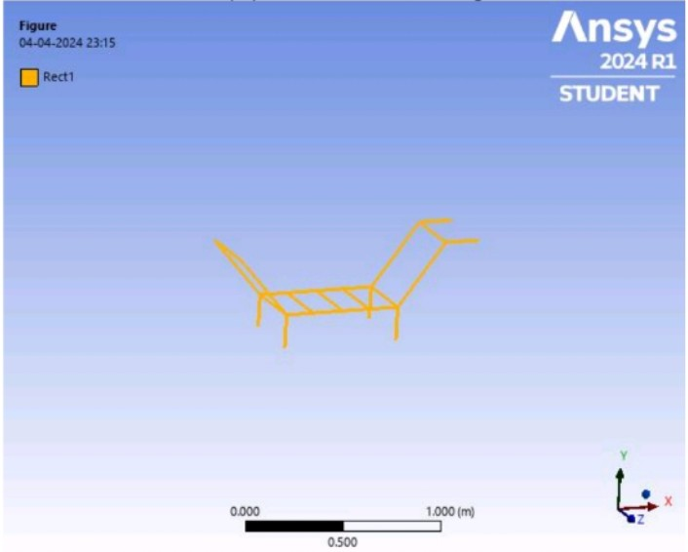

**MESHING**

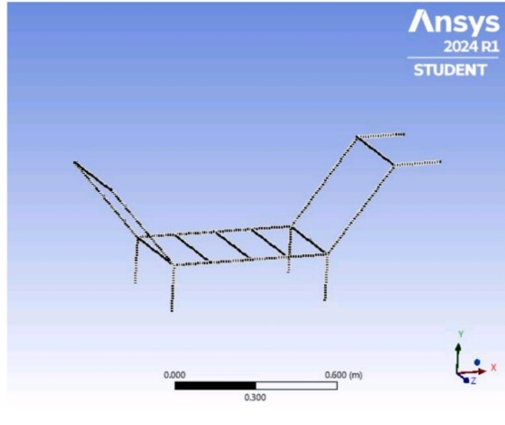

**FORCE**

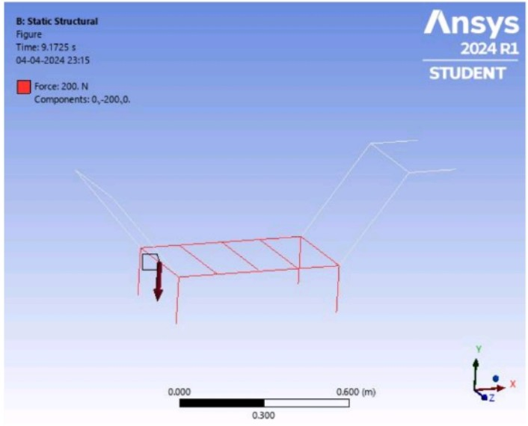

**TOTAL DEFORMATION**

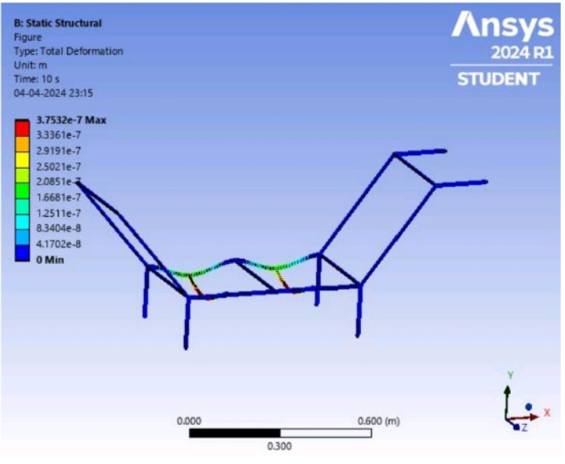

**DIRECTIONAL DEFORMATION**

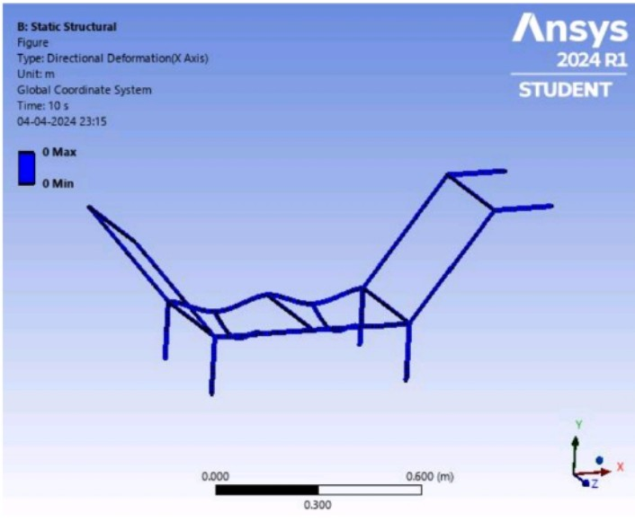

**TOTAL BENDING MOMENT**

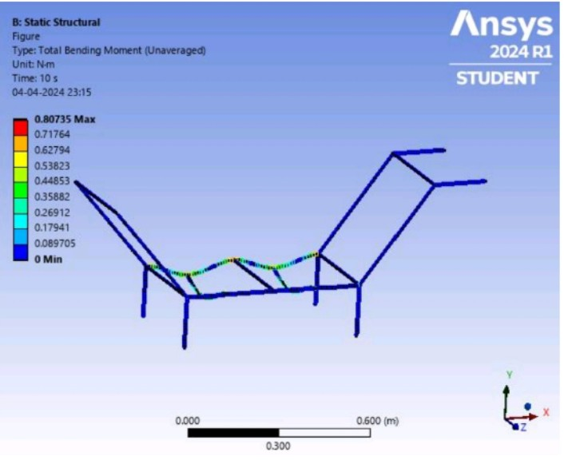

**TOTAL SHEAR FORCE**

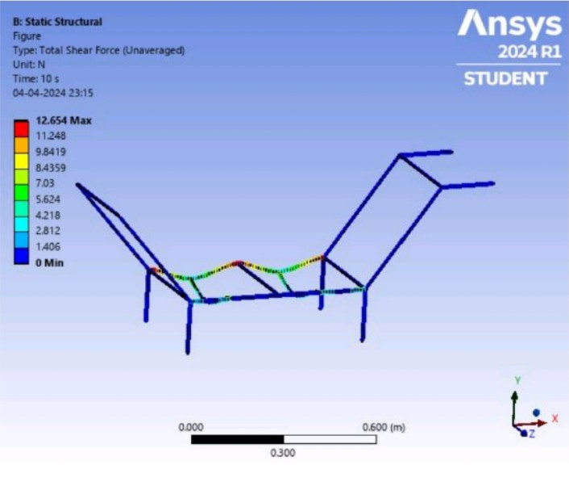

**Production Process of the Solar Based Pesticide Duster**

**A. Design and Fabrication:** The production process begins with designing the components and fabricating the solar based pesticide duster casing.

**B. Integration of Solar Panels**: Solar panels are integrated into the design, ensuring maximum exposure to sunlight for efficient power generation.

**C.** **Assembly and Testing** :The various components are assembled, and rigorous testing is conducted to ensure the functionality and reliability of the duster.

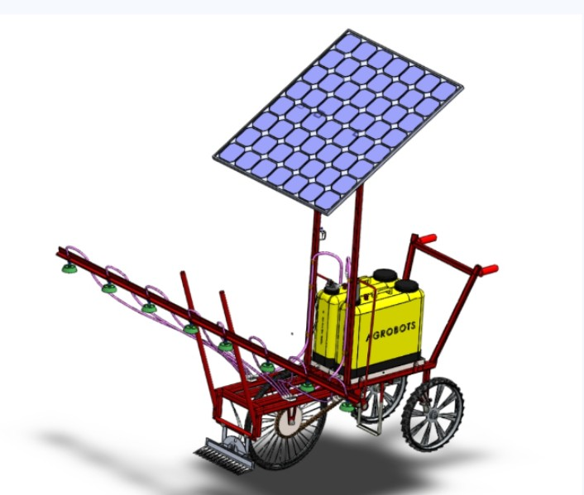

**Fig: Concept of Prototype**

The system consists of Solar panel, charging unit, battery, pump and sprayer. The solar panel delivers an output in the order of 12 volts and 20 Watts power to the charging unit. The charging unit is used to strengthen the signal from the solar panel. The charging unit delivers the signal which charges the battery. According to the charged unit, the pump operates, such that the sprayer works. Here fertilizer can be stored in tank. When the sun rays are falling on the solar panel electricity will be generated through the solar cells and stored in the battery. By the electric power in the battery the pump operates and therefore fertilizers from the tank is sprayed out through the sprayers.There is no maintenance cost and operating cost as it is using solar energy and no pollution problem. Its working principle is very easy and it is economical for the farmers, which has one more advantage that it can also generate power that power is saved in the battery and it can be used for both for spraying and well as to light in the houses when there is no current supply.

**ADVANTAGES**

* The machine has very low error.
* The size of project made by is more suitable for material handling system.
* The cost of machine is less. It is easy to make.
* It has low maintenance.
* system has worked fully switched operated.
* Size of machine is small therefore it is easy to transport. Weight of machine is low.

**DISADVANTAGES**

* Relatively high initial cost.
* Lower output in cloudy weather.

**ACKNOWLEDGEMENT**

We extend our sincere appreciation to our guide and superviser for their invaluable feedback and guidance during the completion of this research paper. Their expertise and support have been instrumental shaping work. Additionally we would like to acknowledge the authors of the research papers we examined, as their contributions have significantly advanced the field of agriculture with best use of technology. Their insightful studies have provided us with a strong foundation for our research. It helped us various aspects of project.

**CONCLUSION**

In this study our main focus has been the fabricated model satisfies all the requirements of the user and It is designed according to the parameters. It involves minimum intervention of manpower. It completely eliminates use of fossil fuels and uses renewable resource i.e. solar energy . The trolley based system also relief user from back mounting which would cause back pain . The designed model is compact, affordable, user friendly and produces no bad impact on environment. Hence the designed model is cost effective and compatible with other models available commercially. It is observed that, this model of solar powered pesticide sprayer is gives the effective results in spraying operation.

**REFERENCES**

https://diypestcontrol.com/pest-control- /dusters

https://agritech.tnau.ac.in/crop_protection/crop_prot_plant_protection%20_equipments_classification.html

https://khetigaadi.com/blog/dusters-in-agriculture

“Solar Operated Multiple Granulated Pesticide Duster” by- Abhishek Jivrag , Vinayak Chawre , Aditya Bhagwat.

“Solar Operated Pesticide Sprayer” by- Pandurang Lad, Virendra Patil, Prashant Patil, Tushar Patil and Pravin Patil.

Solar Pesticide Sprayer” by- Krishna Murthy B, Rajan KanwarIndrajeet Yadav and Vishnu Das.

“Solar Powered Pesticide Sprayer” by- M. Sabhita, N. Sampath , V. Rajesh, B. Sai ram Goud.