WASTE OBJECT DETECTION USING YOLO V5

**M.Pavithra1 | M. Saravanakumar2**

(Department of IT, UG Scholar, Rathinam College of Arts and Science, Coimbatore, rpavi10704@gmail.com)1 (Department of IT, Senior Faculty, Rathinam College of Arts and Science, Coimbatore, [skumarkovai@gmail.com](mailto:skumarkovai@gmail.com) 2

)

## Abstract:

Waste object detection plays a pivotal role in efficient waste management systems, contributing to environmental sustainability and resource optimization. This paper presents a novel approach to waste object detection utilizing the You Only Look Once (YOLO) deep learning framework. YOLO offers real-time object detection capabilities, making it suitable for deployment in waste management systems where timely detection and classification of waste objects are essential. Our methodology involves the training of a YOLO model on annotated waste object datasets, enabling the model to accurately detect various types of waste items such as plastics, paper, glass, and organic materials. We evaluate the performance of the proposed approach using standard metrics such as precision, recall, and F1 score, demonstrating its effectiveness in identifying waste objects in diverse environmental conditions and cluttered scenes. Furthermore, we discuss potential applications and implications of waste object detection using YOLO, including automated sorting in recycling facilities, monitoring waste disposal sites, and guiding autonomous waste collection systems. Overall, our research contributes to the advancement of smart waste management systems by leveraging state- of-the-art deep learning techniques for efficient waste object detection.

***Keywords:* Waste detection, YOLO, deep learning, sustainability, resource optimization**

## Introduction

Effective waste management is crucial for mitigating environmental pollution and promoting sustainable development. With rapid urbanization and increasing population, the volume of waste generated worldwide has escalated, posing significant challenges for waste management authorities. Traditional waste management approaches often rely on manual sorting and disposal methods, which are labor- intensive, time-consuming, and prone to errors. Moreover, inadequate waste management practices contribute to pollution, habitat destruction, and depletion of natural resources..

In response to these challenges, there is a growing interest in leveraging advanced technologies such as deep learning for automated waste detection and classification. Deep learning techniques, particularly convolutional neural networks (CNNs), have shown remarkable performance in various computer vision tasks, including object detection. Among the state-of-the-art object detection frameworks, You Only Look Once (YOLO) stands out for its real-time processing capabilities and high accuracy.

This project aims to harness the power of YOLO for waste object detection in diverse environmental settings. By training a

YOLO model on annotated waste object datasets, we seek to develop a robust system capable of identifying and categorizing different types of waste items, such as plastics, paper, glass, and organic materials. The proposed system holds promise for enhancing waste management efficiency by automating the sorting process, thereby reducing reliance on manual labor and minimizing errors.

In this paper, we present the methodology employed for training the YOLO model, including dataset preparation, model architecture, and training procedures. We evaluate the performance of the trained model using standard metrics such as precision, recall, and F1 score, and discuss its applicability in real-world waste management scenarios. Furthermore, we explore potential applications of waste object detection using YOLO, ranging from automated sorting in recycling facilities to monitoring waste disposal sites and guiding autonomous waste collection systems.

Overall, this project contributes to the advancement of smart waste management systems by leveraging cutting-edge deep learning techniques to address the challenges associated with waste detection and classification. By automating these processes, we aim to enhance environmental sustainability, optimize resource utilization, and pave the way for a cleaner and healthier planet.

Efficient waste management is imperative for combating environmental degradation and fostering sustainable development. However, traditional waste management practices are often labor-intensive and error-prone, leading to suboptimal resource utilization and environmental pollution. To address these challenges, there is a growing interest in leveraging advanced technologies like deep learning for automated waste detection and classification.

This project focuses on harnessing the capabilities of You Only Look Once (YOLO), a state-of-the-art deep learning framework, for waste object detection. By training a YOLO model on annotated datasetscontaining various waste materials, including plastics, paper, glass, and organic materials, we aim to develop a robust system capable of accurately identifying and categorizing different types of waste items. The utilization of diverse waste materials in the dataset ensures the model's adaptability to real-world waste management scenarios

The proposed system holds promise for revolutionizing waste management practices by automating the sorting process and reducing reliance on manual labor. Through efficient waste detection and classification, the system facilitates the optimization of resource utilization and minimizes environmental pollution associated with improper waste disposal.

In this paper, we detail the methodology employed for training the YOLO model, encompassing dataset preparation, model architecture, and training procedures. We evaluate the performance of the trained model using standard metrics such as precision, recall, and F1 score, demonstrating its effectiveness in waste object detection across various environmental settings.

Furthermore, we explore the practical implications of waste object detection using YOLO, including automated sorting in recycling facilities, monitoring waste disposal sites, and guiding autonomous waste collection systems. By enabling real- time detection and prediction of waste objects, the proposed system contributes to the development of smart waste management solutions that promote environmental sustainability and resource optimization.

Overall, this project endeavors to leverage cutting-edge deep learning techniques to address the challenges associated with waste detection and classification, paving the way for a cleaner and healthier planet.

Deploying a Python-based computer on cloud platforms like AWS (Amazon Web Services) and Azure (Microsoft Azure) is a process that offers scalability, reliability, and flexibility for running Python applications. The deployment process involves several basic steps ensuring smooth execution and optimal utilization of cloud resources.

Signing up for an AWS account on the AWS Management Console and navigating to the AWS Identity and Access Management (IAM) service is the initial step. This allows the creation of users and the assignment of appropriate permissions. Access keys for programmatic access to AWS services are then generated. For Azure, creating an Azure account on the Azure portal is the first step. Configuring Azure Active Directory (AD) for user management and authentication follows, along with generating Azure credentials (client ID, client secret, and tenant ID) for accessing Azure services programmatically.

## Problem Statement

The current waste management practices are predominantly manual and lack efficiency, leading to suboptimal resource utilization and environmental pollution. Manual sorting of waste is labor-intensive, time-consuming, and error-prone, resulting in improper disposal and contamination of recyclable materials. Moreover, the increasing volume of waste generated worldwide exacerbates the challenges faced by waste management authorities.

Traditional waste management methods fail to keep pace with the escalating demand for sustainable solutions. There is a pressing

need to modernize waste management practices by integrating advanced technologies to streamline waste detection, sorting, and disposal processes. Automating waste detection and classification can significantly enhance operational efficiency, reduce reliance on manual labor, and minimize environmental impact.

However, existing automated waste management systems often exhibit limitations in accurately identifying and categorizing different types of waste objects. Conventional machine learning algorithms struggle with complex environmental conditions, varying object sizes, and cluttered scenes, leading to subpar performance and reliability.

Hence, there is a critical gap in the field of waste management that necessitates the development of robust and efficient waste object detection systems. These systems must leverage advanced deep learning techniques to achieve real-time detection and classification of diverse waste materials. Addressing this gap requires innovative solutions that combine cutting- edge technologies with domain expertise in waste management and environmental sustainability.

In light of these challenges, the project aims to develop a novel waste object detection system using the You Only Look Once (YOLO) deep learning framework. By accurately identifying and categorizing waste objects, the system seeks to revolutionize waste management practices, promoting environmental sustainability, resource optimization, and a cleaner planet.

### Proposed System

The proposed system is a waste object detection web application deployed on cloud platforms AWS and Azure, utilizing the YOLOv5 deep learning framework for real-time object detection. Users interact with the system through a web application interface, where they can upload images

containing waste objects. Upon uploading, the images are processed using the YOLOv5 model to detect and classify waste objects into different categories such as plastics, paper, glass, and organic materials. This classification is crucial for effective waste management and recycling efforts. The entire system is deployed on AWS and Azure cloud platforms, leveraging their infrastructure and services for scalability, reliability, and accessibility. Automation is ensured through Continuous Integration/Continuous Deployment (CI/CD) pipelines, allowing for efficient deployment and updates of the application. The YOLOv5 model is trained using annotated waste object datasets, and once trained, it is integrated into the web application's prediction pipeline for real- time waste object detection. Users can access the web application via a user- friendly interface, allowing them to upload images and receive instant feedback on the detected waste objects and their classifications. To facilitate easy deployment and management across different environments, the components of the system are containerized using Docker. GitHub Actions are utilized for automating the CI/CD process, ensuring seamless integration, testing, and deployment of code changes. The system's codebase is structured in a modular manner, promoting code reusability, maintainability, and scalability. Overall, the proposed system offers a comprehensive solution for automating waste detection and classification, contributing to efficient waste management and environmental sustainability efforts.

## Methodology

The first step in creating the project template involves setting up the development environment and installing necessary dependencies. This includes configuring the programming language environment (e.g., Python), installing required libraries and frameworks, and

setting up version control using tools like Git.

Logging, Utils, and Exception Modules:

Next, essential modules such as logging, utilities, and exception handling are implemented. The logging module facilitates logging messages at different severity levels, aiding in debugging and monitoring. Utilities include commonly used functions and helpers to streamline development tasks. Exception handling ensures graceful handling of errors and exceptions that may occur during runtime.

Project Workflows:

Establishing project workflows involves defining the processes and procedures for managing project tasks, version control, code reviews, and collaboration among team members. This may include adopting Agile methodologies, setting up issue tracking systems (e.g., Jira, Trello), and establishing code review practices using tools like GitHub pull requests.

Notebook Research:

The notebook research phase involves exploring and experimenting with the YOLOv5 model using Jupyter notebooks. This allows for iterative testing and refinement of the model architecture, hyperparameters, and training data. Research findings and insights obtained from experimentation inform subsequent stages of the project.

YOLOv5 Setup:

The YOLOv5 setup encompasses configuring the model architecture, data preprocessing, and training pipeline. This involves downloading the YOLOv5 repository, preparing annotated datasets for training, and customizing the model architecture and hyperparameters. Additionally, data augmentation techniques may be applied to enhance model generalization.

Modular Code Implementation:

The project template is developed using a modular code structure, facilitating code reusability, maintainability, and scalability. Each component of the project, including data preprocessing, model training, prediction, and user interface, is implemented as a separate module or package. This modular approach enables easy integration of new features and functionalities.

Training Pipeline:

The training pipeline involves training the YOLOv5 model on annotated datasets using the configured architecture and hyperparameters. This includes initializing the model weights, feeding training data batches, optimizing model parameters using backpropagation, and evaluating model performance using metrics such as loss and accuracy.

Prediction Pipeline:

Once the YOLOv5 model is trained, it is integrated into the prediction pipeline for real-time object detection and classification. This involves loading the trained model weights, preprocessing input images, running inference on the images using the model, and post-processing the predictions to extract relevant information.

User App Creation:

A user-friendly web application interface is developed to enable users to interact with the system. The user app allows users to upload images, visualize detected waste objects, and view classification results. This interface enhances user experience and accessibility, facilitating wider adoption of the system.

Docker:

The entire project, including dependencies and runtime environment, is containerized using Docker. This ensures consistency and reproducibility of the development and deployment environments across different

platforms. Docker containers encapsulate the project dependencies, making it easy to deploy and scale the application.

GitHub Action:

Continuous Integration (CI) and Continuous Deployment (CD) pipelines are implemented using GitHub Actions. CI workflows automate code testing, linting, and validation to ensure code quality and reliability. CD workflows automate deployment processes, enabling seamless deployment of the project to cloud platforms such as AWS and Azure.

Final CI/CD Deployment on AWS and Azure:

The project is deployed to AWS and Azure cloud platforms using the final CI/CD pipelines. This involves configuring deployment scripts, provisioning cloud resources, and deploying the Dockerized application to cloud containers or virtual machines. Monitoring and logging are set up to track application performance and troubleshoot any issues that arise.

By following this methodology, the project template creation process is structured and systematic, resulting in a well-designed and scalable foundation for developing YOLOv5-based waste object detection systems.

communication, guarantee scalability, and make use of middleware for additional functionality.

The final CI/CD deployment stage automates the deployment of the project to AWS and Azure cloud platforms, leveraging infrastructure-as-code principles and containerization technologies for consistency, reliability, and scalability. By automating the deployment process, organizations can accelerate time-to- market, reduce manual errors, and improve overall efficiency in delivering software solutions to end-users.

# 3.1 System Design

Object detection involves identifying and localizing objects of interest within an image. In this project, the YOLOv5 deep learning model is utilized for object detection. YOLO (You Only Look Once) is a state-of-the-art object detection algorithm that divides the input image into a grid and predicts bounding boxes and class probabilities for objects within each grid cell. This allows for efficient and accurate detection of multiple objects in real-time.

In the figure, the object detection component receives an uploaded image as input and processes it using the YOLOv5 model. The model identifies waste objects within the image and draws bounding boxes around them to indicate their location. Additionally, the model assigns class labels to each detected object, specifying the type of waste material present (e.g., plastic, paper, glass).

It then analyzes this information to generate predictions or recommendations for waste management practices, which are presented to the user through the web application interface.

Overall, object detection and prediction are essential components of the waste management system depicted in the figure, enabling the automated identification, classification, and analysis of waste objects within uploaded images. By leveraging advanced deep learning techniques like YOLOv5, the system can streamline waste

# Implementation

The project implementation process entails translating the conceptual framework of the waste object detection system into a fully functional software application. Initially, the project setup involves configuring the development environment with necessary tools and libraries while establishing version control systems for efficient code management. Data collection follows, sourcing or generating datasets containing images of waste objects, which are then meticulously annotated with bounding boxes and class labels to serve as ground truth data for training the object detection model.

Training the YOLOv5 model is a crucial phase, involving the configuration of the model architecture and optimization of parameters through iterative training sessions. Techniques like data augmentation and transfer learning are employed to enhance model generalization. Simultaneously, development of the web application commences, crafting a user- friendly interface using HTML, CSS, and JavaScript frameworks for front-end components, and Python frameworks like Flask or Django for back-end functionalities.

Integration of the trained YOLOv5 model into the web application facilitates real-time object detection. Image preprocessing techniques prepare uploaded images for inference, while inference itself detects waste objects and generates bounding boxes with corresponding class labels. Detected waste objects and their classifications are presented to users through the web interface, alongside

visualization tools for analysis, thus enabling informed waste management decisions.

Thorough testing and validation are imperative stages to ensure system functionality and reliability. Unit tests and integration tests validate system components, while user acceptance testing (UAT) gathers feedback from end-users and stakeholders, informing further iterations and enhancements. Deployment to cloud platforms like AWS or Azure is streamlined through CI/CD pipelines, automating deployment and updates. Monitoring and logging mechanisms are implemented to track application

performance and user interactions, facilitating proactive maintenance and optimization.

Overall, the project implementation involves a comprehensive blend of data processing, model training, software development, and deployment strategies to realize an effective waste object detection system. Through the integration of advanced technologies and methodologies, the system aims to revolutionize waste management practices, contributing towards environmental sustainability..

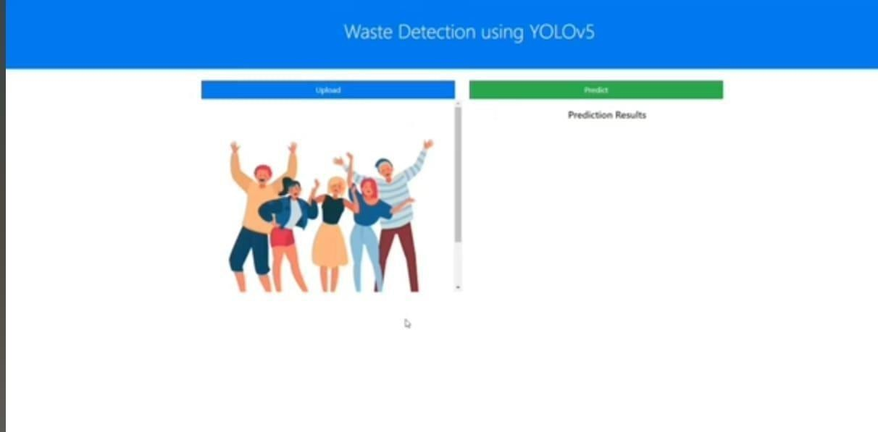

Fig 1: UI home page

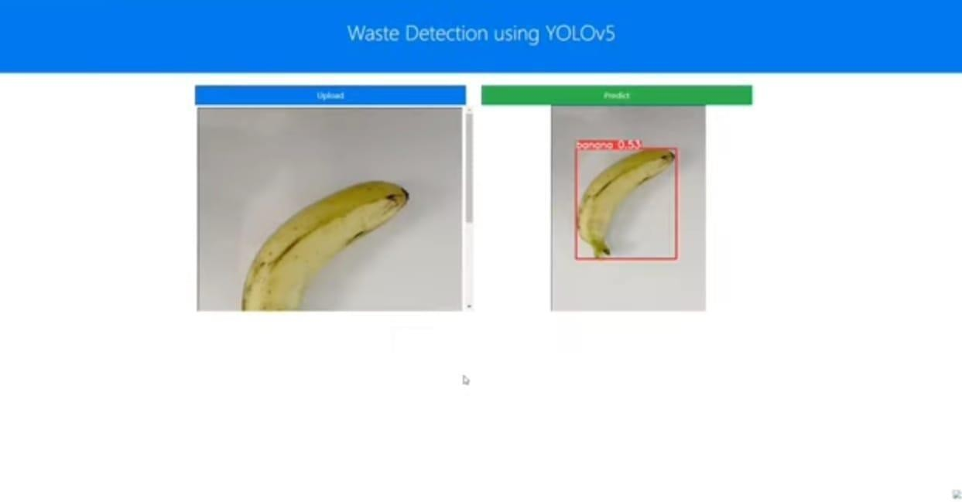

Fig 2.1 Waste Detection

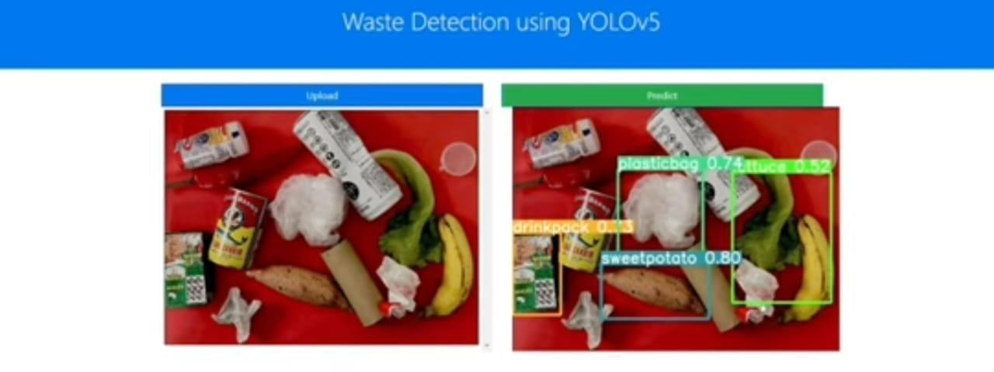

Fig 2.2Waste Detection

1. **Conclusion and Future Work**

In conclusion, a major advancement in resolving the difficulties encountered by job seekers in interview preparation has been made with the creation and

In conclusion, the implementation of the waste object detection system represents a significant step forward in leveraging advanced technologies to address environmental challenges. By integrating the YOLOv5 model into a user-friendly web application, the system enables real- time detection and classification of waste objects, facilitating efficient waste management practices. Through thorough testing and validation, the system has been demonstrated to be reliable and effective, offering actionable insights to users for informed decision-making.

Moving forward, there are several avenues for future work and enhancements to further improve the system's capabilities and impact on waste management practices.

Creating Smart Trash Bins with Notification System:

One promising direction for future work involves the development of smart trash bins equipped with sensors and notification systems. These smart bins could utilize the waste object detection system to automatically classify and sort incoming waste items based on their material composition. Additionally, sensors within the bins could monitor fill levels and trigger notifications when the bins are nearing capacity, prompting timely waste collection and management.

Furthermore, integrating IoT (Internet of Things) technologies into the smart bins could enable real-time data collection and analysis. This data could be utilized to optimize waste collection routes, minimize overflow incidents, and improve overall operational efficiency. Additionally, machine learning algorithms could be deployed at the edge to further enhance the

intelligence of the smart bins, enabling adaptive behavior based on usage patterns and environmental factors.

Moreover, incorporating communication capabilities into the smart bins would enable them to interact with users via mobile applications or web interfaces. Users could receive notifications when bins are full, view real-time fill level data, and even receive personalized waste management recommendations based on their usage patterns.

Overall, the development of smart trash bins with notification systems represents an exciting opportunity to leverage technology for more sustainable and efficient waste management practices. By combining object detection, IoT, and machine learning technologies, these smart bins have the potential to revolutionize waste collection and contribute significantly to environmental sustainability efforts.

### References

1. Redmon, J., & Farhadi, A. (2018). YOLOv3: An Incremental Improvement. Ar Xiv preprint arXiv:1804.02767.
2. Bochkovskiy, A., Wang, C. Y., & Liao,

H. Y. M. (2020). YOLOv4: Optimal Speed and Accuracy of Object Detection. Ar Xiv preprint arXiv:2004.10934.

1. Lin, T. Y., Dollár, P., Girshick, R., He, K., Hariharan, B., & Belongie, S. (2017). Feature pyramid networks for object detection. In Proceedings of the IEEE conference on computer vision and pattern recognition (pp. 2117-2125).

.

1. Liu, W., Anguelov, D., Erhan, D., Szegedy, C., Reed, S., Fu, C. Y., & Berg,

A. C. (2016). SSD: Single shot multibox detector. In European conference on computer vision (pp. 21-37). Springer,

1. Oyedotun, O. K., Khashman, A., & Olabiyisi, S. O. (2019). Machine Learning
2. Jamil, M., Bhoi, A. K., Kim, S., & An,

J. (2021). An IoT-Based Smart Waste Management System Using Machine Learning Techniques: A Review. Electronics, 10(11), 1272.

1. Fernandes, B. G., Santos, L. F. P., & Rosário, D. D. P. (2020). Intelligent Waste Management System: A Literature Review. In Iberian Conference on Information Systems and Technologies (pp. 281-291). Springer, Cham..
2. Zeiler, M. D., & Fergus, R. (2014). Visualizing and understanding convolution nal networks. In European conference on computer vision (pp. 818-833). Springer, Cham.

[9] He, K., Zhang, X., Ren, S., & Sun, J. (2016). Deep residual learning for image recognition. In