**“BEHAVIOUR AND DESIGN OF GEOPOLYMER BASED REINFORCED CONCRETE AND NORMAL RCC STRUCTURAL MEMBERS”**

**Rahul Kumar a, Dr. Manendra Pratap Vermab**

**M.Tech. Scholara, Professorb, **Madhyanchal Professional University**, Faculty of engineering & Technology, School of civil engineering Bhopal, M.P., India. **

[bindasrahulranjan@gmail.coma](mailto:bindasrahulranjan@gmail.coma), dr.mpverma@mpu.ac.inb

***ABSTRACT***

It is shown that the current provisions for OPC concrete can be conservatively used for design of reinforced geo polymer concrete members Fly ash based geo polymer is an alternative binder that has potential to reduce the CO2 emission of concrete production. It has been shown in different studies that the mechanical properties of geo polymer concrete are comparable to those of ordinary Portland cement (OPC) concrete. This paper describes the behavior and design aspects of geo polymer concrete structural members. The worldwide production of concrete is on the increase in order to meet the increasing rate of construction. Since cement production contributes to the greenhouse gas emission, it is vital to develop alternative low-emission binders to reduce the carbon footprint of concrete. We found geo polymer based concrete showing grate result as compare to normal rcc concrete in all mechanical properties such as compressive strength, tensile strength as well flexural strength in M25 grade of concrete.

***Key words:*** Portland cement (OPC) concrete, compressive strength, tensile strength as well flexural strength

**Introduction**

Concrete is a composite material composed of fine and coarse aggregate bonded together with a fluid cement (cement paste) that hardens over time. It is one of the most widely used construction materials in the world due to its versatility, durability, and relatively low cost. Concrete is mixed onsite or at a batching plant, where the ingredients are combined in specific proportions according to the desired strength and characteristics of the final product. Once mixed, concrete can be poured into molds or formwork to create various structures such as buildings, bridges, roads, dams, and more. After placement, concrete undergoes a curing process, during which it gradually hardens and gains strength. Some advantages of concrete include its high compressive strength, fire resistance, resistance to weathering and corrosion, and ability to be molded into various shapes and sizes. However, concrete does have some limitations, such as low tensile strength and susceptibility to cracking under certain conditions. These limitations can be addressed through the use of reinforcement, such as steel bars (rebar), to create reinforced concrete, which combines the compressive strength of concrete with the tensile strength of steel.

**Reinforced Cement Concrete**

Reinforced concrete, often abbreviated as RCC, is a composite material in which concrete's relatively low tensile strength and ductility are counteracted by the inclusion of reinforcement having higher tensile strength or ductility. The reinforcement is usually, though not necessarily, steel reinforcing bars (rebar) and is typically embedded passively in the concrete before the concrete sets. Reinforcing schemes are generally designed to resist tensile stresses in particular regions of the concrete that might cause unacceptable cracking and/or structural failure.

Reinforced concrete is widely used in construction due to its strength, durability, and versatility. It's used in various structures such as buildings, bridges, dams, roads, and foundations. The combination of concrete's compressive strength and the reinforcement's tensile strength makes reinforced concrete an ideal material for withstanding a wide range of loads and environmental conditions.

**Geoploymer Based Reinforced Concrete**

Geopolymer-based reinforced concrete is a type of concrete that utilizes geopolymers as the binder material instead of traditional Portland cement. Geopolymers are inorganic, amorphous aluminosilicate materials synthesized from industrial by-products or naturally occurring materials, such as fly ash, slag, met kaolin, or clay. Geopolymer-based reinforced concrete represents a promising alternative to traditional Portland cement concrete, offering potential environmental benefits and improved performance characteristics in certain applications. Continued research and development are essential to address remaining challenges and further optimize the material for widespread use.

**LITERATURE REVIEW**

**Saloma et al (2024)** was studythe study investigates the shear capacity of deep beams made of geopolymer concrete, considering various ratios of transverse reinforcement under monotonic loads. Deep beams are known for their high load support capacity based on building function but can be susceptible to shear failures due to overstress. Geopolymer concrete, with compressive strength equal to or higher than conventional concrete, presents potential as a structural material, but its performance in deep beams requires further exploration. The objectives of the study include analyzing the performance of geopolymer concrete deep beams through load-deflection curves, ductility ratio, stress and deflection contours, stiffness, dissipation energy, and shear capacity. The analysis is conducted using software based on the finite element method. The study suggests that geopolymer concrete shows promise for enhancing the performance of deep beams, particularly in terms of shear capacity and overall structural behavior. Geopolymer concrete deep beams with a transverse reinforcement ratio of 0.25% exhibit the highest load-bearing capacity. These beams demonstrate lower deflection compared to counterparts with lower shear reinforcement ratios under the same load. They also achieve better dissipation energy, ductility ratio, and shear capacity compared to normal concrete deep beams.

**Ms salomai et al (2023)** the study described focuses on investigating the structural behavior of reinforced concrete beams made with geopolymer concrete (GPC), which is considered a sustainable alternative to Portland cement concrete due to its lower CO2 emission rate. Geopolymer concrete is formed by combining fly ash with sodium hydroxide and sodium silicate solutions. The objective of the study was to experimentally examine the compressive and flexural strength of reinforced geopolymer concrete beams. The experimental program involved testing nine geopolymer cubes measuring 150x150x150mm for compressive strength at ages 7, 14, and 28 days. The results showed a slight reduction of 7.7% in compressive strength compared to conventional concrete. Furthermore, the flexural behavior of three geopolymer beams with dimensions of 700x150x150mm was evaluated using a two-point load test to determine beam deflection. The load-deflection characteristics of the geopolymer beams were found to be similar to those of reinforced concrete beams. Non-destructive testing (NDT) was also conducted on the beams to assess the quality of the geopolymer concrete. Specifically, the rebound hammer test was performed on the geopolymer beams, yielding a rebound hammer number of 48, indicating a very good hard layer. This suggests that the geopolymer concrete used in the beams exhibited favorable strength properties, as indicated by the rebound hammer test results. Overall, the study provides insights into the structural performance of reinforced geopolymer concrete beams and their potential application in construction as a sustainable alternative to conventional concrete.

**OBJECTIVE OF PAPER**

Find the structural behavior of reinforced cement concrete and Geo polymer based concrete.

**METHODS OF ANALYSIS**

**Mixing:** The aluminosilicate material, aggregates, and water are mixed together. Mixing is a crucial step in the process of creating materials such as concrete or ceramics, especially when dealing with components like aluminosilicate material, aggregates, and water. This process ensures proper distribution and bonding of the constituents to achieve desired properties. The aluminosilicate material, aggregates, and water can be effectively mixed together to create a homogeneous mixture suitable for various applications.

**Preparation of Components**: Before mixing, ensure that all components are properly prepared. This may involve measuring out the correct proportions of aluminosilicate material (such as clay or other minerals rich in aluminum and silicon), aggregates (such as gravel or crushed stone), and water according to the desired recipe or specifications.

**Addition of Alkaline Activator:** The alkaline activator is added to the mixture and thoroughly mixed. Adding an alkaline activator is a common practice in various chemical processes, particularly in industries such as cement production, water treatment, and polymer synthesis. Alkaline activators are substances that increase the alkalinity of a solution or mixture, thereby promoting certain chemical reactions or enhancing the performance of certain materials. It's important to note that the specific choice of alkaline activator and its concentration depends on the intended application, the properties of the materials involved, and the desired outcomes of the process. Additionally, careful consideration should be given to safety and environmental concerns when handling alkaline substances, as they can be corrosive or hazardous if mishandled.

**Increased pH**: Alkaline activators typically raise the pH of a solution or mixture by introducing hydroxide ions (OH-) or other alkaline species. This increase in pH can initiate or accelerate specific chemical reactions that require alkaline conditions.

**Activation of Chemical Reactions**: Many chemical reactions are pH-dependent, meaning they occur more readily under alkaline or acidic conditions. By adding an alkaline activator, you can shift the pH of the system to favor the desired reactions. For example, in geopolymerization processes used in cement production, alkaline activators such as sodium hydroxide (NaOH) or potassium hydroxide (KOH) are added to promote the dissolution of aluminosilicate materials and the formation of stable silicate bonds.

**Hydrolysis and Dissolution**: In some cases, alkaline activators facilitate the hydrolysis or dissolution of certain compounds. For instance, in water treatment processes, alkaline substances like lime (calcium hydroxide, Ca (OH)2) are added to raise the pH and facilitate the precipitation of metals or the coagulation of suspended particles.

**Polymerization**: Alkaline activators can also play a crucial role in polymer synthesis. They may be used to initiate polymerization reactions or adjust the pH to optimize the polymerization process. In the production of certain resins or plastics, alkaline catalysts are often employed to enhance reaction rates and control molecular weight distribution.

**Stabilization and Preservation**: Alkaline conditions can sometimes contribute to the stabilization or preservation of materials by inhibiting the growth of microorganisms or preventing certain chemical degradation reactions

**Pouring and Curing:** The geopolymer concrete is poured into formwork and allowed to cure under controlled conditions, typically at elevated temperatures.

Reinforce cement concrete mix design consider as per IS 10262-2009 and IS 456-200. But here we discussed in details of mix design geoploymer based concrete.

**Step – 1 Calculate target mean strength**

**F’ck = Fck + 1.65 S**

**Where**

F’ck =Target mean strength

Fck  = Characteristic compressive strength after 28 days For M25 grade of concrete 25 N/mm2

S = Standard derivation for M25 is 4

So,

**F’ck = 25+1.65 X 4 = 31.6 N/mm2**

**As per target mean strength and graph we calculate quantity of fly ash for our project**

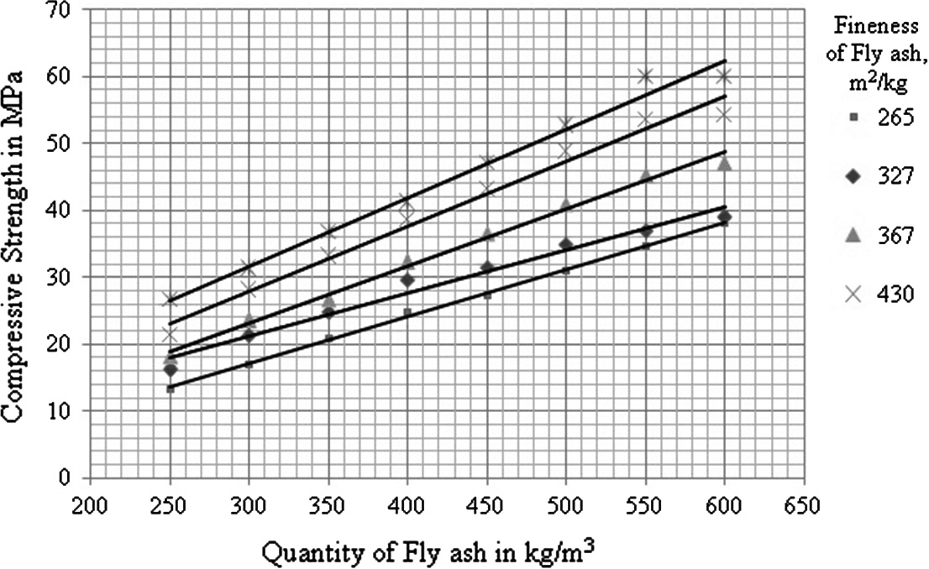

**Figure 1 Graf taken from shubhas V Partaker for calculation of fly ash quantity**

According to graph for target mean strength 31.6 N/mm2 quantity of fly ash is approx. 370 kg/m3

Solution to fly ash ratio = 0.35

Mass of [Na2Sio3 + NaOH] / Fly ash = 0.35

[Na2Sio3 + NaOH] / 370 = 0.35

Mass of [Na2Sio3 + NaOH] = 129.5

Take the sodium silicate to sodium hydroxide ratio by mass is 1

So Mass of sodium hydroxide (NaOH) = 64.75 Kg/m3

Mass of sodium silicate solutions (Na2Sio3) = 64.75 Kg/m3

Solid contain in sodium silicate solution = (50.32/100) X 64.75 = 32.58 Kg/m3

Wet density of geo polymer concrete = 2565 Kg/m3

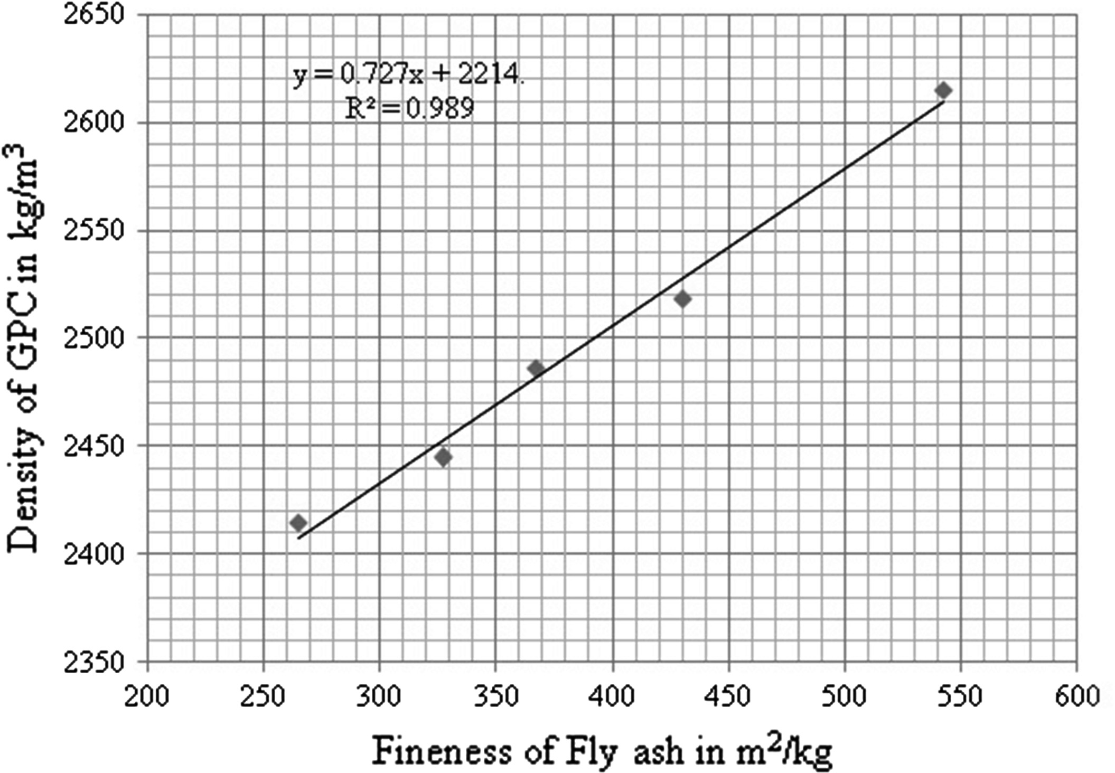

**Figure 2 showing the graph between fineness of fly ash and density of geoploymer concrete**

Total Aggregate content = [wet density of geopolymer concrete] – [Quantity of fly ash] + [quantity of both solution]

= 2565 – [370 + 129.5]

Total Aggregate content = 2065.5 Kg/ m3

Sand Contain = % of fine to total aggregate X Total aggregate content

Sand Contain = (35/100) X 2065.5 = 722.93 Kg/m3

Coarse Aggregate content = Total quantity of all aggregate – sand contain

2065.5 - 722.93 = 1342.57 Kg/m3

**Table 1 water contain as per workability required**

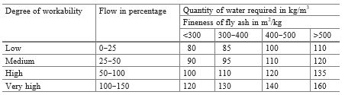

**Table 2 M25 grade geo polymer concrete per meter cube**

|  |  |
| --- | --- |
| **Items** | **Quantity** |
| Fly ash | 370 kg/m3 |
| NaOH | 64.75 Kg/m3 |
| Na2Sio3 | 64.75 Kg/m3 |
| Sand | 722.93 Kg/m3 |
| Aggregate | 1342.57 Kg/m3 |
| Water | 95 Kg/m3 |

Table 2 shown the quantity of material required to design of M25 geo polymer concrete, we would need to know the density of the polymer concrete mixture and the desired thickness of the concrete. Without specific values for the density of the polymer concrete mixture and the thickness of the concrete, it's not possible to provide an exact quantity.

**RESULTS AND DISCUSSION**

The result of a project can provide valuable insights into its quality and potential adoptability, it's important to recognize that there are various factors that can influence the outcome, even if the methods and materials used were sound. Here are a few reasons why the result may not be in your favor, even if you haven't necessarily done anything wrong. While the result of a project can provide valuable feedback on its quality and adoptability, it's essential to recognize that there are many potential reasons why the outcome may not be in your favor. Rather than viewing such outcomes as indicative of failure or wrongdoing, it's important to approach them as opportunities for learning and refinement for future endeavors. Despite careful planning and execution, there may be variables at play that were not accounted for in the initial project design. These variables could introduce unexpected complexities or confounding factors that affect the outcome.

**Compressive strength**

Compressive strength is the ability of a material or structure to resist forces that tend to crush or shorten it. It's the opposite of tensile strength, which measures a material's ability to resist pulling forces.

Comparing the compressive strength of M25 grade concrete with geopolymer concrete can provide valuable insights into the performance of these materials. Compressive strength is a critical parameter in determining the ability of concrete to withstand loads and stresses. The experiment provides valuable data on the compressive strength of M25 grade concrete and geopolymer concrete, contributing to the understanding and advancement of sustainable construction materials. The compressive strength of both types of concrete cubes was compared. Geopolymer concrete likely showed either higher or comparable compressive strength compared to M25 grade concrete. This result suggests that geopolymer concrete could be a viable alternative to traditional concrete, offering potentially superior performance in terms of compressive strength.

**Table 3 showing value of compressive strength after 28 days curing**

|  |  |
| --- | --- |
| **Compressive strength after 28 days N/mm2** | |
| **Normal R.C.C concrete** | **Geopolymer Based Reinforced concrete** |
| 31.56 | 36.98 |

**Figure 3 Compressive strength of normal rcc concrete and geopolymer based reinforced concrete**

**Tensile strength**

By conducting tests on specimens made from both geopolymer concrete and normal concrete and comparing the results after 28 days, you can effectively evaluate the effectiveness of geopolymer concrete in enhancing tensile strength. The improved performance of geopolymer concrete suggests that it could be a promising alternative to traditional concrete in construction projects where high tensile strength is crucial, such as in bridges, pavements, and high-rise buildings.

It's essential to document and analyze these results thoroughly to understand the factors contributing to the enhanced tensile strength of geopolymer concrete. This information can be valuable for further research and development efforts aimed at optimizing the performance of concrete materials in various applications.

**Table 4 Showing value of tensile strength**

|  |  |
| --- | --- |
| **Tensile strength after 28 days N/mm2** | |
| **Normal R.C.C concrete** | **Geopolymer Based Reinforced concrete** |
| 3.97 | 4.72 |

**Figure 4 Tensile strength of normal rcc concrete and geopolymer based reinforced concrete**

**Flexural Strength**

The flexural strength, also referred to as the modulus of rupture or bend strength, is a critical material property commonly used to assess the ability of a material to withstand bending stresses before yielding or fracturing. It is defined as the maximum stress experienced by a material just before it yields in a flexural test.

The symbol commonly used to represent flexural strength in equations and calculations is typically σ (sigma). The flexural strength is a crucial mechanical property used to evaluate a material's resistance to bending stresses, providing valuable insights into its structural integrity and suitability for various applications.

**Table 5 showing the result Flexural strength of concrete**

|  |  |
| --- | --- |
| **Flexural strength after 28 days N/mm2** | |
| **Normal R.C.C concrete** | **Geopolymer Based Reinforced concrete** |
| 8.96 | 10.54 |

**Figure 5 Flexural strength of normal rcc concrete and geopolymer based reinforced concrete**

**CONCLUSION**

Findings comparing the mechanical behavior of normal RCC concrete and geopolymer-based reinforced concrete. Geopolymer concrete indeed holds promise as an environmentally friendly alternative to traditional concrete due to its reduced carbon footprint. The fact that geopolymer concrete exhibited better results in your analysis suggests its potential for various applications. The decision to subject the geopolymer concrete to higher temperature curing (60 degrees Celsius) while keeping the normal concrete at room temperature for 24 hours likely influenced the outcomes. Temperature curing can significantly affect the strength and durability properties of concrete that the elevated curing temperature contributed to the superior performance of the geopolymer concrete. We also see geopolymer concrete offers the advantage of being more environmentally sustainable compared to conventional concrete, as it reduces CO2 emissions associated with cement production. This makes it an attractive option for construction projects aiming to minimize their environmental impact. In my research findings suggest that geopolymer-based reinforced concrete could be a promising alternative to traditional RCC concrete, offering improved mechanical properties and environmental benefits. Further studies and real-world applications could help validate and expand upon these findings, potentially leading to widespread adoption of geopolymer concrete in the construction industry.

**REFERENCES**

1. Saloma, Siti Aisyah Nurjannah* , Arie Putra Usman, Kiagus Muhammad Aminuddin, Maulid M. Iqbal, Rifkah “Shear Capacity of Geopolymer Concrete Deep Beams with Variation of Transverse Reinforcement Ratio” Civil Engineering and Architecture 12(1): 293-311, 2024 http://www.hrpub.org DOI: 10.13189/cea.2024.120123.

2. Ms. Salomie S. Lemos, 2Dr. Sumedh Y. Mhaske “Use of Geopolymer Concrete for Reinforced Beam” 2023 IJRTI | Volume 8, Issue 7 | ISSN: 2456-3315

3. Eliana Parcesepe Eliana Parcesepea,∗, Carmine Limab, Giuseppe Maddaloni a, Maria Rosaria Peccea “engineering properties of geopolymer concrete: a review” Acta Polytechnica CTU Proceedings 33:444–451, 2022 © 2022 The Author(s). Licensed under a CC-BY 4.0 licence Published by the Czech Technical University in Prague

4. Swapnil Kumar Sutar1, Mrs. Ramyashree2, Yashwanth N “Behavior of Geopolymer Concrete Columns Subjected to Biaxial Loading” International Research Journal of Engineering and Technology (IRJET) e-ISSN: 2395-0056 Volume: 07 Issue: 09 | Sep 2020 www.irjet.net p-ISSN: 2395-0072

5. Rajiv H Pazare1 , Anant N Dabhade “development on fly-ash based geopolymer concrete” JETIR2309411 Journal of Emerging Technologies and Innovative Research (JETIR) www.jetir.org e94 2023 JETIR September 2023, Volume 10, Issue 9 [www.jetir.org(ISSN-2349-5162)](http://www.jetir.org(ISSN-2349-5162))

6. Subhash V. Patankar, Yuwaraj M. Ghugal and Sanjay S. Jamkar “Mix Design of Fly Ash Based Geopolymer Concret” See discussions, stats, and author profiles for this publication at: <https://www.researchgate.net/publication/275340304> Conference Paper · December 2014 DOI: 10.1007/978-81-322-2187-6_123

7. Dattatreya J K1 , Rajamane NP2 , Sabitha D1 , Ambily P S1 , Nataraja MC “Flexural behaviour of reinforced Geopolymer concrete beams” international journal of civil and structural engineering Volume 2, No 1, 2011 © Copyright 2010 All rights reserved Integrated Publishing services Research article ISSN 0976 – 4399

## 8. Tobias Huber, Franz Untermarzoner, Johann Kollegger “Experimental investigation and mechanical modelling of shear failure in reinforced concrete members with plain and ribbed bent-up bars” <https://doi.org/10.1016/j.engstruct.2023.115793> [Engineering Structures](https://www.sciencedirect.com/journal/engineering-structures) [Volume 283](https://www.sciencedirect.com/journal/engineering-structures/vol/283/suppl/C), 15 May 2023, 115793