AN IoT BASED SMART HEALTH MONITORING SYSTEM(SHM-IOT)

|  |  |  |
| --- | --- | --- |
| Monika Jayasri K  Department of Computer Science  Rathinam College Of Arts And Science  Coimbatore | Priyadharshini S  Department of Computer Science  Rathinam College Of Arts And Science  Coimbatore | Rubini S  Department of Computer Science  Rathinam College Of Arts And Science  Coimbatore |

***Abstract:***

***In recent years, the world is facing a common problem that the number of elderly people is increasing. Hence, the problem of home-care for elderly people is very important. In concern of that ,Our project is implemented as a working model in which we incorporate sensors to measure parameters like body temperature, heart beat rate and body movement of a patient using IoT architecture. An Arduino microcontroller board used here for analysing the inputs from the patient. The hardware device will continuously send the data from sensors to the cloud and stored for future analysis. The patient data will be monitored remotely via a web application portal which is deployed in cloud for high availability. If any critical situation arises in a patient, it will alert us by graphs. In this, IoT is becoming a major platform for many services & applications, also using Node MCU not just as a sensor node but also a controller here. Paper proposes a generic health monitoring system as a step forward to the progress made in this department till now.***

***Keywords—patient health monitoring, sensors, dedicated patient care portal, IoT hardware device, Cloud Computing.***

# INTRODUCTION

Nowadays, the interest about enhancing Healthcare IoT refers to the integration of internet-connected devices and sensors into the healthcare industry. It involves the use of technology to collect, transmit and analyse data in real-time to improve patient care and outcomes. Examples of healthcare IoT include: Wearable devices for monitoring vital signs, such as heart rate and activity levels. Remote patient monitoring systems that allow healthcare providers to collect and analyse data from patients in real-time, regardless of location.

Overall, the goal of healthcare IoT is to improve the quality and efficiency of patient care, reduce costs and enhance patient outcomes. An IoT-based healthcare monitoring system has the potential to improve the quality of life for patients.

This system would utilize Internet of Things (IoT) devices to continuously monitor vital signs and other health parameters, and provide real-time data to healthcare providers. This would allow for earlier detection of potential health problems and prompt intervention, leading to improved patient outcomes. Additionally, the system could also provide patients with remote access to their health information and support self-management of their condition. The aim of this project is to design and implement an IoT based healthcare monitoring system to enhance the quality of life for patients through improved monitoring and management of their health.

# PROJECT OVERVIEW

*A. Scope of the project*

The Internet of Things (IoT) and cloud technology have the potential to greatly improve healthcare by allowing for better data collection, analysis, and dissemination.

1. Remote Monitoring IoT devices can be used for remote monitoring of patients, allowing doctors to track their health status and respond to changes more quickly.
2. Improved Data Collection with IoT devices, healthcare providers can collect more comprehensive and real-time data, which can help to improve diagnosis and treatment decisions.
3. Enhanced Collaboration Cloud technology can enable healthcare professionals to share and access patient data from different locations, improving collaboration between providers and reducing the risk of medical errors.
4. Predictive Analytics The use of cloud technology and IoT can enable the analysis of large amounts of patient data to identify patterns and predict future health outcomes, enabling more proactive and preventive care.
5. Cost Savings: By reducing the need for in-person visits and allowing for remote monitoring, IoT and cloud technology can help to reduce healthcare costs for patients and providers. Overall, the integration of IoT and cloud technology in healthcare has the potential to greatly improve patient outcomes, increase efficiency, and reduce costs.

# INTERNET OF THINGS(IOT)

IoT (Internet of Things) design is the process of designing connected devices and systems for the Internet of Things. It involves defining the requirements, Overview of Proposed system selecting the components, creating the architecture, and developing the software and firmware that runs on the devices. A patient-to-healthcare monitor system is an IoT based platform that enables patients to monitor their health and transmit vital health data to healthcare providers in realtime.

The system typically consists of a set of sensors and other medical devices that are connected to a cloud-based platform using wireless communication technologies such as Wi-Fi or Bluetooth. Patients can use the system to track their health metrics such as heart rate, blood pressure, temperature, and other vital signs, and share the data with their healthcare providers. Real-time monitoring: The system enables patients to monitor their health in real-time and transmit vital health data to healthcare providers, allowing for early detection of health issues. Data analytics the system can be used to analyse patient data over time to identify trends, predict future health issues, and improve healthcare outcomes. Secure data transmission the system ensures the secure transmission of patient data using encryption and other security measures a

patient-to-healthcare monitor system can help improve patient outcomes, reduce healthcare costs, and increase patient engagement in their own healthcare.

The system can be particularly useful for patients with chronic conditions or those requiring continuous monitoring of their health. A healthcare monitor system that collects patient data can be used to provide patients with valuable information about their health status and progress.

Here are some examples of how patients can access their health data through a healthcare monitor system Patient portals have been created by us that allow patients to securely access their health information, including test results, diagnosis, and treatment plans. These portals can be integrated with healthcare monitor systems to display real-time health data. Wearable devices Some healthcare monitor systems use wearable devices such as smartwatches or fitness trackers to collect patient data. Patients can access their health data through an accompanying mobile app or a web-based dashboard. A healthcare monitor system can provide patients with valuable information about their health status and progress, allowing them to take an active role in managing their own health. By using a patient-centred approach, healthcare providers can engage patients in their own care and help them achieve better health outcomes.

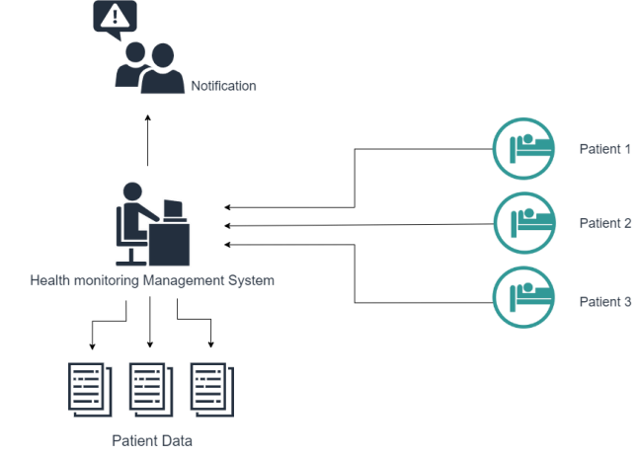

Fig.3.1

# HARDWARE MODULES

EXISTING SYSTEM

1.Manual monitoring

2.Distance between patient and monitoring unit are minimum.

3.In existing 8051 controller is used.

4.Single parameter monitoring system.

PROPOSED SYSTEM

1.Remote monitoring

2.Monitoring the patient as an easy one.

3.In proposed, Arduino microcontroller is used.

4.Multi parameter monitoring system.

HARDWARE MODULES:

* NODE MCU
* Heart beat sensor
* Temperature sensor
* MEMS sensor
* Node MCU
* LED
* Node MCU (ESP8266)

The Node MCU ESP8266 development board comes with the ESP-12E module containing the ESP8266 chip having Tensilica Xtensa 32-bit LX106 RISC microprocessor. This microprocessor supports

RTOS and operates at 80MHz to 160 MHz adjustable clock frequency. Node MCU has 128 KB RAM and 4MB of Flash memory to store data and programs. Its high processing power with in-built Wi-Fi / Bluetooth and Deep Sleep Operating features make it ideal for IoT projects. Node MCU can be powered using a Micro USB jack and VIN pin (External Supply Pin). It supports UART, SPI, and I2C interface.

* Pulse Sensor

A pulse sensor is an electronic device that measures the pulse rate or heart rate by detecting changes in blood flow through the wrist or neck. The pulse sensor typically works by emitting infrared light into the tissue and measuring the amount of light that is reflected back. This information is then processed to determine the heart rate. Pulse sensors are commonly used in wearable fitness devices, medical equipment, and other applications where monitoring the pulse rate is important. They are often small, lightweight, and battery-powered, making them convenient and portable.

* Temperature sensor

A temperature sensor is a device that measures temperature and converts it into an electrical signal that can be read and processed by a computer or other electronic device. There are several types of temperature sensors including thermocouples, RTDs (Resistance Temperature Detectors), thermistors, and infrared temperature sensors. Each type works differently but the basic principle is to measure the thermal energy in a material and convert it into a signal that can be interpreted as temperature.

* MEMS Sensor

MEMS (Micro Electro-Mechanical Systems) sensors are small, integrated devices that combine mechanical and electrical elements to detect changes in physical parameters such as acceleration, pressure, temperature, and flow. widely used in consumer electronics, such as smartphones and gaming devices, to detect movement, orientation and location. They are also used in automotive systems to monitor tire pressure and airbags, in medical devices to track body movements, and in industrial applications to measure pressure, temperature, and flow.

* LED

Light Emitting Diode, a type of solid-state lighting that converts electrical energy into light. LEDs consist of a semiconductor material that emits light when a current is passed through it. They are small, efficient, and long-lasting, making them ideal for a wide range of applications. LED lighting technology is constantly evolving, making it possible to produce light in a range of colors and brightness levels, making it an essential component in many modern devices and systems.

* Buzzer

A 5V passive buzzer is a type of buzzer that operates on a 5V DC power supply and does not have an internal oscillator. It produces sound by converting an external AC signal into an audible vibration. To use a 5V passive buzzer, an AC signal at the resonant frequency of the buzzer must be applied to it. This can be done using an oscillator circuit or by using a microcontroller or other digital signal source. It is suitable for use with common microcontroller platforms such as Arduino, which typically operate on 5V power supplies.

SOFTWARE MODULES:

* + AWS
  + ThingSpeak cloud
  + Arduino IDE

AWS - Amazon lightsail

* Amazon Lightsail Is a Powerful Virtual Server That Is Built For Reliability & Performance. Intuitive Management Console With Preconfigured Linux and Windows Application Stacks. Performance At Scale. Secure Solutions. Easily Manage Clusters. Virtual Private Cloud.

ThingSpeak cloud

* ThingSpeak is an IoT analytics platform service that allows you to aggregate, visualize, and analyse live data streams in the cloud.

Arduino IDE

* Open-source electronic prototyping platform enabling users to create interactive electronic objects.

# RELATED WORK

AMON - A Wearable Medical Computer For High Risk

Patients

The AMON (Advanced Medical Monitor) system is a wearable medical monitoring computer that has been developed by the European Union. It provides complex monitoring, data analysis and communication capabilities in a single wrist worn unit.

AUTHOR: Boyi Xu, Li Da Xu, Senior Member, IEEE,

Hongming Cai, Cheng Xie Year: 2020

UBIQUITOUS DATA ACCESSING METHOD IN IOTBASED INFORMATION SYSTEM FOR EMERGENCY MEDICAL SERVICES

In this project present an IoT-based system for emergency medical services to demonstrate how to collect, integrate, and interoperate IoT data flexibly in order to provide support to emergency medical services.

AUTHOR: Boyi Xu, Li Da Xu, Senior Member, IEEE,

Hongming Cai, Cheng Xie

Year: 2021

APPLICATION OF VIRTUAL MOBILE NETWORKING TO REAL TIME PATIENT MONITORING

Wireless sensors are used to monitor patient health statistics and activity. In this paper with the ubiquity of wireless mobile personal devices (such as smartphones) they describe, which is to utilize, through virtualization, an individual’s Smartphone

AUTHOR: Devan Rehunathan, Saleem Bhatti

Year: 2021

SIMPLICITY FOR WIRELESS MEDICAL BODY SENSORS

Body sensor network consists of smart wireless medical sensors measuring for example ECG, non-invasive blood pressure and the blood oxygen saturation. By means of advanced low-power radios based on the emerging 802.15.4 low-rate wireless personal area network standard the body worn sensors can communicate with another within a range of typically 5 to 10 meters.

AUTHOR: Thomas Falck, Heribert Baldus, Javier Espina,

Karin Klabunde

Year: 2021

DEVELOPMENT OF SMART

HEALTHCARE MONITORING SYSTEM IN IoT ENVIRONMENT

Knowledge enabled personalized monitoring for patients self-Management It is a Hardware mainly used to help monitoring patients though Components.

Authors: Md. Milon Islam, Ashikur Rahaman Md. Rashedul Islam.

Year: 2020.

DEVELOPING IoT BASED SMART HEALTH MONITORING SYSTEMS

The use of IoT and sensor-based intensive health care systems are increasing rapidly.

Authors: Rahaman A, Islam M, Islam M, Sadi M, Nooruddin S.

Year: 2019.

# OUTPUT

Arduino IDE

It shows the output of the embedded code in ESP2866 that runned in Arduino IDE, which is used to write and upload the embedded code to the microcontroller boards. It also act as a compiler for converting the code into machine readable-format and also provides uploader for transferring the compiled code to the arduino boards. An easy-to-use interface is provided by the Arduino IDE for authoring, compiling, and uploading code to an Arduino board. It has a

text editor for creating code, a compiler for turning that code into machine-readable form, and an uploader for sending that code to the Arduino board.

Here in this output, the data that is generated at the given time interval will be displayed in the IDE.

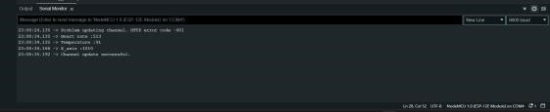

AWS lightsail

AWS Lightsail is a cloud-based virtual private server (VPS) solution provided by Amazon Web Services (AWS). It is designed to make it easy for developers, businesses, and individuals to quickly launch and manage virtual private servers, databases, and other application resources in the cloud. We can simply scale our resources up or down with AWS Lightsail as necessary to manage changes in traffic or consumption without worrying about capacity planning.

AWS Lightsail is a cost-effective solution for hosting websites and applications in the cloud. It offers a range of pre-configured plans with fixed monthly pricing, so you can easily predict your costs and avoid unexpected charges.

This service of an AWS cloud will be charged low as compared with other cloud providers in the market. This output displays a word press application that is hosted in AWS lightsail service.

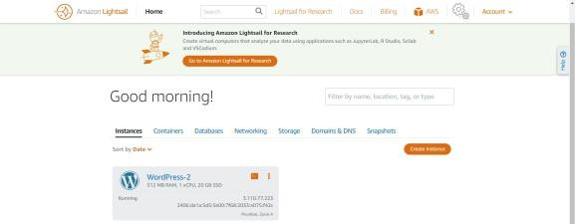

ThingSpeak cloud

ThingSpeak is an IoT analytics platform service that allows you to aggregate, visualize, and analyse live data streams in the cloud. You can send data to ThingSpeak from your devices, create instant visualization of live data, and send alerts.

With ThingSpeak, we can collect data from a wide range of sensors and devices, such as temperature sensors, humidity sensors, and GPS trackers, and store that data in the cloud. It is then used to analyse trends in data, identify patterns, and make decisions for business needs. ThingSpeak can be easily integrated with other IoT platforms, such as Arduino, Raspberry Pi, and Particle, as well as with other cloud platforms, such as AWS and Google Cloud Platform. This output displays the patients data that is collected from sensors.

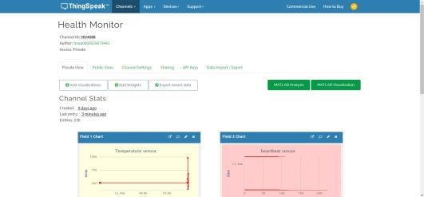

# CONCLUSION

Our project involves the integration of multiple technologies to monitor the health of patients. Firstly, we are using sensors to capture data from the patients continuously. The data is then streamed to the ThingSpeak IoT cloud service, which provides a platform for the storage and analysis of the data. The ThingSpeak service also enables us to set up alerts and triggers based on the data values. The data is then redirected to a WordPress web portal that is hosted on an AWS Lightsail service.

The WordPress web portal serves as the interface for monitoring the patients' health. The application allows users to log in and access the patients' data, including real-time monitoring of the patients' vital signs, such as heart rate, blood pressure, and sudden movements in patients body. To make the portal accessible on mobile and desktop, we have developed responsive web design and optimized the application for both platforms. The application is accessible through any modern web browser and can be easily accessed from a mobile device, tablet, or desktop computer. This system will be very helpful for the person, who's vital work is to continuously monitor multiple patients in their ward in hospitals. Overall, our solution provides an effective and efficient way to monitor patients' health using IoT technology and employing the features of cloud technologies. The integration of different technologies has enabled us to create a seamless system that allows for realtime monitoring of patients' health in hospitals.

This output displays the web portal which is used to monitor the multiple patients commonly in a single interface by logging into the system using appropriate patient credentials.

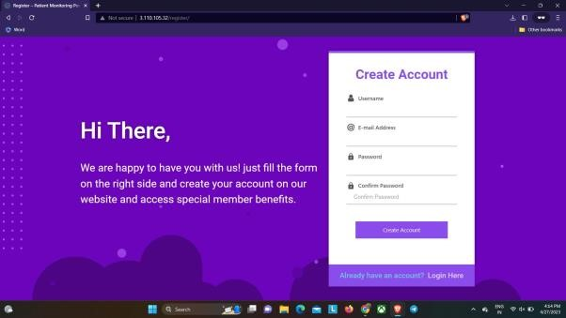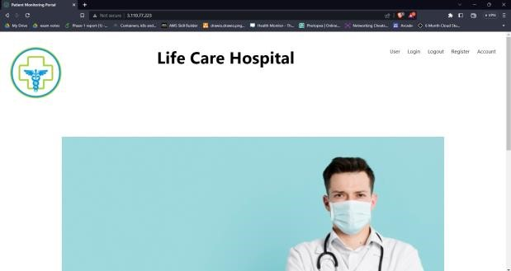

# FUTURE WORK

Artificial Intelligence and Machine Learning: Integrating artificial intelligence (AI) and machine learning algorithms into the system can enhance the accuracy of data analysis and predictions, providing healthcare providers with even more insights and recommendations.

Integration with Electronic Health Records: Integrating the Healthcare Monitoring System in IoT Cloud with electronic health records (EHRs) can provide a more

comprehensive view of a patient’s health history and improve the overall quality of care.Expansion to Remote Areas: The Healthcare Monitoring System in IoT Cloud has the potential to improve healthcare in remote areas by providing remote monitoring and telemedicine services to patients.Predictive Analytics: Predictive analytics can be used to predict potential health issues and provide early interventions, improving patient outcomes and reducing healthcare costs.

Personalized Medicine: The system can be used to personalize medicine by collecting and analyzing patient data to develop tailored treatment plans for each individual.

Wearable Devices and Sensors: The development of new wearable devices and sensors can provide healthcare providers with even more data about a patient’s health and improve the accuracy of monitoring and analysis.

Interoperability Standards: Developing and implementing interoperability standards can make it easier for different systems to communicate and exchange data, improving the overall efficiency of the Healthcare Monitoring System in IoT Cloud.

# REFERENCES

1. ”IoT and Cloud Computing-based Healthcare: A Comprehensive Review and Future Directions” Authors: S. B. K. Darbha, P. S. S. Dev, S. R. T. S. Adusumilli,and S. Krishna Source: IEEE Communications Surveys Tutorials, Vol. 23, No.1, First Quarter 2021, pp. 447-478.
2. ”Healthcare IoT and Cloud Computing: A Review and

Future Directions” Authors: N. Kalra, S. K. Singh, and S. Kaur Source: IEEE Access, Vol. 8, 2020, pp.181355181367.

1. ”An IoT and Cloud Computing-based Healthcare Monitoring System” Authors:D. Bhatia, N. Verma, and V. S. Rana Source: IEEE Internet of Things Journal,Vol. 7, No. 6, June 2020, pp. 7441-7449.
2. ”Towards a Smart and Scalable Healthcare System with IoT and Cloud Computing” Authors: A. Jain, A. R.

Chaudhary, and S. Chaudhary Source: IEEE Internet of Things Journal, Vol. 8, No. 1, January 2021, pp. 443-450.

1. ”Cloud-based Healthcare Monitoring System using IoT and Machine Learning”Authors: P. K. Das and S. K. Sahoo Source: IEEE Transactions on Emerging Topics in Computing, Vol. 9, No. 2, April 2021, pp. 449-459.
2. ”A Review of IoT and Cloud Computing in Healthcare:

Current Status and Future Directions” Authors: S. B. K.

Darbha, P. S. S. Dev, S. R. T. S. Adusumilli,and S. Krishna Source: IEEE Communications Surveys Tutorials, Vol. 23, No.2, Second Quarter 2021, pp. 1361-1391. [7] ”IoT and Cloud Computing for Healthcare: A Review of

Current Applications and Future Opportunities” Authors: M. R. AlSaqqaf, J. J. Rodriguez, and H. A.Al-Khuzaie Source: IEEE Internet of Things Journal, Vol. 8, No. 2, February 2021, pp. 1148-1157.

1. ”A Cloud-based Healthcare Monitoring System with IoT and Wireless Body Area Networks” Authors: S. L. Lee, Y. H. Kim, and H. K. Kim Source: IEEE Internet of Things Journal, Vol. 8, No. 2, February 2021, pp. 674681.
2. ”IoT and Cloud Computing for Personalized Healthcare:

A Review and Future Directions” Authors: A. N. AlAzzawi,

K. Alawadhi, and T. AlBashir Source:IEEE Communications Magazine, Vol. 58, No. 9, September 2020, pp. 108-115.

1. ”IoT and Cloud Computing for Remote Health Monitoring: A Survey” Authors:X. Zhang, X. Zhang, and Y.

Sun Source: IEEE Communications Surveys Tutorials, Vol. 23, No. 1, First Quarter 2021, pp. 119-135.

1. ”A review of the recent advancements in IoT-based cloud computing for healthcare systems” Authors: M.

Khan, M. Younis, M. A. Khan, and S. U. Rehman

Source:IEEE

Communications Surveys Tutorials, Vol. 22, No. 4, Fourth Quarter 2020, pp. 3322-3347.

1. ”IoT-based cloud computing for telemedicine systems:

A comprehensive review”Authors: H. J. Kim, J. H. Lee, and Y. J. Lee Source: IEEE Journal of Biomedical and Health Informatics, Vol. 26, No. 1, January 2022, pp. 38-51.

1. ”A Survey on Blockchain-based Healthcare IoT in Cloud Computing Environments” Authors: Y. Xing, Y. Liu, and X. Li Source: IEEE Communications Surveys Tutorials, Vol. 22, No. 4, Fourth Quarter 2020, pp. 3733-3755.
2. ”A Review of Cloud Computing and Internet of Things in Healthcare: Current State and Future Directions” Authors: H. Zhang, L. Wang, H. Zhang, J. Lu, and Y. Chen Source: IEEE Communications Magazine, Vol. 57, No. 7, July 2019,pp. 70-76. [15] ”A Federated Learning Approach for Secure and

Privacy-Preserving Healthcare IoT in Cloud Computing” Authors: X. Zhang, Y. Liu, Y. Xing, and X. Li Source:IEEE Transactions on Emerging Topics in Computing, Vol. 9, No. 1, February 2021, pp. 190-203.

[16] ”Edge Computing-based Healthcare IoT Systems in

Cloud Computing Environments” Authors: Y. Xing, Y. Liu,

X. Zhang, and X. Li Source: IEEE Journal on Selected Areas in Communications, Vol. 39, No. 2, February 2021, pp. 316-328.

1. ”IoT-based Wearable Devices and Cloud Computing for Remote Healthcare Monitoring” Authors: S. V. P.

Kumar, V. K. S. N. S. Sastry, and K. R. V. S. Reddy Source: IEEE Communications Magazine, Vol. 59, No. 1, January 2021, pp.84-89.

1. ”Big Data Analytics in Healthcare IoT Systems with

Cloud Computing” Authors:Y. Xing, Y. Liu, X. Zhang, and X. Li Source: IEEE Transactions on Big Data,Vol. 7, No. 4, December 2021, pp. 561-574.

1. ”A secure and privacy-preserving framework for cloudbased healthcare IoT systems” Authors: J. Chen, H. Liu, and L. Wang Source: IEEE Transactions on Information Forensics and Security, Vol. 16, No. 11, November 2021, pp. 2962-2975.
2. ”A Review of IoT-based mHealth Solutions in Cloud Computing Environments”Authors: S. H. Kim, Y. K.

Kim, and J. H. Lee Source: IEEE Journal of Biomedical and Health Informatics, Vol. 26, No. 2, March 2022, pp. 493-504.

1. ”An Energy-Efficient Resource Allocation Framework for Healthcare IoT in Cloud Computing” Authors: Y. Xing, Y. Liu, X. Zhang, and X. Li Source: IEEE Transactions on Sustainable Computing, Vol. 6, No. 4, October 2021, pp. 563-574.
2. ”Integration of Internet of Things and Cloud Computing in Healthcare: A Review” Authors: M. Khan, M. Younis, and M. A. Khan Source: IEEE Access, Vol.6, 2018, pp. 68235-68252.
3. ”A Survey on IoT and Cloud Computing for Healthcare Applications” Authors:H. Hasan and T. Ahmed Source:

IEEE Communications Surveys Tutorials, Vol.19, No. 2, Second Quarter 2017, pp. 917-947.

1. ”IoT-Based Healthcare: A Review of the State of the

Art and Future Opportunities” Authors: M. H. Al-Nuaimy,

S. Al-Dubai, and K. J. Kim Source: IEEE Communications Magazine, Vol. 55, No. 12, December 2017, pp. 128-134.

[25] ”Internet of Things in Healthcare: A Review of the

State of the Art and Future Challenges” Authors: M. H. AlNuaimy, S. Al-Dubai, and K. J. Kim Source:IEEE Communications Magazine, Vol. 56, No. 5, May 2018, pp. 94-101.