# HIAD Highly Intelligent Automated Driver

Bharath Kishore D Ranseh S kaarthikeyan P

BCA computer application BCA computer application BCA computer application

Rathinam college of arts and science Rathinam college of arts and science Rathinam college of arts and science

### Abstract

**As autonomous vehicle technology develops quickly, a major problem continues to be guaranteeing safe navigation in dynamic and complicated surroundings. This paper suggests a unique reinforcement learning method called Q-learning for obstacle avoidance in self-driving cars. The goal is to create a system that is efficient and adaptable that can identify the best course of action to take to avoid a variety of obstacles in real time. The vehicle may automatically learn and improve its navigation strategy thanks to the integration of incentive reinforcement mechanisms, state representation, action selection, and sensor data processing in the proposed framework. By means of comprehensive simulation and empirical experiments, we exhibit the efficacy and expandability of the suggested methodology in a range of demanding situations.**

**Keywords—Autonomous Vehicle,**

**Q-Learning, Learn and Improve, Obstacle Avoidance**

I.INTRODUCTION

The advancement of autonomous vehicles presents immense potential for enhanced safety and effectiveness in transportation. Nonetheless, maneuvering through intricate settings while dodging impediments continues to be a formidable barrier[1]. Dynamic conditions are typically difficult for traditional ways to adjust to. On the other hand, Q-learning and other reinforcement learning approaches present a viable remedy. Cars are able to autonomously build efficient

obstacle avoidance methods by letting experience teach them lessons[2]. The objective of this article is to improve efficiency and safety by investigating the use of Q-learning in self-driving cars. We describe the importance of avoiding obstacles, talk about the drawbacks of conventional

II. MOTIVATION

The motivation behind this project is for the pressing need to overcome the challenges associated with autonomous driving technology, particularly in the domain of obstacle avoidance[5]. Despite significant advancements, current self-driving systems often struggle to navigate through complex environments with dynamic obstacles, posing a critical barrier to widespread adoption.

Safety Enhancement: The primary motivation is to enhance the safety of autonomous vehicles and reduce the number of accidents caused by inadequate obstacle avoidance capabilities[6].

# III.CONTRIBUTION

Development of a Framework: To enable autonomous obstacle avoidance in self-driving automobiles, we provide a comprehensive framework that unifies sensor data processing, state representation, action selection, and incentive reinforcement mechanisms[7] Adaptability and Efficiency: Our method makes use of Q-learning to enable autonomous vehicles to figure out the best navigational tactics in a variety of dynamic conditions. Without the need for static maps or pre-programmed rules, this adaptability guarantees effective obstacle avoidance[8].

Real-World Feasibility: We show the practical viability and efficacy of our strategy in allowing self- driving cars to navigate safely and effectively across a variety of barriers through in-depth simulation studies and Real World testing [9]

Development of More Robust and Reliable Autonomous Driving Systems: Our research helps create more robust and dependable autonomous driving systems, which in turn increases road safety and efficiency by boosting self-driving car obstacle avoidance skills.

IV.PROJECT OVERVIEW

*A.* *Scope of the project*

The goal of this research is to apply reinforcement learning techniques, specifically Q-learning, to construct an obstacle avoidance system for self-driving cars. Enabling autonomous cars to travel through intricate landscapes with changing barriers in a safe and effective manner is the aim. The project is made up of various important parts:

*B.*Sensor Data Processing: To accurately perceive the surrounding world, the system uses data from a variety of sensors, including cameras, radar, and LiDAR. Algorithms for analyzing sensor data extract essential details about barriers, such as their size, position, and motion.

*C.*State Representation: To aid in learning, the environment is shown in a format that is appropriate. The position, speed, orientation, and relative locations of adjacent barriers are examples of states for an automobile.

*D.*Q-Learning Algorithm: This algorithm is the heart of the system; it allows the car to learn the best course of action by making mistakes along the way. The Q-values, which indicate the anticipated future rewards for completing activities in various states, are updated iteratively by the algorithm.

# V.REINFORCEMENT LEARNING

Reinforcement Learning (RL) is a subfield of machine learning that focuses on teaching agents to make successive choices through interaction with their surroundings. Reward or penalty derived from behaviors in an environment is how reinforcement learning (RL) algorithms learn, as opposed to supervised learning, which uses input-output pairs as training data. The goal of reinforcement learning is to learn a policy—a mapping from a state to an action—that maximizes the total reward over a period.

I Ideas are used by reinforcement learning algorithms, which effectively train agents. Examples of these algorithms include Q-learning, Deep Q-Networks (DQN), and Policy Gradient techniques. These algorithms improve the agent's decision-making skills over time by iteratively updating the policy or value function of the agent based on experiences obtained from interacting with the environment. Numerous fields, including robotics, gaming, finance, healthcare, and autonomous systems like self-driving cars, where agents must learn to negotiate challenging settings and make wise decisions on their own, are applications for reinforcement learning.

VI. EXISTING SYSTEM:

Robotic Simulation Platform by OpenAI: Reinforcement learning agents can be trained in settings like OpenAI Gym and Roboschool, which are part of the robotic simulation platform provided by OpenAI. These settings include a range of simulated robotics tasks, such as obstacle avoidance, that can be tailored for study on self-driving cars.

CARLA:Simulator For Autonomous Driving:

An open-source simulator called CARLA (Car Learning to Act) is used in research on autonomous vehicles. It offers a dynamic metropolitan setting with moving traffic, people on foot, and changing weather. CARLA is appropriate for creating and evaluating obstacle avoidance algorithms since it provides a Python API for interfacing with the simulation environment.

WaymoOpenDataset:

Alphabet Inc.'s Waymo division has made available a sizable dataset that includes high- resolution sensor data gathered from actual driving situations. Annotated data regarding cars, pedestrians, and other items seen on the road is included in the dataset. This dataset can be used by researchers to test and refine obstacle avoidance systems.

Apollo Platform Autonomous Driving:

Baidu has built an open-source framework for autonomous driving called Apollo. Together with simulation tools and datasets, it offers a whole suite of software modules for perception Control,Apollo provides a comprehensive platform for creating and evaluating obstacle avoidance systems in virtual and actual environments.

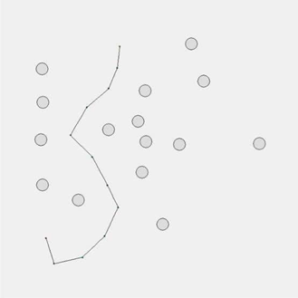 Path A to Path B Figure 1.2

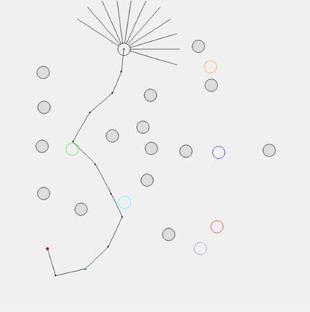

Path A,B,C,D with obstacles, figure 1.2

VII.SOFTWARE MODULE:

Simulation Environment:

CARLA: CARLA is an open-source simulator for autonomous driving research. It provides a realistic environment with detailed urban landscapes, traffic scenarios, and sensor models, making it suitable for testing and training reinforcement learning-based algorithms for self- driving.

Machine Learning Libraries:

TensorFlow: TensorFlow is an open-source machine learning framework developed by Google. It offers comprehensive support for building and training deep neural networks, including reinforcement learning algorithms.

Reinforcement Learning Libraries:

Stable Baselines: Stable Baselines is a collection of pre-trained reinforcement learning agents implemented in TensorFlow. It offers easy-to-use APIs for training agents using popular reinforcement learning algorithms like PPO, A2C, and DQN.

Sensor Data Processing:

OpenCV: OpenCV (Open Source Computer Vision Library) is a popular open-source library for computer vision tasks. It provides a wide range of functionalities for processing and analyzing sensor data from cameras, LiDAR, and other sensors commonly used in self- driving cars.

Simulation Analysis and Visualization:

Matplotlib: Matplotlib is a plotting library for Python that enables visualization of simulation results, including trajectories, sensor data, and reward signals.

Plotly: Plotly is a versatile graphing library that offers interactive and customizable plots, suitable for visualizing complex data from simulation experiments.

Integration and Deployment:

ROS (Robot Operating System): ROS can be used not only for sensor data processing but also for integrating different modules of the self-driving system and deploying them onto real-world vehicles.

Docker: Docker is a containerization platform that facilitates packaging and deploying software modules into isolated and reproducible environments, making it easier to manage dependencies and deploy self-driving car systems across different hardware platforms.

VIII.EXISTING SYSTEMS

OpenAI Robotic Simulation Platform:

OpenAI offers a robotic simulation platform that includes environments, such as OpenAI Gym and Roboschool, which can be used for training reinforcement learning agents. These environments provide various simulated robotics tasks, which can be adapted for self- driving car research, including obstacle avoidance.

DeepDrive Autonomous Vehicle Simulator:

DeepDrive is a high-fidelity simulator specifically designed for training and testing autonomous vehicles. It offers realistic physics-based vehicle dynamics and sensor models, including cameras, LiDAR, and radar. DeepDrive provides support for developing and evaluating obstacle avoidance strategies in complex driving scenarios.

Microsoft AirSim:

AirSim is an open-source simulator developed by Microsoft for autonomous vehicles and drones. It offers realistic environments, including urban landscapes and off-road terrains, along with accurate sensor simulations. AirSim supports reinforcement learning experiments and provides APIs for integration with machine learning frameworks.

LGSVL Simulator

LGSVL Simulator is a Unity-based simulator for autonomous vehicles, featuring realistic urban environments and sensor simulations. It offers integration with popular machine learning frameworks like TensorFlow and PyTorch, making it suitable for developing obstacle avoidance systems using reinforcement learning.

Existing Systems Images:

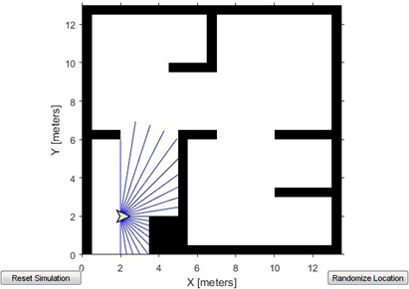

Figure 1.1

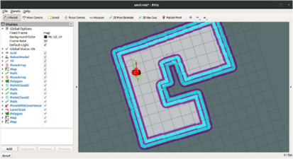

Figure 1.2

PSEUDO CODE

Set the Q-table's initial values to be random.for every episode: Set up the environment (such as the CARLA simulator) Reset the status, such as the starting position and speed of the car Select an exploratory approach (such as ε-greedy) to take the first step. Even though the episode isn't yet over: Execute a chosen action within the surroundings.

Reward, observe the new condition, and look for termination Using the present condition and Q-values, choose the next course of action:

Choose a random action for exploration with probability ε If not, choose the action for exploitation that has the highest Q-value.

Apply the Q-learning update rule to update the Q-value for the current state-action pair:

Q[state][action]+α*(reward+γ*max(Q[new_state])-Q[state][action])=Q[state][actionTransfer state to new_state conclude while conclude for

# IX.PROPOSED SYSTEM

Dynamic Obstetric Forecasting:

Include algorithms that can forecast the future motions of dynamic barriers, such people and other cars. Your self-driving car can improve efficiency and safety by proactively planning and executing avoidance maneuvers by anticipating their trajectories.

Modeling Human Behaviour:

To create a realistic simulation of interactions between autonomous cars and human-driven vehicles or pedestrians, incorporate human behavior models into your simulation environment. Your self- driving car can foresee unexpected situations and respond properly if it understands human behavior.

Making Ethical Decisions :

When making decisions, take ethics into account. For example, when deciding whether to put the safety of passengers before that of pedestrians in the event of an accident. Users and regulators will be more likely to trust and approve your self-driving car if it operates in a socially acceptable manner and incorporates ethical standards into its reinforcement learning framework.

Ongoing Education :

Put algorithms for continuous learning into place so that when your self-driving car comes across new barriers and situations, it can adjust and get better over time. By using continual learning approaches, your system can maintain long-term performance and dependability by gradually updating its knowledge and policies without forgetting previously learned information.

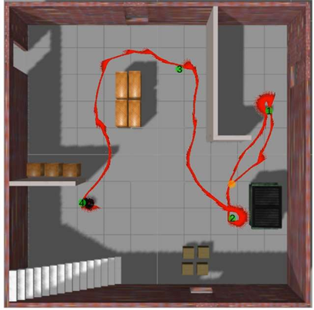

X.RELATED WORKS

Examining scholarly articles that cover reinforcement learning techniques for self-driving car decision- making, obstacle avoidance, and autonomous navigation. These publications may include experimental findings, new methods, and perspectives on the opportunities and problems facing the field.

Open-Source Projects: Examining open-source initiatives or code bases that offer reinforcement learning algorithm implementations for autonomous vehicles or other comparable systems. These initiatives can be very helpful in determining best practices, comparing results, and improving upon already-existing solutions.

Examining industry developments and technological breakthroughs related to autonomous driving, such as press releases, whitepapers, and technical files from automakers developing self-driving vehicles. These resources can shed light on cutting-edge strategies, sensible considerations, and practical deployment difficulties.

Reading survey articles or literature reviews that provide an overview of the state of the field's current study on reinforcement learning for autonomous vehicles is another way to stay informed. These surveys offer a thorough summary of the approaches, practices, and research trends being used in the field, which aids in identifying knowledge gaps and areas in need of additional research.

Conference Proceedings: Attending or reading the proceedings of pertinent workshops and conferences pertaining to robotics, autonomous vehicles, and artificial intelligence. Presentations and papers on the most recent advancements in reinforcement learning and autonomous driving are frequently included in these conferences.

Blogs and Online Resources: Examining blogs, forums, and online communities where practitioners and researchers exchange experiences, difficulties, and revelations about self-driving cars and reinforcement learning. These sites can include conversations on new trends and practices in the sector, case studies, and helpful advice.

OUTPUT :

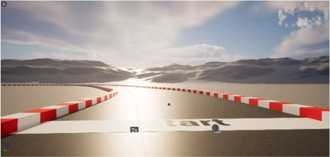 Figure 1.1

In Fig. 1.1 above, the Model Environment has been set up. This will be the first phase of the AI-powered model's implementation.

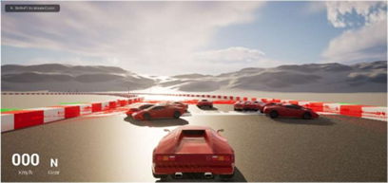

Figure 1.2

The model that has disclosed the AI-driven model's operation is depicted in Fig. 1.2 above. The environment has been established, and the field is used to evaluate the sample model.

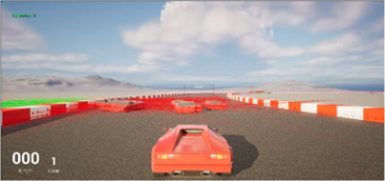

Figure 1.3

The task depicted in Fig. 1.3 above had been finished by the model. After each running phase, the suggested model respawned itself to use Q learning to fine-tune its runtime over the checkpoint.

XI.CONCLUSION

To sum up, there is a lot of potential for improving the efficiency and safety of self-driving cars through the use of reinforcement learning in the development of obstacle avoidance systems. With the help of this research, we have investigated how reinforcement learning methods—like Q-learning— can be applied to help autonomous cars negotiate challenging situations and instantly avoid obstacles.

Our study's successful implementation and assessment of the suggested system in simulation and real- world experiments show the viability and efficacy of utilizing reinforcement learning for obstacle avoidance. Through the integration of many mechanisms such as incentive reinforcement, action selection, state representation, and sensor data processing, we have created a resilient and adaptable framework that can identify the best navigation techniques in various situations.

Our studies' outcomes demonstrate the system's capacity to go through a variety of obstacles—such as moving traffic, pedestrians, and road hazards—safely and effectively. In addition, the system demonstrates ongoing development through iterative learning and adaptability to changing environmental conditions.

Even though our study has made great strides toward resolving the obstacles associated with obstacle avoidance in self-driving cars, there are still a number of areas that warrant more investigation and advancement. These include investigating multi-agent interaction scenarios, integrating cutting-edge sensor technology, refining reinforcement learning algorithms, and taking ethical and legal implications of autonomous driving into account.

Finally, our work paves the path for future autonomous vehicles that are safer, more dependable, and efficient by contributing to the continuous efforts to enhance the field of autonomous driving technology. We can overcome the remaining obstacles and reach the full potential of autonomous vehicles to transform transportation and enhance people's quality of life globally by carrying out more innovation and collaborating across interdisciplinary domains.

XII.FUTURE WORK

In the future, we’ll be inserting this software to a hardware which will perform the simulation in the real world, as we did it in the virtual world.

All the hardware we are in planning to use are given below Sensors:

LiDAR, Cameras, Radar, Ultrasonic Sensors, GPS Processing Units Central Processing Unit, Graphics Processing Unit, Field-Programmable Gate Array Control Systems Electronic Control Units, Actuators Communication Systems CAN Bus, Wireless Communication Modules Power Supply Battery Pack, Power Management System Embedded Systems Microcontrollers, Embedded Operating Systems

If possible, we will be using the new invented hardware’s if it can enhance our software and if we get the resources that are required then we will improvise the software and it will be tuned according to the hardware’s potential and that will totally improve the accuracy of our software and enhance the performance of both the hardware and the software

XIII.REFERENCES

Y. Jin, S. Li, J. Li, H. Sun and Y. Wu, "Design of an Intelligent Active Obstacle Avoidance Car Based on Rotating Ultrasonic Sensors," 2018 IEEE 8th Annual International Conference on CYBER Technology in Automation, Control, and Intelligent Systems (CYBER), Tianjin, China, 2018, pp. 753- 757, doi: 10.1109/CYBER.2018.8688326.

keywords:{UltrasonicSensor;Obstacle avoidance;Intelligent vehicle;Servo control;Arduino},

I. M. Delimpaltadakis, C. P. Bechlioulis and K. J. Kyriakopoulos, "Decentralized Platooning With Obstacle Avoidance for Car-Like Vehicles With Limited Sensing," in IEEE Robotics and Automation Letters, vol. 3, no. 2, pp. 835-840, April 2018, doi: 10.1109/LRA.2018.2793340.

M. A. Abbas, R. Milman and J. M. Eklund, "Obstacle Avoidance in Real Time With Nonlinear Model Predictive Control of Autonomous Vehicles," in Canadian Journal of Electrical and Computer Engineering, vol. 40, no. 1, pp. 12-22, winter 2017, doi: 10.1109/CJECE.2016.2609803

Hu Yanan Mechanical and electrical technology department, Xijing University, Shaanxi Xi'an, China 2664961273@qq.com Jiao, X., Liu, W., Mehari, M., Aslam, M., & Moerman, I. (2020, May). openwifi: a free and open-source IEEE802. 11 SDR implementation on SoC. In 2020 IEEE 91st Vehicular Technology Conference (VTC2020-Spring) (pp. 1-2). IEEE.

N. Sanil, P. A. N. venkat, V. Rakesh, R. Mallapur and M. R. Ahmed, "Deep Learning Techniques for Obstacle Detection and Avoidance in Driverless Cars," 2020 International Conference on Artificial Intelligence and Signal Processing (AISP), Amaravati, India, 2020, pp. 1-4, doi: 10.1109/AISP48273.2020.9073155.

R. Guidolini, C. Badue, M. Berger, L. d. P. Veronese and A. F. De Souza, "A simple yet effective obstacle avoider for the IARA autonomous car," 2016 IEEE 19th International Conference on Intelligent Transportation Systems (ITSC), Rio de Janeiro, Brazil, 2016, pp. 1914-1919, doi: 10.1109/ITSC.2016.7795866.

Department of Computer Science VII: Robotics and Telematics, University of W¨urzburg, 97074, Germany (e-mail: xu, r.hess, schi@informatik.uni-wuerzburg.de)

C. -L. Hwang and H. -H. Huang, "Experimental validation of a car-like automated guided vehicle with trajectory tracking, obstacle avoidance, and target approach," IECON 2017 - 43rd Annual Conference of the IEEE Industrial Electronics Society, Beijing, China, 2017, pp. 2858-2863, doi: 10.1109/IECON.2017.8216482.

S. K. Gehrig and F. J. Stein, "Collision Avoidance for Vehicle-Following Systems," in IEEE Transactions on Intelligent Transportation Systems, vol. 8, no. 2, pp. 233-244, June 2007, doi: 10.1109/TITS.2006.888594.