 

**IOT BASED PETROL PUMP AUTOMATION WITH ENVIRONMENT MONITORING**

## A PROJECT REPORT

***Submitted by***

|  |  |
| --- | --- |
| **S. LOGA VIGNESH** | **(Reg.No:312319105078)** |
| **P. MADHAN KUMAR** | **(Reg.No:312319105081)** |

***In partial fulfillment for the award of the degree of***

# BACHELOR OF ENGINEERING

## IN

ELECTRICAL AND ELECTRONICS ENGINEERING

**St.JOSEPH’S COLLEGE OF ENGINEERING**

# (An Autonomous Institution) ANNA UNIVERSITY:CHENNAI‐600025

April 2023

**ANNA UNIVERSITY: CHENNAI-600025**

# BONAFIDE CERTIFICATE

Certified that this project report “**IOT BASED PETROL PUMP AUTOMATION WITH ENVIRONMENT MONITORING**” is the bonafide work of **S.LOGA VIGNESH (312319105078), P.MADHAN KUMAR**

**(312319105081)** who carried out the project work under my supervision.

|  |  |
| --- | --- |
| **Signature** | **Signature** |
| **Dr.JAYARAMAPRADEEP M.E.,Ph.D PROFESSOR**  **HEAD OF THE DEPARTMENT**  Department of Electrical and Electronics Engineering,  St. Joseph’s College of Engineering OMR,  Chennai‐600 119. | **Mr.S.S.HARISH M.E. ASSISTANT PROFESSOR SUPERVISOR**  Department of Electrical and Electronics Engineering,  St. Joseph’s College of Engineering OMR,  Chennai‐600 119. |

ii

**CERTIFICATE OF EVALUATION**

|  |  |  |
| --- | --- | --- |
| **College Name** | **:** | St. Joseph’s College of Engineering |
| **Branch Name** | **:** | Electrical and Electronics Engineering |
| **Semester** | **:** | 08 |

|  |  |  |  |
| --- | --- | --- | --- |
| **S.NO** | **NAME OF THE STUDENT** | **TITLE OFTHE PROJECT** | **NAME OF THE SUPERVISOR WITH**  **DESIGNATION** |
|  | **S.LOGA VIGNESH (312319105078)** | **IOT BASED** |  |
| **1** | **PETROL PUMP**  **AUTOMATION** | **Mr.S.S.HARISH M.E. ASSISTANT PROFESSOR** |
|  |  |
| **2** | **P.MADHAN KUMAR (312319105081)** | **WITH ENVIRONMENT**  **MONITORING.** | **SUPERVISOR**  Department of Electrical and Electronics Engineering. |

The report of the project work submitted by the above students in partial fulfillment for the award of **Bachelor of Engineering** degree in **Electrical and Electronics Engineering** of Anna University were evaluated and confirmed to be report of the work done by the above students.

Submitted for the project viva-voice held on:

## INTERNAL EXAMINER EXTERNAL EXAMINER

ACKNOWLEDGEMENT

We wish to convey our gratitude to our Chairman **Dr.B.Babu Manoharan M.A, M.B.A, Ph.D** and beloved Managing Director **Mrs.B. Jessie Priya M.Com** and Executive Director **Mr.B.Shashi Sekar M.Sc** of St.Joseph’s College of Engineering, St. Joseph’s group of institutions for providing an opportunity to study in their esteemed institution.

We convey our sincere thanks to our beloved and encouraging Principal **Dr.Vaddi Seshagiri Rao M.E., M.B.A., Ph.D** St.Joseph’s College of Engineering for his encouragement throughout the course.

We express our sincere thanks and most heartfelt sense of gratitude to **Dr.Jayarama Pradeep M.E., Ph.D & Dr.T.V.Narmadha M.E., Ph.D** Professor,Head of the Department of Electrical and Electronics Engineering, for their dedication, commendable support and encouragement for the completion of the project with perfection.

We wish to express our sincere and thanks to our Project Co-ordinators **Dr.M.Venmathi M.E.,Ph.D,**Professor,**Dr.S.Sridharan M.E.,Ph.D**,Associate Professor, **Mr.R.Elanthirayan M.E.,(Ph.D)** Assistant Professor,Department of Electrical and Electronics Engineering for their enthusiastic guidance, wonderful motivation, valuable support and constructive remarks provided by them till the end of the project.

It is with deep sense of gratitude that we acknowledge our indebtedness to our beloved supervisor **Mr.S.S.HARISH,M.E,(Ph.D)** Assistant Professor for his expert guidance and connoisseur suggestion.

We thank all the faculty members and non-teaching staff of the Department of Electrical and Electronics Engineering who rendered their help in our endeavor.

Our sincere thanks to our parents for their continuous support, cheer and motivation for the successful completion of the project.

**ABSTRACT**

A fuel station is a facility which sells fuel and lubricants via fuel dispensers which themselves are used to pump gasoline, diesel, kerosene, etc. into vehicles. The dispensing of the fuel to huge number of vehicles at the fuel stations has caused many complications in India. The vehicle driver has to pay for fuel and may have to pay more than the amount of dispensed fuel due to the lack of small money change available with station operator. RFID Based Automated Petrol Pump is to reduce human work and develop an auto-guided mechanism and to implement the task sequentially by using RFID technology.RFID is a versatile and trending technology which is used in many real time applications. In this proposed work, RFID system is a microcontroller-based system that reduces the man power and dispenses the accurate amount of fuel. The main aim of this project is to deal with all stated problems by developing an automated petrol dispensing system using RFID technology and to determine the trust worthiness of the fuel station. In addition, it can detect the Temperature and the humidity of the surroundings by using the sensors. After collecting the environmental data the values are pushed into the cloud by using the Iot platform named Thinkspeak. Then the collected values are visualized in the form of graph and can separate the normal and the abnormal values of the atmospheric temperature by using the Machine learning concept.

Table of contents

|  |  |  |  |
| --- | --- | --- | --- |
| **CHAPTER**  **NO.** |  | **CONTENTS** | **PAGE**  **NO.** |
|  | ABSTRACT | | v |
|  | LIST OF ABBREVATIONS | | ix |
|  | LIST OF FIGURES | | x |
|  | LIST OF TABLES | | xi |
| **1** | **INTRODUCTION** | | **1** |
|  | 1.1 | INTRODUCTION | 1 |
|  | 1.2 | SCOPE OF THE PROJECT | 1 |
|  | 1.3 | OBJECTIVE | 1 |
|  | 1.4 | SUMMARY | 2 |
| **2** | **LITERATURE SURVEY** | | **3** |
|  | 2.1 | INTRODUCTION | 3 |
|  | 2.2 | RFID | 3 |
|  | 2.3 | SUMMARY | 6 |
| **3** | **EXISTING SYSTEM**  3.1 INTRODUCTION | | **7**  **7** |
|  | 3.2 | BLOCK DIAGRAM | 7 |
|  | 3.3 | DISADVANTAGES | 9 |
|  | 3.4 | SUMMARY | 9 |
| **4** | **PROPOSED SYSTEM** | | **10** |
|  | 4.1 | INTRODUCTION | 10 |
|  | 4.2 | BLOCK DIAGRAM | 11 |

|  |  |  |  |  |
| --- | --- | --- | --- | --- |
|  | 4.3 | ADVANTAGES | | 13 |
|  | 4.4 | APPLICATIONS | | 13 |
|  | 4.5 | SUMMARY | | 14 |
| **5** | **HARDWARE AND SOFTWARE**  **DESCRIPTION** | | | **15** |
|  | **5.1** | INTRODUCTION | | 15 |
|  | **5.2** | HARDWARE DESCRIPTION | | 15 |
|  |  | **5.2.1** | ARDUINO ATMEGA328P | 15 |
|  |  | **5.2.2** | POWER SUPPLY | 19 |
|  |  | **5.2.3** | LCD | 20 |
|  |  | **5.2.4** | KEYPAD | 22 |
|  |  | **5.2.5** | MQ135 GAS SENSOR | 23 |
|  |  | **5.2.6** | RFID | 24 |
|  |  | **5.2.7** | DC MTOR PUMP | 28 |
|  |  | **5.2.8** | MQ6 SENSOR | 29 |
|  |  | **5.2.9** | TEMPERATURE AND  HUMIDITY SENSOR | 30 |
|  | **5.3** | SOFTWARE DESCRIPTION | | **31** |
|  |  | **5.3.2** | ARDUINO CODE | 32 |
|  |  | **5.3.3** | ESP8266 CODE | 35 |
|  |  | **5.3.4** | EMBEDDED C | 38 |
|  |  | **5.3.5** | ARDUINO IDE | 39 |
|  | **5.4** | **SUMMARY** | | 42 |
| **6** | **RESULT** | |  | **43** |
|  | **6.1** | INTRODUCTION | | 43 |

|  |  |  |  |
| --- | --- | --- | --- |
|  | **6.2** | SOFTWARE | 43 |
|  | **6.3** | HARDWARE | 45 |
|  | **6.4** | SUMMARY | 46 |
| **7** | **CONCLUSION AND FUTURE SCOPE** | | **47** |
|  | **7.1** CONCLUSION | | 47 |
|  | **7.2** FUTURE SCOPE | | 47 |
|  | **REFERENCES** | | **48** |

## LIST OF ABBREVATION

|  |  |  |
| --- | --- | --- |
| S.NO | ABBREVATION | EXPANSION |
| 1 | RFID Radio Frequency Identification | |
| 2 | IDE | Integrated Development Environment |
| 3 | LCD | Liquid Crystal Display |
| 4 | LED | Light Emitting Diode |
| 5 | IC | Integrated Circuit |
| 6 | AIDC | Automatic Identification and Data Capture |
| 7 | ABR | American Barcode and RFID |
| 8 | BAP | Battery Assistant Passive |
| 9 | PRAT | Passive Reader Active Tag |
| 10 | ARPT | Active Reader Passive Tag |
| 11 | ARAT | Active Reader Active Tag |

**LIST OF FIGURES**

|  |  |  |
| --- | --- | --- |
| **FIGURE NO** | **NAME OF THE FIGURE** | **PAGE NO.** |
| 3.1 | Existing system | 8 |
| 4.1 | Proposed system | 11 |
| 5.1 | Arduino Atmega328p | 15 |
| 5.2 | Microcontroller components | 17 |
| 5.3 | Power Supply | 19 |
| 5.4 | LCD pin diagram | 20 |
| 5.5 | 4*4 matrix keypad | 22 |
| 5.6 | Keypad circuit diagram | 23 |
| 5.7 | Components of MQ135 | 24 |
| 5.8 | RFID Card | 26 |
| 5.9 | RFID card reader | 27 |
| 5.10 | DC Motor pump | 28 |
| 5.11 | MQ6 Sensor | 29 |
| 5.12 | Temperature and humidity sensor | 30 |
| 5.13 | Arduino program example | 31 |
| 5.14 | Embedded C programming | 39 |
| 5.15 | Library usage in Arduino | 41 |
| 6.1  6.2  6.3  6.4  6.5 | Dendrogram graph for MQ6 Dendrogram graph for MQ135 MQ6 level vs identification MQ135 level vs identification  RFID based petrol pump automation | 43  44  44  44  45 |

**LIST OF TABLES**

|  |  |  |
| --- | --- | --- |
| **TABLE NO.** | **TITLE** | **PAGE NO.** |
| 5.1  5.2 | ATmega 328P  LCD | 16  21 |

# CHAPTER – 1 INTRODUCTION

## INTRODUCTION:

This chapter deals with the introduction to RFID Based Automated Petrol Pump. The dispensing of the fuel to huge number of vehicles at the fuel stations has caused manycomplications in India. The vehicle driver has to pay for fuel with cash money and may have to pay more than the amount of dispensed fuel due to the lack of small money change available with station operator. RFID Based Automated Petrol Pump isto reduce human work and develop an auto-guided mechanism and to implement the task sequentially by using RFID technology. These systems are highly reliable and less time- consuming devices.

## SCOPE OF THE PROJECT:

Scope of the project is discussed here

* This system is used in monitoring petrol refilling system.
* This Automated Petrol Pump reduces human work and develop a auto guided mechanism to implement the task sequentially by using RFID technology.
* This system helps in removing the possibility of fraudulent transactions.
* This system ensures user safety to safeguard from fire accidents.

## OBJECTIVE

The objective of project is discussed here. To design a system which is capable of automatically deducting the amount petrol is dispensed from the user card based on RFID technology.

* To operate petrol distribution system with prepaid cardusing RFID Technology.
* To ensure user’s security for password protection.
* To ensure user safety to safe guard from fire accidents .

## SUMMARY:

A petrol card reader is installed in the bunk in which the petrol card can be swiped. On swiping instruction will be prompted in each step namely password and petrol quantity in liters. In case of low balance amount in the card, online recharge facility is provided to customer at the bunk. In addition to automated fuel filling, level and temperature detection are also done in this proposed project. A digital temperature and humidity sensor (DTH)is also connected to detect the temperature and humidity of the bulk environment. To prevent the bulk from accidents the temperature sensor is located. MQ6 sensor is connected to detect the gas, if industries are founded nearby bulk the sensor will detect how much gas they released during the peak hours. A MQ135 sensor is connected to detect the quality of the air. After collecting the environmental data the values are pushed into the cloud by using the Iot platform named Thinkspeak.

# CHAPTER - 2 LITERATURE SURVEY

## INTRODUCTION:

This chapter discusses about the methodologies referred from various publications on RFID Based Automated Petrol Pump. Traditional methods of monitoring petrol pump in gas station by humans on site are unable to meet the expectations for efficiency, accuracy and cost. Setting up an RFID and ESP8266 based petrol station monitoring system is a good approach to improve monitoring efficiency and to improve management efficiency in stations. The system uses a centralized database to allow fuel stations to share the same data about vehicles and related balance.

## RFID

* + 1. **Title : RFID Based Automated Petrol Pump System**

**Authors :** Kirti Chaudhary , Harsh Gupta , Divya Tyagi , Amarjeet Kumar.

**Year**: 2020

## Description:

The dispensing of the fuel to huge number of vehicles at the fuel stationshas Caused many complications in India. The vehicle driver has to pay for fuel with cash money and may have to paymore than the amount of dispensed fuel due to the lack of small money change available with station operator. RFID Based Automated Petrol Pump is to reduce human work and develop an auto-guided mechanism and to implement the task sequentially by using RFID technology.These systems are highly reliable and less time-consuming devices. The components used in this project are 8051 Microcontroller, RFID tags, Power supply, an LCD display, a Motor driver and an RFID reader. Petroleum products are one of the valuable and rare creations of the nature.

The proper use and distribution are an important task to survive these products. A fuel station is a facility which sells fuel and lubricants via fuel dispensers which themselves are used to pump gasoline, Diesel, kerosene, etc. into vehicles and to calculate the financial cost of the product thus dispensed the emergency of radio frequency technology has changed the traditional methods of data collection.Compared to the traditional bar code, magnetic card and IC cards,RFID tags.

* + 1. **Title**: Smart Automatic Petrol Pump System Based on RFID and ESP8266.

**Authors**: Zahra’a M. Baqir and Hassan. J. Motlak

**Year**: 2021

## Description:

Traditional methods of monitoring petrol pump in gas station by humans on site are unable to meet the expectations for efficiency, accuracy and cost. Setting up anRFID and ESP8266 based petrol station monitoring system is a good approach to improve monitoring efficiency and to improve management efficiency in stations. Although there are still some problems to be solved for RFID and WIFI technologies, their unique features still make the monitoring system based on thema promising system. The architecture of the RFID as prepaid system and ESP8266 as monitoring system in petrol station is presented in this paper.

* + 1. **Title**: RFID Based Fuel Station Automation using Arduino Uno **Authors**: Gandha Dhairya P., Dr.Tejas V. Shah , Dr.Deepali H. Shah **Year**: 2020

## Description:

Petroleum is the foremost and mainstay of modern civilization. It is one of the nature's rare and valuable creation. Its formation takes millions of years which insist proper utilization of the resource. In present scenario, fuel stations are operated manually which consist a controlling unit to perform various tasks. The present manual fuel

stations consumes more time and requires substantial man power.

Moreover, it is prone to malpractices and higher probability of human initiated errors. These limitations restrict installation of fuel stations in distant areas. The main aim of this paper is to deal with all stated problems by developing an automated petrol dispensing system using RFID technology. Such a system enables a user to use a RFID based prepaid card to access petrol at fuel stations. Whenever the user wants to fill the tank from the fuel dispenser, user has to enter the amount first and then place the RFID card near the RFID reader. The Arduino Uno manages to read the data from the RFID reader and perform action according to the customer requirements as well as the amount is deducted from the user's card. The RFID and Arduino Uno are used for improvement of present petrol dispensing system by reducing human work and providing an auto guided mechanism to carry out the tasks consecutively. These systems are highly reliable and conserves the time

* + 1. **Title:** Design and Implementation of RFID-based Fuel Dispensing System

**Authors:** [Fawzi Mohammed Munir Al-Naima](https://www.researchgate.net/profile/Fawzi-Al-Naima)

**Year:** 2015

## Description:

This paper presents a fuel dispensing system based on RFID technology. The system can improve the fueling process in order to make it much easier, secure and reliable. It prevents unauthorized fueling by assigning a specified amount of fuel for registered vehicles, depending on their types, within a specific period of time so that each vehicle will get a sufficient amount of fuel. It also provides efficient statistics about the various quantities of fuel at the stations. The system was implemented at the Oil Products Distribution Company, The Distribution of Baghdad. It uses ELA816B RFID reader with its passive tags. It has a software application, built using VB.Net, for registration of customers, updating their accounts and charging them for the designated amount of fuel. The hardware part

of this system consists of a microcontroller, card relay, LCD and other basic electronic components, and itis attached to conventional fuel dispensers in order to make them work under the RFID technology. The system uses a centralized database to allow fuel stations to share the same data about vehicles and related balance. Additional features of this system include a website and a phone application, which allow customers to login to their accounts.

* + 1. **Title:** RFID Based Petrol Pump Automation System

**Authors**: Pooja Mandhare , Rajwardhan Autade , Vishal Gutal , Dr.S.Shribahad, Prof. P. Upadhye

**Year**: 2021

## Description:

Everything has been digitized. In many existing systems, almost all petrolpumps have a controlling unit to perform the tasks like managing the electrical pump electrical pump, drive the display, measure the flow &OFF the electrical pump. But still a person is required to collect the money and there is card to access petrol at different petrol stations of different petrol companies across the country and here, connecting all these petrol stations using single web server. This web server access is secured by a password which is known only to the petrol companies. Whenever want to fill the tank from the fuel dispenser, just have to place the RFID card near the RFID reader.

## SUMMARY:

This Literature Survey describes the RFID technology and its applications in today’s world. RFID Based Automated Petrol Pump is to reduce human work and develop an auto-guided mechanism and to implement the task sequentially by using RFID technology . It also deals with all stated problems by developing an automated petrol dispensing system using RFID technology. The architecture of the RFID as prepaid system and ESP8266 as monitoring system is presented and discussed.

## CHAPTER - 3 EXISTING SYSTEM

* 1. **INTRODUCTION:**

This chapter deals with the existing system of petrol pump system. A fuel station is a facility which sells fuel and lubricants via fuel dispensers which themselves are used to pump gasoline, Diesel, kerosene, etc. into vehicles. The dispensing of the fuel to huge number of vehicles at the fuel stations has caused many complications in India. The vehicle driver has to pay for fuel with cash money and may have to pay more than the amount of dispensed fuel due to the lack of small money change available with station operator. Fuel dispensers are used to pump fuel into the tanks within vehicles and calculate the financial cost of the fuel transferred to the vehicle. If a filling station allows customers to pay at the dispenser, the data from the dispenser maybe transmitted via [RS232, RS485](https://en.wikipedia.org/wiki/RS232) or [Ethernet](https://en.wikipedia.org/wiki/Ethernet) to the point of sale, usually inside the filling station's building, and fed into the station's cash register operating system. The cash register system gives a limited control over the fuel dispenser, and is usually limited to allowing the clerks to turn the pumps on and off.

## BLOCK DIAGRAM:

This figure 3.1 below depicts the block diagram of existing system and the components of the existing system is discussed.

**ARDUINO ATMEGA 328P**- Arduino is [open-source hardware](https://en.wikipedia.org/wiki/Open-source_hardware). The hardware reference designs are distributed under a [Creative Commons](https://en.wikipedia.org/wiki/Creative_Commons) Attribution Share- Alike 2.5 license and are available on the Arduino website. Layout and production files for some versions of the hardware are also available.

4 x 3 Keypad

RFID

Tags

LCD Display

EM18 RFID Module Rx

5v Gnd

A0 A1 A2 A3 A4 A5

Tx

Micro controller

ATMEGA 328P

LM2595 – Step

down converter

D8 D7 D6 D5 D4 D3 D2

O/P

D13

Relay module

Fig 3.1 - Block Diagram of Existing System

**RELAY** - A relay is an [electrically](https://en.wikipedia.org/wiki/Electric) operated [switch](https://en.wikipedia.org/wiki/Switch). It consists of a set of input Terminals, For a single or multiple control signals, and a set of operating contact terminals. Relay is used here to switch on the motor for pumping.

**REGULATED POWER SUPPLY -** A regulated power supply converts unregulated AC ([Alternating Current](https://www.electrical4u.com/alternating-current/)) to a constant DC (Direct [Current](https://www.electrical4u.com/electric-current-and-theory-of-electricity/)). A regu-

-lated power supply Is used to ensure that the output remains constant even if the input changes.A regulated DC power supply is also known as a linear power supply,it is an embedded circuit and consists of various blocks.

**LCD -** LCD screen is an electronic display module and find a wide range of applications. A 16x2 LCD display is very basic module and is very commonly usedin various devices and circuits. These modules are preferred over [seven](http://www.engineersgarage.com/content/seven-segment-display) [segments](http://www.engineersgarage.com/content/seven-segment-display) and other multi segment [LED](http://www.engineersgarage.com/content/led)s.

**KEYPAD -** At the lowest level, keyboards are organized in a matrix of rows and columns.The CPU accesses both rows and column through ports; therefore, with two 8-bit ports, an 8*8 matrix of keys can be connected to a microprocessor. When a key pressed, a row and column make a connect; otherwise, there is no connection between row and column.

**Pump -** DC water pump is a machine that transports liquid or pressurizes liquid. When the water pump is working, the coil and commutator rotate, but the magneticsteel and carbon brushes do not rotate. The alternating current direction of the coil is changed by the commutator and brushes that rotate with the motor.

## DISADVANTAGES:

The disadvantages are listed below

1. There is no option to use physical currency (coin).
2. Loss of Money.
3. No return policy for the unused charging time.

## SUMMARY:

In this chapter it is discussed about the existing system. Here vehicle driver has to pay for fuel with cash money and may have to pay more than the amount of dispensedfuel due to the lack of small money change available with station operator. The components used in this project are 8051 Microcontroller, Power supply, an LCD display, a Motor driver. Traditional methods of monitoring petrolpump in gas station by humans on site are unable to meet the expectations for efficiency, accuracy and cost. In present scenario, fuel stations are operated manually which consist a controlling unit to perform various tasks. The present manual fuel stations consumes more time and requires substantial man power. Moreover, it is prone to malpractices and higher probability of human initiated errors. These limitations restrict installation of fuel stations in distant areas.

## CHAPTER-4 PROPOSED SYSTEM

* 1. **INTRODUCTION:**

This chapter deals with the proposed system of petrol pump system. In present scenario, fuel stations are operated manually which consist a controlling unit to perform various tasks. The present manual fuel stations consume more time and requires substantial man power. Moreover, it is prone to malpractices and higher probability of human initiated errors. These limitations restrictinstallation of fuel stations in distant areas. The main aim of this project is to deal with all stated problems by developing an automated petrol dispensing system using RFID technology. Such a system enables a user to use a RFID based prepaid card to access petrol at fuel stations. Whenever the user wants to fill the tank from the fuel dispenser, user has to enter the amount first And then place the RFID card near the RFID reader. The Arduino Atmega328p manages to read the data from the RFID reader and perform action according to the customer requirements as well as the amount deducted from the users card’s. In this system, provide the measurement of the correct petrol for the current price and also given the petrol accuracy rate. A digital temperature and humidity sensor (DTH)is also connected to detect the temperature and humidity of the bulk environment. To prevent the bulk from accidents the temperature sensor is located. MQ6 sensor is connected to detect the gas, if industries are founded nearby bulk the sensor will detect how much gas they released during the peak hours. A MQ135 sensor is connected to detect the quality of the air. After collecting the environmental data the values are pushed into the cloud by using the Iot platform named Thinkspeak.

ThingSpeak provides very good tool for IoT based projects. By using ThingSpeak site, monitor the data and control for system over the Internet, using the Channels and webpages provided by ThingSpeak. ThingSpeak ‘Collects’ the data from the sensors, ‘Analyze and Visualize’ the data and ‘Acts’ by triggering a reaction.

## BLOCK DIAGRAM:

The fig 4.2 below describes the proposed system of the project .Here RFIDused as an advancement. Gas sensor is used to ensure no fire accidents.

DHT 11 TEMPERATURE AND HUMIDITY

SWITCH



ESP8266 NODEMCU

MQ 135 AIR QUALITY SENSOR

MICRO -

CONTROLLER ATMEGA 328P

THINKSPEAK CLOUD

MQ6 GAS SENSOR

Fig 4.1-Block diagram of proposed system

LM2596 – STEP DOWN CONVERTER

ML – HIERARCHIAL CLUSTERING

**ARDUINO ATMEGA328P** - ATmega328 is commonly used in many projects and autonomous systems where a simple, low-powered micro-controller is needed. Arduino UNO is a microcontroller based on the ATmega328P. It has 14 digital input/output pins (of which 6 PWM outputs), 6 analog inputs, a 16 MHz ceramic resonator, a USB connection, a power jack, an ICSP header and a reset button.

**POWER SUPPLY** - This section describes to generate +5V DC power supply. The power supply section successful working of the project. A 0-12V/1 mA transformer is used for this purpose.

**LCD**(Liquid Crystal Display) - LCD screen is an electronic display module and

finda wide range of applications. A 16x2 LCD display is very basic module and is very commonly used in various devices and circuits.

**KEYPAD** - At the lowest level, keyboards are organized in a matrix of rows and columns.The CPU accesses both rows and column through ports; therefore, with two 8-bit ports, an8*8 matrix of keys can be connected to a microprocessor.

**DHT11 SENSOR -** The DHT11 is a basic, ultra low-cost digital temperature and humidity sensor. It uses a capacitive humidity sensor and a thermistor to measure the surrounding air and spits out a digital signal on the data pin (no analog input pins needed). It's fairly simple to use but requires careful timing to grab data.

**RFID(**Radio Frequency Identification) - Radio-frequency identification (RFID) uses [electromagnetic fields](https://en.wikipedia.org/wiki/Electromagnetic_field) to automatically identify and track tags attached to objects. The tagscontain electronically stored information.

**MOTOR DRIVER** - Motor drivers acts as an interface between the motors and the controlcircuits. Motor require high amount of current whereas the controller circuit works on low current signals. So the function of motor drivers is to take a low-current control signal and then turn it into a higher-current signal that can drive a motor.

**MQ135 SENSOR** – The MQ-135 Gas sensor can detect gases like Ammonia (NH3), sulfur (S), Benzene (C6H6), CO2, and other harmful gases and smoke. Similar to other MQ series gas sensor, this sensor also has a digital and analog output pin. When the level of these gases go beyond a threshold limit in the air the digital pin goes high.

**MQ6 SENSOR -** The Grove - Gas Sensor (MQ9) module is useful for gas

leakage detection (in home and industry). It is suitable for detecting LPG, CO, CH4. Due to its high sensitivity and fast response time, measurements can be taken as soon as possible. The sensitivity of the sensor can be adjusted by using the potentiometer.

**LM2596 buck converter**- LM2596 is a step-down voltage regulator, also known as buck convertor, mainly used to step down the voltage or to drive load under 3A. It carries the remarkable load and line regulation and is available in fixed output voltages including 3.3V, 5V, 12V.

**RFID TAG** - A radio-frequency identification system uses tags, or labels attached to the objects to be identified. Two-way radio transmitter-receivers called interrogators or readers send a signal to the tag and read its response.

**ESP8266 WiFi Module** - The ESP8266 WiFi Module is a self contained SOC with integrated TCP/IP protocol stack that can give any microcontroller access to the WiFi network. The ESP8266 is capable of either hosting an application or offloading all WiFi networking functions from another application processor.

## ADVANTAGES:

The advantages are listed below,

* No Loss Money.
* Accurate rate.
* To obtain correct value.
* More accuracy.
* Easy to pay.

## APPLICATIONS:

This is used in monitoring petrol refilling system.

## SUMMARY:

In this chapter have discussed about the proposed system RFID Based Automated Petrol Pump is to reduce human work and develop an auto-guided mechanism and to implement the task sequentially by using RFID technology. These systems are highly reliable and less time-consuming devices. The proper use and distribution are an important task to survive these products. A fuel station is a facility which sells fuel and lubricants via fuel dispensers which themselves are used to pump vehicles and to calculate the financial cost of the product thus dispensed the emergency of radio frequency technology has changed the traditional methods of data collection. Comparedto the traditional bar code, magnetic card and IC cards, RFID tags.

## CHAPTER - 5

**HARDWARE AND SOFTWARE DESCRIPTION**

## INTRODUCTION:

This chapter deals with the hardware and software designs are freely available under[copy left](https://en.wikipedia.org/wiki/Copyleft) licenses, the developers have requested the name Arduino to be [exclusive to the official product](https://en.wikipedia.org/wiki/Generic_trademark) and not be used for derived works without permission. The official policy document on use of the Arduino name emphasizes that the project is open to incorporating work by others into the official product.

## HARDWARE DESCRIPTION:

* + 1. **ARDUINO ATMEGA328P:**

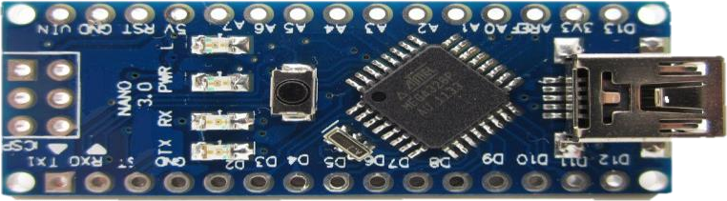

Fig 5.1 Arduino Atmega328p

The ATmega328P is the microcontroller that powers the Arduino Uno development board. The Arduino board makes it easy to interface with the pins on the ATmega328P while adding extra features that don't come with the standalone microcontroller, including a USB serial interface and 16 MHz clock. It contains everything needed to support the microcontroller; simply connect itto a computer with a USB cable or power it with an AC -to- DC adapter or battery to get started.

## TECHNICAL SPECIFICATIONS:

The Table 5.1 lists the technical specifications of ATmega328P.

Table 5.1 Technical Specifications:

|  |  |
| --- | --- |
| **Microcontroller** | [ATmega328P](http://www.atmel.com/Images/Atmel-2549-8-bit-AVR-Microcontroller-ATmega640-1280-1281-2560-2561_datasheet.pdf) |
| **Operating Voltage** | 5V |
| **Input Voltage (recommended)** | 7-12V |
| **Input Voltage (limit)** | 6-20V |
| **Digital I/O Pins** | 28 pins and 3 ports |
| **Analog Input Pins** | 6 |
| **Speed** | Up to 20 MHZ |
| **Core size** | 8 bit |
| **Flash Memory** | 32 KB |
| **RAM** | 2K x 8 |
| **EEPROM** | 1K x 8 |
| **Clock Speed** | one clocked at 8MHz and one at  128kHz. |
| **IC type** | AVR Micro Controller |

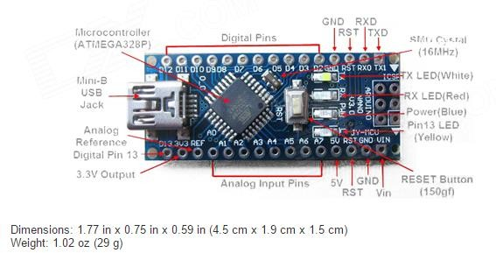

Fig 5.2 Arduino Atmega328P microcontroller components

Arduino is [open-source hardware](https://en.wikipedia.org/wiki/Open-source_hardware). The hardware reference designs are distributed under a [Creative Commons](https://en.wikipedia.org/wiki/Creative_Commons) Attribution Share-Alike 2.5 license and are available on the Arduino website. Layout and production files for some versions of the hardware are also available.

Several Arduino-compatible products commercially released have avoided the project name by using various names ending in Arduino . An early Arduino board with an [RS-232](https://en.wikipedia.org/wiki/RS-232) [serial](https://en.wikipedia.org/wiki/RS-232) interface (upper left) and an Atmel ATmega8 microcontroller The - ATmega328 is commonly used in many projects and autonomous systems where a simple, low-powered micro-controller is needed. Arduino UNO is a microcontroller based on the ATmega328P. It has 14 digital input/output pins (of which 6 PWM outputs), 6 analog inputs, a 16 MHz ceramic resonator, a USB connection, a power jack, an ICSP header and a reset button.

Most Arduino boards consist of an [Atmel](https://en.wikipedia.org/wiki/Atmel) 8-bit [AVR microcontroller](https://en.wikipedia.org/wiki/AVR_microcontroller) (ATmega8, ATmega168, [ATmega328](https://en.wikipedia.org/wiki/ATmega328),ATmega1280, ATmega2560) with varying amounts of flash memory, pins, and features. The 32- bit [Arduino Due](https://en.wikipedia.org/wiki/Arduino_Due), based on the Atmel [SAM3X8E](https://en.wikipedia.org/wiki/Atmel_ARM-based_processors#SAM_3) was introduced in 2012. The boards use single or double-row pins or female headers that facilitate connections for programming and incorporation into

other circuits. These may connect with add- on modules termed shields. Multiple and possibly stacked shields may be individually addressable via an [I²C serial](https://en.wikipedia.org/wiki/I%C2%B2C) [bus](https://en.wikipedia.org/wiki/I%C2%B2C). Most boards include a 5 V [linear regulator](https://en.wikipedia.org/wiki/Linear_regulator) and a 16 MHz [crystal oscillator](https://en.wikipedia.org/wiki/Crystal_oscillator) or [ceramic resonator](https://en.wikipedia.org/wiki/Ceramic_resonator). Some designs, such as the LilyPad, run at 8 MHz and dispense with the onboard voltage regulator due to specific form-factor restrictions.

Arduino microcontrollers are pre-programmed with a [boot loader](https://en.wikipedia.org/wiki/Boot_loader) that simplifies uploading of programs to the on-chip [flash memory](https://en.wikipedia.org/wiki/Flash_memory). The default bootloader of the Arduino UNO is the optiboot bootloader. Boards are loaded with program code via aserial connection to another computer. Some serial Arduino boards contain a level shifter circuit to convert between [RS-232](https://en.wikipedia.org/wiki/RS-232) logic levels and [transistor–transistor logic](https://en.wikipedia.org/wiki/Transistor%E2%80%93transistor_logic) (TTL) level signals. Current Arduino boards are programmed via [Universal Serial Bus](https://en.wikipedia.org/wiki/Universal_Serial_Bus) (USB), implemented using USB-to-serial adapter chips such as the [FTDI](https://en.wikipedia.org/wiki/FTDI)FT232. Some boards, such as later-model Uno boards, substitute the [FTDI](https://en.wikipedia.org/wiki/FTDI) chip witha separate AVR chip containing USB-to- serial firmware, which is reprogrammable via its own [ICSP](https://en.wikipedia.org/wiki/In-system_programming) header. Other variants, such as the Arduino Mini and the unofficial Boarduino, use a detachable USB- to-serial adapter board or cable. When used with traditional microcontroller tools, instead of the Arduino IDE. An official Arduino Uno R2 with descriptions ofthe I/O locations. The Arduino board exposes most of the microcontroller's I/O pins for use by other circuits. The Diecimila, Due milanove and current Uno provide 14 digital I/O pins, six of which can produce [pulse-width modulated](https://en.wikipedia.org/wiki/Pulse-width_modulation) signals, and six analog inputs, which can also be used as six digital I/O pins. These pins are on the top of the board, via female 0.1-inch (2.54 mm) headers. Several plug-in application shields are also commercially available. The Arduino Nano, and Arduino- compatible Bare Bones Board and arduino boards may provide male header pins on the underside of the board that can plug into solderless [breadboards.](https://en.wikipedia.org/wiki/Breadboard)

Many Arduino-compatible and Arduino-derived boards exist. Some are functionally equivalent to an Arduino and can be used interchangeably. Many enhance the basic Arduino by adding output drivers, often for use in school-level education, to simplifymaking buggies and small robots. Others are electrically equivalent but change the formfactor, sometimes retaining compatibility with shields, sometimes not. Some variants use different processors, of varying compatibility.

## POWER SUPPLY:

This section describes how to generate +5V DC power supply. The power supply section successful working of the project. A 0-12V/1 mA transformer is used for this purpose. The primary of this transformer is connected into main supply through on/off switch& fuse for protecting from overload and short circuit protection. The secondary isconnected to the diodes to convert 12V AC to 12V DC voltage. And filtered by the capacitors,Which is further regulated to +5v, by using I C 7805.

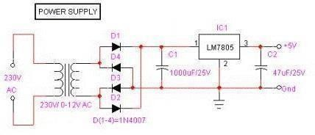

Fig 5.3 Power Supply

## LCD(Liquid Crystal Display):

LCD screen is an electronic display module and find a wide range of applications.

A 16x2 LCD display is very basic module and is very commonly used in various devices and circuits. These modules are preferred over [sevensegments](http://www.engineersgarage.com/content/seven-segment-display) and other multi segment [LED](http://www.engineersgarage.com/content/led)s. The reasons being: LCDs are economical; easily programmable; have no limitation of displaying special & even [custom characters](http://www.engineersgarage.com/microcontroller/8051projects/create-custom-characters-LCD-AT89C51) (unlike in seven segments), [animations](http://www.engineersgarage.com/microcontroller/8051projects/display-custom-animations-LCD-AT89C51) and so on.

A **16x2 LCD** means it can display 16 characters per line and there are 2 such lines. In this LCD each character is displayed in 5x7 pixel matrix. This LCD has two registers, namely, Command and Data.

The command register stores the command instructions given to the LCD. A command is an instruction given to LCD to do a predefined task like initializing it, clearing its screen, setting the cursor position, controlling display etc. The data register stores the data to be displayed on the LCD. The data is the ASCII value of the character to be displayed on the LCD. Click to learn more about internal structure of a [LCD](http://www.engineersgarage.com/insight/how-lcd-works).

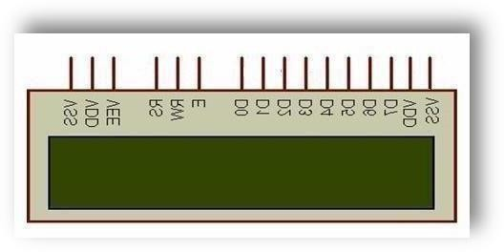

Fig 5.4 Pin Diagram of LCD

## Pin Description:

The table below describes the pin description of LCD.

Table 5.2 pin description of LCD

|  |  |  |
| --- | --- | --- |
| **Pin No** | **Function** | **Name** |
| 1 | Ground (0V) | Ground |
| 2 | Supply voltage; 5V (4.7V – 5.3V) | Vcc |
| 3 | Contrast adjustment; through a variable resistor | VEE |
| 4 | Selects command register when low; and data registerwhen high | Register Select |
| 5 | Low to write to the register; High to read from the register | Read/wr  ite |
| 6 | Sends data to data pins when a high to low pulse is given | Enable |
| 7 | 8-bit datapins | DB0 |
| 8 | DB1 |
| 9 | DB2 |
| 10 | DB3 |
| 11 | DB4 |
| 12 | DB5 |
| 13 | DB6 |
| 14 | DB7 |
| 15 | Backlight VCC (5V) | Led+ |
| 16 | Backlight Ground (0V) | Led- |

The most commonly used LCDs found in the market today are 1 Line, 2 Lineor 4 Line LCDs which have only 1 controller and support at most of 80 characters, whereas LCDs supporting more than 80 characters make use of2 HD44780 controllers.

Most LCDs with 1 controller has 14 Pins and LCDs with 2 controller has 16 Pins (two pins are extra in both for back-light LED connections). Pin description is shown in the table below.

## KEYPAD:

At the lowest level, keyboards are organized in a matrix of rows and columns.The CPU accesses both rows and column through ports; therefore, with two 8-bit ports, an 8*8 matrix of keys can be connected to a microprocessor. When a key pressed, a row and column make a connect; otherwise, there is no connection between row and column.

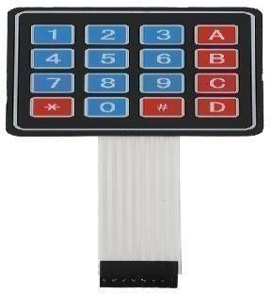

Fig 5.5 4*4 matrix Keypad

In IBM PC keyboards, a single microcontroller (consisting of microprocessor, RAM and EPROM, and several ports all on a single chip) takes care of software and hardware interfacing of keyboard. In such systems it is the function of programs stored in the EPROM of microcontroller to scan the keys continuously, identify which one has been activated, and present it to the motherboard. Figure shows a 4*4 matrix connected to two ports

The rows are connected to an output port and the columns are connected to aninput port. If no key has been pressed, reading the input port will yield 1s for allcolumns since they are all connected to high (Vcc) If all the rows are grounded and a key is pressed, one of the columns will have 0 since the key pressed provides the path to ground.

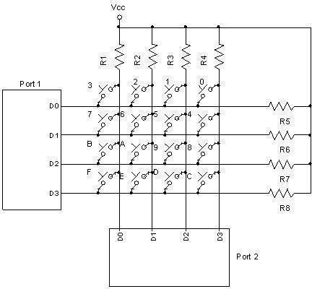

Fig 5.6 Circiut Diagram of keypad

To detect a pressed key, the microcontroller grounds all rows by providing 0 to the output latch, and then it reads the columns. If the data read from the columns is D3- D0=1111, no key has been pressed and the process continues until a key press is detected. However, if one of the column bits has a zero, this means that a key press has occurred. For example, if D3-D0=1101, this means that a key in the D1 column has been pressed. After a key press is detected, the microcontroller will go through the process of identifying the key. Starting with the top row, the microcontroller grounds it by providing a low to row D0 only; then it reads the columns. If the data read is all1s, no key in that row is activated and the process is moved to the next row. It grounds the next row, reads the columns, and checks for any zero. This process continues until the row is identified. After identification of the row in which the key has been pressed, the next task is to find out which column the pressed key belongs to. This should be easy since the microcontroller knows at any time which row and column are being accessed.

* + 1. **MQ135 GAS SENSOR:**

A device that is used to detect or measure or monitor the gases like ammonia, benzene, sulfur, carbon dioxide, smoke, and other harmful gases are called as an air quality gas sensor. The MQ135 air quality sensor, which belongs to the series of MQ gas [sensors](https://www.elprocus.com/types-of-sensors-with-circuits/), is widely used to detect harmful gases, and smoke in the fresh air. This article gives a brief description of how to measure and detect gases by using an MQ135 air quality sensor.

An MQ135 air quality sensor is one type of MQ gas sensor used to detect, measure, and monitor a wide range of gases present in air like ammonia, alcohol, benzene, smoke, carbon dioxide, etc. It operates at a 5V supply with 150mA consumption. Preheating of 20 seconds is required before the operation, to obtain the accurate output.

It is a semiconductor air quality check sensor suitable for monitoring applications of air quality. It is highly sensitive to NH3, NOx, CO2, benzene, smoke, and other dangerous gases in the atmosphere. It is available at a low cost for harmful gas detection and monitoring applications.

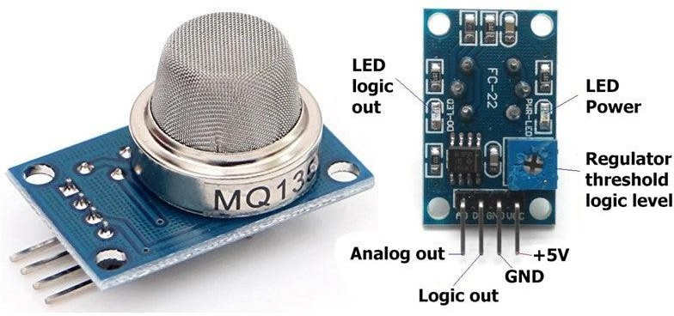If the concentration of gases exceeds the threshold limit in the air, then the digital output pin goes high. Using the potentiometer of the sensor can vary the threshold value. The analog output voltage is obtained from the analog pin of the sensor, which gives the approximate value of the gas level present in the air.

Fig 5.7 Components of MQ135

## RFID(RADIO-FREQUENCY IDENTIFICATION):

Radio-frequency identification (RFID) uses [electromagnetic fields](https://en.wikipedia.org/wiki/Electromagnetic_field) to automatically identify and track tags attached to objects. The tags contain electronically stored information. Passive tags collect energy from a nearby RFID reader's interrogating [radio waves.](https://en.wikipedia.org/wiki/Radio_wave)RFID is similar to barcoding in that data from a tag or label are captured by a device that stores the data in a database. RFID, however, has several advantages over systems that use barcode asset tracking

software.The most notableis that RFID tag data can be read outside the line-of- sight, whereas barcodes must be aligned with an optical scanner.

If are considering implementing an [RFID solution,](https://www.abr.com/solutions/rfid/) take the next step and contact the RFID experts at AB&R® (American Barcode and RFID).

Active tags have a local power source (such as a battery) and may operate hundreds of meters from the RFID reader. Unlike a [barcode](https://en.wikipedia.org/wiki/Barcode), the tags don't need to be within the line of sight of the reader, so it may be embedded in the trackedobject. RFID is one method of [automatic identification and data capture](https://en.wikipedia.org/wiki/Automatic_identification_and_data_capture) (AIDC).

RFID tags are used in many industries. For example, an RFID tag attached to an automobile during production can be used to track its progress through the assemblyline; RFID-tagged pharmaceuticals can be tracked through warehouses; and [implanting RFID microchips](https://en.wikipedia.org/wiki/Microchip_implant_(animal)) in livestock and pets enables positive identification of animals.Since RFID tags can be attached to cash, clothing, and possessions, or implanted in animals and people, the possibility of reading personally-linked information without consent has raised serious privacy concerns. These concerns resulted in standard specifications development addressing privacy and security issues.An RFID reader is a device that is used to interrogate an RFID tag. Thereader has anantenna that emits radio waves; the tag responds by sending back its data.An RFID tag is a microchip combined with an antenna in a compact package; the packaging is structured to allow the RFID tag to be attached to an object to be tracked.

When radio waves from the reader are encountered by a passive RFID tag, the coiled antenna within the tag forms a magnetic field. The tag draws power from it, energizing the circuits in the tag. The tag then sends the information encoded in the tag's memory.Then the reader senses the data from the Tag and transmits the sensed data to microcontroller via serial port.

Power-up the module and connect the transmit pin of the module to receive pin of microcontroller. card within the reading distance and the card number is

thrown at the output. Optionally the module can be configured for also an output.

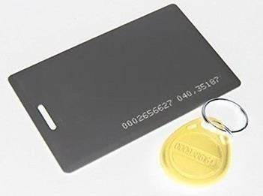

Fig5.8 RFID Card

A radio-frequency identification system uses tags, or labels attached to the objectsto be identified. Two-way radio transmitter-receivers called interrogators or readers send a signal to the tag and read its response.

"RFID" stands for Radio Frequency Identification.

RFID tags can be passive, active or battery-assisted passive. An active tag has an on-board battery and periodically transmits its ID signal. A battery- assisted passive (BAP) has a small battery on board and is activated when in the presence of an RFID reader. A passive tag is cheaper and smaller because it has no battery; instead, the tag uses the radio energy transmitted by the reader. However, to operate apassive tag, it must be illuminated with a power level roughly a thousand times stronger than for signal transmission. That makes a difference in interference and in exposure to radiation.

Tags may either be read-only, having a factory-assigned serial number that is used as a key into a database, or may be read/write, where object -specific data can be written into the tag by the system user. Field programmable tags may be writing- once, read-multiple; "blank" tags may be written with an electronic product code by the user.

RFID tags contain at least three parts: an [integrated circuit](https://en.wikipedia.org/wiki/Integrated_circuit) that stores and processes information and that [modulates](https://en.wikipedia.org/wiki/Modulation) and [demodulates radio-](https://en.wikipedia.org/wiki/Demodulation) [frequency](https://en.wikipedia.org/wiki/Radio-frequency) (RF)

signals; a means of collecting DC power from the incident reader signal; and an [antenna](https://en.wikipedia.org/wiki/Antenna_(radio)) for receiving and transmitting the signal. The tag informationis stored in a non-volatile memory. The RFID tag includes either fixed or programmable logic for processing the transmission and sensor data, respectively.

An RFID reader transmits an encoded radio signal to interrogate the tag. The RFID tag receives the message and then responds with its identification and other information. This may be only a unique tag serial number, or may be product- related information such as a stock number, lot or batch number, production date, orother specific information. Since tags have individual serial numbers, the RFID system design can discriminate among several tags that might be within the rangeofthe RFIDreader and read them simultaneously

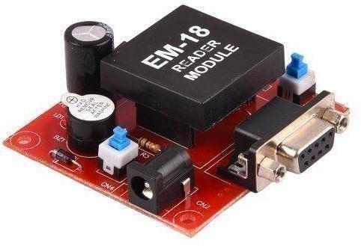

Fig 5.9 RFID Reader Module(EM-18)

RFID systems can be classified by the type of tag and reader. A Passive Reader Active Tag (PRAT) system has a passive reader which only receives radio signals from active tags (battery operated, transmit only). The reception range of a PRAT system reader can be adjusted from 1–2,000 feet (0–600 m), allowing flexibility in applications such as asset protection and supervision.

An Active Reader Passive Tag (ARPT) system has an active reader, which transmits interrogator signals and also receives authentication replies from passive tags.

An Active Reader Active Tag (ARAT) system uses active tags awoken with an

interrogator signal from the active reader. A variation of this system could also usea Battery-Assisted Passive (BAP) tag which acts like a passive tag but hasa small battery to power the tag's return reporting signal.

Fixed readers are set up to create a specific interrogation zone which can be tightly controlled. This allows a highly defined reading area for when tags goin and out of the interrogation zone. Mobile readers may be handheld or mounted on carts or vehicles.

## DC MOTOR PUMP:

DC powered pumps use direct current from motor, battery, or solar power to move fluid in a variety of ways. Motorized pumps typically operate on 6, 12, 24, or 32 volts of DC power. Solar-powered DC pumps use photovoltaic (PV) panels with solar cells that produce direct current when exposed to sunlight. The main advantage of DC (direct current) pumps over AC (alternating current) pumps is that they can operate directly from a battery, making them more convenient and portable. They are easier to operate and control, since AC systems typically require a controller to manage speed. DC pumps also tend to be more efficient. However, AC pumps usually are designed for higher speeds and larger bursts of power. They also have a longer working lifespan than DC pumps.

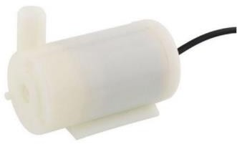

Fig 5.10 DC MOTOR PUMP

The main advantage of DC (direct current) pumps over AC (alternating current) pumps is that they can operate directly from a battery, making them more convenient and portable. They are easier to operate and control, since AC systems

typically require a controller to manage speed. A DC solar pump is more efficient as it gives maximum output with fewer solar panels. AC solar pumps need more solar panels as the electricity has to be converted into AC for utilization. As a result, the efficiency of the system is reduced in the latter's case. Micro DC 3-6V Micro Submersible Pump Mini water pump For Fountain Garden Mini water circulation System DIY project. This is a low cost, small size Submersible Pump Motor which can be operated from a 3 ~ 6V power supply. It can take up to 120 liters per hour with very low current consumption of 220mA. Just connect tube pipe to the motor outlet, submerge it in water and power it. Make sure that the water level is always higher than the motor. Dry run may damage the motor due to heating and it will also produce noise.

## MQ6 SENSOR:

The Grove - Gas Sensor (MQ9) module is useful for gas leakage detection (in home and industry). It is suitable for detecting LPG, CO, CH4. Due to its high sensitivity and fast response time, measurements can be taken as soon as possible. The sensitivity of the sensor can be adjusted by using the potentiometer.

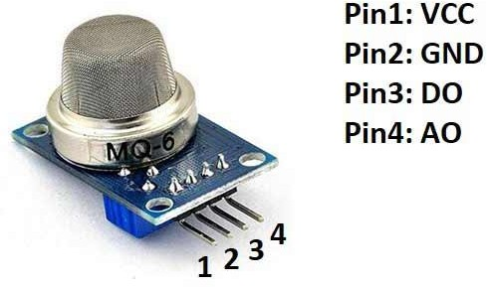

Fig 5.11 MQ6 Sensor

The sensor value only reflects the approximated trend of gas concentration in a permissible error range; it DOES NOT represent the exact gas concentration. The detection of certain components in the air usually requires a more precise and costly instrument, which cannot be done with a single gas sensor.

Features :

* Wide detecting scope.
* Stable and long life.
* Fast response and High sensitivity.

About 1 million people are in habit of tobacco smoking globally of which majority population is from developing countries. Every year nearly 4.9 million people died due to smoking according to the 2007 report. In addition, second- hand smoke is a serious threat to the health of people of all ages causes 41000 deaths each year.

## TEMPERATURE AND HUMIDITY SENSOR:

Measurement of temperature is important for the safety of people and affects the life skills. The greenhouse effect can be monitored by measuring temperature and comparing temperature changes from historical to present time especially since the industrial revolution using climate data. Humidity is a type of gas that protects us from UV rays from the sun and helps trap heat on Earth, thereby making the climate on Earth, a pleasant one for living. But as humidity increases, the warmth on Earth also increases which makes life uncomfortable. Humidity is essential for various storage and food processing facilities.

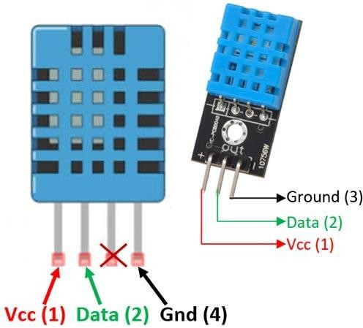

Fig 5.12 Temperature and Humidity Sensor

## SOFTWARE DESCRIPTION

* + 1. **PROGRAMMING:**

The Atmega328pboard can be programmed with the [Arduino Software (IDE).](https://www.arduino.cc/en/Main/Software) For details, see the [reference](https://www.arduino.cc/en/Reference/HomePage) and [tutorials](https://www.arduino.cc/en/Tutorial/HomePage). The ATmega328p on the Atmega328p comes preprogrammed with a [boot loader](https://www.arduino.cc/en/Hacking/Bootloader?from=Tutorial.Bootloader) that allows to upload new code to it without the use of an external hardware programmer.

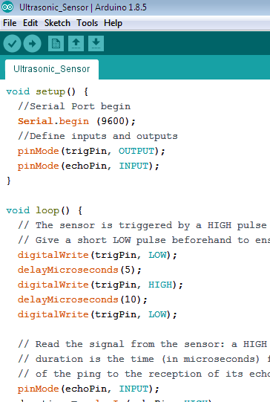It communicates using the original STK500 protocol ([reference](http://www.atmel.com/Images/doc2525.pdf), [C header](http://www.atmel.com/dyn/resources/prod_documents/avr061.zip) [files](http://www.atmel.com/dyn/resources/prod_documents/avr061.zip)).Bypass the boot loader and program the microcontroller through the ICSP (In-Circuit Serial Programming) header using [Arduino ISP](https://www.arduino.cc/en/Main/ArduinoISP) or similar; see these [instructions for details.](https://www.arduino.cc/en/Hacking/Programmer)

Fig 5.13 Example of Arduino program

The ATmega16U2/8U2 is loaded with a DFU boot loader, which can be activated by: 1 boards: connecting the solder jumper on the back of the board (near the map of Italy)and then resetting the 8U2.

**On Rev 2 or later boards:** there is a resistor that pulling the 8U2/16U2 HWB line to ground, making it easier to put into DFU mode. Then use [Atmel's](http://www.atmel.com/dyn/products/tools_card.asp?tool_id=3886) [FLIP](http://www.atmel.com/dyn/products/tools_card.asp?tool_id=3886) [software](http://www.atmel.com/dyn/products/tools_card.asp?tool_id=3886) (Windows) or the [DFU programmer](http://dfu-programmer.sourceforge.net/) (Mac OS X and Linux) to load a

newfirmware. Or use the an extension programmer (overwriting the DFU boot loader). See [this user-contributed tutorial](http://www.arduino.cc/cgi-bin/yabb2/YaBB.pl?num=1285962838) for more information

The applications are listed below

[Arduboy,](https://en.wikipedia.org/wiki/Arduboy) a [handheld game console](https://en.wikipedia.org/wiki/Handheld_game_console) based on Arduino. [Arduinome,](https://en.wikipedia.org/wiki/Arduinome) a [MIDI](https://en.wikipedia.org/wiki/MIDI_controller) [controller](https://en.wikipedia.org/wiki/MIDI_controller) device that mimics the [Monome.](https://en.wikipedia.org/wiki/Monome)

[Ardupilot](https://en.wikipedia.org/wiki/Ardupilot), drone software and hardware.[ArduSat](https://en.wikipedia.org/wiki/ArduSat), a cubesat based on Arduino. Data loggers for scientific research. [Arduino,](https://en.wikipedia.org/wiki/OBDuino) a [trip computer](https://en.wikipedia.org/wiki/Trip_computer) that uses the [on-board](https://en.wikipedia.org/wiki/On-board_diagnostics) [diagnostics](https://en.wikipedia.org/wiki/On-board_diagnostics) interface found in most moderncars.

* + 1. **ARDUINO CODE:** #include "DHT.h" #define DHTPIN 11

#define DHTTYPE DHT11 DHT dht(DHTPIN, DHTTYPE);

const int DOUTpin1 = 10; //MQ6 int limit1;

int value1;

const int DOUTpin2 = 12; //MQ135 int limit2;

int value2;

String readstringdata = ""; void setup()

{

Serial.begin(9600);//sets the baud rate dht.begin();

}

void loop()

{

readstringdata = "";

/*..........GAS (MQ6). */

value1 = analogRead(A1);

limit1 = digitalRead(DOUTpin1); #ifdef serial

Serial.print("MQ6 value: "); Serial.print(value1);//prints the alcohol value Serial.print(" Limit: ");

Serial.println(limit);/*prints the limit reached as either LOW or HIGH (above or underneath) */

#endif

/*..........GAS (MQ135). */

value2 = analogRead(A0);

limit2 = digitalRead(DOUTpin2); #ifdef serial

Serial.print("MQ135 value: "); Serial.print(value1);//prints the alcohol value Serial.print(" Limit: ");

Serial.println(limit);/*prints the limit reached as either LOW or HIGH (above or underneath) */

#endif

/*..........DHT11 TEMPERATURE AND HUMIDITY SENSOR. */

// Reading temperature or humidity takes about 250 milliseconds!

// Sensor readings may also be up to 2 seconds 'old' (its a very slow sensor) float h = dht.readHumidity();

// Read temperature as Celsius (the default) float t = dht.readTemperature();

// Read temperature as Fahrenheit (isFahrenheit = true) float f = dht.readTemperature(true);

// Check if any reads failed and exit early (to try again).

if (isnan(h) || isnan(t) || isnan(f)) { #ifdef serial

Serial.println("Failed to read from DHT sensor!"); #endif

return;

}

// Compute heat index in Fahrenheit (the default) float hif = dht.computeHeatIndex(f, h);

// Compute heat index in Celsius (isFahreheit = false) float hic = dht.computeHeatIndex(t, h, false);

#ifdef serial Serial.print("Humidity: "); Serial.print(h); Serial.print(" %\t");

Serial.print("Temperature: "); Serial.print(t);

Serial.print(" *C "); Serial.print(f); Serial.print(" *F\t"); Serial.print("Heat index: "); Serial.print(hic); Serial.print(" *C "); Serial.print(hif); Serial.println(" *F"); #endif

readstringdata += String(h); readstringdata += String(","); readstringdata += String(t); readstringdata += String(",");

readstringdata += String(value1);//mq6 readstringdata += String(","); readstringdata += String(value2);//mq135 readstringdata += String('#'); Serial.println(readstringdata); delay(500);

#ifdef serial Serial.println("****************************************");

Serial.println(" "); #endif

readstringdata = ""; delay(5000);

}

## ESP8266 CODE:

#include <Arduino.h> #if defined(ESP32) #include <WiFi.h> #elif defined(ESP8266)

#include <ESP8266WiFi.h> #endif

#include <ESP_Mail_Client.h>

#include <WiFiClient.h> //Client wifi connection library #include <ThingSpeak.h> //ThingSpeak Cloud library #define WIFI_SSID "TP-Link_8E98"

#define WIFI_PASSWORD "86427920"

WiFiClient client; //client configuration

unsigned long myChannelNumber = 2017697; //Thingspeak channel number const char * myWriteAPIKey = "3TNPUTORXOPIW1QJ"; //Thingspeak Write

API key

String readstring = ""; String h, t;

String mq6, mq135; int ind1; // , locations int ind2;

int ind3; int ind4;

void setup()

{

Serial.begin(9600); Serial.println(); Serial.print("Connecting to AP");

WiFi.begin(WIFI_SSID, WIFI_PASSWORD);

while (WiFi.status() != WL_CONNECTED)

{

Serial.print("."); delay(200);

}

Serial.println(""); Serial.println("WiFi connected."); Serial.println("IP address: "); Serial.println(WiFi.localIP()); Serial.println(); ThingSpeak.begin(client);

}

void loop()

{

readstring = ""; //Reset the variable

while (Serial.available())

{ //Check if there is an available byte to read delay(10); //Delay added to make thing stable char c = Serial.read(); //Conduct a serial read

if (c == '#') {break;} //Exit the loop when the # is detected after the word readstring += c; //build the string

}

if (readstring.length() > 0)

{

Serial.println(readstring); ind1 = readstring.indexOf(',');

h = readstring.substring(0, ind1);

ind2 = readstring.indexOf(',', ind1+1);//finds location of second , t = readstring.substring(ind1+1, ind2);

ind3 = readstring.indexOf(',',ind2+1);

mq6 = readstring.substring(ind2+1, ind3); ind4 = readstring.indexOf(',',ind3+1);

mq135 = readstring.substring(ind3+1);//captures remain part of data after last char carray1[t.length() + 1]; //determine size of the array t.toCharArray(carray1, sizeof(carray1)); //put readStringinto an array

float temp = atof(carray1); //convert the array into a float char carray2[h.length() + 1];

h.toCharArray(carray2, sizeof(carray2)); int hum = atoi(carray2);

char carray3[mq6.length() + 1]; mq6.toCharArray(carray3, sizeof(carray3)); int mq6_val = atoi(carray3);

char carray4[mq135.length() + 1]; mq135.toCharArray(carray4, sizeof(carray4)); int mq135_val = atoi(carray4); Serial.print("Humidity: "); Serial.println(hum); Serial.print("Temperature: "); Serial.println(temp);

Serial.print("MQ6: "); Serial.println(mq6_val); Serial.print("MQ135: "); Serial.println(mq135_val); ThingSpeak.setField(1, hum); ThingSpeak.setField(2, temp); ThingSpeak.setField(3, mq6_val); ThingSpeak.setField(4, mq135_val);

ThingSpeak.writeFields(myChannelNumber, myWriteAPIKey); delay(1000);

}

}

## EMBEDDED C:

Embedded C is most popular programming language in software field for developing electronic gadgets. Each processor used in electronic system is associated with embedded software.Embedded C programming plays a key role in performing specific function by the processor. In day-to-day life used many electronic devices such as mobile phone, washing machine, digital camera, etc. These all device working is based on microcontroller that are programmed by embedded C.

The Embedded C code written in above block diagram is used for blinking the LED connected with Port0 of microcontroller. In embedded system programming C code is preferred over other language. Due tothe following reasons:

* High Reliability
* Portability
* Scalability
* Easy to understand

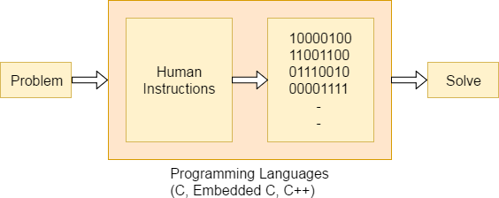

Fig 5.14 block diagram of Embedded C Programming development

Function is a collection of statements that is used for performing a specific task and a collection of one or more functions is called a programming language. Every language is consisting of basic elements and grammatical rules. The C language programming is designed for function with variables, character set, data types, keywords, expression and so on are used for writing a C program.

The extension in C language is known as embedded C programming language. As compared to above the embedded programming in C is also have some additional features like data types, keywords and header file etc is represented by #include**<microcontroller** name.h**>**.

## ARDUINO IDE:

The Arduino Integrated Development Environment - or Arduino Software (IDE)

- contains a text editor for writing code, a message area, a text console, a toolbar with

buttons for common functions and a series of menus. It connects to the Arduino and Genuino hardware to upload programs and communicate with the

Programs written using Arduino Software (IDE) are called sketches. These sketches are written in the text editor and are saved with the file extension .ino. The editor has features for cutting/pasting and for searching/replacing text. The message area gives feedback whilesaving and exporting and also displays errors. The console displays text output by the Arduino Software (IDE), including complete error messages and other information. The bottom right hand corner of the window displays the configured board and serial port. The toolbar buttons allow to verify and upload programs, create, open, and save sketches,and open the serial monitor.

The Arduino Software (IDE) uses the concept of a sketchbook: a standard place to storeyour programs (or sketches). The sketches in the sketchbook can be opened fromthe File **Sketchbook** menu or from the **Open** button on the toolbar. The first time to run the Arduino software, it will automatically create a directory for the sketchbook. software can view or change the location of the sketchbook location from with the Preferences dialog.

**LIBRARIES:**Libraries provide extra functionality for use in sketches, e.g. working with hardware or manipulating data. To use a library in a sketch, select it from the **Sketch > Import Library** menu. This will insert one or more **#include** statements at the top of the sketch and compile the library with the sketch. Because libraries are uploaded to the board with the sketch, they increase the amount of space it takes up.

There is a [list of libraries](https://www.arduino.cc/en/Reference/Libraries) in the reference. Some libraries are included with the Arduinosoftware. Others can be downloaded from a variety of sources or through the Library Manager. Starting with version 1.0.5 of the IDE, do can import a library from a zip file and use it in an open sketch.

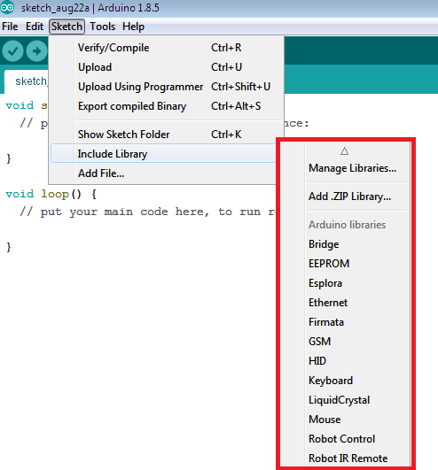

Fig 5.16 Library usage in Arduino

Support for third-party hardware can be added to the **hardware** directory of the sketchbook directory. Platforms installed there may include board definitions (which appear in the board menu), core libraries, bootloaders, and programmer definitions. To install, create the **hardware** directory, then unzip the third-party platform into its own sub- directory. (Don't use "arduino" as the sub-directory name the built-in Arduino platform.) To uninstall, simply delete its directory. For details on creating packages for third-party hardware, see the [Arduino IDE 1.5](https://github.com/arduino/Arduino/wiki/Arduino-IDE-1.5-3rd-party-Hardware-specification) [3rd party Hardwarespecification.](https://github.com/arduino/Arduino/wiki/Arduino-IDE-1.5-3rd-party-Hardware-specification)

This displays serial sent from the Arduino or Genuino board over USB or serial connector. To send data to the board, enter text and click on the "send" button press enter. Choose the baud rate from the drop-down menu that matches the rate passed to **Serial.begin** in the sketch

Some preferences can be set in the preferences dialog (found under the **Arduino** menu on the Mac, or **File** on Windows and Linux). The rest can be found in the preferences file, whose location is shown in the preference dialog.

## SUMMARY:

In this chapter discussed about hardware and software components. Arduino microcontrollers are pre-programmed with a [boot loader](https://en.wikipedia.org/wiki/Boot_loader) that simplifies uploading of programs to the on-chip [flash memory](https://en.wikipedia.org/wiki/Flash_memory). The default bootloader of the Arduino UNO is the opti boot bootloader. Boards are loaded with program code via a serial connection to another computer. Radio-frequency identification (RFID) uses [electromagnetic fields](https://en.wikipedia.org/wiki/Electromagnetic_field) to automatically identify and track tags attached to objects. The tags contain electronically stored information.

* 1. **INTRODUCTION:**

## CHAPTER - 6 RESULT

This chapter displays the Software and hardware results of petrol pump automation using RFID obtained. The hardware results and software results show the fuel fillingand recharging process and displays the balance every time by tapping the card.

## SOFTWARE:

The figure 6.1 below describes the fuel recharging process where the usercan recharge in a website after logging in it.

## NORMAL AND ABNORMAL VALUES OF GASES:

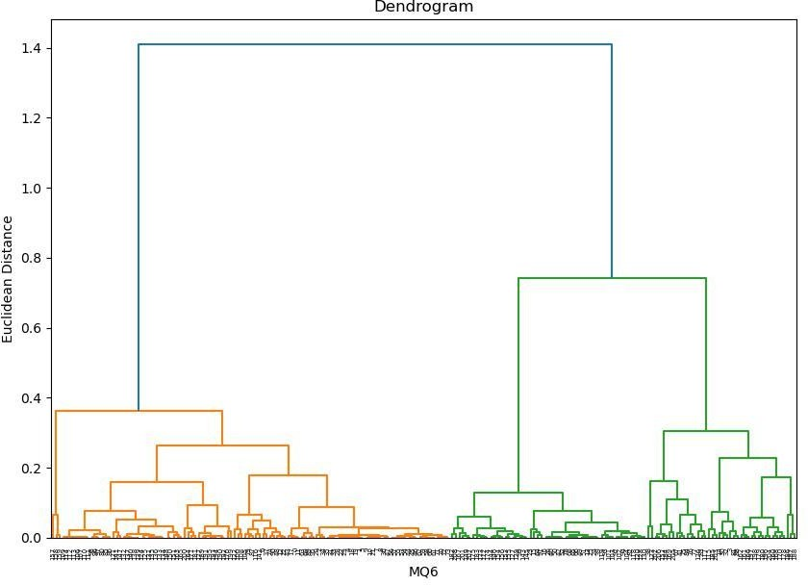

Fig 6.1 Dendogram graph for MQ6

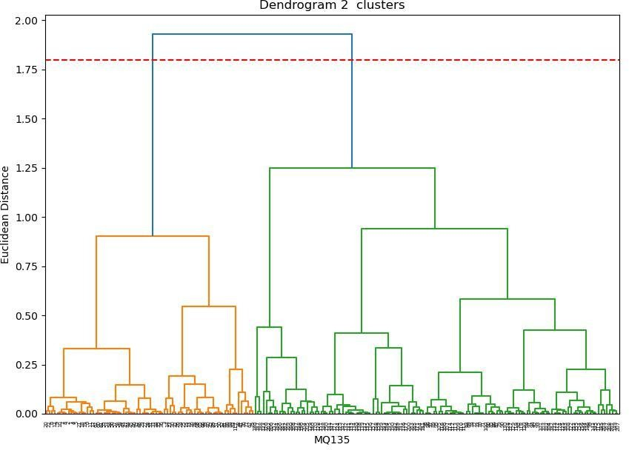

Fig 6.2 Dendogram graph for MQ135

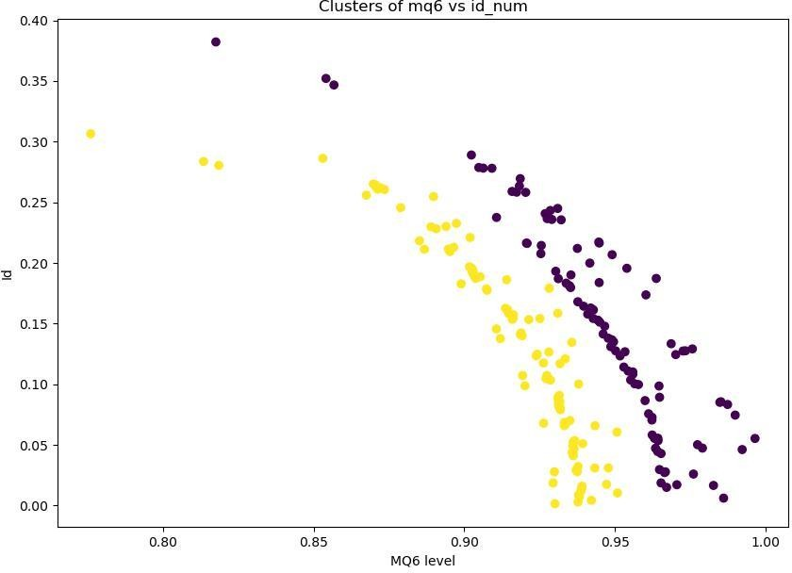

Fig 6.3 MQ6 level vs identification graph

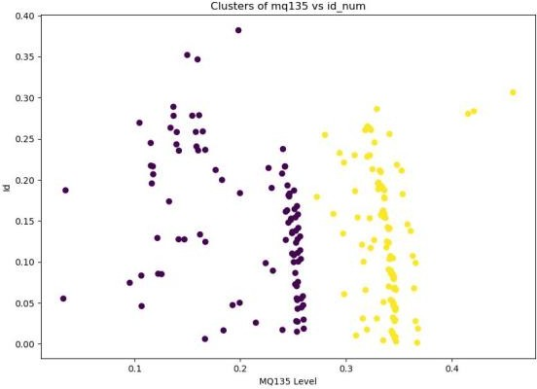

Fig 6.4 MQ135 level vs identification graph

## HARDWARE:

The fig 6.5 shows the hardware design and the results obtained. This describes the entire Fuel filling process from tapping the card to automated fuel filling.

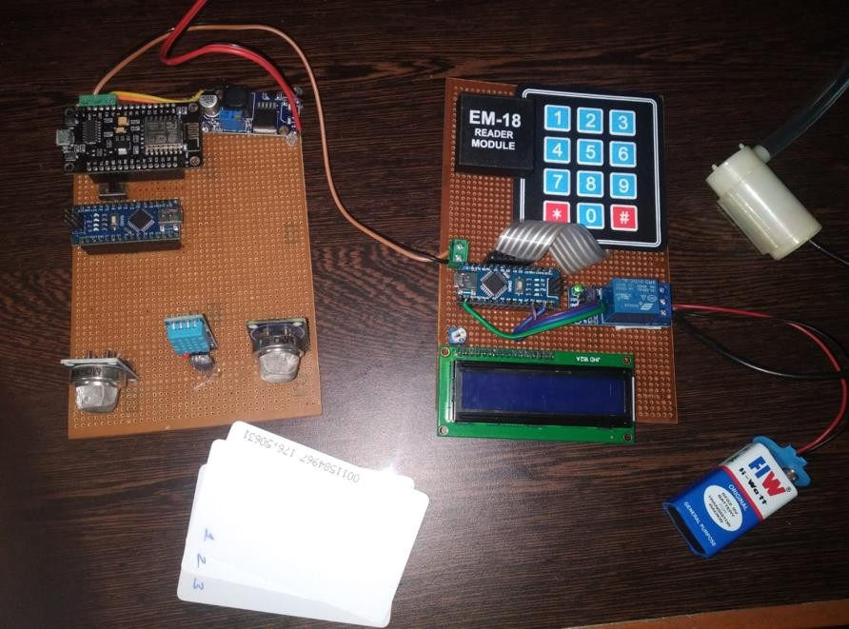

Fig 6.5 RFID Based Petrol pump Automation using IOT

A petrol card reader is installed in the bunk in which the petrol card can be swiped. On swiping instruction will be prompted in each step namely password and petrol quantity in liters. In case of low balance amount in the card, online recharge facility is provided to customer at the bunk. In addition to automated fuel filling, level and temperature detection are also done in this proposed project. A digital temperature and humidity sensor (DTH)is also connected to detect the temperature and humidity of the bulk environment. To prevent the bulk from accidents the temperature sensor is located. MQ6 sensor is connected to detect the gas, if industries are founded nearby bulk the sensor will detect how much gas they released during the peak hours. A MQ135 sensor is connected to detect the quality of the air. After collecting the environmental data the values are pushed into the cloud by using the Iot platform named Thinkspeak.

The main aim of this project is to deal with all stated problems by developing an automated petrol dispensing system using RFID technology. Such a system enables a user to use a RFID based prepaid card to access petrol at fuel stations. Whenever the user wants to fill the tank from the fuel dispenser, user has to enter the amount first And then place the RFID card near the RFID reader. The Arduino Atmega328p manages to read the data from the RFID reader and perform action according to the customer requirements as well as the amount deducted from the users card’s. In this system, provide the measurement of the correct petrol for the current price and also given the petrol accuracy rate. A digital temperature and humidity sensor (DTH)is also connected to detect the temperature and humidity of the bulk environment. To prevent the bulk from accidents the temperature sensor is located. MQ6 sensor is connected to detect the gas, if industries are founded nearby bulk the sensor will detect how much gas they released during the peak hours. A MQ135 sensor is connected to detect the quality of the air. After collecting the environmental data the values are pushed into the cloud by using the Iot platform named Thinkspeak.

## SUMMARY:

In this chapter the hardware and software results are discussed. This results show how this system is very effective and user friendly. The fuel filling is very easier and the transaction process is very simple. This system helps in removing the possibility of fraudulent transactions. This system is very accurate and arehighly reliable and less time- consuming.

## CHAPTER - 7 CONCLUSION AND FUTURE SCOPE

* 1. **CONCLUSION:**

The above mentioned model proposes to remove all the shortcomings of the manually operated petrol pumps by replacing them with automated ones. RFID is a versatile technology, easy to use and it can be efficiently used in this real time application. The proposed model consists of certain goals like ensuring right amount of fuel dispensed, removing all human errors by the use of RFID cards and ensuring customer's trust for a fair sale of the product. Automated fuel stations provide a lot more advantages as they reduce man power with the automated self-service. With this simple technology in use, any person can easily access for fuel at Fuel Stations. Apart from this all, these systems are less time consuming compared to the traditional ones. The technology proposed is very cost efficient and has low power consumption as well, which sets the major benchmark in today's scenario.

## FUTURE SCOPE:

It has been observed that the proposed system extremely beneficial as it provides the secure and cashless digital system which avoids the fuel theft in bulk. RFID card belonging persons only allowed to use it access for fuel stations.The unauthorized user is disallowed for any access to the system.The main aim is to reduce the human work in the bulk and make the system fully automated. Automation plays a vital role in future.

## REFERENCES:

1. Y. Yan, Q. Li, W. R. Chen, W. Q. Huang, and J. W. Liu (Apr. 2020), “Hierarchicalmanagement control based on equivalent fitting circle and equivalent energy consumption method for multiple fuel cells hybrid power system,” IEEE Transactions on Industrial Electronics, vol. 67, no. 4, pp. 2786–2797.
2. L. Zhang, X. S. Hu, Z. P. Wang, F. C. Sun, J. J. Deng, and D. G. Dorrell,(Apr. 2020), “Multiobjective optimal sizing of hybrid energy storage system for electric vehicles,” IEEE Transactions on Vehicular Technology, vol. 67, no. 2, pp. 1027– 1035x.
3. Q. Li, B. Su, Y. C. Pu, Y. Han, T. H. Wang, L. Z. Yin, and W. R. Chen,(Jun. 2019), “A statemachine control based on equivalent consumption minimization for fuel cell/supercapacitor hybrid tramway,” IEEE Transactions on Transportation Electrification, vol. 5, no. 2, pp. 552–564.
4. Q. Yan, B. Zhang, and M. Kezunovic ,(Mar. 2019), “Optimized operational cost reduction foran EV charging station integrated with battery energy storage and PV generation,” IEEE Transactions on Smart Grid, vol. 10, no. 2, pp. 2096–2106.
5. Q. Y. Sun, S. Chen, L. Chen, and D. Z. Ma,(Jun. 2017), “Quasi-Z-source networkbased hybrid power supply system for aluminum electrolysis industry,” IEEE Transactions on Industrial Informatics, vol. 13, no. 3, pp. 1141– 1151.
6. F. Nejabatkhah and Y. W. Li (Jun. 2017), “Overview of power management strategies of hybrid AC/DC microgrid,” IEEE Transactions on Power Electronics, vol.
7. H. Tu, H. Feng, S. Srdic, and S. Lukic, “Extreme fast charging of electric vehicles: a technology overview,” IEEE Transactions on Transportation Electrification, vol. 5, no. 4, pp. 861–878, Dec. 2019.
8. Q. Li, T. H. Wang, C. H. Dai, W. R. Chen, and L. Ma, “Power management strategy based on adaptive droop control for a fuel cellbattery-supercapacitor hybridtramway,” IEEE Transactions on Vehicular Technology, vol. 67, no. 7, pp. 5658– 5670, Jul. 2018.
9. M. M. Mahfouz and M. R. Iravani, “Grid-integration of battery-enabled dc fast charging station for electric vehicles,” IEEE Transactions on Energy Conversion, vol. 35, no. 1, pp. 375–385, Mar. 2020.
10. T. H. Wang, Q. Li, X. T. Wang, Y. B. Qiu, M. Liu, X. Meng, J. C. Li, and

W. R. Chen, “An optimized energy management strategy for fuel cell hybrid power system based on maximum efficiency range identification,” Journal of Power Sources, vol. 445, pp. 227333, Jan. 2020.