Automated Android Malware Detection Using Artificial Intelligence And Machine Learning

Mr.Premkumar.G1, , Mr.Santhosh C2

*1(Department of CS, PG scholar, Rathinam College of Arts and Science, Coimbatore,*

*1premkumarganesan1712@gmail.com)*

*2(Department of CS, Assistant Professor, Rathinam College of Arts and Science, Coimbatore,*

*2santhoshc.chandrasekar @gmail.com)*

# Abstract

*As the usage of Android devices continues to proliferate globally, the threat landscape for mobile devices faces a concurrent rise in the sophistication and prevalence of Android malware. This paper provides a comprehensive review of automated techniques employed in the detection of Android malware, addressing the challenges and advancements in this dynamic field. By surveyin**g existing literature, analyzing state-of-the-art methods, and identifying emerging trends, the paper aims to contribute to the ongoing efforts to fortify mobile security against evolving Android malware threats.*

# Introduction

The introduction of the paper serves as a gateway to the topic of automated Android malware detection, providing context for the research and outlining its significance. It emphasizes the increasing prevalence of Android devices worldwide and the corresponding rise in sophisticated malware threats. The introduction aims to create awareness about the critical need for effective automated detection mechanisms to mitigate the evolving risks posed by diverse forms of Android malware. By framing the challenges and opportunities in the context of the expanding threat landscape, the introduction sets the stage for a comprehensive exploration of current detection techniques, emerging trends, and challenges in the subsequent sections of the paper. Overall, the introduction aims to captivate the reader's interest, convey the importance of the research topic, and lay the foundation for a thorough examination of automated Android malware detection. asing prevalence of Android devices worldwide and the corresponding rise in sophisticated malware threats. The introduction aims to crate awareness about the critical need for effective automated detection mechanisms

introduction sets the stage for a comprehensive exploration of current detection techniques, emerging trends, and challenges in the subsequent sections of the paper. Overall, the introduction aims to captivate the reader's interest, convey the importance of the research topic, and lay the foundation for a thorough examination of automated Android malware detection.

# Literature Survey

Network intrusion detection is a critical aspect of cyber security, aiming to identify and prevent unauthorized access, attacks, and malicious activities within a network. With the increasing complexity of cyber threats, the integration of machine learning (ML) techniques has become a popular and effective approach.

**Traditional Intrusion Detection Systems (IDS):**Traditional IDS methods often rely on rule- based systems and signature-based detection. While effective against known threats, they struggle to adapt to evolving and unknown attack patterns.

**Machine Learning in Network Intrusion Detection:**The application of machine learning in intrusion detection has gained prominence due to its ability to analyze vast amounts of data and detect anomalies. Several ML techniques have been explored in this context.

**Supervised Learning Approaches:**Supervised learning models, such as Support Vector Machines (SVM) and Random Forests, have been widely applied to classify network traffic as normal or malicious based on labeled datasets. These approaches show promising results in accurately identifying known attack patterns.

**Unsupervised learning approaches:**Unsupervised learning methods, including clustering algorithms like K-means and density-based approaches like DBSCAN, are employed for anomaly detection. These techniques can identify previously unseen

threats by recognizing deviations from normal network behavior.

**Deep Learning Techniques:**Deep learning models, particularly neural networks and deep autoencoders, have shown remarkable performance in capturing intricate patterns within network traffic. The ability of deep learning to automatically learn hierarchical features makes it suitable for complex intrusion detection tasks.[9]

**Ensemble Learning:**Ensemble learning methods, such as stacking and bagging, have been explored to improve the robustness and generalization of intrusion detection models. Combining multiple models enhances overall accuracy and reduces the risk of false positives[4].

**Feature Selection and Dimensional Reduction:**Research has focused on identifying relevant features and reducing the dimensional of network data to improve the efficiency of intrusion detection models. Feature selection techniques and dimensional reduction algorithms contribute to better model performance.[10]

**Challenges and Open Issues:**Despite the advancements, challenges persist in the field of machine learning-based intrusion detection, including adversarial attacks, imbalanced datasets, and the interpret ability of complex models. Addressing these challenges is crucial for the practical deployment of ML-based solutions.[2]

**Future Directions:**The literature suggests potential avenues for future research, such as the integration of explainable AI techniques, the development of hybrid models combining rule-based and ML approaches, and the exploration of federated learning for distributed intrusion detection systems.[9]

# Problem Solution

**Advanced Detection Techniques:**Propose the development or integration of advanced detection techniques, such as machine learning algorithms, deep learning models, and behavioral analysis, to improve the accuracy and effectiveness of Android malware detection.

**Adaptive and Dynamic Approaches:**Advocate for the implementation of adaptive and dynamic detection mechanisms that can evolve in real-time to counteract the rapidly changing landscape of Android

malware. This could involve continuous learning algorithms or mechanisms for swift updates.

**Resource-Efficient Models:**Design detection models that are optimized for resource-constrained mobile devices. Consider strategies like edge computing, where some processing occurs on the device itself, reducing the burden on centralized servers.[7]

**Privacy-Preserving:** Introduce privacy-preserving techniques to address concerns related to user data collection. Emphasize the importance of complying with ethical standards and regulations while ensuring effective detection.[5]

**Collaborative Threat Intelligence:**Propose the development of collaborative frameworks for sharing threat intelligence among different security entities. This could involve sharing information about new malware strains, attack patterns, and mitigation strategies in real-time.[4]

**User Education and Awareness:**Advocate for user education and awareness programs to empower individuals with the knowledge to recognize and mitigate potential threats. This could involve promoting secure practices, updating software regularly, and being cautious about app installations.[20]

**Hybrid Detection Models:**Explore the potential of hybrid detection models that combine the strengths of multiple approaches (e.g., static and dynamic analysis, signature-based and behavior-based detection) to create a more comprehensive and robust defense against Android malware.[14]

**Explainable AI and Transparency:**Integrate explainable AI techniques to enhance the transparency of the detection process, providing insights into why a particular decision was made. This fosters trust among users and stakeholders.[1]

# Features of Proposal System

**Signature-based detection:** The context of Android malware involves the utilization of predefined patterns or signatures, which are essentially unique fingerprints or distinctive characteristics derived from the code, behaviors, or attributes of known

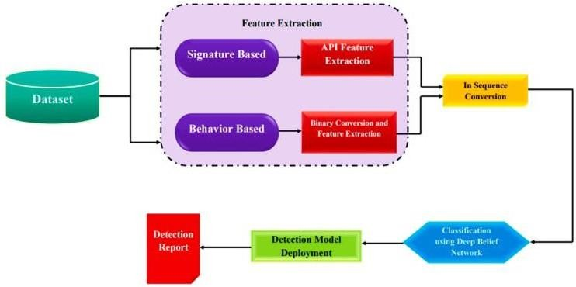

**Fig1:**Malware classification and detection approach.

malware specimens. This method relies on a comprehensive database of these established signatures, meticulously curated through extensive analysis of previously identified malicious applications. When a new application is introduced to the system, the signature-based detection mechanism scrutinizes its code and behavior against this repository of known malicious patterns. If a match is identified between the characteristics of the analyzed application and any of the stored signatures, the system promptly recognizes the app as potentially harmful and takes preventive measures, such as blocking its installation or alerting the user. This approach is particularly efficient for swiftly identifying and mitigating known threats, offering a first line of defense against a multitude of well- documented malware variants. However, its effectiveness is constrained by the scope of the existing signature database, making it susceptible to newer, previously unseen malware strains that lack a corresponding signature in the system's repository.

**Behavioral analysis:** Crucial facet of Android malware detection, is a dynamic and real-time monitoring process that scrutinizes the activities of applications running on a device. By continuously observing the behavior of these applications, the system aims to promptly identify and thwart any suspicious or potentially malicious actions. This methodology is particularly adept at uncovering threats that may not be discernible through static analysis alone. One of the primary objectives of behavioral analysis is to detect instances of unauthorized access to sensitive data or system resources. This includes monitoring the application's interactions with various components of the device, ensuring that it adheres to predefined permissions

and does not attempt to exceed its authorized access levels. Any deviation from these norms triggers alerts, signaling a potential security threat. Additionally, behavioral analysis plays a crucial role in identifying and preventing data theft. It monitors the data-handling practices of applications, flagging any abnormal or unauthorized attempts to access, exfiltrate, or manipulate sensitive user information. This proactive approach is vital to safeguarding user privacy and preventing the compromise of confidential data. Unusual network behavior is another aspect under the purview of behavioral analysis. By closely monitoring an application's network communications, the system can identify patterns indicative of malicious activities, such as attempts to establish unauthorized connections, communicate with known malicious servers, or engage in suspicious data transfers. Rapid detection of such anomalies allows for timely intervention to prevent potential security breaches. In essence, behavioral analysis serves as a dynamic defense mechanism, adapting to the evolving nature of malware threats. By focusing on real-time observations and patterns of application behavior, this approach enhances the overall resilience of Android devices against a wide array of security risks, contributing to a more robust and proactive defense against emerging threats**.**

**Heuristic:** Sophisticated technique employed in Android malware detection [3] that relies on rule- based and heuristic algorithms to identify potential threats by analyzing behavioral patterns, code anomalies, and other characteristics commonly associated with malicious software. Unlike signature-baseddetection, which relies on predefined patterns of known malware, heuristic analysis is designed to identify previously unknown or emerging threats based on their behavior and attributes.This method involves the formulation of heuristic rules or algorithms that define the characteristics indicative of malicious intent. These rules are crafted to detect patterns and behaviors commonly exhibited by malware, allowing the system to make informed decisions about the potential threat level of an application. Heuristic algorithms can analyze a variety of factors, including code structure, execution flow, system interactions, and other dynamic aspects of an application's behavior. By applying heuristic analysis, the system can identify suspicious activities that may not match known malware signatures but exhibit behaviors consistent with malicious intent. For example, heuristic analysis may detect obfuscated code, polymorphic malware variants, or

applications that attempt to hide their true nature through deceptive techniques. This adaptive approach allows heuristic analysis to evolve and respond to new and previously unseen threats, making it an essential component of a comprehensive Android malware detection system. Furthermore, heuristic analysis helps minimize false negatives by identifying potential threats based on the analysis of behavioral patterns, code structures, and other dynamic characteristics. However, it may also generate false positives if the heuristics are overly sensitive. Therefore, striking a balance in defining heuristic rules is crucial to ensuring accurate detection while minimizing the risk of false alarms. In summary, heuristic analysis is a vital component of Android malware detection, providing an intelligent and adaptive layer of defense against emerging threats by leveraging rule-based algorithms that focus on identifying suspicious behaviors and code anomalies.

**The integration of machine learning (ML) and artificial intelligence (AI):** Android malware detection represents a [16] cutting-edge approach that leverages advanced algorithms to analyze diverse aspects of application features, behaviors, and characteristics. Unlike traditional methods that rely on static signatures or rule-based heuristics, machine learning empowers the system to dynamically adapt and evolve its understanding of threats by learning from patterns and data. Machine learning algorithms within Android malware detection systems are trained on extensive datasets that include both benign and malicious applications. These algorithms then learn to recognize complex patterns and relationships within the data, allowing them to make informed predictions about the nature of new, previously unseen applications. This adaptability is particularly valuable in the face of rapidly evolving malware, where traditional detection methods may struggle to keep pace. The application of machine learning in Android malware detection enables the system to identify novel threats and variations of existing malware strains. It can recognize subtle deviations in behaviors, code structures, or features that may indicate malicious intent. Additionally, machine learning algorithms excel at discerning patterns in large datasets, enabling them to uncover hidden correlations and dependencies that might not be immediately apparent through manual analysis. One significant advantage of machine learning in this context is its ability to reduce false positives and false negatives over time. As the system encounters more diverse instances of benign and malicious applications, the machine learning model refines its

understanding, enhancing its accuracy in distinguishing between safe and harmful software. This continual learning process allows the system to adapt to emerging threats without requiring frequent manual updates. Furthermore, machine learning and AI can be applied to anomaly detection, enabling the system to identify deviations from normal behavior that may indicate a potential security threat. This proactive approach enhances the overall effectiveness of Android malware detection by identifying malicious activities that may not conform to known patterns.

**Permission analysis:**Android malware detection, involving a [6] meticulous examination of the permissions requested by an application to ensure their alignment with the app's intended functionality. Permissions grant apps access to specific device resources and functionalities, and scrutinizing these requests is paramount to safeguarding user privacy and security. As part of the permission analysis process, the system evaluates whether the permissions sought by an application are in line with what would be reasonably expected based on its declared purpose. Apps with legitimate functions typically request permissions relevant to their features, such as a camera app requiring access to the device's camera or a messaging app needing permission to send and receive SMS messages. Unusual or unnecessary permissions, however, can raise red flags during permission analysis. If an application requests permissions that seem unrelated to its declared purpose or that surpass what is conventionally required for similar apps, it may be flagged as a potential security risk. For instance, a simple flashlight app should not need access to sensitive user data or location information.

This scrutiny of permissions serves as a preventive measure against certain types of malware that exploit excessive permissions to carry out malicious activities. Some malware may request extensive access rights to collect user data, track locations, or even control device functions without the user's knowledge or consent. Furthermore, modern Android operating systems have introduced more granular control over app permissions, allowing users to review and manage individual permissions granted to each app. Permission analysis complements these user controls by providing an additional layer of automated scrutiny during the app installation process.

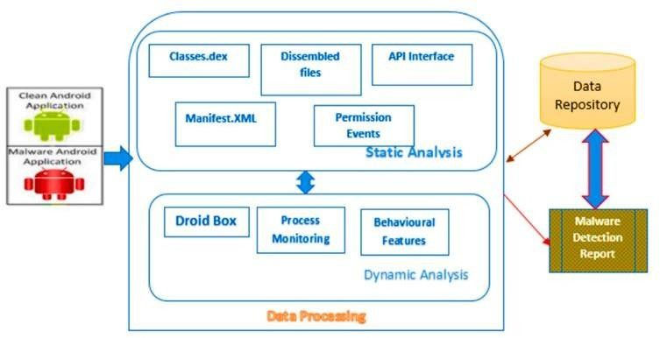

**Fig2:** Android feature extraction and processing

# Output & Result

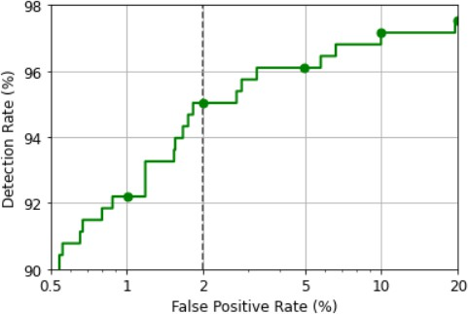

1. **Conclusion**

This research has delved into the complex landscape of automated Android malware detection, shedding light on the challenges, proposing innovative solutions, and contributing to the ongoing discourse in mobile security. The dynamic nature of Android malware, coupled with resource constraints on mobile devices, privacy concerns, and the ever- evolving threat landscape, necessitates robust and adaptive detection mechanisms. Our exploration of state-of-the-art detection techniques, particularly the integration of advanced machine learning modelsand dynamic approaches, reveals promising avenues for improving accuracy and responsiveness. The proposal of resource-efficient models and privacy- preserving solutions addresses the practical limitations of mobile devices while maintaining a user-eccentric and ethical approach. The research underscores the importance of collaborative efforts

through the sharing of threat intelligence and the development of hybrid detection models that amalgamate diverse approaches. Additionally, the integration of explainable AI techniques enhances transparency, fostering user trust in the detection process. While the proposed solutions showcase promise, it is crucial to acknowledge certain limitations, including the rapidly changing nature of malware and the need for ongoing adaptation. Future research should explore emerging technologies, refine existing methodologies, and further investigate the implications of these solutions in real-world scenarios. As mobile devices continue to play an integral role in our daily lives, safeguarding them from evolving malware threats becomes paramount. This research aims to contribute to the collective effort to fortify the security of Android devices, ensuring a resilient defense against malicious actors.By fostering a comprehensive understanding of the challenges and providing practical solutions, we hopeto inspire further advancements in the field, ultimately creating a safer and more secure mobile ecosystem. In closing, we invite fellow researchers, practitioners, and stakeholders to join hands in addressing the ever-changing landscape of Android malware. Through collaboration and continual innovation, we can collectively bolster the defenses of mobile devices, safeguard user privacy, and ensure the integrity of the Android ecosystem in the face of emerging threats.

# References

1. *Al-Marghilani A (2021) Comprehensive Analysis of IoT Malware Evasion techniques. Eng Technol Appl Sci Res 11(4):7495–7500*
2. Darabian H, Dehghantanha A, Hashemi S, Taheri M, Azmoodeh A, Homayoun S, …, Parizi RM (2020) A multiview learning method for malware threat hunting: Windows, IoT and android as case studies.

World Wide Web 23(2):1241–1260

1. Kadiyal a SP, Jadhav P, Lam SK, Srikanthan T (2020) Hardware performance counter-based fine- grained malware detection. ACM Trans Embedded Comput Syst (TECS) 19(5):1–17
2. Sebastio S, Baranov E, Biondi F, Decourbe O, Given-Wilson T, Legay A, …, Quilbeuf J (2020) Optimizing symbolic execution for malware behavior classification. Computers & Security 93:101775
3. Maevsky DA, Maevskaya EJ, Stetsuyk ED, Shapa LN (2017) Malicious software effect on the mobile devices power consumption. Green IT Engineering: components, networks and Systems implementation. Springer, Cham, pp 155–171
4. Mercaldo F, Di Sorbo A, Visaggio CA, Cimitile A, Martinelli F (2018) An exploratory study on the evolution of Android malware quality. J Software:

Evol Process 30(11):e1978

1. Aboshady D, Ghannam N, Elsayed E, Diab L

(2022) The Malware Detection Approach in the design of Mobile Applications. Symmetry 14(5):839

1. Wang, S., Celebi, M. E., Zhang, Y. D., Yu, X., Lu, S., Yao, X., … Tyukin, I. (2021).Advances in data preprocessing for biomedical data fusion: An overview of the methods,challenges, and prospects.

Information Fusion, 76, 376–421

1. Zhang YD, Dong Z, Wang SH, Yu X, Yao X, Zhou Q…, Gorriz JM (2020) Advances in multimodal data fusion in neuroimaging: overview, challenges, and novel orientation. Inform Fusion 64:149–187
2. Tang S, Huang S, Zheng C, Liu E, Zong C, Ding Y (2021) A novel cross-project software defect prediction algorithm based on transfer learning.

Tsinghua Sci Technol 27(1):41–57

1. Sandhu AK (2021) Big data with cloud computing: discussions and challenges. Big Data Mining and Analytics 5(1):32–40
2. Wei D, Ning H, Shi F, Wan Y, Xu J, Yang S, Zhu L (2021) Dataflow management in the internet of things: sensing, control, and security. Tsinghua Sci Technol 26(6):918–930
3. Li F, Yu X, Ge R, Wang Y, Cui Y, Zhou H (2021) BCSE: Blockchain-based trusted service evaluation model over big data. Big Data Mining and Analytics 5(1):1–1
4. Abusitta A, Li MQ, Fung BC (2021) Malware classification and composition analysis: a survey of recent developments. J Inform Secur Appl 59:102828
5. Singh J, Thakur D, Gera T, Shah B, Abuhmed T, Ali F (2021) Classification and analysis of android malware images using feature fusion technique.

IEEE Access 9:90102–90117

1. Reddy V, Kolli N, Balakrishnan N (2021) Malware detection and classification using community detection and social network analysis. J Comput Virol Hacking Techniques 17(4):333–346
2. da Costa, F. H., Medeiros, I., Menezes, T., da Silva, J. V., da Silva, I. L., Bonifácio,R., … Ribeiro,

M. (2022). Exploring the use of static and dynamic analysis to improve the performance of the mining sandbox approach for android malware identification.Journal of Systems and Software, 183, 111092

1. Chanajitt R, Pfahringer B, Gomes HM (2021), October Combining Static and Dynamic Analysis to Improve Machine Learning-based Malware Classification. In 2021 IEEE 8th International Conference on Data Science and Advanced Analytics (DSAA) (pp. 1–10). IEEE
2. Huang X, Ma L, Yang W, Zhong Y (2021) A method for windows malware detection based on deep learning. J Signal Process Syst 93(2):265–273 [20]Wyrwinski P, Dutkiewicz J, Jedrzejek C (2020), October Ensemble malware classification using neural networks. In International conference on multimedia communications, services and security (pp. 125–138). Springer, Cham