**ALGAE DEFENDER AQUASCRUB**

Midhun K Manoj1, Nandana Jyothikumar2, Nandana R Nadh3,Nikhitha Manoj4

Dr.Godwinraj D5,Ranjitha Rajan6

Students, Electronics & Communication Engineering, Amal Jyothi College of Engineering, Kanjirappally

Associate Professor, Electronics & Communication Engineering, Amal Jyothi College of Engineering, Kanjirappally

Assistant Professor, Electronics & Communication Engineering, Amal Jyothi College of Engineering, Kanjirappally

# ABSTRACT

The Underwater Algae Cleaning System project presents a robust solution for efficiently removing algae buildup in underwater environments, such as aquariums or water tanks. This project utilizes readily available components, including the 775 motor, L293D motor driver, rotary brush, and a switch system, to create a simple yet effective cleaning mechanism.The core of the system revolves around the 775 motor, which drives the rotary brush to scrub algae off submerged surfaces. The L293D motor driver facilitates precise control of the motor's speed and direction, ensuring optimal cleaning performance. A switch system is incorporated to enable user-friendly activation and deactivation of the cleaning mechanism. Through careful design and integration of these components, the Underwater Algae Cleaning System offers a practical and accessible solution for maintaining cleanliness in underwater environments. Its versatility allows for customization and adaptation to various tank sizes and algae densities, while its simplicity ensures ease of operation and maintenance. By harnessing the power of the 775 motor and rotary brush technology, this project demonstrates the feasibility of using basic mechanical components for effective algae removal underwater. It serves as a valuable resource for aquarium enthusiasts, aquaculture professionals, and anyone seeking to maintain a clean and healthy aquatic environment.

**Keywords:** 775 motor,L293D motor driver,Arduino

# INTRODUCTION

This project introduces an innovative solution to address the pervasive issue of algae overgrowth in water bodies. Algae Removal machine used to detect and eliminate algae efficiently. This sustainable approach aims to improve water quality and maintain ecological balance in various aquatic environments.The project aligns with the growing need for eco-friendly technologies to combat environmental challenges associated with algae proliferation in water bodies.The proliferation of algae in underwater environments poses a significant challenge for maintaining cleanliness and health in aquariums, water tanks, and aquatic habitats. The accumulation of algae not only detracts from the aesthetic appeal of these environments but can also disrupt the ecological balance and endanger the health of aquatic organisms.

Addressing this issue requires efficient and reliable cleaning mechanisms capable of effectively removing algae buildup from submerged surfaces.The Underwater Algae Cleaning System project aims to provide a practical solution to this problem by developing a cleaning mechanism specifically designed for underwater use. Utilizing components such as the 775 motor, L293D motor driver, rotary brush, and a switch system, the project seeks to create a simple yet effective cleaning system capable of scrubbing algae off submerged surfaces.

**Graphical Abstract:**

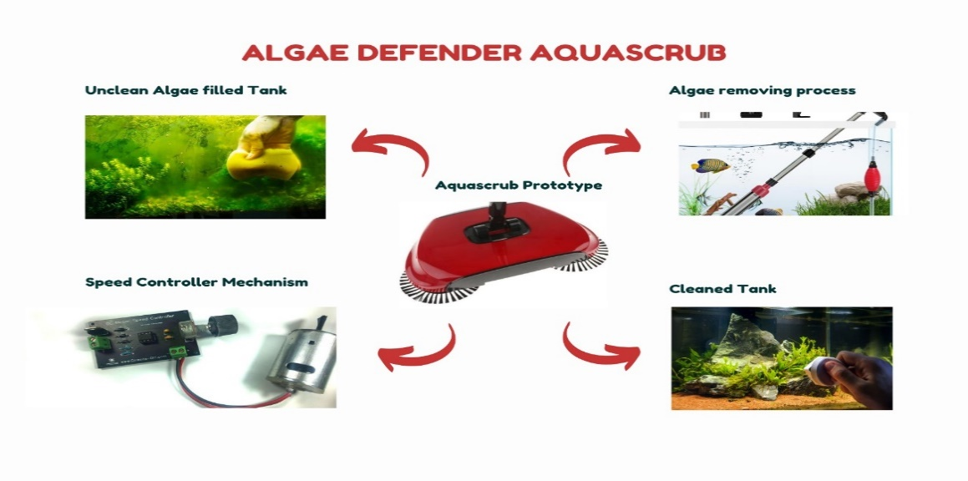

.

## 1.1PROBLEM STATEMENT

Underwater algae can cause a number of problems, such as:

1. Decreased Oxygen Contents: The oxygen in the water can be reduced by algae blooms, endangering aquatic life and creating "dead zones" where marine life finds it difficult to thrive.

1. Impaired Water Quality: Toxins and organic debris are released by algae, which has a detrimental effect on water quality. Ecosystems may suffer as a result, and drinking water may become dangerous.

1. Disruption of Habitat: Overgrowth of algae can change aquatic environments, upsetting ecosystem balances and harming a variety of plant and animal species.

1. Congested Waterways: Algal buildup can impede waterways, making it more difficult to navigate and making it more difficult for ships or boats to move.

1. Visual Concerns: Algal blooms frequently produce ugly green or brown water, which detracts from the visual appeal of outdoor spaces.

# 2.LITERATURE SURVEY

(1)The automatic water tank cleanser that was described in the last journal effectively used revolving brushes to clean the water tanks.Utilising revolving brushes, the water tank cleaner was used to clean the tanks. Comparing this procedure to the traditional ones, it was safer and more effective.(2)This model has a sophisticated tank cleaning technology that makes the operation more user-friendly and can clean water tanks with less time and human effort. The prototype's functionality appears promising in terms of promoting cleanliness and preventing the need for excessive labour. The project's future goals include adding an autofeeding mechanism to reduce the amount of labour required for feeding. The autofeed technology makes it simple to clean the tanks without using too many labourers. By insulating the frame and other parts with stainless steel, the project can even be expanded to improve the tank's cleanliness.(3)The emphasis of this project is on operational supply flexibility.This is frequently simple to use and requires little upkeep. Therefore, the goal of this project is typically to create a system that is both highly useful and reasonably priced for eliminating water contaminants such as plastics, trash, and water debris that floats on the surface of ponds and rivers.The longevity of aquatic animals and the preservation of human health are the two key benefits of this. (4)The suggested solution, which runs on an Arduino Uno, reduces the need for fuel-operated garbage collectors by cleaning the trash in both small and large lakes. It also lessens the amount of labour needed by humans to clean the lake and preserves the lives of aquatic animals.(5)This project's lightweight design and compact dimensions offer a reliable and strong option for cleaning water bodies. It can handle up to 5 kg of trash in one go, and the mechanical arm can lift up to 1.5 kg at a time. The model has been powered using solar energy, a renewable energy source. Reducing time and power consumption has been our main focus in order to boost effectiveness and efficiency. It works well for picking up floating trash such as plastic bags, leaves, sticks, and wrappers.

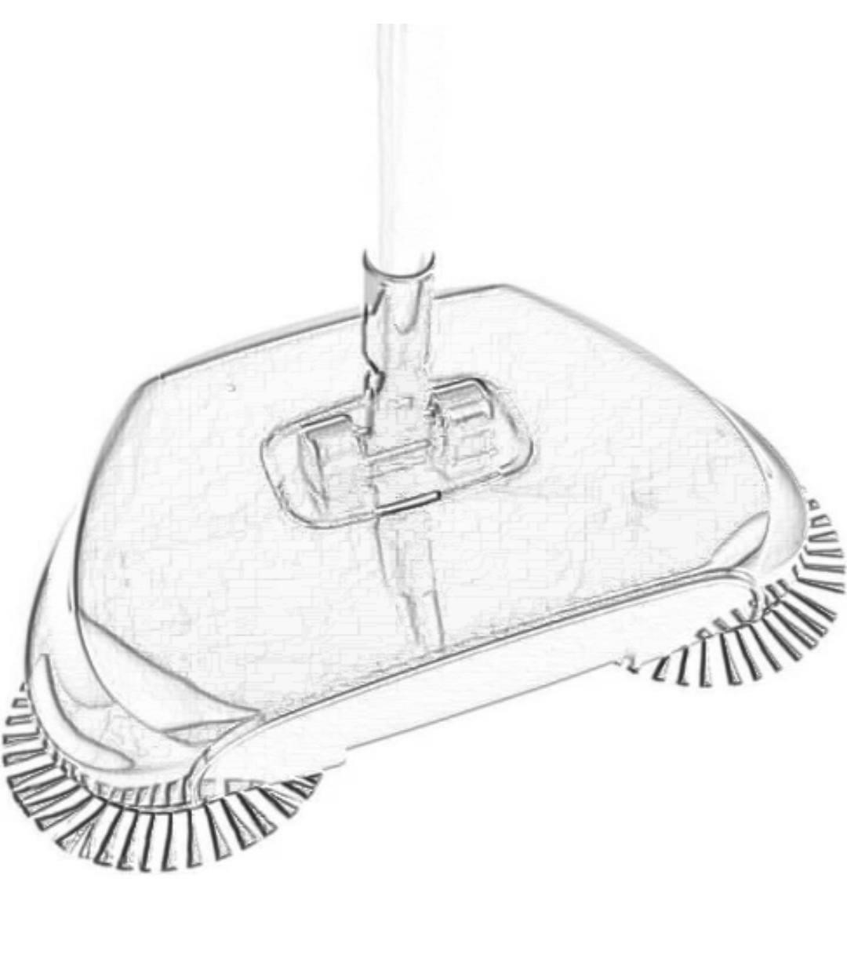

**Fig:1 Aquascrub Model**

(6)This journal discusses an Arduino-powered automatic water cleaner, which is a potentially effective and cutting-edge approach to water purification. Programming can be customised on the Arduino platform to provide features like data logging, automated filtration, and real-time monitoring. However, the calibre of the parts utilised determines how successful the system is. Make sure the design is sturdy to withstand changing water conditions. Maintaining proper functioning requires routine maintenance. All things considered, this is a promising technique that could improve the management of water quality.(7)We learned about an autonomous water tank cleaning mechanism by reading this article; Arduino is a useful invention for preserving water hygiene. Thorough tank sanitation is ensured and manual labour is reduced thanks to the automated cleaning procedure. The machine's functioning and design have a major role in its effectiveness. Take into account elements like the capacity of the water tank, the effectiveness of the cleaning system, and the convenience of use. It takes routine upkeep and sporadic inspections to stop any problems. In conclusion, an automatic water tank cleaning system can greatly help to provide clean and safe water storage if it is well-designed and maintained.(8)This article highlights a notable invention in addressing environmental concerns: a remote-controlled, autonomous river cleaning bot. For effective cleaning, the remote control capability increases operating flexibility. The bot's ability to adjust to different river conditions determines how effective it will be. To avoid faults and guarantee ongoing functioning, routine maintenance and monitoring are essential. All things considered, this technology offers a viable way to mitigate river pollution and shows promise for long-term, automated environmental preservation. (9)An analysis of 775 motor films on YouTube may offer insightful information about this widely used motor type. Review topics could include things like effectiveness, robustness, and adaptability to various settings. Viewers would be more interested if concrete use cases, projects, and adaptations employing 775 motors were highlighted. All things considered, DIY enthusiasts, hobbyists, and anyone looking for knowledge on motor possibilities would probably be interested in watching a comprehensive movie that examines the various facets of 775 motors. (10)Viewers interested in cleaning solutions might find informational and helpful in a YouTube video that features a rotary brush. The perfect review would address the rotary brush's functionality, build quality, and design. proving its efficacy in a variety of tasks, including floor and other water surface cleaning.All things considered, a well-written review can assist readers in making defensible choices regarding the addition of a rotary brush to their cleaning regimens.

# 3.PROPOSED SYSTEM

Algae can lead to problems with water quality by releasing toxins, lowering oxygen levels, and producing unpleasant odours. Algae cleaners lessen the growth of algae and preserve a healthy aquatic environment, which helps to alleviate these issues.Water bodies can become unpleasant and undesirable due to excessive algal development. Algae cleansers control the growth of algae, which helps revitalise the aesthetic appeal of water bodies.In water treatment systems, algae can block pipes, filters, and other equipment, leading to problems with operation and higher maintenance expenses. Algae cleansers save time and resources by reducing the need for manual cleaning and maintenance.A robust frame or container intended to be submerged in a body of water, like a pond, aquarium, or wastewater treatment system, would make up the algae scrubber device. The frame would hold up different parts of the system.All things considered, the suggested algae scrubber device system provides an effective and sustainable means of reducing the amount of algae in water bodies, enhancing water quality, and preserving the health of ecosystems.

## 3.1 BLOCK DIAGRAM

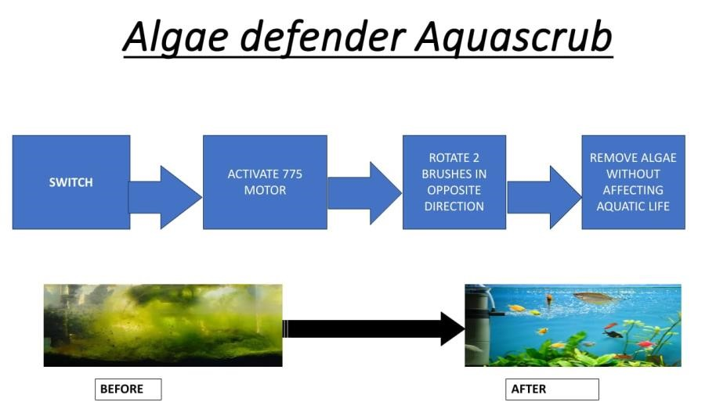

**Fig:2 Block diagram of the model**

A block diagram is a diagram of a system in which the principal parts or functions are represented by blocks connected by lines that show the relationships of the blocks. The above block diagrams shows the complete working of the Algae defender aquascrub.The system consists various hardware part like Arduino, 775 motor,rotary brushes,motordriver,12Vbattery.

**4.CIRCUIT DESIGN**

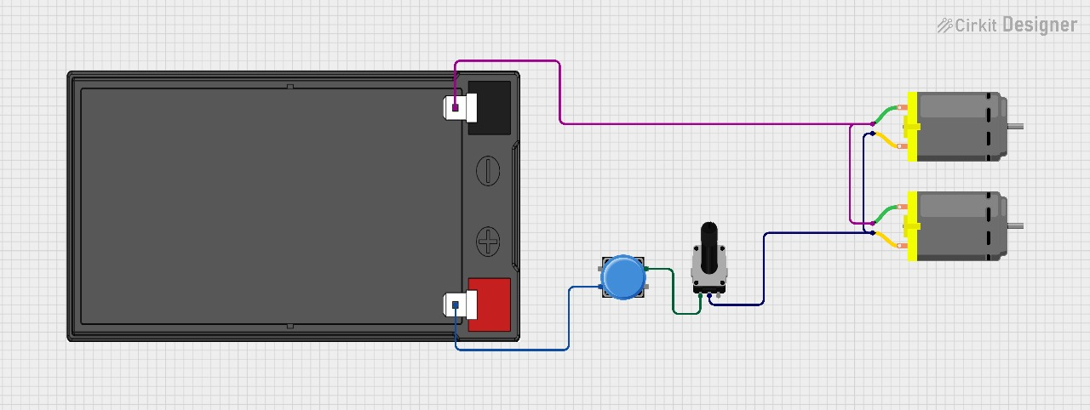

**Fig:3 Circuit Design Of Aquascrub**

**5.CONCLUSION**

In conclusion, underwater algae removal devices play a major role in the fight against aquatic ecosystems' algal overgrowth. These devices protect biodiversity, keep the water clear, and lessen the harmful effects of too much algae. Design, technology, and the devices' ability to adjust to certain underwater conditions are some of the aspects that determine how effective these gadgets are. Underwater algae removal machines must be made more sustainable and efficient by ongoing innovation and research in this area.

**6.REFRENCES**

1. Automatic Overhead Water Tank Cleaning System: A Review and an Approach Rohit R. Dabhade1 , Shubham V. Lasankute2 , Sanket P. Wankhade3 , Shubham G. Darokar4 , Prof. Vikramsingh.R Parihar

1. PVC Water Tank & Slurry Cleaning Machine: Ritesh Chaurasiya1, Paras Chamoli1,2, Sufiyan Ahmed1,2, Vishant Vashisth1,2 and Dr. Dharmendra Singh

1. Automatic Water Tank Cleaning Machine: Thonge Suraj D.1, Shelke Prasad K.2, Wakte Vaibhav B.3, Thonge Sharad A.4, Prof. Shinde R.S

1. Design and Fabrication of Automatic Water Tank Cleaning Machine: Anirudh Ramachandran, Aravind Iyer, Shabharish Iyer, Vineet Mudaliyar, Siddique Ahmed

1. Smart water tank cleaning machine for household applications: Chaudhary Parth1, Darji Birenpattel2, Harsh3,Gautam Singh Rajput4
2. Modification of the Automatic Control System for Arduino ATmega328 Based Water Gallon Cleaner:Kharisma Ramadhan,Lutfi Hinda M, M. Raghib Alashbahanni Mahfudz,M. Dafa Dezan Rezaputra,M. Taufiqul Hafizh <https://youtube.com/watch?v=0GQlNqdFZW8&si=_op7SBuOD0vhGlUu>

1. Automatic Tank Cleaner: R. Raffik1 , S. Shameer Kamal2 , S. Arun3 , P. Prabhu Raja4 & R. Manoj Kumar5

1. Remote controlled unmanned river cleaning bot:Akash Shahu