**MANUFACTURING DEFECT DETECTION SYSTEM FOR GEAR BY USING IMAGE PROCESSING**

**Bhushan Duryodhan Sapkal1, Rishab Guunwanta Sarve2, Shah Faisal3, Pawar Rushikesh Rahul4**

1,2,3,4Department of Electrical Engineering, Zeal College of Engineering and Research

(ZCOER) Pune, India

**ABSTRACT**

A sampling method of gathering representative data from a group. For example, a manufacturer might check only 2 or 3 gears from a batch of 100 gears. Due to which the whole lot gets rejected if any gear in between has error in it. Thus we need to check each and every gear in the batch but manually this process is time consuming. In our project we are designing and manufacturing a system which will be checking every gear. We use a conveyor belt for movement of gear, a camera for capturing and checking the gear parameters for its error by comparing the parameters stored at the back end. If the parameters are matched with the stored parameters then it goes to the accepted lot otherwise with the help of shooting gun it goes to the rejected lot.

1. **INTRODUCTION**

Gear is a widely used mechanical component whose primary use is to transmit power from one shaft to other. These gears are of many types namely spur gear, helical gears, worm gears etc. Gear drives are used to various kinds of machines like automobiles, metal cutting tools, material handling equipment, rolling mills, marine power plants etc. The friction and other losses in this type of power transmission equipment is comparatively very low.

In this work we use a software called “MATLAB” to determine gear parameters. MATLAB is extensively used for scientific & research purposes. It is accurate & also having several built-in functions which makes it versatile. The program is a user friendly one & when executed it ask the inputs and performs the necessary design calculations and gives necessary output values. As computers are used to perform the task of gear design becomes simple, friendly & error free.

In this world of fast paced computation where resources with time and money/capital are very important the activities in manufacturing and processing industries are day by day being performed by computers, algorithms and computing agents replacing human or semi-human

intervention. Here in the industries that require gears the filtering and classification of gears is very important and is done by human labor, precisely human labor is limited to its way of working and the time, cost required. Classification can be done with the use of imaging devices, Cameras, and scanners with developing an algorithm that describes what to accept and reject.

Computer science image processing technology is gradually becoming a part of our daily life as it continues to get excellent results while promoting the technological advancement and development. As the key role of technology that presents gear size and measurement and guides to do research and develop more advanced computer technologies, such as DSP (digital signal processing) technology, and DIP (digital image) processing) technology. We will measure the image object features easily by using these technologies.

The measurement is essential task to limit the gear at specific size. By using image processing the fundamental work has been carried out to measure following things which are its most important features.

1. To calculate outer diameter (Addendum diameter).
2. To calculate inner diameter (Dedendum diameter).
3. To count the number of teeth in gear image object.
4. To calculate tooth height.
5. To calculate PCD of gear.
6. To calculate module of gear
7. **METHODOLOGY**

**2.1 Methodology**

In figure, the original gear image is read by tool and converted into grayscale then threshold it, after that the area of gear image calculated and highlighted the interested region for to count the teeth, then teeth of the gear counted as shown in below steps.

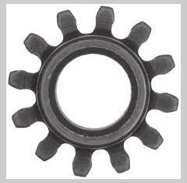

Read the Image from file

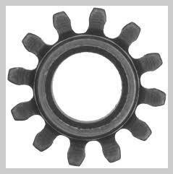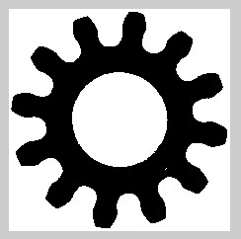

Converted the RGB image to Gray

Scale

image

Convert Gray scale image to binary

image using threshold

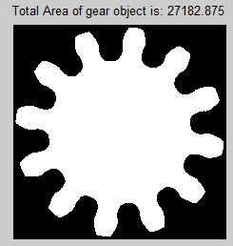

Inverted the binary image

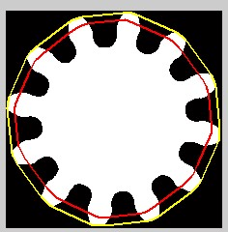

Highlighted the region of interest

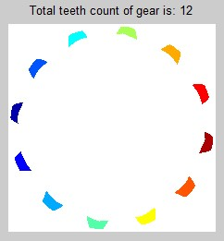

Counted the teeth of gear are **12**

* 1. **Construction**

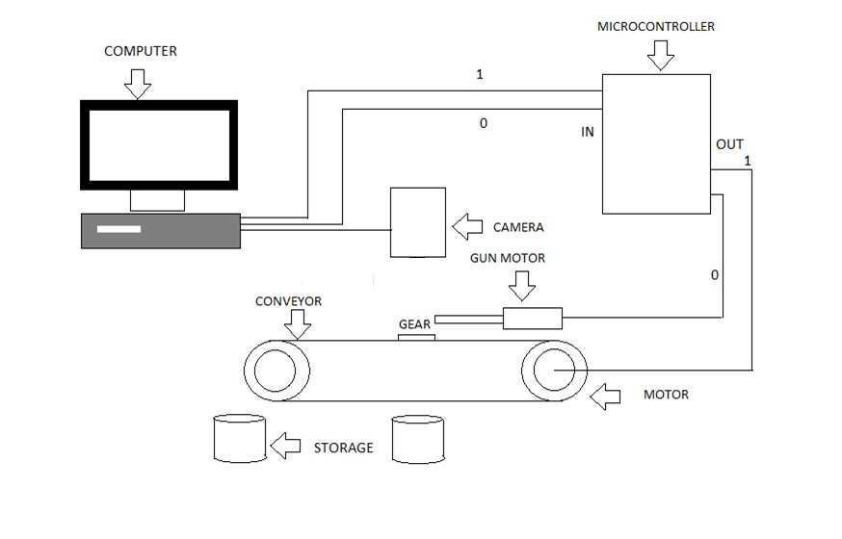

1. The gear parameters are calculated and teeth counted by using image processing in the matlab tool.
2. Computer is the main unit of the project. The I/O devices are connected across the parallel port of computer.
3. Image processing is any form of [signal processing](http://en.wikipedia.org/wiki/Signal_processing) for which the input is an image, such as a photograph or [video frame;](http://en.wikipedia.org/wiki/Video_frame) th[e output](http://en.wikipedia.org/wiki/Output) of image processing may be either an image or, a set of characteristics o[r parameters](http://en.wikipedia.org/wiki/Parameter) related to the image.
4. Most image-processing techniques involve treating the image as a [two-dimensional](http://en.wikipedia.org/wiki/Two-dimensional) [signal](http://en.wikipedia.org/wiki/Signal_%28electrical_engineering%29) and applying standard signal-processing techniques to it.
5. Two rollers are mounted according to the required distance, the belt is mounted on the rollers on which the materials are placed.
6. The rollers shaft is coupled with the Motor drive hence when power is supplied to the motor rollers rotate with a certain time delay according to the Motor drive and the belt moves along the rollers. Thus, material handling is carried out.
7. With help of the Motor drive the time delay can be achieved.
8. Initially Motor conveyor is stationary.
9. Gear is kept on conveyor belt and the gear image is captured by the camera which is fixed at the top of the setup.
10. The captured image is sent to the computer
11. Matlab algorithm read image and processes with the help of image processing and results are displayed on command window of Matlab.
12. Selected piece (right gear) is collected in a separate tray and the rejected piece (wrong gear) is collected in another tray with the help of dc gun motor.
13. A pushing rod is mounted in front of the dc gun with help of hinge and spring arrangement. When the dc gun extends it pushes the plate hence the work piece in front is also pushed and collected in the tray. When the dc gun is retracted the plate also comes back to its position with help of spring.
14. **RESULTS AND DISCUSSION**

In the result of this simulation, when we have added a virtual terminal or a similar component for displaying UART communication, we can open it within the Proteus environment. Once opened, we will see the initial message, "Enter 1 or 0 to proceed," which is sent by the microcontroller. To test the motors and UART communication, which we can use the virtual terminal to send characters to the microcontroller. Specifically, if we enter '0' or any other character and send it through the virtual terminal. The microcontroller will respond based on the character you input. If you send '0', it will activate the sorting motor and control the conveyor motor accordingly, as specified in the code. If you input any other character, it will follow the corresponding logic described in the code, adjusting the behavior of the motors accordingly.

1. **CONCLUSION**

In conclusion, this project illustrates the practical application of embedded systems in a controlled environment. By simulating the behavior of an Arduino microcontroller within Proteus, we have showcased the ability to interface with external components, such as motors and UART communication, to create a responsive system. The provided code allows users to command the behavior of these components, providing a clear demonstration of the embedded system's functionality. Through this project, we have highlighted the importance of proper setup and simulation for testing and validating embedded system designs. The ability to troubleshoot and refine the system within the Proteus environment is a crucial aspect of the development process. Overall, this project serves as an example of how embedded systems can be effectively designed and tested using modern simulation tools, setting the stage for real-world applications and innovations

1. **REFERENCES**
2. E.S. Gadelmawla ‘Computer Vision Algorithms For Measurement and Inspection Of Spur Gears’, Measurement 44(2011) 1669-1678 .
3. Amandeep Mavi, Mandeep Kaur ‘Identfy Defects In Gears Using Digital Image Processing’ ISSN:2278-067X,Volume1,Issue 6 (June2012) .
4. MD. Hazrat Ali, Syuhei Kurokawa,Kensuke Uesugi ‘Vision Based Measurement System For Gear Profile’ IEEE 2013.
5. MD. Hazrat Ali, Syuhei Kurokawa,Kensuke Uesugi ‘ Camera Based Precision Measurement In Improving Measurement Accuracy’ Measurement 49(2014) 138-147.
6. Sanjana HK, Soniya MG, Sunitha NR,Vismitha PV ‘Quality management Of Mechanical Parts Using Image Processing’ ISSN:2229-6093(2017) .