# ENVIRONMENTAL IMPACT ASSESSMENT FOR DEVELOPMENTAL PROJECTS

***Misal Shubham Ravsaheb1, Pansare Shivani Bhausaheb 2,*** ***Pomnar Dhanshri Ramesh3,*** ***Shaikh Mustakim Alam 4, Prof. Shinde P.B 5***

1,2,3,4 Student, Department of Civil Engineering, Vidya Niketan College of engineering, Bota.

5 Lecturer, Department of Civil Engineering, Vidya Niketan College of engineering, Bota.

**ABSTRACT**

Environmental Impact Assessment (EIA) is a crucial process in the realm of developmental projects, aiming to evaluate and mitigate the environmental repercussions of various initiatives. This study delves into the methodologies employed for assessing the potential environmental impacts associated with developmental projects, such as infrastructure developments. It particularly focuses on addressing issues like biodiversity loss and disruptions in ecosystems that may arise due to such projects. The primary objective of this research is to advocate for sustainable practices within developmental projects. By analyzing and understanding the environmental consequences, it seeks to provide insights into achieving a balance between development goals and environmental conservation efforts. Through comprehensive assessments, the study aims to inform policymakers, project planners, and stakeholders about the significance of integrating effective EIA measures into project planning processes. By emphasizing the importance of responsible and eco-friendly development practices, this study aims to contribute to the broader discourse on sustainable development. It highlights the necessity of considering environmental factors alongside economic and social considerations in project planning. Ultimately, the findings of this research endeavor to foster a more holistic approach towards developmental projects, ensuring their compatibility with environmental preservation goals.

**keywords:** Environmental Impact Assessment (EIA), Developmental Projects, Sustainability, Biodiversity, Ecosystem.

**INTRODUCTION**

This study explores the critical aspect of Environmental Impact Assessment (EIA) in the context of developmental projects. It aims to analyze and mitigate the environmental consequences of various development initiatives. The research investigates methodologies for assessing potential environmental impacts, biodiversity loss, and ecosystem disruptions caused by infrastructure projects. Emphasizing sustainable practices, the study seeks to provide comprehensive insights into balancing developmental goals with environmental conservation. The findings aim to inform policymakers, project planners, and stakeholders on integrating effective EIA measures to ensure responsible and eco-friendly development practices in diverse project scenarios. This study aims to delve into the key aspects of EIA, analyze its underlying principles, and critically evaluate its role in promoting sustainable development. To comprehend the significance of EIA, it is essential to recognize the complex and interconnected relationship between human activities and the environment. Various development projects, such as infrastructure development, industrial activities, mining operations, and land-use changes, can have far-reaching ecological consequences. EIA acts as a preemptive measure to assess the potential environmental impacts of these projects, allowing decision-makers to make informed choices and mitigate adverse effects. This study will examine the fundamental components of an EIA policy, exploring the legal and regulatory frameworks governing its implementation. It will analyze the key principles and objectives guiding the EIA process, such as the consideration of alternatives, stakeholder participation, and the incorporation of scientific expertise. The interdependence between environmental well-being and sustainable development has become increasingly evident on a global scale. Recognizing the intricate relationship between economic progress and its potential environmental consequences, the concept of Environmental Impact Assessment (EIA) has emerged as a pivotal tool. EIA is fundamentally concerned with systematically identifying and evaluating the environmental effects of development projects, plans, programs, and policies. This process facilitates informed decision-making by presenting alternatives that balance developmental goals with ecological considerations. While traditionally applied to specific projects, the scope of EIA is expanding to encompass broader land-use and sectoral plans.Top of Form

**1.1 Significance of Environmental Impact Assessment (EIA)**

EIA plays a crucial role in protecting the environment and promoting sustainable development. By identifying potential impacts and proposing mitigation measures, it ensures that projects are designed and implemented in an environmentally responsible manner. The process helps identify potential environmental impacts at an early stage, allowing for appropriate measures to be taken to prevent or minimize adverse effects. It enables the integration of environmental considerations into project planning and decision-making. EIA promotes public participation, allowing affected communities and stakeholders to voice their concerns and contribute to the decision-making process. This transparency enhances public trust and accountability. Lastly, EIA ensures that environmental considerations are integrated into the planning and design of projects from the early stages. Doing so helps avoid costly and environmentally damaging modifications later in the project lifecycle.

**1.3 EIA Process**

The EIA process comprises several key steps to ensure a comprehensive assessment of potential environmental impacts. These steps include screening and scoping, baseline data collection, impact prediction, mitigation measures and alternatives identification, public consultation, and the review and decision-making process.

* **Screening and Scoping Processes in EIA**

The screening process involves determining whether a project requires an EIA based on size, nature, and potential impacts. Scoping involves identifying the key issues and potential impacts that should be addressed in the EIA study.

* **Baseline Data Collection and Impact Prediction Techniques**

Baseline data collection is crucial in understanding the existing environmental conditions before a project is implemented. This includes collecting information on air quality, water quality, soil conditions, biodiversity, and socio-economic aspects. Then, based on the collected baseline data, impact prediction techniques are used to assess how the proposed project may affect the environment.

* **Mitigation Measures and Alternatives Assessment**

Once potential impacts are identified, mitigation measures are proposed to minimize or eliminate adverse effects. Alternatives assessment involves evaluating different project options or locations to identify those with lesser environmental impacts.

* **Public Consultation and Participation in EIA**

Public consultation is a fundamental aspect of the EIA process, allowing affected communities and other stakeholders to provide input and raise concerns. This ensures that the decision-making process is transparent and considers diverse perspectives.

* **Review and Decision-Making Process**

The relevant authorities review the EIA report, including the findings from the assessment and proposed mitigation measures. Based on the report and public inputs, a decision is made regarding the project's approval, rejection, or approval with conditions.

**1.2 Impacts of EIA**

EIA considers various components to assess a project's potential environmental impacts comprehensively. It evaluates the

* Physical impacts such as land use changes and habitat loss
* Biological impacts such as effects on flora and fauna and
* Social impacts such as displacement of communities and changes in livelihoods

EIA assesses a project's potential impacts on air quality, including emissions of pollutants. It also considers impacts on water resources, such as water availability and quality changes. Additionally, soil quality is assessed to determine potential impacts on agricultural productivity and soil erosion. The process evaluates potential impacts on biodiversity, including terrestrial and aquatic ecosystems. In addition, it considers the conservation of endangered species, habitat fragmentation, and ecosystem services. EIA also includes assessing socio-economic aspects, such as impacts on local communities, employment, and infrastructure. It also examines potential health impacts on workers and nearby communities due to project activities.

## PROBLEM STATEMENT

The environmental impact assessment (EIA) for developmental projects faces a critical problem in ensuring a comprehensive and effective evaluation of potential environmental consequences. Existing practices often fall short in addressing the complexities of diverse ecosystems, biodiversity conservation, and sustainable development. Inadequate consideration of cumulative impacts, insufficient public participation, and the absence of standardized evaluation criteria further hinder the EIA process. This research aims to identify and address these gaps, seeking to enhance the precision and inclusivity of EIA methodologies. The goal is to develop a more robust framework that facilitates informed decision-making, promoting environmentally responsible developmental projects in line with global sustainability goals.

## LITRATURE REVIEW

**Attaullah Shah (2010)** conducted research on “Environmental Impact Assessment (EIA) Of Infrastructure Development Projects in Developing Countries” This Study highlights the role of Environmental Impact Assessment (EIA) as a tool for identifying and mitigating the environmental, social, and economic impacts of projects. It emphasizes the historical shortcomings of EIA practices in developing countries, particularly in South Asia. Despite recent improvements in legislative frameworks, the paper focuses on the inadequacies in the EIA process, using the example of the Zero Point Interchange Project (ZPIP) in Pakistan. The study underscores the need for holistic EIA practices to ensure sustainable development and prevent environmentally detrimental projects. **Simon Tarabon(2019)** conducted research on “Environmental impact assessment of development projects improved by merging species distribution and habitat connectivity modelling” This study addresses the limited focus on landscape-scale impacts in Environmental Impact Assessment (EIA) methodologies for development projects. Using the example of a new stadium project in Lyon, France, the proposed framework combines species distribution and landscape connectivity models to assess the impact on red squirrels and Eurasian badgers. The development project negatively affects habitat connectivity, emphasizing the importance of implementing avoidance and reduction measures. **Chrysanthus Chukwuma(2015)** conducted research on “Environmental impact assessment of Development projects and natural Resources a viewpoint” This research highlights the growing global recognition of the link between the environment and successful economic development. Environmental Impact Assessment (EIA) has emerged as a crucial tool for predicting and addressing the environmental effects of development projects, plans, and policies. While EIAs traditionally focus on development projects, there is a need to extend their scope to include land-use and sectoral plans. The complexity of identifying and assessing environmental impacts necessitates structured approaches, often referred to as EIA methodologies, to gather extensive data and effectively communicate findings to decision-makers and the public. **Peter N. Duinker (2007)** conducted research on “Scenario analysis in environmental impact assessment: Improving explorations of the future Peter” Scenarios and scenario analysis have become popular approaches in organizational planning and participatory exercises in pursuit of sustainable development. However, they are little used, at least in any formal way, in environmental impact assessment (EIA). This is puzzling because EIA is a process specifically dedicated to exploring options for more-sustainable (i.e., less environmentally damaging) futures. In this paper, we review the state of the art associated with scenarios and scenario analysis, and describe two areas where scenario analysis could be particularly helpful in EIA: (a) in defining future developments for cumulative effects assessment; and (b) in considering the influence of contextual change – e.g. climate change – on impact forecasts for specific projects. We conclude by encouraging EIA practitioners to learn about the promise of scenario-based analysis and implement scenario-based methods so that EIA can become more effective in fostering sustainable development.

**Daniel R. Mandelker (2010)** conducted research on “The National Environmental Policy Act: A Review of Its Experience and Problems” The National Environmental Policy Act (“NEPA”), the Magna Carta of environmental law, requires all federal agencies to evaluate the environmental impacts of their actions, a duty that extends to state, local, and private entities when a federal link is present. NEPA’s environmental full disclosure requirement was intended as a wake-up call to federal agencies to add environmental values to their decision making. The intent was that decision-making procedures based on a narrow agency mission focus often neglected environmental concerns and would now be widened to take these concerns into account. The problem is that difficulties in the implementation of the statute have limited the achievement of this objective. **Bao Cun-kuan (2004)** conducted research on “Framework and operational procedure for implementing Strategic Environmental Assessment in China” Over the last 20 years, Environmental Impact Assessment (EIA) has been implemented and become an important instrument for decision-making in development projects in China. The Environmental Impact Assessment Law of the P.R. China was promulgated on 28 October 2002 and will be put into effect on 1 September of 2003. The law provides that Strategic Environmental Assessment (SEA) is required in regional and sector plans and programs. This paper introduces the research achievements and practice of SEA in China, discusses the relationship of SEA and ‘‘integrating of environment and development in decision-making (IEDD)’’, and relevant political and legal basis of SEA. The framework and operational procedures of SEA administration and enforcement are presented. Nine cases are analyzed and some proposals are given. **Wenfeng Mao (2002)** conducted research on “Impacts of the economic-political reform on environmental impact assessment implementation in China” Economic, political and institutional reform has significant implications for environmental regulation; however, the linkages between them have received little attention in the research literature or in governmental studies until very recently. This paper analyzes the impacts of economic– political reform on environmental regulation in China by examining the implementation of its environmental impact assessment (EIA) system. Local governments can design and enforce their own environmental policies, while local leaders have both incentive and means to impede the implementation of environmental regulations when deemed unfavorable for local economic growth. The paper argues that the impacts of China’s economic–political reform on its environmental regulation in general, and EIA implementation in particular, are mixed and less than beneficial. The economic–political reforms in China have brought about mixed impacts on its environmental regulation. On the one hand, they allow local governments to design and enforce their own environ- mental policies according to their particular circumstances. On the other hand, they enable local leaders to have both incentives and means to impede the implementation of environmental regulations when deemed as unfavorable for local economic growth; this leads to lax, selective or inconsistent environmental implementation at local levels. **Leonard Ortolano (1995)** conducted research on “Environmental Impact Assessment: Challenges and Opportunities” Environmental impact assessment (EIA) is required, in one form or another, in more than half the nations of the world. This paper examines how EIA requirements have influenced projects, programs, and organizations. EIAs have had far less influence than their original supporters had hoped. This paper provides organizational and methodological reasons for this disparity and indicates ways in which EIA might be used more productively in the future. Environmental impact assessment programs have changed the way project proponents and government agencies charged with approving projects do business. These changes have occurred in both projects and organizations. The most evident change is the inclusion of measures in project proposals to mitigate adverse environmental effects. A less common, but significant project-level change is where ElAs have affected project type, size and location. What is arguably more significant but less widely studied is the influence of EIA on project proponents. While many project proponents have been inarginally affected, others have changed fundamentally.

**I. M. GRAY (1998)** conducted research on “A review of the quality of environmental impact assessments in the Scottish forest sector” The Environmental Assessment (Afforestation) Regulations 1988 became effective on 12 July 1988. In Scotland, between 1988 and 1996 a total of 160 applications for grant assistance for afforestation proposals received by the Forestry Commission have been subject to Environmental Impact Assessment (EIA). Of these, 81 had been completed by 1996 and the assessment process concluded. Although there were instances of good practice in the assessment process, the review highlighted the overall poor quality of EIA and ES production. The recurring elemental failure, which subsequently led to additional difficulties, was the absence of a full scoping phase. Assessments were therefore unfocused, did not adequately investigate the key issues and wasted effort on irrelevancies. This in turn led to the col- lection of inadequate baseline data, which later made the task of assessing the magnitude and significance of impact extremely difficult. The review also noted that only one Woodland Grant Scheme (WGS) application was rejected following EIA, and that none of the ESs reviewed found any significant impacts. In light of the poor coverage of mitigation methods this suggests that both project screening and EIA practice require strengthening. The authors wish to thank the Forestry Authority for the assistance given while carrying out the background research for this paper. **Jing Wu (2011)** conducted research on “Strategic environmental assessment implementation in China Five-year review and prospects” Through literature review and questionnaire survey, the purpose of this study is to understand current status and major fields of SEA implementation in China, and then to provide advice for future improvement of SEA system, according to objective evaluation of the effectiveness of SEA implementation. Major types and fields of SEA implementation were firstly studied to conclude that the attitude of decision-makers and competent authority of SEA implementation does generate direct impacts on SEA implementation. Current status of SEA implementation was then studied, in terms of timing, techniques and methodologies, public participation, information disclosure, alternative, and review organization, to conclude that SEA implementation in China is “impact-based SEA” and the major problems of SEA implementation are resulted from deficient and defective management of SEA system, such as laws, regulations, and means of management. In order to have objective evaluation on the effectiveness of SEA implementation, to understand good practice of SEA implementation, and to provide advice for future improvement of SEA system, it is necessary to establish reasonable and feasible evaluation criteria for the effectiveness of SEA implementation, based upon foreign experience and political, legislative, administrative and cultural characteristics of China. Various types and stages of SEA should be carefully considered to be included into the evaluation criteria for the effectiveness of SEA implementation. **Matthew Cashmore (2004)** conducted research on “The interminable issue of effectiveness: substantive purposes, outcomes and research challenges in the advancement of environmental impact assessment theory” An analysis of studies of the outcomes of environ- mental impact assessment (EIA) indicates that its role in consent and design decisions is limited, due primarily to passive integration with the decision processes it is intended to inform. How much EIA helps sustainable development is largely unknown, but it is hypothesized that it is more than is typically assumed, through a plethora of causes, including emancipation of stakeholders and incremental change in the bureaucracy, companies and scientific institutions. To enhance the effectiveness of EIA, research should focus more on theory about the nature and operation of diverse causal pro- cases, even though the concepts, methods and analytical challenges would be substantial. The issue of effectiveness has been an overarching theme of EIA research ever since this decision tool was first enacted (Sadler, 1996). Nonetheless, re- search has focused overwhelmingly on procedural definitions of effectiveness, and remarkably little is known about the degree to which EIA is achieving its substantive purposes. It is, furthermore, evident that the precise purposes of this decision tool have been interpreted in different ways, in part due to the diversity of scientific disciplines EIA encompasses and the changing nature of the human–environment relationship.

**Ben F Harris-Roxas (2011)** conducted research on “A rapid equity focused health impact assessment of a policy implementation plan: An Australian case study and impact evaluation” Equity focused health impact assessments (EFHIAs), or health equity impact assessments, are being increasingly promoted internationally as a mechanism for enhancing the consideration of health equity in the development of policies, programs and projects. Despite this there are relatively few examples of examples of completed EFHIAs available. This paper presents a case study of a rapid EFHIA that was conducted in Australia on a health promotion policy implementation plan. It briefly describes the process and findings of the EFHIA and evaluates the impact on decision-making and implementation. The rapid EFHIA was undertaken in four days, drawing on an expert panel and limited review of the literature. A process evaluation was undertaken by email one month after the EFHIA was completed. An impact evaluation was undertaken two years later based on five semi-structured interviews with members of the EFHIA working group and policy officers and managers responsible for implementing the plan. A cost estimation was conducted by the EFHIA working group. This EFHIA was conducted in a short timeframe using relatively few resources. It had some reported impacts on the development of the implementation plan and enhanced overall consideration of health equity. This case highlights some of the factors and preconditions that may maximize the impact of future EFHIAs on decision-making and implementation. **Françoise Jabot 1, (2020)** conducted research on “A Comparative Analysis of Health Impact Assessment Implementation Models in the Regions of Montérégie (Québec, Canada) and Nouvelle-Aquitaine (France) Françoise” Many countries have introduced health impact assessment (HIA) at the national, regional, or local levels. In France and in Québec, there is increasing interest in using HIA to inform decision-makers and influence policies, programs, and projects. This paper aims to compare HIA implementation models in two regions: Nouvelle-Aquitaine (France) and Montérégie (Québec, Canada) using a case study methodology. The objective is to gain a better understanding of the similarities and differences in the approaches used to achieve the operationalization of HIA. The methodological approach involves four steps: (1) design of an analytical framework based on the literature; (2) exchanges within the research team and review of documents concerning the two implementation strategies under study; (3) development of the case studies based on the proposed framework; and (4) cross-comparison analysis of the case studies. The findings show that the two regions share certain similarities, including the strong commitment and political will of the public health organizations involved and a well-established culture of engaging in Intersectoral action with municipal partners. Differences mainly concern their different approaches to implementing HIAs in accordance with the regional policies and the organizational and administrative contexts in place. This study identifies potential avenues for supporting the practice of HIA at the municipal level. **Andrea Collins (2009)** conducted research on “Assessing the environmental impacts of mega sporting events: Two options?” At a time when public and private agencies recognize the importance of sustainable development, the environmental impacts of mega sporting events are commanding increasing attention. However, despite event sponsors often flagging the importance of environmental as well as socio-economic legacy components, the environmental impacts of events are difficult to assess quantitatively, being complex and often occurring over extended periods. The general assessment issue is particularly acute with regard to mega events such as the Olympic Games and FIFA World Cup. The practical issues mean that any quantitative techniques seeking to assess environmental impacts are likely to be partial in scope. This paper examines two such approaches for quantitative impact assessment of selected environmental externalities connected with visitation at sporting events. The paper considers the use of Ecological Footprint analysis and Environmental Input–Output modelling. It provides examples of the applications of these techniques to discrete sporting events in a UK region, and discusses whether these techniques are appropriate for exploring the environmental impacts of mega events.

## 3. PROPOSED METHODOLOGY AND OPERATING PRINCIPLE

* Provide a brief overview of the topic, including the significance of studying the Environmental Impact Assessment (EIA) policy and its implementation strategy.
* State the research objectives and research questions that will guide the study.

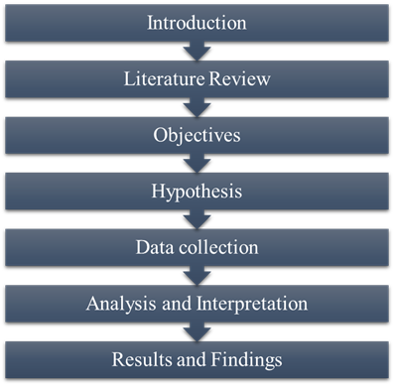

**3.1 Data collection**

In terms of methodology, both primary and secondary data will be used for this research Primary Data Will be collected through methods such as surveys, interviews, and focus groups & Secondary data, on the other hand, will be obtained from sources such as reports, articles, and statistics, and can provide a more general overview.

**3.2 Primary Data:**

* Surveys: Conducting surveys among individuals and communities affected by environmental impact assessments (EIAs) to gather first-hand information about their experiences, perceptions, and concerns. This data can provide insights into the effectiveness of the policy and its implementation strategy.
* Field Observations: Making direct observations of the EIA process in action, such as attending public hearings, site visits, and monitoring environmental mitigation measures.
* Case Studies: Conducting detailed case studies of specific projects that have undergone the EIA process to analyze the environmental impacts and the effectiveness of the policy in mitigating those impacts. This data can provide specific examples and insights into the policy's outcomes.

**3.3 Secondary data:**

* Government Reports: Analyzing official reports and documents published by government agencies responsible for implementing and regulating environmental impact assessment policies. These reports may include information on policy guidelines, implementation strategies, monitoring mechanisms, and statistical data on EIA outcomes.
* Academic Research: Reviewing existing research studies, journal articles, and academic papers related to environmental impact assessment policies and their implementation strategies. Environmental Impact Assessment.
* Reports: Analyzing EIA reports submitted by project developers as part of the assessment process. These reports contain detailed information about the environmental baseline, predicted impacts, proposed mitigation measures, and monitoring plans.

**3.4 Data Analysis**

* Describe the process of data analysis, including the software or analytical techniques to be used.
* Specify the types of data analysis techniques appropriate for the research questions.
* Present a plan for organizing, coding, and interpreting the collected data.
* Outline how the research findings will be validated and any measures taken to ensure data accuracy and reliability.

**3.5 Sample Size-**

To calculate the sample size for a population of 150 using Cronbach alpha, you will need to provide additional information such as the expected Cronbach alpha, the expected population correlation coefficient, the desired level of statistical power, and the desired level of significance.

Assuming that you want to estimate the sample size needed to achieve a 95% confidence level, 80% power, and a Cronbach alpha of 0.8, with an expected population correlation coefficient of 0.5, and a margin of error of 5%, you can use the following formula:

The Cochran formula is as follows:

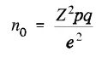

i.e.,

Z = 95 percent confidence level yields Z values of 1.96.

p = 50% of population Size. (0.5)

q = 1-p (1-0.5) = 0.5

e = Margin of error (0.05)

((1.96)2 (0.5) (0.5)) / (0.05)2 = 385.

Cochran's formulae for Smaller Size population

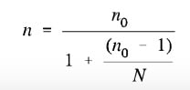

Here n0 is Cochran’s sample size recommendation, N is the population size, and n is the new, adjusted sample size. In our example, there were just 305 employees from manufacturing industry so we get sample size as,

385 / (1 + (384 / 305)) = 180.

**3.6 Study Area- Undri**

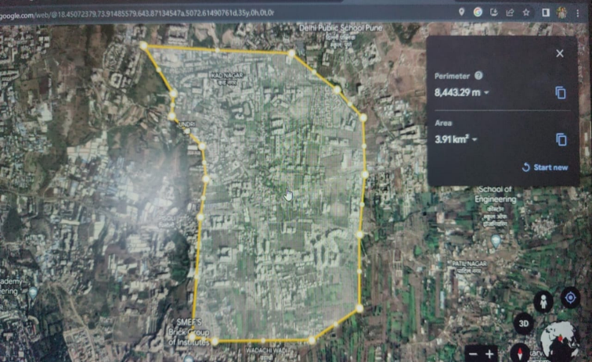

**Figure 1. Geographical structure**

**3.7 Tool used Spss software**

SPSS (Statistical Package for the Social Sciences) is a software package used for statistical analysis, data management, and data documentation. It was developed by IBM and is widely used in the social sciences, business, and other fields for analyzing and interpreting data. Key features of SPSS include data manipulation, descriptive statistics, graphical representation of data, and advanced statistical analysis.

**Here are some general aspects of SPSS software:**

* Data Management: SPSS allows users to import, clean, and organize data from various sources, including spreadsheets, databases, and text files. It provides tools for data transformation, recoding variables, and handling missing data.
* Descriptive Statistics: SPSS offers a range of descriptive statistical procedures, such as frequencies, descriptive ratios, measures of central tendency (mean, median, mode), measures of variability (standard deviation, variance), and cross-tabulations.
* Data Visualization: SPSS enables users to create a wide range of graphs and charts to visualize data, including histograms, scatterplots, bar charts, line charts, and pie charts. These visual representations help in understanding patterns and relationships within the data.
* Output and Reporting: SPSS generates comprehensive output reports that include tables, charts, and statistical results. These reports can be exported to various formats, such as Microsoft Word, Excel, and PDF, making it easy to share and present findings

**WORKING PRINCIPLE**

The working principle of Environmental Impact Assessment (EIA) for developmental projects involves systematically identifying, predicting, evaluating, and mitigating the potential environmental, social, and economic impacts of proposed projects. This process ensures that decision-makers have comprehensive information to make informed choices that promote sustainable development and minimize adverse effects on the environment.

## RESULT AND DISCUSSION

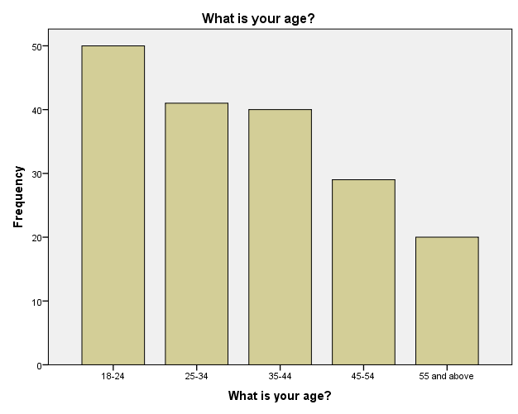

**Figure No.1 What is your age?**

According to the table, the majority of the respondents fall within the 18-24 age range, with a frequency of 50, representing 27.8% of the total sample. The next largest group is the 25-34 age range, with a frequency of 41, accounting for 22.8% of the sample. The 35-44 age range follows closely behind with a frequency of 40, representing 22.2% of the respondents. The 45-54 age range has a lower frequency of 29, accounting for 16.1% of the sample. Finally, the 55 and above age range has the smallest frequency of 20, making up 11.1% of the total respondents. The cumulative percentage column shows the accumulation of the valid percentages as we move down the table. For example, the cumulative percentage at the end of the 18-24 age range is 27.8%, which indicates that 27.8% of the respondents are 24 years old or younger. This value increases as we move down the table and reaches 100% at the end, indicating the total coverage of all age ranges.

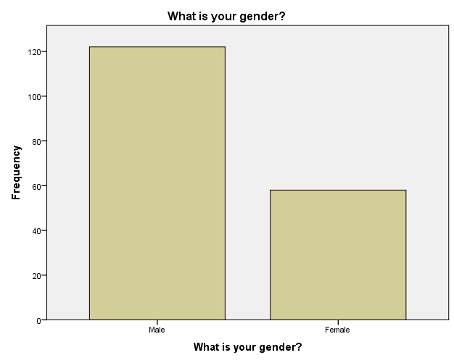

**Figure No.2 What is your gender?**

Based on the given data, there were 180 respondents in total who were asked about their gender. Out of these respondents, 122 (67.8%) identified as male, while 58 (32.2%) identified as female. This distribution indicates that the majority of respondents were male, accounting for nearly two-thirds of the sample, while females comprised around one-third. It's important to note that these numbers are specific to the survey data provided and may not reflect the gender distribution in the general population.

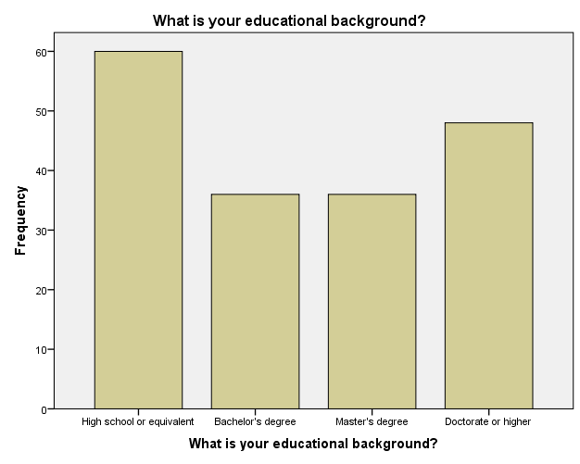

**Figure No. 3 What is your educational background?**

Based on the provided data, the educational background of the respondents is as follows. Out of the total 180 respondents, 60 (33.3%) reported having a high school diploma or an equivalent qualification. 36 (20.0%) respondents held a bachelor's degree, while another 36 (20.0%) had a master's degree. The highest level of education, a doctorate or higher, was reported by 48 (26.7%) respondents. These figures indicate a diverse range of educational backgrounds among the respondents, with a significant number holding advanced degrees. It's important to note that this data is specific to the sample surveyed and may not represent the educational distribution in the general population.

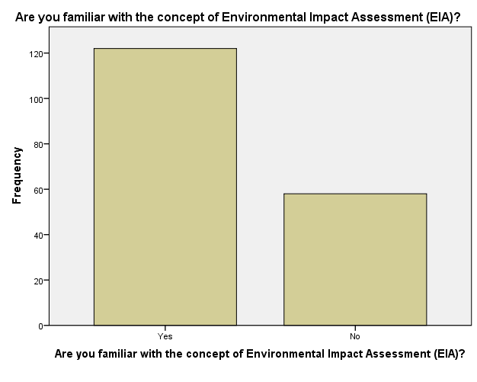

**Figure No. 4 Are you familiar with the concept of Environmental Impact Assessment (EIA)?**

Based on the provided data, it appears that 67.8% of the respondents, which is 122 individuals, indicated their familiarity with the concept of Environmental Impact Assessment (EIA). On the other hand, 32.2% of the respondents, equivalent to 58 individuals, stated that they were not familiar with EIA. This suggests that the majority of the surveyed individuals have some level of knowledge or awareness about Environmental Impact Assessment. It is important to note that this data is specific to the respondents in the survey and may not reflect the overall familiarity with EIA among the general population.

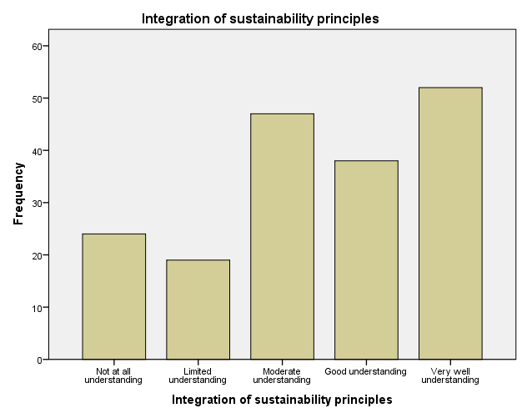

**Figure No.5 Integration of sustainability principles**

The data provided suggests that the respondents' understanding of the integration of sustainability principles can be categorized into five levels. Thirteen point three percent of the respondents reported having no understanding, while 10.6% had a limited understanding. On the other hand, 26.1% expressed a moderate understanding, and 21.1% reported a good understanding. The highest proportion, 28.9%, claimed to have a very well understanding of sustainability principles. These findings demonstrate a varied level of comprehension among the surveyed individuals, with a significant portion having a moderate to high understanding. However, it's important to remember that these results are specific to the survey participants and may not reflect the overall understanding of sustainability principles in the wider population.

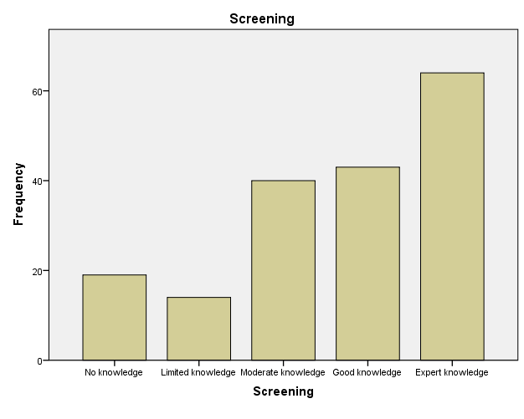

**Figure No.6 Screening**

The provided data indicates the level of knowledge among respondents regarding screening. The results can be categorized into five levels. Approximately 10.6% of respondents reported having no knowledge of screening, while 7.8% had limited knowledge. A larger portion, 22.2%, possessed a moderate level of knowledge. Additionally, 23.9% of respondents demonstrated good knowledge, and the highest proportion, 35.6%, claimed to have expert knowledge in screening. These findings show a range of knowledge levels among the surveyed individuals, with a significant percentage having at least a moderate understanding or higher. It's important to note that these results are specific to the respondents in the survey and may not represent the overall knowledge level regarding screening in the wider population.

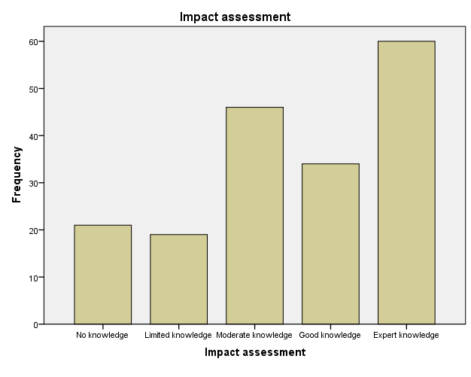

**Figure No.7 Impact assessment**

The data provided shows the level of knowledge among respondents regarding impact assessment. The results can be categorized into five levels. Approximately 11.7% of respondents reported having no knowledge of impact assessment, while 10.6% had limited knowledge. A larger portion, 25.6%, possessed a moderate level of knowledge. Furthermore, 18.9% of respondents demonstrated good knowledge, and the highest proportion, 33.3%, claimed to have expert knowledge in impact assessment. These findings indicate a range of knowledge levels among the surveyed individuals, with a notable percentage having at least a moderate understanding or higher. It's important to note that these results are specific to the respondents in the survey and may not represent the overall knowledge level regarding impact assessment in the wider population.

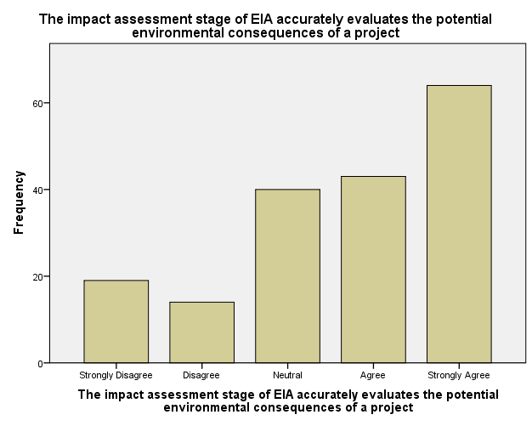

**Figure No.8 The impact assessment stage of EIA accurately evaluates the potential environmental consequences of a project**

Based on the provided data, opinions regarding the accuracy of the impact assessment stage of Environmental Impact Assessment (EIA) can be categorized into five levels. Approximately 10.6% of respondents strongly disagreed with the statement, while 7.8% disagreed. On the other hand, 22.2% expressed a neutral stance. Meanwhile, 23.9% agreed with the statement, and the highest proportion, 35.6%, strongly agreed. These findings demonstrate a range of opinions among the surveyed individuals regarding the accuracy of the impact assessment stage in evaluating the potential environmental consequences of a project. It's important to note that these results reflect the perceptions of the respondents and may vary based on their individual experiences and understanding of EIA processes.

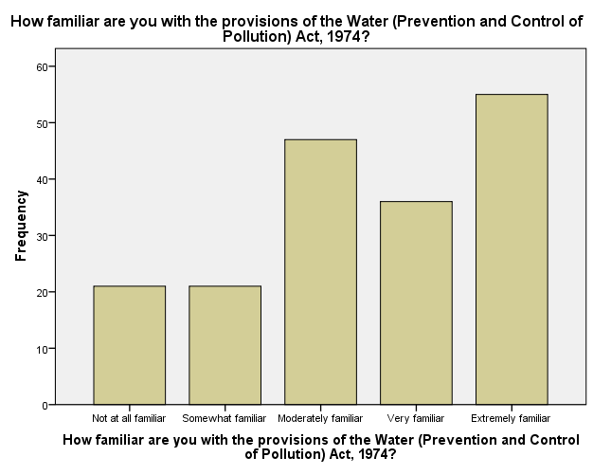

**Figure No.9 How familiar are you with the provisions of the Water (Prevention and Control of Pollution) Act, 1974?**

Based on the provided data, the familiarity levels of the respondents regarding the provisions of the Water (Prevention and Control of Pollution) Act, 1974, can be categorized into five levels. Approximately 11.7% of respondents reported being not at all familiar with the act, while another 11.7% considered themselves somewhat familiar. A larger portion, 26.1%, claimed to be moderately familiar with the act. Furthermore, 20.0% of respondents expressed being very familiar, and the highest proportion, 30.6%, stated being extremely familiar with the provisions of the act. These findings indicate a range of familiarity levels among the surveyed individuals regarding the Water (Prevention and Control of Pollution) Act, 1974. It's important to note that these results reflect the self-reported familiarity of the respondents and may vary based on their specific knowledge and experiences related to the act.

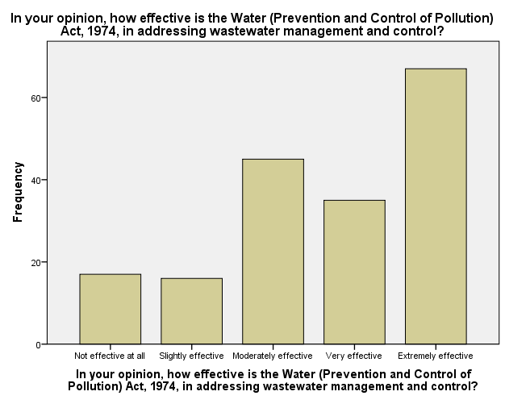

**Figure No.10 In your opinion, how effective is the Water (Prevention and Control of Pollution) Act, 1974, in addressing wastewater management and control?**

Based on the provided data, opinions regarding the effectiveness of the Water (Prevention and Control of Pollution) Act, 1974, in addressing wastewater management and control can be categorized into five levels. Approximately 9.4% of respondents considered the act not effective at all in this regard, while 8.9% believed it to be slightly effective. A larger portion, 25.0%, perceived the act to be moderately effective. Additionally, 19.4% of respondents regarded it as very effective, and the highest proportion, 37.2%, deemed it extremely effective in addressing wastewater management and control. These findings reflect the opinions of the respondents regarding the effectiveness of the Water (Prevention and Control of Pollution) Act, 1974, in relation to managing and controlling wastewater. It's important to note that these opinions are subjective and may vary based on the individual perspectives and experiences of the respondents.

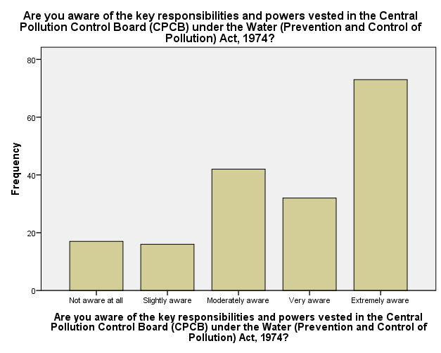

**Figure No.11 Are you aware of the key responsibilities and powers vested in the Central Pollution Control Board (CPCB) under the Water (Prevention and Control of Pollution) Act, 1974?**

Based on the provided data, the awareness levels of the respondents regarding the key responsibilities and powers vested in the Central Pollution Control Board (CPCB) under the Water (Prevention and Control of Pollution) Act, 1974, can be categorized into five levels. Approximately 9.4% of respondents reported being not aware at all, while 8.9% considered themselves slightly aware. A larger portion, 23.3%, claimed to be moderately aware of the responsibilities and powers of the CPCB. Furthermore, 17.8% of respondents expressed being very aware, and the highest proportion, 40.6%, stated being extremely aware of the CPCB's key responsibilities and powers under the act. These findings indicate a range of awareness levels among the surveyed individuals regarding the role and authority of the CPCB as defined in the Water (Prevention and Control of Pollution) Act, 1974. It's important to note that these results reflect the self-reported awareness of the respondents and may vary based on their specific knowledge and understanding of the act and the CPCB's functions.

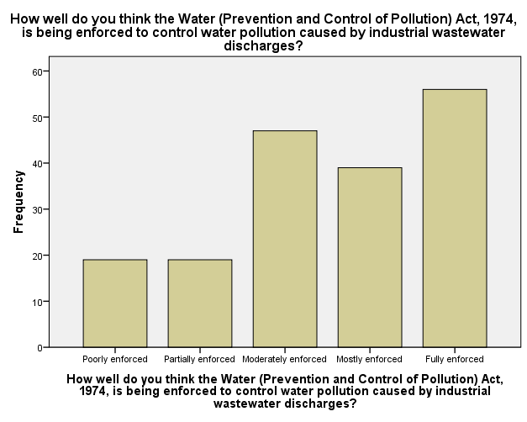

**Figure No.12 How well do you think the Water (Prevention and Control of Pollution) Act, 1974, is being enforced to control water pollution caused by industrial wastewater discharges?**

Based on the provided data, opinions regarding the enforcement of the Water (Prevention and Control of Pollution) Act, 1974, to control water pollution caused by industrial wastewater discharges can be categorized into five levels. Approximately 10.6% of respondents believed that the act is poorly enforced, while another 10.6% considered it partially enforced. A larger portion, 26.1%, perceived the act to be moderately enforced. Furthermore, 21.7% of respondents believed it is mostly enforced, and the highest proportion, 31.1%, regarded it as fully enforced in controlling water pollution caused by industrial wastewater discharges. These findings reflect the opinions of the respondents regarding the enforcement of the Water (Prevention and Control of Pollution) Act, 1974. It's important to note that these opinions are subjective and may vary based on the individual perspectives and experiences of the respondents.

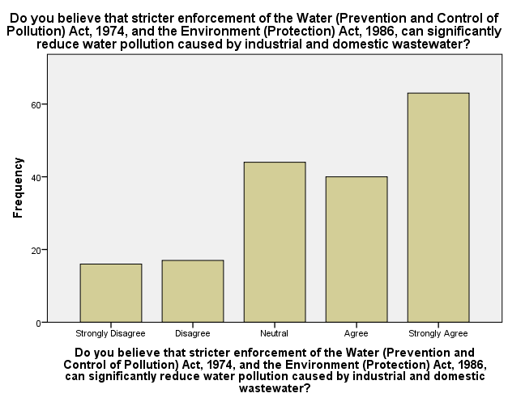

**Figure No.13 Do you believe that stricter enforcement of the Water (Prevention and Control of Pollution) Act, 1974, and the Environment (Protection) Act, 1986, can significantly reduce water pollution caused by industrial and domestic wastewater?**

Based on the provided data, opinions regarding the belief that stricter enforcement of the Water (Prevention and Control of Pollution) Act, 1974, and the Environment (Protection) Act, 1986, can significantly reduce water pollution caused by industrial and domestic wastewater can be categorized into five levels. Approximately 8.9% of respondents strongly disagreed with the statement, while 9.4% disagreed. On the other hand, 24.4% expressed a neutral stance. Meanwhile, 22.2% of respondents agreed with the statement, and the highest proportion, 35.0%, strongly agreed. These findings reflect the range of opinions among the surveyed individuals regarding the potential impact of stricter enforcement of the mentioned acts in reducing water pollution caused by industrial and domestic wastewater. It's important to note that these opinions are subjective and may vary based on the individual perspectives and experiences of the respondents.

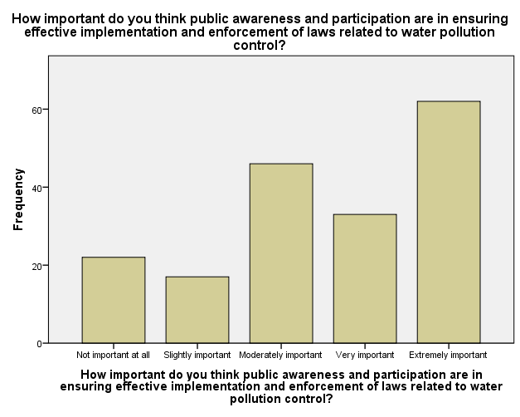

**Figure No.14 How important do you think public awareness and participation are in ensuring effective implementation and enforcement of laws related to water pollution control?**

Based on the provided data, opinions regarding the importance of public awareness and participation in ensuring effective implementation and enforcement of laws related to water pollution control can be categorized into five levels. Approximately 12.2% of respondents considered public awareness and participation not important at all in this context, while 9.4% believed it to be slightly important. A larger portion, 25.6%, regarded public awareness and participation as moderately important. Additionally, 18.3% of respondents perceived it to be very important, and the highest proportion, 34.4%, deemed it extremely important in ensuring the effective implementation and enforcement of laws related to water pollution control. These findings reflect the opinions of the respondents regarding the significance of public awareness and participation in addressing water pollution. It's important to note that these opinions are subjective and may vary based on the individual perspectives and experiences of the respondents.

**Table No.1 ANOVA**

|  |  |  |  |  |  |  |
| --- | --- | --- | --- | --- | --- | --- |
|  | | Sum of Squares | df | Mean Square | F | Sig. |
| The EIA policy in India is up-to-date with recent developments and future directions | Between Groups | 236.653 | 4 | 59.163 | 139.270 | .000 |
| Within Groups | 74.342 | 175 | .425 |  |  |
| Total | 310.994 | 179 |  |  |  |
| The scoping phase of EIA effectively identifies and addresses key environmental concerns | Between Groups | 202.735 | 4 | 50.684 | 79.324 | .000 |
| Within Groups | 111.815 | 175 | .639 |  |  |
| Total | 314.550 | 179 |  |  |  |
| The impact assessment stage of EIA accurately evaluates the potential environmental consequences of a project | Between Groups | 176.657 | 4 | 44.164 | 57.819 | .000 |
| Within Groups | 133.671 | 175 | .764 |  |  |
| Total | 310.328 | 179 |  |  |  |
| How familiar are you with the provisions of the Water (Prevention and Control of Pollution) Act, 1974? | Between Groups | 5.098 | 4 | 1.274 | .702 | .591 |
| Within Groups | 317.630 | 175 | 1.815 |  |  |
| Total | 322.728 | 179 |  |  |  |
| In your opinion, how effective is the Water (Prevention and Control of Pollution) Act, 1974, in addressing wastewater management and control? | Between Groups | 5.162 | 4 | 1.290 | .745 | .563 |
| Within Groups | 303.166 | 175 | 1.732 |  |  |
| Total | 308.328 | 179 |  |  |  |
| Are you aware of the key responsibilities and powers vested in the Central Pollution Control Board (CPCB) under the Water (Prevention and Control of Pollution) Act, 1974? | Between Groups | 176.932 | 4 | 44.233 | 55.273 | .000 |
| Within Groups | 140.046 | 175 | .800 |  |  |
| Total | 316.978 | 179 |  |  |  |
| How well do you think the Water (Prevention and Control of Pollution) Act, 1974, is being enforced to control water pollution caused by industrial wastewater discharges? | Between Groups | 8.128 | 4 | 2.032 | 1.182 | .320 |
| Within Groups | 300.783 | 175 | 1.719 |  |  |
| Total | 308.911 | 179 |  |  |  |
| How well do you think the Environment (Protection) Act, 1986, has been implemented to regulate activities that contribute to water pollution? | Between Groups | 202.735 | 4 | 50.684 | 79.324 | .000 |
| Within Groups | 111.815 | 175 | .639 |  |  |
| Total | 314.550 | 179 |  |  |  |
| Do you believe that stricter enforcement of the Water (Prevention and Control of Pollution) Act, 1974, and the Environment (Protection) Act, 1986, can significantly reduce water pollution caused by industrial and domestic wastewater? | Between Groups | 8.121 | 4 | 2.030 | 1.230 | .300 |
| Within Groups | 288.829 | 175 | 1.650 |  |  |
| Total | 296.950 | 179 |  |  |  |
| How important do you think public awareness and participation are in ensuring effective implementation and enforcement of laws related to water pollution control? | Between Groups | 28.828 | 4 | 7.207 | 4.122 | .003 |
| Within Groups | 305.972 | 175 | 1.748 |  |  |
| Total | 334.800 | 179 |  |  |  |

The provided table presents the results of the analysis of variance (ANOVA) conducted for several statements related to environmental policies and acts. The ANOVA compares the variation between groups with the variation within groups to determine if there are significant differences between the responses.

For the statement regarding the up-to-dateness of the EIA policy in India, there is a significant difference between the groups, indicating that the perception of the policy varies significantly among the respondents.

Similarly, for the effectiveness of the scoping phase of EIA and the accuracy of the impact assessment stage of EIA, there are significant differences between the groups, suggesting that respondents have diverse opinions on these aspects.

In contrast, for the familiarity with the provisions of the Water (Prevention and Control of Pollution) Act, 1974, the effectiveness of the act in addressing wastewater management, the awareness of the key responsibilities of the CPCB, the enforcement of the act to control water pollution caused by industrial wastewater discharges, and the implementation of the Environment (Protection) Act, 1986, there are no significant differences between the groups.

However, for the importance of public awareness and participation in ensuring effective implementation and enforcement of laws related to water pollution control, there are significant differences between the groups, indicating that respondents hold varying levels of importance regarding this matter.

Overall, the ANOVA results provide insights into the variability of opinions among the respondents concerning different aspects of environmental policies and acts, highlighting areas where there are significant differences in perception.

## CONCLUSION

The study and analysis of the Environmental Impact Assessment (EIA) policy and its implementation strategy have shed light on several significant aspects. The objectives of this research were successfully achieved, providing an overview of recent developments and future directions in EIA, including proposed amendments to the EIA Notification and the integration of sustainability principles. The step-by-step process of EIA, encompassing screening, scoping, impact assessment, public consultation, and monitoring, was outlined comprehensively. This elucidation has enhanced understanding regarding the various stages involved in conducting an EIA, ensuring that potential environmental impacts are identified, assessed, and managed effectively. The examination of the current EIA policy framework in India revealed certain gaps and areas of improvement. By identifying these shortcomings, policymakers and stakeholders can work towards enhancing the effectiveness and efficiency of the EIA process. These findings highlight the need for continuous evaluation and refinement of the policy framework to ensure that it aligns with evolving environmental challenges and global best practices. Moreover, the specific case study focused on the EIA of a residential building in the Pune region. The findings of this study have contributed to the body of knowledge regarding the environmental implications of such projects. The case study serves as a practical example to illustrate the application of the EIA process, providing insights into the potential impacts of residential development on the local environment. Additionally, multiple regression analysis was conducted to assess the feasibility of the EIA process. This statistical technique allowed for the examination of the relationships between various factors and their influence on the environmental impact of the project. The findings from the regression analysis provide valuable insights for decision-makers and policymakers, enabling them to make informed choices and develop strategies that minimize adverse environmental effects. In summary, the study and analysis of the Environmental Impact Assessment policy and its implementation strategy have provided a comprehensive understanding of EIA processes and their significance in sustainable development. The research has highlighted the need for continuous improvement in the policy framework and emphasized the importance of incorporating sustainability principles. The insights gained from this study can guide future endeavors to enhance the effectiveness and efficiency of EIA practices, contributing to the overall goal of achieving sustainable development while mitigating environmental impacts.

## FUTURE SCOPE

The future scope of Environmental Impact Assessment (EIA) for developmental projects is promising and multifaceted. Firstly, advancements in technology, such as remote sensing and geographic information systems (GIS), offer opportunities for more accurate and comprehensive data collection and analysis. Integrating machine learning and artificial intelligence can enhance predictive modeling of environmental impacts. Additionally, there is growing recognition of the need for holistic approaches, including Social Impact Assessment (SIA) and Health Impact Assessment (HIA), to address broader societal concerns. Collaboration between stakeholders, including governments, industries, and local communities, will be essential for effective EIA implementation. Furthermore, exploring the incorporation of indigenous knowledge systems and traditional ecological knowledge can enrich EIA processes, fostering cultural sensitivity and sustainability. Lastly, as global environmental challenges intensify, such as climate change and biodiversity loss, EIA will play a pivotal role in promoting resilient and adaptive development practices.

### REFERANCE

1. Daniel R, M. (2016). The National Environmental Policy Act. Decision Making in Environmental Law, 271–282. <https://doi.org/10.4337/9781783478408.ii.20>
2. Duinker, P. N., & Greig, L. A. (2007). Scenario analysis in environmental impact assessment: Improving explorations of the future. Environmental Impact Assessment Review, 27(3), 206–219. <https://doi.org/10.1016/j.eiar.2006.11.001>
3. Bao, C. K., Lu, Y. Sen, & Shang, J. C. (2004). Framework and operational procedure for implementing Strategic Environmental Assessment in China. Environmental Impact Assessment Review, 24(1), 27–46. <https://doi.org/10.1016/S0195-9255(03)00137-9>
4. Mao, W., & Hills, P. (2002). Impacts of the economic-political reform on environmental impact assessment implementation in China. Impact Assessment and Project Appraisal, 20(2), 101–111. <https://doi.org/10.3152/147154602781766744>
5. Ortolano, L., & Shepherd, A. (1995). Environmental impact assessment: Challenges and opportunities. Impact Assessment, 13(1), 3–30. <https://doi.org/10.1080/07349165.1995.9726076>
6. Daniel R, M. (2016). The National Environmental Policy Act. Decision Making in Environmental Law, 271–282. <https://doi.org/10.4337/9781783478408.ii.20>
7. Duinker, P. N., & Greig, L. A. (2007). Scenario analysis in environmental impact assessment: Improving explorations of the future. Environmental Impact Assessment Review, 27(3), 206–219. <https://doi.org/10.1016/j.eiar.2006.11.001>
8. Bao, C. K., Lu, Y. Sen, & Shang, J. C. (2004). Framework and operational procedure for implementing Strategic Environmental Assessment in China. Environmental Impact Assessment Review, 24(1), 27–46. <https://doi.org/10.1016/S0195-9255(03)00137-9>
9. Mao, W., & Hills, P. (2002). Impacts of the economic-political reform on environmental impact assessment implementation in China. Impact Assessment and Project Appraisal, 20(2), 101–111. <https://doi.org/10.3152/147154602781766744>
10. Ortolano, L., & Shepherd, A. (1995). Environmental impact assessment: Challenges and opportunities. Impact Assessment, 13(1), 3–30. https://doi.org/10.1080/07349165.1995.9726076
11. Gray, I. M. (1999). A review of the quality of environmental impact assessments in the Scottish forest sector. Advances, 72(18), 20001–20001.
12. Wu, J., Chang, I. S., Bina, O., Lam, K. C., & Xu, H. (2011). Strategic environmental assessment implementation in China - Five-year review and prospects. Environmental Impact Assessment Review, 31(1), 77–84. <https://doi.org/10.1016/j.eiar.2010.04.010>
13. Cashmore, M., Gwilliam, R., Morgan, R., Cobb, D., & Bond, A. (2004). The interminable issue of effectiveness: Substantive purposes, outcomes and research challenges in the advancement of environmental impact assessment theory. Impact Assessment and Project Appraisal, 22(4), 295–310. <https://doi.org/10.3152/147154604781765860>
14. Harris-Roxas, B. F., Harris, P. J., Harris, E., & Kemp, L. A. (2011). A rapid equity focused health impact assessment of a policy implementation plan: An Australian case study and impact evaluation. International Journal for Equity in Health, 10, 1–12. <https://doi.org/10.1186/1475-9276-10-6>
15. Jabot, F., Tremblay, E., Rivadeneyra, A., Diallo, T. A., & Lapointe, G. (2020). A comparative analysis of health impact assessment implementation models in the regions of Montérégie (Québec, canada) and nouvelle-aquitaine (france). International Journal of Environmental Research and Public Health, 17(18), 1–18. <https://doi.org/10.3390/ijerph17186558>
16. Collins, A., Jones, C., & Munday, M. (2009). Assessing the environmental impacts of mega sporting events: Two options? Tourism Management, 30(6), 828–837. <https://doi.org/10.1016/j.tourman.2008.12.006>
17. Munyazikwiye, F. (2011). An assessment of environmental impact assessment (eia) procedures and challenges faced by environmental officers in eia implementation in rwanda. Phys. Rev. E. <http://www.ainfo.inia.uy/digital/bitstream/item/7130/1/LUZARDO-BUIATRIA-2017.pdf>
18. Shah, A. (2010). Environmental Impact Assessment ( Eia ) Of Infrastructure Development Projects In.
19. Tarabon, S., Bergès, L., Dutoit, T., & Isselin-nondedeu, F. (2019). Environmental impact assessment of development projects improved by merging species distribution and habitat connectivity modelling. 0–28.
20. Chukwuma, C. (2007). Environmental impact assessment of development projects and natural resources—a viewpoint. February 2015, 37–41. <Https://doi.org/10.1080/00207239608711056>