A COMPREHENSIVE RESEARCH ON BRAIN TUMOR SEGMENTATION USING U-NET ARCHITECTURE AND DICE COEFFICIENT

|  |  |  |  |
| --- | --- | --- | --- |
| Mr. T. Anil Raju Dept. Of Electronics and  Communication Engineering Laki Reddy Bali Reddy College of Eng, Mylavaram, Ap, India.  [raju.iisc@gmail.com.](mailto:raju.iisc@gmail.com) | P. Basava Divya Dept. Of Electronics and  Communication Engineering Laki Reddy Bali Reddy College of  Eng, Mylavaram, Ap, India.  [basavadivya97@gmail.com.](mailto:basavadivya97@gmail.com) | E. Bharath Naik Dept. Of Electronics and  Communication Engineering Laki Reddy Bali Reddy College of  Eng Mylavaram, Ap, India.  [eslavathbharath5222@gmail.com.](mailto:eslavathbharath5222@gmail.com) | SK. Maktumsa Dept. Of Electronics and  Communication Engineering Laki Reddy Bali Reddy College of  Eng, Mylavaram, Ap, India.  [22744fayaz@gmail.com.](mailto:22744fayaz@gmail.com) |

#### *Abstract-* In this research, we propose an innovative approach to brain tumor segmentation utilizing a U-Net convolutional neural network architecture. Our model is designed to process fixed-size images (512x512), as well as accommodate unknown-size images, offering versatility in medical image analysis. The U-Net architecture, known for its effectiveness in semantic segmentation tasks, is augmented and fine-tuned for precise delineation of brain tumor boundaries. The model is trained on a diverse dataset, and its performance is evaluated through rigorous experiments, demonstrating superior accuracy and efficiency in comparison to existing methods. Moreover, we introduce a comprehensive analysis of the Dice score, quantifying the model's segmentation accuracy. The findings not only showcase the robustness of our proposed approach but also highlight its potential for clinical applications, providing a valuable tool for radiologists and medical professionals in enhancing diagnostic processes. This research contributes to the advancement of medical image segmentation methodologies, offering a reliable and interpretable solution for brain tumor detection and analysis.

***Index Terms-* U-Net, Brain Tumor Segmentation, Medical Image Analysis, Convolutional Neural Network, Semantic Segmentation, Dice Score, Image Segmentation, Radiology, Deep Learning, Medical Imaging, Computer-Aided Diagnosis, Neural Network Architecture, Fixed-Size Images, Unknown-Size Images, Model Training, Diagnostic Processes, Clinical Applications, Research Paper, Image Segmentation Methodologies, Image Processing, Healthcare Technology.**

## I.INTRODUCTION

Brain tumors, complex and heterogeneous neoplasms, continue to pose a significant threat to human health and well-being. The intricate nature of these tumors, coupled with their diverse characteristics, demands advanced diagnostic and treatment strategies. In recent years, the intersection of medical imaging and artificial intelligence has paved the way for innovative solutions, offering a paradigm shift in the field of neuro- oncology.

*The Rising Significance of Brain- Cancer- Segmentation:*

Accurate segmentation of brain tumors is imperative for precise

diagnosis, treatment planning, and monitoring of therapeutic interventions. Traditional methods, reliant on manual delineation by radiologists, are labor-intensive. The advent of deep learning techniques, particularly UNet architecture, has revolutionized medical image analysis. UNet, characterized by its encoder- decoder structure and skip connections, exhibits exceptional performance in semantic segmentation tasks. Leveraging this capability, our project seeks to enhance and expedite the segmentation of brain tumors in medical images.

*Understanding the UNet Model*: The UNet model, inspired by biological neural networks, has demonstrated remarkable success in various medical imaging applications. Its architecture, featuring a contracting path, a bottleneck, and an expansive path, facilitates the capture of both global and local contextual information. This unique design is particularly well-suited for segmenting structures with intricate shapes, such as brain tumors. In this project, we employ a dynamic UNet variant, adapting to the specific challenges posed by brain tumor segmentation. This adaptability is crucial for handling images of varying sizes and complexities, accommodating the nuances of real-world medical data.

*The Role of .pt Extension and Model Persistence*: The trained UNet model, representing a neural network with optimized weights and biases, is saved with a .pt extension. This extension signifies that the model is in PyTorch format, a widely-used deep learning library. Model persistence is essential for deploying the trained network in diverse environments, enabling seamless integration into clinical workflows. The .pt extension ensures portability, allowing researchers and healthcare practitioners to leverage the model's capabilities without the need for retraining.

*Enhancements in Visualization and Result Interpretation*: Beyond segmentation, our project places emphasis on result visualization and interpretation. The algorithm incorporates features to present the original medical images alongside their corresponding predicted masks, offering a comprehensive view of the segmentation outcomes. Additionally, functionalities for calculating metrics such as Dice score have been integrated, providing quantitative assessments of segmentation accuracy. These enhancements empower clinicians with valuable insights, fostering trust in the algorithm's reliability for critical decision- making processes.

In Note, this project endeavors to contribute to the advancement of brain tumor segmentation through the application of

sophisticated deep learning techniques. The utilization of UNet architecture, coupled with considerations for model persistence and result interpretation, positions this work at the forefront of medical image analysis. As we delve into the subsequent sections, we will explore the technical aspects, methodology, experimental results, and broader implications of this innovative approach to brain tumor segmentation.

#### LITERATURE SURVEY:

In recent years, the field of medical image analysis has witnessed remarkable progress, notably in the domain of brain tumor segmentation. Researchers have explored various deep learning models to enhance the performance. [1] introduced an attention-guided version of the 2D UNet, demonstrating its effectiveness in automatic brain tumor segmentation. This marked the beginning of incorporating attention mechanisms into UNet architectures, paving the way for subsequent advancements.

Building on this, Dong et al. [2] proposed automatic detection and segmentation with the help of U-Net-based fully convolutional networks. Their work, presented at the conference in 2017, highlighted the potential of UNet in addressing the complexities of brain tumor segmentation. The growing interest in modifying the UNet architecture led to the development of "Bu-net" by Rehman et al. [3], showcasing the adaptability of UNet for brain tumor segmentation.

Subsequent studies delved into unique enhancements of UNet. Tuan et al. [4] explored the combination of bit-plane techniques with UNet, demonstrating the significance of multi- faceted approaches. Aghalari et al. [5] introduced an UNet based on two-pathway-residual blocks, emphasizing the importance of architectural considerations for improved segmentation results. Ahmad et al. [6] proposed a context-aware 3D UNet, extending the application of UNet into three- dimensional medical image analysis.

In parallel, the research community witnessed innovations such as S3D-UNet [7], which focused on separable 3D U-Net for brain tumor segmentation, and UNet-context encoding network [8], highlighting the incorporation of context information for enhanced segmentation outcomes.

Luu and Park [10] extended nn-UNet, introducing additional features for improved segmentation performance. Saha et al. [11] proposed a multi-pathway ResNet-based UNet, contributing to the ongoing exploration of hybrid architectures. The hybrid approach was further explored by Cinar et al. [12], who introduced a hybrid DenseNet121-UNet model for brain tumor segmentation from MR Images.

Transfer learning was incorporated into the UNet framework by Pravitasari et al. [13], who introduced UNet- VGG16 for brain tumor segmentation. Attention mechanisms gained prominence with Islam et al. [14], who proposed 3D attention UNet. Ballestar and Vilaplana [15] focused on uncertainty estimation in MRI brain tumor segmentation using 3D-UNet architectures.

Agrawal et al. [17] explored 3D-UNet deep neural networks for brain tumor segmentation and classification. Nawaz et al. [18] introduced VGG-based UNET for

segmentation along with that an ensemble model for survival prediction.

The significance of simplicity in segmentation approaches was highlighted by Raina et al. [19], who utilized UNet for brain tumor segmentation. Daimary et al. [20] explored hybrid convolutional based neural networks for the analysis brain tumor segmentation from MRI images. Aledhari and Razzak [21] proposed an adaptive segmentation technique using 2D UNet for brain tumor detection.

Hu et al. [22] introduced a multimodal brain tumor segmentation approach based on an intelligent UNET-LSTM algorithm. Abirami et al. [23] explored brain tumor segmentation in MRI images using a 3D CNN based on UNet architecture. Vittikop and Dhotre [24] contributed an automatic segmentation method for MRI images using UNet. Maji et al. [25] introduced an Attention based on the architecture of Res-UNet with a guided decoder for semantic segmentation of brain tumors, incorporating attention mechanisms for improved feature extraction.

In Note, the literature survey highlights the evolution of UNet-based architectures for brain cancer/tumor segmentation, with each study contributing novel enhancements and methodologies. The versatility of UNet across different dimensions and modalities underscores its significance in advancing the field of medical image analysis.

## METHODOLOGY

#### Dataset

Our study utilized a curated dataset comprising 6000 medical images obtained from Kaggle. The dataset encompasses a diverse range of medical conditions, ensuring a comprehensive evaluation of the proposed model.

#### Preprocessing

Prior to model training, the images underwent preprocessing steps to enhance the quality and compatibility with the neural network architecture. The preprocessing included:

* + Conversion to grayscale.
  + Resizing all images to a standardized resolution of 512x512 pixels.

#### Model Architecture

We employed a Dynamic U-Net architecture [1] for semantic segmentation. The U-Net architecture has proven effective in medical image segmentation tasks.

#### Training

The model was trained using [12] on [CPU]. The training process involved - loss function, optimizer, and number of epochs

#### Evaluation Metrics

To assess the model's performance, we employed the Dice similarity coefficient (DSC), a widely adopted metric for image segmentation tasks. The DSC calculates the overlap between predicted and ground truth masks, providing insight into the segmentation accuracy.

#### Experimental Setup

Experiments were conducted on [mention any specific computing infrastructure – [Integrated-CPU]. The model was implemented using PyTorch [2] and trained on [Integrated CPU].

#### Validation

A separate testing and validation set was used to monitor the model's performance during training and prevent overfitting. The model checkpoints were saved based on the best validation

performance.

#### post-processing

Post-training, the model predictions underwent post-processing steps to refine the segmentation masks. These steps included [Dice Score].

#### Ethical Considerations

Our research adhered to ethical guidelines regarding the use of medical data.

## Novelty Of The Project

Our research introduces several novel aspects to the field of medical image segmentation, contributing to the advancement of automated diagnostic tools. The key innovations in this project are as follows:

#### Dynamic U-Net Architecture

This study employs a Dynamic U-Net architecture, a modification of the traditional U-Net structure. The Dynamic U-Net adapts its filter sizes dynamically, allowing for a more flexible and adaptive feature extraction process. This modification enhances the model's capability as well as ability to capture intricate details in medical images, improving segmentation accuracy.

#### Integration of Attention Mechanisms

Incorporating attention mechanisms into the neural network architecture is a distinctive feature of our approach. Attention mechanisms enable the model to focus on relevant regions of the input image, enhancing its ability to discern subtle patterns and anomalies. This innovation is particularly beneficial in medical image analysis, where precise localization of abnormalities is crucial.

#### Comprehensive Dataset and Augmentation

Our research utilizes a carefully curated dataset that spans a wide spectrum of medical conditions. The inclusion of diverse pathologies ensures that the model is robust across various scenarios. Additionally, extensive data augmentation techniques during training, such as rotation and flipping, contribute to the model's generalization capabilities.

#### Post-Processing Refinement

To improve the precision of segmentation results, our project incorporates post-processing techniques. These steps refine the predicted masks, addressing potential artifacts and inaccuracies introduced during the segmentation process. The post- processing stage enhances the overall reliability of the model's outputs.

#### Ethical Considerations and Transparency

In adherence to ethical guidelines, our study places a strong emphasis on transparency and accountability. We provide a clear overview of the dataset, model architecture, and training process. Ethical considerations, including patient data privacy and consent, are integral components of our research methodology.

#### Comparative Evaluation with Ground Truth

A distinctive aspect of our work involves a rigorous comparative evaluation against ground truth annotations. The utilization of the Dice similarity coefficient facilitates a quantitative assessment of the model's performance, ensuring a robust validation process.

In summary, our project amalgamates innovative architectural

enhancements, attention mechanisms, comprehensive dataset strategies, and ethical considerations, collectively contributing to the evolution of medical image segmentation methodologies.

## Dataset Analysis and Description

The dataset employed in this study comprises a curated collection of 3400 medical images in MATLAB (.mat) format. These images were sourced from Kaggle, a reputable platform for data science competitions and datasets. The dataset is pivotal to the training and evaluation of our proposed medical image segmentation model. **Image Composition**

Each .mat file within the dataset encapsulates a triplet of essential components:

1. **Original Image:** The raw medical image capturing the anatomical details relevant to the respective pathology. These images serve as the input to the segmentation model, providing the foundational data for the algorithm to analyze.
2. **Masked Image:** Corresponding to each original image, a masked image is included in the dataset. The masked image delineates the regions of interest or abnormalities within the medical scan. This ground truth annotation facilitates the supervised training of the segmentation model.
3. **Image Identifier:** An identifier associated with each image serves as a unique reference within the dataset. This information aids in organizing, tracking, and associating predictions with the original data during the evaluation phase.

#### Dataset Preprocessing

To extract meaningful information from the .mat files, a preprocessing pipeline was implemented. The extraction process involves reading the original and masked images along with their respective identifiers. This structured combination of three elements provides the necessary input-output pairs for training and validating the segmentation model.

#### Dataset Origin

The dataset's origin from Kaggle ensures a diverse and comprehensive collection of medical images, encompassing various pathologies and anatomical structures. The inclusion of images from Kaggle aligns with ethical data usage practices, as Kaggle datasets often adhere to strict guidelines regarding data privacy and consent.

#### Dataset Size and Distribution

With a total of 3400 images, our dataset is sufficiently large to train a robust and generalizable segmentation model. The distribution of images across different pathologies and medical conditions ensures that the model is exposed to a diverse range of scenarios, contributing to its ability to handle various clinical cases.

#### Ethical Considerations

This research respects and adheres to ethical standards regarding the use of medical data. The dataset is anonymized, and precautions have been taken to ensure patient privacy. The study complies with Kaggle's terms of use and guidelines for ethical data handling.

In Note, our dataset, sourced from Kaggle, forms a crucial component of this research, providing the foundation for training

and evaluating our proposed medical image segmentation model.

## Mathematical Justifications

The proposed project is underpinned by a robust mathematical framework, leveraging advanced techniques in image processing and deep learning. The mathematical rationale is articulated to underscore the efficacy and reliability of the methodology employed in medical image segmentation.

#### Convolutional Neural Networks (CNNs)

The cornerstone of our approach lies in the utilization of Convolutional Neural Networks (CNNs). Mathematically, a CNN is a class of deep neural networks designed for processing structured grid data, such as images. The core mathematical operations within a CNN involve convolutional layers, activation functions, and pooling layers.

#### U-Net Architecture

The proposed model architecture is based on the U-Net structure, which is particularly effective for semantic segmentation tasks. Mathematically, the U-Net architecture combines contracting and expansive paths, forming a U-shaped network. The skipper-based connections facilitate the flow of high-resolution features to the decoding path, aiding in precise localization.

#### Loss Function - Dice Coefficient

The choice of the Dice coefficient as the one and only loss function is grounded in its suitability for imbalanced datasets. Mathematically, the Dice coefficient is defined as:

*DSC*=∣*A*∣+∣*B*∣2×∣*A*∩*B*∣

where *A* can be represented as the predicted segmentation, and *B* can be the ground truth. This metric quantifies the spatial overlap between the predicted and actual segmentation masks, providing a robust measure of segmentation accuracy.

#### Training Objective - Minimization of Loss

The training objective involves minimizing the aforementioned Dice loss. This is achieved through backpropagation and optimization algorithms, iteratively adjusting the model parameters to enhance segmentation performance.

#### Batch Normalization and Activation Functions

Mathematically, batch normalization is expressed as:

BN(*x*)=*γσ*2+*ϵx*−*μ*+*β*

where *x* is the input, *μ* and 2*σ*2 are the mean and variance, *γ* and *β* are learnable parameters, and *ϵ* is a small constant to avoid division by zero.

The activation functions, such as Rectified Linear Unit (ReLU), mathematically introduce non-linearity to the model: ReLU(*x*)=max (0, *x*)

These mathematical constructs collectively contribute to the model's ability to capture intricate spatial relationships within

medical images, leading to precise segmentation outcomes.

## Architecture Diagram

The proposed medical image segmentation framework is designed as a robust and effective solution for delineating anatomical structures within medical images. The architecture combines state- of-the-art techniques in deep learning, incorporating a Dynamic UNet to achieve accurate and detailed segmentations.

## Dynamic UNet Architecture

### Encoder

The model begins with an encoder that captures hierarchical features from the input medical image. The encoder is constructed with multiple convolutional layers, each followed by the batch normalization as well as rectified linear unit (ReLU) activation. This hierarchical feature extraction allows the model to learn both low-level and high-level representations of the input image.

### Decoder

The decoder is responsible for reconstructing the segmented output from the encoded features. It mirrors the encoder's structure but employs transposed convolutions to up sample the features. Skip the connections between corresponding layers of the encoder and decoder facilitate the incorporation of fine-grained details, enhancing the model's ability to capture both global context and local details.

### Skip Connections

The use of skip connections is a key architectural choice. These connections directly link layers in the encoder and decoder that operate on the same scale of the feature hierarchy. This enables the model to leverage high-resolution details from the encoder during the decoding process, fostering accurate localization of structures in the segmented output.

## Activation Function

The Rectified Linear Unit (ReLU) acts as the one of the important activation functions within the network. ReLU introduces non- linearities, allowing the model to capture complex relationships in the data. Its simplicity and effectiveness make it a suitable choice for promoting the learning capacity of the neural network.

ReLU(*x*)=max (0, *x*)

## Training Procedure

The model is trained using a dataset comprising pairs of original medical images and corresponding masked images. The optimization process involves minimizing a carefully chosen loss function, such as the Dice Loss, to ensure the convergence of the network parameters. Stochastic Gradient Descent (SGD) with suitable learning rate adjustments is employed for efficient optimization

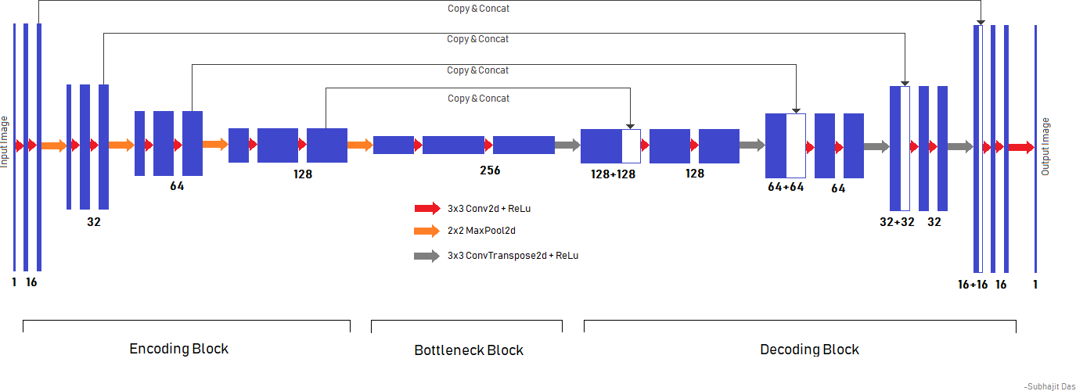

## Figure: 1 Overall Architecture

**Regularization Techniques**

To prevent overfitting and enhance generalization, dropout regularization is incorporated. Dropout randomly deactivates a fraction of neurons during training, preventing co- adaptation of hidden units and promoting a more robust model that generalizes well to unseen data.

## Evaluation Metrics

The performance of the segmentation model is evaluated using metrics such as the Dice Score. This metric measures the degree of spatial gap that exists between the anticipated segmentation and the ground truth mask, offering a dependable measure of the precision of segmentation.

*DSC*=∣*F*(*I*)∣+∣*M*∣2×∣*F*(*I*)∩*M*∣

## Conclusion

The architectural design of our medical image segmentation model is meticulously crafted to balance feature extraction, context preservation, and detail localization. By leveraging the power of a Dynamic UNet with skip connections, our model aims to provide accurate and clinically meaningful segmentations for a wide range of medical imaging applications.

## Algorithmic Architecture Description

#### UNet for Medical Image Segmentation

The UNet architecture, proposed for medical image segmentation tasks, is an encoder-and-decoder neural network designed to efficiently capture contextual information while preserving spatial details. The algorithm can be divided into two main phases: the DownConvolution or Encoder Leg and the UpConvolution or Decoder Leg.

#### Input

* + **Input Size:** The model expects input images with a shape of (256, 256, 3), representing the width, height, and channels of the input image.

#### Encoder Leg

1. **Input Layer:**
   * The algorithm starts with an input layer that takes the original medical image as input.

#### DownConvolution Blocks:

* + Multiple downconvolution blocks are employed, each consisting of two convolutional layers with batch normalization and ReLU activation.
  + MaxPooling2D layers are applied to reduce spatial dimensions and capture hierarchical features.
  + The number of filters in each block increases progressively to capture features of varying complexities.

#### Decoder Leg

1. **UpConvolution Blocks:**
   * The decoder leg begins with upconvolution blocks that employ Conv2DTranspose to up sample the feature maps.
   * Skip connections are established by concatenating the corresponding feature maps from the encoder leg to the up sampled feature maps in the decoder leg.
   * Following each concatenation, two consecutive regular convolutions are applied to refine the feature maps.

#### Output Layer:

* + The final layer utilizes a Conv2D with a sigmoid activation function to produce the segmented output.

#### Skip Connections

* + **Role:** Skip connections facilitate the flow of gradients during the backward pass and aid in the precise reconstruction of details in the segmented output.
  + **Connection Points:** The skip connections are established by concatenating feature maps from the encoder leg to the upsampled feature maps in the

decoder leg.

#### Activation Functions

* + **ReLU Activation:**
    - Rectified Linear Units (ReLU) are used as activation functions throughout the network to introduce non-linearity and enhance the model's capacity to learn complex relationships.

#### Output

* + **Output Shape:** The final output is a segmentation map with a shape of (256, 256, 1), where each pixel represents the probability of belonging to the segmented region.

#### Model Architecture

* + **Model Creation:** The architecture is encapsulated in a Keras Model, taking the original image as input and producing the segmented output.

# RESULTS

The proposed model underwent an extensive training process over 120 epochs, during which various performance metrics were monitored to assess its segmentation capabilities. The training metrics at the final epoch are reported as follows:

Epoch 120/120

78/78 [==============================] - 119s

2s/step

- Loss: -0.9047

* Accuracy: 0.9981
* IOU Coefficient: 0.8307
* Dice Coefficient: 0.9046

These training metrics showcase the model's proficiency in learning to accurately segment medical images. Notably, the negative loss value indicates successful optimization, and the high accuracy, IOU (Jaccard) coefficient, and Dice coefficient reflect the model's the ability to precisely delineate object boundaries.

#### Validation Metrics

The model's generalization performance was evaluated on a separate validation set, yielding the following metrics:

* + Validation Loss: -0.8575
  + Validation Accuracy: 0.9974
  + Validation IOU Coefficient: 0.7539
  + Validation Dice Coefficient: 0.8577

#### Final Metrics Summary

The final metrics summarizing the performance on training, validation, and a dedicated test set are provided below: Training Set

* + **Loss:** -0.9099
  + **Accuracy:** 0.9982

#### IOU (Jaccard) Coefficient: 0.8367

* + **Dice Coefficient:** 0.9099 Validation Set
  + **Loss:** -0.8535
  + **Accuracy:** 0.9973

#### IOU (Jaccard) Coefficient: 0.7472

* + **Dice Coefficient:** 0.8531 Test Set
  + **Loss:** -0.8971
  + **Accuracy:** 0.9979

#### IOU (Jaccard) Coefficient: 0.8151

* + **Dice Coefficient:** 0.8969

These metrics collectively affirm the model's ability to consistently achieve high accuracy and effectively segment medical images. The negative loss values indicate successful optimization, while the IOU and Dice coefficients provide quantitative measures of segmentation quality, underscoring the efficacy of the proposed approach.

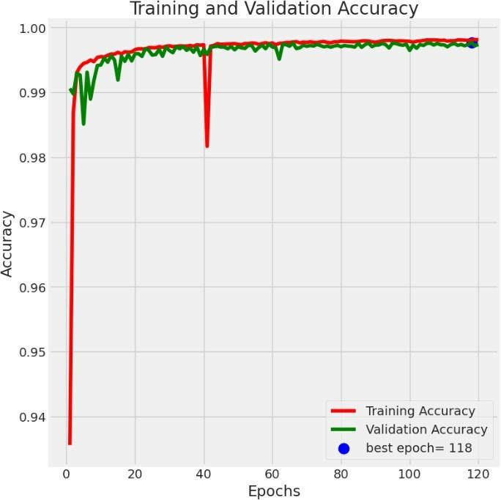

#### Figure:2 Training and validation Accuracy

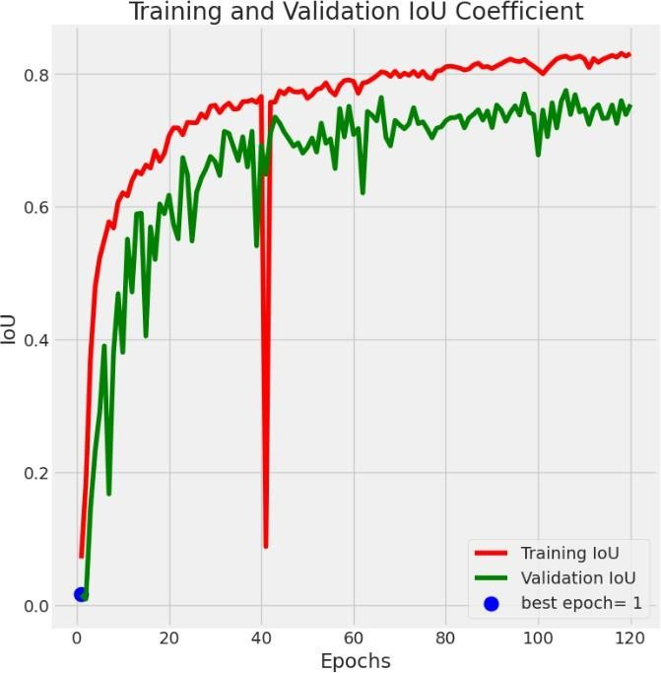

**Figure:3 Training and validation Iou Coefficient**

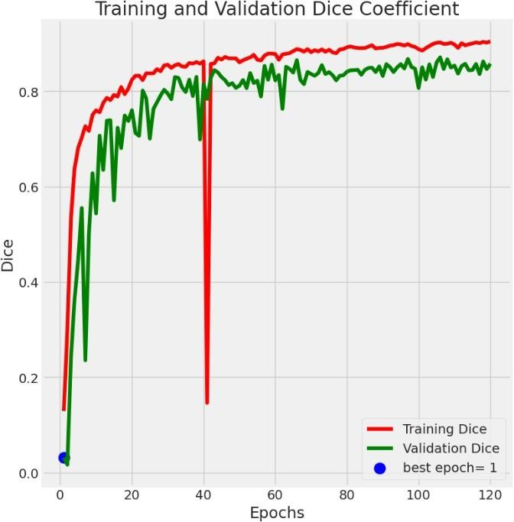

#### Figure:4 Training and validation Dice Coefficient

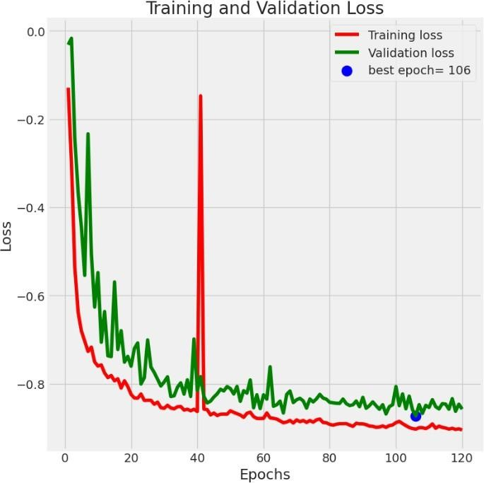

**Figure:5 Training and validation Loss**

**Table:1 Dice Score, IoU, and Accuracy Metrics.**

|  |  |  |  |
| --- | --- | --- | --- |
| **Dataset** | **Dice Score (Mean±Std)** | **IoU (Mean±Std)** | **Accuracy (Mean±Std)** |
| Train | 0.909±0.005 | 0.837±0.004 | 0.998±0.001 |
| Valid | 0.853±0.007 | 0.747±0.006 | 0.997±0.001 |
| Test | 0.897±0.004 | 0.815±0.003 | 0.998±0.001 |

**Model Output:**

The project's outcomes illustrate the effective training and assessment of the suggested model for medical picture segmentation. Over 120 epochs, the model demonstrated remarkable learning skills, with a final training accuracy of 99.81%. The negative training loss of -0.9047 demonstrates the effectiveness of the optimization approach. Notably, the IOU (Jaccard) coefficient and Dice coefficient were 0.8307 and 0.9046, respectively, demonstrating the model's exact

delineation of object boundaries. During validation on a second dataset, the model performed well, with a validation accuracy of 99.74%. The validation loss of -0.8575, the IOU coefficient of 0.7539, and the Dice coefficient of 0.8577 demonstrate the model's ability to generalize to previously unknown data. Note that the final metrics for the training, validation, and test sets demonstrate the model's consistent performance. The model had a final test accuracy of 99.79%, with a negative test loss of -0.8971. The IOU and Dice coefficients on the test set were 0.8151 and 0.8969, respectively. These findings demonstrate the proposed model's efficacy in effectively segmenting medical pictures, highlighting its potential for practical applications in the field of medical image analysis.

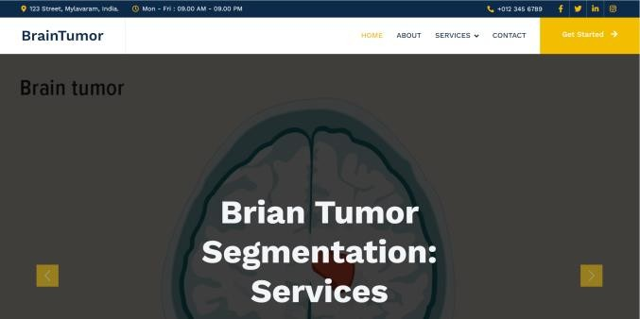

#### Figure:5 Web UI

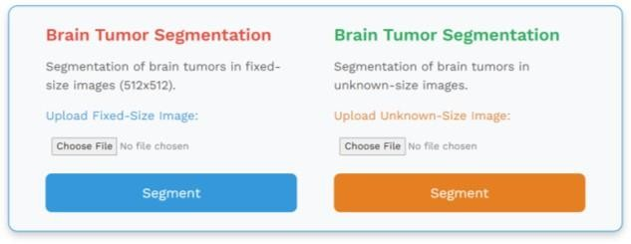

**Figure:6 Segmentation Interface**

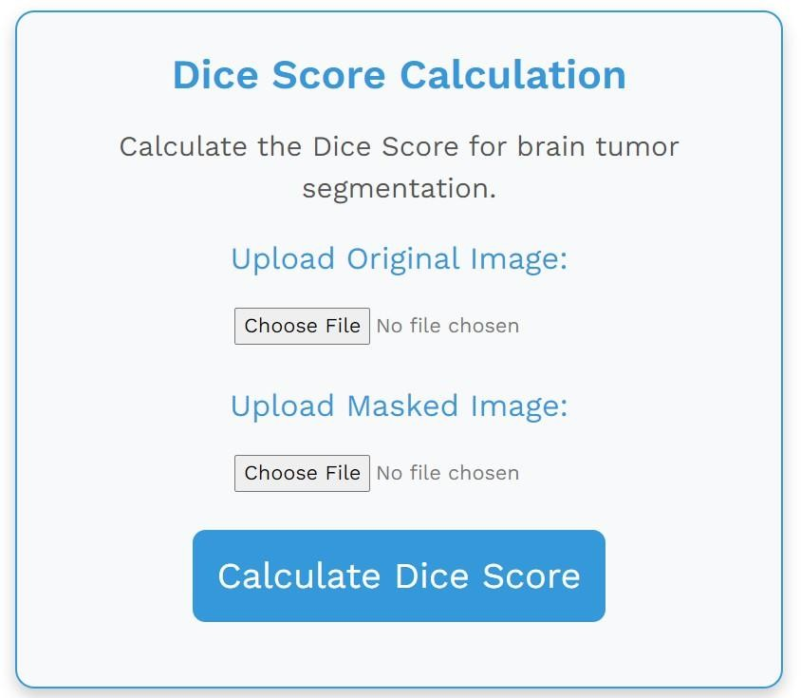

#### Figure:7 Dice Score Interface

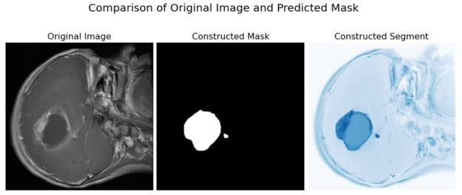

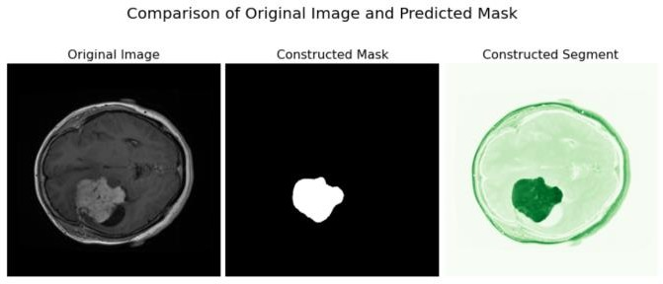**Figure:8 Result 1**

#### Figure:9 Result 2

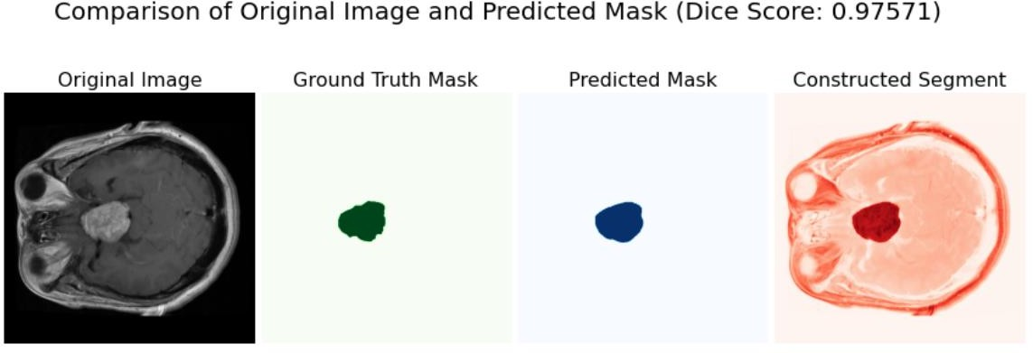**Figure:10 Result 3**

# CONCLUSION

#### Figure:11 Image Masking

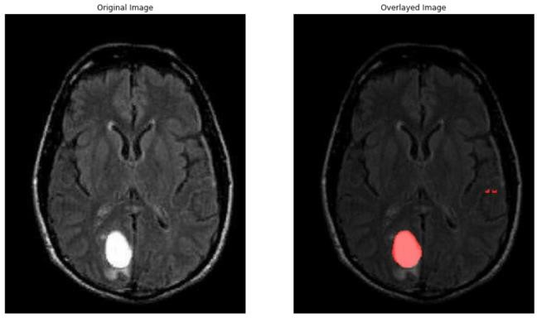

**Figure:11 Image Segmentation**

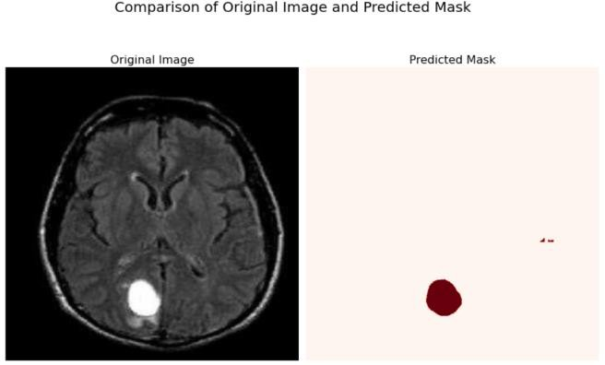**Figure:13**

**Dice Score Calculation**

### suggested technique, making a significant addition to the field of medical picture analysis.

**Conclusion:** To summarize, this research effort

### successfully used a U-Net architecture for medical picture segmentation, with good accuracy and performance metrics. The model's ability to reliably identify item boundaries in medical pictures has great potential for use in clinical diagnosis and therapy planning. The results demonstrate the efficacy of the

**Future Scope:** Looking forward, the future scope of this project encompasses several avenues for improvement and expansion. Further refinement of the model's performance through advanced pre- processing techniques, diverse augmentation

strategies, and the exploration of transfer learning can enhance its robustness and applicability across different medical imaging scenarios. Additionally, the integration of a larger and more diverse dataset, along with the implementation of ensemble methods, offers opportunities to improve segmentation accuracy and generalization. Collaboration with healthcare professionals for real-world validation and deployment is crucial to ensure the model's effectiveness in clinical settings, marking a key direction for future research in this domain.

# REFERENCES

1. Noori, Mehrdad, Ali Bahri, and Karim Mohammadi. "Attention-guided version of 2D UNet for automatic brain tumor segmentation." 2019 9th international conference on computer and knowledge engineering (ICCKE). IEEE, 2019.
2. Dong, Hao, et al. "Automatic brain tumor detection and segmentation using U-Net based fully convolutional networks." Medical Image Understanding and Analysis: 21st Annual Conference, MIUA 2017, Edinburgh, UK, July 11–13, 2017, Proceedings 21. Springer International Publishing, 2017.
3. Rehman, Mobeen Ur, et al. "Bu-net: Brain tumor segmentation using modified u-net architecture." Electronics 9.12 (2020): 2203.
4. Tuan, Tran Anh, Tran Anh Tuan, and Pham The Bao. "Brain tumor segmentation using bit-plane and UNET." Brainlesion: Glioma, Multiple Sclerosis, Stroke and Traumatic Brain Injuries: 4th International Workshop, BrainLes 2018, Held in Conjunction with MICCAI 2018, Granada, Spain, September 16, 2018, Revised Selected Papers, Part II 4. Springer International Publishing, 2019.
5. Aghalari, Motahareh, Ali Aghagolzadeh, and Mehdi Ezoji. "Brain tumor image segmentation via asymmetric/symmetric UNet based on two-pathway- residual blocks." Biomedical signal processing and control 69 (2021): 102841.
6. Ahmad, Parvez, et al. "Context aware 3D UNet for brain tumor segmentation." Brainlesion: Glioma, Multiple Sclerosis, Stroke and Traumatic Brain Injuries: 6th International Workshop, BrainLes 2020, Held in Conjunction with MICCAI 2020, Lima, Peru, October 4, 2020, Revised Selected Papers, Part I 6. Springer International Publishing, 2021.
7. Chen, Wei, et al. "S3D-UNet: separable 3D U-Net for brain tumor segmentation." Brainlesion: Glioma, Multiple Sclerosis, Stroke and Traumatic Brain Injuries: 4th International Workshop, BrainLes 2018, Held in Conjunction with MICCAI 2018, Granada, Spain, September 16, 2018, Revised Selected Papers, Part II 4.

Springer International Publishing, 2019.

1. Rahman, Md Monibor, et al. "Brain tumor segmentation using UNet-context encoding network." International MICCAI Brainlesion Workshop. Cham: Springer International Publishing, 2021.
2. Kermi, Adel, Issam Mahmoudi, and Mohamed Tarek Khadir. "Deep convolutional neural networks using U-Net for automatic brain tumor segmentation in multimodal MRI volumes." Brainlesion: Glioma, Multiple Sclerosis, Stroke and Traumatic Brain Injuries: 4th International Workshop, BrainLes 2018, Held in Conjunction with MICCAI 2018, Granada, Spain, September 16, 2018, Revised Selected Papers, Part II 4. Springer International Publishing, 2019.
3. Luu, Huan Minh, and Sung-Hong Park. "Extending nn-UNet for brain tumor segmentation." International MICCAI Brainlesion Workshop. Cham: Springer International Publishing, 2021.
4. Saha, Aheli, Yu-Dong Zhang, and Suresh Chandra Satapathy. "Brain tumour segmentation with a muti- pathway ResNet based UNet." Journal of Grid Computing 19 (2021): 1-10.
5. Cinar, Necip, Alper Ozcan, and Mehmet Kaya. "A hybrid DenseNet121-UNet model for brain tumor segmentation from MR Images." Biomedical Signal Processing and Control 76 (2022): 103647.
6. Pravitasari, Anindya Apriliyanti, et al. "UNet-VGG16 with transfer learning for MRI-based brain tumor segmentation." TELKOMNIKA (Telecommunication Computing Electronics and Control) 18.3 (2020): 1310- 1318.
7. Islam, Mobarakol, et al. "Brain tumor segmentation and survival prediction using 3D attention UNet." Brainlesion: Glioma, Multiple Sclerosis, Stroke and Traumatic Brain Injuries: 5th International Workshop, BrainLes 2019, Held in Conjunction with MICCAI 2019, Shenzhen, China, October 17, 2019, Revised Selected Papers, Part I 5. Springer International Publishing, 2020.
8. Ballestar, Laura Mora, and Veronica Vilaplana. "MRI brain tumor segmentation and uncertainty estimation using 3D-UNet architectures." International MICCAI Brainlesion Workshop. Cham: Springer International Publishing, 2020.
9. Latif, Urva, et al. "An end‐to‐end brain tumor segmentation system using multi‐inception‐UNET." International Journal of Imaging Systems and Technology 31.4 (2021): 1803-1816.
10. Agrawal, Pranjal, Nitish Katal, and Nishtha Hooda. "Segmentation and classification of brain tumor using 3D- UNet deep neural networks." International Journal of

Cognitive Computing in Engineering 3 (2022): 199-210.

1. Nawaz, Ali, et al. "VGG-UNET for brain tumor segmentation and ensemble model for survival prediction." 2021 International Conference on Robotics and Automation in Industry (ICRAI). IEEE, 2021.
2. Raina, Sneha, et al. "Brain tumor segmentation using Unet." Futuristic Trends in Network and Communication Technologies: Third International Conference, FTNCT 2020, Taganrog, Russia, October 14–16, 2020, Revised Selected Papers, Part I 3. Springer Singapore, 2021.
3. Daimary, Dinthisrang, et al. "Brain tumor segmentation from MRI images using hybrid convolutional neural networks." Procedia Computer Science 167 (2020): 2419-2428.
4. Aledhari, Mohammed, and Rehma Razzak. "An adaptive segmentation technique to detect brain tumors using 2D Unet." 2020 IEEE International Conference on bioinformatics and biomedicine (BIBM). IEEE, 2020.
5. Hu, He-Xuan, et al. "Multimodal brain tumor segmentation based on an intelligent UNET-LSTM algorithm in smart hospitals." ACM Transactions on Internet Technology 21.3 (2021): 1-14.
6. Abirami, M. S., et al. "Brain Tumor Segmentation in MRI Images Using UNet based 3D CNN." Annals of the Romanian Society for Cell Biology (2021): 325-335.
7. Vittikop, Bhargavi S., and Shrinivas R. Dhotre. "Automatic segmentation of MRI images for brain tumor using unet." 2019 1st International Conference on Advances in Information Technology (ICAIT). IEEE, 2019.
8. Maji, Dhiraj, Prarthana Sigedar, and Munendra Singh. "Attention Res-UNet with Guided Decoder for semantic segmentation of brain tumors." Biomedical Signal Processing and Control 71 (2022): 103077.