HealthCare
Sumit.S.Raskar  Information Technology  Met’s Institute of Technology Polytechnic, Bhujbal Knowledge City, Adgaon, Nashik, Maharashtra, India  email:raskarsumit159@gmail.com | Mohit.D.Khandale  Information Technology  Met’s Institute of Technology Polytechnic, Bhujbal Knowledge City, Adgaon, Nashik, Maharashtra, India  email:khandalemohit28@gmail.com | Arjun.B.Rakte  Information Technology  Met’s Institute of Technology Polytechnic, Bhujbal Knowledge City, Adgaon, Nashik, Maharashtra, India  email:arjunrakte3@gmail.com

Pallavi.M.Takate  Project Guide  Information Technology  Met’s Institute of Technology Polytechnic,  Bhujbal Knowledge City, Adgaon, Nashik, Maharashtra, India  email:pallavit_iot@bkc.met.edu | Sanjeev.B.Patil  HOD, Dept. of Information Technology  Met’s Institute of Technology Polytechnic,  Bhujbal Knowledge City, Adgaon, Nashik, Maharashtra, India  email:sanjeevp_iot@bkc.met.edu

Abstract- Patients of Shrewd Healthcare Frameworks have get to to their therapeutic records through an online entry. Due to the truth that patients do not need their names made open, keeping up information protection and security is basic to the victory of the association. Clients are required to yield individual data to an verification server some time recently they can continue with the login prepare. The data incorporates a login ID as well as a secret word. It is conceivable that the patient's enemies will be able to abuse their right to protection if they are able to keep an eye on the persistent or get in touch with them. Subsequently, in this body of work, we recommend a procedure to ensure the security of patients and the privacy of their restorative data from perils postured by the Authorization Benefit and other parties. In the course of this investigate, we used a strategy known as camel-based turning board signature. This was done not just to secure the patients' protection but moreover to secure the arrange itself from potential dangers. The hypothetical examination of the execution of the computer program uncovered various layers of security that are able to withstand a wide assortment of diverse sorts of assaults.
Keyword: HealthCare, Doctors, Book Appointment.
1. INTRODUCTION

In today's rapidly evolving world, healthcare stands at the forefront of technological innovation. With the advent of digital solutions, the landscape of healthcare delivery is undergoing a profound transformation. In this era of interconnectedness and data-driven decision-making, healthcare applications emerge as indispensable tools in enhancing patient care, streamlining processes, and empowering both patients and healthcare professionals. Our healthcare application represents a pioneering endeavor to leverage technology for the betterment of healthcare delivery. By seamlessly integrating various facets of healthcare into a userfriendly platform, we aim to revolutionize the way individuals engage with their health and interact with healthcare providers. With our application, users gain access to a comprehensive suite of features designed to address their diverse healthcare needs. From scheduling appointments and managing medical records to receiving personalized health recommendations and monitoring vital signs, our platform offers a holistic approach to healthcare management. Moreover, our application fosters collaboration and communication between patients and healthcare providers, promoting a more patient-centric model of care delivery. In an era where convenience, accessibility, and efficiency are paramount, our healthcare application serves as a beacon of innovation. By harnessing the power of technology, we aspire to empower individuals to take control of their health journey and foster a healthier, more connected society. Join us as we embark on this transformative journey towards a future where healthcare is not just a service, but a seamless, personalized experience tailored to individual needs and preferences. Together, let us redefine the boundaries of possibility and usher in a new era of healthcare excellence.

2. Literature Review

Dialect is fundamental for interfacing with individuals from all over the world, and being able to talk more than one dialect makes a difference us communicate more viably and express ourselves. So, my address is; are we being instructed sufficient around dialect in school?

In Norwegian schools, English classes ordinarily start in the to begin with review, and by the time understudies reach eighth review, most understudies can both type in and talk English well. Moreover, when coming to eighth review, understudies can select another dialect to think about, such as German, French, or Spanish. This presentation to different dialects permits understudies to create a broader understanding of diverse societies and points of view. Despite the endeavors made in dialect instruction, there are occurrences when we discover ourselves battling to communicate with individuals in other nations, expecting that everybody talks English. These encounters serve as a update of the benefit of being multilingual and highlight the significance of dialect instruction in schools. We too know that investigate has appeared that people learn best in their early a long time, so this contention focuses to the significance of beginning to prioritize dialect in school early. In conclusion, The Norwegian school framework offers their understudies assets they require to think about dialects. In any case, there is continuously room for enhancement. By putting more prominent center on dialect instruction and creating an indeed more strong learning environment, the school framework can enchase one’s etymological abilities indeed more.

3. Methodology

1. Android

Android is a Linux based working framework it is planned fundamentally for touch screens versatile gadgets such as smartphones and tablet computers. The working framework has created a parcel in the final 15 a long time beginning from dark and white phones to later smartphones or smaller than expected computers. One of the most broadly utilized portable OS these days is android. The android is program that was established in Palo Alto of California in 2003. Android is a capable working framework and it bolsters a expansive number of applications in Smartphones. These applications are more comfortable and progressed for clients. The android is an opensource working framework that implies that it’s free and anybody can utilize it. The android has got millions of apps accessible that can offer assistance you oversee your life. Android improvement bolsters the full java programming dialect. The most recent upgraded form is a Android.

2. Methodology for Developing a Healthcare Application:

Prerequisite Analysis: Conduct comprehensive partner interviews with healthcare suppliers, chairmen, and patients to get it their needs and torment points. Define useful and non-functional necessities, considering administrative compliance, security, convenience, and scalability. User-Centered Design: Utilize standards of human-computer interaction (HCI) to plan natural client interfacing that cater to the differing needs of patients and healthcare professionals. Develop client personas and client travel maps to direct the plan prepare and guarantee a user-centric approach. Agile Development: Adopt an Spry technique such as Scrum or Kanban to iteratively create and convey highlights in brief cycles. Prioritize highlights based on partner input, advertise patterns, and trade esteem to maximize the application's impact. Prototyping and Iterative Testing: Create intuitively models of key workflows and functionalities to assemble early input from stakeholders. Conduct convenience testing sessions with agent clients to distinguish ease of use issues and refine the plan iteratively. Modular Development: Break down the application into secluded components that can be created and tried independently. Use persistent integration and persistent sending (CI/CD) pipelines to computerize the construct, test, and arrangement processes. Security and Compliance: Implement security best hones such as input approval, verification, authorization, encryption, and review logging to secure delicate persistent data. Conduct standard security evaluations and compliance reviews to guarantee adherence to administrative benchmarks such as HIPAA, GDPR, and HITECH. Interoperability and Integration: Design the application with interoperability in intellect, utilizing measures like HL7 FHIR to encourage consistent integration with outside healthcare frameworks and devices. Develop vigorous APIs and web administrations to empower information trade with electronic therapeutic record (EMR) frameworks, research facility data frameworks (LIS), drug store frameworks, and other healthcare IT solutions. Quality Affirmation and Testing: Perform comprehensive testing, counting unit testing, integration testing, relapse testing, and execution testing, to guarantee the unwavering quality, adaptability, and execution of the application. Use mechanized testing instruments and systems to streamline the testing prepare and recognize absconds early in the improvement lifecycle. Training and Documentation: Provide comprehensive preparing materials and documentation for healthcare suppliers, directors, and patients to onboard them viably onto the application. Offer continuous bolster and preparing sessions to address any questions or issues that emerge post-launch. Gather criticism from clients through studies, analytics, and back channels to distinguish regions for improvement.

3. Firebase Database

Firebase gives devices for following analytics, announcing and settling app crashes, making promoting and item explore. Firebase offers a number of administrations, counting: Analytics Google Analytics for Firebase offers free, boundless announcing on as numerous as 500 partitioned even.

4. ER-Model

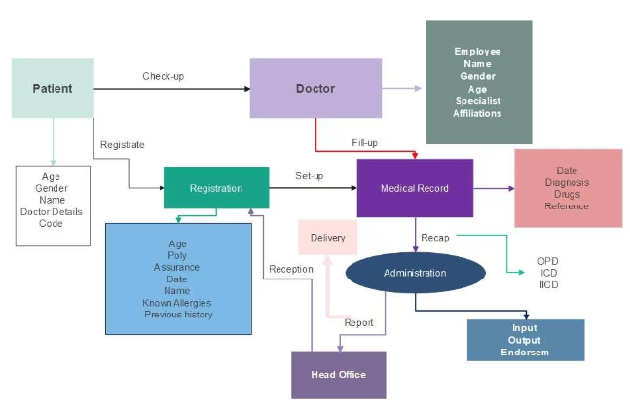

4.Results
Client Engagement: The number of dynamic clients, recurrence of utilization, and client input can show how well-received the application is among its aiming audience.
Health Results: For healthcare applications centered on overseeing inveterate conditions or advancing wellness, changes in wellbeing results such as diminished side effects, way better administration of conditions, or progressed generally wellbeing measurements among clients would be a key degree of success.
Cost Reserve funds: If the application points to diminish healthcare costs by advancing preventative care or making strides treatment adherence, the monetary affect, such as diminished healing center affirmations or medicine costs, would be an vital metric.

5. Future Scope
Remote Patient Monitoring: Healthcare apps can enable real-time monitoring of patients' health conditions from remote locations, allowing for timely interventions and reducing the need for in-person visits.
Telemedicine: Telemedicine apps facilitate virtual consultations between patients and healthcare providers, improving access to healthcare services, especially in rural or underserved areas.
Personalized Medicine: Healthcare apps can leverage data analytics and machine learning to provide personalized treatment plans based on an individual's genetic makeup, lifestyle, and health history.
Health and Fitness Tracking: Apps that track users' physical activity, diet, and vital signs can help promote healthier lifestyles and prevent chronic diseases.
Medical Education and Training: Healthcare apps can be used for medical education, training healthcare professionals, and providing information to patients about their conditions and treatments.
Healthcare Data Management: Apps that securely store and manage healthcare data can improve the efficiency of healthcare delivery and ensure better coordination among healthcare providers.
Wearable Health Technology: Integration with wearable devices can provide continuous monitoring of health metrics, enabling early detection of health issues and proactive interventions.
Healthcare Blockchain Applications: Blockchain technology can be used to securely store and share healthcare data, ensuring patient privacy and data integrity.

6. Output

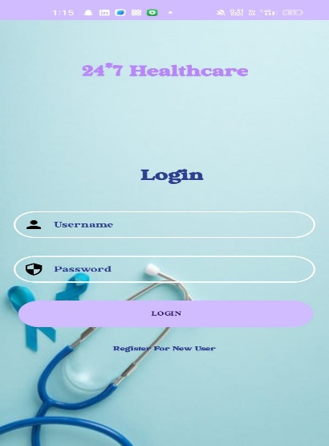

7. CONCLUSION
In conclusion, healthcare applications have a promising future, poised to revolutionize the way healthcare is delivered and accessed. Through remote patient monitoring, telemedicine, personalized medicine, health and fitness tracking, medical education, and data management, these applications have the potential to improve patient outcomes, increase access to healthcare services, and enhance the efficiency of healthcare delivery. Integration with wearable devices and blockchain technology further expands the scope of these applications, enabling continuous monitoring of health metrics and ensuring the security and privacy of healthcare data. As technology continues to advance, healthcare applications will play an increasingly important role in transforming the healthcare industry and improving the quality of care for patients worldwide.

- REFERENCES
- Bashshur, R. L., Shannon, G. W., & Krupinski, E. A. (2016). The taxonomy of telemedicine. Telemedicine and e-Health, 22(8), 609-613.

- Goldsack, J. C., Coravos, A., Bakker, J. P., Bent, B., Dowling, A. V., Fitzer-Attas, C., ... & Chodakewitz, J. (2019). Verification, analytical validation, and clinical validation (V3): the foundation of determining fit-for-purpose for Biometric Monitoring Technologies (BioMeTs). npj Digital Medicine, 2(1), 1-10.

- Gopal, R., Krishna, R. B., Aarthi, N., & Sridhar, S. (2021). A survey on wearable health monitoring systems for COVID-19. Journal of Ambient Intelligence and Humanized Computing, 1-16.

- Hollander, J. E., & Carr, B. G. (2020). Virtually perfect? Telemedicine for Covid-19. New England Journal of Medicine, 382(18), 1679-1681.

- Patel, M. S., Asch, D. A., & Volpp, K. G. (2015). Wearable devices as facilitators, not drivers, of health behavior change. JAMA, 313(5), 459-460.

- Steinhubl, S. R., & Topol, E. J. (2019). Digital medicine, on its way to being just plain medicine. npj Digital Medicine, 2(1), 1-3.

- Topol, E. (2012). The creative destruction of medicine: How the digital revolution will create better health care. Basic Books.

- World Health Organization. (2019). WHO guideline recommendations on digital interventions for health system strengthening. World Health Organization.

