POWER GENERATION AND STORAGE THROUGH WATER PIPES

**Mathews K Reji1, Meenakshi Shylesh2, Maneul Benny3, Dr.Godwinraj D 4, Ranjitha Rajan 5**

1,2,3Students, Electronics & Communication Engineering, Amal Jyothi College of Engineering, India.

## 4Associate Professor, Electronics & Communication Engineering, Amal Jyothi College of Engineering, India...

## 5Assistant Professor, Electronics & Communication Engineering, Amal Jyothi College of Engineering, India...

**ABSTRACT**

This research dives into the novel idea of using water pipes not just to transport water, but also to generate power and store energy. Water pipes, which are ubiquitous in both urban and rural environments, have intrinsic potential as conduits for generating renewable energy. By strategically placing turbines along the pipeline route, we can harness the kinetic energy of flowing water and the hydraulic pressure generated within the pipes to generate electricity. These turbines, which are adapted to the pipeline's individual features, efficiently transform the mechanical energy of water flow into electrical energy, so contributing to renewable energy generation without requiring extra infrastructure. The developed system is an inline hydropower generator intended for tiny pipelines (0.5 to 1 inch).It has a charging circuit to store the electricity produced into battery cells and a turbine that rotates in response to the flowing water in these pipelines to produce energy. The turbine's rotation will increase as the water flow increases, which will increase the amount of energy produced. In order to overcome the intermittent nature of renewable energy sources and maximize energy consumption, the project also investigates the integration of energy storage systems into water pipes. One way to store excess energy during times of low electricity demand or excess renewable energy generation is to include various storage technologies, like flow batteries or pumped hydro storage, into the pipeline infrastructure.

Keywords: Stepper Motor, DC to DC booster circuit, Lithium ion battery, TP4056 module

**1. INTRODUCTION**

Exploiting the inherent energy in water pipelines offers a possible path to sustainable power generation. Even in the home, renewable energy sources are widely available. Renewable energy sources include energy from the sun, wind, water, and other sources. The utilization of this renewable energy source is still not ideal, though. The need to continue using fossil fuels is still great. The world is reportedly facing an energy crisis at the end of 2021 as a result of a shortage of fossil fuels including coal and natural gas [1]. Renewable energy sources can be used on a large or small scale, even within a family. Harvesting energy from adjacent houses is another name for using renewable energy sources around the house. By employing different kinds of generators that are tailored to each of these energy sources, electrical energy can be produced from existing energy sources. Each generator produces its own electrical energy, which is subsequently processed by power electronics equipment to enable battery charging or storage or direct use in powering domestic appliances [2]. The flow of water in residential plumbing systems is one potential source of water energy. There has already been research on producing electricity from the in-pipe water flow of residential plumbing systems [3]. According to earlier studies, a generator utilizing that type of water energy source can produce up to 3.25 watts of electricity. The generator utilized in that study is a small, readily available 12V 10W turbine generator that works well with 1/2-inch tubing.

This research intends to capture the kinetic energy of flowing water by strategically placing turbine devices into water pipelines. We want to design and deploy turbine-generator systems that are optimized for efficient energy extraction by taking use of the pressure generated during water transportation. With an emphasis on areas with high water demand and tall water towers, we hope to enhance electricity output by utilizing the gravitational potential energy stored in elevated water sources. By adapting turbine designs to specific pipeline specifications and flow rates, we hope to improve energy conversion and overall power generating capabilities. Typically, in the arrangement for producing and storing power from water pipes, a turbine or generator is located within the pipeline. Their principal function is to capture the kinetic energy of the flowing water. This energy is harnessed and then turned into mechanical energy. This conversion process is aided by a mechanical energy converter, which converts the kinetic energy obtained from the turbine or generator into electrical energy. As a result, this electrical energy becomes available for immediate use, such as immediately powering equipment, or it can be stored in batteries for later use or backup. In essence, the whole system works by using the movement of water to generate power, offering a renewable and sustainable supply of power.

Two things are necessary for this project to succeed: an affordable generator and an appropriate turbine. The turbine is an essential component because it transforms the energy of the flowing water into mechanical energy. The generator, which is attached to the turbine, is then responsible for converting this mechanical energy into electrical energy, which is the main objective of the system. [4] centers on the examination and enhancement of small-scale hydroelectric generators in water supply networks. The design, effectiveness, and possible advancements of generators used to capture hydropower from water supply systems are probably the subjects of the research. This could entail improving energy conversion efficiency, optimizing generator layouts, and taking into account the environmental effects of such systems. It's important to remember that there are several kinds of turbines, each designed to meet particular needs and circumstances. Thus, choosing the appropriate kind of turbine is essential to guaranteeing the efficacy and efficiency of the system as a whole. This meticulous selection guarantees that the turbine can efficiently capture the energy from the water flow, maximizing the power production setup's total performance. [5] is centered on using spherical turbines to capture hydroelectric power. These turbines are made to effectively harness the energy of flowing water in a variety of settings. The goal of using this technology is to produce electricity in a sustainable way, providing viable options for the generation of renewable energy. The strategy might have an impact on improving energy efficiency and lowering dependency on conventional fossil fuels. We can lessen the burden on the current power infrastructure, lowering pollution and energy prices while creating new revenue streams, by using this underutilized renewable energy source. The goal of this research is to not only show that using water pipeline energy is technically feasible, but also to open the door for a wider use of this novel method of producing renewable energy. We seek to verify the viability and efficacy of our design concept by building small-scale functional prototypes and doing extensive testing, ultimately advancing sustainable energy solutions for communities across the globe.

**1.1. PROBLEM STATEMENT**

Conventional water pipes may be doing more. They aren't just for carrying water. What if these pipes could be used as energy storage and generation devices? That is the premise behind this research. We're researching whether it's conceivable and practicable to place technology in water pipes that generates electricity from the flow of water and stores any excess energy for later use. By using this untapped energy source, we want to improve the efficiency and environmental friendliness of our water systems. There are obstacles to be addressed, too, such as ensuring that this technology is both economical and ecologically friendly and working out how to integrate it into the current infrastructure. The goal of this project is to investigate these issues and identify potential game-changing remedies

**2. LITERATURE SURVEY**

In the paper [6] that has been referred, "Small Hydro Power for Water Pipeline Systems" by Bhadani, R., Bajracharya, R.” examines the viability and possible advantages of integrating tiny hydro power units into the architecture of water pipelines. It could go over practical consequences for the production of renewable energy as well as technical issues like turbine designs and integration techniques. In the paper [7] that has been referred,” Energy Recovery from Water Supply Pipeline Systems" by Ghimire, G. P., & Karki, R. M” examines techniques and innovations for reclaiming energy from pipeline systems used for water supply. This could involve methods like harnessing the energy of flowing water to create electricity through the use of turbines or other equipment. Energy recovery systems in water pipes may be reviewed for their viability, effectiveness, and possible advantages. Their implications for sustainability and the production of renewable energy may also be examined. In the paper [8] that has been referred, “Experimental and Numerical Investigation of Water Pipeline Turbines for Power Generation" by Thapa, B., & Schneider, J. M.” it seems like the paper discusses results from numerical simulations and experiments that looked into how well water pipeline turbines worked as power generators. Comparisons between computer models and experimental data, as well as insights into turbine design, efficiency, and energy output, may be included in the review. In the paper [9] that has been referred, "Turbine Design and Its Impact on Energy Harvesting from In-Pipe Hydro Systems by Hani Muhsen, Mariam Ibrahim, Ahmad alsheikh, Mohammed Qanadilo, and Abdallah Karadsheh,” investigates the impact of turbine design on the efficacy and efficiency of in-pipe hydro system energy harvesting. In-pipe hydro systems use the flow of water within pipelines to generate energy. The assessment may address a number of turbine design factors, such as the size, shape, and orientation of the blades and how these affect power output and energy conversion efficiency. The essay may also cover technological developments and optimization techniques meant to improve the efficiency of in-pipe hydro systems for the production of renewable energy. In the paper [10] that has been referred, "Analysis and Design of Water Pipelines for Power Generation" by Sonawane, H. G., et al.”

provides a thorough examination of the potential and technical issues of using water pipelines to generate power. The research explores the examination of several design factors, such as structural integrity, fluid dynamics, and efficiency optimization. Through the incorporation of engineering principles and renewable energy goals, the writers offer significant perspectives on the practicability and enhancement of pipeline hydropower extraction. Researchers, engineers, and legislators interested in promoting sustainable energy solutions through creative use of infrastructure will find this work to be a useful resource. In the paper [11] that has been referred, “Power Generation from Water in Pipeline through Hydro Generator" by Avdhoot Sunil Kulkarni, Prof R. S. Ambekar” investigates the possibility of employing hydro generators to create power from the movement of water through pipelines. Hydro generators are machines that create electrical energy from the kinetic energy of flowing water. The design and operation of hydro generators, the effectiveness of energy conversion, and the general viability and sustainability of using water pipes for the production of electricity are just a few of the components of the power generation process that may be included in this assessment. The essay may also go into the advantages and disadvantages of this renewable energy source for the environment, as well as possible uses in both rural and urban infrastructure. In the paper [12] that has been referred, "In-pipe Turbines for Power Generation in Water Distribution Networks" by Santagata, M., et al” investigates the possibility of using in-pipe turbines to generate electricity inside water distribution networks. In order to capture energy from flowing water, the study looks into the performance, viability, and difficulties of inserting turbines into already-existing pipes. Through their examination of real-world case studies and technical issues, the authors provide insightful information about how to optimize and apply this renewable energy technology. By utilizing the infrastructure of water distribution networks for electricity generation, their study advances sustainable energy options. In the paper [13] that has been referred, “Using Water Energy for Electrical Energy Conservation by Building of Micro hydroelectric Generators on The Water Pipelines That Depend on The Difference in Elevation by Engineer Mohammed Taih Gatte, Engineer Rasim Azeez Kadhim, Engineer Farhan Leftah Rasheed” suggests a workable method for utilizing water energy to save electricity. The study intends to make use of existing infrastructure for renewable energy generation by mounting micro hydropower generators on water pipelines that take advantage of elevation variations. This creative idea promotes sustainability and energy conservation in addition to providing the possibility for decentralized power generation. The study emphasizes how crucial it is to investigate a variety of renewable energy sources in order to reduce environmental effect and improve energy resiliency. In the paper [14] that has been referred, “Screw Turbine in In-pipe Hydroelectric Power Generation Rizki Nurilyas Ahmad, Dimas Lugia Hardianto , Abimanyu Abimanyu , and Laili Etika Rahmawati” examines the performance and practicality of screw turbines for the generation of hydroelectric power inside pipes. The goal of the research is to maximize energy extraction from flowing water in pipelines by concentrating on this novel turbine design. The writers examine the screw turbine's efficiency, practical use, and technical details, offering insightful analysis of the device's potential as a renewable energy source. Their research advances the subject of in-pipe hydroelectric power generation and presents encouraging opportunities for the use of current water infrastructure to provide sustainable energy. In the paper [15] that has been referred, "A Review on Micro-Hydro Power Generation from Water Pipelines" by Bhattarai, R., & Shrestha, P” gives a thorough rundown of methods for producing micro-hydro power that are suited for water pipelines. The review summarizes the body of research on the subject, emphasizing important techniques, difficulties, and prospects related to pipeline energy harvesting. For academics, engineers, and politicians interested in advancing micro-hydro power generation from water pipelines, the authors provide insightful analysis by methodically examining numerous factors, including turbine designs, installation methodologies, and efficiency optimization strategies. Understanding the most recent methods and directing further research in this area are made easier with the help of this review.

**3. BLOCK DIAGRAM**

The accompanying block diagrams depict the entire process of power generation and storage via water pipelines. The system consists of numerous hardware components, such as a stepper motor. DC-DC booster circuit, Lithium-ion battery, TP4056 module, 1N4148 diode, capacitor, and LED bulb. The separate gadgets were assembled and observed to be operating efficiently.

Water turbine installation

Stepper motor

Bridge Rectifier circuit

DC to DC booster circuit

Lithium ion battery

Fig1. Block diagram for the proposed system

### 4. CIRCUIT DIAGRAM

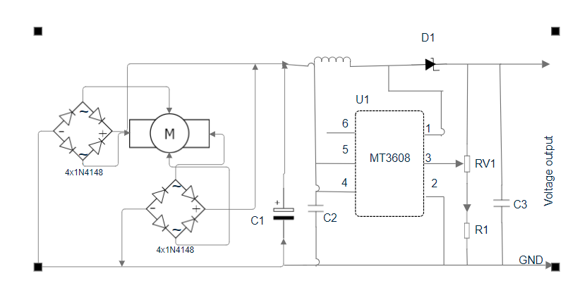

Fig2. Showing the circuit diagram of the proposed system

**5. TURBINE DESIGN-3D PRINTING**

In this section, three-bladed turbines with an adequate angle of attack are designed using SolidWorks, and they appear to be more efficient than other turbine designs. The purpose of the spherical turbine is to rotate transversely inside a cylindrical pipe that is connected to a generator. In one version, the spherical turbine's blades curve in a plane at an inclined angle to a central shaft's rotational axis, roughly forming a 180-degree arc.

SolidWorks software was used to create the turbine blades, which were then 3D-printed layer by layer utilizing technology. The 3D printing procedure utilized Poly Lactic Acid (PLA), an organic substance composed primarily of sugarcane and corn-starch. We chose this material for its safety, convenience of usage, and flawless finish. Furthermore, ABA and carbon fibre can be used for 3D printing, but because of their biodegradability, PLA is considered more environmentally friendly than ABS, which is not biodegradable and typically requires chemical recycling processes that can be energy-intensive and potentially harmful to the environment, and their production frequently involves the use of petroleum-derived materials, contributing to carbon emissions.   
Carbon fiber is not intrinsically hazardous to the environment, but its manufacturing requires energy-intensive methods and the usage of petroleum-based precursors. Carbon fiber's environmental impact is mostly determined by production processes, recycling capabilities, and end-of-life disposal alternatives. In general, PLA is regarded the most environmentally friendly alternative among PLA, ABS, and carbon fiber because of its biodegradability and renewable sourcing.

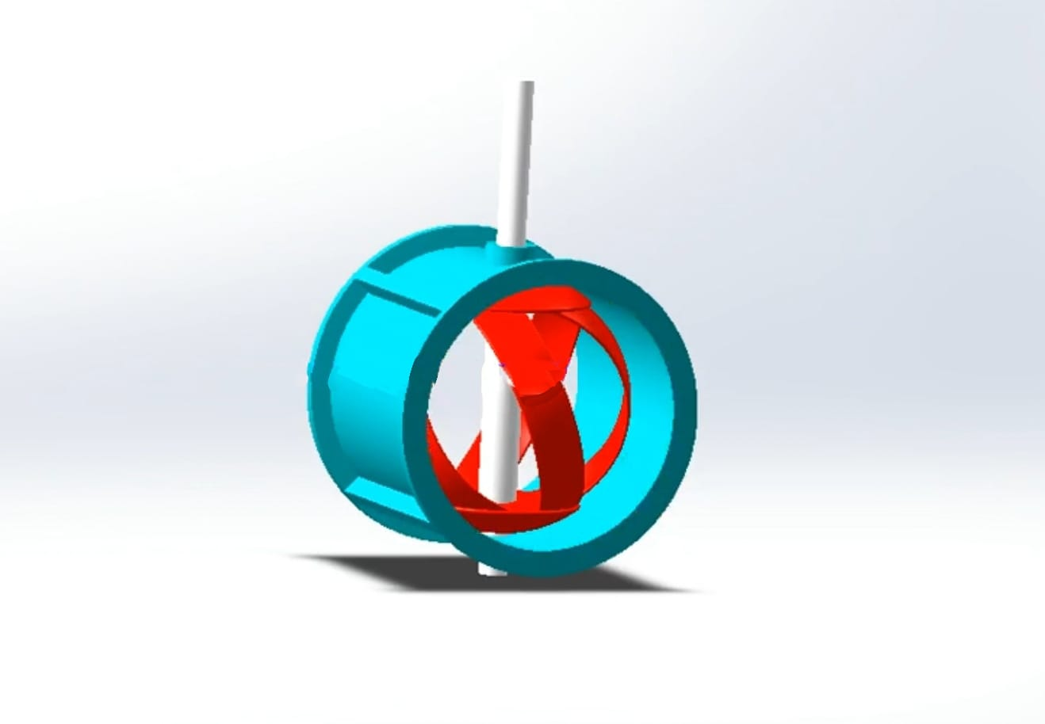

Fig3. 3D printed sample model of turbine

**6. CONCLUSION**

Water pipelines are a promising method for producing and storing renewable energy. It is doable and has little effect on the environment because it uses the current infrastructure. Reliability is increased by storage system integration. Technological developments increase productivity, providing advantages for the economy and contributing to environmental conservation. Policies that provide support are essential for broad adoption. To put it shortly, there is a lot of promise for sustainable and renewable energy generation and storage with this strategy.

**7. REFRENCES**

[1] T. F. Arbar. Krisis Energi Hantam Dunia, Ramai-ramai 'Berebut' Batu Bara? 2021 October 4th [cited 2021 November 15th]; Available from: <https://www.cnbcindonesia.com/news/20211004080800-4-281092/krisis-energi-hantam-dunia-ramai-ramai-berebut-batu-bara>

[2] T. Taufik, “The DC House Project: An Alternate Solution for Rural Electrification,” IEEE Glob. Humanit. Technol. Conf. (GHTC 2014), 2014, pp. 174–179

[3] R.N. Ahmad. Topologi dan Kajian Kinerja Multi Konverter Arus Searah untuk Multi Mini Generator-Hidro, in Teknik Elektro. Universitas Diponegoro: Semaran (2021)

[4] Guilherme A. Caxaria1, Duarte de Mesquita e Sousa, Helena M. Ramos, Small scale hydropower: generator analysis and optimization for water supply systems, 2011.

[5] In-Line Water Power Generation Using Spherical Turbine, developed by Dipali Tathe, Volume 8, 2021.

[6] Small Hydro Power for Water Pipeline Systems" by Bhadani, R.,Bajracharya, R.

[7] Energy Recovery from Water Supply Pipeline Systems" by Ghimire, G. P., & Karki, R. M

[8] Experimental and Numerical Investigation of Water Pipeline Turbines for Power Generation" by Thapa, B., & Schneider, J. M

[9] Turbine Design and Its Impact on Energy Harvesting from In-Pipe Hydro Systems by Hani Muhsen,Mariam Ibrahim, Ahmad alsheikh, Mohammed Qanadilo, and Abdallah Karadsheh

[10] Analysis and Design of Water Pipelines for Power Generation" by Sonawane, H. G., et al.

[11] Power Generation from Water in Pipeline through Hydro Generator" by Avdhoot Sunil Kulkarni, Prof R. S. Ambekar, 2021

[12] In-pipe Turbines for Power Generation in Water Distribution Networks" by Santagata, M., et al.

[13] Using Water Energy for Electrical Energy Conservation by Building of Micro hydroelectric Generators on The Water Pipelines That Depend on The Difference in Elevation by Engineer Mohammed Taih Gatte, Engineer Rasim Azeez Kadhim, Engineer Farhan Leftah Rasheed, 2010.

[14] Screw Turbine in In-pipe Hydroelectric Power Generation Rizki Nurilyas Ahmad , Dimas Lugia Hardianto , Abimanyu Abimanyu , and Laili Etika Rahmawati, 2022.

[15] A Review on Micro-Hydro Power Generation from Water Pipelines" by Bhattarai, R., & Shrestha, P.