AUTOMATIC SOLAR PANEL TILTING SYSTEM

# Neha Mariya Tomy1, Nidha Susan Mathew2, Nirald Lansan3 Godwinraj D4,Ranjitha Rajan5

## 1,2,3,4Students, Electronics & Communication Engineering, Amal Jyothi College of Engineering, Kottayam, India.

5Associate Professor,6Assistant Professor, Electronics &Communication Engineering, Amal Jyothi College of Engineering, India.

# ABSTRACT

The goal of our project is to increase solar panel efficiency. We aim to develop an automated solar panel tilting mechanism that uses a stepper motor to modify the panel's orientation in response to varying solar radiation levels. The mechanical structure that will enable the solar panel to tilt and the microcontroller such as an Arduino that will precisely manage the system based on input parameters like sunlight angle or time of day are what we have built to do this. To guarantee precise panel orientation, our team is creating algorithms for the best solar monitoring and putting safety precautions in place to avoid any mishaps. For even more ease, the system can be watched over remotely. We are increasing the efficiency of solar energy harvesting by combining all of these elements, which will eventually lead to a more sustainable future.

**Keywords:** Arduino UNO, Stepper motor, Solar panel, Gear

# 1. INTRODUCTION

Solar tracking is a technique used to keep solar collectors, like Photovoltaic (PV) or photothermal systems, perpendicular to the sun's radiation throughout the daylight hours. This increases the energy collected and ensures maximum solar irradiation. A solar tracking system is a mechanism designed to align solar panels or solar collectors toward the sun to optimize their energy output. The primary goal of a solar tracking system is to increase the efficiency of solar energy capture by ensuring that the panels are always facing the sun as it moves across the sky during the day. There are various types of solar tracking systems. Single-axis tracking systems move the solar panels along one axis either horizontally or vertically to track the sun's daily east-to-west path across the sky. Dual-axis tracking systems move the solar panels along two axes, usually both horizontally and vertically, enabling them to follow both the sun's daily path and its seasonal variations. Active tracking systems employ motors and sensors to continuously adjust the position of the solar panels based on the sun's position throughout the day. Passive tracking systems, on the other hand, use mechanical designs that automatically adjust the position of the solar panels in response to changes in temperature or sunlight intensity, without the need for motors or sensors. While solar tracking systems can significantly increase the energy output of solar installations, particularly in areas with high solar resource availability, they also add complexity and cost to the system. Therefore, their suitability depends on several factors, such as available space, budget, and desired level of energy production efficiency. In this project, we designed gear shafts with specific shapes and functions. We created a half-shaped gear shaft that is connected behind the solar panel and a rotating gear shaft that is connected to a stepper motor. When the motor is activated, it causes the gear shaft to rotate. As a result, the half-shaped gear shaft also starts to rotate since the two gears are linked to each other. This mechanism allows for the efficient transfer of energy and is a crucial part of the overall project design. Gear shaft mechanisms are commonly used in solar tracking systems to facilitate the movement of solar panels or collectors. These mechanisms offer numerous advantages, including Reliability: Gear shaft mechanisms are renowned for their reliability and durability. They can withstand harsh weather conditions and continuous operation over long periods without significant wear or maintenance issues. Precision: Gear shaft mechanisms provide precise control over the movement of solar panels, allowing for accurate tracking of the sun's position throughout the day. This precision ensures optimal solar energy capture, maximizing the efficiency of the solar system. Mechanical Advantage: Gears provide a mechanical advantage, allowing for smooth and efficient movement of heavy solar panels or arrays. This mechanical advantage reduces the energy required for tracking, making the system more energy-efficient overall. Versatility: Gear shaft mechanisms can be adapted to different types of solar tracking systems, including single-axis and dual-axis trackers. They can also be scaled to accommodate various sizes of solar installations, from small residential setups to large utility-scale arrays. Cost-effectiveness: Although gear shaft mechanisms may have higher upfront costs compared to some other tracking systems, they offer long-term cost savings through their reliability and efficiency. They typically require minimal maintenance and have a long service life, resulting in lower lifecycle costs. Adaptability: Gear shaft mechanisms can be integrated with various types of drive systems, including electric motors, hydraulic actuators, or even manual cranks. This adaptability allows for flexibility in design and implementation, catering to different site-specific requirements and preferences. Overall, the use of gear shaft mechanisms in solar tracking systems contributes to increased energy production, improved reliability, and enhanced performance, making them a popular choice for many solar installations.

### PROBLEM STATEMENT

To generate the maximum amount of energy, solar energy systems require optimal sunlight direction. However, solar planters face several challenges related to sunlight direction that can affect energy production.

• One of the major challenges is suboptimal energy production, which occurs when solar panels are not oriented correctly to capture sunlight effectively. To maximize exposure to sunlight throughout the day, solar panels should ideally face south in the Northern Hemisphere and north in the Southern Hemisphere.

• Shading is another key issue that can reduce energy production. Even partial shading on a solar panel array can significantly diminish overall output. Careful site selection and regular maintenance to mitigate shading issues are therefore essential for maximizing energy production.

• Variation in sunlight angle is also a challenge that solar planters face. The angle of sunlight changes throughout the day and across seasons due to the Earth's axial tilt and orbit around the sun. Fixed solar panel installations may not be optimized to capture sunlight at different angles, resulting in decreased energy production, particularly during mornings, evenings, and winter months.

• Single-axis solar tracking systems can improve energy production by adjusting solar panel tilt to follow the sun's path across the sky. However, they may not fully account for changes in sunlight angle during different seasons, leading to some inefficiencies. Dual-axis solar tracking systems offer greater precision by adjusting both azimuth and elevation angles to track the sun's position more accurately, but they are more complex and expensive to install and maintain compared to single-axis systems.

• Efficiency losses can occur in solar tracking mechanisms due to mechanical wear, motor failures, or sensor inaccuracies, resulting in energy losses. Regular maintenance and monitoring are therefore essential to ensure that tracking systems operate smoothly and effectively. Determining the optimal orientation and tilt angle for solar panels at a given location requires careful consideration of factors such as latitude, climate, electricity demand patterns, and financial constraints. While tools and software exist to help optimize solar panel placement, achieving the perfect orientation may not always be feasible or cost-effective.

To address these challenges, solar planters must conduct thorough site assessments, consider local climate conditions and energy demand patterns, and select appropriate solar panel orientation and tracking systems to maximize energy production and return on investment. Ongoing research and technological advancements in solar tracking, panel efficiency, and system design are also helping to improve the performance and reliability of solar energy systems.

# 2. LITERATURE SURVEY

# _______________________________________________________________________________

In the paper [1] that has been referred to, “Design and Implementation of a Dual-Axis Solar Tracking System”.

The first paper, published in 2023, documents the design and implementation of a dual-axis solar tracking system using the photoelectric method to track the sun's movement. The paper provides a detailed description of the system's structure, highlighting its novel and simple design. The theoretical comparison of solar radiation values between the designed system and a fixed panel system showed that the proposed system is more efficient in collecting solar energy. The experimental measurements showed that the proposed system collected 24.6% more energy than the fixed system.

In the paper [2] that has been referred to, “Design for manufacture and assembly of an intelligent single axis solar tracking system”.

The second paper, published in 2020, describes a research project aimed at designing an intelligent single-axis solar tracking system. The paper documents the three concepts that were analyzed, and how the most appropriate solution was selected using the binary dominance matrix. The chosen design was then developed and optimized to maximize the solar panel's efficiency by tilting it to be perpendicular to solar radiation at all times. The solar tracker was developed using locally available materials, making it feasible and economical. The system resulted in a significant 25% increase in efficiency, making it a potential game-changer in the solar energy industry in Zimbabwe and the Southern African region.

In the paper [3] that has been referred to, "A Solar Radiation Tracker for Solar Energy Optimization"

The third paper, published in 2016, proposes a dynamic dual-axis tracking system that uses a microcontroller-based design to align the solar panel with the sun's position. The paper provides a detailed description of the hybrid hardware and software system, including the use of the solar panel itself as a sensor to determine the optimal location for the panel to receive the most power from the sun. The paper explains the use of two M42SP-7 stepper motors, two ULN2003 stepper motor drivers, two gear drives, and a 10-watt 12 V monocrystalline solar panel to align the panel with the sun's position. The system is automated through control software to ensure that the PV panel receives maximum solar energy all day.

In the paper [4] that has been referred to, "Tilt angle optimization to maximize incident solar radiation"

The fourth paper, published in 2013, discusses the importance of determining the optimal tilt angle for solar panels to maximize energy production. The paper provides an overview of the current status of research and applications of various methods for determining the optimal tilt angle of solar panels using different optimization techniques. The paper highlights the need for accurate determination of the optimal tilt angle, which is highly dependent on the specific location where the system is installed and varies based on the daily, monthly, and yearly path of the sun.

In the paper [5] that has been referred to, as "analytical and experimental analysis of optimal tilt angle of solar photovoltaic systems. The fifth paper, published in 2020, provides a detailed analytical and experimental analysis of the optimal tilt angle of PV panels concerning the horizontal plane. The paper highlights the various factors that influence the optimal tilt angle, such as local atmospheric conditions, altitude, and the movement of the sun. The paper provides an overview of the methods used to determine the optimal tilt angle and provides an in-depth analysis of the results obtained from experimental measurements. The paper also highlights the importance of accurately determining the optimal tilt angle to maximize energy production, and the potential benefits it brings for the wider adoption of solar energy systems.

In the paper [6] that has been referred to, "solar tracking design system"

In the paper that has been cited, "Solar Tracking Design System," published in 2013, it is mentioned that the United States is the second-largest consumer of energy in the world, with most of the energy being sourced from fossil fuels, which are limited resources. Therefore, the use of renewable energy is being encouraged. Our team has been assigned the task of designing and building a solar tracking system that would allow power generation comparison with and without the tracking device. Also, we were required to conduct a lifecycle cost analysis of the solar system with and without the tracking device. The project budget is $2000 and is being carried out for Dr. Thomas Acker and the Consortium for Environmental Education and Technology Development (WERC). To meet the client's needs, we evaluated their requirements against a list of engineering requirements and prioritized them accordingly. The team generated five initial concepts, consisting of single and dual-axis designs. We performed a preliminary analysis to evaluate the concepts and selected the Rotisserie design based on a decision matrix. This design is a single tracker with a fixed second axis, providing an efficient, simple, and cost-effective solution. After selecting the design, we conducted a full engineering analysis of the two best designs. Both designs met the requirements, but the Rotisserie design was cheaper. The power consumption required to operate the Rotisserie design is estimated to be 0.4615 kWh/year. Based on the engineering analysis, the total cost of all the components needed to build this design is $268.39. Once the clients approve this design, the team will move on to the building stage next semester.

In the paper [7] it has been referred to, as "Improved photovoltaic energy output for cloudy conditions with a solar tracking system"

It was published in 2009 and explores the optimization of solar energy capture under varying weather conditions, particularly focusing on cloudy periods. It discusses how traditional solar tracking systems, which typically involve pointing solar modules directly towards the sun, may not be the most efficient solution during overcast weather when solar irradiance is predominantly diffuse radiation distributed evenly across the sky. The study proposes an innovative tracking algorithm that adapts the orientation of solar arrays based on prevailing weather conditions. Specifically, during cloud-free periods when direct sunlight is abundant, the solar arrays employ 2-axis tracking to maximize energy capture. However, during overcast conditions, where diffuse radiation dominates, the arrays switch to a horizontal configuration, pointing towards the zenith to capture the maximum amount of isotopically distributed sky radiation. The research findings indicate that during cloudy periods, this horizontal module orientation significantly increases solar energy capture by nearly 50% compared to the conventional 2-axis solar tracking systems. This approach holds significant implications for the practical utilization of solar energy, particularly in applications such as fueling fuel-cell electric vehicles or charging extended-range electric vehicles. By enhancing energy capture during days with limited direct sunlight, it helps to mitigate challenges related to hydrogen generation and reduces the overall system size and cost. In summary, the paper provides valuable insights into optimizing solar energy capture under varying weather conditions, showcasing the potential benefits of adaptive tracking algorithms to improve energy efficiency and usability in real-world applications.

In the paper [8] that has been referred to, "Maximum Collectable Solar Energy by Different Solar Tracking Systems".

It was published in 2010, and investigates the effectiveness of various solar tracking systems in maximizing solar energy input and electrical output. The study compares different tracking methods, including fixed systems, vertical-axis trackers, 6-degree tilted-axis trackers, and two-axis trackers. Throughout the research, each tracking system was equipped with microprocessors to control their movements and featured photovoltaic arrays for converting solar energy into electricity. The study spanned a full year, during which solar radiation input and electric power output were measured and analyzed to assess the performance of the different tracking systems. The findings of the study indicate that solar tracking systems outperform stationary systems in terms of both solar energy collection and electrical output. Among the tracking systems tested, the two-axis tracker demonstrated the highest gains, followed by the vertical-axis tracker, and then the 6-degree tilted-axis tracker. These results suggest that more sophisticated tracking mechanisms, capable of adjusting both azimuth and elevation angles, are more effective in maximizing solar energy capture compared to simpler tracking systems. Overall, the paper highlights the importance of utilizing solar tracking systems to enhance the efficiency and output of solar energy systems. It provides valuable insights into the comparative performance of various tracking methods, offering guidance for the design and implementation of solar energy systems aimed at maximizing energy production.

# 3. PROPOSED SYSTEM

# _______________________________________________________________________________

A solar tilting system that tracks the sun throughout the day can be achieved through the use of two gear shafts and a stepper motor. The stepper motor rotates the gear shafts based on signals received from a controller or sensor that detects the position of the sun. This rotation adjusts the solar panel's tilt angle, allowing it to face the sun optimally for increased energy generation. The gear shafts' movement results in the angular movement of the solar panel, which follows the sun's path precisely. The stepper motor's precise control ensures accurate tracking, maximizing the solar panel's efficiency. Overall, the system is an effective way to optimize solar panel orientation for increased energy generation.

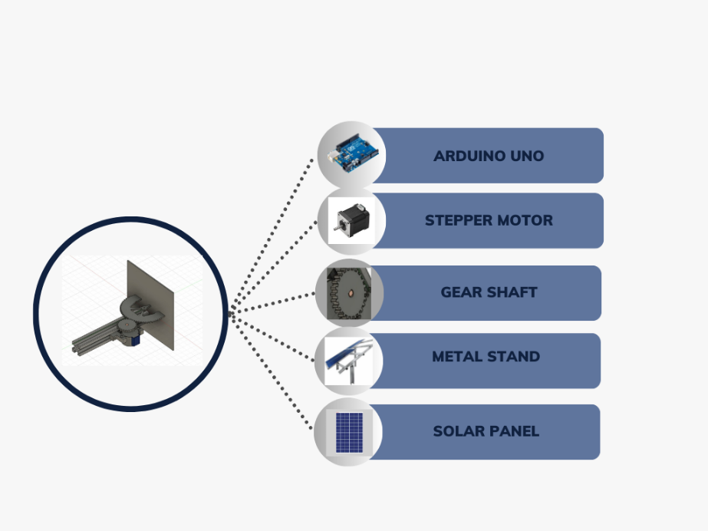

**Fig.1 Proposed Diagram of Automatic Solar Panel Tilting System**

**3.1 BLOCK DIAGRAM**

_______________________________________________________________________________________________

The stepper motor is a crucial component of a solar panel tilting system. It operates by converting electrical pulses into precise rotational movements and consists of coils and a rotor with permanent magnets. The controller, often an Arduino Uno or a similar device, sends specific sequences of electrical pulses to the motor windings, causing the rotor to move in defined steps.

To adjust the solar panels' tilt angle, the stepper motor connects to a mechanism responsible for the task. The controller calculates the optimal tilt angle based on environmental factors like the sun's position, time of day, or light intensity. Once the optimal tilt angle is determined, the controller sends the appropriate signals to the stepper motor to rotate the panels to the desired position.

The stepper motor's precise increments allow for accurate adjustments, ensuring that the solar panels capture the maximum amount of sunlight, improving overall energy efficiency.

A rotating gear shaft connects to the stepper motor in a solar panel tilting setup. When the motor receives signals from a controller, like an Arduino Uno, indicating the need to change the tilt angle of the solar panels, it starts rotating the shaft. This rotation causes the attached half-shaped gear shaft to rotate, tilting the solar panel along a predetermined axis. It provides a mechanical linkage between the motor and the solar panels, allowing for controlled and precise adjustments in response to environmental factors.

A quarter-shaped gear is a specific type of gear often used with a motor, like a stepper motor, to achieve controlled rotational movement. This type of gear may also be part of the gearing system connected to a motor responsible for adjusting the tilt angle of the solar panels.

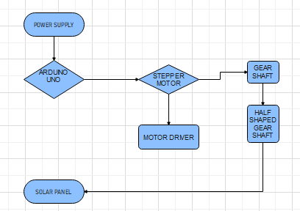

**Fig. 2 Block Diagram of Automatic Solar Panel Tilting System**

**3.2 CIRCUIT DIAGRAM**

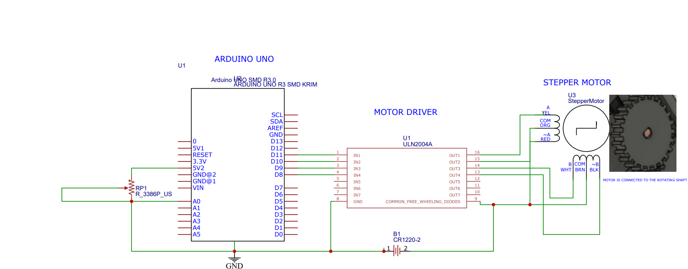

**Fig 3 Circuit Diagram Of Automatic Solar Panel Tilting System**

**4. CONCLUSION**

**_______________________________________________________________________________**

In conclusion, solar panel tilting using a gear shaft and time delay mechanism is an innovative approach that offers a sophisticated and effective solution for enhancing energy capture. By optimizing panel angles in response to the sun's movement, this approach ensures consistent and efficient sunlight exposure, which significantly contributes to the overall energy capture of solar panels. The precision offered by the gear shaft, coupled with the timely adjustments facilitated by the time delay, collectively maximizes energy output from solar panels, making the system a promising advancement in solar technology.

**5. REFERENCE**

**_________________________________________________________________________________**

[1] N.H. Helwa, A.B.G. Bahgat, A.M.R. El Shafee, E.T.El Shenawy “Maximum Collectable Solar Energy by Different Solar Tracking Systems”

[2] Nelson A. Kelly, Thomas L. Gibson “Improved photovoltaic energy output for cloudy conditions with a solar tracking system”

[3] Mohamad Fakir Naen, Muhamad Hariz Muhamad Adnan, Nurul AdilahYazi,Chee Ken Nee , "Development of

Attendance Monitoring System with Artificial Intelligence Optimization in Cloud",

[4] Muhammad Farhan Siddiqui, Waqas Ahmed Siddique, Mushtaq Ahmedhand Awais Khan Jumani, "Face Detection and Recognition System for Enhancing Security Measures Using Artificial Intelligence System"

[5] Hashem Bukhamsin, Angelo Edge, Roger Guiel, Dan Verne “Solar Tracking Structure Design”

[6] Anu George, Robins Anto “Analytical and experimental analysis of optimal tilt angle of solar photovoltaic systems”

[7] Amit Kumar Yadav, S.S. Chandel“Tilt angle optimization to maximize incident solar radiation: A review”

[8]Erwin Normanyo, Awingot Richard Akparibo “A Solar Radiation Tracker for Solar Energy Optimisation”

[9] Ömer Gönül a b, Fatih Yazar a, A. Can Duman a b, Önder Güler“A comparative techno-economic assessment of manually adjustable tilt mechanisms and automatic solar trackers for behind-the-meter PV applications”

[10] Ömer Gönül, A. Can Duman, Burak Barutçu, Önder Güler,“Techno-economic analysis of PV systems with manually adjustable tilt mechanisms”