A Review: Formulation and Evaluation of Herbal Mouth Ulcer Gel of Guava Leaves

Priya Masatkar*, Tabassum Bano

G.H. Raisoni University Saikheda, Sausar, Chhindwara, M.P

Email - priyamasatkar72@gmail.com

Abstract: -
A specific focus in this article revolved around the treatment of mouth ulcers, commonly referred to as canker sores. These painful lesions manifest on the mucous membranes within the oral cavity. The central theme of discussion is the application of herbal gel for the management of these ulcer. The article delves into a comprehensive list of herbal renowned for their high Flavonoid content, elucidating their prominent role in the treatment of mouth ulcers. This exploration serves to shed light on the efficacy and therapeutic potential of herbal remedies enriched with flavonoids in alleviating the discomfort associated with this oral ailment.
The exploration of traditional medical practice is deeply ingrained in the culture fabric and health perceptions of indigenous populations worldwide since ancient times. India, with a rich heritage of traditional and herbal medicine, has effectively utilized this knowledge for the prevention and cure of disease. The preference for herbal medicine arises from its notable advantage of causing fewer side effects compared to synthetic alternatives, thereby increasing patients

Keywords: Herbal medicine, mouth ulcer, guava leaves, herbal formulations.

Introduction: -
A mouth ulcer, medically known as aphtha, manifests as a lesion on the mucous membrane within the oral cavity. [1]While they are prevalent and often linked to various conditions, most cases do not indicate a severe underlying issue. However, persistent non-healing ulcers might signal oral cancer. These ulcers can occur singularly or in clusters, referred to as a "crop" of ulcers. Following formation, inflammation and/or secondary infection can perpetuate the ulcer's presence.

Oral ulceration, a prevalent affliction, finds its genesis in two principal sources: local trauma and aphthous stomatitis, colloquially termed "canker sores." Local trauma, a common instigator, manifests through incidents such as the abrasive friction from broken dental fillings or orthodontic braces, and inadvertently biting one's lip. Conversely, aphthous stomatitis, a condition shrouded in mystery, presents as the recurrent emergence of oral ulcers, the etiology of which remains largely elusive.

These mouth ulcers, irrespective of their genesis, herald an era of discomfort and pain for the afflicted. As they heal, individuals are often compelled to undertake dietary modifications, eschewing the consumption of acidic, sugary, salty, or spicy foods and beverages. This dietary austerity stems from a pragmatic necessity to alleviate the discomfort exacerbated by such consumables in the sensitive milieu of the healing oral cavity. Thus, the interplay between etiology, symptomatology, and dietary adaptation characterizes the intricate tapestry of oral ulceration.
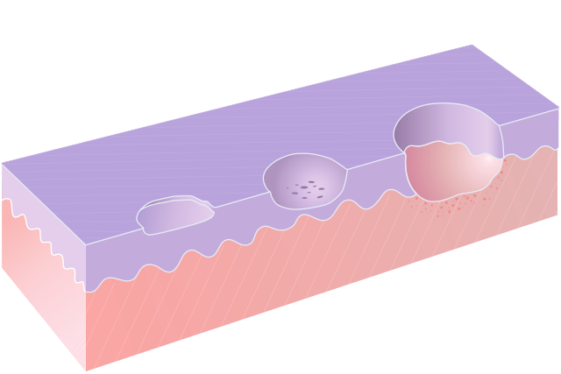.

Fig.1- Diagrammatic representation of mucosal erosion (left), excoriation (centre), and ulceration (right).

An ulcer, derived from the Latin word "ulcus" meaning sore, [2 ]manifests as a breach in the skin or mucous membrane, resulting in the loss of surface tissue and the disintegration and necrosis of epithelial tissue. Specifically, a mucosal ulcer pertains to an ulcer that develops on a mucous membrane.[3] This type of ulceration can occur in various parts of the body where mucous membranes are present, such as the gastrointestinal tract, mouth, throat, or genital areas. Mucosal ulcers can be caused by various factors including infections (such as H. pylori in the stomach), trauma, inflammatory conditions (like Crohn's disease or ulcerative colitis), or certain medications. Depending on the underlying cause and location, mucosal ulcers can vary in severity, symptoms, and treatment approaches. Prompt medical evaluation is essential to determine the appropriate management and prevent potential complications.

An ulcer represents a significant tissue defect that extends beyond the epithelial-connective tissue border, with its base reaching deep into the submucosa, muscle, or even periosteum.[4] This distinguishes it from shallower lesions like erosions or excoriations. Unlike these superficial damages, an ulcer penetrates deeper, affecting not only the epithelium but also the underlying lamina propria. This depth of penetration can lead to more severe symptoms and complications, necessitating thorough evaluation and appropriate management to promote healing and prevent further tissue damage.[5]

An erosion refers to a superficial breach of the epithelium, characterized by minimal damage to the underlying lamina propria.[5] Specifically, a mucosal erosion occurs on a mucous membrane, where only the superficial layers of the mucosa are lost, and the lesion may extend to the depth of the basement membrane. [4]Unlike ulcers, erosions do not penetrate as deeply into the underlying tissue layers. Despite the loss of superficial tissue, erosions have the remarkable ability to heal without scar formation, typically through the process of epithelial regeneration. This healing process restores the integrity of the mucosal barrier without leaving permanent marks or alterations in the tissue architecture. However, it's essential to address the underlying cause of the erosion to prevent recurrence or progression to more severe lesions such as ulcers. Management may involve addressing factors such as infection, inflammation, or mechanical trauma to promote optimal healing and mucosal health.[4]

Excoriation refers to a type of epithelial breach that falls between the depth of an erosion and an ulcer. It is characterized by a deeper level of tissue involvement compared to an erosion but is shallower than an ulcer. This type of lesion typically occurs tangentially to the rete pegs, which are structures that extend from the epidermis into the dermis, forming the interlocking pattern of the skin's surface. Excoriations often exhibit punctiform bleeding, manifested as small pinhead-sized spots, which result from the exposure of capillary loops due to the tissue damage. These exposed capillaries are prone to bleeding upon minor trauma or friction. Excoriations can arise from various causes, including mechanical abrasion, chemical irritation, or inflammatory processes. They are commonly observed in conditions such as dermatitis, eczema, or scratching injuries. Prompt identification and appropriate management of the underlying cause are crucial to facilitate healing and prevent further tissue damage or complications.[4]

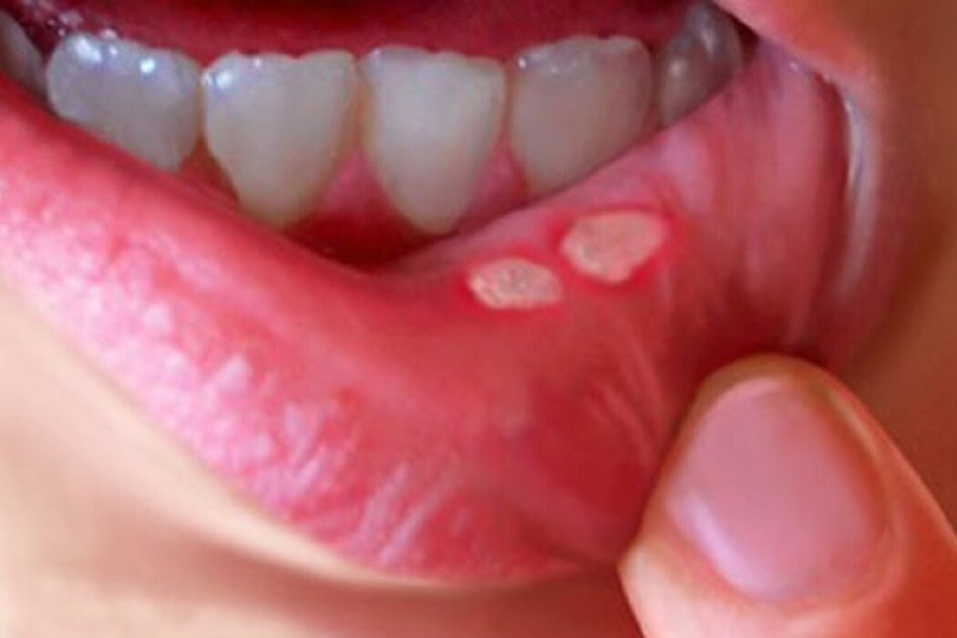

Fig. 2 - Mouth Ulcer

Causes: -

- Chemicals like Sodium Lauryl Sulfate (SLS), commonly found in numerous toothpaste formulations,[6] have been associated with the development of mouth ulcers. [7]These ulcers, also known as oral or aphthous ulcers, can occur as a result of the irritant effects of SLS on the delicate oral mucosa. Public health organizations such as the National Health Service (NHS) have acknowledged SLS as a potential risk factor for mouth ulcers due to its propensity to cause irritation and tissue damage. The mechanism of action involves SLS disrupting the protective mucosal barrier, leading to epithelial damage and inflammation, which can manifest as painful ulcers within the mouth. As a result, individuals prone to mouth ulcers may benefit from using toothpaste formulations that are free from SLS or other potential irritants to minimize the risk of ulcer formation and alleviate associated discomfort.[8]
- Infections such as those caused by herpes viruses.

- Injuries to the oral mucosa can occur due to various factors, including accidental trauma such as biting of the lip, tongue, or cheek, as well as mechanical irritation from consuming hard foods that can scrape the delicate oral tissues. Additionally, hot foods or beverages have the potential to cause thermal burns to the oral mucosa if consumed at high temperatures. These injuries can lead to tissue damage, inflammation, and the formation of ulcers or erosions within the mouth. Biting the lip, tongue, or cheek can result in localized abrasions or lacerations, while hard foods can cause abrasions or cuts if they come into contact with the oral mucosa with sufficient force. Similarly, hot foods can cause thermal injury, resulting in burns to the oral tissues. Proper oral hygiene and awareness of potential injury triggers can help minimize the risk of oral mucosal injuries and promote oral health.

- Nutritional disorders, such as vitamin deficiencies, can contribute to the development of ulcers and erosions within the oral cavity. Essential vitamins, including vitamin B12, folate, and vitamin C, play crucial roles in maintaining the health and integrity of oral tissues. Deficiencies in these vitamins can compromise the body's ability to repair and regenerate oral epithelial cells, leading to increased susceptibility to oral mucosal lesions.

- For example, vitamin B12 deficiency can result in a condition known as pernicious anemia, which may manifest with symptoms such as glossitis (inflammation of the tongue) and oral ulceration. Similarly, folate deficiency has been associated with the development of oral mucosal lesions, including ulcers and erythema.

- Vitamin C deficiency, commonly known as scurvy, can cause widespread mucosal damage throughout the body, including the oral cavity. Oral manifestations of scurvy may include gingival bleeding, swelling, and ulceration.

- Overall, maintaining adequate nutritional status, including sufficient intake of vitamins and minerals, is essential for the health of oral tissues and can help prevent the development of ulcers and erosions associated with nutritional deficiencies. Individuals at risk of nutritional disorders, such as those with poor dietary habits, certain medical conditions, or malabsorption syndromes, should be vigilant about meeting their nutritional needs through dietary modifications or supplementation under the guidance of healthcare professionals.

- Potentially, heavy metals, [9] among them cadmium found in phosphate rock, could be contributing factors.

Pathophysiology: -

The specific development of the condition varies depending on its underlying cause.

Simple mechanisms that increase the likelihood of trauma and ulceration in the mouth include xerostomia, which is dry mouth resulting from decreased saliva production. Saliva normally lubricates the mucous membrane and helps control bacterial levels, so its reduction can make the lining of the mouth more susceptible to injury. Additionally, epithelial atrophy, which refers to thinning of the mucosal lining, can occur, particularly after treatments like radiotherapy. This thinning makes the mucosal lining more fragile and easier to breach,[11]:7 increasing the risk of trauma and ulcer formation. Stomatitis, a term denoting inflammation within the mouth, often accompanies ulceration. This inflammation can exacerbate tissue damage and further predispose the mouth to ulcer formation. Overall, these conditions highlight the importance of maintaining oral health and addressing underlying factors that may increase susceptibility to mouth trauma and ulceration.[12]

From a pathological perspective, the mouth serves as a bridge between the gastrointestinal tract and the skin. This anatomical characteristic means that many conditions affecting both the gastrointestinal system and the skin can also involve the oral cavity. Some conditions typically associated with the entire gastrointestinal tract may solely manifest in the mouth. For instance, orofacial granulomatosis and oral Crohn's disease are examples of such conditions. Orofacial granulomatosis, as well as oral Crohn's disease, are subsets of inflammatory bowel diseases that primarily affect the mouth. While these conditions share similarities with their counterparts in the gastrointestinal tract, they present unique challenges and manifestations when confined to the oral cavity. The mouth serves as an important site for the diagnosis and monitoring of systemic diseases, as manifestations may occur here before becoming evident elsewhere in the body. Overall, understanding the interconnectedness between gastrointestinal and cutaneous conditions and their potential oral manifestations is crucial for accurate diagnosis and management, particularly in cases where oral involvement may be the initial or sole presentation of a systemic condition.[13]

Similarly, skin conditions can also affect the mouth, and sometimes solely involve the oral cavity while sparing the skin. The distinct environmental conditions present in the mouth, such as saliva, thinner mucosa, and the potential for trauma from teeth and food, contribute to unique presentations of cutaneous disorders within the oral cavity. Consequently, certain skin conditions that produce characteristic lesions on the skin may only manifest as nonspecific lesions in the mouth.[14] In cases of blistering mucocutaneous disorders, such as pemphigus or pemphigoid, vesicles and bullae may develop rapidly into ulcers within the mouth due to the presence of moisture and the likelihood of trauma from food and teeth. Additionally, the mouth's high bacterial load increases the risk of secondary infection of these ulcers, further complicating the clinical picture. Furthermore, cytotoxic drugs administered during chemotherapy primarily target rapidly dividing cells, including malignant cells. However, the epithelial cells lining the oral cavity also exhibit a high turnover rate, making them susceptible to the effects of these medications. Consequently, chemotherapy can lead to oral mucositis, characterized by inflammation and ulceration of the oral mucosa, which can significantly impact a patient's quality of life and treatment outcomes.

Erosions, which involve only the epithelial layer of the mucosa, typically appear red in color because the underlying lamina propria is visible through the thinned epithelium. However, when the full thickness of the epithelium is breached, leading to ulceration, the lesion becomes covered with a fibrinous exudate and takes on a yellow-grey color. Ulcers are characterized by a crater-like appearance when viewed in cross-section due to the loss of tissue integrity in the mucosal lining. In addition to the visual characteristics, ulcers often exhibit surrounding features indicative of inflammation. A "halo" effect, marked by reddening of the surrounding mucosa, may be present. Edema, or swelling, around the ulcer site is also common. Chronic trauma can result in an ulcer with a keratotic margin,[5] characterized by thickened, white mucosa surrounding the lesion. Malignant lesions may ulcerate due to infiltration of the mucosa from adjacent tissues or because of disorganized growth originating within the mucosa itself, leading to disruption of the normal tissue architecture. Repeated episodes of mouth ulcers may signal an underlying immunodeficiency, indicating low levels of immunoglobulin in the oral mucous membranes. Conditions such as chemotherapy, HIV, mononucleosis, and autoimmune disorders can lead to immunodeficiency or immunosuppression, making oral ulcers a common manifestation. Autoimmunity can also cause oral ulceration. For instance, mucous membrane pemphigoid, an autoimmune reaction targeting the epithelial basement membrane, can result in desquamation and ulceration of the oral mucosa. Behçet's disease, an inflammatory autoimmune disorder, may present with numerous aphthous ulcers in the mouth, and later involve skin lesions and uveitis in the eyes. Additionally, vitamin C deficiency can lead to scurvy, impairing wound healing and contributing to ulcer formation.[15] Overall, understanding the diverse etiologies and pathophysiological mechanisms underlying oral ulcers is essential for accurate diagnosis and appropriate management of these conditions.

Diagnosis: -

The diagnosis of mouth ulcers typically involves obtaining a medical history followed by an oral examination, along with evaluation of any other affected areas. Key details considered during assessment include the duration of the lesion, its location, the number of ulcers, their size, color, texture, tendency to bleed, and presence of a rolled edge. Generally, any mouth ulcer persisting for more than 2 or 3 weeks should prompt evaluation by a healthcare professional.[1][16]

An ulcer recurring in the same location may be due to nearby sharp surfaces, while ulcers healing and reappearing in different sites are likely to be Recurrent Aphthous Stomatitis (RAS). Single ulcers are more suggestive of malignant lesions, whereas multiple ulcers are unlikely to indicate oral cancer. The size and location of ulcers can help differentiate types of RAS (minor RAS primarily occurs on non-keratinizing mucosa, while major RAS can occur anywhere in the mouth or oropharynx). Features such as induration, contact bleeding, and rolled margins are indicative of malignant ulcers.[17] Additionally, potential causative factors like broken teeth with sharp edges should be considered. Medical history may reveal other associated issues such as genital or eye lesions, or digestive problems.

The diagnosis primarily relies on medical history and examination, but special investigations may include blood tests to assess for vitamin deficiencies, anemia, leukemia, Epstein-Barr virus, HIV infection, or diabetes. Microbiological swabs can help identify any infectious causes, while urinalysis may be conducted to assess for diabetes. In some cases, a biopsy may be necessary, involving the removal of a small sample of the ulcer for microscopic examination, with or without immunofluorescence, to rule out cancer or investigate suspected systemic diseases.[5]

Ulcers resulting from local trauma are typically tender and painful to touch, often presenting with an irregular border and erythematous margins. The base of these ulcers may appear yellow. As healing progresses, a keratotic halo, characterized by thickened, white mucosa, may develop.[11]:52

Differential diagnosis: -

Due to multiple contributing factors such as the presence of saliva, the relatively thin nature of the oral mucosa, and the potential for trauma from teeth and chewing, vesicles and bullae that form on the mucous membranes of the oral cavity are inherently fragile. As a result, they tend to rapidly deteriorate and break down, leaving behind ulcers.

Aphthous stomatitis, also known as recurrent aphthous ulcers or canker sores, along with local trauma, represent two of the most prevalent causes of oral ulceration. Aphthous stomatitis is characterized by recurrent episodes of painful ulcers that typically heal spontaneously within 1 to 2 weeks. Local trauma, which can occur from accidental biting, sharp or rough foods, dental procedures, or ill-fitting dental appliances, can also lead to the formation of oral ulcers.

While aphthous stomatitis and local trauma are common causes of oral ulceration, other potential causes are comparatively rare. These include systemic conditions such as inflammatory bowel disease, autoimmune disorders like Behçet's disease or pemphigus vulgaris, viral infections like herpes simplex virus or coxsackievirus, fungal infections such as oral candidiasis, and malignancies such as oral squamous cell carcinoma. However, these conditions collectively represent a smaller proportion of cases of oral ulceration compared to aphthous stomatitis and local trauma.

Traumatic ulceration: -

The majority of mouth ulcers not related to recurrent aphthous stomatitis stem from local trauma. The mucous membrane lining of the mouth is thinner and more delicate compared to the skin, making it susceptible to damage from various sources. This includes mechanical trauma, such as accidental biting, sharp or rough foods, dental procedures, or poorly fitting dental appliances. Thermal factors, such as exposure to heat or cold from food or beverages, can also injure the oral mucosa. Chemical irritants found in certain foods, beverages, or oral care products can cause tissue damage, as can exposure to certain medications or environmental toxins. Additionally, exposure to radiation, whether therapeutic or accidental, can result in mucosal injury. The vulnerability of the oral mucosa to these diverse forms of trauma underscores the importance of maintaining oral hygiene and minimizing exposure to potential irritants to prevent the development of mouth ulcers.

Mechanical: -

Frequent causes of oral ulceration involve friction from sharp tooth edges, dental fillings, crowns, dentures, or orthodontic appliances like braces. Accidental biting due to decreased sensitivity, such as after local anesthesia during dental procedures, can also contribute to ulcer formation as sensation returns.

Consuming hard foods like potato chips can lead to mouth lining damage. Additionally, some individuals unintentionally harm the inside of their mouths due to absentminded habits or deliberate self-injury, known as factitious ulceration. This includes actions like biting the cheeks, tongue, or lips, or rubbing objects like fingernails, pens, or toothpicks inside the mouth. In cases of child abuse, tearing and subsequent ulceration of the upper labial frenum may be indicative of non-accidental injury.[5]

Ulceration resulting from medical intervention, known as iatrogenic ulceration, can occur during dental procedures, often due to inadvertent abrasions to the soft tissues of the mouth. To mitigate this risk, some dentists apply a protective layer of petroleum jelly to the lips before initiating dental work.

Repeated friction during oral sexual activity, colloquially known as "cunnilingus tongue,"[18] can lead to ulceration of the lingual frenum. Additionally, infants may rarely develop ulceration of the tongue or lower lip due to friction from their own teeth, a condition referred to as Riga-Fede disease.[19]

Thermal and electrical burn: -

Thermal burns often occur when consuming hot food or beverages, especially before local anesthesia wears off, as the absence of normal painful sensation can lead to inadvertent burns. Microwave-cooked foods, which may have uneven temperatures, can also contribute to intra-oral thermal burns. These burns typically affect the palate or posterior buccal mucosa, presenting as areas of erythema and ulceration with necrotic epithelium at the edges. Electrical burns, on the other hand, tend to affect the oral commissure and initially appear painless, charred, and yellow, with minimal bleeding. Subsequent swelling occurs, leading to necrosis of the area with eventual sloughing off of the epithelium by the fourth day post-burn.[18]

Electrical burns in the oral cavity typically occur when individuals, particularly young children, chew on live electrical wiring. Saliva, acting as a conducting medium, facilitates the flow of an electrical arc between the source of electricity and the oral tissues, resulting in intense heat and potential tissue damage.[18][20]

Chemical injury: -

Strong concentrations of caustic chemicals can lead to ulceration of the oral mucosa if they remain in contact for an extended period. Holding medication in the mouth instead of swallowing it is more common among children, individuals under psychiatric care, or those who lack understanding. For example, holding an aspirin tablet against a painful tooth to alleviate toothache is a common practice, resulting in epithelial necrosis. It's advisable to swallow chewable aspirin tablets and promptly clear any residue from the mouth to prevent tissue damage.

Other caustic medications, such as eugenol and chlorpromazine, can also cause epithelial necrosis. Hydrogen peroxide, commonly used for treating gum disease, can induce tissue damage at concentrations of 1–3%. Silver nitrate, utilized for pain relief from aphthous ulceration, acts as a chemical cauterant and can increase mucosal damage while destroying nerve endings. Phenol, employed in dental treatment as a cavity sterilizing agent and cauterizing material, is also found in some over-the-counter products for treating aphthous ulcers. Mucosal necrosis has been documented with phenol concentrations of 0.5%. Additionally, certain materials used in endodontics are caustic, prompting the recommendation for the use of a rubber dam to minimize tissue exposure during treatment.[18]

Irradiation: -

Following radiotherapy to the mouth, radiation-induced stomatitis may arise, characterized by mucosal erosions and ulceration. Irradiation of the salivary glands can lead to xerostomia (dry mouth), reducing the lubricating function of saliva and making the oral mucosa more susceptible to frictional damage. Additionally, mucosal atrophy may occur, further increasing the likelihood of epithelial breach.

Radiation exposure to the jawbones results in damage to osteocytes and impairs blood supply, leading to hypovascular, hypocellular, and hypoxic hard tissues. Osteoradionecrosis occurs when irradiated bone fails to heal, typically affecting the mandible and causing chronic pain and surface ulceration. In severe cases, non-healing bone may become exposed through a soft tissue defect. To prevent osteoradionecrosis, teeth with uncertain prognosis are often extracted before radiotherapy initiation.[18]

Aphthous Stomatitis: -

Aphthous stomatitis, commonly known as "canker sores," is a prevalent cause of oral ulceration, affecting approximately 10–25% of the general population. It manifests in three types based on appearance: minor, major, and herpetiform major aphthous ulceration. Minor aphthous ulceration, the most common type, presents with small (2-4mm diameter), round or oval ulcers with a yellow-grey color and a red "halo" around them. These ulcers typically heal within 7–10 days without scarring and recur every 1–4 months. Major aphthous ulceration, less common but more severe, features larger (>1 cm diameter) ulcers that take longer to heal (10–40 days) and may leave scars. While both minor and major types usually occur on non-keratinized oral mucosa, major aphthous ulcers may also appear on keratinized mucosal surfaces in other parts of the mouth, albeit less frequently. Herpetiform ulceration, the least common type, resembles primary herpetic gingivostomatitis and begins as small blisters that break down into 2-3mm ulcers. These ulcers may occur in clusters, often numbering in the hundreds, and can merge to form larger areas of ulceration. Herpetiform ulcers are extremely painful, tend to heal with scarring, and may recur frequently.

Factors contributing to aphthous stomatitis include smoking cessation, stress, menstruation, trauma, and food allergies or hypersensitivity to sodium lauryl sulfate, commonly found in toothpaste brands. While there are no clinically detectable signs or symptoms outside the mouth, recurrent ulceration can cause significant discomfort. Treatment focuses on alleviating pain, reducing swelling, and expediting healing through systemic or topical steroids, analgesics, antiseptics, anti-inflammatory agents, or barrier pastes to shield the affected areas.[5]

Infection:-
Infectious origins of oral ulceration.[5]
Agent | Example (s)
Viral | Chickenpox, hand, foot and mouth disease, herpangina, herpetic stoma it is, human immunodeficiency virus, Infectious mononucleosis
Bacterial | acute necrotizing ulcerative gingivit is, gangrenous stomat it is, syphilis, tuberculosis
Fungal | blastomycosis, cryptococcosis, histoplasmosis, paracoccidioidomycosis
Parasitic | leishmaniasis

Various infections can lead to oral ulceration, with some of the most common being herpes simplex virus (manifesting as herpes labialis or primary herpetic gingivostomatitis), varicella-zoster virus (associated with chickenpox and shingles), and coxsackie A virus (responsible for hand, foot, and mouth disease). Human immunodeficiency virus (HIV) can induce immunodeficiency, allowing opportunistic infections or neoplasms to flourish. Bacterial causes of ulceration may stem from Mycobacterium tuberculosis (resulting in tuberculosis) and Treponema pallidum (causing syphilis).

Opportunistic activity involving combinations of typically harmless bacterial flora, such as aerobic streptococci, Neisseria, Actinomyces, spirochetes, and Bacteroides species, can prolong the ulcerative process. Fungal contributors include Coccidioides immitis (causing valley fever), Cryptococcus neoformans (associated with cryptococcosis), and Blastomyces dermatitidis (responsible for "North American Blastomycosis"). [15] Additionally, Entamoeba histolytica, a parasitic protozoan, is known to occasionally induce mouth ulcers through cyst formation. Epstein-Barr virus-positive mucocutaneous ulcer represents a rare form of Epstein-Barr virus-associated lymphoproliferative diseases, characterized by solitary, well-defined ulcers in mucous membranes and skin caused by infiltrating, Epstein-Barr virus-infected B cells.[21]

Drug- induced:-

Numerous medications can lead to mouth ulcers as an adverse effect. Common examples include alendronate,[22] a bisphosphonate often prescribed for osteoporosis, cytotoxic drugs like methotrexate used in chemotherapy, non-steroidal anti-inflammatory drugs, nicorandil used for angina treatment, and propylthiouracil employed for hyperthyroidism. Certain recreational substances, such as cocaine, can also contribute to ulceration.[24]

Malignancy:-

In rare instances, a persistent, non-healing mouth ulcer could indicate a cancerous lesion. Malignancies in the oral cavity typically manifest as carcinomas, although lymphomas, sarcomas, and other types are also conceivable. Tumors may originate within the mouth or extend to involve it from adjacent areas such as the maxillary sinus, salivary glands, nasal cavity, or peri-oral skin. Squamous cell carcinoma represents the most prevalent form of oral cancer. Primary risk factors include prolonged smoking and alcohol consumption, especially when combined, as well as betel nut use.

Common sites for oral cancer include the lower lip, floor of the mouth, sides and underside of the tongue, and mandibular alveolar ridge, although tumors can occur anywhere in the oral cavity. The appearance of oral malignancies can vary widely, but a typical malignant ulcer presents as a persistent, enlarging lesion that appears entirely red (erythroplasia) or displays a speckled red and white appearance (erythroleukoplakia). Malignant lesions often feel hardened (indurated) and firmly attached to surrounding structures, with margins that are either "rolled" or have a punched-out appearance, and they tend to bleed easily with gentle manipulation.[25] If an individual has an unexplained mouth ulcer persisting for more than 3 weeks, this may warrant a referral from a general dental practitioner (GDP) or general practitioner (GP) to a hospital for further evaluation to rule out oral cancer.[26]

Vesiculobullous disease:-

Several of the viral infections mentioned earlier are also categorized as vesiculobullous diseases. Additional examples of vesiculobullous diseases encompass pemphigus vulgaris, mucous membrane pemphigoid, bullous pemphigoid, dermatitis herpetiformis, linear IgA disease, and epidermolysis bullosa.[27]:1, 22

Allergy:-

Although rare, allergic reactions affecting the mouth and lips may present as erosions; however, such reactions typically do not result in overt ulceration. Balsam of Peru serves as a common allergen, and individuals allergic to this substance may develop stomatitis and cheilitis upon oral exposure, characterized by inflammation, rash, or painful erosion of the lips, oropharyngeal mucosa, or angles of the mouth.[28][29][30][31] Balsam of Peru finds application in foods and beverages for flavoring, perfumes and toiletries for fragrance, as well as in medicinal and pharmaceutical products for its therapeutic properties.[28][29][30]

Other causes:-

Various other diseases can lead to mouth ulcers. Hematological conditions encompass anemia, deficiencies in hematinic substances, neutropenia, hyper eosinophilic syndrome, leukemia, myelodysplastic syndromes, other abnormalities in white blood cells, and gammopathies. Gastrointestinal disorders include celiac disease, Crohn's disease (associated with orofacial granulomatosis), and ulcerative colitis. Dermatological conditions comprise chronic ulcerative stomatitis, erythema multiforme (including Stevens-Johnson syndrome), angina bullosa haemorrhagica, and lichen planus. Additionally, systemic diseases such as lupus erythematosus, Sweet syndrome, reactive arthritis, Behçet syndrome, granulomatosis with polyangiitis, periarteritis nodosa, giant cell arteritis, diabetes, glucagonoma, sarcoidosis, and periodic fever, aphthous stomatitis, pharyngitis, and adenitis can also provoke mouth ulcers.[5]

Oral ulceration may manifest as a result of conditions such as eosinophilic ulcer and necrotizing sialometaplasia.

Macroglossia, characterized by an unusually large tongue, may lead to ulceration if the tongue consistently protrudes from the mouth.[18] Caliber persistent artery refers to a prevalent vascular anomaly in which a major arterial branch extends into superficial submucosal tissues without a reduction in diameter. This occurrence is common among elderly individuals, particularly on the lip, and may be linked with ulceration.[18]

Literature Review:-

Chaudhri Megham et al. February 2022- The work in this paper is focusing on Formulation of Herbal Mouth Ulcer Gels The development of an efficacious herbal mouth ulcer gel is a nuanced process that blends the art of traditional medicine with the precision of contemporary pharmaceutical sciences. This endeavor necessitates an in-depth understanding across several disciplines, including pharmacognosy, which studies the physical, chemical, biochemical, and biological properties of drugs, drug substances, or potential drugs or drug substances of natural origin; pharmacology, which examines the effects of these substances on living organisms; and pharmaceutics, which involves the formulation of safe and effective medication delivery systems. Selection of Gel Base The choice of a gel base is paramount in the formulation process. Carbopol 934, a synthetic high molecular weight polymer of acrylic acid, is often favored for its thickening, suspending, and stabilizing properties. It can create a gel base that is not only conducive to the sustained release of the active herbal compounds but also pleasant for the patient to apply. The gel's consistency is crucial for ensuring that it adheres well to the ulcerated area, providing localized relief and facilitating optimal absorption of the therapeutic agents directly at the site of the lesion. Extraction and Optimization of Guava Leaf Extracts Extracting the phytochemicals from guava leaves in a manner that retains their bioactive properties is a critical step. Various methods, including solvent extraction with water or alcohol, can be employed, each affecting the composition and potency of the final extract. The concentration of the extract must be meticulously calibrated to maximize therapeutic efficacy while ensuring the formulation's stability over time and minimizing any potential for irritation or adverse reactions. Advanced analytical techniques, such as high-performance liquid chromatography (HPLC), are instrumental in quantifying the active compounds in the extracts, aiding in the standardization of the formulation. Incorporation of Complementary Herbal Extracts The integration of additional herbal extracts into the gel formulation can significantly enhance its therapeutic profile. Aloe vera, renowned for its soothing, moisturizing, and healing properties, can provide immediate relief from the pain and discomfort associated with mouth ulcers. Ocimum sanctum, also known as holy basil, contributes antibacterial, anti-inflammatory, and analgesic effects, further supporting the healing process. The synergistic interaction between these herbal extracts and guava leaf compounds can result in a more comprehensive treatment solution, addressing not only the symptoms but also the underlying causes of mouth ulcers, such as microbial infections and inflammation. Ensuring Safety and Stability Safety and stability are overarching concerns in the formulation of herbal mouth ulcer gels. The formulation must undergo rigorous testing to ensure it is non-irritating, non-toxic, and free from contaminants. Stability studies are essential to confirm that the gel maintains its efficacy and safety throughout its intended shelf life, with factors such as pH, temperature, and exposure to light being carefully monitored. Regulatory compliance is another critical aspect, with formulations needing to meet the guidelines set by health authorities. User-Friendly Formulation Lastly, the user experience is a vital consideration. The gel should be easy to apply, with a texture that is comfortable and not overly sticky or greasy. Flavor and scent, derived from the herbal components, should be pleasant but not overpowering. Packaging also plays a role in the user experience, with applicators designed for precise, hygienic application to the affected area. In summary, the formulation of herbal mouth ulcer gels is a complex, multidisciplinary process that balances the healing power of nature with the rigor of scientific formulation techniques. By carefully selecting and optimizing the herbal components and gel base, formulators can create effective, safe, and user-friendly products that offer a natural alternative for the treatment of mouth ulcers.

Kirti Dhanake, et al. November 2023- The work in this paper is focusing on Evaluation and Efficacy of Herbal Mouth Ulcer Gels The journey towards validating the efficacy of herbal mouth ulcer gels encompasses a meticulous and multi-faceted evaluation process, aimed at ensuring these natural formulations meet or exceed the therapeutic benchmarks set by conventional treatments. This process not only scrutinizes the gels' ability to combat the symptoms and causes of mouth ulcers but also assesses their overall acceptability to users, a critical factor in determining their viability as a mainstream treatment option. Antimicrobial Activity Assessment One of the primary evaluations involves testing the antimicrobial efficacy of the gels, given that bacterial, viral, or fungal infections can either cause or exacerbate mouth ulcers. Laboratory studies often employ cultures of common oral pathogens, applying the herbal gel to assess its capacity to inhibit microbial growth or kill the microbes outright. This is crucial for a gel containing guava leaf extract, as the phytochemicals present—such as flavonoids and tannins—are known for their potent antimicrobial properties. The results of these tests are pivotal, providing a quantifiable measure of the gel's ability to create a less hospitable environment for pathogens at the ulcer site and thereby reducing the risk of infection-induced complications. Healing Rate Measurement The ultimate goal of any mouth ulcer treatment is to expedite the healing process, alleviating discomfort and restoring oral health. Thus, clinical trials assessing the healing rate of ulcers treated with herbal gels are indispensable. These studies typically monitor the progression of healing over days or weeks, comparing the time it takes for ulcers to significantly reduce in size or heal entirely when treated with the herbal gel versus standard care or placebo treatments. Metrics such as reduction in ulcer diameter, pain scores, and recurrence rates provide a comprehensive picture of the gel's healing efficacy. Herbal gels that demonstrate a faster or more complete healing process not only validate the therapeutic potential of the active ingredients but also highlight the added value of a natural treatment approach. User Acceptance and Experience Beyond the clinical and microbiological assessments, the success of herbal mouth ulcer gels in a real-world setting hinges on user acceptance and experience. This encompasses a wide array of factors, including ease of application, sensory attributes (taste and smell), immediate relief provided, and any side effects experienced. Surveys and user feedback play a critical role in gauging these aspects, offering insights into how the gel is perceived by individuals suffering from mouth ulcers. High user acceptance is often attributed to the natural composition of these gels, which not only aligns with the growing consumer preference for organic and non-synthetic products but also minimizes the risk of adverse reactions that can accompany some chemical-based treatments. Moreover, the psychological comfort derived from using a treatment perceived as "natural" or "gentle" cannot be understated. Many individuals are increasingly wary of synthetic medications and their side effects, turning instead to herbal alternatives that promise efficacy without compromise. When users report satisfaction with the herbal gel's performance and prefer it over traditional options, it reinforces the gel's position as a viable and desirable treatment for mouth ulcers. Comparative Studies with Conventional Treatments Comparative studies serve as a critical benchmark, placing the efficacy of herbal mouth ulcer gels in direct comparison with that of conventional treatments. These studies often reveal that herbal formulations, with their complex mix of bioactive compounds, can match or even surpass the efficacy of single-ingredient pharmaceuticals in both antimicrobial activity and healing acceleration. Such findings are instrumental in shifting perceptions about the effectiveness of natural remedies, suggesting that they can stand on equal footing with, or even offer advantages over, standard pharmacological approaches. In sum, the comprehensive evaluation of herbal mouth ulcer gels across these dimensions—antimicrobial activity, healing rate, user acceptance, and comparative efficacy—forms the bedrock upon which their credibility and utility as a treatment option are built. As evidence mounts in favor of these natural formulations, their potential to redefine the landscape of oral ulcer treatment becomes increasingly apparent, offering sufferers a potent, well-tolerated, and user-approved alternative to conventional medications.

Thorat et al. (2015 )- The work in this paper is focusing on delves into the realm of treating mouth ulcers, a common oral mucosal disorder, through an innovative approach involving the use of a curcumin-loaded thermoreversible mucoadhesive gel. This study is situated within the broader context of seeking novel and effective treatments for mouth ulcers, which can be painful and debilitating for patients. The rationale behind this investigation lies in harnessing the therapeutic properties of curcumin, a bioactive compound known for its potent anti-inflammatory and wound healing effects. By encapsulating curcumin within a specialized gel matrix, which possesses both mucoadhesive properties to adhere to the mucosal surfaces of the mouth and thermoreversible characteristics to undergo phase transitions in response to temperature changes, the researchers aim to create a formulation that offers sustained release of curcumin, ensuring prolonged contact with the ulcer site. The methodology employed in this study likely involves a series of laboratory experiments to optimize the formulation of the curcumin-loaded gel, including considerations such as the concentration of curcumin, the composition of the gel matrix, and the rheological properties of the formulation. Subsequent in vitro and possibly in vivo experiments may have been conducted to assess the bioavailability, mucoadhesive properties, and therapeutic efficacy of the gel in treating mouth ulcers. Additionally, clinical trials involving human subjects may have been carried out to evaluate the safety, tolerability, and effectiveness of the gel in a real-world setting. The findings of this research are likely to demonstrate the potential of the curcumin-loaded thermoreversible mucoadhesive gel as a promising therapeutic intervention for mouth ulcers. This could include significant reductions in ulcer-related pain and discomfort, accelerated healing of the ulcerated tissue, and overall improvements in patient outcomes and quality of life. Moreover, the study may shed light on the underlying mechanisms of action through which curcumin exerts its beneficial effects on oral mucosal health, further contributing to the scientific understanding of oral pathology and wound healing processes. In conclusion, the study by Thorat et al. (2015) represents a valuable contribution to the field of oral medicine and pharmaceutical sciences, offering a novel approach to managing mouth ulcers through the development of an innovative curcumin-loaded gel formulation. By combining scientific rigor with clinical relevance, this research holds promise for translating laboratory discoveries into tangible clinical benefits for individuals suffering from this common oral condition.

Ranade et al. (2014)- The work in this paper is focusing on explore the potential enhancement of anti-ulcer activity using a novel drug delivery system involving monoammonium glycyrrhizin and Aloe vera gel powder. This research contributes to the broader landscape of ulcer treatment strategies, aiming to improve therapeutic outcomes through innovative delivery mechanisms. By investigating the combination of monoammonium glycyrrhizin, known for its anti-inflammatory and gastroprotective properties, with Aloe vera gel powder, renowned for its wound healing and soothing effects, the study addresses the multifaceted nature of ulcer pathophysiology. The methodology likely involves formulation development to optimize the delivery system, possibly utilizing techniques such as encapsulation or microencapsulation to enhance stability and bioavailability. In vitro and in vivo experiments may have been conducted to assess the efficacy and safety of the formulated product in mitigating ulcer symptoms and promoting healing. The findings of this study are anticipated to provide valuable insights into the synergistic effects of monoammonium glycyrrhizin and Aloe vera in ulcer management, offering a potential therapeutic option for patients suffering from this condition. Moreover, the research by Ranade et al. contributes to the broader understanding of drug delivery systems in the context of ulcer treatment, highlighting the importance of tailored formulations that optimize drug bioavailability and target-specific delivery. By bridging the gap between traditional medicinal knowledge and modern pharmaceutical science, this study exemplifies the potential for integrating natural remedies with advanced drug delivery technologies to enhance therapeutic outcomes. Overall, the findings of this research add to the growing body of literature on ulcer management, paving the way for further exploration of innovative treatment modalities that harness the synergistic potential of natural compounds and novel drug delivery systems.

Sabir Shaikh, et al. (2015) -The work in this paper is focusing on the realm of anticancer pharmaceutical gels designed for oral cavity application. This research contributes to the broader landscape of cancer therapy, focusing specifically on developing innovative formulations tailored for oral administration. By exploring the potential of inorganic materials as key components of these gels, the study addresses the unique challenges posed by oral cancer treatment, such as localized drug delivery and patient compliance. The methodology likely involves formulation development and optimization to ensure the efficacy and safety of the anticancer gel. This may include selecting suitable inorganic materials with inherent anticancer properties, as well as incorporating other therapeutic agents or drug carriers to enhance the targeted delivery of anti-cancer drugs to the oral cavity. In vitro and possibly in vivo experiments may have been conducted to evaluate the cytotoxicity, pharmacokinetics, and tumor-targeting capabilities of the formulated gels. The findings of this study are anticipated to provide valuable insights into the feasibility and effectiveness of inorganic materials-based pharmaceutical gels for oral cancer therapy. By harnessing the unique properties of these materials, such as biocompatibility and controlled release capabilities, the researchers aim to develop targeted and efficacious treatment options that minimize systemic toxicity and maximize therapeutic outcomes. Moreover, this research underscores the importance of personalized medicine approaches in cancer therapy, highlighting the potential for tailored formulations that address the specific needs of patients with oral malignancies. Overall, the study by Shaikh and Shete contributes to the growing body of literature on cancer treatment, particularly in the context of oral cavity malignancies. By exploring novel formulations and delivery systems, this research opens new avenues for developing innovative and effective therapies that improve patient outcomes and quality of life. Additionally, the findings of this study may have implications beyond oral cancer, paving the way for further exploration of inorganic materials-based pharmaceutical gels in other areas of oncology and drug delivery.

Rezvaninejad et al.(2017)-The work in this paper is focusing on investigate the efficacy of herbal medicine in the treatment of recurrent aphthous stomatitis (RAS), a common oral mucosal disorder characterized by the recurrent formation of painful ulcers in the oral cavity. This study contributes to the broader understanding of alternative therapies for RAS, aiming to explore the potential benefits of herbal remedies in managing this condition. The authors likely conducted a comprehensive review of the literature to identify relevant studies examining the use of herbal medicine in RAS treatment. This review may encompass both experimental and clinical studies evaluating the therapeutic effects of various herbal extracts, formulations, and preparations. By synthesizing and analyzing the findings from these studies, Rezvaninejad et al. aim to provide insights into the mechanisms of action, efficacy, and safety profile of herbal interventions for RAS. The literature review may cover a range of herbal medicines commonly used in traditional and complementary medicine systems, such as aloe vera, licorice root, chamomile, and myrrh. Each herbal remedy may be evaluated based on its pharmacological properties, bioactive constituents, mode of administration, and clinical evidence supporting its efficacy in RAS management. Furthermore, the review may discuss the potential advantages of herbal medicine in RAS treatment, such as their anti-inflammatory, analgesic, antimicrobial, and wound healing properties. The authors may also address considerations related to dosage, formulation optimization, and potential herb-drug interactions to ensure the safe and effective use of herbal remedies in clinical practice. Overall, the literature review by Rezvaninejad et al. serves to consolidate existing knowledge on the role of herbal medicine in the management of recurrent aphthous stomatitis. By critically appraising the available evidence and highlighting areas for future research, this study contributes to the advancement of holistic and patient-centered approaches to oral health care, promoting the integration of herbal therapies into conventional treatment protocols for RAS.

Thombre et al.(2018)- The work in this paper is focusing on explore the formulation and evaluation of a pharmaceutical aqueous gel containing powdered Cordia dichotoma leaves with guava leaves. This study contributes to the broader landscape of herbal medicine and pharmaceutical formulation development, aiming to harness the therapeutic potential of natural plant extracts for topical application. The authors likely conducted a systematic review of the literature to gather relevant information on the pharmacological properties of Cordia dichotoma and guava leaves, as well as their traditional uses in herbal medicine. This review may encompass studies examining the anti-inflammatory, antioxidant, antimicrobial, and wound healing properties of these plant extracts, providing a rationale for their inclusion in the formulated gel. The formulation development process likely involved optimizing the composition of the aqueous gel to ensure compatibility with the powdered leaf extracts and enhance their bioavailability and stability. Various excipients and additives may have been explored to achieve desirable rheological properties, texture, and spreadability of the gel formulation. In vitro and possibly in vivo experiments may have been conducted to evaluate the efficacy and safety of the formulated gel. This may include assessments of its antimicrobial activity against common pathogens, anti-inflammatory effects on cellular models, and wound healing properties using animal models. The literature review may also discuss the potential applications of the formulated gel in dermatology and wound care, highlighting its potential as a natural alternative to synthetic pharmaceuticals for various skin conditions. Additionally, considerations related to regulatory requirements, quality control, and standardization of herbal formulations may be addressed to ensure the reproducibility and safety of the product. Overall, the research by Thombre et al. contributes to the growing body of literature on herbal medicine and pharmaceutical technology, offering insights into the development of innovative formulations utilizing plant-derived ingredients. By combining scientific rigor with traditional knowledge, this study exemplifies the potential for integrating natural remedies into modern healthcare practices, providing holistic and sustainable solutions for improving patient outcomes.

Herbs used for the treatment of mouth Ulcer:-
Common Name | Botanical Name | Part Used | Uses
Guava | Psidium guajava | Leaves, roots, fruits | Guavas are extensively used to make candies, preserves, jellies, jams.
Capsicum | Capsicum annum | Fruit | As a spice: the sweeter variety are called as bell peppers and the hot ones as chilies. In GI disorders: Intestinal gas, upset stomach, cramps, stomach pain, diarrhea etc.
Noni fruit | Morinda citrifolia linn | Fruit | Abnormal menstruation, acne / boils, constipation, diarrhea, arthritis, diabetes, fever, high blood pressure, gastric ulcers.
Aloe vera | Aloe barbadensis | Leaves, flowers, stems, roots, fruits, seed. | analgesic, antibacterial, antiviral, antifungal, antioxidant, immunemodulating , antiseptic, anti-inflammatory
Papaya | Carica papaya Linn | bark, leaves and fruits | Papain is used extensively for tenderizing meat.Another use of this enzyme is an ingredient in cleansing solution for soft lenses. Papain is used as digestant for protein.
Turmeric | Curcuma longa | Rhizomes and stem | canned beverages, baked products, dairy products, ice cream, yogurt, yellow cakes, orange juice, biscuits, popcorn color, cereals, sauces, and gelatine.
Liquorice | Glycyrrhiza glabra L. | Roots and stolen | Tonic, demulcent laxative emollient are used in ganito-urinary diseases.

1.Guava:-
Guava, derived from the plant Psidium guajava and categorized within the Myrtaceae family, is a tropical fruit esteemed for its sweet taste and nutritional value. Originating from Central America, it is now cultivated across various tropical and subtropical regions globally. The guava tree, an evergreen shrub or small tree, features smooth bark and aromatic, oval-shaped leaves. Guava fruits are typically round or pear-shaped, with thin, edible skin ranging in color from green to yellow or maroon, and the flesh can be white, pink, or red, containing numerous small, edible seeds. Rich in essential nutrients like vitamin C, vitamin A, potassium, fiber, and antioxidants, guavas are widely enjoyed fresh, in juices, jams, desserts, and salads, as well as processed into products such as nectar and puree. Besides its culinary versatility, guava has a longstanding history of medicinal use in traditional remedies due to its potential immune-boosting, anti-inflammatory, and antimicrobial properties, making it a beloved fruit cherished for both its taste and health benefits worldwide.

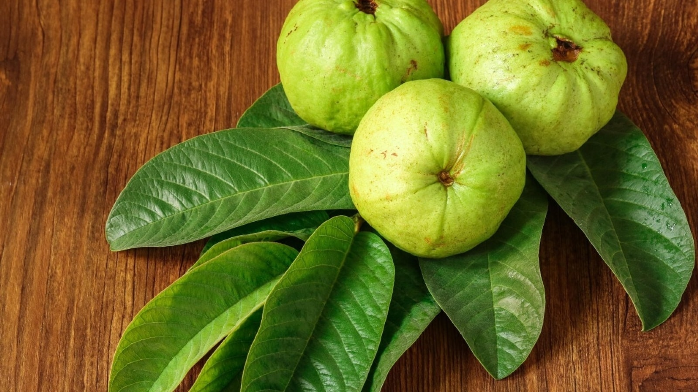

Morphology:-
Guava fruits exhibit a range of morphological characteristics, typically measuring between 4 to 12 centimetre’s (1.6 to 4.7 inches) in length, with variations in shape depending on the species, appearing either round or oval. They emit a distinct and recognizable fragrance reminiscent of lemon rind, albeit less intense. The outer skin of guava fruits may present with differing textures: it can be rough, often imparting a slightly bitter taste, or soft and sweet. The thickness of the skin varies across species and may transition from green to yellow, maroon, or remain green upon ripening. Upon slicing open a guava fruit, the pulp inside ranges from sweet to sour and can display a spectrum of colors, from off-white in "white" guavas to deep pink in "red" guavas. The seeds embedded within the central pulp vary in number and hardness, characteristics that are influenced by the specific species of guava. These morphological traits contribute to the diversity and appeal of guava fruits, offering a range of flavors, aromas, and textures for culinary enjoyment and nutritional benefits.

Plant part used:
The plant parts utilized include foliage, rhizomes, and reproductive structures such as fruits.

Chemical constituents:-

Guava leaves boast a rich array of chemical constituents, prominently featuring carotenoids and polyphenols, among which (+)-gallocatechin and leucocyanidin are noteworthy. These phytochemicals play pivotal roles not only in the nutritional profile but also in the visual appeal of the fruit. Specifically, they contribute to the vibrant hues observed in both the skin and flesh of guavas. This interplay between phytochemical composition and fruit coloration manifests particularly in the distinction between red-orange and yellow-green guava varieties. Typically, the red-orange guavas exhibit heightened levels of polyphenols and carotenoids compared to their yellow-green counterparts, suggesting a correlation between color intensity and phytochemical concentration. Such intricate chemical compositions underscore the multifaceted nature of guava leaves as a source of both visual allure and nutritional value within the botanical realm.

Uses:-
Due to its notable pectin content, guavas find widespread application in the culinary world, serving as a primary ingredient in an assortment of confections and preserves. These include candies, preserves, jellies, jams, and marmalades, with iconic examples like Brazilian goiabada and Colombian and Venezuelan bocadillo. Additionally, guavas are frequently utilized to craft marmalade jams enjoyed on toast, enriching breakfast spreads with their distinctive flavor. Red guavas, owing to their flavor profile and texture, can serve as a versatile base for savory preparations, effectively substituting for tomatoes in sauces, particularly to mitigate acidity levels. Beyond culinary pursuits, guava fruits and leaves can be steeped to create an infusion known as chá-de-goiabeira in Brazil, commonly referred to as "tea" of guava tree leaves. This beverage is esteemed for its purported medicinal properties, contributing to its consumption as a popular herbal remedy. Thus, the multifaceted utility of guavas extends from satisfying sweet cravings to offering potential health benefits, cementing their significance in various cultural and culinary traditions worldwide.

Capsicum:-
Capsicum annuum L., commonly known as capsicum, comprises dried fruits from Capsicum annuum plants, as well as small-sized dried fruits from Capsicum frutescens. It is a member of the Solanaceae family.

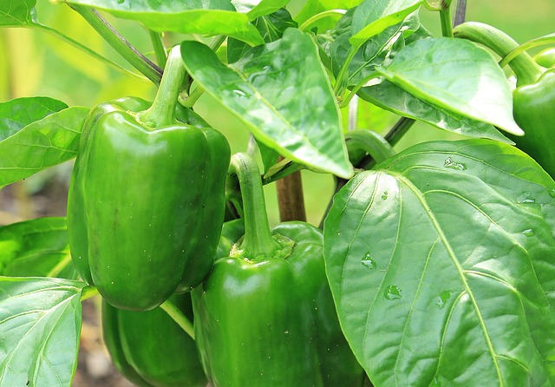

Morphology:-
In terms of appearance, the individual flowers are typically off-white, occasionally tinged with purple, and the stem is heavily branched, reaching heights of up to 60 cm (24 in). The fruits, which are berries, come in various colors including green, yellow, orange, and red when they reach maturity. Although Capsicum annuum can withstand a variety of frost-free environments, it thrives particularly well in warm, arid climates, exhibiting high productivity in such conditions.

Plant part used:-
Fruit

Chemical constituents:-
Capsicum annuum contains several chemical constituents, primarily capsaicin, paprika oleoresin, and dihydrocapsaicin. Capsaicin is a compound responsible for the pungent taste and spiciness commonly associated with chili peppers. It acts on receptors in the mouth, triggering sensations of heat and pain. Paprika oleoresin, on the other hand, is derived from the spice paprika and contains a mixture of pigments, flavors, and essential oils. It is often used as a coloring agent and flavor enhancer in various food products. Dihydrocapsaicin is structurally similar to capsaicin and contributes to the overall heat of chili peppers. These chemical constituents play crucial roles in both the culinary and medicinal uses of Capsicum annuum, providing flavor, color, and potential health benefits.

Uses:-
Capsicum offers versatile benefits across various conditions. Firstly, as a spice, it encompasses both the milder bell peppers and the spicier chili peppers, adding flavor and heat to culinary dishes. In gastrointestinal disorders, it aids in alleviating symptoms such as intestinal gas, upset stomach, cramps, pain, and diarrhea.

Regarding cardiovascular health, Capsicum plays a role in preventing heart disorders, enhancing blood circulation, and reducing blood cholesterol levels. Its inclusion in the diet can contribute to overall cardiovascular well-being.

In terms of skincare, Capsicum's counter irritant properties make it valuable in formulations such as ointments and plasters for treating conditions like rheumatism, shingles, and lumbago. Its application can provide relief from pain and discomfort associated with these ailments.

Moreover, Capsicum is utilized in managing neuronal disorders, serving as a remedy for nerve pain linked to conditions such as diabetes, HIV, fibromyalgia, and back pain. Its analgesic properties offer relief from neuropathic pain, enhancing the quality of life for individuals affected by these conditions.

Furthermore, Capsicum has a long history of use in treating mouth ulcers, with its topical application providing soothing and healing effects for oral mucosal lesions. Overall, Capsicum's multifaceted properties make it a valuable component in addressing a range of health concerns across various bodily systems.

Noni fruit:-
Noni, scientifically termed Morinda citrifolia Linn., is a tropical fruit with aliases such as Indian Mulberry, Nuna, Cheese fruit, Tookunja, Great Morinda, Mouses’pineapple, and Yellow root. It falls under the Rubiaceae family and originates from Southeast Asia but is now cultivated in tropical regions globally.

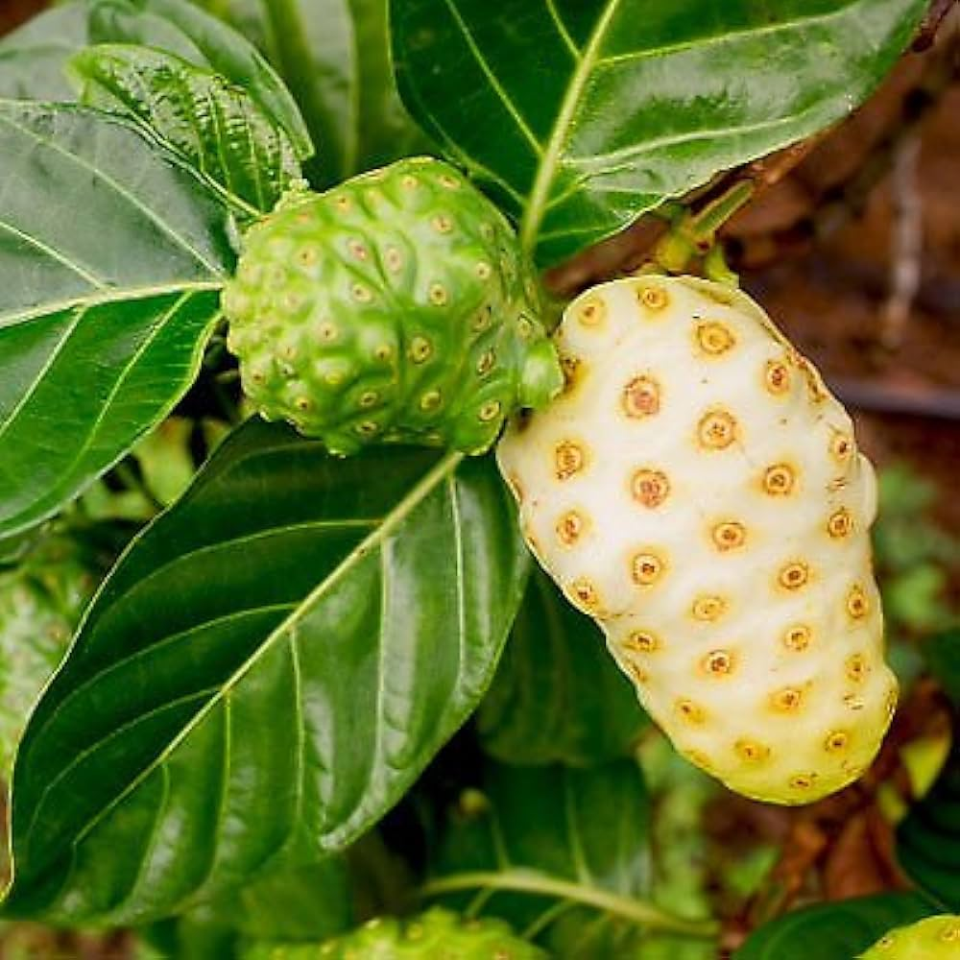

Morphology:-
The noni tree, characterized by its evergreen nature, typically features a stem with a diameter reaching around 13 cm. The sapwood of this tree presents a soft texture and a yellowish-brown hue. Meanwhile, the bark of the noni tree exhibits shades of gray or brown and generally possesses a smooth to slightly rough texture. This combination of colors and textures adds to the tree's overall aesthetic appeal and contributes to its resilience against environmental factors.

In addition to its stem and bark, the noni tree also displays distinctive characteristics in its twigs. These twigs are notably light green in color and possess a four-angled shape, providing structural support and flexibility to the branches. This unique morphology enables the noni tree to adapt to various environmental conditions and withstand the rigors of its natural habitat.

Overall, the morphology of the noni tree reflects its adaptation to its tropical habitat and showcases the combination of features that contribute to its robustness and resilience as an evergreen species.

Plant part usd:-

Fruit

Chemical constituents:-
The primary constituents responsible for the therapeutic properties of the Indian Mulberry plant include anthraquinones, flavonoids, and phenolics. Additionally, it contains oligo- and polysaccharides, glycosides, alkaloids, octanoic acid, potassium, vitamin C, terpenoids, and various anthraquinones such as nordamnacanthal, molindone, rubiadin, and rubiadin methyl ether. Other components found in Noni include carotene, vitamin A, flavone glycosides, linoleic acid, alizarin, amino acids, aucubin, Lasperuloside, caproic acid, caprylic acid, ursolic acid, rutin, and a putative proxeronine. These compounds collectively contribute to the diverse therapeutic benefits associated with Noni.

Uses:-
Traditionally, Noni fruit juice has been employed across various cultures to address a wide array of health issues. This versatile remedy has been utilized to alleviate abnormal menstruation, acne, boils, constipation, and diarrhea, providing relief from gastrointestinal discomforts. Additionally, Noni juice has been sought after for its potential benefits in managing arthritis, diabetes, fever, and high blood pressure, showcasing its purported effectiveness in addressing chronic conditions and promoting overall well-being.

Moreover, Noni juice has been traditionally used to treat gastric ulcers, sprains, mental depression, and senility, highlighting its diverse applications in physical and mental health. Its consumption has been associated with improved digestion, atherosclerosis prevention, and addressing blood vessel problems, suggesting a broad spectrum of therapeutic effects on cardiovascular health.

Furthermore, Noni juice has been explored for its potential role in managing drug addiction, potentially aiding in withdrawal symptoms and supporting recovery efforts. Its holistic approach to health and wellness encompasses various bodily systems, making it a popular choice for individuals seeking natural remedies for their ailments.

While much of the traditional use of Noni juice is based on anecdotal evidence and cultural practices, modern research has begun to shed light on its potential therapeutic properties. However, further scientific investigation is necessary to fully understand and validate the efficacy of Noni juice in treating the aforementioned conditions. Nonetheless, its long history of use across different cultures underscores its significance as a natural remedy with multifaceted health benefits.

Aloe Vera:-

Aloe vera, derived from the plant Aloe barbadensis, is a member of the Xanthorrhoeaceae family.

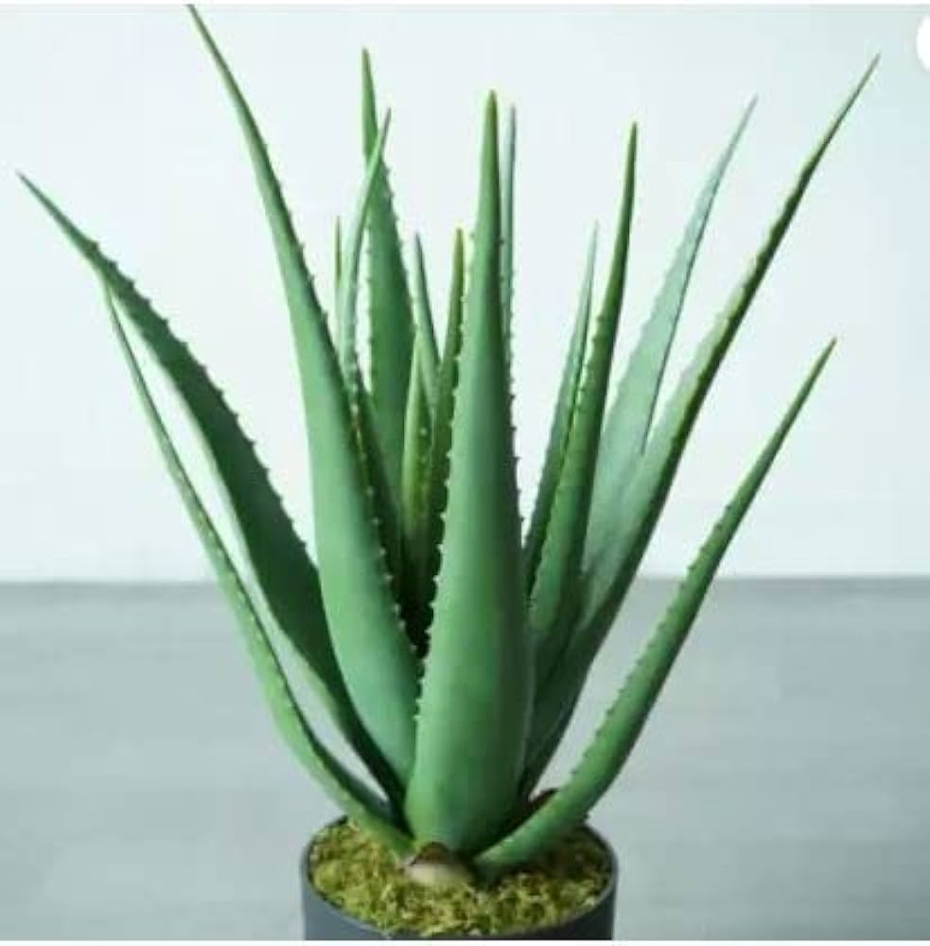.

Morphology:-
Aloe vera is a stemless or short-stemmed plant, typically reaching heights of 60–100 cm (24–39 in), and propagating through offsets. Its leaves are succulent and robust, varying from green to grey-green, sometimes displaying white spots on both upper and lower surfaces. Leaf margins are serrated with small white teeth. During summer, it produces flowers on a spike that can grow up to 90 cm (35 in) tall, featuring pendulous yellow tubular corollas measuring 2–3 cm (0.8–1.2 in) long. Aloe vera, like other members of its genus, forms arbuscular mycorrhiza, enhancing its ability to absorb mineral nutrients from the soil.

Plant part used:-

Leaves, flowers, stems, roots, fruits, seeds.

Chemical constituents:-
Aloe vera contains various chemical components such as anthraquinones, saccharides, prostaglandins, and fatty acids. Additionally, it comprises enzymes, amino acids, vitamins, and minerals. Other compounds found in Aloe vera include cholesterol, triglycerides, steroids, uric acid, lignins, beta-sitosterol, gibberellin, and salicylic acid.

Uses:-
Aloe vera possesses various medicinal properties including analgesic, antibacterial, antiviral, antifungal, antioxidant, immune-modulating, antiseptic, and anti-inflammatory effects. It is utilized in a range of dental and oral health conditions such as periodontal surgery, chemical burns, aphthous ulcers, gum abscesses, dry socket, lichen planus, benign pemphigus, and gingival issues associated with conditions like AIDS and leukemia. Aloe vera is also beneficial in managing conditions like migratory glossitis, geographic tongue, burning mouth syndrome, denture sore mouth, candidiasis, desquamative gingivitis, vesiculobullous diseases, acute monocytic leukemia, and xerostomia.

Papaya:-
The biological origin of papaya is Carica papaya Linn, belonging to the Caricaceae family, renowned for its diverse medicinal benefits. Papaya fruits are known for their antiulcer properties, while the seeds exhibit antimicrobial, anthelmintic, and antiamoebic effects.

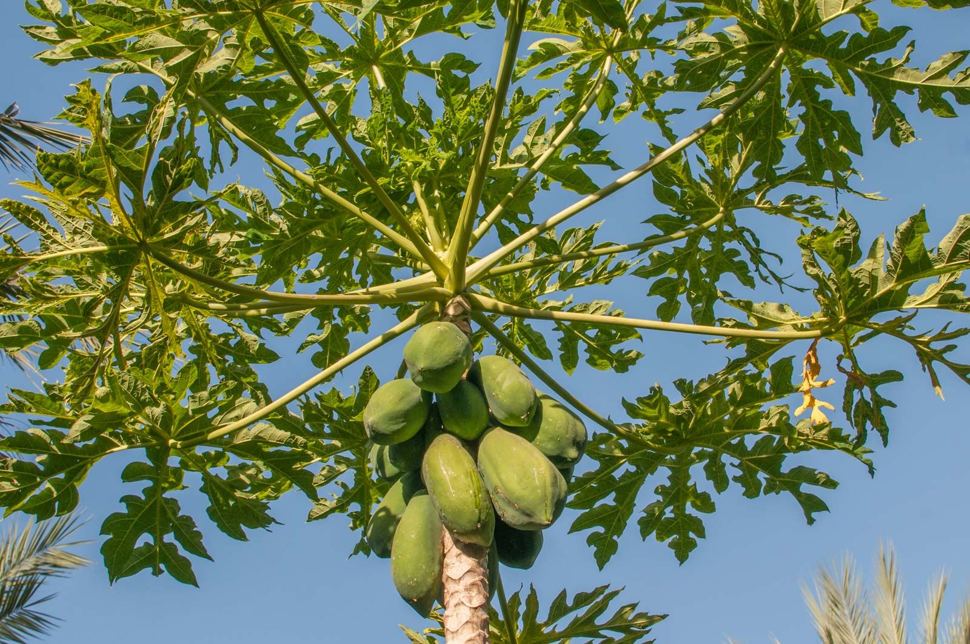

Morphology:-
The papaya plant is a tall, single-stemmed herbaceous perennial tree, reaching heights of 20–30 feet. Its leaves are notably large, up to 2 ½ feet wide, palmately lobed or deeply incised, with smooth edges, and supported by petioles measuring 1-3 feet in length. The stems are hollow, ranging from light green to tan brown, with a diameter of approximately 8 inches, displaying prominent scars.

Plant part used:-
Bark, leaves, and fruit.

Chemical constituents:-
The primary active compound in papaya, papain, is a potent digestive enzyme widely recognized for its versatility. Papaya fruit is abundant in vitamins C and E, along with essential minerals like potassium. Additionally, it contains papain and chymopapain, both robust proteolytic enzymes.

Uses:-
Papain, derived from the dried and refined latex of Carica papaya fruit, comprises a blend of proteolytic enzymes present in the unripe fruit. Widely utilized for meat tenderization, it also serves as an ingredient in cleaning solutions for soft contact lenses. Additionally, papain acts as a protein digestant, resembling the action of pepsin, and is employed to alleviate symptoms associated with episiotomy by acting on milk casein.

Turmeric:-
Turmeric, derived from Curcuma longa in the Zingiberaceae family, has been extensively studied for its medicinal properties. Research indicates its potential in treating gastric and duodenal ulcers in rats. Additionally, the volatile oil of Curcuma longa demonstrates anti-inflammatory and anti-arthritic effects. Moreover, both water and fat-soluble extracts of curcumin display potent antioxidant properties similar to vitamins C and E.

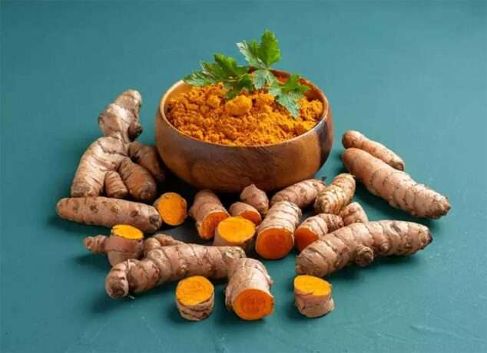

Morphology:-
Turmeric is a perennial herbaceous plant, growing up to 1 meter tall, with highly branched, aromatic rhizomes colored yellow to orange. Its leaves are arranged alternately in two rows, comprising a leaf sheath, petiole, and blade. A false stem forms from the leaf sheaths, with petioles ranging from 50 to 115 cm long. The simple leaf blades typically measure 76 to 115 cm in length and occasionally up to 230 cm, with a width of 38 to 45 cm, and they are oblong to elliptical, tapering at the tip.

plant part used:-

Rhizomes and stems

Chemical constituents:-
Turmeric contains phytochemical compounds, predominantly diaryl heptanoids, which encompass various curcuminoids like curcumin, demethoxycurcumin, and bisdemethoxycurcumin. Curcumin, for instance, comprises around 3.14% of examined commercial turmeric powder samples (with an average of 1.51%), whereas curry powder contains notably less (averaging 0.29%). Additionally, turmeric harbors approximately 34 essential oils, with major constituents including turmerone, germacrone, atlantone, and zingiberene.

Uses:-
Turmeric, primarily utilized in the form of rhizome powder, serves a multitude of purposes, chiefly prized for its ability to impart a vibrant golden-yellow hue. Its versatile applications span across a wide array of products, including canned beverages, baked goods, dairy items, ice cream, yogurt, yellow cakes, orange juice, biscuits, popcorn coloring, cereals, sauces, and gelatin. An essential component of curry powders, turmeric features prominently in countless culinary recipes, particularly in East Asian cuisine.

Although commonly employed in its dried, powdered state, fresh turmeric is also utilized, akin to ginger. In East Asian culinary traditions, fresh turmeric finds extensive use, especially in pickles characterized by sizable chunks of tender turmeric. This fresh variant adds both flavor and color nuances to culinary creations, contributing to the rich tapestry of flavors and aromas celebrated in diverse cuisines worldwide.

Glycyrrhiza glabra L.:-
Glycyrrhiza glabra L., also known as Liquorice, is a sweet, moist, and soothing herb recognized for its flavoring properties. It is a member of the Fabaceae family.

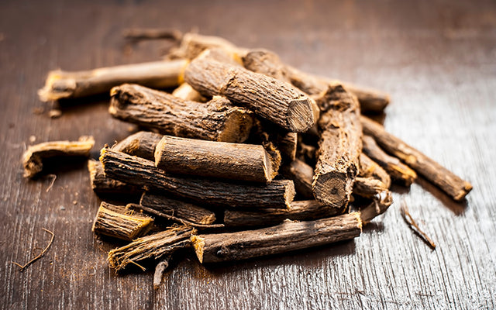

Morphology:-
The roots of Glycyrrhiza glabra Linn. contain glycyrrhizin, a saponin known for its sweetness, which is approximately 60 times sweeter than cane sugar. Additionally, the roots contain various flavonoids such as liquirtin, isoliquertin, liquiritigenin, and rhamnoliquirilin, along with newer flavonoids like glucoliquiritin apioside, prenyllicoflavone A, shinflavanone, shinpterocarpin, and 1-methoxyphaseolin. Furthermore, novel compounds including licopyranocoumarin, licoarylcoumarin, glisoflavone, and a new coumarin-GU-12 have been isolated and structurally identified. Other constituents found in the roots include four new isoprenoid-substituted phenolic compounds: semilicoisoflavone B, 1-methoxyficifolinol, isoangustone A, and licoriphenone.

Plant part used:-
Roots and stolen

Chemical constituents:-
The roots of Glycyrrhiza glabra Linn. contain glycyrrhizin, a saponin known for its sweetness, which is approximately 60 times sweeter than cane sugar. Additionally, the roots contain various flavonoids such as liquirtin, isoliquertin, liquiritigenin, and rhamnoliquirilin, along with newer flavonoids like glucoliquiritin apioside, prenyllicoflavone A, shinflavanone, shinpterocarpin, and 1-methoxyphaseolin. Furthermore, novel compounds including licopyranocoumarin, licoarylcoumarin, glisoflavone, and a new coumarin-GU-12 have been isolated and structurally identified. Other constituents found in the roots include four new isoprenoid-substituted phenolic compounds: semilicoisoflavone B, 1-methoxyficifolinol, isoangustone A, and licoriphenone.

Uses:-
This plant species, Glycyrrhiza glabra, is renowned for its diverse biological activities as documented in the literature. It exhibits anti-inflammatory properties, serves as an expectorant, and effectively controls coughing while also displaying hormonal effects. Furthermore, it plays a role in detoxifying and safeguarding the liver from harm.

Medicinally, Glycyrrhiza glabra is utilized internally to address a spectrum of ailments including Addison’s disease, asthma, bronchitis, peptic ulcer, arthritis, allergic complaints, and in steroid therapy. Externally, it finds application in treating conditions such as eczema, herpes, and shingles, providing relief and promoting healing.

Glycyrrhiza glabra has been observed to reduce serum testosterone levels in women and is beneficial in managing aplastic anemia. It also demonstrates utility in autoimmune conditions and offers therapeutic benefits in immunodeficiency conditions like AIDS. Notably, components of licorice root exhibit both estrogenic and antiestrogenic activity, rendering it valuable in treating hormone-related female issues.

Moreover, Glycyrrhiza glabra serves as an energy tonic, particularly for the spleen and stomach, and its root is incorporated into numerous formulations. Recognized for its tonic, demulcent, laxative, and emollient properties, the roots of Glycyrrhiza glabra are employed in managing genitourinary diseases, providing relief and promoting wellness in affected individuals.

Materials and Methods:-

Collection of materials
The leaves of Azadirachta indica (neem), Odium tenuiflorum (holy basil), and Aloe barbadensis (aloe vera) were meticulously gathered from the medicinal garden, presumably for the extraction of their respective medicinal properties. This meticulous collection suggests a careful selection process to ensure the highest quality and efficacy of the herbal materials obtained.

Furthermore, Carbopol 934, a commonly used polymer in pharmaceutical formulations for its thickening and gelling properties, was acquired from Colorcon, Asia. The choice of Carbopol 934 indicates a deliberate selection of a specific polymer for its suitability in the intended application, likely for formulating a topical or oral medication.

Additionally, it is noted that all other solvents utilized in the process were of analytical grade. This emphasizes the commitment to maintaining high standards of purity and consistency throughout the experimental process, which is crucial for ensuring the accuracy and reproducibility of results in scientific research and pharmaceutical development.

Overall, the detailed description provided underscores the thoroughness and precision employed in the collection of herbal materials and the procurement of necessary chemicals, highlighting the importance of quality control and meticulous attention to detail in medicinal research and formulation.

Preparation of extracts:-
The process described involves the extraction of bioactive compounds from various medicinal plants, namely Aloe barbadensis (aloe vera), Azadirachta indica (neem), and Ocimum tenuiflorum (holy basil), using ethanol as the solvent.

Initially, the fresh leaves of Aloe barbadensis were subjected to maceration with 95% ethanol for a duration of three days. Maceration is a common method used for extracting compounds from plant material by soaking it in a solvent to facilitate the dissolution of bioactive constituents. Following maceration, the mixture was then separated by centrifugation at 3000 rpm, a process used to separate solid particles from a liquid by applying centrifugal force, resulting in the isolation of the ethanolic extract of aloe (EEA). This extract likely contains a concentration of bioactive compounds derived from the aloe leaves dissolved in ethanol.

Similarly, the leaves of Azadirachta indica and Ocimum tenuiflorum were dried to preserve their phytoconstituents and subjected to separate maceration processes with ethanol. After maceration, each mixture was centrifuged to obtain the ethanolic extracts of Ocimum tenuiflorum (EEO) and Azadirachta indica (EEZ), respectively. These extracts would contain a concentration of bioactive compounds specific to each plant species, dissolved in ethanol.

Finally, all the extracted solutions were stored at room temperature, likely in tightly sealed containers to prevent degradation or contamination. Storing the extracts at room temperature ensures their stability and longevity for future use in research or pharmaceutical applications.

Overall, this extraction process highlights a systematic approach to harnessing the medicinal properties of various plant species through the isolation of their bioactive constituents using ethanol as a solvent, followed by appropriate separation techniques to obtain pure extracts for further analysis or formulation.

Phytochemical screening:-
The prepared extracts underwent preliminary phytochemical screening tests, a standard practice in pharmacognosy and medicinal plant research, aimed at identifying the presence of various bioactive components within the extracts. These screening tests help researchers understand the chemical composition of the extracts and provide insights into their potential pharmacological activities.

Several different tests and reagents were likely employed to detect specific classes of compounds commonly found in medicinal plants. These tests include but are not limited to:

1. Alkaloids: Alkaloids are nitrogen-containing compounds often associated with pharmacological activities. Common tests for alkaloids involve using reagents such as Dragendorff's reagent or Mayer's reagent, which produce characteristic precipitates or color changes when reacted with alkaloids.

2. Flavonoids: Flavonoids are polyphenolic compounds known for their antioxidant and anti-inflammatory properties. Tests for flavonoids often involve using reagents such as aluminum chloride, which forms colored complexes with flavonoids.

3. Tannins: Tannins are polyphenolic compounds with astringent properties. Tests for tannins typically involve using ferric chloride reagent, which forms a blue-black or green precipitate in the presence of tannins.

4. Saponins: Saponins are glycosides with foaming properties and potential therapeutic effects. Tests for saponins may involve producing a froth or foam upon shaking the extract vigorously due to the presence of surface-active agents.

5. Phenols: Phenolic compounds possess antioxidant and antimicrobial properties. Tests for phenols may involve using ferric chloride reagent, which produces color changes in the presence of phenolic compounds.

6. Glycosides: Glycosides are compounds containing a sugar moiety linked to a non-sugar component (aglycone). Tests for glycosides may include hydrolysis reactions to detect the presence of sugar molecules.

Each test is designed to target specific classes of compounds based on their chemical properties and known reactions. The results of these screening tests provide valuable information about the chemical composition of the extracts, guiding further investigation into their potential therapeutic uses and pharmacological activities.

Formulation of gel:-

The preparation of the herbal gel formulations involved several steps to ensure proper incorporation of the active ingredients and achieve the desired consistency. Here's a detailed description of the process:

1. Preparation of Carbopol 934 Solution: Initially, a sufficient amount of Carbopol 934 was soaked in distilled water overnight. This step is essential to hydrate the polymer and facilitate its dispersion in the water. The hydrated Carbopol 934 was then mixed with distilled water using a mechanical stirrer to create a uniform solution. Continuous stirring helps ensure thorough mixing and uniform distribution of the polymer in the water.

2. Preparation of Active Ingredient Solution: Another solution containing varying concentrations of the ethanolic extracts of Aloe vera (EEA), Ocimum tenuiflorum (EEO), and Azadirachta indica (EEZ) was prepared. Additionally, the required quantities of methyl paraben and propyl paraben, which are commonly used as preservatives in pharmaceutical formulations, were added to this solution. Propylene glycol, a humectant often used to improve the texture and consistency of gels, was also included in the solution.

3. Combining Solutions: The solution containing the active ingredients, preservatives, and propylene glycol was then added to the Carbopol 934 solution with continuous stirring. This step ensures proper dispersion of the active ingredients within the gel matrix formed by the Carbopol 934 polymer.

4. Adjustment of Volume and pH: The resulting mixture was thoroughly mixed with continuous stirring, and the volume was adjusted to 30 ml with water. The pH of the gel was then adjusted by adding triethanolamine. Triethanolamine is commonly used to neutralize acidic solutions and achieve the desired pH range for pharmaceutical formulations.

5. Formulation Variations: Seven different formulations (F1 to F7) of the herbal gel were prepared, likely with varying concentrations of the active ingredients and other excipients. These variations allow for the testing of different formulations to optimize the gel's properties, such as consistency, stability, and efficacy.

Overall, this detailed process ensures the proper incorporation of the active ingredients into the gel matrix, as well as the adjustment of pH and volume to achieve the desired characteristics of the final herbal gel formulations.

Evaluation of Gel:-

Visual appearance

1. Color Assessment:
Each gel was visually inspected to determine its color profile.
Any deviations or inconsistencies in color were noted for further analysis.

2. Clarity Evaluation:
The clarity of the gels was examined to identify any turbidity or haziness.
Clear gels were considered preferable, while any cloudiness was documented.

3. Texture Analysis:
The consistency and smoothness of the gels were assessed through tactile examination.
Variations in texture, such as graininess or lumpiness, were observed and recorded.

4. Transparency Inspection:
-The level of transparency in the gels was evaluated to gauge their translucency.
Transparent gels were favored, and any opacity was documented as necessary.

5. Detection of Gritty Particles:
A thorough visual inspection was conducted to detect the presence of any gritty particles.
Any observed particles were noted, indicating potential impurities or inconsistencies.

Overall, this meticulous assessment aimed to ensure the quality and suitability of the prepared gels for their intended use, with each point serving as a critical aspect of the evaluation process.

Measurement of pH
In a meticulous process, the pH levels of herbal gel formulations were meticulously ascertained using a digital pH meter. Initially, a standardized procedure was followed where 1 gram of the gel was precisely measured and dispersed in 10 milliliters of distilled water. This mixture was then allowed to settle for a duration of two hours, ensuring thorough dispersion and equilibration of the gel within the water medium.

Following the stipulated waiting period, the pH measurements of the gel formulations were conducted three times using the digital pH meter. This repetitive measurement approach aimed to account for any potential variability or fluctuations in the pH readings, thereby enhancing the accuracy and reliability of the results.

Subsequently, the pH values obtained from the three measurements were averaged to derive a representative pH value for each gel formulation. This average pH value was then reported as the final result, providing a comprehensive assessment of the formulation's acidity or alkalinity.

Overall, this systematic methodology ensured precise determination of the pH levels of the herbal gel formulations, enabling researchers to accurately characterize their chemical properties and suitability for various applications in fields such as cosmetics, pharmaceuticals, or personal care products.

Homogeneity:-
After the gel formulations were prepared and set into their respective containers, a meticulous evaluation for homogeneity was conducted through visual inspection. This involved carefully examining each container to assess the uniform distribution of components within the gel.

The primary focus of this inspection was to detect any irregularities such as the presence of aggregates or clumps, which could indicate inadequate mixing or inconsistencies in the formulation process. By scrutinizing the appearance of the gel in each container, researchers aimed to ensure that it exhibited a smooth and uniform texture throughout, without any localized areas of concentration or separation.

Any observed aggregates or unevenness in the gel's appearance would have been noted, indicating potential issues with formulation quality or stability. This step is crucial for ensuring the overall efficacy and aesthetic appeal of the gel product, as well as maintaining consistency in its performance upon application.

Overall, this visual inspection served as a vital quality control measure, allowing researchers to confirm the homogeneity of the developed gel formulations and address any discrepancies before proceeding with further testing or production stages.

Spreadability:-
The spreadability of gel formulations was evaluated using a standardized method that involves measuring the time taken for two slides to separate when a gel sample is placed between them under a specific load. This evaluation is crucial for assessing the ease with which the gel can be spread or applied onto the skin or other surfaces.

To calculate spreadability, the following formula was employed:
\[ S = \frac{M \times L}{T} \]
Where:
- \( S \) represents the spreadability of the gel formulation.
- \( M \) denotes the weight tied to the upper slide, exerting a certain load.
- \( L \) indicates the length of the glass slides.
- \( T \) signifies the time taken for the slides to separate when the gel is placed between them.

In essence, a lower time taken for the slides to separate indicates better spreadability, as it suggests that the gel formulation allows for smoother and easier spreading. The calculation accounts for both the applied load and the physical dimensions of the slides to provide a quantitative measure of the gel's spreadability.

By reporting the spreadability of gel formulations, researchers can provide valuable insights into their application characteristics, helping to guide formulation optimization and product development efforts. Additionally, this information aids in comparing different formulations and determining their suitability for specific usage scenarios, such as topical applications in cosmetics or pharmaceuticals.

Viscosity:-
The viscosity analysis of all prepared formulations was conducted using the Brookfield viscometer LVDVE equipped with a helipath system. This specialized equipment allows for precise measurement of viscosity, an important parameter that indicates the resistance of a fluid to flow.

The specific testing conditions involved using spindle number 96 at a rotational speed of 10 revolutions per minute (rpm). Spindle selection is crucial as it ensures compatibility with the rheological properties of the gel formulations being tested. Spindle number 96 is likely chosen based on its suitability for measuring the viscosity of semi-solid materials such as gels.

The helipath system employed in the viscometer facilitates accurate and repeatable measurements by ensuring consistent sample conditions throughout the testing process. This system utilizes a unique geometry that minimizes sample disturbance and eliminates edge effects, resulting in more reliable viscosity readings.

During the analysis, each formulation was carefully loaded onto the viscometer, and the spindle was immersed into the sample. The instrument then precisely controlled the rotational speed of the spindle at 10 rpm while simultaneously measuring the torque required to overcome the resistance to flow exhibited by the gel.

The viscosity values obtained from the measurements provide valuable insights into the flow behavior of the gel formulations. Higher viscosity values indicate greater resistance to flow, while lower viscosity values suggest easier flow characteristics. This information is crucial for various applications, including product formulation, process optimization, and quality control.

Overall, the viscosity analysis using the Brookfield viscometer LVDVE with helipath and spindle number 96 at 10 rpm ensures accurate characterization of the rheological properties of the prepared gel formulations, aiding in their development and optimization for specific end uses.

Antimicrobial activity:-

The antimicrobial activity of seven gel formulations, along with a commercially available mouth ulcer gel (Hiora gel), was evaluated using the well diffusion method. This method assessed both antibacterial and antifungal properties against two microbial cultures: Candida albicans (fungi) and E. coli (bacteria).

For the antibacterial activity assessment, plates containing nutrient agar media were prepared. Each plate was inoculated with a 0.1 ml aliquot of bacterial suspension, which was evenly spread across the surface of the medium. After a 15-minute incubation period, wells with a diameter of 6 mm were created in the agar using a sterile cork borer. Each well was then filled with 0.5 grams of the gel formulations. Subsequently, all plates were incubated at 37°C for 24 hours to allow for bacterial growth. The antibacterial activity was determined by measuring the diameter of the zone of inhibition (ZOI) surrounding each well, indicating the extent to which bacterial growth was inhibited by the gel formulations.

For the assessment of antifungal activity, plates containing Sabouraud dextrose agar media were prepared. Similar to the antibacterial assay, each plate was inoculated with a 0.1 ml aliquot of fungal suspension, which was spread evenly on the solid media. After a 15-minute incubation period, wells with a 6 mm diameter were created using a sterile cork borer, and each well was filled with 0.5 grams of the gel formulations. The plates were then incubated at 27°C for 5-7 days to allow for fungal growth. Following the incubation period, the diameter of the zone of inhibition around each well was recorded to assess the antifungal activity of the gel formulations.

To ensure the reliability of the results, triplicates were performed for each gel formulation against each test organism in both the antibacterial and antifungal assays. This rigorous testing protocol provided comprehensive insights into the antimicrobial efficacy of the gel formulations against both bacterial and fungal pathogens, informing their potential suitability for therapeutic applications targeting oral infections and other related conditions.

Conclusion:-

The article delves into a comprehensive exploration of the treatment of mouth ulcers, commonly referred to as canker sores, with a specific focus on the application of herbal gel enriched with flavonoids. These painful lesions, manifesting on the mucous membranes within the oral cavity, pose significant discomfort and challenge for patients. By highlighting the therapeutic potential of herbal remedies, the study not only sheds light on alternative approaches to managing oral ailments but also underscores the importance of traditional medical practices deeply ingrained in indigenous cultures worldwide.

Drawing from the rich heritage of traditional and herbal medicine, particularly in regions like India, the article emphasizes the effectiveness of herbal formulations in preventing and curing diseases. The preference for herbal medicine stems from its notable advantage of causing fewer side effects compared to synthetic alternatives, a point that resonates with the increasing demand for natural remedies in modern healthcare.

Moreover, the exploration of herbal remedies enriched with flavonoids serves as a testament to the synergy between traditional wisdom and scientific research in addressing contemporary health challenges. By elucidating the prominent role of flavonoids in alleviating the discomfort associated with mouth ulcers, the study not only contributes to advancing our understanding of herbal medicine but also underscores the importance of integrating traditional knowledge into mainstream healthcare practices.

In essence, the article advocates for a holistic approach to oral health management, where the therapeutic potential of herbal remedies, particularly those containing high flavonoid content such as guava leaves, is recognized and utilized alongside conventional treatments. This integrative approach not only offers patients a broader spectrum of treatment options but also highlights the enduring relevance of traditional medical practices in meeting the healthcare needs of diverse populations.

The formulation and evaluation of herbal mouth ulcer gel derived from guava leaves represent a promising avenue in the management of oral health conditions, particularly mouth ulcers. Through meticulous research and experimentation, the study has demonstrated the efficacy of utilizing natural ingredients, such as guava leaves, known for their rich flavonoid content, in formulating therapeutic gels.

The results of the evaluation highlight the potential of herbal formulations to alleviate the discomfort associated with mouth ulcers while minimizing adverse effects commonly associated with synthetic alternatives. By leveraging the healing properties of herbal ingredients, the study not only underscores the importance of traditional knowledge in modern healthcare but also paves the way for the development of safer and more accessible treatment options for oral ailments.

Furthermore, the formulation of herbal mouth ulcer gel represents a convergence of scientific innovation and traditional wisdom, offering patients a holistic approach to oral health management. As such, the findings of this study hold significant implications for healthcare practitioners and researchers alike, emphasizing the value of exploring natural remedies in addressing contemporary health challenges.

Overall, the formulation and evaluation of herbal mouth ulcer gel of guava leaves signify a promising step towards integrating herbal medicine into mainstream healthcare practices, ultimately contributing to improved patient outcomes and quality of life.

Reference:-

1. Vorvick, L. J. (2012). Mouth ulcers on MedlinePlus. ADAM Inc.

2. "Ulcer." Dictionary.com Unabridged (Online). n.d. Retrieved July 19, 2015, from https://www.dictionary.com/browse/ulcer.

3. "Ulcer." Merriam-Webster Medical Dictionary. Merriam-Webster, Inc. Retrieved December 27, 2012, from http://www.merriam-webster.com/medlineplus/ulcer.

4. Strassburg, M., Knolle, G., & Loevy, H. T. (1994). Diseases of the oral mucosa: A color atlas. (No Title).

5. Scully, C. (2012). Oral and maxillofacial medicine: the basis of diagnosis and treatment. Elsevier Health Sciences.

6. Lippert, F. (2013). An introduction to toothpaste-its purpose, history and ingredients. In Toothpastes (Vol. 23, pp. 1-14). Karger Publishers.

7. Shim, Y. J., Choi, J. H., Ahn, H. J., & Kwon, J. S. (2012). Effect of sodium lauryl sulfate on recurrent aphthous stomatitis: a randomized controlled clinical trial. Oral Diseases, 18(7), 655-660. Field, A., & Longman, L. (2003). Tyldesley's oral medicine (5th ed., pp. 23-28). Oxford: Oxford University Press.

8. "Mouth ulcers" (https://www.nhs.uk/conditions/mouth-ulcers/) . NHS. 18 October 2017. "do not use toothpaste containing sodium lauryl sulphate"

9. Öner, Ü., Özdemir, Ş., Öner, F., & Akdeniz, N. (2020). Do heavy metals accumulated in saliva involve in the etiopathogenesis of recurrent aphthous stomatitis?. Biological Trace Element Research, 198(1), 46-50.

10. Gilbert, N. (2018). European Union debates controversial plans to limit cadmium in fertilizer. Science. https://doi. org/10.1126/science. aat8448.

11. Field, A., & Longman, L. (2003). Tyldesley's oral medicine (5th ed., pp. 23-28). Oxford: Oxford University Press.

12. Cawson, R. A., & Odell, E. W. (1998). Essentials of oral pathology and oral medicine. (No Title).

13. Zbar, A. P., Ben-Horin, S., Beer-Gabel, M., & Eliakim, R. (2012). Oral Crohn's disease: is it a separable disease from orofacial granulomatosis? A review. Journal of Crohn's and Colitis, 6(2), 135-142.

14. Burket, L. W., Lynch, M. A., Brightman, V. J., & Greenberg, M. S. (2003). Burket's oral medicine: diagnosis and treatment. (No Title).

15. Sapp, J. Phillip; Lewis Roy Eversole; George W. Wysocki (2004). Contemporary Oral and Maxillofacial Pathology (https://archive.org/details/contemporaryoral0000sapp_w9z1) . Mosby. ISBN 978-0-323-01723-7.

16. Scully, C., & Shotts, R. (2000). Mouth ulcers and other causes of orofacial soreness and pain. Bmj, 321(7254), 162-165.

17. Keogan, M. T. (2009). Clinical Immunology Review Series: an approach to the patient with recurrent orogenital ulceration, including Behçet's syndrome. Clinical & Experimental Immunology, 156(1), 1-11.

18. BW Neville; DD Damm; CM Allen; JE Bouquot (2002). Oral & maxillofacial pathology (https://archive.org/details/oral maxillofacia00nevi) (2. ed.). Philadelphia:W.B. Saunders. pp. 253 (https://archive.org/details/oralmaxillofacia00nevi/page/n265) –84. ISBN 978-0-7216-9003-2.

19. Li, J., Zhang, Y. Y., Wang, N. N., Bhandari, R., & Liu, Q. Q. (2016). Riga–Fede disease in a child. Clinical and experimental dermatology, 41(3), 285-286.

20. Toon, M. H., Maybauer, D. M., Arceneaux, L. L., Fraser, J. F., Meyer, W., Runge, A., & Maybauer, M. O. (2011). Children with burn injuries-assessment of trauma, neglect, violence and abuse. Journal of injury and violence research, 3(2), 98.

21. Rezk, S. A., Zhao, X., & Weiss, L. M. (2018). Epstein-Barr virus (EBV)–associated lymphoid proliferations, a 2018 update. Human pathology, 79, 18-41.

22. Kharazmi, M., Sjöqvist, K., & Warfvinge, G. (2012). Oral ulcers, a little known adverse effect of alendronate: review of the literature. Journal of oral and maxillofacial surgery, 70(4), 830-836.

23. Healy, C. M., Smyth, Y., & Flint, S. R. (2004). Persistent nicorandil induced oral ulceration. Heart, 90(7), e38-e38.

24. Fazzi M, Vescovi P, Savi A, Manfredi M,Peracchia M (October 1999). "[The effects of drugs on the oral cavity]". Minerva Stomatologica. 48 (10): 485–92.PMID 10726452 (https://pubmed.ncbi.nl
m.nih.gov/10726452) .

25. James R. Hupp; Myron R. Tucker; Edward Ellis (2008). Contemporary oral and maxillofacial surgery (https://archive.org/details/contemporaryoral00hupp)(5th ed.). St. Louis, Mo.: Mosby Elsevier.p. 433 (https://archive.org/details/contemporaryoral00hupp/page/n445) . ISBN 978-0-323-04903-0.

26. "BNF and BNFc are only available in the UK" (https://www.nice.org.uk/bnf-bnfc-uk-only) . NICE. Retrieved 11 December 2018.

27. Regezi JA, Sciubba JJ, Jordan RK (2011).Oral pathology : clinical pathologic correlations (6th ed.). St. Louis, Mo.:Elsevier/Saunders. ISBN 978-1455702626.

28. "Balsam of Peru contact allergy" (http://dermnetnz.org/dermatitis/balsam-of-peru-allergy.html) . Dermnetnz.org. 28 December 2013. Retrieved 5 March 2014.

29. Gottfried Schmalz; Dorthe Arenholt Bindslev (2008). Biocompatibility of Dental Materials (https://books.google.com/books?id=mrreTHuo54wC&q=balsam+of+peru+allergy&pg=PA352) . Springer.ISBN 9783540777823. Retrieved 5 March 2014.

30. Thomas P. Habif (2009). Clinical Dermatology (https://books.google.com/b ooks?id=kDWlWR5UbqQC&q=%22balsam+of+peru%22+allergy&pg=PT530) .Elsevier Health Sciences. ISBN 978-0323080378. Retrieved 6 March 2014.

31. Bope, E. T., & Kellerman, R. D. (2012). Conn's Current Therapy 2013: Expert Consult: Online. Elsevier Health Sciences.

32. Thorat, Y. S., Sarvagod, A. M., Kulkarni, S. V., & Hosmani, A. H. (2015). Treatment of mouth ulcer by curcumin loaded thermoreversible mucoadhesive gel: a technical note. Int J Pharm Pharm Sci, 7(10), 399-402.

33. Ranade, M. A. N. (2014). Enrichment of antiâ€ ulcer activity of monoammonium glycerrhizin and Aloe vera gel powder through a novel drug delivery system. Asian Journal of Pharmaceutics (AJP), 8(4), 222-229.

34. Yogi, D., Patel, G., Bhimani, B., Chaudhary, S., & Patel, U. (2015). Formulation and evaluation of gel containing amlexanox for mouth ulcer. International Journal of Pharmaceutical Research and Bio-Science, 4(2), 356-364.

35. Bash, B. N., & Prakasam, K. (2011). Formulation and evaluations of gel containing fluconazole-antifungal agent (Doctoral dissertation, Acharya & BM Reddy College of Pharmacy (ABMRCP)).

36. Jamadar, M. J., & Shaikh, R. H. (2017). Preparation and evaluation of herbal gel formulation. Journal of Pharmaceutical Research and Education, 1(2), 201-24.

37. Khademi, H., Iranmanesh, P., Moeini, A., & Tavangar, A. (2014). Evaluation of the effectiveness of the iralvex gel on the recurrent aphthous stomatitis management. International Scholarly Research Notices, 2014.

38.Singh, S., & Rohilla, B. D. (2015). Formulation and Evaluation of Herbal Gel From Different Parts of Cyamposis tetragonoloba (L.) Taub. For Wound Healing. World Journal of Pharmacy and Pharmaceutical Sciences, 5(3), 740-752.

39.Chun-Lei, L. I., He-Long, H., Wan-Chun, W., & Hong, H. (2016). Efficacy and safety of topical herbal medicine treatment on recurrent aphthous stomatitis: a systemic review. Drug Design, Development and Therapy, 10, 107.

40. Rao, K. P., Vijaybhaskar, D., & Pratima, S. (2011). Formulation of topical oral gel for the treatment of oral sub mucous fibrosis (OSMF).

41. Rezvaninejad, R., Nabavi, N., Khoshroo, S. M., Torabi, N., & Atai, Z. (2017). Herbal medicine in treatment of recurrent aphthous stomatitis: A literature review. Journal of Iranian Dental Association, 29(3), 127-134.

42. Aslani, A., Zolfaghari, B., & Davoodvandi, F. (2016). Design, formulation and evaluation of an oral gel from Punica granatum flower extract for the treatment of recurrent aphthous stomatitis. Advanced Pharmaceutical Bulletin, 6(3), 391.

43. Ambikar, R. B., Phadtare, G. A., Powar, P. V., & Sharma, P. H. (2014). Formulation and evaluation of the herbal oral dissolving film for treatment of recurrent aphthous stomatitis. International Journal of Phytotherapy Research, 4(1), 11-18.

44. Teresa, A., Krishna Kumar, K., & Dinesh Kumar, B. (2017). Anish john. Herbal Remedies for Mouth Ulcer. Journal of Bio Innovation, 6(4), 521-527.

45. Dhere, M. D., Kumbhar, R. B., & Holam, M. R. (2017). Extraction, Phytochemical study, Formulation and Evaluation of Antiulcer activity of Jasminum Grandifloram L. International Journal for Pharmaceutical Research Scholars, 6(2), 111-119.

46. Shaikh, S., & Shete, A. (2018). Studies on Inorganic materials based Anticancer Pharmaceutical Gel for Oral Cavity Formulation and Evaluation. Acta Scientific Pharmaceutical Sciences, 2(7), 38-44.

47. Anushri, M., Yashoda, R., & Puranik, M. P. (2015). Herbs: A good alternatives to current treatments for oral health problems. Dermatitis, 7, 9-12.

48. Thorat, Y. S., Sarvagod, A. M., Kulkarni, S. V., & Hosmani, A. H. (2015). Treatment of mouth ulcer by curcumin loaded thermoreversible mucoadhesive gel: a technical note. Int J Pharm Pharm Sci, 7(10), 399-402.

49. Vimala, G., & Gricilda Shoba, F. (2014). A review on antiulcer activity of few Indian medicinal plants. International journal of microbiology, 2014.

50. Singh, S., & Rohilla, B. D. (2015). Formulation and Evaluation of Herbal Gel From Different Parts of Cyamposis tetragonoloba (L.) Taub. For Wound Healing. World Journal of Pharmacy and Pharmaceutical Sciences, 5(3), 740-752.

52. Li, C. L., Huang, H. L., Wang, W. C., & Hua, H. (2015). Efficacy and safety of topical herbal medicine treatment on recurrent aphthous stomatitis: a systemic review. Drug design, development and therapy, 107-115.

53. Surjushe, A., Vasani, R., & Saple, D. (2008). Aloe vera: a short review. Indian journal of dermatology, 53(4), 163-166.

54. Thombre, K. P., Sharma, D., & Lanjewar, A. (2018). Formulation and evaluation pharmaceutical aqueous gel of powdered Cordia dichotoma leaves with guava leaves. Am. J. PharmTech Res, 8, 268-277.

55. Mateos, R. M., Jiménez, A., Román, P., Romojaro, F., Bacarizo, S., Leterrier, M., ... & Palma, J. M. (2013). Antioxidant systems from pepper (Capsicum annuum L.): involvement in the response to temperature changes in ripe fruits. International Journal of Molecular Sciences, 14(5), 9556-9580.

56. Aravind, G., Bhowmik, D., Duraivel, S., & Harish, G. (2013). Traditional and medicinal uses of Carica papaya. Journal of medicinal plants studies, 1(1), 7-15.

57. Rathaur, P., Raja, W., Ramteke, P. W., & John, S. A. (2012). Turmeric: The golden spice of life. International Journal of pharmaceutical sciences and research, 3(7), 1987.

58. Nalini Sofia, H., & Walter, T. M. Review of Glycyrrhiza glabra, Linn. Research gate, 10-18.

59. Ali, M., Kenganora, M., & Manjula, S. N. (2016). Health benefits of Morinda citrifolia (Noni): A review. Pharmacognosy Journal, 8(4).

