Electronic Voting Mechanism using Microcontroller ATmega328P with ESP8266 WiFi Module

Shelly bansal
Shellybansal2001@gmail.com

Abstract—Election is one of the major issues when it comes to deciding the representative of the country. The methods which are used today for voting are not accurate and advantageous and the result of this voting is sometimes get inaccurate .That’s why , community has no trust on this election process and not also on the parties who take part in elections. This project creates an electronic voting system facilitates the fast, free and fair election of leader. The basic idea used in this machine is to provide a mechanism that will help eliminate fraud and advance form of electronic voting book.
In this proposed system the whole data is upload on the server through ESP8266 WI-FI module and after the voters voted then the result is uploaded on server and the result is displayed on the LCD. . Here, the live votes would also be showed using Thing Speak server to stop any distortion with the votes which can be occur on the old method of voting system.

Introduction

An election is the the process in which a party can give the vote to an individual without any force . In addition, elections may include any type of voting which will depend on location most positions within regional , state, and central governments vote in some type of election. In all-paper elections, voters give their votes by actually placing their ballots in sealed boxes located throughout the constituencies in a given round. s .. after the end of the electoral period, some of these containers are unlock and the votes are counted in the existense of some officers.

on this manner, there may be error in counting of votes or in a few cases electorate find methods to vote extra than as soon as. now and again votes are even influence to distract the output of an election in favour of positive candidates. in order to erradicate those situations , the authorities of India came up with direct-recording electronic (DRE) balloting system which might be usually electronic vote casting machine (EVM).
The aim of this challenge is to develop an digital balloting machine the use of Arduino a good way to help to get rid of the use of guide vote casting device that have numerous dangers like inconsistency in statistics access, room for errors, mis-keying statistics. The present system will used to create a clear environment without distortion of information, as it is capable of instantly freezing the vote. The gadget right here refers to n different switches in which n represents a number of political events like BJP, congress and many others.
The user/voter selects the preferred candidate from the alternatives. The very last vote is then displayed on the LCD and the final result is mechanically obtained by clicking the output button. it is here that live voices can additionally be displayed using the ThingSpeak server to avoid any distortion of statistics that might happen if we save on external power.

MOTIVATION FOR THE CURRENT WORK

The most important advantage is that it can save printing
millions of ballot papers, because each polling station only
needs one vote for the voting group, not one vote for each
voter. This results in significant savings in paper, printing,
shipping, storage and distribution costs. Secondly, while thevote count is very fast and tickets can be issued in 2-3 hour
, the normal process takes an average of 30-40 hours, Third
, there are no invalid votes according to voting in EVMs .
.The importance of this is better understood if you that,
remember that, in all general elections,the number of
wrong votes in most constituencies exceed the number
of winners and runners-up.

Refrence OF THE CURRENT WORK

In order to build-up the project, the data of the studies
in the voting state are analyzed. Most show interest in
poll based voting, while others are interested in
fingerprinting, sales, etc. developed electronic voting
machines that use different features and indicators such a However, the previous procedure was ineffective to
prevent vote fraud in the system. So, this study solves the problem.Arduino UNO ,ESP 8266 WiFi module and
LCD display were used to create the proposed syestem.

REsearch REVIEW

Agarwal et al. [2] developed a cryptographic system to increase the value of the system by publishing the results in a short time. Section improves the security of existing
systems. They offer to expand the constituency as they
grow. Matching here is done at the server level.
Additionally, GSM and IOT are used to generate results
very quickly to increase operational efficiency [3].
KoneSrikrishnaswetha et al. Research on facial
recognition and proof of aadhar and smart voting e-voting with IOT is presented. Its users have found it a
very secure voting device as it uses facial recognition and a
unique Aadhar number to identify IOT. It targets
different users for longterm use and ensures data security [5].
RahilRezwan et al. A biometric secure electronic voting machine using Arduino and fingerprint scanner is proposed to help identify all users and avoid fake voters. The reporting system is a digital security system used in countries such as Bangladesh [4].
.

PROPOSED SYSTEM
,
This project is about a simple smart electronic voting machine using Arduino. The major concept of this undertaking is to create an digital balloting device that will assist cast off poll fraud and the previous model of electronic voting. The system has n keys, where n is the batch number. Here,
voters will be allowed to select their favorite candidates from a panel of buttons. Final voting results are then displayed on the LCD to the delight of voters.

In this system we used ESP8266 wi-fi module which will help to give access to the arduino with wi-fi network . This module is able of hosting an application or overloading all wi-fi networking function from other Processor.SO with the help of ESP8266 wi-fi module we are able to send and receive data over wifi.

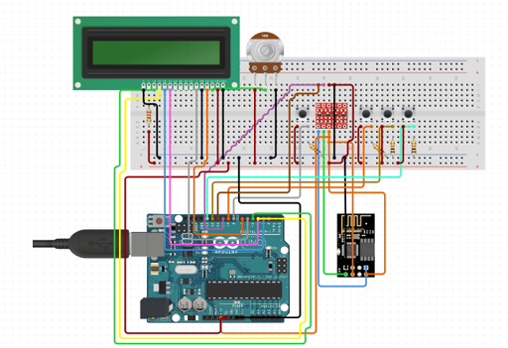
Fig.1 Circuit Diagram of the Arduino

Advantages of this machine

- Votes are counted very quickly and results are announced in 2 to 3 hours, compared to the average 30 to 40 hours with traditional systems.
- According to the voting held in EVMs, there are no invalid votes.
- When using EVM, the choice of voters will be more reflected.
- Voting using EVM saves millions of paper printing costs, reducing environmental impact and costs.

vi. TECHNOLOGY USED

Things speak- Things speak free software net of factors (IOT) application and API to shop and retrieve information from things the use of the HTTP and MQTT protocol over the internet or via local region network.Thing Speak permits the introduction of sensor
logs, place tracking programs and all types of relationshp
with popularity updates.” Thing speak changed into orignally released with the aid of io Bridge in 2010 as a
Service in guide of IOT packages.Thing Speak IOT
Integrates instructions from Math Works' math softwareMATLAB, allowing Thing Speak users to review and visualize data downloaded using Matlab without obtaining a Matlab license from Math Works.

B).Arduino-- Arduino Integrated Development Environment(IDE) is an integrated programming written in C and C++. Widely used on Arduino forum to write and add packages, but with the help of1/3 of the famous cores from other dealer developer forums.

vii. COMPONENTS USED

- Arduino Board
- Push Buttons
- ESP8266 Wi-Fi Module
- Potentiometer
- Liquid Crystal Display
- Connecting wires

Arduino Board: Arduino UNO is an free-source microcontroller board based totally at the Microchip ATmega328P microcontroller and advanced by way of Arduino.cc.
The board is ready to interact with the digital and analog input/output (I/O) pins of various development groups (development forums) and other circuits.
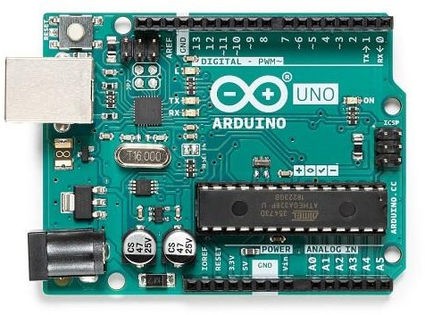
Fig.2 Arduino board

Push button:Thesebutton is a simple sort of transfer that controls an order in a machine or a few kind of method.typically the buttons are plastic or metallic. Buttons can be finger or hand fashioned for ease of use, or just

undeniable.

Fig.3 Push Buttons

Liquid Crystal Display: lcd modules form a very crucial in lots of Arduino based totally embedded gadget designs to enhance the person interface of the
system.Interfacing with Arduino gives the programmer greater freedom to coustimise the code effortlessly.

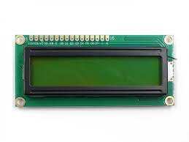
Fig.4 LCD Display

Connectingwires:Jumpers offer a medium for
electric powered modern -day to journey from one
point of a circuit to another.. inside the case of computer systems, wires are embedded into circuit forums to carry pulses of electricity. The connected wires of a tool are used to attract electricity and strength and perform particular tasks.
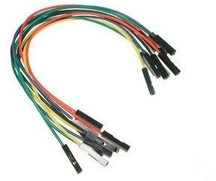
Fig. 5 Connecting wires
Potentiometer:A potentiometer is a simple switch on the Arduino board that provides a differential that we can read analogously.
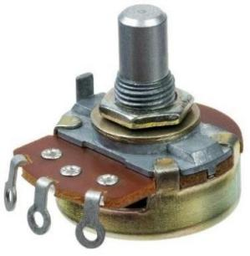
Fig.6 Potentiometer

ESP8266WIFi ModuleThe ESP8266 module is a
Standalone SOC containing a TCP/IP protocol stack
that allows any microcontroller to access your WiFi network. The ESP8266 can host a software website or load all network functions from other electronic devices.
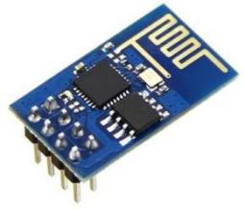
Fig.7 ESP WIFI Module

VIII. WORKFLOW OF THE PROPOSED SYSTEM

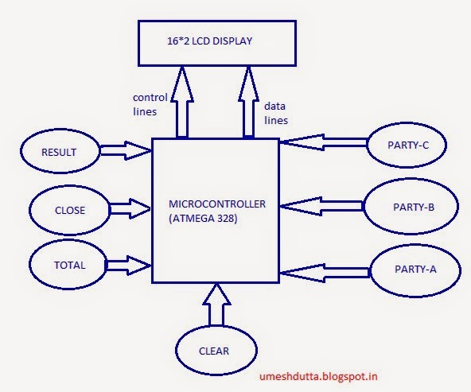
Fig.8 Workflow of the Project

Step 1: Vote Casting and Display the casted vote on LCD

The hardware here is designed using Arduino UNO board. The four buttons are for candidates competing in the election. Three buttons are used for candidates A, B, C and the las button is used to view the election results. By pressing threebuttons, the voting results are displayed on the LCD to
the voters. Also, in the case of the ballot box, each press of
the button will increase the candidate's vote value by one.
When the voting is finished, use the results button to view the results on the LCD. The whole process is done with the help of Arduino UNO Board which plays an important role to this whole mechanism .

Step 2: Upload data on server

Here the details of the votes will be sent permanently to the central database of the polling station, which uses the ThingSpeak server to maintain data management. This will also help count the votes on the site. We can also use the Blynk App to send data to the server.

IX. Result of the Hardware connection

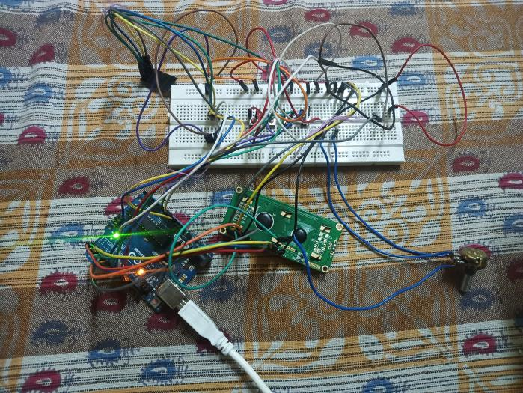

Fig.9 Connection of proposed system

Initial Phase of LCD

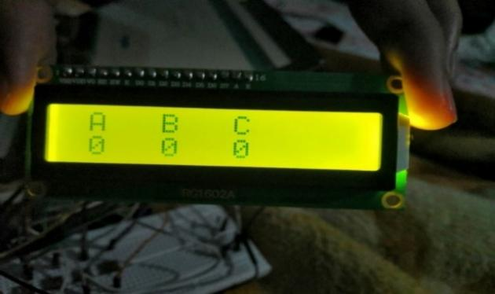
Fig.10 Result on the LCD display when no vote is casted

Report election results. Here, candidate "A" is ahead of other candidates because "A" got 2 votes. And 'B' and 'C' get one vote each.

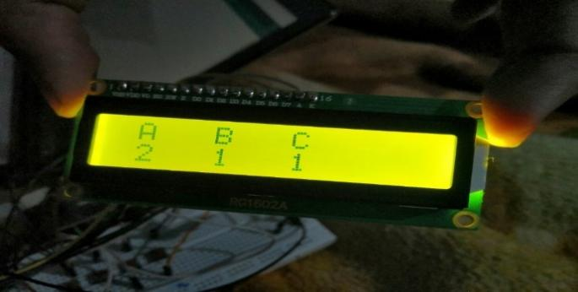

Fig.11 Final Phase of LCD

The LCD display shows the final result after casting the vote.

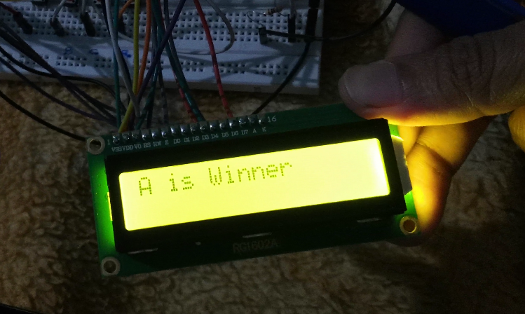

Fig.12 Results Displayed on the LCD

Show the monitor when establishing the WIFI connection
and the results sent to the server during selection.

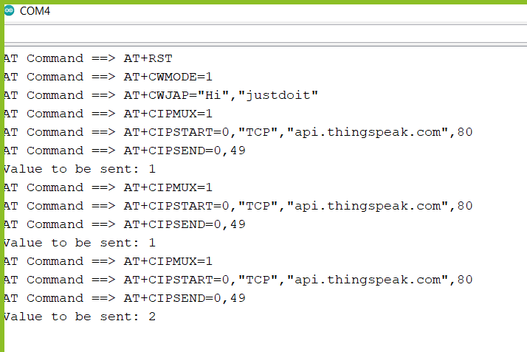

Fig.13 WiFi Connection Setup through Serial Monitor

Fig.14Information indicating each candidate is continuously transferred to the server. Shown here are three field for
Candidates A ,B and C respectively. As you can see,
at the end of the process, candidate A wins.

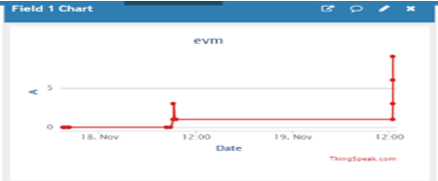

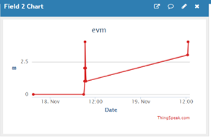
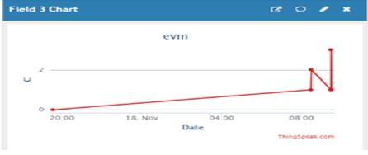
Fig.14 Thing Speak Server Result

X. CONCLUSIONS

The intention of the presented system is to expand the system, which is of higher quality and more reliable than the previous ones. in addition, we used two-step verification before casting the vote. IoT is used to improvise on the general efficiency of the system through frequent sending of reliable election facts to the crucial server of the election branch of the Government of India.

XI. FUTURE SCOPE
In future scope , we can make this voting system more secure and make it error free with the help of face recognition and biometric verification. We can also provide power back-up supply during the power loss and make it more reliable. If we want make this system more transparent we can add block-chain system in our electronic voting machine in this system a single cryptocurrency or token is given to each voter .In this system each candidate have a unique wallet address . The voters will vote by sending their token or crypto to the candidate of their choice.This system is basically based on IOT which has limitless use in future and which make our system more authenticate and secure with the help of face recognition and biometric. In this system we can add personal id verification process in which we can able to validate aadhar card , pan card and any of one personal id of eligible voters.

XII. ACKNOWLEDGMENTS
.
We express our sincere gratitude and earnest indebtedness to MADHAV INSTITUTE OF TECHNOLOGY AND SCIENCE, GWALIOR (M.P.) for providing us the golden opportunity to complete our project.

XIII. REFERENCES

[1] S. Sridharan, &quot;Implementation of authenticated and secure online voting system,&quot; 2013 Fourth International Conference on
[2] H. Agarwal and G. N. Pandey, &quot;Online voting system for India based on ADHAAR ID,&quot; 2013 Eleventh International Conference on ICT and Knowledge Engineering,Bangkok,2013, pp 1-4:10.1109/ICTKE.2013.6756265
[3] Anandaraj S, Anish R and Devakumar P.V, &quot; Secured e voting machine using biometric,&quot; 2015 International Conference on Innovations in Information, Embedded and Communication Systems(ICIIECS), Coimbatore, 2015, pp. 1-5:10.1109/ICIIECS.2015.7192976.
[4] R. Rezwan, H. Ahmed, M. R. N. Biplob, S. M. Shuvo and M. A. Rahman, &quot;Biometric secured e voting machine,&quot; 2017 IEEE Region 10 Humanitarian Technology Conference (R10-HTC), Dhaka, 2017, pp. 510- 512: 10.1109/R10-HTC.2017.8289010.
[5] Srikrishnaswetha, Kone Kumar, Sandeep Mahmood, Smart Electronics Voting Machine Using Face Recognition and Adhar Verification with IOT. 10.1007/978-981-13-3765-9_10.
[6] M. Khasawneh, M. Malkawi, O. Al-Jarrah, L. Barakat, T. S.Hayajneh and M. S. Ebaid, &quot;A biometric-secure voting system for election process,&quot; 2008 5th International Symposium on Mechatronics and Its Applications, Amman, 2008, pp. 1-8:0.1109/ISMA.2008.4648818
[7]M. Jagtap, V. Kesarkar and A. Supekar,&quot;Electronic Voting Systemusing Biometrics, Raspberry Pi and TFT,&quot; 2019 3rd International Conference on Trends in Electronics and Informatics (ICOEI),Tirunelveli, India, 2019, pp. 977-982: 10.1109/ICOEI.2019.8862671
[8] B. R., R. B. S., S. P. and K. V.K.G., &quot;Smart voting,&quot; 2017 2nd International Conference on Computing and Communications Technologies (ICCCT), Chennai, 2017, pp. 143-147:10.1109/ICCCT2.2017.7972261
[9] V. K. Priya, V. Vimaladevi, B. Pandimeenal and T. Dhivya,&quot;Arduino based smart voting machine,&quot; 2017 International Conference on Trends in Electronics and Informatics (ICEI), Tirunelveli, 2017, pp. 641-644: 10.1109/ICOEI.2017.8300781.
[10] S. S. Ramprasad, R. Swathi, K. N. Shireesha and V. S. Gavannawar,&quot; Convenient Voting System,&quot; 2018 3rd IEEE International Conference on Recent Trends in Electronics, Information &amp;Communication Technology (RTEICT), Bangalore, India, 2018, pp. 2145-2149: 10.1109/RTEICT42901.2018.9012373.
[11] S. Bhattacharrya, D. Roy, E. Pramanik, T. Nath and S. Kundu,&quot;Voting Machines,&quot; 2019 International Conference on Opto-Electronics and Applied Optics (Optronix), Kolkata, India, 2019, pp.1-3: 10.1109/OPTRONIX.2019.8862393.
[12] Gehlot, Kanwardeep &amp; Jain, Divanshu. (2020). Biometric fingerprint based voting machine using ATmega328P microcontroller. Materials Today: Proceedings. 10.1016/j.matpr.2020.11.087.
[13] Manoharan, Samuel. &quot;Embedded Imaging System Based Behavior Analysis of Dairy Cow.&quot; Journal of Electronics 2, no. 02 (2020):148-154
[14] Raj, Jennifer S., and J. Vijitha Ananthi. &quot;Vision Intensification Using Augumented Reality with Metasurface Application.&quot; Journal of Information Technology 1, no. 02 (2019): 87-95
[15] www.jetbrains.com
[16] www.thingspeak.com
[17] www.python.org
[18] www.opencv.org.

