Anomaly Detection in Crime Data Bases Using CPS

Gokul.k | Mohammed Shahin | Shameer Akthar
B.Sc Computer Science | B.Sc Computer Science | B.Sc Computer Science
Rathinam College Of Arts And Science | Rathinam college of arts and science | Rathinam College Of Arts And Science
Mr.R.Anjit Raja
MCA.,M.Phil.,MCL.,(Ph.D)
Rathinam College Of Arts And Science

Abstract—This abstract introduces a novel approach to deducing underage drivers through the integration of Cyber-Physical Systems (CPS) and Convolutional Neural Networks (CNNs). The initiative addresses the critical issue of unauthorized individuals operating vehicles below the legal driving age, posing significant risks to road safety. enabling real-time data collection and analysis. CNNs, renowned for their prowess in image processing, provide the means for precise age estimation through facial recognition. The combined use of these technologies establishes a comprehensive framework for anomaly detection, promising a proactive solution to identify underage drivers and enforce legal regulations effectively

Keywords—CPS, CNN, safety, framework, anomaly detection, Underage driver detection , cyber physical system,

I. INTRODUCTION

The rising number of accidents attributable to underage drivers has become a pressing concern, prompting the need for effective solutions. This project aims to address this issue by implementing comprehensive measures to enhance road safety and curb incidents involving inexperienced and underage drivers. Through a combination of educational programs, stricter enforcement of age-related driving restrictions, and the integration of advanced technology in vehicles, our initiative seeks to minimize the risks associated with underage driving. By fostering awareness and instilling responsible driving habits from an early age, we hope to create a safer driving environment, ultimately reducing the frequency and severity of accidents involving underage drivers. This project envisions a future where young individuals are equipped with the knowledge and skills necessary for responsible and safe driving, contributing to an overall decline in road accidents associated with underage drivers.

The combination CPS and CNN is a novel approach that can be considered towards making roads safe and ensuring young people do not drive. This drive is anchored on a firm resolve to safeguard the safety of all road users; hence, this resolve entails enforcing the driving age laws strictly. Existing age verification approaches do not offer real-time execution and hence can expose individuals to hazardous situations. Our hope is to develop a system that will identify teenage drivers with the help of the advanced capabilities of CPS and CNNs in an impeccable manner.

Such an integration constitutes a preventive mechanism of shifting in technology towards safe and law-abiding driving environment. Moreover, the motivation is derived from the

fact that it is vital in building customized measures and provision of specific educational programs which will generate evidence for future policy guidelines in ensuring long term road safety. Thus, this application of CPS and CNNs towards the conclusion that minors are driving is what we all consider as promoting credibility, cooperation, and a higher quality of security in our roads.

- CONTRIBUTION

There is an increase in the accidents that are caused by minors driving and this means that appropriate measures should be put in place. Therefore, this project intends to solve this problem through an elaborate plan of ensuring security on roads that include dealing with young and inexperienced drivers. Our initiative aims at creating educational programs for underage drivers, upholding driving guidelines for young people, and applying sophisticated technology into cars. We aim at creating awareness on responsible driving among young people and ensuring that they drive safely so that they reduce accidents in future. The goal of this project is that all youths will have the knowhow as well as the ability to drive responsibly and safely so as to reduce the number of accidents caused by teenagers drivers.

The integration of Cyber-Physical Systems (CPS) and Convolutional Neural Networks (CNNs) for drivers' age identification represents a sophisticated and innovative solution at the intersection of artificial intelligence and real-world physical processes. CPS provides the infrastructure to merge the digital and physical realms, enabling the seamless integration of computational algorithms with the tangible environment. In the context of drivers' age identification, this involves the deployment of smart cameras and sensors in vehicles or at key points on roadways, creating a network that captures real-time data.

The power of Convolutional Neural Networks comes into play as they are specifically designed to excel in image processing tasks. In the case of age identification, CNNs are trained on extensive datasets of facial images, learning intricate patterns and features associated with different age groups. This training allows the neural network to generalize and recognize age-related characteristics, making it adept at estimating the age of a driver based on facial attributes.As a driver interacts with the transportation system, CPS captures visual data through cameras, which is then fed into the embedded CNN for analysis. The neural network processes

XXX-X-XXXX-XXXX-X/XX/$XX.00 ©20XX IEEE

the facial features, leveraging its learned knowledge to make accurate predictions about the driver's age in real-time.

Beyond the fundamental task of age verification, this integrated system opens up a multitude of applications. It introduces a new dimension to road safety by enabling age specific interventions and alerts. For instance, a young, inexperienced driver might receive tailored safety tips or warnings about risky behaviors, while an older driver might benefit from assistance systems designed to accommodate potential age-related limitations.

Furthermore, the adaptability of CNNs ensures that the model can continually refine its understanding of facial features, making it robust to variations in lighting conditions, facial expressions, and demographic diversity. This adaptability is crucial in handling the complexities of real-world scenarios where drivers may present themselves differently.

The combination CPS and CNN is a novel approach that can be considered towards making roads safe and ensuring young people do not drive. This drive is anchored on a firm resolve to safeguard the safety of all road users; hence, this resolve entails enforcing the driving age laws strictly. Existing ageverification approaches do not offer real-time execution and hence can expose individuals to hazardous situations. Our hope is to develop a system that will identify teenage drivers with the help of the advanced capabilities of CPS and CNNs in an impeccable manner. Such an integration constitutes a preventive mechanism of shifting in technology towards safe and law abiding driving environment. Moreover, the motivation is derived from the fact that it is vital in building customized measures and provision of specific educational programs which will generate evidence for future policy guidelines in ensuring long term road safety. Thus, this application of CPS and CNNs towards the conclusion that minors are driving is what we all consider as promoting credibility, cooperation, and a higher quality of security in our roads.

- RELATED WORKS

It is crucial to protect cyber-physical systems (CPS) from malicious assaults since they have the potential to permanently harm physical systems. According to recent research, control programs operating on CPS devices are vulnerable to data-oriented and control-oriented attacks, such as non-control data attacks and code-injection or code-reuse attacks. Unfortunately, because runtime execution semantics checking is absent, current detection algorithms are unable to identify runtime data-oriented attacks. In this work, we present Orpheus, a novel security mechanism that enforces cyber-physical execution semantics to counter data-oriented attacks. First, we introduce a basic framework for reasoning about the cyber physical execution semantics of a control program, which includes event identification and dependence analysis. This framework identifies causal relationships between program control flows and the physical context/event. As an example.

OVER 80,000 people die prematurely from traffic-related injuries each year, according to the WHO, making this a significant public health issue in the WHO European Region [1]. Every year, traffic accidents cause significant injuries to
almost 2.7 million individuals. They cost society a significant amount of money—up to 3% of the GDP of any one nation.

Human factors are consistently cited as the primary cause of traffic collisions, accounting for 65% to 95% of incidents . Therefore, it is essential to have a thorough understanding of those elements in order to provide fresh, practical strategies for influencing safe driving habits. This strategy is supported by driver behavior analytics, which track and finetune driver behavior in real time. They have significant uses.

IV. METHODOLOGY

Cyber-Physical Systems (CPS) represent a transformative technological paradigm that seamlessly integrates computational elements with the physical world, creating interconnected systems capable of real-time interaction and decision-making. At its core, CPS involves the convergence of digital algorithms, communication networks, and physical processes. These systems are prevalent in various domains, including transportation, healthcare, manufacturing, and infrastructure. In CPS, sensors embedded in the physical environment gather real-time data, which is then processed by computational components to make informed decisions. This bidirectional communication facilitates dynamic responses to changes in the physical world. The integration of CPS enhances efficiency, responsiveness, and automation in complex systems. From smart transportation systems optimizing traffic flow to healthcare applications monitoring patient vital signs, CPS exemplifies a holistic approach that leverages technology to bridge the gap between the digital and physical realms, ushering in a new era of interconnected and intelligent systems.

Convolutional Neural Networks (CNNs) excel in deducting or recognizing faces through a process known as face detection. The capability of CNNs to understand and identify complex patterns in visual data makes them highly effective for this task. Here's a simplified explanation of how CNNs deduce faces.

Artificial intelligence relies heavily on Convolutional Neural Networks (CNNs), especially for image and pattern recognition. CNNs are excellent at extracting hierarchical features from visual data because they are designed to mimic the human visual system. CNNs are composed of layers of pooling and convolutional operations that work methodically to recognize complex shapes, textures, and patterns in input images. By using filters to scan the input, the convolutional layers highlight spatial hierarchies that capture progressively more complex features. This data is condensed by later pooling layers, which lessen computational complexity while keeping important details. CNNs' strength is their capacity to automatically pick up pertinent features during a training phase and adjust to a variety of datasets. CNNs are frequently used in image classification, object detection, and facial recognition applications.

V. PROBLEM STATEMENT

Using Cyber-Physical System and Convolution Neural Network to detect anomaly of young drivers is topical issue in modern road security. It refers to youths who are not allowed by law to drive but they are still on wheel. This causes traffic congestion, increase in road accident cases, and illegal offence. In real-time scenarios, traditional age verification methods are not enough, so advanced technology

is needed. Integration of CPS that can collect real time data together with CNN which are good at images processing will result to one full system for detecting anomalies.

This issue, therefore, requires advanced technology that can combine real-world features with information about a minor driver and deliver it effortlessly in time. It is necessary to construct a comprehensive CPS-CNN model capable of both successful age authentication and anomaly anticipation for safe street management. This objective aims at employing latest technologies in order to improve road safety, reduce accident possibilities, and implement relevant age-based traffic rules efficiently

VI. PROPOSED FRAMEWORK
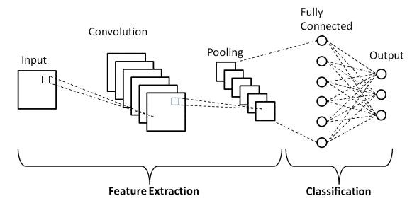
CPS combine real time sensing, monitoring, controlling, and optimizing involving physical processes by integrating them with computational components. Sensors, embedded hardware, and actuators constitute the physical layer, while control controllers, networks, and human operators are part of the cyber layer. Data sensors collect information from the real world; integrated hardware units process such data for further evaluation and conversion. Actuators transform commands into tangible actions while controls are based on sensor-captured information, as an interconnection network facilitates data sharing. Human operators supervise this system This integration makes it easy for CPS to fine-tune its performance, adjust to varying conditions, and improve safety and efficiencies.

VII. FUTURE WORK

CNN architecture

A feature extraction tool that involves separation and labelling of different aspects of an image for further examination using a Convolution Tool.There are multiple pairs of convolutional and pooling layers forming a feature extracting network.A fully connected layer with the output from the convolution step feeding into it and predicting the image’s classification based on the previously obtained features.The proposed model for feature extraction in CNN tries to limit the number of relevant features contained in a data set. It generates novel characteristics that abstracts an initial set of features in a summary form. As illustrated by the CNN architecture, there are a good number of CNN layers.
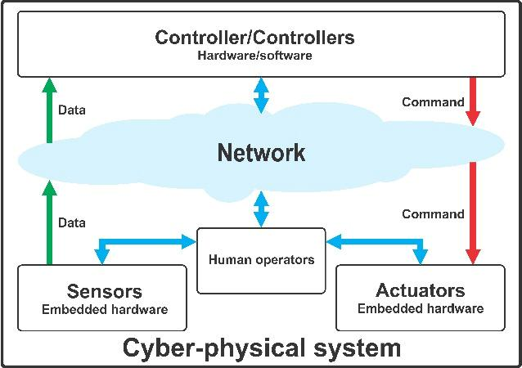

Cyber physical systems (CPS) Architecture

In future we will detect the under age drives and put fine suddenly, this project will reduce the accident which is occur by teens who do not have licence Driving the bike & cars who doesn’t have licence given by Government will be punished buy the Government

VIII. CONCLUSION

In conclusion, the fusion of Convolutional Neural Networks (CNNs) and Cyber-Physical Systems (CPS) for anomaly detection in identifying underage drivers represents a pioneering approach with profound implications for road safety and regulatory compliance. The integration of CNNs provides a powerful tool for precise age estimation through facial recognition, while CPS facilitates real-time data collection and seamless communication between the physical and digital domains. The potential impact of this technology is substantial, promising a future where the risks associated with underage driving can be swiftly identified and mitigated. As we look ahead, further research and development in refining CNN models, optimizing CPS components, and incorporating advanced machine learning techniques will be pivotal. Privacy considerations and ethical standards must be carefully woven into the fabric of these innovations responsible implementation. Ultimately, the synergy between CNNs and CPS not only represents a technical breakthrough but also signifies a collective commitment to building safer roads and a more secure transportation ecosystem for all.

IX. REFERENCE

- Cheng, L., Tian, K., Yao, D. D., Sha, L., & Beyah, R. A. (2019). Checking is believing: Event-aware program anomaly detection in cyber-physical systems. IEEE Transactions on Dependable and Secure Computing, 18(2), 825-842.

  - Hao, W., Yang, T., & Yang, Q. (2021). Hybrid statistical-machine learning for real-time anomaly detection in industrial cyber-physical systems. IEEE Transactions on Automation Science and Engineering.

  - L. Cheng, K. Tain, and D. D. Yao, “Enforcing cyber-physical execution semantics to defend against data-oriented attacks,” in ACSAC, 2017.

- A. B. Sharma, F. Ivancˇic ,́ A. Niculescu-Mizil, H. Chen, and G. Jiang, “Modeling and analytics for cyber-physical systems in the age of big data,” SIGMETRICS Perform. Eval.
Rev., vol. 41, no. 4, pp. 74–77, 2014.

- S. Sridhar, A. Hahn, and M. Govindarasu, “Cyber-physical system security for the electric power grid,”

Proceedings of the IEEE, vol. 100, no. 1, pp. 210–224, 2012.
- A. A. Cárdenas, S. Amin, Z.-S. Lin, Y.-L. Huang, C.-Y.

Huang, and S. Sastry, “Attacks against process control systems: Risk assessment, detection,and response,”in

ASIACCS,2011

.

