**Soil degradation assessment using remote sensing in Yavatmal district, Maharashtra**

Gauri P. Gawande

Rushikesh S. Metangale

KEYWORDS: Soil degradation; Soil erosion; Remote sensing; Farmer distress

Abstract

Soil physical degradation is a major environmental problem throughout the world due to its negative impact on biomass and economic production. This study conducts rapid soil analysis using GIS and remote sensing imagery to provide a precision mapping of soil physical condition indicators in the study area and producing fertility status using Geostatistical approach. Study has been carried out to map the areas with physical degradation using remotely sensed data from Indian Remote Sensing LISS III sensor. Satellite data have been used for qualitative assessment of areas, being subject to soil erosion. The RUSLE method was used to arrive at final soil degradation maps. The eroded areas of degraded lands will be used as an input for planning reclamation and conservation programs, distress mapping and social outreach in Yavatmal District of Maharashtra.

Introduction

Land is the most valuable resource for the production of food, fiber, fuel and many other essential goods required to meet human and animal needs. However, it is facing serious threats of deterioration due to unrelenting human pressure and commercialization of agriculture, land is losing its productivity making farmers prone to distress. Land degradation in general, implies temporary or permanent recession from a higher to a lower status of productivity through deterioration of physical, chemical and biological aspects. It is a complex ensemble of surface processes (e.g. wind erosion, water erosion, soil compaction, salinization, and soil water-logging). These can ultimately lead to ‘‘Desertification” GIS proved to be an effective tool in handling spatial data available at different scales, voluminous point data such as soil information, rainfall, temperature etc. and socioeconomic data and to perform integrated analysis of data on various resources of any region and to arrive at optimum solutions for various problems. The study was carried out with the objective being delineation of degradation area by using satellite data and GIS software and producing the nutrient status and physical degradation maps (increase in bulk density and water erosion) using Geostatistical approach. The specific objectives of this study were to identify degradation degree of soil erosion based on satellite images and physical degradation status, and to identify spatial patterns of physical and chemical soil properties and spatial distribution of soil fertility.

Material and methods

Chamarajanagar district with an area about 13,582 Km2, is located in the central cotton belt of Maharashtra. It falls in the southern dry zone. Topography is undulating and mountainous with north south trending hills.IRS-P6 LISS-III (FCC) images of February 2006, 13 February 2012 and LISS-IV January, March and November 2012 were used for Visual interpretation of erosion along with soil survey carried out in the field.. The data therefore represent spring (Rabi), autumn (Kharif) and summer seasons. Large part of the study is mainly covered by Agriculture.

The standard false color composite (FCC) images of the study area were prepared using bands 4 (NIR), 3 (Red), and 2 (Green) and discrimination of features was made by visual interpretation (on screen) using these images (Venkataratnam L., 2009). The interpretation key was based on the relationships established between ground features and image elements, like, texture, tone, shape, location and pattern (Lal, 1998). IRS-LISS-III and IRS-LISS-IV Satellite data were used for qualitative assessment of areas, being subject to soil erosion. Based on length and degree of slope from SRTM, ASTER and topographic sheets (1:50,000 and 1:250,000) (Gupta, 2001), representative sample sites were selected for ground truth data collection. During field visits, features of topography and soil profiles were studied (Das, 1985); site characteristics and soil samples were also collected for laboratory analysis. The preliminary interpreted maps were modified based on the field data and analytical data and final maps were prepared with appropriate legend. Land use/land cover was produced supervised classification (maximum likelihood method using ENVI 5.1 software) (Rao, 2014)and visual interpretation done for enhancing the accuracy of the classification along with ground truth points through field trips with overall accuracy 96.7%. In Chamarajanagar district, the problem of soil degradation is caused mainly by soil erosion. The assessment of soil physical degradation entailed prediction of the risk of soil loss. The RUSLE (Revised Universal Soil Loss Equation) model equation (Renard, 1997) is a multiplicative function of five factors controlling the erosion:

**A=R*K*LS*C*P**

where:

A is the mean annual soil loss expressed in tonnha * yr.

R is rainfall and runoff erosivity index (in

MJ * mmnha * yr).

K is soil erodibility factor (in ton * ha * h/ha * MJ * mm).

LS is slope and length factor (dimensionless).

C is the cover factor (dimensionless).

P is the conservation practice factor (dimensionless).

Results and discussion

Land use and land cover

From the estimation of GIS calculation it is found that forest areas are occupying 47.54%, Agricultural land 42.61%, Wastelands 4.58%, Built-up land 1.03%, Water Bodies 1.92%, Grassland/Grazing land 0.28%, and other land use/land cover areas occupying 2.04 of the total areas derived from IRS 2013.

Figure 1.0.1 Land Use and Land Cover map

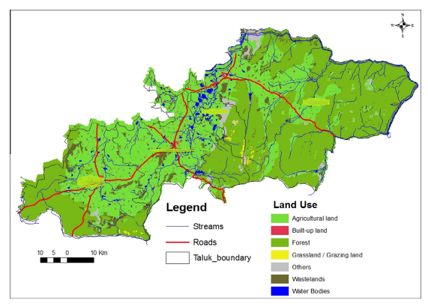

Slope of study area

In this study, SRTM resolution (90 m) and ASTER resolution (30 m) data can be freely downloaded from internet websites and topographic sheets scaled (1:50,000 and 1:250,000) were used. The major part of the area is having 0–3 slope per cent. However, variations in the slope (0–100%) was made to group the entire area into six slope classes i.e., 0–3,3–5,5–15,15–30, 30–50 and >50%. The areas having slope 0–3 and 3–5% were assigned moderate in erosion and the areas, which were having slope >5% were considered as severe in view of the erosion. Soil loss increases as slope increases but after 50% slope, soil erosion tends to decrease due to the presence of dense vegetation. With the increase in vegetation cover, average soil loss dramatically decreases.

Assessment of soil erosion

FCCs obtained from LISS III and IV sensors (with 23.9 m and 5.8 m spatial resolution) were evaluated for delineation of eroded areas. It was observed that the data enabled better delineation of small units of eroded areas. Based on soil, slope, and land use/land cover, current soil erosion status was mapped. Visual interpretation involves identification and delineation of degraded lands that are manifested on False Color Composite (FCC) (NRSA, 2013). The False Color Composites are analyzed initially with the help of topographical maps, published reports and other available ancillary data; broad categories of degraded lands were delineated. Soil erosion categories were delineated through visual interpretation of IRS data and found to be none or slight, moderate, severe and very severe as shown in the Fig.

Figure 1.0.2 Present Erosion Level Map

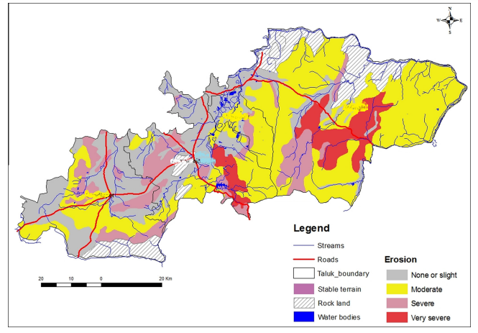

The eroded areas were identified distinctly on the FCC as a result of erosion of soil by running water. They are more common on sloping surface. Fig. shows the soil erosion (due to water) map of the site.

Figure 1.0.3 Present Water Erosion Map

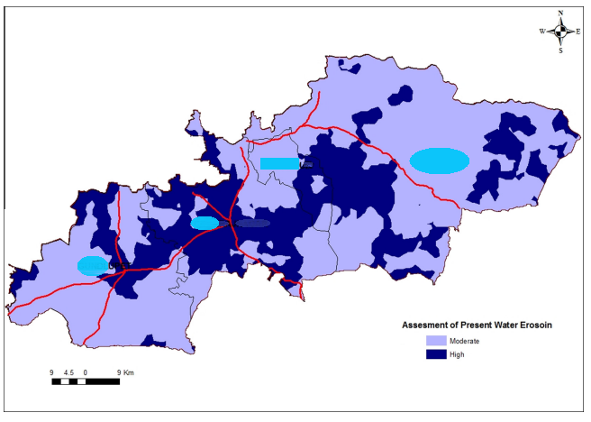

The RUSLE calculation considered all the variables which affect the soil erosion. These parameters affecting soil degradation like (natural vegetation factor, climatic factor, land use factor, soil factor, management factor, topographic factor) have been generated from fieldwork data and have been classified according to the RUSLE in integer values to obtain the ranges for the assessment of the risk of Water Erosion and assessment of present Water Erosion and those two map were generated using Geostatistical approach for predicting the spatial distributions of maps. These outputs have been analyzed and weighted in terms of degradation classes. Moderate and high classes depend on the magnitude of annual soil loss (RUSLE).

Degradation risk assessment

Degradation potential based on risk factors gives idea of future degradation risks. This map shows potential degration scenario in no action taken conditions. The results show that the majority of the study area fall under the moderate land erosion risk zone. High land degradation class has been found in areas affected by high soil loss; this is the major reason for Biological Degradation by removing plow layer of the top soil. It is a well-known fact that soil organic matter is the main biological wealth of soils. Erosion removes the SOM (Soil Organic Matter) along with other mineral components of the soil resulting in soil biological degradation, creating a positive feedback loop, aggravating the erosion.

Figure1.4 Land Degradation Risk Map

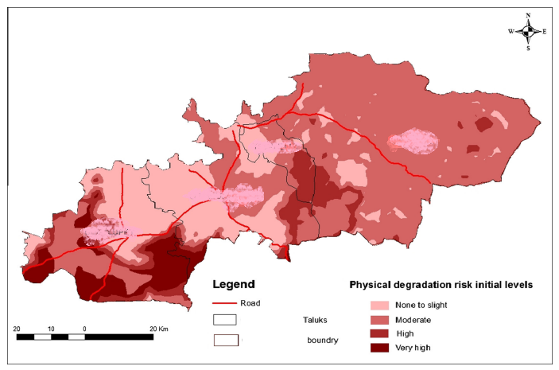

GIS spatial modeling tools manifested great efficiency in land degradation assessment process, whose results hopefully may help decision makers to take the necessary actions to protect the most degraded spots. Such data can be used to ensure focused aid to distressed farmers, education, counselling and mitigation measures.

Conclusions

Based on the length and degree of slope from SRTM, land use/cover and soil characteristics as revealed by IRS-LISS-III and IV data and other related ancillary data from field survey, assessment of soil erosion was found to be none or slight to very sever while using RUSLE the present water erosion was found to be moderate to high in Chamrajanajar district of Karnataka. The extent and geographical distribution of degraded lands areas can be used as an input for future planning reclamation conservation program. IRS LISS-III & IV remotely sensed satellite digital data have been used to classify the different land use/land covers, and Shuttle Radar Topographic Mission (SRTM) digital elevation model (DEM) data were used to draw the classified slope maps. Satellite data have become valuable tools in studying the spatial extent of degraded lands and for monitoring the changes that have taken place over a period of time. Land degradation map is generated from the combination of many parameters (soil degradation factors) which interact with each other in a complex way generating the final quantitative degradation classes. The data showed that there is severe degradation of soil in farmlands of Yavatmal district. Social and economic stresses emanate from this stress on soil. Targeted approach for land reclamation and restoration along with adaptation plan is warranted.

# References

Das, D. (1985). Problem of soil erosion and land degradation in India.

Gupta, H. (2001). Remote sensing techniques for evaluating soil fertility and soil erosion.

Lal, R. (1998). Lal, R., 1998. Soil erosion impact on agronomic productivity and soil quality.

Lillesand, T. K. (2000). Remote Sensing and Image interpretation.

Lowery, B. H.-J. (1998). Model estimates for soil quality and soil erosion analysis and interpretation.

NRSA. (2013). *Project report: Satellite remote sensing survey for soil and land use in part of Uttar Pradesh.*

Rao, K. B. (2014). *Remote Sensing for soil conservation and watershed management.*

Renard, K. f. (1997). *‘‘Predicting Soil Erosion by Water: A Guide to conservation planning with the Revised Universal Soil Loss Equation.* USDA.

Venkataratnam L., R. K. (2009). *Computer aided classification and mapping soils and soil limitations using Landsat multispectral data.*