**SMART THERMO SCANNING SYSTEM**

**Karthikeyan C1, Subash S2, Anandhan D3, Mirra K B4**

1,2,3 Student, Department of Computer Science and Engineering, National Engineering College, Kovilpatti, [2012083@nec.edu.in](mailto:2012083@nec.edu.in%20) 1 , [2012099@nec.edu.in](mailto:2012099@nec.edu.in%20) 2 , [2012054@nec.edu.in3](mailto:2012054@nec.edu.in3%20) 4Assistant Professor Department of Computer Science and Engineering, National Engineering College, Kovilpatti, [mirra-cse@nec.edu.in](mailto:kanthimathi_cse@nec.edu.in) 4

**Abstract:**

Temperature scanning in office buildings, colleges, and hospitals used to be done manually by human operators, which left room for potential errors and inconsistencies in the collected data. To address this issue, a new solution has been proposed: to use RFID (radio-frequency identification) readers to scan ID cards and automatically record the temperature of individuals via contactless scanning. This data can then be stored in the cloud for analysis through a web interface. This approach is designed to improve accuracy, speed up processes, and increase efficiency while also allowing for remote monitoring and management of the collected data. It would allow organizations to quickly monitor the temperatures of individuals entering their premises more accurately than ever before; it would also enable administrators to remotely manage all collected data without having physical access. Overall, this solution aims to reduce errors while increasing accuracy and efficiency when it comes to temperature scanning in office buildings, colleges, or hospitals.

**Keywords:**

Remote temperature monitoring, Real-time temperature analysis, Temperature detection and analysis, IoT-based temperature sensing, Human body temperature monitoring.

**Introduction:**

The COVID-19 pandemic has highlighted the significance of precise and effective temperature monitoring in a variety of environments, including offices, schools, and hospitals. Traditional manual temperature screening techniques are error-prone and time-consuming, which could result in inconsistent data collecting. A smart temperature scanning system with RFID integration and email alarm notification has been presented as a solution to these problems

The purpose of the smart temperature scanning system is to increase accuracy, simplify procedures, and guarantee quick reaction to high temperatures. Individuals' ID cards can be scanned without making physical touch using RFID technology and contactless scanning, enabling automatic temperature recording and lowering the possibility of mistakes. For analysis, the gathered data is safely saved in the cloud and is accessible via a straightforward web interface. Additionally, when high temperatures are found, an alarm is sent off and immediate emails are sent to authorized individuals.

This system differs from traditional approaches because to a number of special characteristics it offers. By reducing lines and congestion, the contactless scanning procedure guarantees a quicker and more effective screening experience. Utilizing RFID technology improves accuracy and dependability while removing human error in manual recording. The alarm notification system sends out email alerts right away, allowing for prompt response and the right course of action.

Implementing the smart temperature scanning system allows organizations to benefit from improved accuracy, efficiency, and overall effectiveness in temperature monitoring. The automatic data collection and cloud storage feature enable comprehensive record-keeping and data analysis, facilitating better decision-making and proactive management of potential health risks. The alarm notification system ensures high temperatures are promptly identified and addressed, enhancing the safety of individuals within the premises.

Inthis research paper, our goal is to explore the performance and implementation of the suggested system, concentrating on how well it works in workplaces like offices, colleges, and hospitals. We will assess its accuracy, effectiveness, user happiness, and the effect of warning notifications on prompt reaction using practical investigations and data analysis. The results of this study will help advance temperature monitoring techniques, making these spaces safer and healthier for the people who use them.

**Literature Survey:**

In [1] Asif A. Rahimoon (2020) proposed the Design of a contactless body temperature measurement system using Arduino. Affordable monitoring devices are now available because to recent advancements in electronics and microelectronics, which are being utilized by people to check their health in advance. A variety of bodily vital signs can be converted into electrical impulses via sensors used in medical devices. Healthcare monitoring systems provide a practical answer for a comfortable home life by using non-invasive, wearable sensors with built-in communication capabilities. The system described in this paper uses an Arduino controller and other sensors that are connected to the internet via Wi-Fi to wirelessly monitor human body temperature (HBT). Through IoT applications, the system enables the transmission of real-time temperature data to a specified observer. According to the study's findings, Sensor S1 and S2 are about 15°C apart in temperature.

Prof. Dr. Badar Muneer, Prof. Dr. Bhawani Shankar Chowdhry, Prof. Dr. Faisal karim Shaikh and Ghulam Hyder Palli (2022) [2] proposed Smart non-contact IR-Temperature scanning and online database system integrated with RFID authentication. To maintain public safety during the ongoing COVID-19 outbreak, a non-contact temperature monitoring system that is coupled with an RFID authentication system, Android application, and web portal has been suggested. Businesses, schools, factories, and other corporate sectors can successfully monitor temperatures thanks to this real-time technology. Every day, every week, and every month, the system monitors and regulates temperature variations of registered users. Linked to the user's RFID card is a real-time database that stores temperature data. Authorized personnel are informed via the web portal when a high temperature alert is found, and the device sounds an alarm to notify surrounding security personnel. Notifications are also sent to authorized personnel's desktop or mobile devices via the web portal. Based on survey and testing in a range of temperature settings, the system exhibits an excellent overall accuracy of 99%.

In [3] Dr. Sudha S, P. Shruthi, M. Sharanya (2018) proposed IOT based measurement of body temperature using MAX30205. Temperature is a crucial factor in determining a person's health status and is crucial in making a diagnosis. An individual can quickly and conveniently measure his body temperature with the Fever Click MAX30205 sensor. Using the mobile application built on the Firebase platform, a patient who cannot see the doctor in person or needs frequent monitoring can transmit the doctor his body temperature at any time. The ESP8266 Wi-Fi Module is being used to retrieve values from the sensor and send them to Firebase.

Prajoona Valsalan, Tariq Ahmed Barham Baomar and Ali Hussain Omar Baabood (2020) proposed [4] IOT based health monitoring system. An Internet of Things-based health monitoring system is thought to be the most appropriate approach in view of the importance of healthcare during the COVID-19 pandemic. Healthcare has been transformed by the Internet of Things (IoT), which is also a field of study that is expanding quickly. Wearable sensors and cell phones have made it possible to monitor healthcare remotely, enabling accurate diagnosis and illness prevention even from a distance. The study describes a portable physiological monitoring device that can continually measure vital signs including temperature and heartbeat. The patient's data is saved on a server for remote access by authorized staff using a Wi-Fi-based communication. Using IoT technology, doctors can provide remote healthcare monitoring and diagnose ailments based on the data they have received.

B Varshini, (2021) [6] proposed IoT-Enabled smart doors for monitoring body temperature and face mask detection. The COVID-19 epidemic has caused a global health disaster, underscoring the significance of using face masks when in public. To stop the spread of viruses, lockdowns were instituted everywhere. This study offers a smart door with IoT capabilities that can recognize face masks and track body temperature using machine learning. The model can be used to create a healthy environment utilizing AI and sensors in a variety of contexts, including hotels, apartment entrances, and shopping malls. The suggested solution uses a non-contact temperature sensor and the TensorFlow software library for Face Mask Detection to track users' body temperatures. This system is capable of quickly identifying probable COVID-19 situations thanks to IoT technologies.

G. Sivasankar (2022) proposed IOT based smart students' body temperature monitoring system for a safe campus. In [6] the research, a system using an IR (infrared temperature sensor) and RFID technology is suggested for keeping track of students' body temperatures at the door. Machine learning algorithms can anticipate body temperature and block access if it rises above the acceptable range. IFTTT is used by in charge to receive notifications. Students are identified with RFID tags, which SMS their information. For precise detection, machine learning examines temperature history. Wi-Fi allows Node MCU to connect to the IoT cloud, and a buzzer notifies pupils of rising temperatures. A servo motor operates the door, effectively assisting in the prevention of COVID-19 by preventing individuals with high body temperatures from entering the college grounds.

L. Suwondo, Teresa (2022) proposed Smart Thermal Scanner Camera Implementation for Primary Screening of Covid-19 Suspects at Financial Planning Office’s Lobby [7]. With the increasing rate of COVID-19 spread and cases, community participation and technological development are crucial for minimizing transmission. Implementing technology in offices can enhance efficiency and effectiveness in curbing the virus's spread. By integrating Smart Thermal Scanner Camera technology into door sensors, it identifies potential COVID-19 cases and reduces transmission risks. The research employs a descriptive qualitative methodology, focusing on implementing modern technologies like UV lamp air purifiers, touchless door sensors, and thermal scanners in the office lobby. These technologies support safer and more comfortable in-office services for workers and guests during the COVID-19 pandemic.

Nadeem Mahmood, Asadullah Shah proposed “RFID based smart hospital management system” [8]. Since the previous two decades, one of the key topics of research has been the incorporation of information and communication technology (ICT) in the healthcare industry. The usage of RFID (Radio Frequency Identification) technology is widespread in the healthcare industry to deliver better, more dependable, and secure services. RFID technologies are linked into hospital information systems to fully automate and streamline crucial patient identification, staffing, doctor, medication, and treatment modules. In this research, we propose an RFID-based conceptual framework for a smart hospital management system that offers a safe and secure patient data management system. With the aid of an example case study and a functional prototype application, we further emphasize the significance of RFID in the healthcare industry.

Sara Amendola, Rossella proposed RFID Technology for “IoT-Based Personal Healthcare in Smart Spaces” [9]. The Internet of Things (IoT) and RFID technology can facilitate the transition away from conventional medical models and toward participatory medicine. The Internet of Things (IoT) uses ambient, implanted, and wearable sensors in homes to track users' health and offer remote support. RFID technology enables data collection on temperature, humidity, and gases related to the user's living environment, providing a mature and affordable option for personal healthcare in smart environments. The current state of RFID applications in body-centric systems and environmental monitoring is surveyed in this study. The discussion of several RFID systems demonstrates how they may gather and interpret multichannel data on human behaviour while abiding by power exposure and health laws. The report finishes by emphasizing unresolved issues and proposed lines of further investigation.

In [10] Ramani G, Pradeepkumar G proposed “Smart Attendance Monitoring System Using IoT”. Maintaining a student's attendance at a single university is currently challenging. In order to make keeping track of students' presence easier, this study suggests a clever way for doing so. In corporations and academic organizations, it has largely taken the place of the conventional roll call practice. It cuts down on the time staff spends manually entering attendance data by automatically recording attendance in the database. Instead of laborious paper logs, the Internet of Things' RFID tags and readers can be used to identify event attendance. For the typical person, they are easy to use. Through the use of an RFID-based access control system, unauthorized kids would not be permitted to enter the school.

**Proposed Methodology:**

The system will use RFID readers to scan the ID cards of individuals entering a facility. The RFID readers will then automatically record the temperature of the individual using a contactless temperature sensor. The temperature data will be stored in a cloud-based database. A web-based interface will be used by administrators to view the temperature data and manage the system. The system will be able to generate reports on temperature trends and patterns. The system will be able to integrate with existing security systems, such as access control systems, to allow for more seamless and secure access to facilities. The system will be able to provide real-time alerts to administrators if someone with a high temperature attempts to enter a facility.

The system will be developed using a modular approach, with each component being developed as a separate module. This will make the system easier to maintain and update. The system will be deployed to a cloud-based server, which will allow it to be accessed by users from anywhere in the world.

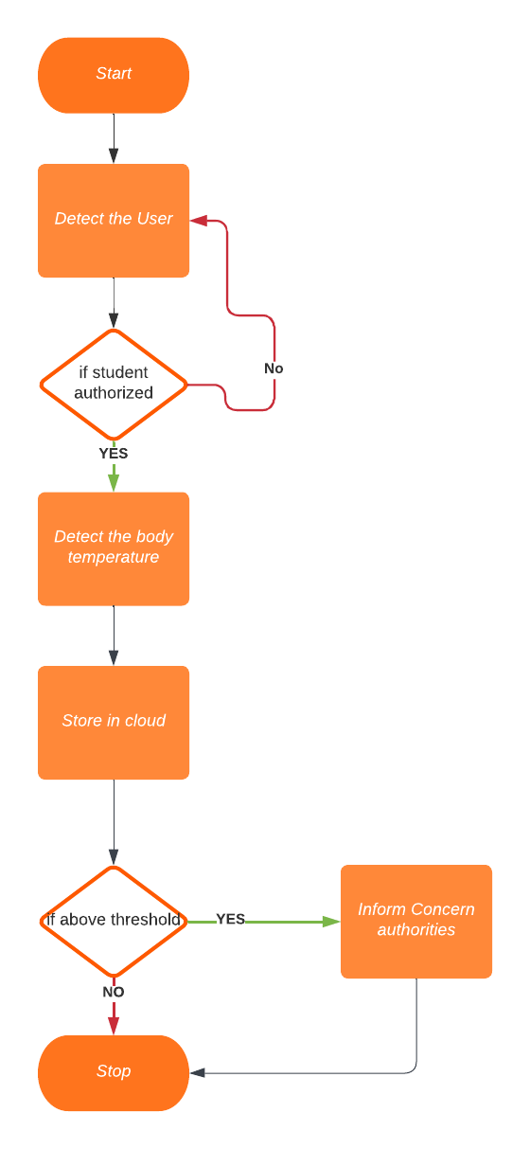

**Fig.1. Proposed Methodology**

The flowchart in Fig. 1 illustrates the methodology for the contactless temperature scanning system.

A modular approach to software development involves breaking the system down into smaller, independent modules. This makes the system easier to understand, maintain, and update. Each module can be developed and tested independently, which can help to reduce the overall development time.

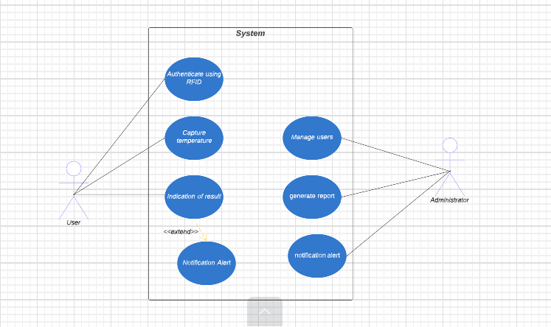

**Fig. 2 Use Case Diagram**

In the context of the contactless temperature scanning system, the system would be broken down into the following modules:

* RFID reader module: This module is responsible for scanning the ID cards of individuals entering a facility.
* The RFID reader will then record the individual's temperature using a contactless temperature sensor.
* Temperature sensor module: This module is responsible for measuring the temperature of individuals without the need for physical contact. The temperature sensor will then transmit the temperature data to the RFID reader module.

**Implementation:**

The implementation of the smart temperature scanning system involves setting up the hardware components and deploying the software applications. The system is installed at the entry points of office buildings, colleges, and hospitals to facilitate contactless temperature monitoring. The key steps in the implementation process are as follows:

**Hardware setup:**

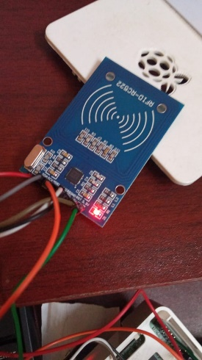 **Fig 3,4 Hardware Implementation**

The hardware components, including RFID readers, contactless temperature sensors (ISB-TS45D), microcontrollers (Raspberry Pi), and alarm systems (buzzer and LEDs), are assembled and integrated into a compact and user-friendly design shown in fig 3,4. The system is designed to be easily accessible for users entering the premises.

**Web Interface and Application Development:**

The web application is developed to provide administrators and users with access to the system's functionalities. The web interface allows administrators to register devices, manage users, and visualize temperature data as shown in Fig 7.

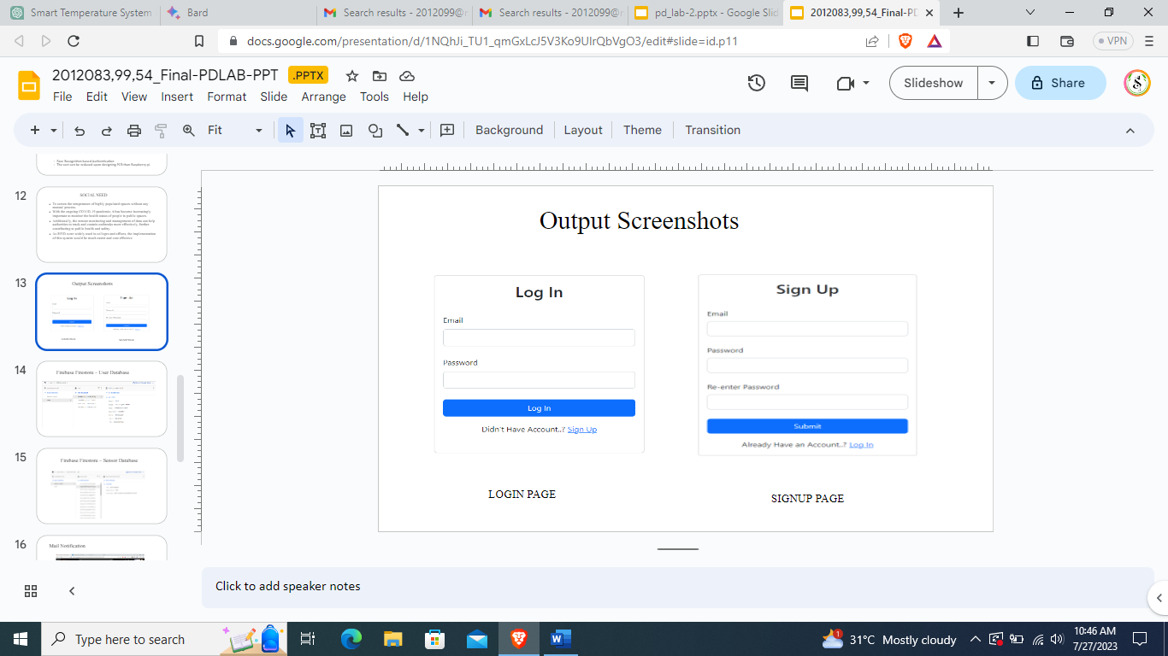

**Fig.5 Software Implementation**

**Real-time Data Transmission:**

The recorded temperature data is transmitted in real-time to a central database using the Raspberry Pi's wireless communication capabilities. The data transmission ensures that temperature records are promptly saved in firebase cloud as in Fig 6.

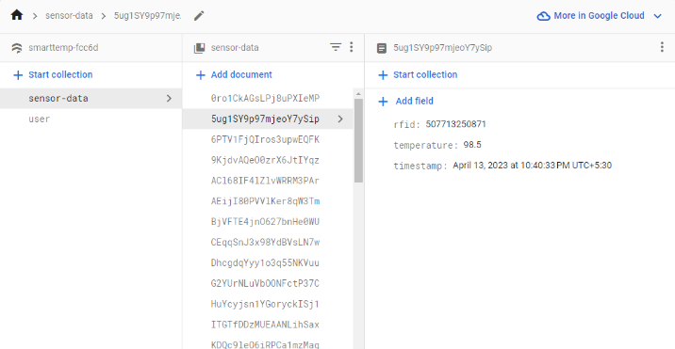

**Fig. 6 Firebase Database**

**Alarm Notification System**:

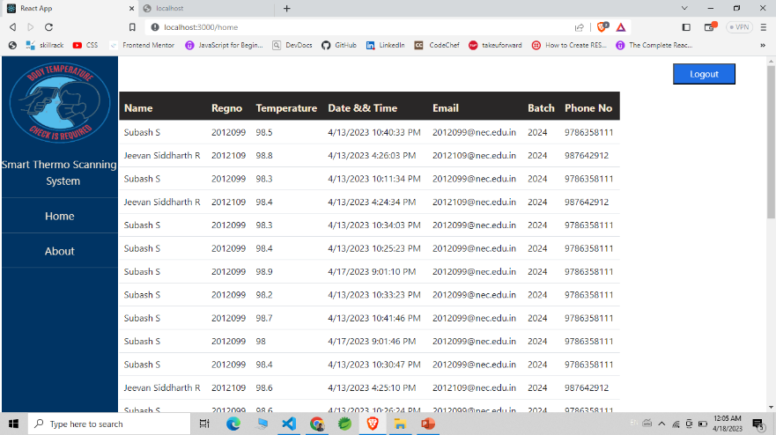

**Fig.7 Users – temperature visualization**

In the event of an abnormal (high) temperature reading, the system triggers an alarm to draw attention to the potential health risk. The alarm system includes a buzzer and blinking LEDs for immediate notification. Simultaneously, an alert is sent to authorized personnel on their mobile phones or desktop systems via e-mail.

**Data Analysis and Visualization:**

The collected temperature data is securely stored in the database and can be accessed through the web application. Users can view their own temperature records, while administrators can access data for all users in their organization. The data is presented in graphical and tabular formats, facilitating trend analysis and temperature variations assessment.

**Conclusion:**

The contactless temperature scanning system is a promising new technology that has the potential to improve the safety of individuals and organizations. The system can help to prevent the spread of illness by quickly and accurately measuring the temperature of individuals without the need for physical contact. The system has the potential to be a valuable tool for a wide range of organizations, including schools, businesses, and healthcare facilities. The system is also scalable and can be adapted to meet the specific needs of different organizations.

We believe that the contactless temperature scanning system has the potential to make a significant contribution to the fight against infectious diseases. The system is a valuable tool for organizations that are looking to improve the safety of their employees and customers. We encourage further research and development of this technology to ensure that it is widely available and used to its full potential.

**REFERENCES:**

[1] Rahimoon, A., Abdullah, M. N. and Taib, I. (2020) **“**Design of a contactless body temperature measurement system using Arduino”, Available at: <https://ijeecs.iaescore.com/index.php/IJEECS/article/view/22407>

[2] Prof. Badar Muneer, Prof. Bhawani Shankar Chowdhry, Prof. Faisal karim Shaikh and Ghulam Hyder Palli (2022) proposed “Smart non-contact IR-Temperature scanning and online database system integrated with RFID authentication”. Available at: <https://ieeexplore.ieee.org/document/10013563>

[3] Tang, H. F. and Hung, K. (2017) “Design of a non-contact body temperature measurement system for the smart campus”, Available at: <https://ieeexplore.ieee.org/abstract/document/7849773>

[4] Prajoona Valsalan, Tariq Ahmed Barham Baomar and Ali Hussain Omar Baabood (2020) proposed “IOT based health monitoring system”. Available at: <https://www.researchgate.net/publication/340665031_IOT_BASED_HEALTH_MONITORING_SYSTEM>

[5] B Varshini, (2021) proposed “IoT-Enabled smart doors for monitoring body temperature and face mask detection”. Available at: <https://www.sciencedirect.com/science/article/pii/S2666285X21000996>

[6] G. Sivasankar (2022) proposed “IOT based smart students' body temperature monitoring system for a safe campus”. Available at: <https://ieeexplore.ieee.org/document/9788409>

[7] L. Suwando, Teresa (2022) proposed Smart Thermal Scanner Camera Implementation for Primary Screening of Covid-19 Suspects at Financial Planning Office’s Lobby. Available at: <https://iopscience.iop.org/article/10.1088/1755-1315/998/1/012043/meta>

[8] Nadeem Mahmood, Asadullah Shah proposed “RFID based smart hospital management system”. Available at: <https://ieeexplore.ieee.org/document/7020594>

[9] Sara Amendola, Rossella proposed RFID Technology for IoT-Based Personal Healthcare in Smart Spaces. Available at: <https://ieeexplore.ieee.org/document/6780609>

[10] Ramani G, Pradeepkumar G proposed Smart Attendance Monitoring System Using IoT.

Available at: <https://ieeexplore.ieee.org/document/10112850>