MICROCONTROLLER BASED ANESTHESIA INJECTOR

**Sreedev Dharman P1, Sreelekha M2, Tony Jose3, Dr.Godwinraj D4, Ranjitha Rajan5** 1,2,3,Students, Electronics & Communication Engineering, Amal Jyothi College of Engineering, India.

## 4Associate Professor,5Assistant Professor, Electronics & Communication Engineering, Amal Jyothi College of Engineering, India..

**ABSTRACT**

This project presents an automatic anesthesia injection device that uses a micro-controller to deliver anesthesia safely and precisely during medical procedures. By combining actuators, a user interface, and sensors, the system guarantees precise dosage and in-the-moment modifications, improving patient care and lowering the risk of human mistake. The apparatus functions by analyzing patient data, such as body temperature, blood pressure, and blood oxygen levels. A micro-controller (ESP32) is employed to deliver anesthetic through a syringe and stepper motor in response to real-time variations in the patient's state. The apparatus reduces the possibility of human error while guaranteeing accurate dosage and vital sign monitoring by automating the anesthetic delivery procedure.

**Keywords:** heart rate Sensor, humidity sensor, temperature sensor.

# INTRODUCTION

The administration of anesthesia is a vital component in medical procedures, providing the comfort and safety of patients undergoing surgeries or other invasive treatments. However, traditional manual techniques of providing anesthetic are inherently prone to errors made by humans, which might risk patient safety. In answer to this difficulty, this initiative pushes for the creation of a microcontroller-based automatic anaesthesia injection system. The latest innovation uses microcontroller capabilities to streamline the anesthesia distribution procedure, improving precision and patient care while limiting the risks associated with manual administration. The gadget analyzes crucial medical data, such as body temperature, blood pressure, and blood oxygen levels, and uses a microcontroller, such as the ESP32, to precisely administer anesthesia via a syringe and stepper motor. This automated system allows for real-time adjustments in anesthesia dosage based on fluctuations in the patient's condition, providing ideal degrees of sedation while reducing the possibility of mistakes being made by humans. Finally, by automating anesthetic distribution and enabling accurate dosing and vital sign monitoring, this device has the potential to greatly improve patient outcomes and safety in medical procedures.

### PROBLEM STATEMENT

In order to guarantee the accurate and safe delivery of anesthesia during medical procedures, designing a microcontroller-based anesthesia system requires resolving a number of significant obstacles. First, in order to correctly manage the delivery of anesthetic chemicals, the system needs to have precise dosage control systems. This entails adjusting the dosage based on the specific requirements of each patient, taking their weight, age, and medical history into account. In order to guarantee the patient's safety during the process, the system should also incorporate sensors and monitoring equipment to continuously evaluate the patient's vital indicators, such as heart rate, blood pressure, and oxygen saturation. In order to connect with the system and input patient data, modify anesthetic parameters, and track the patient's state in real time, healthcare providers need an intuitive user interface. Additionally, the system has to have an alarm method to notify medical personnel of any departures from standard operating procedures or any safety hazards, allowing for timely action when required. Finally, because the method is vital, power efficiency and dependability are critical factors to guarantee continuous functioning throughout the process. A microcontroller-based anesthetic system seeks to overcome these obstacles in order to deliver anesthesia to patients in a way that is precise, safe, and dependable while lowering patient risks and assisting medical personnel in their work.

# LITERATURE SURVEY

In the paper [1] that has been referred, "Predefined  Logics  Based  Anesthesia  Delivery  Module  withVital Monitoring" by”Natasha Mukhtiar, Nida Shabbir,UmnaLiaquat,Hinesh Kumar,FahadShamim” examines An Automatic Anesthesia Regularization System (AARS) prototype with vital monitoring is presented in this study. Using a microcontroller-based methodology, the system integrates sensors to track temperature, heart rate, and oxygen saturation, among other vital indications. It includes pre-programmed logics for the delivery of anesthetic, enabling accurate and timely drug administration. When the prototype is compared to commercially available monitors, its accuracy (95–98%) looks good. With the help of automation, the study hopes to lower the risk of human mistake, improve patient safety, and make anesthetists' jobs easier when performing medical procedures. The outcomes show that medication distribution with an emergency stop feature and vital monitoring are completed successfully. It is advised to conduct more research on a variety of logics and contexts.In the paper [2] that has been referred,” Microcontroller Based Automated Anesthesia Injector" by” Devika M, Manasa D, ShwetaaV.J” examines a Microcontroller-Based Automated Anesthesia Injector, which is presented in this work. The goal of the research is to develop an automatic anesthesia/fluid injector using embedded system technology.The system, which is powered by a nodeMCU, uses signals from a computer or mobile device to turn on a motor driver, which in turn controls a linear actuator to precisely change pressure. Long-term procedures require the integration of sensors to monitor several patient parameters, including temperature, breathing, and heartbeat.The anesthetic is gradually given in tiny doses every hour to avoid the hazards connected with a single dose. Additionally, the idea makes it easier for people to administer medication on time and without human assistance by using a mobile phone.In the paper[3] that has been referred, “Study of Automatic Anesthesia Controller" by” Ishwari Ingale , Akanksha Pusatkar  , Snehal Yeola” The paper details the development of a microcontroller-based anesthesia injector system by Smt. Leela Salim and a group of Mar Athanasius College of Engineering undergraduate students. The goal of the system is to use a microcontroller, sensors (heartbeat, blood pressure, and temperature), a DC motor, and a syringe infusion pump to automate the delivery of anesthetic during major surgeries. To ensure accurate and timely anesthetic delivery, the microcontroller processes sensor inputs to drive the motor and regulate the infusion pump. The parts consist of a syringe infusion pump, a DC motor, an L293D motor driver circuit, an LM35 temperature sensor, a pressure sensor, a heartbeat sensor, and an ATmega328 microprocessor. Proteus was the program used to simulate the system.In the paper [4] that has been referred, "Microcontroller based Anesthesia Injector” by,” Smt.Leela Salim, Abey Thomas, Akshay M, Athul K Alias, Muhammed Irshad E K” The construction of an Automatic Anesthesia Controller system with an AVR processor is covered in the abstract. Continuous monitoring of physiological indicators such as blood pressure, heart rate, and body temperature is part of this closed-loop system. The goal of the system is to ensure efficient pain management during surgeries by automating the delivery of anesthetic. The suggested system makes use of temperature, heart rate, and blood pressure sensors, such as the DS18B20, which are all managed by an AVR CPU. The apparatus consists of an LCD monitor, a motor driver, and a keypad for adjusting the dosage of anesthetic. With monitoring and safety precautions in place, the anesthetic dosage is modified in accordance with the patient's condition. The objective of the suggested method is to improve the accuracy and security of anesthetic distribution during medical procedures. In the paper [5] that has been referred, "MICROCONTROLLER BASED ANAESTHESIA INJECTOR" by” M.KAVYA SAI, P.V.S.MEGHANA , M.SAI PRANEETH , N.MANOJ KALYAN.” The remainder of this article explains the value of anesthesia in surgical procedures and presents a project that uses an embedded system to automate the anesthetic delivery process. The system consists of a stepper motor coupled to a syringe infusion pump for accurate drug injection, an LCD for display, and a keypad for setting anesthesia levels. The project report describes the system's operation, parts, and Arduino Mega interface. Helping an anesthetist, minimizing human mistake, and guaranteeing a safe and painless procedure are the goals.In the paper[6],” Design Multiparameter Anaesthesia Depth Monitor System”by,Ran Qiming, Wang Wei, Hu Na, Guan Fangyong, Li Zhangyong, The difficulties in keeping track of the depth of anesthesia (DOA) during surgeries, especially on young patients, are covered in this section of the article. The limits of conventional approaches resulting from the use of different medicines are emphasized, and the clinical indicators of DOA are explained. The emphasis is on heart rate variability (HRV) as a non-invasive technique for kids, with enhanced accuracy achieved by combining ECG, PETCO2, and SpO2 monitoring. The ECG extraction module, the PETCO2 monitor, and a microcontroller (MSP430F449IPZ) are included in the design details. To assess the depth of anesthesia, the entire system processes and displays physiological data in real-time.In the paper[7],” Improving Technologies in Anesthesia”,by” Patrick Kolbay, Joseph Orr, Kai Kück”, The article highlights the drawbacks of conventional anesthetic machines, especially in underdeveloped nations and small-office settings where they can result in a higher risk of anesthesia-related mortality as well as environmental issues. The long-term objective is to create solutions that minimize emissions, lower costs, and increase the use of safe anesthetic. The immediate goal is to develop a feedback-controlled vaporizer-scavenger system for anesthetic gases. The idea is to reduce the quantity required and improve control during the delivery of anesthesia by using mesoporous materials and feedback control to enable the reproducible capture and release of expired anesthetic gases.In the paper[8],” Automatic Anesthesia Using  Controller”,by” Dipika Khot1 , Chiranjeevi Biradar2, Ashwini Kudtarkar3 , Jyoti Waykule. The concept emphasizes how crucial it is to give anesthetic to patients at predetermined intervals during surgeries in order to prevent health problems. By employing a PIC microcontroller to construct an automatic anesthetic system, the project seeks to remedy this. Prior to administering anesthesia, the system measures vital signs such as blood pressure, temperature, and heart rate in the patient. The PIC16F877A, blood pressure and heartbeat module, 16x2 LCD, relay, relay driver (ULN2003), temperature sensor LM35, and syringe pump are among the hardware components. The architecture and functioning of the system are depicted in the flowchart and block diagram. The findings show that the method makes sure anesthesia is only administered when the patient's condition is normal, which improves patient and anesthesiologist safety and comfort.In the paper[9],” Automatic anesthesia regularization system (AARS) with patient monitoring modules”,by” S.Krishnakumar , J. Bethanney Janney , W. Antony Josephine Snowfy , S. Joshin Sharon , S. Vinodh Kumar” This study evaluates an Automatic Anesthesia Regularization System (AARS) that was created to solve problems with the administration of anesthesia during surgery. The device, which is based on a microprocessor, controls the level of anesthesia by using clinical indicators such as body temperature, heart rate, and breathing. The anesthetist can program the required dosage via a keypad, and the microcontroller will use that information to regulate an injection pump driven by a DC motor. By automating anesthesia procedures, the embedded system hopes to lower human error and provide effective medication administration. Anesthesiologists can concentrate on other duties while improving safety by modifying anesthetic based on the patient's state thanks to the heart rate monitor.In the paper[10],” Self-Regulated Anaesthesia Feeder for Surgical Patients",by” S. K. Kabilesh, K. C. Sivashree, S. Sumathiiswarya, G. Narmathadevi, R. Panjavarnam”, This research study focuses on an embedded system based on Arduino that provides a self-regulated anesthetic feeder for surgical patients. The goal is to address issues with the delivery of anesthetic during procedures, where exact dosages are essential to prevent side effects. The system uses an Arduino UNO to control the infusion pump, a DC motor for regular intervals, and a buzzer for notification. Patient analysis data, which takes into account variables like temperature, blood pressure, heart rate, and more, is stored in the cloud via IoT. By minimizing human error, the automated method promises precise and prompt anesthetic delivery for painless procedures.

1. **COMPONENTS**
   1. **ESP32**

A popular combination of strong microcontroller and Wi-Fi module in Internet of Things projects is the ESP32. It has a large number of peripherals, built-in Wi-Fi and Bluetooth, and dual-core processors. It is perfect for a variety of applications, such as wearable technology, industrial IoT solutions, and home automation, because to its adaptability, low power consumption, and affordability.

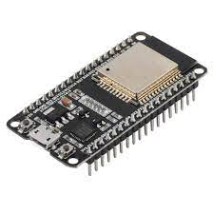

**3.2 MAX30100 heart rate sensor and oxymeter**

The MAX30100 is a sensor that monitors oxygen saturation and heart rate. It measures light absorption for determining blood oxygen levels and utilizes light to detect changes in blood volume for heart rate monitoring. It is frequently utilized in wearable technology applications for medical monitoring and health tracking.

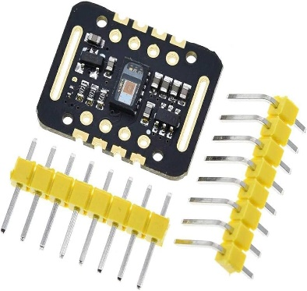

* 1. **DHT 11 temperature sensor module**

A affordable temperature and humidity sensor module is the DHT11. It measures the outside temperature and humidity using a thermistor and a capacitive humidity sensor. Since the sensor produces digital output, integrating it with microcontrollers such as Arduino is simple. Because of its price and ease of use, it is frequently utilized in a variety of do-it-yourself projects, weather stations, and environmental monitoring systems.

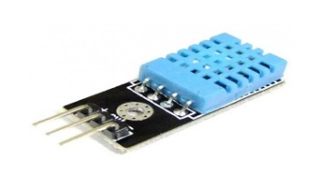

* 1. **Stepper motor**

An electric motor that moves in precise, distinct steps is called a stepper motor. It is frequently utilized in applications like robots, CNC machines, and 3D printers that need precise placement. Stepper motors may be precisely regulated in rotation by applying digital pulses to their windings. They are prized for their dependability, simplicity, and capacity to deliver accurate motion control. They are available in a variety of forms, including as bipolar and unipolar.

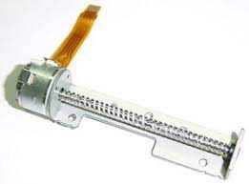

* 1. **Syringe**

A syringe is a basic yet essential medical instrument that is used to inject drugs, give shots, or remove bodily fluids. Syringes are made up of a barrel, plunger, and needle. They are available in many sizes and materials, from flimsy plastic ones to more robust metal ones. Because they enable accurate dosage delivery and guarantee sterile processes, they are essential to the healthcare industry. Syringes are also used in industrial and scientific settings outside of the medical field. Their design keeps changing, improving in many domains in terms of efficiency, safety, and use.   
  
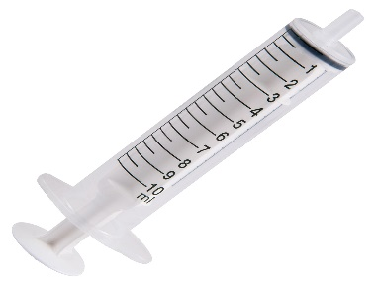

**3.6 Matrix keybroad**

An input device with 16 keys organized in a grid of four rows and four columns is called a 4x4 matrix keypad. Electronics frequently use it to input commands or data. Because each key denotes a distinct set of row and column connections, microcontrollers can quickly determine which key is pressed.



# 

# PROPOSED SYSTEM

The suggested microcontroller-based anesthetic system is a ground-breaking method of administering anesthesia that puts an emphasis on efficiency, accuracy, and safety during medical procedures. A painstakingly programmed microprocessor at the heart of the system is responsible for controlling the accurate supply of anesthetic chemicals depending on patient-specific data like as age, weight, and medical history. This reduces the possibility of under- or oversedation by ensuring customized dosages. Integrated sensors continuously track vital signs like blood pressure, oxygen saturation, heart rate, and breathing rate. They give the microcontroller real-time feedback so it can react quickly to any changes from the expected range. Healthcare personnel may input patient data, modify anesthetic parameters, and monitor vital signs in real-time with the system thanks to an intuitive user interface that makes interacting with it easy. The system also provides visual and audio feedback alerts users to important occasions. By sending out signals in the event of aberrant vital signs or equipment failure, an alarm system improves patient safety by enabling medical personnel to act quickly. The system also logs all data pertaining to anesthesia for analysis and documentation, assisting in efforts to enhance quality and conduct research. The suggested system combines cutting-edge technology with strong safety features and intuitive user interfaces to enhance anesthesia delivery, enhance patient outcomes, and progress medical practice.

### BLOCK DIAGRAM

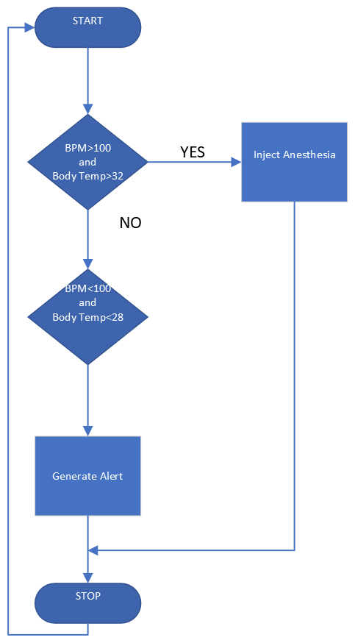

### Fig. 1

### CIRCUIT DIAGRAM

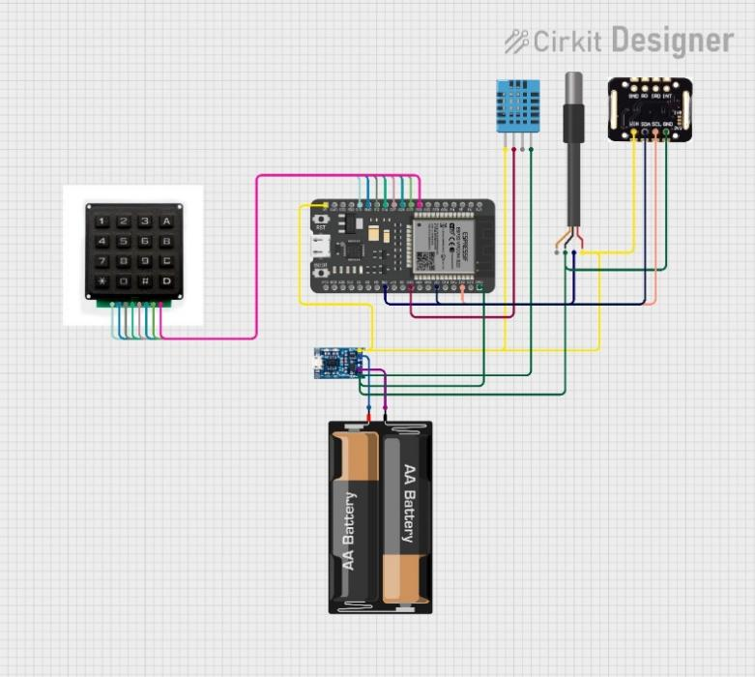

**Fig.2**

### GRAPHICAL ABSTRACT

### 

### 

1. **CONCLUSIONS**

In conclusion, the development of a microcontroller-based automatic anesthesia injector represents a significant advancement in medical technology aimed at improving patient safety and procedural outcomes during medical procedures. Traditional manual methods of anesthesia delivery are prone to human error, leading to potential risks for patients due to inaccurate dosing and inadequate monitoring. By harnessing the capabilities of microcontrollers, this innovative device automates the anesthesia delivery process, ensuring precise dosing and real-time adjustments based on the patient's condition. Through the integration of sensors and advanced control algorithms, the device enables continuous monitoring of vital signs, enhancing patient safety and reducing the occurrence of adverse events. Overall, the microcontroller-based automatic anesthesia injector offers a promising solution to mitigate the risks associated with manual anesthesia administration, ultimately improving the quality of care and outcomes for patients undergoing medical procedures.

# REFRENCES

1. Predefined  Logics  Based  Anesthesia  Delivery  Module  with Vital Monitoring byNatasha Mukhtiar, Nida Shabbir,UmnaLiaquat,Hinesh Kumar,FahadShamim.
2. Microcontroller Based Automated Anesthesia Injector by Devika M, Manasa D, ShwetaaV.J.
3. Study of Automatic Anesthesia Controller by Ishwari Ingale , Akanksha Pusatkar  , Snehal Yeola.
4. Microcontroller based Anesthesia Injector by, Smt.Leela Salim, Abey Thomas, Akshay M, Athul K Alias, Muhammed Irshad E K.
5. MICROCONTROLLER BASED ANAESTHESIA INJECTOR by M.KAVYA SAI, P.V.S.MEGHANA , M.SAI PRANEETH , N.MANOJ KALYAN.
6. Design Multiparameter Anaesthesia Depth Monitor System by,Ran Qiming, Wang Wei, Hu Na, Guan Fangyong, Li Zhangyong.
7. Improving Technologies in Anesthesia ,by Patrick Kolbay, Joseph Orr, Kai Kück.
8. Automatic Anesthesia Using  Controller ,by Dipika Khot1 , Chiranjeevi Biradar2, Ashwini Kudtarkar3 , Jyoti Waykule.
9. Automatic Anesthesia Using  Controller ,by Dipika Khot1 , Chiranjeevi Biradar2, Ashwini Kudtarkar3 , Jyoti Waykule.
10. Self-Regulated Anaesthesia Feeder for Surgical Patients ,by S. K. Kabilesh, K. C. Sivashree, S. Sumathiiswarya, G. Narmathadevi, R. Panjavarnam.