prem kumar

*by* Prem Kumar Prem Kumar

Submission date: 23-Feb-2024 08:41AM (UTC+0530)

Submission ID: 2302128043

File name: prem_kumar.pdf (390.05K)

Word count: 3293

Character count: 20415

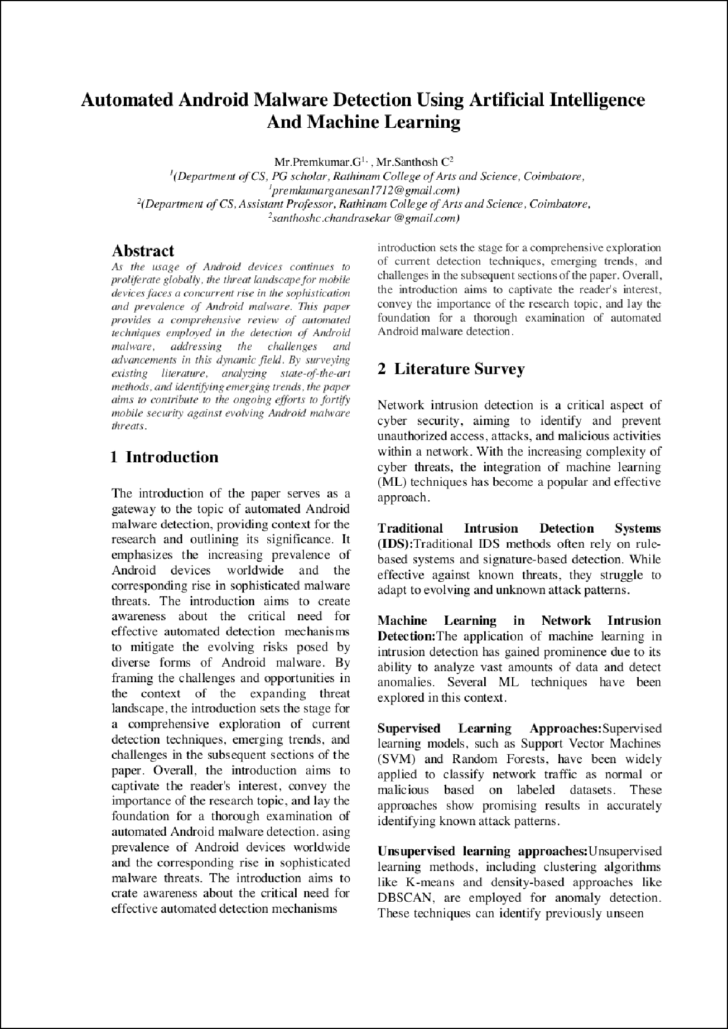

1

1

11

5

8

12

3

4

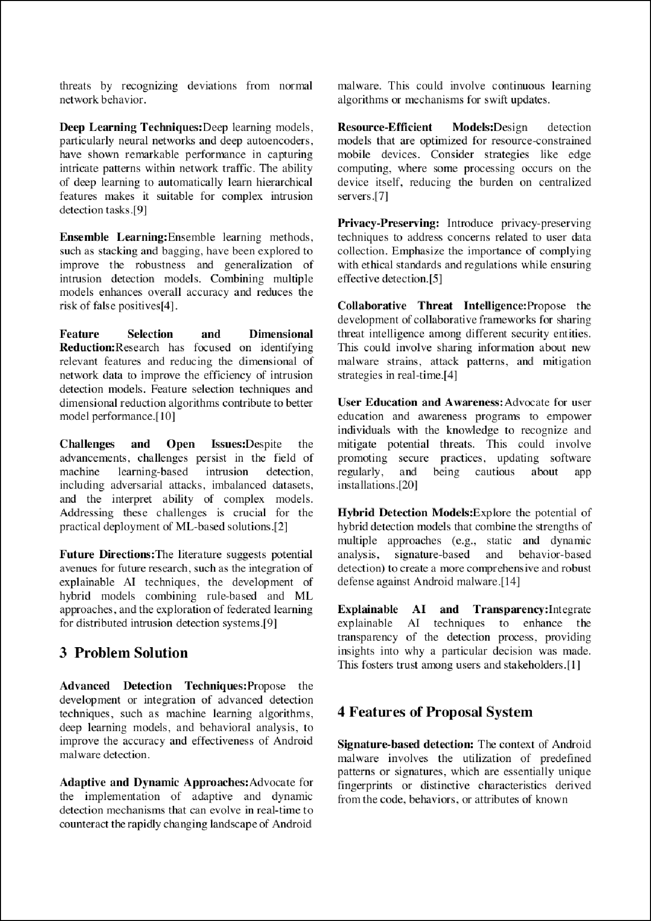

17

10

7

13

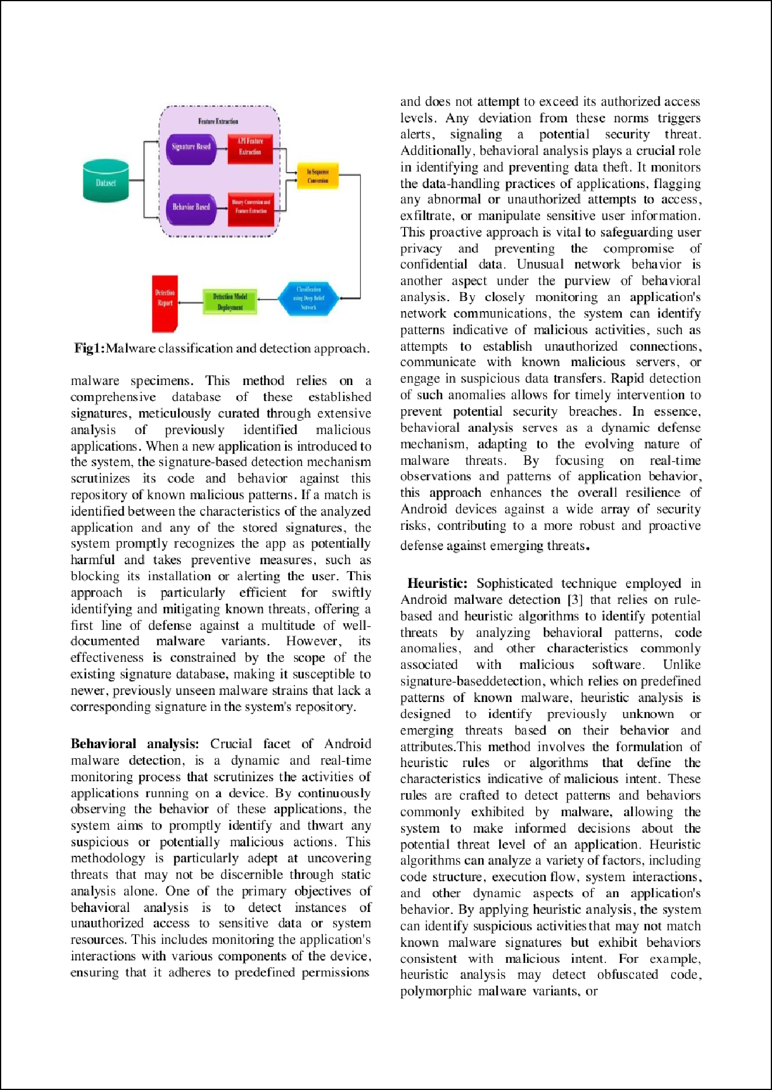

2

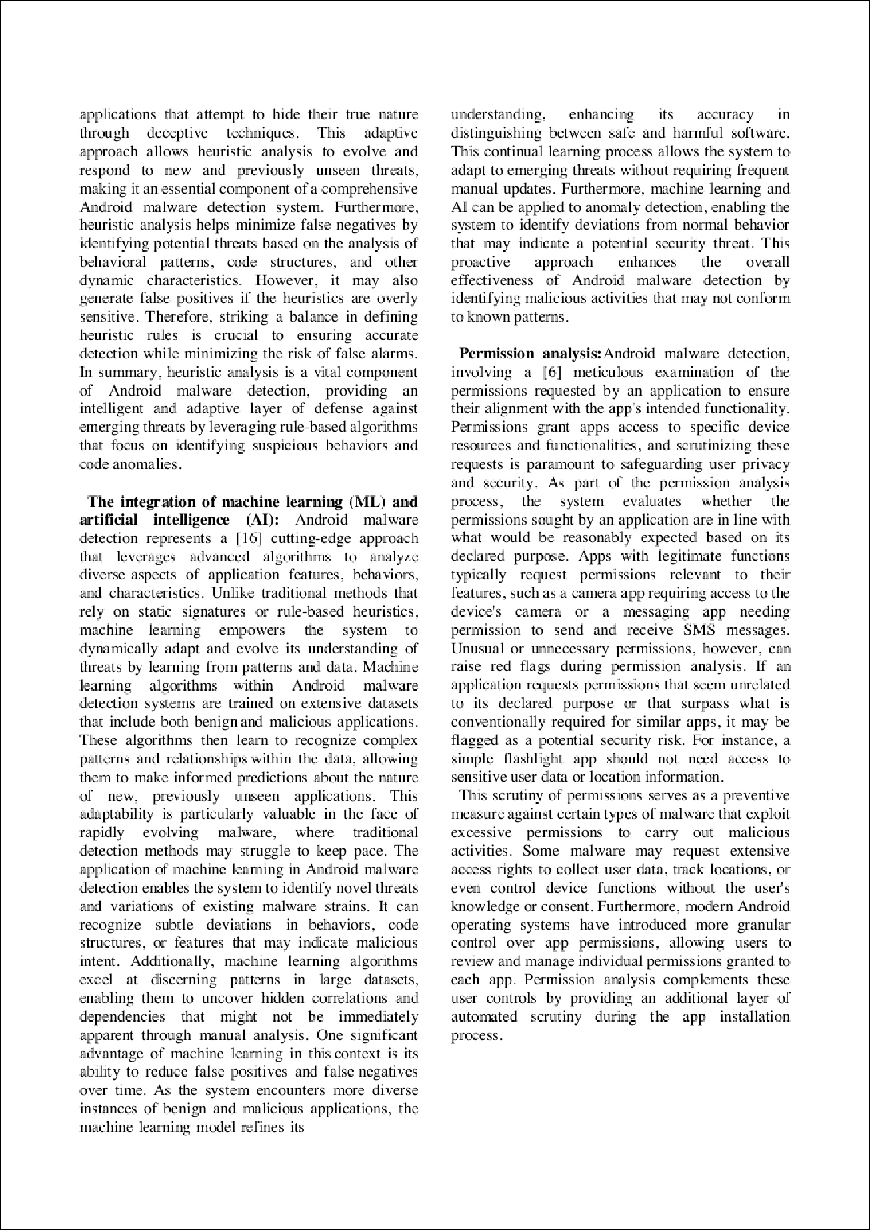

2

6

9

15

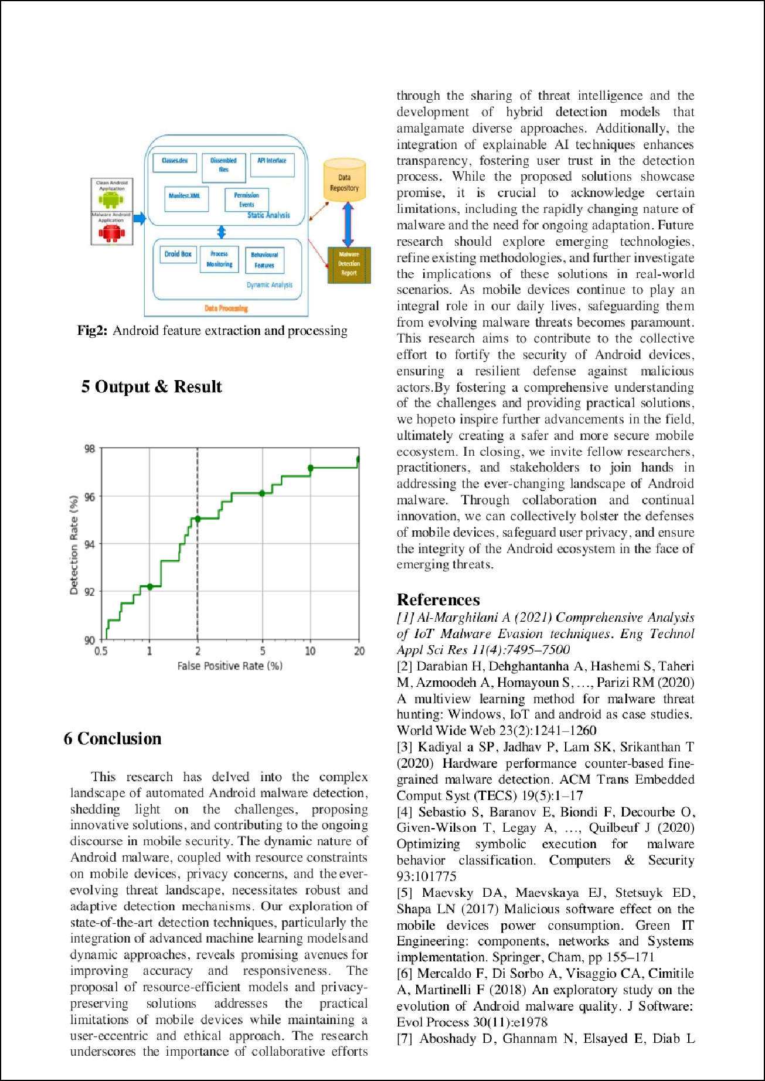

14

16

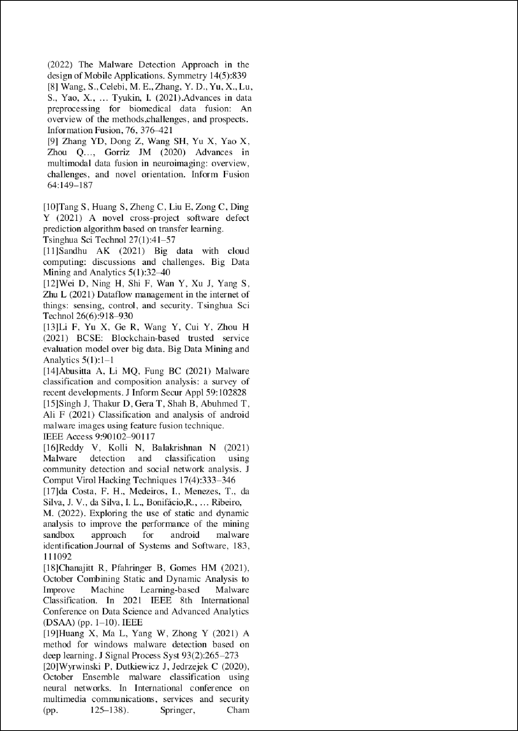



prem kumar

ORIGINALITY REPORT

6

%

SIMILARITY INDEX

3%

INTERNET SOURCES

4%

PUBLICATIONS

2%

STUDENT PAPERS

PRIMARY SOURCES

1 D. Sathya, D. Jagadeesan, P. Betty. "Online Communication with Natural Language", 2019 International Conference on Smart Systems and Inventive Technology (ICSSIT), 2019

Publication

2 Gaofeng Zhang, Yu Li, Xudan Bao, Chinmay Chakarborty et al. "TSDroid: A Novel Android Malware Detection Framework Based on Temporal & Spatial Metrics in IoMT", ACM Transactions on Sensor Networks, 2022

Publication

3 Submitted to University of Northumbria at Newcastle

Student Paper

Submitted to University of Gloucestershire

4

Student Paper

Submitted to Manipal University

5

Student Paper

Submitted to Webster University

6

Student Paper

1%

1%

1%

<1%

<1%

<1%

7

8

9

10

11

12

13

Jahangir Hossain, Nagham Saeed, Rampelli Manojkumar, Mousa Marzband, Khaled Sedraoui, Yusuf Al-Turki. "Optimal peak- shaving for dynamic demand response in smart Malaysian commercial buildings utilizing an efficient PV-BES system", Sustainable Cities and Society, 2023

Publication

docplayer.net

Internet Source

[www.ncbi.nlm.nih.gov](http://www.ncbi.nlm.nih.gov/)

Internet Source

Vasim Ahmad, Richa Goel, Lalit Goyal, Anita Venaik, Rakesh Kumar. "The Contribution of Blockchain-based Supply Chain Finance to Sustainability and Social Responsibility", 2023 Second International Conference on Augmented Intelligence and Sustainable Systems (ICAISS), 2023

Publication

link.springer.com

Internet Source

pergamos.lib.uoa.gr

Internet Source

publisher.unimas.my

Internet Source

<1%

<1%

<1%

<1%

<1%

<1%

<1%

14

15

16

17

[www.mdpi.com](http://www.mdpi.com/)

Internet Source

"Handbook of Big Data Analytics and Forensics", Springer Science and Business Media LLC, 2022

Publication

Doaa Aboshady, Naglaa E. Ghannam, Eman K. Elsayed, L. S. Diab. "APKOWL: An Automatic Approach to Enhance the Malware Detection", Mobile Networks and Applications, 2023

Publication

Houssem Lahiani, Mondher Frikha. "The Impact of Artificial Intelligence on Anomaly Detection in Android: A Survey", 2023 International Conference on Cyberworlds (CW), 2023

Publication

<1%

<1%

<1%

<1%

Exclude quotes Off Exclude bibliography On

Exclude matches Off