# “A COMPREHENSIVE REVIEW ON HERBAL LIP BALMS”

Sable Santosh Barikrao, Ms.Lad S., Dr. Garje S.Y., Dr. Sayyed G.A.

# Abstract:

Cosmetics have been in high demand since ancient times, with a modern shift towards naturally derived products. Herbal lip balms, designed to hydrate, soothe chapped lips, and protect against drying, are widely used but not without drawbacks. This review explores the formulation, benefits, and concerns surrounding natural lip balms, emphasizing their role in maintaining lip health while addressing potential risks associated with everyday use.

Keywords:

Natural Lip Balm, Formulation, Lip Care, Natural Ingredients

# Introduction:

Cosmeceuticals featuring medicinal properties, offer topical benefits and protection against skin conditions. This review focuses on lip balms, essential for lip protection, often formulated with plant extracts renowned for their reliability and safety compared to synthetic products. The evolution of lip cosmetics, including herbal formulations, aims to enhance lip beauty while ensuring biological skin functions are improved through nutrient-rich ingredients.

Anatomy of lip:

The lips are essential for various functions such as grasping, sucking, and articulating speech. They consist of layers including the skin, superficial fascia, orbicularis muscle, and surrounding muscles. The lip margins are lined with a dry, red mucous membrane that continues from the skin and contains vascular papillae and touch corpuscles. Internally, the mucous membrane extends onto the gums and forms two folds in the midline known as the superiors and inferiors.

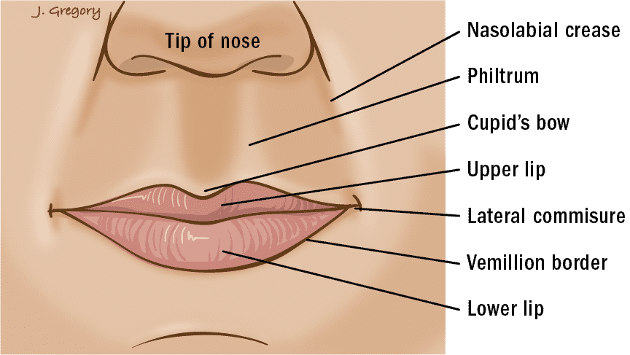

**Fig. Anatomy of lip balm**

# Lip balm:

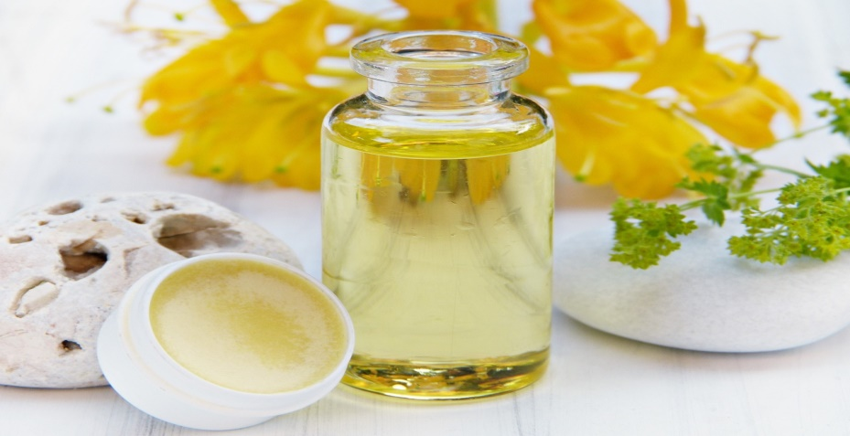

**Fig. Lip Balm**

Lip balm, a waxy substance, serves to moisturize and protect lips from external elements such as cold weather, preventing dryness and chapping while reducing irritation and infection risk. Unlike lipstick, lip balms are gender-neutral and typically possess a waxy texture, aiding in the healing of chapped lips.

# Application of Herbal Lip Balm:

Herbal lip balms provide a natural solution to dryness and environmental factors, with various options available from reputable brands. Due to potential ingestion, regulatory scrutiny of ingredients is crucial, necessitating a balanced formulation of key components like oils, waxes, and additives for optimal effectiveness and safety.

List of Natural Ingredients:

**1. Base:**

- Ghee

- Beeswax

- White beeswax

- Cocoa butter

- Candelilla wax

-Mango butter

**2.Oil:**

- Castor oil

- Coconut oil

- Olive oil

- Almond oil

- Sunflower oil

-Jojoba oil

**3. Agents:**

- Carrot

- Beetroot

- Saffron

- Cherry

- Honey

-Turmeric

-Watermelon

**4.Flavouring Agent:**

- Orange

- Vanilla

- Mango

- Honey

- Blueberry

-Strawberry

-Cherry

**5.Antioxidant:**

- Grape seed

- Aloe vera

- Green tea

- Rosemary

# Herbal Ingredients and their source and uses:

|  |  |  |
| --- | --- | --- |
| **Ingredient** | **Source** | **Use** |
| Beeswax | Beeswax is a product made from the honeycomb of the honeybee | thickness |
| Coconut oil | Coconut oil obtained from the coconut tree (Cocos nucifera) | Moisturizer |
| Carrot | The source of carrot seed essential oil (CSEO) are mainly seeds of wild carrots (Daucus carota L. ssp. carota | Colourant |
| Vanilla | Vanilla is a spice derived from orchids of the genus Vanilla | Flavouring Agent |
| Aloe vera | Obtain from Aloe barbadensis | Antioxidant |
| Grape seed | Grape seed extract, which is made from the seeds of wine grapes | Antioxidant |
| Orange | originally came from China | Flavouring Agent |
| Beetroot | The beetroot is the taproot portion of a beet plant | Colourant |
| White beeswax | White beeswax is obtained from yellow beeswax | thickners |

# Marketed Preperation Of lip balm:

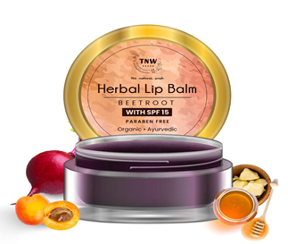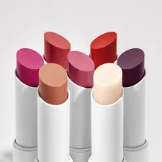

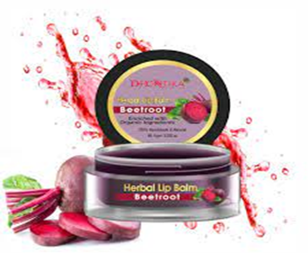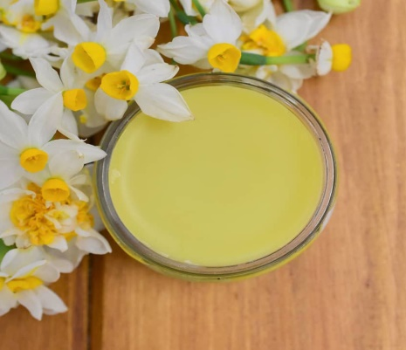

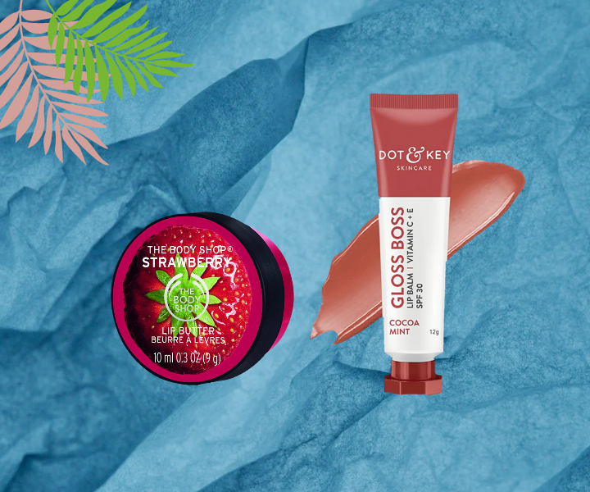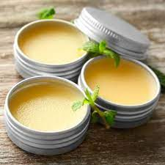

**1. Base:**

Waxes play a crucial role in various industries, including personal care products and decorative cosmetics. They offer unique properties such as resistance to moisture, oxidation, and bacteria, making them valuable in different applications. Here's a breakdown of the information provided.

**Classification of Waxes:**

Animal Waxes: Beeswax, lanolin, spermaceti.

Plant Waxes: Carnauba, candelilla, jojoba.

Mineral Waxes: Ozokerite, paraffin, microcrystalline, ceresin.

Synthetic Waxes: Polyethylene, carbowax, acrawax, stearon.

**2. Oil**

The distinction between oils and fats lies primarily in their physical forms at room temperature, with fats being solid and oils being liquid. Both are chemically triglycerides, composed of glycerol and fatty acids. The stability and properties of oils are influenced by the saturation levels of their fatty acids.

**Saturated Oils:** These contain a high proportion of saturated fatty acids such as lauric, myristic, palmitic, and stearic acids. Examples include coconut oil, cottonseed oil, and palm oil. Saturated oils tend to be more stable and resist rancidity.

**Unsaturated Oils:** These contain a high proportion of unsaturated fatty acids like oleic, arachidonic, and linoleic acids. Examples include canola oil, olive oil, corn oil, almond oil, safflower oil, castor oil, and avocado oil. Unsaturated oils are smoother, less greasy, and better absorbed by the skin but are more prone to rancidity.

**3. Colouring agent**

Colorants or coloring agents play a vital role in providing a distinctive appearance to cosmetic products. Since ancient times, color has been utilized in cosmetics to appeal to the senses of sight, touch, and smell, influencing consumers' desire to purchase these products.In lip cosmetics, color is imparted to the lips in two primary ways:

**Staining the Skin:** This method involves applying a solution of dyestuff that can penetrate the outer layer of the lip skin, leaving a lasting color. Staining agents are formulated to adhere to the lips and provide long-lasting coloration.

**4.Flavoring agents:**

are utilized to mask the four basic taste sensations and enhance the overall sensory experience of the product. Flavors create a mixed sensation involving taste, touch, smell, sight, and sound, influencing the perception of substances.

**Selection and Creation of Flavors:**

The flavor industry has expanded with technology, leading to the development of artificial or imitation flavors.Creating an acceptable flavor is considered more of an art than a science, with flavorants chosen based on the taste of the ingredients they need to mask or complement.

**Type of lip balm:**

# 1.UV Filter Lip Balm:

Ideal for year-round use, especially beneficial in summer or in areas with high sun exposure.Provides protection against UV radiation, helping to prevent sunburn and damage to the lips.

## 2.Nourishing Lip Balm:

Best suited for use in winter when the skin tends to be drier and more prone to chapping. It Contains ingredients that nourish and replenish moisture, helping to keep lips soft and supple.

## 3.Moisturizing Lip Balm:

Suitable for year-round use, particularly effective for dry lips. Absorbs quickly to provide hydration and relief from dryness, but may not be ideal for use in extremely cold conditions where rapid absorption could lead to further dryness or chapping.

## 4.Medicated Lip Balm:

Contains ingredients with softening and antiseptic properties, providing relief for chapped or irritated lips.Should be applied carefully, especially if sensitive to certain medicinal ingredients.

## 5.Tinted Lip Balm:

Can be worn year-round for a touch of color while also providing hydration and protection to the lips.Offers a subtle tint to enhance the natural color of the lips without the heaviness of lipstick.

# Conclusion:

Your product sounds impressive! With its patented formula combining a humectant, an emollient, and an occlusive humectant, along with added benefits like nutrition, scar healing, and sun protection, it offers comprehensive care for lips. The inclusion of honey, hyaluronic acid, and SPF further enhances its appeal. Plus, being made from 100% botanical ingredients is a great selling point for health-conscious consumers.

# Reference:

1. V.P. Kapoor, Herbal cosmetics for skin and hair care, Natural Product Radiance. 4 (2005) 306-314.

2. B. J. Kukreja, V. Dodwad, Herbal mouthwashes-A gift of nature, International Journal of Pharma and Bio Sciences. 3 (2012) 46-

52.

3. . P.K. Chattopadhyay, Herbal cosmetics and ayurvedic medicines, National institute of Industrial Research. 1 (2005) 45-50.

4. Medscape. http://emedicine.medscape.com/article/835209-overview (assessed on 8 January 2015)

5. . M.S. Balsam, E. Sagarin, Cosmetics science and technology, second ed., Wiley Interscience Publication, NY, USA, 2008, 1,

pp. 365.

6. K.V. Allam, G.P. Kumar, Colorants the cosmetics for the pharmaceutical dosage forms, Int. Jou. of Pharmacy and Pharm. Sci.,

3 (2011) 13-21.

7. S.V. Magee, et al Botnical butter stick lip balm. US patent US20080089916 A1, 2008.

8. . B.M. Mittal, R.N. Saha, A Handbook of cosmetics, first ed., Vallabh Prakashan: New Delhi, India, 2000.

13. M.A. Mundo, O.I. Padilla-Zakour, R.W. Worobo, Growth inhibition of foodborne pathogens and

food spoilage organisms by select raw honeys, International Journal of Food Microbiology, 97 (2004) 1-

8. S.A. Sahar, M. Soltan, M.E.M. Shehata, the effects of using color foods of children on immunity

properties and liver, kidney on rats, Food and Nutrition Sciences. 3 (2012) 897-904.

9. Mahony, Effect of color on odour, flavorand acceptance properties of food and beverages, M.Tech

Thesis, B.S., Chapman University, 2001.

10. A.V. Sharma, P.V. Sharma, Flavouring agents in pharmaceutical formulations. Ancient Science of Life.

8 (1988) 38-40.

11. B.N. Basha, K. Prakasam, D. Goli, Formulation and evaluation of gel containing fluconazole -antifungal agent, International Journal of Drug Development and Research, 3 (2011) 4.

12. M.S. Balsam, E. Sagarin, Cosmetics science and technology, second ed., Wiley IntersciencePublication, NY, USA, 2008, 1, pp. 365.

13. K.V. Allam, G.P. Kumar, Colorants the cosmetics for the pharmaceutical dosage forms, Int. Jou. ofPharmacy and Pharm. Sci., 3 (2011) 13-21.

14. S. Deshmukh, M. Chavan, M. Sutar, S. Singh, Preparation and evaluation of natural lipsticks frombixa orellana seeds, Int J Pharm Bio Sci. 4 (2013) 139-144.

15. GOUVEA, M.C.B.L.F. Desenvolvimento de base de batons. Cosmet. Toiletries (Portuguese edition),v.5, n.2, p.49-56, 1993.

16. Sharma PP, cosmetics- Formulation, manufacturing and quality control, Edn 5. Vandana publications, Delhi, 2008, 297-313.

17. H. Ratih, H. Titta, C.P. Ratna, Formulation of Cananga Oil Lip Balm as Emolient”. Prosiding Simposium Penelitian Bahan Obat Alami (SPBOA) XIV dan Muktamar XII PERHIPBA 2014.Yogyakarta: Leutikaprio. p. 3, 2014.

18. P.P. Sharma, “Cosmetics-Formulation, manufacturing and quality control”, fourth ed. (2008).Vandana Publications Pvt. Ltd., India.

19. H. I. N. Nasution, “Formulation of Lip Balm using Combination of Palm Kernel Oil (PKO) and Red Palm Oil (RPO) as Lip Moisturizer,” Final project, Universitas Sumatera Utara, 2018.

20. BRASIL. Ministério da Saúde. Agência Nacional de Vigilância Sanitária. Séries Temáticas: Qualidade 1. Guia de Estabilidade de produtos cosméticos. Brasília, v.1, 2004. 45 p.

21. OLIVEIRA, F.O. Contribuição da análise térmica no desenvolvimento de formulações de batons.São Paulo, 2003. 85 p. [Dissertation of Master degree. Institute of Chemistry. University of SãoPaulo].