**Review on Formulation and evaluation of polyherbal toothpaste**

**Gholap Akshay S., PathanV.A., Dr. Garje S.Y., Dr. Sayyed G. A.**

**Abstract:**

This research endeavors to create a herbal toothpaste incorporating natural elements such as Guava leaves, Neem stem, Kalmi bark, Babul leaves, etc., traditionally employed for dental hygiene. The preference for formulations with natural ingredients stems from the perception of their safety compared to synthetic counterparts. The assessment of the formulated herbal toothpaste encompasses organoleptic and physical characteristics, including color, odor, taste, pH, spreadability, moisture content, fineness, and foam ability.

Historically employed for dental hygiene, natural ingredient-infused formulations are perceived as safer compared to synthetic drugs.

The antimicrobial assessment against Staphylococcus aureus indicates that the herbal toothpaste formulation demonstrated significant efficacy, with a zone of inhibition (ZOI) measuring 19.7 mm at a minimum inhibitory concentration (MIC) of 25μg/mL. The findings of this study suggest a comparable and compelling preference for the formulated herbal toothpaste when compared to commercial products such as Colgate, Dabour Red, and Dantkanti.

Toothpaste serves a primary role in oral care, aiding in the upkeep of oral hygiene. It acts as an abrasive, eliminating dental plaque and food particles from the teeth, contributing to the prevention of halitosis by masking or removing it. Additionally, toothpaste releases active substances such as fluoride, assisting in the prevention of tooth and gum diseases like Gingivitis. The toothbrush's mechanical action, coupled with the toothpaste's included excipients, predominantly facilitates the cleaning process.

The toothpaste underwent assessment for various factors such as uniformity, spreadability, foaming ability, stability, pH, moisture content, volatile matter, and more. The evaluation focused on both organoleptic and physical attributes to ensure it possesses the necessary features for effective use against dental issues.

**Keywords:**

Botanical component, dental gel, antibacterial properties, toothpaste, guava, neem, dental issue.

**INTRODUCTION:**

Exploring a chemical solution to replace mechanical plaque control dependent on patients, aiming to streamline the process and effectively minimize and prevent oral diseases. While self-administered mechanical plaque removal is widely accepted, it can be time-consuming, and some individuals may lack motivation for these procedures.

Exploring the flow of creating homemade toothpaste involves planning with plant extracts such as Neem leaves, Guava leaves, Cinnamon bark, along with additional ingredients like Camphor and Honey. The plant extract components exhibit antibacterial properties, contributing to a herbal toothpaste formulation that meets the requirements for maintaining oral freshness and preventing tooth decay caused by bacteria

For centuries, traditional and plant-derived toothpaste has played a crucial role in historical oral care practices. The origins of toothpaste formulations can be traced back to 300-500 BC in China and India, utilizing abrasives like crushed bone, crumbled egg, and clam shells for teeth cleaning. It wasn't until the nineteenth century that modern toothpaste compositions emerged.

Maintaining oral health involves regularly cleaning and ensuring a disease-free mouth, addressing issues such as bad breath. This is achieved through consistent tooth brushing (dental hygiene) and interdental cleaning. Regular oral hygiene practices are crucial for preventing dental problems like cavities (tooth decay) and gum diseases such as gingivitis and periodontitis.

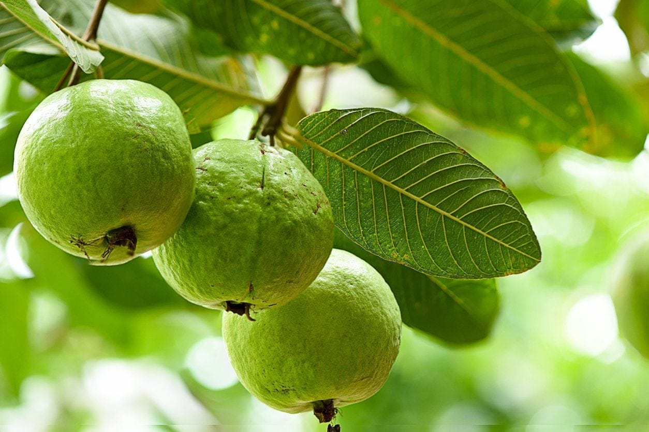The extracts are utilized in diverse categories, such as Neem for its antibacterial properties, Guava for its anti-inflammatory effects, Babul as an astringent, Kalmi as a flavoring agent. Additionally, other ingredients include Camphor for its antiseptic qualities, Honey as a sweetening agent, Glycerine as a humectant, Cal Carbonate as an abrasive, and SLS as a detergent. Sodium chloride and distilled water are also incorporated in the formulation.

**Fig.1: Guava**

**Taxonomical classification of guava:**

Synonyms: Guava Bush and Strawberry Guava

Biological Source: The diminutive medicinal tree Psidium guajava L. originates from South America.

Family: Myrtaceae

Chemical Constituents:

Guava leaves contain primary phenolic compounds, including isoflavonoid, gallic acid, catechin, epicatechin, rutin, and naringenin.

Uses:

- It addresses inflammation.

- Beneficial for treating ulcers, respiratory conditions, diarrhea, and fever.

- Assists in weight loss.

- Helps in regulating blood sugar levels.

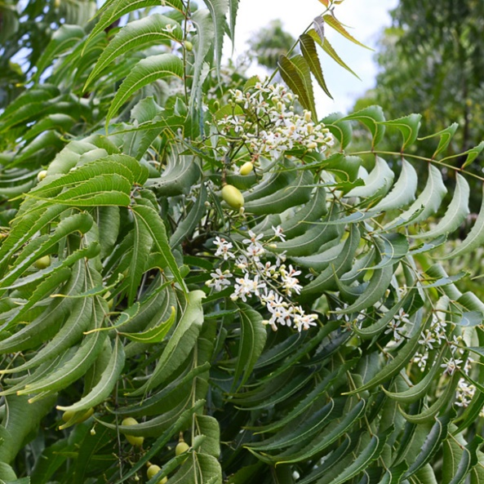- Enhances the skin's texture.

**Fig.2: Neem**

The Neem tree, alternatively referred to as the Nimba tree, Indian lilac, miracle tree, and various other monikers, is scientifically known as Azadirachta indica. It is renowned for its rapid growth, with heights typically ranging from 90-98 ft, occasionally reaching up to 131 ft, and a diameter of about 66–82 ft. This evergreen, deep-rooted perennial is prevalent across arid regions in South Asia. With its robust, furrowed bark, rounded crowns, broad compound leaves, fragrant white flowers, and small, sweet-flavored yellow-green fruit, the Neem tree is easily identifiable.

Propagation of Neem trees is commonly done through seeds, although they can also be cultivated from cuttings or root suckers. Despite its resemblance to the Chinaberry tree, the Neem tree exhibits resilience, thriving even in poor and rocky soils. It adapts well to various environmental conditions and is known for its tolerance.

Neem

Domain: Eukaryota

Kingdom: Plantae

Phylum: Spermatophyta

Subphylum: Angiospermae

Class: Dicotyledonae

Order: Rutales

Family: Meliaceae

Genus: Azadirachta

Species: Azadirachta

**MATERIALS AND METHODS:**

Chemicals such as Calcium carbonate (Balaji Chemicals), Para hydroxyl benzoic acid (Loba Chemicals), Sodium lauryl sulfate (Loba Chemicals), Sodium chloride (Balaji Chemicals), Camphor (Local market), and Honey (Local market) were procured from the market. For collection, Neem, Guava, Babul, and Kalmi were gathered from the plant present at the medicinal garden campus. These plants underwent identification and authentication. For formulation, all herbal ingredients were dried and ground using a domestic mixer. The required quantities of ingredients were weighed and placed in a mortar. Calcium carbonate, Sodium lauryl sulfate, methyl cellulose, honey, and glycerine were combined in water.

Components

The quantity of each component was established through analysis from a prior investigation into the formulation of herbal toothpaste. The ingredients in this toothpaste collectively contribute to a total weight percentage of 100%, indicating that the entire toothpaste quantity will result in 100 grams of toothpaste.

**Dry gum technique:**

Base preparation:

1. Weigh the solid components, including calcium carbonate, sodium lauryl sulfate, glycerin, sodium benzoate, and sodium saccharin, following the specified formula. Sieve them with a No. 80 sieve to maintain the desired particle size.

2. Combine these ingredients in a mortar and pestle, then triturate them with precisely measured glycerin until a semi-solid consistency is achieved.

3. Incorporation of herbal components-

4. Add accurately weighed herbal extract in the form of ginger oil to the base.

5. Finally, introduce peppermint oil to the mixture.

**Trituration technique:**

Begin by pre-mixing the binder with solid abrasive, then triturate the mixture. Next, combine it with the liquid phase containing humectants and oils. Add preservative and sweetener into a mixer. Once a homogeneous paste forms, add flavor and detergent under slow-speed agitation to reduce foaming. Mix, mill, deaerate, and tube the paste.

**ASSESSMENT OF DEVELOPED HERBAL TOOTHPASTE:**

In adherence to the specified guidelines, standards were defined for the evaluation tests of both Type-I (non-fluorinated) and Type-II (Fluorinated) toothpaste formulations. The physical examination encompassed aspects such as color, odor, taste, and smoothness, determined through relative density. The formulated toothpaste underwent scrutiny for its color, with a visual assessment conducted. Odor was assessed through olfactory examination, and taste was manually evaluated by sampling the formulation.

PH:

Determine the pH of the homemade solution using a pH meter. Combine 10g of toothpaste with 150ml of a measuring utensil. Allow 10ml of boiled and cooled water, then vigorously stir to create a suspension.

Homogeneity:

Apply standard force at 27±20C to extract a uniform mass from the collapsible tube or any suitable container. The predominant portion of the product will be expelled from the container fold and subsequently transferred.

The fineness was assessed by precisely weighing 10g of toothpaste, transferring it to a 100 ml beaker. Subsequently, 50 ml of water was added, and the mixture was stirred and left undisturbed for 30 minutes until complete dispersion of the paste occurred.

The remedy was sifted through 150µ and 75µ IS sieves, then rinsed under a gentle tap water flow. After complete drainage, the sieve was dried at 105±2 ̊C in an oven. The residual particles on the sieve were moved onto a watch glass and subsequently weighed.

**Calculation:**

Percentage of material on the sieve = (Retained mass / Initial material mass) x 100.

Antibacterial Activity: The paste's in-vitro antibacterial efficacy was evaluated through a triple-replicated disc diffusion method on Mueller Hinton Agar medium against the pathogenic bacterium Staphylococcus aureus (S. aureus, MTCC 3160). Initially, S. aureus cells were cultured on Muller Hinton agar plates, and the formulated paste-containing discs were placed on the bacterial plates. The incubation was carried out at 37ºC for 24 hours, with ciprofloxacin serving as the positive control. The diameter of the zone of inhibition (ZOI) was measured in millimeters. Minimum inhibitory concentration (MIC), indicating the lowest concentration without visible microbial growth, was determined using the agar streak dilution method in triplicate. The protocol involve…

Stability Investigation:

Conducted per the ICH guideline, the study involved placing the prepared paste into collapsible tubes and subjecting it to varying temperature and humidity conditions, specifically at 25ºC ± 2ºC /

Maintained at 60% ± 5% relative humidity (RH) and 30º C ± 2ºC, as well as 65% ± 5% RH and 40ºC ± 2ºC, along with 75% ± 5% RH, for a three-month duration. Investigated for visual characteristics, pH, and spreadability.

Uniformity:

When a normal force is exerted at 27°C, the toothpaste is expected to extrude a uniformly consistent mass from the collapsible tube or another appropriate container. Additionally, the majority of the

The contents should gradually extend beyond the container's crimp while maintaining control.

Odor Evaluation:

This assessment relied on personal observations regarding its appeal. Five individuals were consulted to gauge the acceptability of the odor, and their perspectives were considered. The fragrance was assessed using the following criteria:

A) The odor was pleasing, on par with the reference toothpaste.

B) The odor wasn't particularly appealing but could be likened to the reference toothpaste.

C) The toothpaste's fragrance was inferior to that of the reference toothpaste.

**RESULTS AND ANALYSIS:**

The formulation of the homemade toothpaste comprised Neem leaves, Guava leaves, cinnamon bark, natural ingredients, and a small amount of synthetic ingredient. In the initial formulation stage, three batches were conducted to address concerns such as homogeneity, spreadability, and foamability. Two batches were permanently eliminated due to these issues, leaving only one batch selected for subsequent phases. The formulated herbal toothpaste exhibited a greenish-brown color, demonstrating excellent homogeneity with no visible lumps and displaying effective antimicrobial activity.

**CONCLUSION:**

The herbal toothpaste stands out as a preferred option in dental research, offering enhanced acceptability and a safer profile with minimal side effects compared to synthetic preparations. The developed toothpaste successfully met the criteria of all evaluation tests, proving its suitability for dental and oral hygiene. The formulated herbal toothpaste holds promising potential in future research on natural remedies and public dental health.

**REFERENCES:**

1. Ersoy M, Tanalp J, Ozel E, Cengizlier R, Soyman M. The allergy of

Toothpaste: a case report. Allergol Immunopathol. 2008; 36(6):368–70.

Doi:10.1016/s0301-0546(08)75871-3.

2. Davies R, Scully C, Preston AJ. Dentifrices- an update.

Medicina Oral Patologia Oral. Cirugia Bucal. 2010;15(6):976–82.

doi:10.4317/medoral.15.e976.

3. Jardim J, Alves L, Maltz M. The history and global market

of oral home-care products. Braz Oral Res. 2009;23:17–22.

doi:10.1590/s1806-83242009000500004.

4. Mithal BM, Saha RN. A handbook of cosmetics; 2000. p. 204–12.

5. Kokate CK, Purohit AP, Gokhale SB. Textbook Of Pharmacognosy;

2002.

6. Nema RK, Ks R, Dubey BK. Textbook of Cosmetics; 2009

7. Nayak A, Ranganathan N, Sowmya GB, Kishore B, Kudalkar M. Evaluation of antibacterial and

anticandidial efficacy of aqueous and alcoholic effect of neem (AzadirachtaIndica): An Invitro study. Int

J Res Ayurveda Pharm. 2011; 2:230–5

8. Prashant GM, Chandu GN, Murulikrishna KS, Shafiulla MD. The effect of mango and neem extract on

four organisms causing dental caries Streptococcus Mutans Streptococcus Salivavius, Streptococ-

cusMitisAnd streptococcus Sanguis: An in Vitro study. Indian J Dent Res. 2007; 18:148–51. [PubMed]

http://dx.doi.org/10.4103/0970-9290.35822.

9. Siswomihardjo W, Sunarintyas SB, Nishimura M, Hamada T. The difference of antibacterial effect of

neem leaves and stick ex- tract. Int Chin J Dent. 2007; 7:27–9.

10. Chava VR, Manjunath SM, Rajanikanth AV, Sridevi N. The effica- cy of neem extract on four

microorganisms responsible for causing dental caries viz Streptococcus Mutans, Streptococcus Salivarius,

Streptococcus Mitis and Streptococcus Sanguis: An in Vitro study. J Contemp Dent Pract. 2012;13:769–

72.[PubMed]

11. Grace X.F. et.al., Preparation and evaluation of herbal dentifrice. Int. Res. J. Pharm. (2015), 6(8):509-

511.

12. Mahendran Sekar*,Noor Jasmin Shamsul Arrifin, Formulation,Evaluation and Antibacterial Properties of

Novel Polyherbal Toothpaste for Oral Care

13. Mahendran sekar*,Muhammad Zulhilmi Abdullah, Formulation,evaluation and antimicrobial properties

of polyherbal toothpaste

14. C.K Kokate, A.P Purohit , S.B GokhalePharmacognosy, NiraliPrakashan , 2014

15. Davies R, Scully C, Preston A.J. Dentifrices- an update. Med Oral Patol Oral Cir Bucal. 2010; 15 (6):

976-82. 2.

16. Ersoy, M; Tanalp, J; Ozel, E; Cengizlier, R; Soyman, M; The allergy of toothpaste: a case report.

AllergoletImmunopathol,2008, 36(6),368-70. 3

17. George J, Hegde S, KS R, Kumar A. The efficacy of a herbal-based toothpaste in the control of plaque and

gingivitis: A clinico_biochemical study. Indian J Dent Res. 2009;20(4): 480

18. Siswomihardjon W, Badawi S S, Nishimura M. The difference of antibacterial effect of neem leaves and

stick extracts. Int Chin J Dent.2007;7: 27-29.

19. Prashant GM, Chandu GN, Murulikrishna KS, Shafiulla MD. The effect of mango and neem extract on four

organisms causing dental cries: Streptococcus mutant, streptococcus salivavvus, streptococcus mitis,and guis:

An in vitrostudy. Indian J Dent Res. 2007;18(4): 148-151.

20.Shah S, Venkataraghavan K, Choudhary P, Mohammad S, Trivedi K, Shah S G. Evaluation of antimicrobial

effect of azadirachtin plant etract (SoluneemTM) on commonly found root canal pathogenic microorganisms

(viz. Entercoccus faecalis) in primary teeth: A microbilogical study. J Indian Soc Pedo Prev Dent. 2016;34(3):

210-216.

21. Telrandhe R. Nanotechnology foapy: Recent developments. Eur J Pharm Med Res. 2016;3(11): 284-294.

22. Singh K, Singh P, Oberoi G. Comparative studies between herbal toothpaste (dantkanti) and nonherbal tooth

paste. Int J Dent Res. 2016;4(2): 53-56.

23. Kokate C K, Purohit A P, Phedn, Nirali Prakashan ; 11 : 81

24. Shende V, Telrandhe R. Formulation and evauation of Tooth Gel from Aloe veratract. Int J Pharm Drug

Analysis. 2017;5(10): 394-398.

25. Telrandhe R, Mahapatra D K, Kamble M A. Bombax ceiba thorn extract mediated synthesis of silver

nanoparticles: Evaluation of anti staphylococcus aureus activity. Int J Pharm Drug Analysis. 2017;5(9): 376-

379.

26. T Mangilal, M Ravikumar. Preparation a Evaluation Of Herbal Toothpaste And Copared With Commercial

Her An Invitro Study. Int J Ayu Herb Med. 2016; 3(6): 2266-2273.

27. Mith BM, Saha RN. A Handbook of Csmetics; 2017. p. 1–228.

28. Mangilal T, Ravikumar M. Preparation and Evaluation of Herbal Toothpaste and Compared with

Commercial Herbal Toothpastes: An In-vitro Study. Int J Ayurvedi Herbal Med. 2016;6(3):2266–73.

29. Mandan SS, Laddha UD, Surana SJ. Experimental Microbiology (Practical).; 2017. p. 62–75.

30. Lieberman HA, Rieger MM, Banker GS. Pharmaceutical Dosage Forms: Disperse Systems. Informa

Healthcare. 2008;2:423–45.

31.Gaud RS, Gupta GD. Practical Microbiology; 2016. p. 63–78.