**ANTI SLEEPING GLASSES**

**K.DAYA1, K.BHARADWAJ2, S.AKASH3 ,B.RAHUL4,G.P.MERLINE5**

1Student, EEE, Holy Mary Institute of Technology & Sciences, Hyderabad, Telangana

2 Student, EEE, Holy Mary Institute of Technology & Sciences, Hyderabad, Telangana

3Student, EEE, Holy Mary Institute of Technology & Sciences, Hyderabad, Telangana

4Student, EEE, Holy Mary Institute of Technology & Sciences, Hyderabad, Telangana

5Professor , EEE, Holy Mary Institute of Technology & Sciences, Hyderabad, Telangana

**ABSTRACT**

In modern-times, owing to hectic schedules it becomes very difficult to remain active all the time. Imagine a situation where a person is driving home from work, dead tired after facing all the challenges of the day. The hands are on the wheel and foot on the pedal but suddenly started feeling drowsy, the eyes start shutting and the vision blurs and before it knew, then the person fall asleep. Falling asleep on the wheel can lead to serious consequences, there may be accidents and people may even lose their lives. This situation is much more common and hence, it is very important to counter this problem. So, to address this issue, the Project Anti-Sleep Alarm for Drivers is introduced.

**Keywords:** Anti sleep.

1. **INTRODUCTION**

The drowsiness detection system is capable of detecting drowsiness in quickly. The system which can differentiate normal eye blink and drowsiness can prevent the driver from entering the state of sleepiness while driving. The system works well irrespective of driver wearing spectacles and under low light conditions also. During the monitoring, the system is able to decide if the eyes are closed or opened. When the eyes have been closed for too long a warning signal is issued. The ultimate goal of the system is to check the drowsiness condition of the driver. Based on the eye movements of the driver, the drowsiness is detected and according o eye blink, the alarm will be generated to alert the driver and to reduce the speed of the vehicle along with the indication of parking light.

.2 BLOCK DIAGRAM OF ANTI SLEEP GLASSES

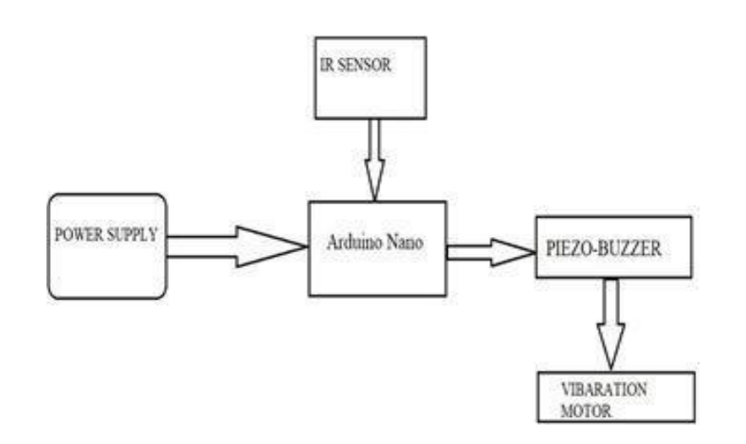

* 1. Functions of the Components:

➢ IR SENSOR: It is a electronic device used to detect some objects near-by surroundings. It detects the movement of an object. In this project we used IR Sensor as an input to detect the moment of eye-blink.

➢ ARDUINO NANO: It is a Microcontroller board. It is used for technical support, where we dump a code into it and it works as a Controller or a Function. The operating Voltage of 5v, however the input Voltage can vary from 7 to 12v.

➢ BUZZER: A piezo Buzzer is used to get output of the executed program and any errors occurs process an immediate buzzer is generated.

HARDWARE COMPONENTS

Arduino Nano The Arduino Nano is a small, complete, and breadboard-friendly board based on the ATmega328P released in 2008. It offers the same connectivity and specs of the Arduino Uno board in a smaller form factor. The Arduino Nano is equipped with 30 male I/O headers, in a DIP-30-like configuration, which can be programmed using the Arduino Software integrated development environment (IDE), which is common to all Arduino boards and running both online and offline. The board can be powered through a type-B mini-USB cable or from a 9 V battery. Despite the size, Arduino Nano packs in more or less the same features as UNO. If you compare UNO and Nano, then Nano lacks the DC Power Jack and contains a mini- B type USB connector. Other than that Nano is very similar to UNO in terms of functionality

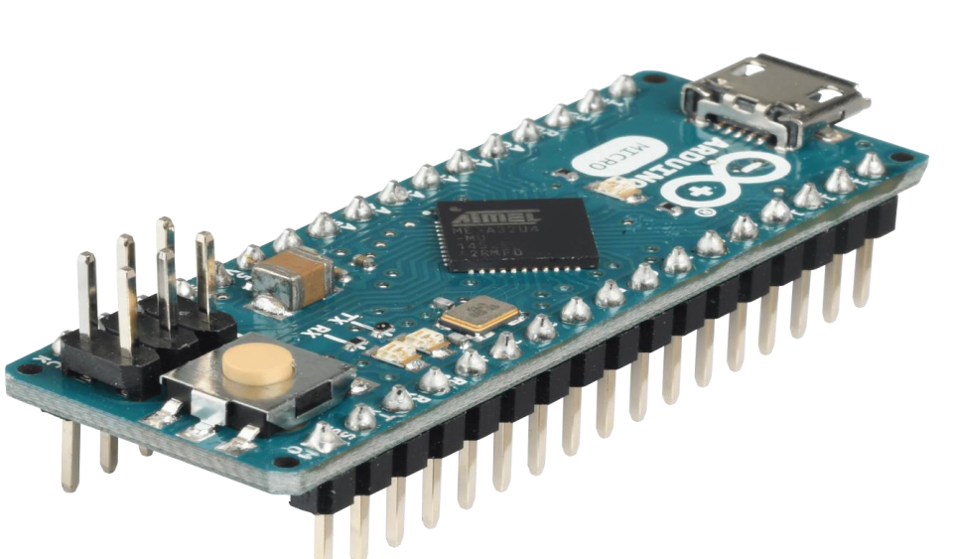**.**

IR Sensor:

IR sensor is an electronic device that emits the light in order to sense some object of the surroundings. An IR Sensor can measure the heat of an object as well as detects the motion. Usually, in the Infrared spectrum all the objects radiate some form of thermal radiation. These types of radiations are invisible to our eyes, but infrared sensor can detect these radiations. The emitter is simply an IR LED and the detector is simply an IR photodiode. Photodiode is sensitive to IR light of the same wavelength which is emitted by the IR LED. When IR light falls on the photodiode, the resistances and the output voltages will change in proportion to the magnitude of the IR light received. There are five basic elements used 5 5 in a typical infrared detection system: an infrared source, a transmission medium, optical component, infrared detectors or receivers and signal processing. Infrared lasers and Infrared LEDs of specific wavelength used as infrared sources. The three main types of media used for infrared transmission are vacuum, atmosphere and optical fiber. Optical components are used to focus the infrared radiation or to limit the spectral response. 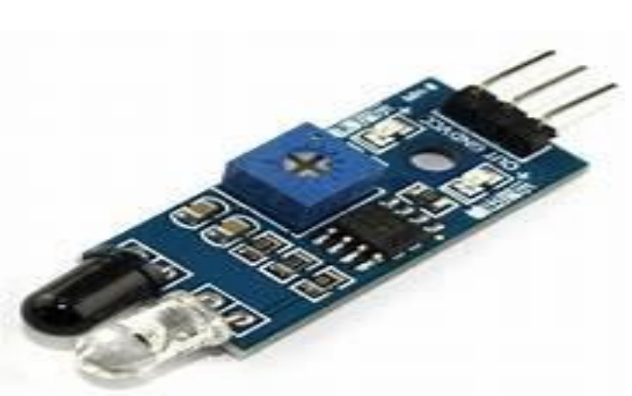

PIEZO BUZZER:

The piezo buzzer produces sound based on reverse of the piezoelectric effect. The generation of pressure variation or strain by the application of electric potential across a piezoelectric material is the underlying principle. These buzzers can be used alert a user of an event corresponding to a switching action, counter signal or sensor input. They are also used in alarm circuits. The buzzer produces a same noisy sound irrespective of the voltage variation applied to it. It consists of piezo crystals between two conductors. When a potential is applied across these crystals, they push on one conductor and pull on the other. This, push 6 6 and pull action, results in a sound wave. Most buzzers produce sound in the range of 2 to 4 kHz. The Red lead is connected to the Input and the Black lead is connected to Ground.

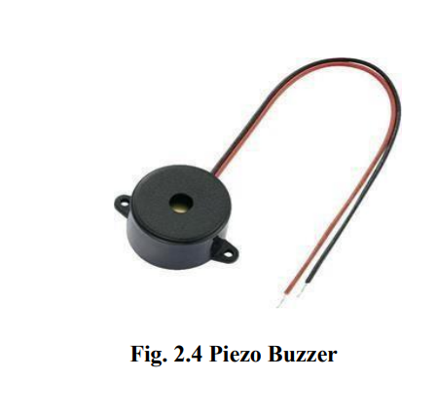MICRO VIBRATION MOTOR:

This is the micro vibration motor, as you can see it has two wires red and black. Red is the positive wire while black is the ground wire. The working voltage of the vibration motor is 2 to 5 volts. The rated voltage is 3.7 volts and the current is .07 amps which is equal to 70milli-amps. As you can see the vibration motor has small thin wires due to which it’s really hard to interface this with the Arduino, so I decided to fix the vibration motor on a small PCB board.

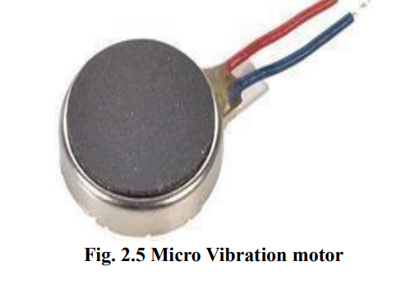

Eye Glasses / Spectacles:

The eye blink system comes with an IR sensor mounted on glasses which the user can wear like regular glasses, shown in the picture below. Eye blink Sensor is a relatively simple sensor used to detect eye blinks. It uses a simple infrared sensor to detect if the person's eye is closed and the corresponding data received can further be processed by any logic as required for the application.

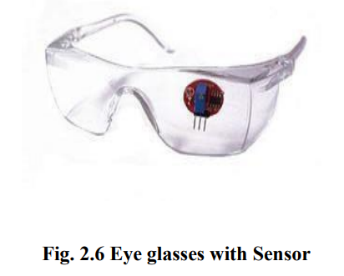

PROJECT WORKING

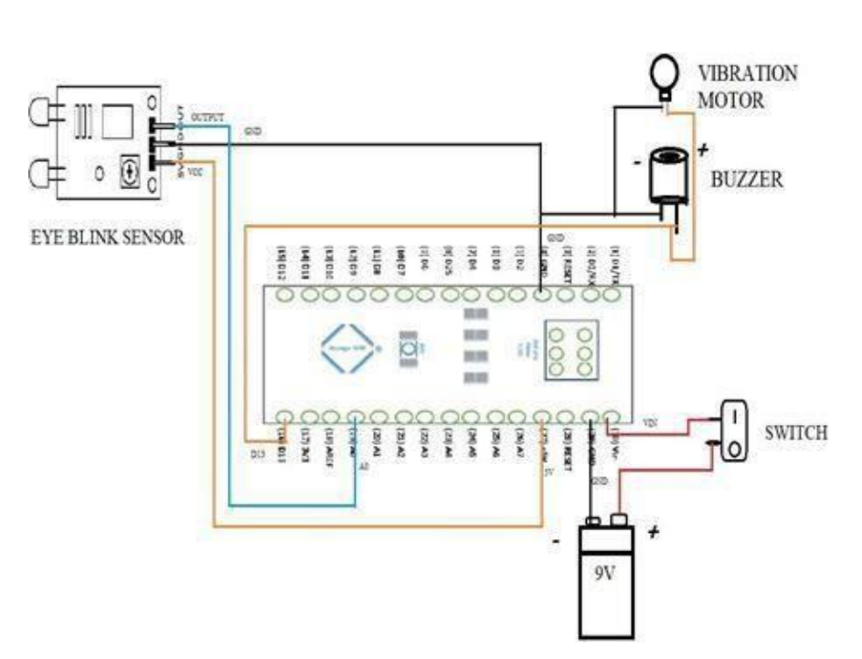ASSEMBLING PROCEDURE:

• Connected all the Components as Shown in above Circuit Diagram.

• Required Code is dumped into Arduino NANO using Arduino IDE by Connecting USB Cable to Laptop/ Computer.

• Now Power supply is given to the Circuit with a help of a 9V Battery.

• IR Sensor is used to detect the Eye-blink or closing the eyes of a person, if eyes closed for a while an immediate buzzer automatically turns ON.

• The buzzer automatically turns OFF, when the person come back to his normal State.

• The Micro vibration motor turns ON simultaneously with the buzzer.

**RESULT & CONCLUSION**

4.1 Prototype of Anti sleep glasses

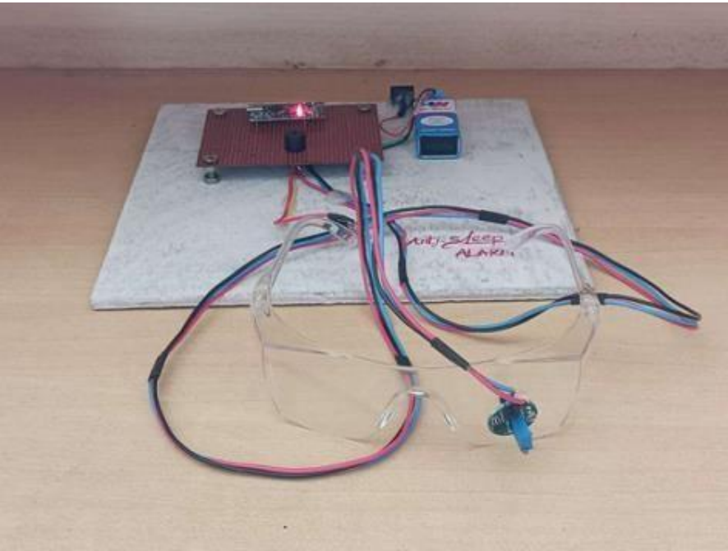

Output of the Prototype model:

• The project is used to detect the Eye-blink or closing the eyes of a person, if eyes closed for a while. The buzzer automatically turns ON, when the person come back to his normal State. The buzzer goes OFF.

• Given below Figure shows the working of the project. 12

4.3 ADVANTAGES:

➢ It is used to avoid the accidents.

➢ It is more-efficient and simple to use.

➢ The Device is useful especially for people who travel long distance and drive late at night.

➢ Using this Device helps the driver to wake up when he/she asleep while driving.

➢ Affordable Cost and Portable Size.

4.4 DISADVANTAGES:

➢ Device may not work when the system circuitry fails.

➢ Yawning repeatedly or rubbing the eyes may get the circuit ON.

4.5 APPLICATIONS:

➢ Eyelid distance tracking to detect the Sleepiness.

➢ Sleepiness detection is Efficient and alarms will generate only when demanded (while in asleep). ➢ This can be used in high-end manufacturing cars to prevent accidents

FUTURE SCOPE & CONCLUSION

5.1 FUTURE SCOPE:

Though the prototype model worked very efficient with remarkable output, the real-life situations is going to be way more challenging and demanding. This system is an attempt to help in decreasing and/or prevent road accidents that happen due to drivers’ drowsiness. Using our Anti Sleep Alarm System, the drivers will be benefited and be alert while driving with a low price. We believe that our model has lots of societal impact which will reduce the accidents. In future we will use small micro camera which will replace the eye sensor and will incorporate GPS module in the device to track the location of the driver. Since the price is very affordable, we have a plan to marketing it in future. It can be added to every high-end manufacturing car to prevent accidents. Sleepiness detection is Efficient and alarms will generate only when demanded (while in asleep). Due to portable size, it can be used in different applications.

5.2 CONCLUSION:

This Project “ANTI-SLEEP ALARM FOR DRIVERS” is successfully designed, and tested and demo unit is fabricated. The goal of this project is to develop a device that can accurately detect sleepy driving and make alarms accordingly, which aims to prevent the drivers from drowsy driving and create a safer driving environment. The project was accomplished by an IR sensor. This system detects the drowsiness in quickly. This system which can differentiate normal eye blink and drowsiness can prevent the driver from entering the state of sleepiness while driving. Whenever a driver asleep due to drowsiness, the buzzer continuously starts beeping unless the driver gets back to his/her normal position. The ultimate goal of the system is to prevent the road accident, where the values measured in life.

References

[1]https://nevonprojects.com/driver-anti-sleep-device/ [2]https://www.academia.edu/34469825/A_Survey_Pape r_On_Drowsiness_Detection_and_Alarm_System_for_D rivers.

[3] D.Jayanthi, M.Bommy. : Vision-based Real-time Driver Fatigue Detection System for Efficient Vehicle Control. In: International Journal of Engineering and Advanced Technology (IJEAT) ISSN: 2249 - 8958, Volume-2, Issue-1, October 2012.

[4] Amol M. Malla, Paul R. Davidson, Philip J. Bones,Richard Green and Richard D. Jones, Automated Video-based Measurement of Eye Closure forDetecting Behavioral Microsleep presented at 32nd Annual International Conference of the IEEE EMBSBuenos Aires, Argentina, August 31 -- September 4,2010. [

5] P. D. Minns, C Programming for the PC the MAC and the Arduino Microcontroller System. Author House, 2013.