**A STUDY ON PERFORMANCE APPRAISAL SYSTEM IN**

**AXIS BANK**

**1Joshi J and 2Surendhar R**

**1 MBA Students Jerusalem College of Engineering, Chennai**

**2 Professor MBA, Jerusalem College of Engineering, Chennai**

**ABSTRACT**

This study delves into the performance appraisal system at Axis Bank, one of India's leading private sector banks, to examine its effectiveness, efficiency, and impact on both employee performance and organizational outcomes. With a comprehensive review of the bank's appraisal mechanisms, the research aims to understand how these processes contribute to motivating employees, identifying training needs, and promoting organizational growth and development. The methodology encompasses a mixed approach, including qualitative interviews with bank employees and managers, and a quantitative analysis of employee performance data, to provide a holistic view of the appraisal system's functionality. The study also considers the bank's strategic objectives, its organizational culture, and the broader banking industry's competitive environment to contextualize the performance appraisal practices. Preliminary findings suggest that Axis Bank's performance appraisal system is robust, with a strong emphasis on continuous feedback, goal alignment, and employee development. However, challenges related to consistency in the implementation of appraisals, subjective biases in evaluations, and the need for enhanced training for appraisers have been identified. The study is not without limitations, notably restricted access to confidential performance data, potential biases in employee self-reporting during interviews, and the inability to conduct a longitudinal analysis to observe changes over time. Despite these constraints, this research offers valuable insights into the performance appraisal practices at Axis Bank, contributing to the broader discourse on human resource management in the banking sector and laying the groundwork for future studies to build upon.

.

**INTRODUCTION**

Performance appraisals are essential for the growth of a company and the employee. It helps the company to find out whether the employee is being productive or is a liability. It helps the employee to find out where his / her career is heading. It is an essential part of HR management. A performance approval need not be a stressful event for the HR / supervisor or for the employee. This can be a productive platform for the employee to express his / her work- related issues and sort it out and for the HR / Supervisor to motivate the employee to contribute more. Following are some of the benefits of performance appraisal. Employee satisfaction and motivation A Performance appraisal meeting is a platform where the employee is recognized for his / her good work and it is important to recognize the work done by an employee. Even if the employee has not done a good work, it is important to show that the organization is interested in his / her individual performance and their growth in the company. This motivates the employee to work hard, which in turn, benefits the company. A regular appraisal program can have a deep impact on levels of employee satisfaction and motivation. Finding out the need for training and development During an appraisal meeting, the employer can point out the areas where the employee needs improvement. The employee can look at the data and agree with the employer, and

then work out a plan for training and development. The training will help the employee to perform better and it will pave the way to future growth. Companies can look at consolidated appraisal data and decide on areas where improvement is needed for individual employees, as well as, for the whole team. Then they can plan for training and development. Analyzing appraisal data for better recruitment Appraisal data helps in monitoring the success of a company’s recruitment practices. For example, how well the employees who were hired in the past one or two years are performing, how is the attrition rate and so on. Based on it, the HR department can strategize future hiring. Improving communication between management and employee Most often, there is a communication gap between the supervisor and the employee, especially when the employee is new to the company. Most of the time supervisor / manager will be too busy to pay proper attention to the new hire. Performance appraisals will help to break that ice, which is good for both the supervisor / manager, as well as, the employee because better communication leads to better productivity.

**OBJECTIVES OF THE STUDY**

**PRIMARY OBJECTIVES:**

* To study on performance appraisal system practiced in Axis Bank.

**SECONDARY OBJECTIVES:**

* To know the employee awareness and level of satisfaction about the performance appraisal practiced.
* To identify the factors inducing to increase the performance of an employee
* To know the factors necessary for appraising the employees
* To provide suggestions to the management in improving performance appraisal system.

**SCOPE OF THE STUDY:**

* To improve the performance of employees
* To understand about performance appraisal system
* To find out employee satisfaction and awareness of performance appraisals

**LIMITATIONS OF THE STUDY**

* The scope of the study encompasses all the members in the organization. The study is conducted to know the expectation among the employees.
* The study is confined to the Chennai city. The study is for a period of 2 months.
* The population size is infinite and the sample size is123
* The project emphasizes the expectations and opinions of employees which would be useful for the organization in understanding the employees’ mind.

**REVIEW OF LITERATURE:**

**1. Susan M. Heathfield 2020** of The Traditional Performance Appraisal Process says Managers cite performance appraisal as the task they dislike the most. This is understandable given that the process of performance appraisal, as traditionally practiced, is fundamentally flawed. It is incongruent with the values-based, vision-driven, mission-oriented, participative work environments favored by forward thinking organizations today. Its macks of an old fashioned, paternalistic, top down, autocratic mode of management which treats employees as possessions of the company.

**2.Bacal’s (2019)** of Performance Management & Appraisal and Work-Related Articles “Performance management and performance appraisal (or employee reviews, annual reviews, etc) are some of the most misused tools anywhere. A fortune is wasted processes, poor forms, and result from mistaken ideas about what performance management is for, and why we do it.

**3.GerardMcLoughlin (2019)** of how to Prepare for a Performance Appraisal Performance appraisal should be treated as an ongoing developmental process rather than a formal once-a-year review. Both employee and reviewer to ensure that targets are being achieved should closely monitor it. By preparing yourself diligently and demonstrating a willingness to co-operate with your reviewer to develop your role, you will create a positiveimpression. To enable you to assess your own performance as objectively as possible, try to view it fromour manager's perspective. Make sure you are conversant with the company's assessment policies and procedures.

**3.**  **Dulewicz (2019)** says that A basic human tendency to make judgments about those one is working with, as well as about oneself." Appraisal, it seems, is both inevitable and universal. In the absence of a carefully structured system of appraisal, people will tend to judge the work performance of others, including subordinates, naturally, informally and arbitrarily. Performance appraisal systems began as simple methods of income justification. That is appraisal was used to decide whether or not the salary or wage of an individual employee was justified. The process was firmly linked to material outcomes. If an employee's performance was found to be less than ideal, a cut in pay would follow. On the other hand, if their performance was better than the supervisor expected, a pay rise was in order**.**

**4. Abteen Ijadi Maghsoodi (2018**)The selection of appropriate Performance Appraisal (PA) techniques and financing scales for organizations in today's dynamic and agile environments is a challenging subject. Performance appraisal has evolved into a strategic strategy to merging company policies with human resource activities in modern enterprises. Finding the best PA approach is more difficult due to the presence of various elements in the decision making process. The current study uses a multiple criteria decision analysis method, MULTIMOORA integrated Shannon's entropy significant coefficient, to examine PA methods. Using correlation coefficients of the final entropy values, the final rankings of the organizational components are compared to TOPSIS and TOPSIS incorporated Shannon's entropy approaches.

**5.** **c)** Researched the design and implementation of performance assessment and management systems to improve efficiency. The study focuses on a model that demonstrates how enhanced performance requires solid HR practices, fair assessment systems, effective performance management, and a clear understanding of an organization's overall strategic goals. The model is supported by three pillars: motivation, evaluation, and results management. The model depicts a perception of a relationship between effort put in and expected outcomes, as well as a perception of a relationship between the achieved result and the expected level of assessment, and a perception of a link between the level of evaluation and the evaluation's outcome.

**RESEARCH METHODOLOGY**

Research methodology refers to the systematic, theoretical analysis of the methods applied to a field of study. In other words, it is simply referred as the practical “how” of any given piece of research. It comprises the technical analysis of the body of methods and principles associated with a branch of knowledge. It helps the researcher to achieve the objectives of the study. Thus, research methodology is about how a researcher systematically designs a study to ensure valid and reliable results that address the research aims and objectives. This research aims to study about consumer preference in apple products. This chapter explains the objectives, data collection methods, sampling techniques used, research design and various other methods followed in carrying out the research.

This chapter provides an explanation of how the study was conducted and includes a detailed outline of the research techniques, the data collection methods.

**ANALYSIS:**

**1.PERCENTAGE ANALYSIS FOR GENDER OF THE RESPONDENT**

**TABLE-1 CHART-1**

|  |  |  |  |  |  |
| --- | --- | --- | --- | --- | --- |
|  | | | | | |
|  | | Frequency | Percent | Valid Percent | Cumulative Percent |
| Valid | Male | 56 | 45.5 | 45.5 | 45.5 |
| Female | 67 | 54.5 | 54.5 | 100.0 |
| Total | 123 | 100.0 | 100.0 |  |

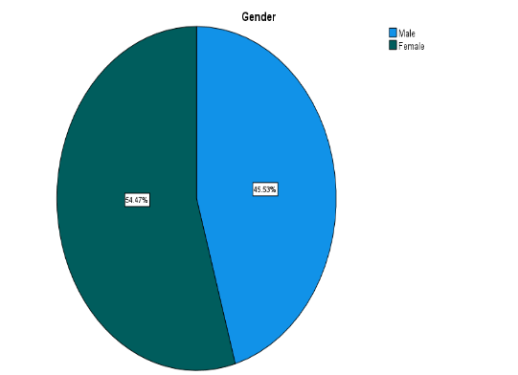

**INFERENCE:**

From the above table and chart, it is understood that 45.5% Male and 54.5% are female. The majority is FEMALE.

.

**2.PERCENTAGE ANALYSIS FOR AGE OF THE RESPONDENT**

**TABLE-2 CHART-2**

|  |  |  |  |  |  |
| --- | --- | --- | --- | --- | --- |
| **Age** | | | | | |
|  | | Frequency | Percent | Valid Percent | Cumulative Percent |
| Valid | 20-30 years | 99 | 80.5 | 80.5 | 80.5 |
| 30-40 years | 21 | 17.1 | 17.1 | 97.6 |
| Above 40 years | 3 | 2.4 | 2.4 | 100.0 |
| Total | 123 | 100.0 | 100.0 |  |

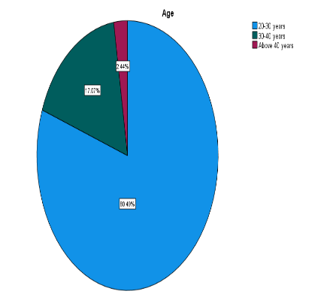

**INFERENCE:**

From the above table and chart are 20-30 years are 80.5 , 30-40 years are 17.1 and above 40 years 2.4.The majority is 20-30 years

**3.PERCENTAGE ANALYSIS FOR EDUCATION QUALIFICATION OF THE RESPONDENT**

**TABLE- 3 CHART-3**

|  |  |  |  |  |  |
| --- | --- | --- | --- | --- | --- |
|  | | | | | |
|  | | Frequency | Percent | Valid Percent | Cumulative Percent |
| Valid | Bachelor's degree | 51 | 41.5 | 41.5 | 41.5 |
| Master's degree | 69 | 56.1 | 56.1 | 97.6 |
| Others | 3 | 2.4 | 2.4 | 100.0 |
| Total | 123 | 100.0 | 100.0 |  |

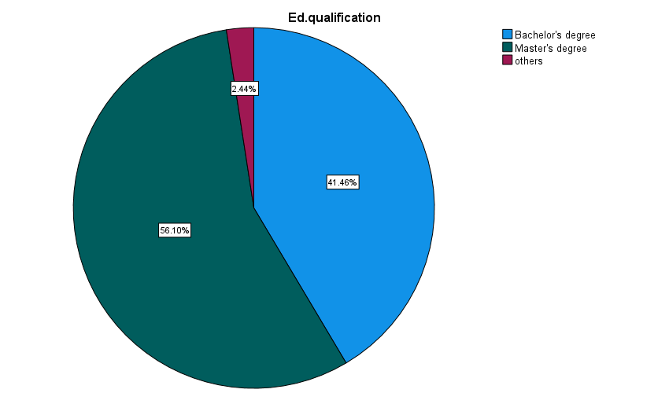

**INFERENCE:**

The above chart claims that 41.5% are from bachelor’s degree , 56.1 are from master’s degree and 2.1 are from others.

**4.PERCENTAGE ANALYSIS FOR EMPLOYMENT STATUS OF THE RESPONDENT**

|  |  |  |  |  |  |
| --- | --- | --- | --- | --- | --- |
| **TABLE-4**  **Current employment status** | | | | | |
|  | | Frequency | Percent | Valid Percent | Cumulative Percent |
| Valid | Full employment | 78 | 63.4 | 63.4 | 63.4 |
| Others | 45 | 36.6 | 36.6 | 100.0 |
|  |  |  |  |  |
| Total | 123 | 100.0 | 100.0 |  |

**CHART-4**

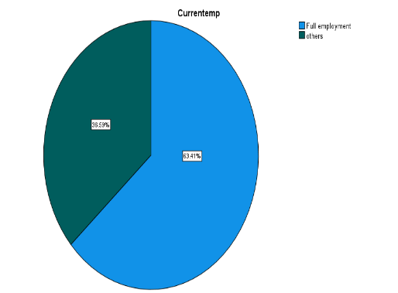

**INFERENCE**:

From the above pie chart, it is understood that 63.4% are full employment and 36.6% are others

**PERCENTAGE ANALYSIS FOR MONTHLY INCOME OF THE RESPONDENT**

**TABLE – 5 CHART-5**

|  |  |  |  |  |  |
| --- | --- | --- | --- | --- | --- |
| **Monthly income** | | | | | |
|  | | Frequency | Percent | Valid Percent | Cumulative Percent |
| Valid | Below 20000 | 53 | 43.1 | 43.1 | 43.1 |
| 20000-50000 | 56 | 45.5 | 45.5 | 88.6 |
| 50000-100000 | 11 | 8.9 | 8.9 | 97.6 |
| Above 100000 | 3 | 2.4 | 2.4 | 100.0 |
| Total | 123 | 100.0 | 100.0 |  |

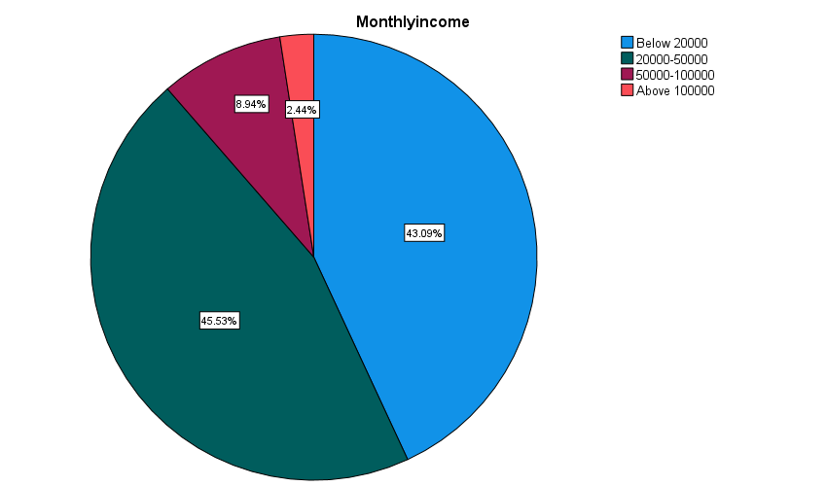

**INFERENCE:**

From the above chart 43.1% are below 20000, 45.5%are 20000-50000, 8.9% are 50000-100000 and 2.4 %are above 100000.The majority is 45.5% 20000-50000.

**CHI-SQUARE**

A chi-square test is a statistical test that is used to compare observed and expected results.

HO: There is no significant association between what type of performance appraisal is followed in your organization and are you satisfied with the present appraisal system followed in your organization.

H1: There is a significant association between what type of performance appraisal is followed in your organization and are you satisfied with the present appraisal system followed in your organization.

|  |  |  |
| --- | --- | --- |
| **Test Statistics** | | |
|  | TypeofPAsystemfollowed | SatisfiedwiththePAsystem |
| Chi-Square | 1.374a | 63.415b |
| Df | 1 | 2 |
| Asymp. Sig. | .241 | .000 |
| a. 0 cells (0.0%) have expected frequencies less than 5. The minimum expected cell frequency is 61.5. | | |
| b. 0 cells (0.0%) have expected frequencies less than 5. The minimum expected cell frequency is 41.0. | | |

**INFERENCE:**

From the above table we found that the calculated value is 0.000 which is less than the table value 0.05, Thus null hypothesis is rejected and alternate hypothesis accepted.

**REGRESSION**

To find out the significant relationship between the specify your satisfaction level regarding the performance appraisal carried out in your organization and at low performance level how does your organization improve the performance level of the employees.

H0: There is a no relationship between the specify your satisfaction level regarding the performance appraisal carried out in your organization and at low performance level how does your organization improve the performance level of the employees.

H1: There is a relationship between the specify your satisfaction level regarding the performance appraisal carried out in your organization and at low performance level how does your organization improve the performance level of the employees.

From the above table we found that the calculated value is 0.000 which is less than the table value 0.05, Thus null hypothesis is rejected and alternate hypothesis accepted

|  |  |  |  |  |  |
| --- | --- | --- | --- | --- | --- |
| Coefficients | | | | | |
| Model | | Unstandardized Coefficients | | Standardized Coefficients | t | | Sig. |
| B | Std. Error | Beta |
| 1 | (Constant) | 1.326 | .108 |  | 12.264 | | .000 |
| SatisfactionlevelregardingPAinorg | -.063 | .049 | -.116 | -1.286 | | .201 |
| a. Dependent Variable: Atlowperformancelevelhowtoimprove | | | | | | | |
|  | | | | | |

**FINDINGS, SUGGESTIONS AND CONCLUSION**

**Findings:**

* The researcher found that the majority of respondents, 54.5% are female.
* The study reveals that majority of the respondents, 80.5% are 20-30 years.
* The study reveals that 41.5% are from bachelor’s degree , 56.1 are from master’s degree and 2.1 are from others.
* The study reveals that 31.7% are married and 68.3 % are single. The majority is single.
* The study reveals that 63.4% are full employment and 36.6% are others.
* The study reveals that 6.5% has 2 persons,21.1% has 3 persons,61.0 has 4 persons and 11.4 persons . The majority is 4 persons.
* The study reveals that 43.1% are below 20000, 45.5%are 20000-50000, 8.9% are 50000-100000 and 2.4 %are above 100000.The majority is 45.5% 20000-50000.
* The study reveals that 41.5% are challenging,33.3 % are interesting,25.2% are normal. The majority opted for challenging.
* The study reveals that 6.4% opted yes and 23.6% opted no for the awareness of performance appraisal system.
* The study reveals that 55.3 % are open system and 44.7 % are confidential system. The majority is open system.
* The study reveals that 63.4% are good,23.6% are fair,13.0% are needs improvement and the majority are good.
* The study reveals that 41.5% are satisfied, 57.7% are partially satisfied,0.8% are opted dissatisfied.
* The study reveals that 72.4% opted yes and 27.6 % opted no. The majority is YES additional satisfaction towards appraisal.
* The researcher identifies that 26.0% are quarterly,30.9 % are half -yearly are 30.9% and more than a year 43.1% is the duration to conduct the appraisal.
* The researcher identifies 11.4% are commitment of work,6.5 %are discipline,1.6% are attendance,.8%are plan of work,79.7% are all the above. The majority opted all the above , for the factors necessary for appraising the employees.
* The study reveals that 94.3 % are yes and 5.7% are no .The majority is accepted that performance appraisal system increase self -development.
* The study reveals that describes 94.3 % are yes and 5.7% are no .The majority is accepted that performance appraisal system increase self -development.
* The researcher identifies that 22% are highly satisfied,48% are moderate, 29.3% are satisfied and 0.8 dissatisfied regarding performance appraisal in the organisation.
* The study reveals 80.5 % are by product training and 19.5% are by sales training at the low performance level.

**Suggestions:**

* **Training Programs**: Since the majority of respondents opt for challenging work (41.5%) and perceive their work quality as good (63.4%), focus on providing training programs that challenge employees and enhance their skills further. Additionally, prioritize product training (80.5%) to improve performance at both individual and organizational levels.
* **Enhance Awareness of Performance Appraisal Systems**: Given that only 6.4% of respondents are aware of the performance appraisal system, it's essential to increase awareness through clear communication and training sessions. This will help employees understand the purpose and benefits of performance appraisals, leading to higher engagement and participation.
* **Ensure Transparency in Appraisal Systems**: With the majority preferring an open appraisal system (55.3%), organizations should prioritize transparency in the appraisal process. This includes clearly outlining evaluation criteria, providing feedback, and ensuring fairness in performance assessments.
* **Address Partial Satisfaction with Appraisal**: Since 57.7% of respondents are only partially satisfied with the performance appraisal process, identify areas for improvement based on employee feedback. This could involve streamlining appraisal procedures, providing more regular feedback, and aligning appraisal criteria with employee goals and expectations.
* **Offer Flexible Appraisal Schedules**: Recognizing that different employees prefer varying appraisal frequencies, consider offering flexible options such as quarterly, half-yearly, or annual appraisals. This allows employees to choose the frequency that best suits their working style and performance goals, leading to a more personalized and effective appraisal process.

**Reference:**

**1. Susan M. Heathfield 2020** This paper aims to discover consumer segments with different behavioral profiles in the mobile phone market.

**2. Angelo DeNisi & Caitlin E. Smith (2014**The purpose of this paper is to present the findings of a recent study which explored consumer perceptions of mobile phone marketing.

**3. Dulewicz (2019)** Discusses the relevance of mobile phone technology in MARKETING to young consumers aged between 18 and 22.

**4. Abteen Ijadi Maghsoodi (2018**)The purpose of this paper is to develop conceptual knowledge and skills in

making financial policy decisions in a rapidly growing and profitable enterprises.