**BRAIN TUMOR DETECTION USING COMPUTER**

**AIDED DIAGNOSTIC SYSTEM**

**Karthick K C1, Vijayakumar J2**

1Student, Department of Electronics and Instrumentation, Bharathiar University, Coimbatore-641046,

Tamil Nadu, India

2Head of the Department, Department of Electronics and Instrumentation, Bharathiar University, Coimbatore-641046,

Tamil Nadu, India

**ABSTRACT**

Nowadays, people face various health issues due to changes in lifestyle, which may cause numerous health problems like sleep disturbance, vision problems, headache, stress and obesity. Moreover, these problems can lead to harmful diseases, like Brain cancer, which are an improper growth of cells inside the brain. Thankfully, advancements in medical technology, like MRI scans, make it easier to spot these diseases early. Even though it is difficult for doctors to detect tumors using their naked eye. To improve the clarity of the images, a preprocessing technique known as adaptive median filtering is applied while evaluating the images from the brain tumor database. Preprocessing removes high-frequency artifacts and noise from the images. One kind of nonlinear digital filter that is frequently used to lower noise in a signal or image is the median filter. The GLCM feature extraction algorithms are updated regardless of the preprocessing method employed. Following feature extraction, the tumors are outlined. We then used segmentation, Clahe, and Wiener filters to extract the precise tumor. To identify the brain tumor, techniques like Support Vector Machine (SVM) Detection are finally applied to the image. The recommended task results in the most implementation to finalize the diseased tumor.

**Keywords:** MATLAB, SVM, Wiener filter, Clahe filter and Brain Tumor.

1. **INTRODUCTION**

This study aims to devise algorithms to detect brain tumors at an early stage. Various computer-based methods exist for early detection, but this research proposes a superior Approach. It offers enhanced speed, effectiveness, and accuracy compared to conventional systems. The goal is to identify tumors before they progress, facilitating timely intervention. This study introduces advancements in brain tumor detection through innovative technology. Brain tumors pose intricate medical challenges, requiring specialized knowledge for accurate diagnosis. These abnormal cell growths within the Brain result in diverse symptoms such as headaches, seizures, alterations in vision or speech, and cognitive impairments [1]. These tumors are classified as either benign or malignant [7]. The initiation of such cells inside the Brain, which is enclosed in a relatively rigid skull, might result in severe pain, which may even cause death [3,9]. Benign tumors are non-cancerous because they cannot metastasize. In contrast, malignant tumors are cancerous, infiltrating nearby tissues and potentially spreading throughout the body, and can form secondary tumors. Elevated intracranial pressure caused by benign or malignant growths can lead to brain damage and potentially fatal outcomes. Some common types of malignant brain tumors such as pituitary adenoma, germinoma, meningioma, and glioma [1-3]. Gliomas, the most prevalent type of primary brain tumor in adults, occur in 6.5 cases per 100,000 individuals in the United States [8]. A pituitary adenoma is a benign tumor characterized by uncontrolled growth of cellular elements of the pituitary gland. Germinoma is a dysontogenic tumor. According to various medical research, brain tumor is the fifth primary cause of death in women from the age of twenty to thirty-nine years [4]. Brain tumors can be categorized as direct or indirect; direct tumors develop within the Brain, whereas indirect tumors, also termed metastatic brain cancers, originate elsewhere in the body before spreading to the Brain, originating from sites such as the skin, intestines, or lungs. Brain tumors represent a significant portion of cancer diagnoses, with approximately one in every 100 cases diagnosed annually in the United States, profoundly impacting individuals' quality of life [8]. Although scientists continue to pursue a universal cure for cancer irrespective of its severity, early detection holds promise for preventing mortality rates. Diagnosing brain tumors necessitates requires the utilization of various techniques by neurologists and neurosurgeons in merging imaging modalities like positron emission tomography (PET), magnetic resonance imaging (MRI), or computed tomography (CT), enabling detailed visualization of tumor characteristics such as location, size, and morphology [17,18]. MRI is widely regarded as the foremost non-invasive diagnostic tool for brain tumors, offering superior tissue contrast compared to routine brain CT scans. However, the manual Segmentation and analysis of brain tumor structures across diverse MRI images present significant challenges due to the broad spectrum of brain tumors and their varied radiologic manifestations. This laborious and time-consuming process typically requires the expertise of neuroradiologists or skilled neurosurgeons. Implementing Computer-Aided Diagnosis (CAD) systems can enhance reliability by supporting doctors in feature extraction, thereby increasing the accuracy of radiological diagnoses and reducing imaging interpretation time [7,9]. The primary objective of brain tumor segmentation is to delineate abnormal cell locations from normal tissue, a pivotal step in diagnosis and treatment planning to optimize outcomes. MRI is favored in diagnostic systems due to its non-ionizing radiation and ability to depict vascular structures accurately. Leveraging sizeable medical image datasets, particularly Brain MRI scans, can benefit from Machine Learning (ML) and Deep Learning (DL) algorithms. Developing ML and DL models entails a multi-step process involving training on substantial medical imaging data to yield accurate predictions for informed clinical decisions [25]. Various medical image segmentation algorithms incorporate moment invariant features of pixels and geometric moments as input features, with artificial neural networks (ANNs) outputting the signed distance function of brain structures to assess their form at different scales. Professionals employ transfer learning techniques to effectively streamline brain MRI image categorization, utilizing models like VGG19, InceptionV3, DenseNet121, and MobileNet [22]. Thus, this study employs a deep learning approach for simultaneous brain tumor segmentation and classification. The grading system for brain tumors assesses their aggressiveness and potential for spreading, ranging from Grade I, least aggressive, to Grade IV, most aggressive, influencing treatment strategies and prognosis.

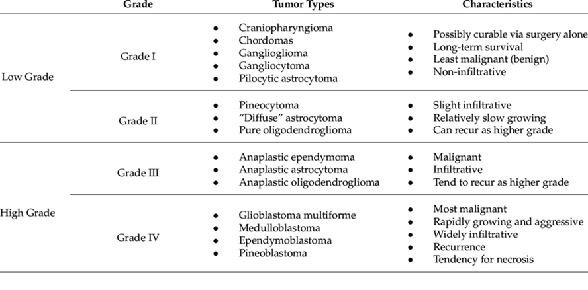

1. **LITERATURE**

**Al-Ansi, A. M., et al**. Brain tumor identification via digitised MRI parameters, utilising automated cognitive analysis and the Eidos intelligent system. Segmenting the database and analysing sample specimens achieves high recognition similarity, recommending its use for tumor identification and improving diagnostic accuracy [1].

**Sharma, Komal, Akwinder Kaur, and Shruti Gujral.** A methodology involving MRI preprocessing, texture feature extraction via GLCM, and classification using MLP and Naive Bayes algorithms. Experimental findings demonstrate high classification accuracy, with MLP achieving 98.6% and Naive Bayes achieving 91.6% [2].

**Sapra, Pankaj, Rupinderpal Singh, and Shivani Khurana.** A modified image segmentation technique and Probabilistic Neural Network (PNN) model for MRI scans. Evaluation reveals rapid, accurate classification, achieving 100% accuracy, emphasising the significance of surgical planning and diagnosis of neurodegenerative disorders [3].

**Amin, Javaria, et al**. It combines the Weiner filter with diverse wavelet bands for lesion enhancement, statistical techniques for tumor segmentation, and feature extraction through LBP and GWT, culminating in enhanced classification accuracy. The evaluation demonstrates the method's effectiveness in pixel- and feature-based analyses [4].

**Hossain, Tonmoy, et al.** It combines Fuzzy C-Means clustering, traditional classifiers, and CNN, outlining steps from preprocessing to classification. CNN achieved a notable accuracy of 97.87% [5].

**Hamghalam, Mohammad, and Amber L**. Simpson Utilizing conditional generative adversarial networks (cGANs) to enhance brain tumor subregion contrast in MRI scans. It presents two models, ESGAN and EnhGAN, aiming to improve voxel-wise and region-wise segmentation approaches, along with a new multi-scale Markovian discriminator and generator for synthesising high-contrast images [6].

**Tripathy, Sushreeta, Rishabh Singh, and Mousim Ray.** It underscores CNN's advantages for automated feature extraction and concentrates on leveraging EfficientNet, especially EfficientNet-B2, for automated tumor detection, enhancing accuracy. The framework involves MRI image preprocessing, augmentation, and model training with pre-trained EfficientNet, yielding high accuracy in tumor detection [7].

**Kordnoori, Shirin, et al**. A deep multi-task learning model designed to simultaneously segment and classify three common primary brain tumors in contrast-enhanced T1-weighted MR images. It targets the challenge of accurately identifying tumor types and borders crucial for pre-operation analysis, achieving a high 97% accuracy for both tasks on a brain tumor MRI dataset [8].

**Alemu, Belayneh Sisay, et al.** The classification performance of brain tumor images from MRI scans using a Support Vector Machine (SVM). Their method incorporates noise reduction, Segmentation, and feature extraction techniques such as median Filtering, wavelet transform, Otsu's thresholding, and Gray-Level Co-occurrence Matrix (GLCM), achieving a remarkable 99.9% accuracy on a dataset of 24 MRI images [9].

**Vankdothu, Ramdas, and Mohd Abdul Hameed**. The adaptive Filtering for noise reduction, improved K-means clustering for Segmentation, grey level co-occurrence matrix for feature extraction, and recurrent convolutional neural networks (RCNN) for classification, achieving a 95.17% accuracy [10].

**Raghuram, B., and Bhukya Hanumanthu**. It combined deep learning and Internet of Medical Things (IoMT) for image recognition of brain tumour. It proposes a support value-based deep neural network (SDNN) leveraging IoMT for e-healthcare, involving skull stripping, feature extraction, and classification, outperforming existing methods in accuracy and reliability [11].

**Anantharajan, Shenbagarajan, et al**. It details preprocessing, Segmentation, feature extraction, and classification with the Ensemble Deep Neural Support Vector Machine (EDN-SVM) classifier, showing enhanced accuracy compared to existing methods [12].

**Kalaiselvi, S., and G. Thailambal.** Brain tumor diagnosis combines PCA and DWT for feature extraction and BMG-SVM for classification, outperforming traditional methods. It tackles challenges in brain tumor diagnosis, stressing the importance of automated diagnostics, and suggests future research directions with no competing interests declared [13].

**da Silva, Rodrigo Dalvit Carvalho, Thomas Richard Jenkyn, and Victor Alexander Carranza.** Using orthogonal moments as a preprocessing technique boosts CNN performance in MRI-based whole-brain Segmentation. Evaluating NFBS, OASIS, and TCIA datasets highlights enhanced accuracy, comparing U-Net, U-Net++, and U-Net3+, with U-Net3+ showing marginal improvement over U-Net [14].

**Gupta, Brij B., Akshat Gaurav, and Varsha Arya**. A three-layer CNN model for early brain tumor detection in Industrial Information Systems, highlighting its 90% precision rate and significance in improving patient prognosis. It underscores the influence of technological advancements and global events like COVID-19 on healthcare, discussing deep learning's extensive use in medical imaging. The research offers a comprehensive performance analysis, including precision, recall, F1-score, accuracy, and a comparative assessment [15].

**Tseng, Cheng-Jui, and Changjiang**. Tang.Brain tumor detection from MRI scans encompasses Bayesian inference, decision trees, and deep learning. Emphasising early detection's significance, it underscores automated methods' potential to enhance accuracy amidst challenges like tissue heterogeneity. It delves into the refined XGBoost technique's facets, spanning image enhancement, Segmentation, feature selection, and classification, alongside outlining future research avenues [16].

**Islam, Md Monirul, et al**. The study applies four prominent transfer learning techniques—VGG19, InceptionV3, MobileNet, and DenseNet121 to categories MRI brain images into four classes. With a dataset comprising MRI images from 7023 patients, including healthy and tumour-afflicted individuals, the study partitions it into training, validation, and test sets. Employing image augmentation for class balance, it evaluates model performance through accuracy, precision, recall, and F1 score metrics. It reveals MobileNet's highest accuracy at 99.60% and compares its efficacy with previous brain tumour classification work [17].

**Dahab, Dina Aboul, Samy SA Ghoniemy, and Gamal M. Selim.** The probabilistic neural network (PNN) methods for automated brain tumor detection and classification details a four-step procedure involving ROI segmentation, feature extraction, selection, and classification, with a specialized PNN model architecture for enhanced efficiency [18].

Ratan, Rajeev, Sanjay Sharma, and S. K. Sharma. A brain tumor detection technique using multi-parameter MRI image analysis, employing block- and image-based methods. It utilizes watershed Segmentation for tumor detection and develops a MATLAB-based user-friendly GUI [19].

**Akram, M. Usman, and Anam Usman**. A three-stage procedure for brain tumor detection and Segmentation from MR images involves image preprocessing for enhancement, global threshold segmentation for tumor isolation, and postprocessing to eliminate false segmented pixels. Experimental findings showcase the method's segmentation accuracy, averaging 97% with a standard deviation of 0.0013 [20].

**Khan, Md Saikat Islam, et al.** A "23-layers CNN" and a "Fine-tuned CNN with VGG16" models cater to both binary and multiclass tumor identification, trained and tested on two datasets totaling 3216 MRI images [21].

**Maqsood, Sarmad, Robertas Damaševičius, and Rytis Maskeliūnas**. A methodology featuring linear contrast stretching, a custom CNN architecture, transfer learning, entropy-based feature selection, and SVM classification, achieving superior accuracy rates of 97.47% and 98.92%. It explores result explainability via Grad-CAM [22].

**Abdusalomov, Akmalbek Bobomirzaevich, Mukhriddin Mukhiddinov, and Taeg Keun Whangbo**. The model's convolutional filters and assessing its performance through metrics such as precision, recall, sensitivity, specificity, accuracy, and F1-score. Furthermore, the study highlights the significance of augmenting the dataset with a broader array of MRI scans to enhance the model's ability to generalize and accurately classify different types of brain tumors [23].

**Lamrani, Driss, et al.** It explores CNNs for brain tumor detection via MRI images, detailing a methodology utilising a Kaggle database of 1500 tumor and 1500 healthy scans. It outlines preprocessing steps, classification algorithms, and performance metrics, showcasing CNN superiority [24].

**Qureshi, Shahzad Ahmad, et al**. An innovative Ultra-Light Deep Learning Architecture (UL-DLA) for brain tumor detection, merging dynamic and textural features into a hybrid feature space (HFS) and employing Support Vector Machine (SVM) for classification. The UL-BTD system attains remarkable accuracy in identifying glioma, meningioma, and pituitary tumors, focusing on aiding intraoperative brain surgery [25].

**Krishna, Bandi, et al.** Examines diverse methodologies and algorithms for tumor segmentation, addressing challenges arising from tumours' spatial and structural variability. Additionally, it highlights the potential of CNN architectures in streamlining the segmentation process for efficient diagnosis [27].

**Ranjbarzadeh, Ramin, et al.** The brain tumor segmentation framework utilizes an optimized CNN and an enhanced Chimp Optimization Algorithm (ChOA). Utilizing the BRATS 2018 dataset, which offers diverse MRI images, the framework includes preprocessing to remove irrelevant image sections and balance the dataset. Feature extraction and an improved ChOA aid in feature selection. At the same time, a two-route CNN model classifies the selected features, showcasing superior performance in accurately segmenting tumors compared to existing models [28].

**Jiang, Song, Yuan Gu, and Ela Kumar**. MRI brain tumor images are classified using machine learning models as part of the process. Principal Component Analysis (PCA) includes dimension reduction, data resizing, labelling, and data import. Additionally, the data is divided into training and testing sets. The training data is then subjected to various machine learning models, and the learned models are subsequently used to predict labels based on the testing features. The models' performances are measured and contrasted using the actual testing label and the anticipated label. There are thousands of photos in each of the four categories in the dataset: normal tissue, gliomas, meningiomas, and pituitary tumors and 250 images were chosen randomly for model efficiency. One can obtain the complete dataset by clicking the link [29hod and analysis which is performed in your research work should be written in this section. A simple strategy to follow is to use keywords from your title in first few sentences [29].

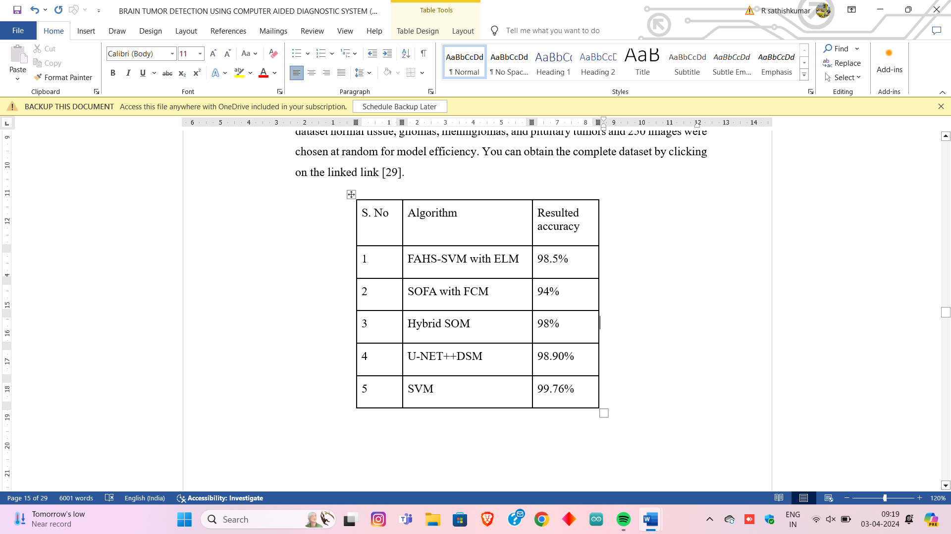

1. **METHODOLOGY**

Brain tumor, a dangerous medical illness for individuals, are an unrecognized and uncontrolled mass of cells resulting in the form of tissue known as a tumor. Various powerful methods define images as a tumor or non-tumor Brain. The segmented part of the tumor from the MRI images is used in this strategy. Image processing techniques were applied to analyses and explore images of brain tumors. The preprocessing steps were carried out in the extraction channel. superior techniques were employed to develop processes for segmenting the tumor, extracting relevant features, evaluating the tumor characteristics, and classifying it. Accuracy, Detection, classification, and were utilized to evaluate the effectiveness of the proposed algorithms.

The proposed system consists of pre-processing, feature extraction, tumor segmentation, and detection stages. At first, the pre-processing procedure will be established over the MRI brain images to upgrade the image's precision. From that point onward, the extraction of features from the improved image is trailed by the ideal elements. The region-based technique is utilized to enhance the Segmentation. A support vector machine is utilized to detect the exact tumor part of the brain image. This work utilized filters such as median, mean and Gaussian, while GLCM was used for feature extraction. In the case of detection mode SVM, the features are extracted from testing brain MR images, including both normal and abnormal. These features are used to detect the test image as normal or abnormal.

This methodology includes the following.

* Preprocessing
* Image Segmentation
* Feature Extraction
* Postprocessing
* Detection

1) pre-processing [ Filtering]

The MRI images contain some noise. The various techniques such as denoising, improving the image to high quality, and other criteria such as resizing, etc take place in this stage. So, the image is filtered using some common types of filters to get a noise-free image. This project employs various filters such as Adaptive median, Mean and Gaussian.

2) Image segmentation

In the segmentation of brain tumor images, morphological operations are pivotal for delineating tumor boundaries and identifying areas of interest. Techniques like erosion and dilation enhance tumor contours, aiding in precise segmentation. Additionally, tumor outline extraction methods help pinpoint essential features for accurate delineation. Region-based segmentation further refines this process by partitioning the image into homogeneous regions, facilitating isolation of tumor regions from surrounding tissues. Overall, integrating these methods enhances the effectiveness of brain tumor image segmentation algorithms, crucial for precise diagnosis and treatment planning. The various stages used for image segmentation were morphological operation, tumor outline and region-based segmentation respectively.

3) Feature extraction

Feature extraction is employed to isolate particular attributes from MRI brain images after the application of image pre-processing techniques. Within the realms of pattern recognition and image processing, feature extraction serves as a distinct form of dimensionality reduction. The analysis of brain MRI scans constitutes an integral aspect of the feature extraction methodology. This approach allows for the identification of specific characteristics inherent in the images. By employing feature extraction, relevant information pertinent to the diagnosis and analysis of brain scans is effectively distilled. Overall, feature extraction facilitates a focused examination of key elements within MRI brain images post-pre-processing. In this proposed work GLCM is used for the process of feature extraction.

4) post-processing

In the analysis of brain tumors, post-processing methods are utilized to enhance the accuracy and clinical significance of segmented images. These techniques encompass actions like reducing noise, eliminating artifacts, and smoothing to elevate image clarity. Morphological operations, like erosion and dilation, are employed to refine the delineation of tumor boundaries. Furthermore, post-processing frequently involves extracting pertinent features to facilitate deeper analysis and diagnosis. Ultimately, the goal of these methodologies is to bolster the dependability and interpretive value of brain tumor imaging data in clinical decision-making processes. The various filters involved in post-processing were wiener and clahe respectively.

5) Detection

Detection in image processing entails identifying and pinpointing particular objects or attributes within an image. This encompasses employing methods like pattern recognition, edge detection, and template matching to discern objects based on their traits. Support Vector Machine (SVM) plays a crucial role here in detecting tumor.

The proposed methodology for the detection of brain tumors were shown in below:



**Figure 1:** Proposed brain tumor detection and segmentation methodology

1. **RESULTS AND DISCUSSION**

The developed algorithm has been experimented with and evaluated for the Brain's images. They have been denoted as follows in Table. 4.1. The brain diseases are (i) Benign, (ii) malignant and (iii) Healthy Brain.

**Table 1.** List of Sample image denotation involved in the experiment



4.2 Results of Pre-processing stage:

Initially, we took tumor images from the dataset and converted it into a binary image. In addition to this , I have applied various filters to enhance the image for further processing steps which is as mentioned below. Moreover, I have used boundary detection in order to bound the tumor particularly.

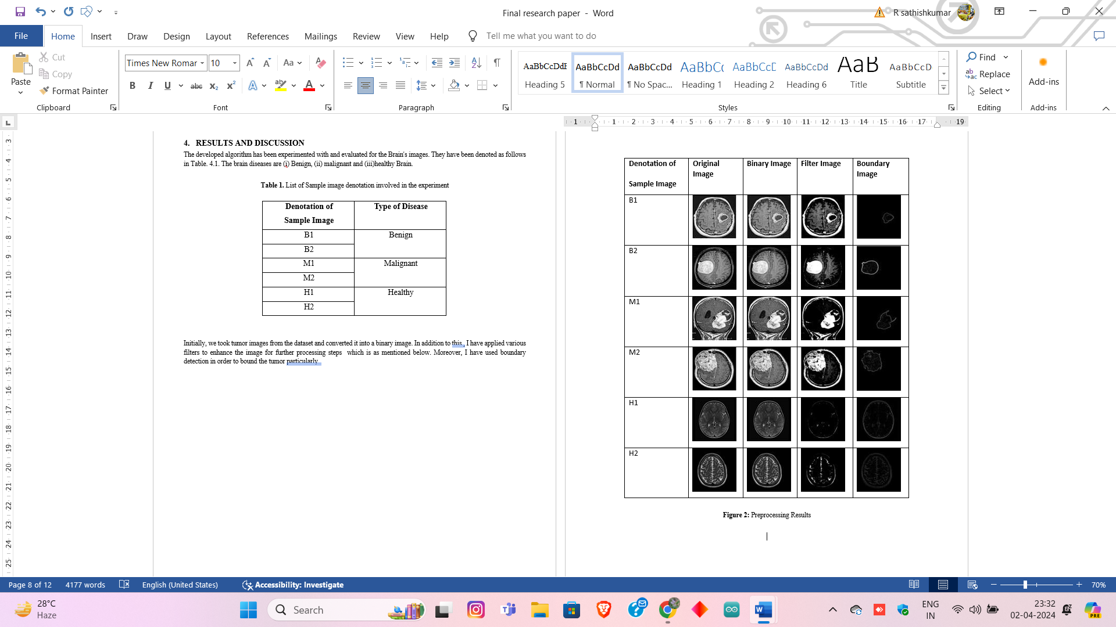

Figure 2: Preprocessing Results

4.3 Feature Extraction of Brain Tumor

Feature extraction aids in efficiently detecting tumors by comparing their features the with input images. The various features such as contrast, correlation, entropy, energy and cluster shade were focused for accurate detection.

|  |  |  |  |  |  |  |  |  |
| --- | --- | --- | --- | --- | --- | --- | --- | --- |
| **Sample image** | **Contrast** | **Correlation** | **Entropy** | **Energy** | **Cluster shade** | **Dissimilarity** | **Maximum Probability** | **Sum of square** |
| **B1** | 0.2030 | 0.9684 | 0.4904 | 0.8222 | 130.472 | 0.0565 | 0.9055 | 5.6192 |
| **B2** | 0.1345 | 0.9108 | 0.2702 | 0.9247 | 28.57 | 0.0386 | 0.9615 | 2.0544 |
| **M1** | 0.2993 | 0.9515 | 0.8259 | 0.5242 | 126.381 | 0.032 | 0.9051 | 5.4 |
| **M2** | 0.3018 | 0.9583 | 0.8278 | 0.7248 | 114.45 | 0.1167 | 0.8499 | 6.7 |
| **H1** | 0.0132 | 0.3466 | 0.0070 | 0.9986 | 0.2054 | 0.0027 | 0.999 | 2.3 |
| **H2** | 0.0153 | 0.2789 | 0.0027 | 0.7943 | 0.1996 | 0.0012 | 0.847 | 1.9 |

Figure 3: GLCM Feature Extraction Values of Brain Tumor

4.4 Results of the Post-processing stage:

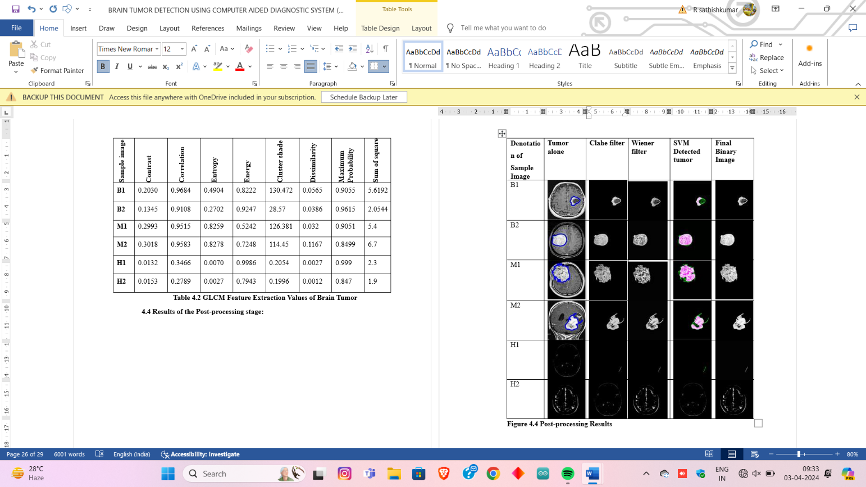 Post-processing results and the detected tumors in the MRI images by the use of SVM detector were shown in the below tabulation and it also compares the accuracy of the clahe and wiener filter respectively.

Figure 3: Postprocessing Results

1. **CONCLUSION**

In summary, the integration of image processing techniques with diverse filters and SVM detectors presents a powerful approach for brain tumor detection. These methods facilitate the extraction of crucial features from medical images, elevating the precision and efficacy of tumor identification. The incorporation of advanced algorithms such as SVM enhances detection performance, playing a pivotal role in early diagnosis and the formulation of effective treatment plans for individuals afflicted with brain tumors.

1. **REFERENCES**

[1]. Al-Ansi, A. M., et al. "Identification of brain tumors based on digitized parameters from magnetic resonance imaging results." Examples and Counterexamples 4 (2023): 100125.

[2]. Sharma, Komal, Akwinder Kaur, and Shruti Gujral. "Brain tumor detection based on machine learning algorithms." International Journal of Computer Applications 103.1 (2014).

[3]. Sapra, Pankaj, Rupinderpal Singh, and Shivani Khurana. "Brain tumor detection using neural network." International Journal of Science and Modern Engineering (IJISME) ISSN (2013): 2319-6386.

[4]. Amin, Javaria, et al. "Brain tumor detection using statistical and machine learning method." Computer methods and programs in biomedicine 177 (2019): 69-79.

[5]. Hossain, Tonmoy, et al. "Brain tumor detection using convolutional neural network." 2019 1st international conference on advances in science, engineering and robotics technology (ICASERT). IEEE, 2019.

[6]. Hamghalam, Mohammad, and Amber L. Simpson. "Medical image synthesis via conditional GANs: Application to segmenting brain tumours." Computers in Biology and Medicine 170 (2024): 107982.

[7]. Tripathy, Sushreeta, Rishabh Singh, and Mousim Ray. "Automation of brain tumor identification using the efficient net on magnetic resonance images." Procedia Computer Science 218 (2023): 1551-1560.

[8]. Kordnoori, Shirin, et al. "Deep multi-task learning structure for segmentation and classification of supratentorial brain tumors in MR images." Interdisciplinary Neurosurgery 36 (2024): 101931.

[9]. Alemu, Belayneh Sisay, et al. "Magnetic resonance imaging-based brain tumor image classification performance enhancement." Scientific African 22 (2023): e01963.

[10]. Vankdothu, Ramdas, and Mohd Abdul Hameed. "Brain tumor MRI images identification and classification based on the recurrent convolutional neural network." Measurement: Sensors 24 (2022): 100412.

[11]. Raghuram, B., and Bhukya Hanumanthu. "Brain tumor image identification and classification on the internet of medical things using deep learning." Measurement: Sensors 30 (2023): 100905.

[12]. Anantharajan, Shenbagarajan, et al. "MRI brain tumor detection using deep learning and machine learning approaches." Measurement: Sensors 31 (2024): 101026.

[13]. Kalaiselvi, S., and G. Thailambal. "Brain tumor diagnosis from MR images using boosted multi-gradient support vector machine classifier." Measurement: Sensors (2024): 101071.

[14]. da Silva, Rodrigo Dalvit Carvalho, Thomas Richard Jenkyn, and Victor Alexander Carranza. "Enhanced preprocessing for deep learning in MRI whole brain segmentation using orthogonal moments." Brain Multiphysics 3 (2022): 100049.

[15]. Gupta, Brij B., Akshat Gaurav, and Varsha Arya. "Deep CNN-based brain tumor detection in intelligent systems." International Journal of Intelligent Networks 5 (2024): 30-37.

[16]. Tseng, Cheng-Jui, and Changjiang Tang. "An optimised XGBoost technique for accurate brain tumor detection using feature selection and image segmentation." Healthcare Analytics 4 (2023): 100217.

[17]. Islam, Md Monirul, et al. "Transfer learning architectures with fine-tuning for brain tumor classification using magnetic resonance imaging." Healthcare Analytics 4 (2023): 100270.

[18]. Dahab, Dina Aboul, Samy SA Ghoniemy, and Gamal M. Selim. "Automated brain tumor detection and identification using image processing and probabilistic neural network techniques." International journal of image processing and visual communication 1.2 (2012): 1-8.

[19]. Ratan, Rajeev, Sanjay Sharma, and S. K. Sharma. "Brain tumor detection based on multi-parameter MRI image analysis." ICGST-GVIP Journal 9.3 (2009): 9-17.

[20]. Akram, M. Usman, and Anam Usman. "Computer-aided system for brain tumor detection and segmentation." International Conference on Computer networks and information technology. IEEE, 2011.

[21]. Khan, Md Saikat Islam, et al. "Accurate brain tumor detection using deep convolutional neural network." Computational and Structural Biotechnology Journal 20 (2022): 4733-4745.

[22]. Maqsood, Sarmad, Robertas Damaševičius, and Rytis Maskeliūnas. "Multi-modal brain tumor detection using deep neural network and multiclass SVM." Medicina 58.8 (2022): 1090.

[23]. Abdusalomov, Akmalbek Bobomirzaevich, Mukhriddin Mukhiddinov, and Taeg Keun Whangbo. "Brain tumor detection based on deep learning approaches and magnetic resonance imaging." Cancers 15.16 (2023): 4172.

[24]. Lamrani, Driss, et al. "Brain tumor detection using MRI images and convolutional neural network." International Journal of Advanced Computer Science and Applications 13.7 (2022).

[25]. Qureshi, Shahzad Ahmad, et al. "Intelligent ultra-light deep learning model for multiclass brain tumor detection." Applied Sciences 12.8 (2022): 3715.

[26]. Mruthyunjaya, Mruthyunjaya, and Suresh Kumar Mandala. "A brain tumor identification using convolution neural network and fully convolution neural network." MATEC Web of Conferences. Vol. 392. EDP Sciences, 2024.

[27]. Krishna, Bandi, et al. "A brain tumor identification using fully convolution neural networks in deep learning." MATEC Web of Conferences. Vol. 392. EDP Sciences, 2024.

[28]. Ranjbarzadeh, Ramin, et al. "Brain tumor segmentation based on optimised convolutional neural network and improved Chimp optimisation algorithm." Computers in Biology and Medicine 168 (2024): 107723.

[29]. Jiang, Song, Yuan Gu, and Ela Kumar. "Magnetic resonance imaging (MRI) brain tumor image classification based on five machine learning algorithms." Cloud Computing and Data Science (2023): 122-133.

[30]. Ibrahim, Walaa Hussein, Ahmed AbdelRhman Ahmed Osman, and Yusra Ibrahim Mohamed. "MRI brain image classification using neural networks." 2013 international conference on computing, electrical and electronic engineering (ICCEEE). IEEE, 2013.