Parking Management utilizing Computer Vision

MS.Ormila, G.Ruthwik Reddy, G.N.S Jashwanth, G. Uday Kiran, G. Sudharshan

*Assistant Professor, Department of computer science and Engineering, Bharath Institution of Higher Education and Research*

*Students, Department of computer science and engineering, Bharath Institution of Higher Education and Research*

[oormlog@gmail.com](mailto:oormlog@gmail.com), [ruthwik56789@gmail.com](mailto:ruthwik56789@gmail.com), j[ashwanthgrandhi234@gmail.com](mailto:Jashwanthgrandhi234@gmail.com), [gunagantiudaykiran@gmail.com](mailto:gunagantiudaykiran@gmail.com) sudhasudha90068@gmail.com

**Computer Vision-Based System for Car Park Management**

***Abstract-Current car park management relies heavily on parking attendants to monitor parking areas and guide drivers to available spots. Unfortunately, in certain shopping centers, there is a lack of information regarding parking availability, leading to challenges for drivers in locating a space and resulting in traffic congestion and time wastage. To combat this issue, this article introduces a groundbreaking approach to car park management by introducing a computer vision-based system for monitoring and overseeing parking areas. The system utilizes a camera positioned in the center of the parking zone along with the HAAR Cascade Classifier technique for car detection and counting. The number of parked cars is then compared to the total number of parking slots. If the current number of parked vehicles is lower than the available slots, the system notifies drivers of the availability of parking spaces and indicates the number of open slots. The camera identifies five designated slot areas based on pre-set coordinates manually. The system showcases a 90% accuracy rate in identifying unoccupied parking spaces. This innovation eliminates the necessity for human attendants and simplifies the process for drivers to locate free parking spots, leading to reduced congestion and time-saving benefits.***

***Keywords—HAAR Cascade Classifier, parking management, computer vision, car detection***

I. INTRODUCTION

The search for parking spaces is increasingly problematic in major cities, especially in shopping malls. At the same time, the number of private vehicles on the roads continues to rise. Shopping centers often lack precise information regarding parking availability. Consequently, drivers must personally search for parking spaces, which is inefficient, especially during peak times when many vehicles are vying for a spot in the shopping area. This results in numerous vehicles circling, contributing to local traffic congestion in the parking lot. Typically, parking attendants assist drivers in locating a parking spot by indicating available areas, but this approach isn't always effective since attendants have to monitor all spaces manually. Innovative solutions utilizing sensors have been developed to address parking

issues by sensors throughout the parking lot, and drivers can be informed of available parking spaces.Applications of sensor-based parking systems Sensor-based parking system applications have been recognized, and researchers have utilized wireless sensor systems to reduce the need for extensive cabling infrastructure. This simplifies installation in widely spaced parking lots, especially in multi-level parking structures. These wireless sensors relay data on the status of each parking spot, yet the expense of installing sensors in each area proves costly as installation costs rise in correlation with the number of parking spaces or lots. An alternative to sensor use, a vision-based system, has been developed to identify and report available parking spots.

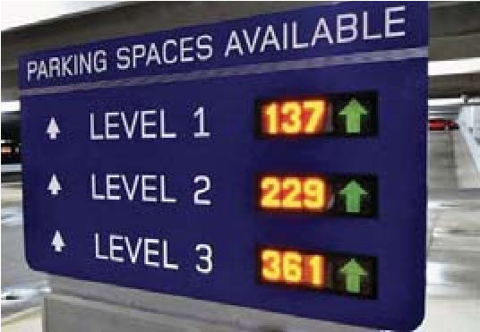

Fig 1. Display the number of parking spaces [10]

An alternative method for identifying available parking spots involves the use of vision-based parking management systems. Previous studies have shown that these systems are effective in overseeing vast spaces. Nonetheless, the existing systems were primarily developed for open-air parking lots, which are susceptible to shifts in light levels. Consequently, our study focuses on creating a vision-based parking management system tailored for indoor parking facilities.

Within this system, CCTV cameras are positioned at the center of each parking spot. The size of the vehicle determines the mapping of each parking area, and car detection at various map coordinates is achieved using the HAAR technique. A single camera can identify up to 5 cars in its vicinity. The data gathered on the Parking Information System: Efficient Resource Management

A lot's occupancy and available spaces are beneficial for managing parking resources effectively.The number of cars parked can be seen and monitored on a PC.

II. THEORY

A. Parking Information System

This parking information system has been proven effective in providing parking details.The parking information system is responsible for giving out details regarding available parking spots, often seen in city centers. It transmits this information to drivers using changeable signs or modern car navigation systems. In some sophisticated navigation systems, drivers can receive data concerning the location of vacant parking spaces. This device helps in lessening the time drivers waste while searching for free parking spots.

**B**.HAAR Cascade Classifiers

HAAR feature-oriented cascade classifiers represent a successful approach for identifying items through machine learning. This technique includes inputting affirmative and disapprove pictures into a cascading function. Affirmative pictures depict the target item for identification, whereas disapproved pictures encompass everything else. Conducting feature extraction becomes imperative to comprehend this input. When computing the HAAR attribute, determinations are performed utilizing kernel convolutions, akin to the manner in which wavelets are computed. A HAAR-Wavelet constitutes a square waveform (black phase and white phase) that is subsequently equated to the mean pixel values of both phases. Upon comparing the two.

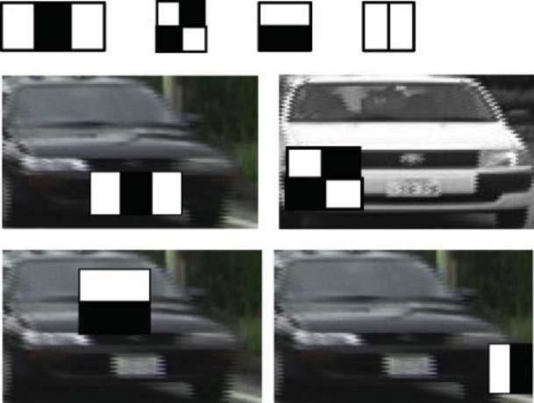

Fig 2. HAAR Vehicle Detection [11]



Should the mean intensity surpass the threshold value, it indicates compliance with the HAAR feature criteria. The illustration of identifying a vehicle through the HAAR-like attribute is depicted in Figure 2

III. METHODOLOGY

In order to spot and locate available parking spaces using vision-based technology, a series of tasks need to be conducted, involving the manual separation of parking models and data related to cars and non-cars, the preparation of data to identify cars and non-cars, eliminating background noise, extracting relevant features, and making decisions. The process, as shown in Figure 5, encompasses the identification and provision of details on parking spot locations through four main steps: manual division of parking models, gathering images, training image data using HAAR features, and identifying objects.

*A.ParkingModel Segmentation*

The initial step requires creating a map of the parking region that will be processed by hand-selecting coordinates through image clicks, followed by the collection of samples.



(b)

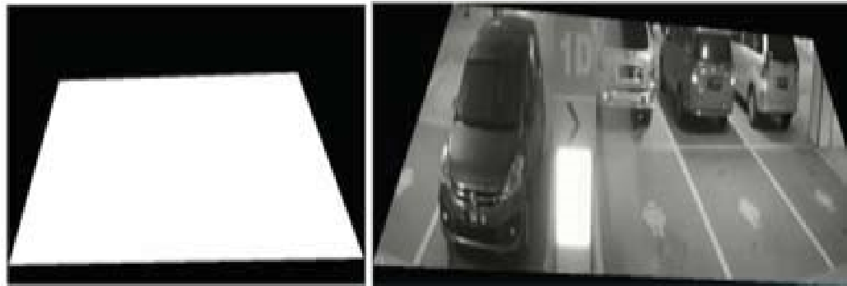

(c) (d)

Fig 4. Parking model segmentation (a) select manual by click on image

(b) coordinate pixel area (c) masking area (d) result of masking

After the user manually selects the area coordinates as ROI, then delete all other areas except for the ROI. Segmentation results are utilized as input for the masking function to ensure the system only processes the masked portion, disregarding the remaining parts.

*B. Image Collection*

The system's training process involves supplying various car image data as positive data, alongside negative images (non-cars). Prior to processing, the image's RGB should be changed to Grayscale. Once a car image is detected and highlighted, it needs to be snipped. The resultant clipped image is then adjusted in size using the resize function, which standardizes the width and length to 24 x 24 pixels, as demonstrated in Figure 5.

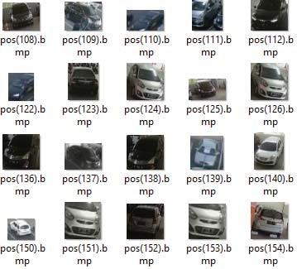 Fig 6. Positive example image (various of the car)

A set of training car pictures are stored in the data folder, known as a positive image. Instances of positive input images can be observed in Figure 6.

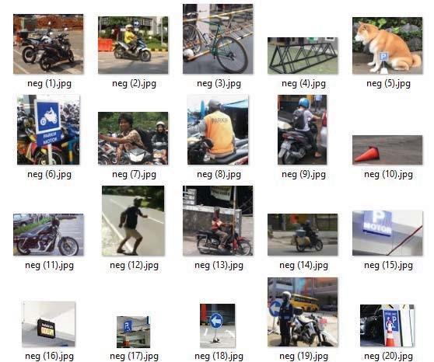

Fig 7. Negative example image (not car)

Next steps, we are required to handle the image of the training not cars, which we refer to as negative images. These negative images, utilized during the classifier training process, consisted of images devoid of any cars. The compilation of negative images was manually acquired through the use of a camera. These images in the dataset must undergo cropping and resizing using the resize function to standardize their width and length. The image dimensions adopted for this study are 24 x 24 pixels. A repository of negative images is retained within the negative data directory. Examples of input images considered negative can be observed in Figure 7.

*C. Adaptive Background Subtraction and Extraction*

In this article, the utilization of HAAR Cascade Classifiers was applied in identifying features observed in input videos to detect if a car is present in a parking area. HAAR Cascade Classifiers work by analyzing changes in contrast values between neighboring sets of pixels rather than focusing on actual pixel values to recognize common patterns within an image. The key objective behind utilizing HAAR Cascade Classifiers is to simplify the categorization process instead of dealing with raw pixel values, as the analysis is conducted in windows comprising 24x24 pixels. These classifiers are primarily employed to extract information about a particular area rather than focusing solely on individual pixel values. By using a set of HAAR Cascade Classifiers, the identification of features and derived data are subsequently fed into a decision tree classifier for classification purposes. The process carried out by HAAR Cascade Classifiers involves examining images within a rectangular box with specific dimensions such as 24 x 24 pixels, as illustrated in Figure 8.

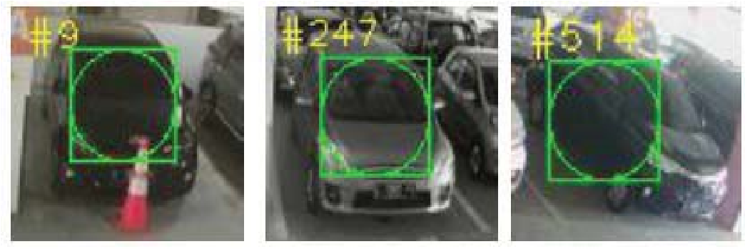

Fig 8. Rectangular box from Car HAAR feature

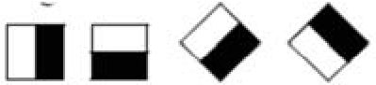

(a)

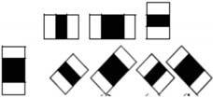

(b)



(c)

Fig 9. Object detection scheme (a) Edge Feature

(b) Line Feature (c) Surround feature

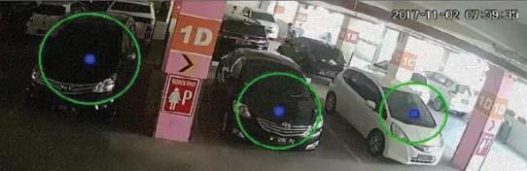

Fig 10. Car Detected

Figure 8 reveals that the filtering process for rectangular objects is conducted to determine if the object is detected or not. Certain HAAR Cascade Classifiers are present for the aim of establishing the range of information, including edge features, line features, and central-surround features [7]. Figure 9 demonstrates the HAAR Cascade Classifiers

*D. Decision*

The amount of identified items is dependent on the quantity of car items detected in each parking lot's processing area. The processing area refers to the masked section obtained through the area segmentation procedure. The outcomes of the item count serve as a reference point for computing the remaining vacant parking spots, which will subsequently serve as parking space details.

For the categorization of the parking lot's availability status, two variables are considered: the existence and nonexistence of items in the parking lot slot.

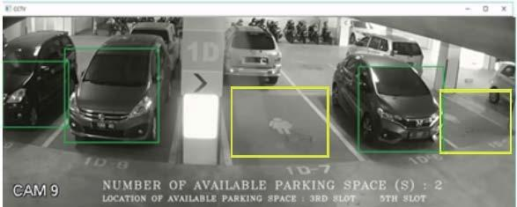

Fig 11. Car (green box) and parking lot slot detection (yellow box)

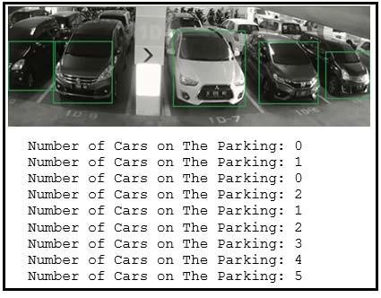

Fig 12. The results of video screenshots of car detection were 271 times out of 300 experiments

TABLE 1. RESULTS CAR DETECTION IN PARKING AREA

| **Total Testing** | **1 car** | | **2 cars** | | **3 cars** | | **4 cars** | | **5 cars** | |
| --- | --- | --- | --- | --- | --- | --- | --- | --- | --- | --- |
| 10 | C | F | C | F | C | F | C | F | C | F |
| 8 | 2 | 10 | 0 | 10 | 0 | 9 | 1 | 8 | 2 |

*C= correct, F = False*

IV. RESULTS

The "Object Creator" program from OpenCV is used to specify the unique coordinates for each parking spot. These coordinates are then fed into a function to identify specific areas where cars might be present. Test outcomes of the car recognition software showed a successful car detection rate of 271 out of 300 attempts, accounting for 90.33% accuracy, with an error rate of 9.66%. In Figure 12, the car classification test results are depicted.

The research involved testing a CCTV camera with the capacity to monitor up to 5 cars within the parking lot. From the data in Table 1, the parking system achieved accuracy rates of 80%, 100%, 100%, 90%, and 80% when identifying 1, 2, 3, 4, and 5 cars, respectively. Consequently, the overall detection success rate for all five cars was 90%. Results suggest that as the number of cars rises, the precision of detection declines. The decrease is accuracy was due to the type of camera used which in this project was a CCTV.



CCTV used in this paper had limited resolution and

TABLE 2. TESTING RESULTS AVAILABLE PARKING SPACE DETECTION inaccurate lighting correction. The initial parking system output can be seen in Figure 13.

| **NO** | **IMAGE** | **DETECTION** |
| --- | --- | --- |
| 1 |  | 5 AREA   1. CAR 2. SPACE   EMPTY |
| 2 |  | 5 AREA  2 CAR  DETECTED  2 SPACE  EMPTY    *1 NOT*  *DETECTED* |
| 3 |  | 5 AREA  3 CAR  2 SPACE  EMPTY |
| 4 |  | 5 AREA  5 CAR  DETECTED  0 SPACE  EMPTY |
| 5 |  | 5 AREA  4 CAR  DETECTED  1 SPACE  EMPTY |

The outcome of the vision-based automatic parking system can be viewed in Figure 14. Two parking spaces are available, while three cars have been detected. Table 2 displays five efforts to identify empty parking spots, with four successes and one failure caused by low light conditions.

!



V. CONCLUSION

"Regarding the study's outcomes, the HAAR-like feature extraction technique shows excellent detection capabilities. Increasing the number of images used for training with HAAR-like features leads to enhanced detection results. However, the system's drawback lies in its slow operation when used for overall detection due to numerous drawing processes, resulting in a running speed of 2 fps, preventing real-time functionality. The accuracy rates for detecting cars and empty parking spaces in this study were 90% and 80%, respectively.

REFERENCES:

* F. Alshehri, A. H. M. Almawgani, A. Alqahtani, and A. Alqahtani, Smart Parking System for Monitoring Cars and Wrong Parking, Riyadh, Saudi Arabia, 2019.

* C. Yuan and L. Qian, Design of intelligent parking lot system based on the wireless network, Chongqing, 2017.

* L. Zhang, P. Mu, and J. Kim, Implement of extended shortcut tree routing for ZigBee-based car park wireless sensor management system, Hangzhou, 2017.

* Y. Kang, D. Jung and I. Doh, Automated parking lot management system using embedded robot type smart car based on wireless sensors, Melbourne, VIC, 2017.

* Yanxu Zheng, S. Rajasegarar, and C. Leckie, Parking availability prediction for sensor-enabled car parks in smart cities, Singapore, 2015.

* Q. Wu, C. Huang, S. Wang, W. Chiu, and T. Chen, Robust Parking Space Detection Considering Inter-Space Correlation, Beijing, 2007.

* V. W. s. Tang, Y. Zheng and J. Cao, An Intelligent Car Park Management System based on Wireless Sensor Networks, Urumqi, 2006.

* S. Lin, Y. Chen and S. Liu, A Vision-Based Parking Lot Management System, Taipei, 2006.

* R. Lienhart and J. Maydt, An extended set of Haar-like features for rapid object detection, Rochester, NY, USA, 2002.

* A. Staff Writer, Camera system guides drivers to open parking spaces in crowded lots, Design World Online.

* W. Xuezhi, Ling Shao, Yu Xue, Wei Fang, A rapid learning algorithm for vehicle classification, Information Sciences, 20 February 2015."