Title :- In Process Quality Control Tests For Solid Dosage Forms: Tablets

Author: Pandhav Vinod Ajinath, Damal Rahul Ramesh

Guided by: prof. vasim pathan,Dr.sanjay Garje,Dr. gaffar sayyed

College name- Shri Amolak Jain Vidya Prasarak Mandals College Of Pharmaceutical Science & Research centre,Kada.

Abstract :-

Drug development is a complicated and lengthy procedure including discovery of drug, studies testing in laboratory, clinical trials and regulatory registration to increase the safety and efficacy of drug product after approval. Regulatory agencies like FDA [food and drug administration] required to testing of drug product for strength, identity, purity, quality, stability before using and releasing in market. This was the reason pharmaceutical validation and process control are required for problems to be controls. In process quality control is one of the most important term used in pharma industry to control the quality of the pharmaceutical product under quality control system IPQC tests are important to remove problems from production lines. Those standards are provided in pharmacopoeias. IPQC system provide good quality of manufactured product which lead to uniformity in quality and improved quality. Hence customer satisfaction is achieved and the growth of industry is fast. Inprocess quality control (IPQC) assessments used.

Keyword :-

Tablet, IPQC, Weight variation, Unique identity, Friablity,

Introduction :-

In-Process Quality Control Tests (IPQC) are accurate and specific for testing of raw materials (RM) to the release of the finished dosage (FD) forms.IPQC tests was performed in production area. Manufacturing practices was include in good quality finished products. GMP is under with both production and quality control (QC). They should not carry any risk for the quality of product. In process testing enables easier identification of problems. The improvement of a drug product is a prolonged process involving drug discovery, laboratory testing, animal studies, medical trials and regulatory registration. To in addition enhance the effectiveness and safety of the drug product after approval, many regulatory companies such as the United States Food and Drug Administration (FDA) additionally require that the drug product be examined for its identity, strength, quality, purity and balance earlier than it can be launched for use.

The QA/QC exact exercise training outlined right here displays Practicality, acceptability, cost-effectiveness, current experience, and the plausible for Software on a world huge basis. A QA/QC programme contributes to the goals of properly Exercise guidance, particularly to enhance transparency, consistency, comparability, Completeness, and self belief in countrywide inventories of emissions estimates.

Tablets and pills are the dosage varieties that are manufactured for pharmaceutical and Dietary dietary supplements which are beneath regulated phrases and laws. Regulations are Imposed in the manufacturing system to make sure the quality, efficacy and security of the Drugs and capsules.Many international locations observe the British Pharmacopoeia to Meet the required regulated requirements in the world market. Manufacturing, production,Packaging, Testing are the essential phases of pharmaceutical merchandise in each and every industry.

Tablet :-

A tablet (also known as a pill) is a pharmaceutical oral dosage form or solid unit dosage form. Tablets may be defined as the solid unit dosage form of medicament or medicaments with suitable excipients.

Tablets are of different types based upon the API. The different types are:

* Uncoated Tablets
* Effervescent tablets
* Coated tablets
* Gastro Resistant Tablet
* Modified Release Tablet
* Dispersible Tablet
* Enteric Coated tablet
* Soluble Tablet
* Controlled release tablets
* Sustained release tablets

Definition Of IPQC :-

IPQC stands for IN PROCESS QUALITY CONTROL . These are checks that are carried out before the manufacturing process is completed. The function of in-process controls is monitoring and if necessary adaption of the manufacturing process in order to comply with the specifications .

Importance Of IPQC :-

1. To detect the errors
2. To minimize the human errors
3. Provide accurate, specific and definite description of the procedure to be employed
4. Is to detect the errors if and when it does occurs

Elements Of QA/QC System :-

1. An Inventory agency responsible for coordinating QA/QC activities
2. A QA/QC plan
3. General QC procedure
4. Quality organization and management
5. Formal qualification of employees
6. Documented field inspection

Quality Control Test For Tablet :-

1 DisintegrationTest :-

Disintegration refers to the mechanical break up of a compressed tablet into small Granules upon ingestion and therefore it is characterised by the breakdown of the Interparticulate bonds, which were forged during the compaction of the tablet. It is Hence a good starting point to briefly reflect on the physical changes that take place During the compaction process:

i)particle rearrangement, ii) elastic deformation, iii)Plastic deformation, iv))fragmentation of particles,

v)the formation of Interparticulate bonds [34].

Steps ii to v may have a direct influence on the Disintegration of the powder compact. The reduction of the compact volume is Performed by the reversible elastic or by the irreversible plastic deformation. After an Initial volume reduction the particles can be divided-up into smaller particles, a process That is also called fragmentation. These smaller particles may then undergo further Elastic and/or plastic deformation. When the particles come into close proximity to Each other they can form interparticulate attraction bonds, such as intermolecular Bonds, solid bridges and mechanical interlocking [34]. Naturally, the bonding Surface area limits the maximum tensile strength that can be achieved for the powder Compact. Intermolecular bonds in general, and van der Waals forces in particular, Dominate the cohesive characteristics of many direct compression binders, such as Microcrystalline cellulose (MCC, Avicel®) and lactose. Solid bridges are defined as The contact at an atomic level between adjacent surfaces of particles and thus, these Forces act up to a distance of 1 nm. Mechanical interlocking is the hooking and twisting Together of packed particles. A high compaction load is required to generate Mechanical interlocking and this bonding mechanism depends on the shape and Surface structure of the particles, i.e. long needles and irregular particles have a higher Tendency to hook and twist together during compaction compared to smooth spherical Particles [34]. Nyström et al. [34] and Adolfsson et al. [35] showed on the basis of the Tensile strength of tablets that the bonding structure and the bonding mechanisms

2 Content Uniformity Test: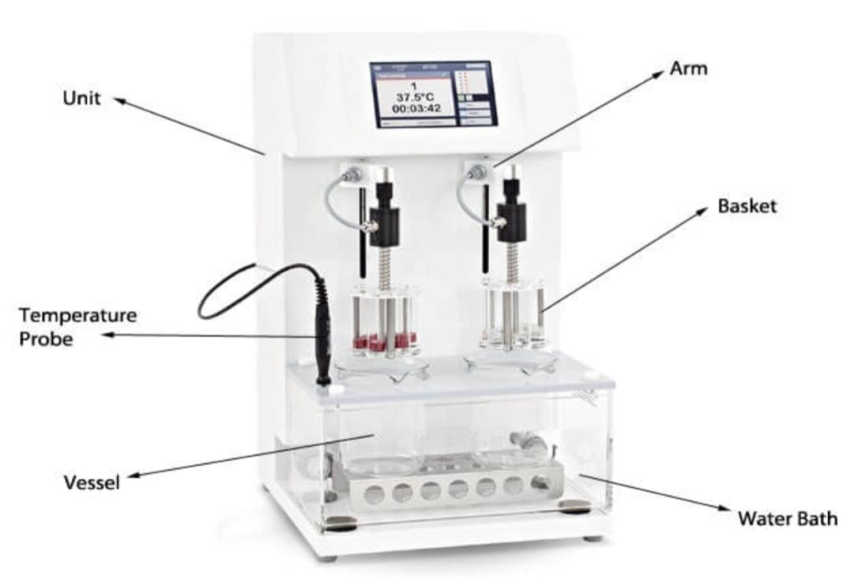

Advanced analytical instruments, such as near infrared (NIR) and Raman spectroscopy, have Revolutionized solid dosage manufacturing by enabling real-time measurements of critical Quality attributes such as content uniformity. Content uniformity testing is an important Assessment for oral solid dosage (OSD) forms. “It is one of two allowable tests to assess the Uniformity of dosage units (UDU), the other being weight variance,” says Darren Andrews, Pharma Business Manager, Raman Spectroscopy, Cobalt Light Systems, part of Agilent Technologies. “UDU is a test of the variance of the active ingredient over the batch manufacturing process.

Analytical methods to assess content uniformity

The most common method for assessing content uniformity in OSDs is high-performance liquid chromatography (HPLC), observes Andrews. “HPLC has the advantages of flexibility, Sensitivity, and ubiquity, and many analytical chemists are trained to use HPLC methods,” he Says. “The disadvantages, however, are the time and resources needed to prepare samples.” Near infrared

Over the past decade, there has been an increasing emphasis on quality by design (QbD) and The use of process analytical technology (PAT) to monitor and control pharmaceutical Manufacturing processes. “FDA encourages the use of new technologies and PATtechniques such as NIR spectroscopy, for content uniformity analysis,” says Robertson. “NIR Spectroscopy can be used throughout the manufacturing process in online, at-line, and offline Modes of operation.” He explains that one such application involves the online monitoring of The blending process with small NIR instrumentation fitted directly onto the blender, or NIR Instrumentation connected to the blender using fiber optics probes. “This set-up allows for realtime measurement of the blending process without the requirement to remove samples for Measurement, which is a significant advantage over other techniques, such as HPLC,” Robertson says. “Different mathematical approaches

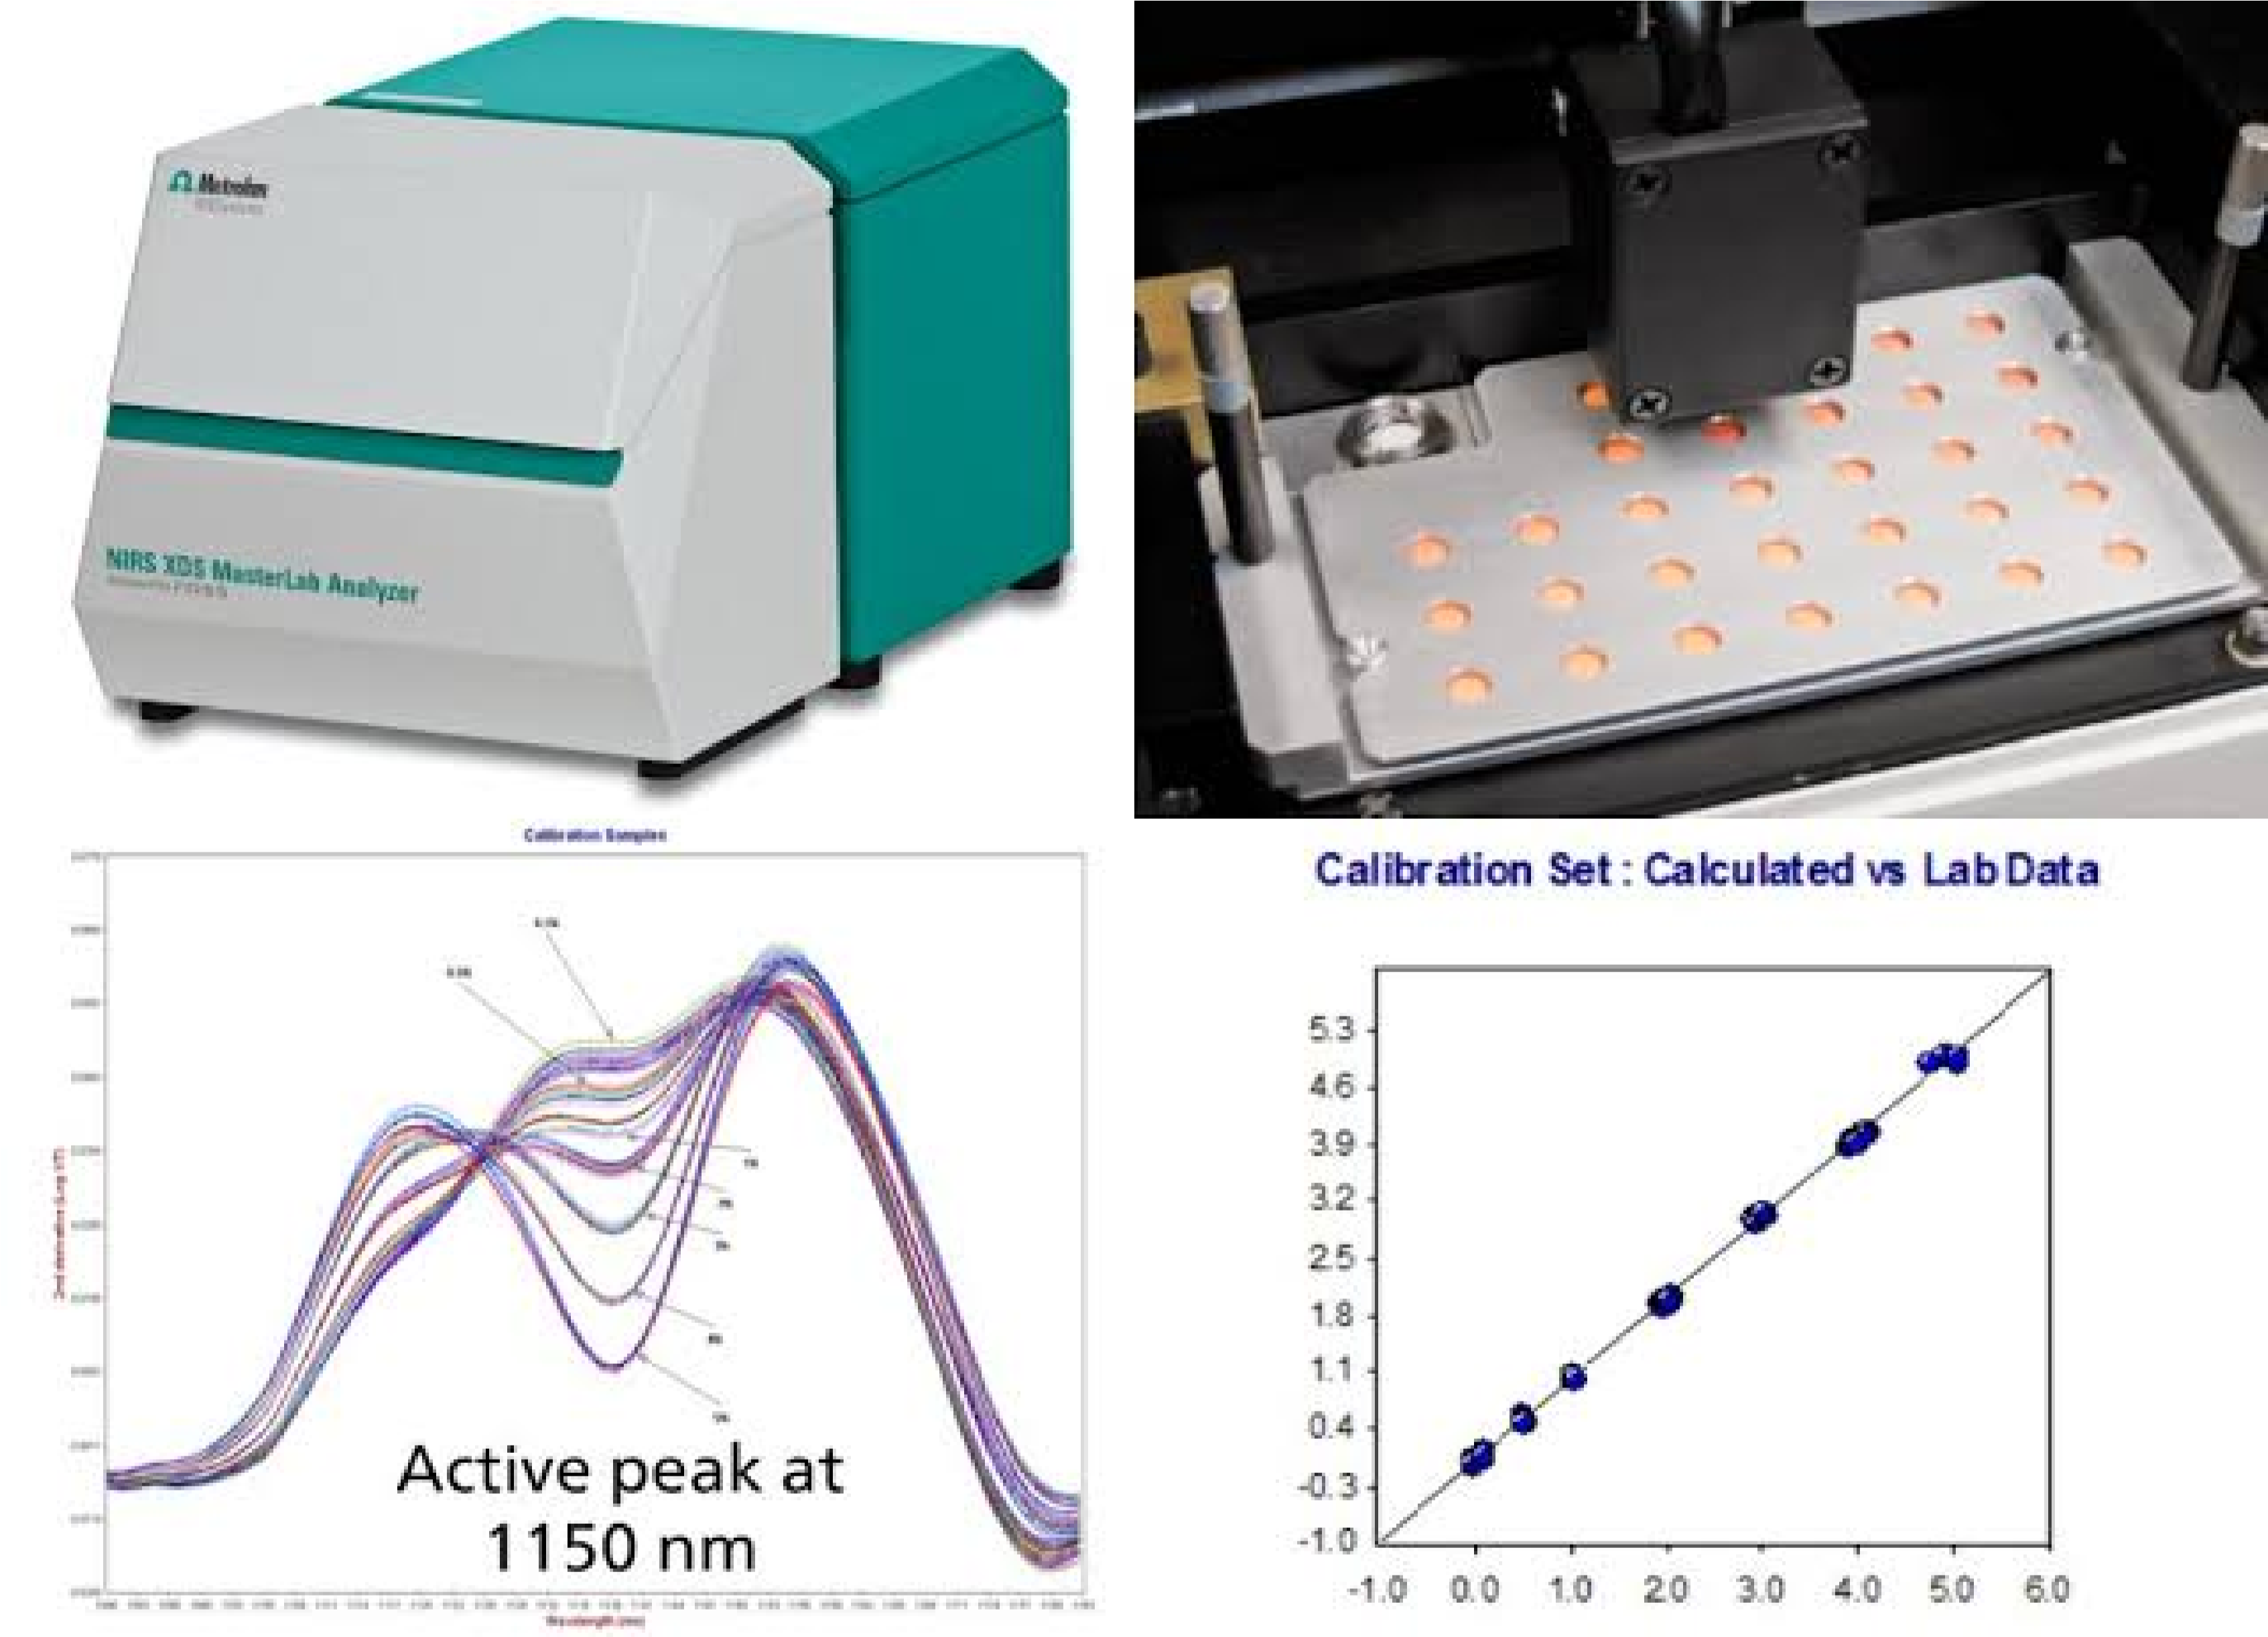

can be applied to the spectral analysis to Determine when the blend is optimized, without the requirementfor quantitative calibration.

3 Hardnesness :-

There are 2 main processes to test tablet hardness: compression testing and 3 point bend testing. For compression testing, the analyst generally aligns the tablet in a repeatable way, and the tablet is squeezed between a fixed and a moving jaw. The first machines continually applied force with a spring and screw thread until the tablet started to break. When the tablet fractured, the hardness was read with a sliding scale.

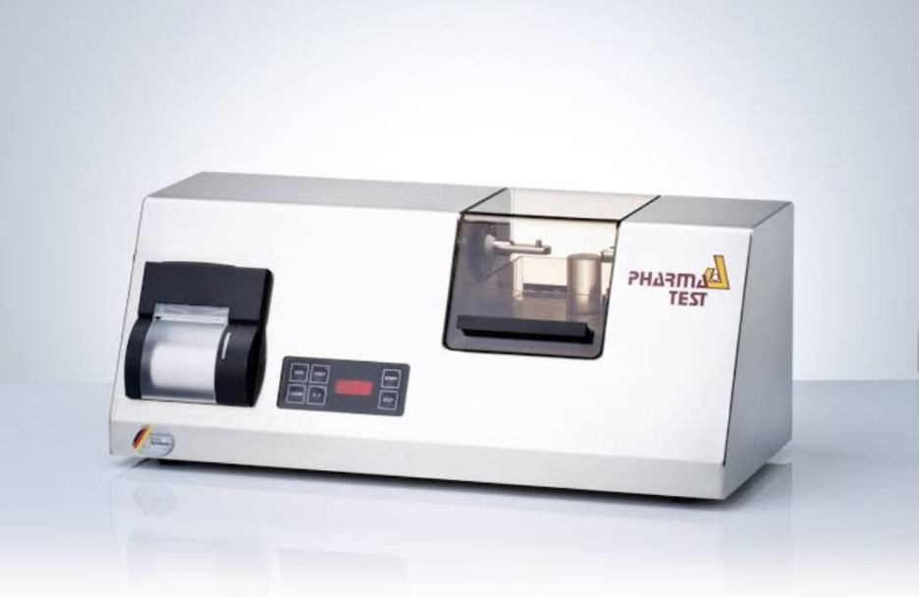

Tablet Hardness :-

1)Take 5 tablets from each formulation for the tablet hardness test, which will be Performed on the TMZ-3U Electronic Micro Sensor device .

1. Turn on the device using the power switch on the front side of the device on the right.
2. At first, set the mode of the measurement for measuring the force: press „↓ MENU“,

Enter the code „07“ , choose „0“ for the force measurement and confirm „ “ (ENTER).

1. Set the range of the measurement: : press „↓MENU“, enter the code „04“ , choose „2“ For the range until 750N and confirm „
2. Now you can start the measurement. At first, measure the dimensions (diameter,

Thickness) of the tablet using the caliper. You will use these data for the subsequent

Calculation of the tablet tensile strength. Then insert the tablet in the middle of the

Instrument jaws, so that the tablet will be deformed in the perpendicular direction to the Direction in which it was compressed. Press „↓MENU“, enter the code „01“ ,

And confirm „ “ (ENTER). This will crush the tablet and the display will show the value of Force. Note this value.

1. After the end of the piston upwards movement remove the tablet and clean the Instrument jaws.
2. Measure all 5 tablets. Express the results in the average, minimal and maximal value of the measured force in the Newton units.
3. Because of the influence of the tablet size on the force needed for the tablet crush, it is Usual to calculate the tensile strength of the tablets. Calculate the value of the tensile Strength according to eq. 1 and determine the relative standard deviation of the Measurement. D v F TS 2 = (1) Where F is a breaking force, d is the tablet diameter and v is Its thickness.
4. Discuss the differences between the formulations.

4 Unique identification marking:-

Pharmaceutical companies manufacturing tablets often use some type of unique Marking on the tablet for identification of their product. The marking utilize same from of Embossing, engraving or printing of company name, symbol or product code. Which are sole Means of identification of tablet. These are used in the form of embossing, engraving or Printing. These can include the company identification marks, or any other symbols related to the dosage form. 5 General Appearance :-

The general appearance of a tablet, its identity, and general elegance is essential for consumer Acceptance, for control of lot-to-lot uniformity and tablet-to-tablet uniformity. The control of General appearance involves the measurement of size, shape, color, presence or absence of Odor, taste etc. Size & Shape:-

It can be dimensionally described & controlled.

The thickness of a tablet is only variables.

Tablet thickness can be measured by micrometer or by another device.

Tablet thickness should be controlled within a ± 5% variation of standard value.

Organoleptic properties:-

Color distribution must be uniform with no mottling.

For visual color comparison compare the color of sample against standard color.

The presence of odor in a batch of tablet indicates a stability problem such as the Characteristics odor of acetic acid in an aspirin tablet.

The presence of odor could be characteristic of the drug (Vitamin), added ingredients (flavoring agent) or the dosage form (film-coated tablet have a characteristic odor).

For chewable tablet presence or absence of specified taste can be checked.

A tablet level of flaws such s chip, cracks, contamination from foreign solid substances (hair, Drops of oil, dirt), surface texture (smooth vs rough) and appearance (shining vs dull) may have zero defect. 6 Friability:-

Use a drum, \* with an internal diameter between 283 and 291 mm and a depth between 36 And 40 mm, of transparent synthetic polymer with polished internal surfaces, and not Subject to static buildup (see figure for a typical apparatus). One side of the drum is Removable. The tablets are tumbled at each turn of the drum by a curved projection with an Inside radius between 75.5 and 85.5 mm that extends from the middle of the drum to the Outer wall. The drum is attached to the horizontal axis of a device that rotates at 25 ±1 rpm.Thus, at each turn the tablets roll or slide and fall onto the drum wall or onto each other.

Friability is defined as the percentage of weight loss of powder from the surface of the Tablets due to mechanical action and the test is performed to measure the weight loss During transportation .

It is a supplement test for Uncoated / Compressed Tablets other than physical measurement e.g. Hardness (Tablet Breaking Force).

Measuring the hardness of a tablet is not a reliable indicator for tablet strength as some Formulations when compressed into very hard tablets tend to ‘cap’ or lose their crown Portions on attrition. Such tablets tend to powder, chip and fragment.

In friability test the tablets are prone to abrasion hence enabling us to check for the tablet Strength under application of force in different manner.

They not only lack elegance and consumer acceptance but also spoil the areas of Manufacturing such as coating and packaging.

Tablets with unit weight equal to or less than 650 mg, take sample of whole corresponding To as near as 6.5 g equivalent.

Tablets with unit weight more than 650 mg, take sample of 10 whole Tablets.

Tablets must be de-dusted prior to and after test

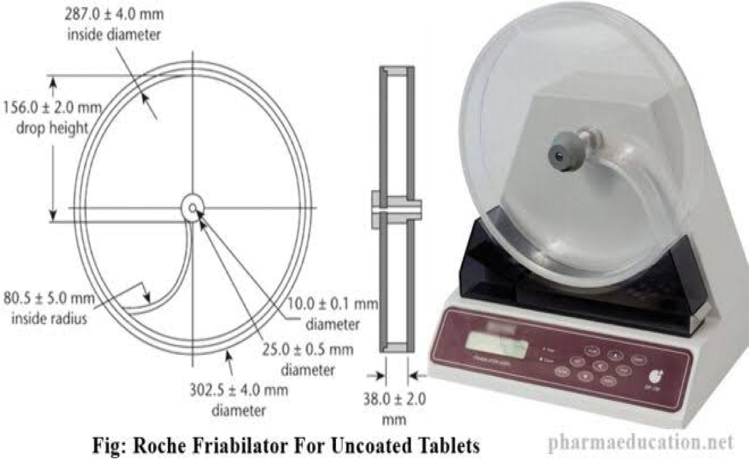

Calculatiin :-

Friability (%) =W1 – W2/ W1 X 100

Where,

W1 = Weight of Tablets (Initial / Before Tumbling) &

W2 = Weight of Tablets (After Tumbling or friability)

Limit : Friability (%) = Not More Than 1.0 % 7 Thickness Test :-

Tablet thickness is determined by the diameter of the die, the amount of fill permitted to Enter the die cavity, the compaction characteristics of the fill material, and the force or Pressure applied during compression. To manufacture tablets of uniform thickness during And between batch productions for the same formulation, care must be exercised to employ The same factors of fill, die, and pressure.

Tablet thickness is measured with a vernier caliper, thickness Gauge or automated equipment (Automatic weight, hardness, thickness, and tablet Diameter test instrument). The thickness of a tablet should be controlled within ±5% Variation of a standard value depending on the size of the tablet.

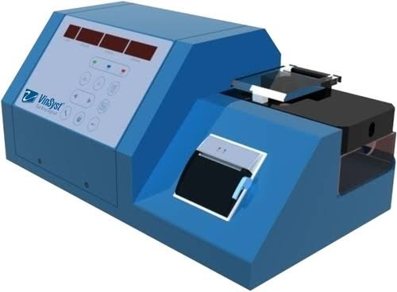

1. Weight Variation Test :-

Weight variation test is also known as uniformity of weight, it is the official quality control Test which is performed to ensure that each tablet dosage form has the accurate amount of Drug. The consistency of weight is a process test parameter that ensures uniformity of dose Units as per the label claim. The test is conducted by weighing 20 tablets individually on an Analytical balance, computing the average weight, and comparing the individual weights of The tablet to the average. The test procedure for weight variation :-

Required apparatus and materials are tablets/caplets/capsules, electronic or analytical Balance, and weighing boat, etc. As per the USP, weigh the randomly selected 20 tablets Individually and calculate the average weight.If no more than two tablets exceed the % limit And no tablets differ by more than twice the percentage limit, the tablet passes the USP Test. The weight variation of the tablet is mostly influenced factors by the machine speed, Head pressure, compression machine, particle size distribution, and the flow properties of The powder, and degree of segregation, these are the common cause of weight variation

1. Dissolution Test :-

Dissolution was conducted to detect the percentage amount of release dosage forms. i.e. Tablet. Small particles of tablet having maximum surface area in dissolving media. Disintegration study was not conform that particles will release drug in solution at an Appropriate rate, that’s why dissolution tests and its specifications developed for all Tablet products. Dissolution is mass transfer process.

Dissolution is mainly depend on Aqueous solubility of drug. It is process in which solid mass transfer in liquid medium. Dissolution based on four process such as,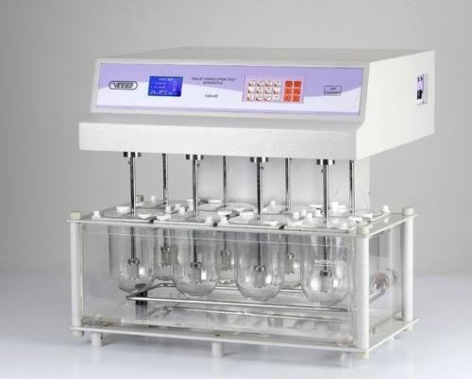

* 1. Wetting
  2. Solubility
  3. Swelling
  4. Diffusion

1. Moisture Content Of Granules :-

Moisture content determination is an important quality control test in pharmaceutical Manufacturing, from the checking of incoming raw materials and in-process control of Tablets and capsules to undertaking quality checks of finished drugs as part of Pharmacopeial testing procedures. Moisture testing is also one of the critical quality Parameters in the stability testing of drugs.

The standard method for measuring moisture in pharmaceuticals is loss on drying using a Drying oven and a laboratory balance. However, this is a time-consuming and laborintensive process. A halogen moisture analyzer is a viable alternative for determining Moisture content that meets regulations and provides fast, precise and reliable Measurements.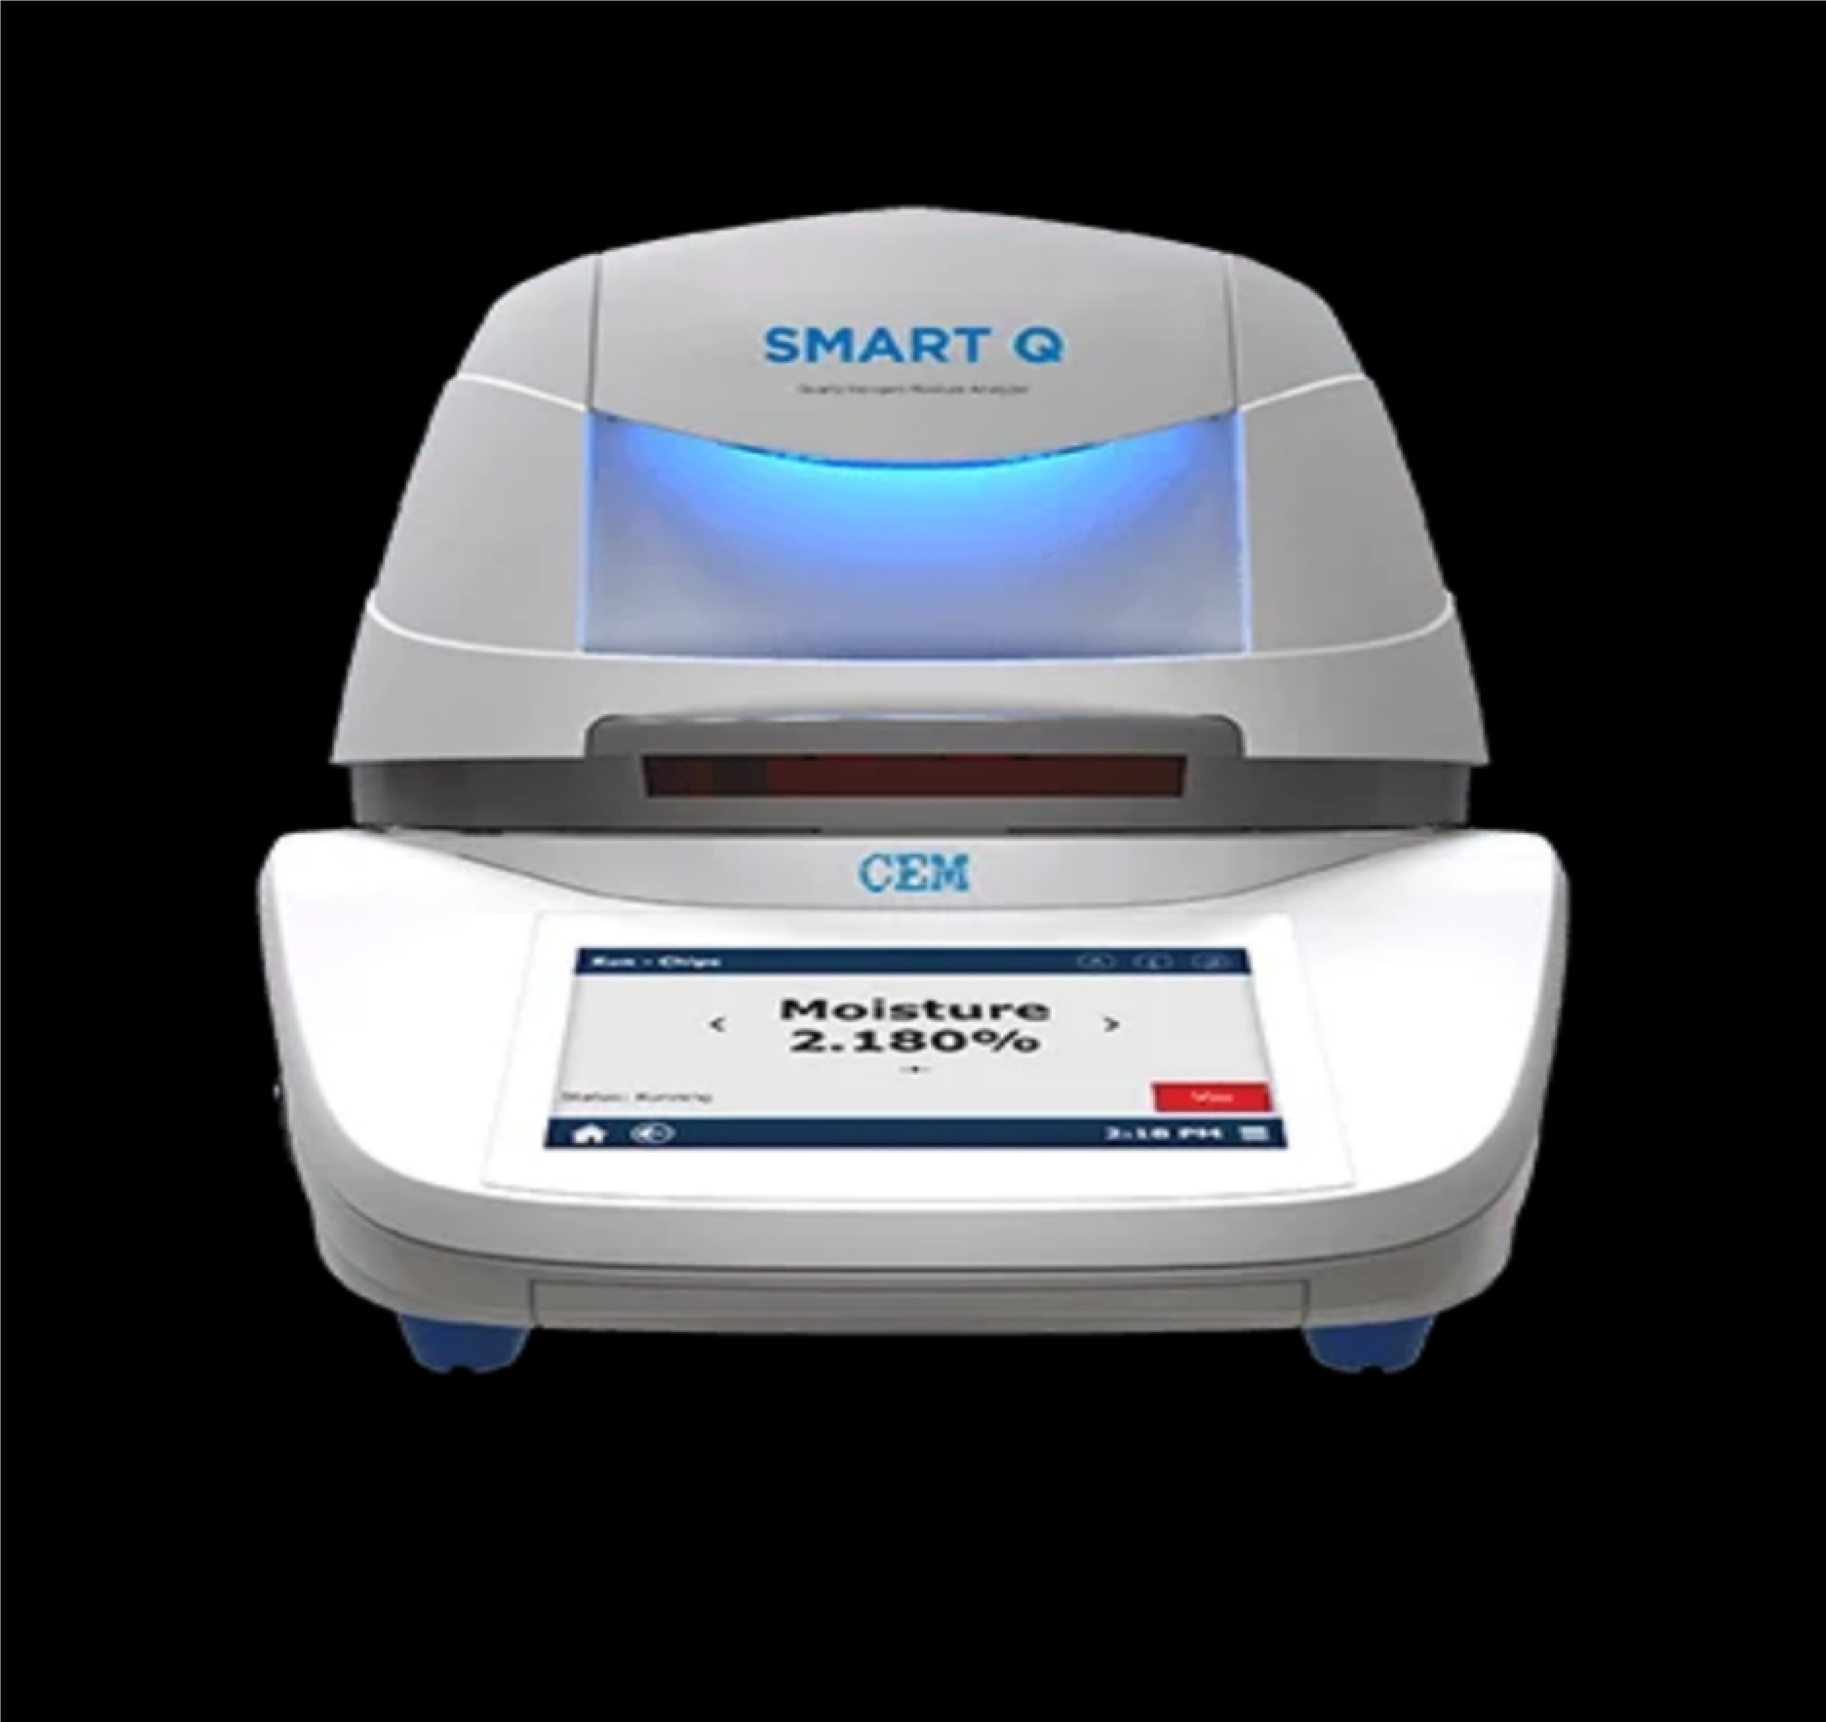

References :-

* 1. USP, USP General Chapter <905> Uniformity of Dosage Units (US Pharmacopeial Convention, Rockville, MD).
  2. EDQM, PhEur General Chapter 2.9.40 Uniformity of Dosage Units (EDQM, Strasbourg, France).
  3. 3. EDQM, PhEur Chapter 2.9.47 Uniformity of Dosage Units Using Large Sample Sizes(EDQM, Strasbourg, France).
  4. 4. FDA, Guidance for Industry, Powder Blends and Finished Dosage Units-Stratified In-Process Dosage Unit Sampling and Assessment (Rockville, MD, October 2003).
  5. 5. J Bergum et al., ISPE Pharmaceutical Engineering 34 (2)

(March/April 2014)

* 1. 6. ASTM Standard Number E2709: Standard Practice for Demonstrating Capability to comply with an Acceptance Procedure, September 2009.
  2. 7. ASTM Standard Number E2810: Standard Practice for Demonstrating Capability to Comply with the Test for Uniformity of Dosage Units, October 2011.
  3. 8. ISPE, “ISPE Group Working on Blend and Content Uniformity Launches Website,” Press Release, Sep. 16, 2014.
  4. The theory and practice of industrial pharmacy. By Lachmann & Liberman III edition, Indian pharmacopoeia 1996.
  5. Allen L. V and Ansel H. C. (2014). Ansel’s Pharmaceutical Dosage Forms and Drug Delivery Systems. Philadelphia: Lippincott Williams and Wilkins.
  6. Dash, A. K., Singh, S. and Tolman, J. (2014). Pharmaceutics – Basic Principles and Application to Pharmacy Practice. USA: Academic Press.

12.Felton, L.A. (2012). Remington Essentials of Pharmaceutics. UK: Pharmaceutical Press.

13.Ghosh, T. K. and Jasti, B. R. (2005). Theory and Practice of Contemporary Pharmaceutics. USA: CRC Press LLC.

14. 1. Savale S K. Formulation and Evalution of Diclofenac

Sustained Released Tablet, Asian Journal of Pharmaceutical

Analysis and Medicinal Chemistry, 3(4), 2015, 214-225

15.Savale S K et al. Formulation and Evaluation of Metformin

HCLGastroretentive Floating Sustained Released Tablet, World

Journal of Pharmacy and Pharmaceutical Sciences, 5(4), 2016, 2456-2466

16.Savale S K. Quality by Design (QbD) Approach used in

Development of Pharmaceutical Formulations, Asian Journal of

Biomaterial Research, 3(6), 2017, 11-24

17.Savale S K. Formulation and Evaluation of Microspheres with Aceclofenac,World Journal of Pharmaceutical and Medical Research, 2(4), 2016, 181-187.

18. Biswas D and Halquist M. Using Biorelevant in Vitro Models Testing to Characterize Release of Non Oral Dosage Forms as another Tool for Safety. J Pharmacovigil. 2016;4:e153.

19.Swain S and Beg S. Emergence in the Lipid-Based Nanostructured

Systems for Optimizing Oral Delivery of Drugs. Pharmaceut Reg Affairs. 2016;5:e157.

20. Gelaw BK, et al. Prescription Pattern of Injection at Out Patient Pharmacy Department of Adama Hospital Medical College, Adama, Ethiopia. Clin Pharmacol Biopharm. 2015;4:146.

21.Kokardekar RR, et al. Development and Evaluation of Sustained Release Microspheres of Glibenclamide by Emulsion Solvent Evaporation Method. Clin Pharmacol Biopharm. 2014;3:127.

1. Kokardekar RR, et al. Development and Evaluation of Sustained Release Microspheres of Glibenclamide by Emulsion Solvent Evaporation Method. Clin Pharmacol Biopharm. 2014;3:127.
2. Abass SAE, et al.Development and Validation of

Spectrophotometric and Pre-column Derivatization HPLC Method for Determination of Famotidine in Pharmaceuticals by Reaction with Sodium Nitroprusside; Application to Combined Tablets.

Pharm Anal Acta.2016;7:476.