**REVIEW ON MUCOADHESIVE MICROSPHERES**

**Karre Supriya1, Kothuri Jyothi 2, Ch. Shanthi Priya3, S. Rohini Reddy4.**

1 Student, Department of Pharmaceutics, Sarojini Naidu Vanita Pharmacy Maha Vidyalaya, Tarnaka, Hyderabad.

2 Student, Department of Pharmaceutics, Sarojini Naidu Vanita Pharmacy Maha Vidyalaya, Tarnaka, Hyderabad.

3Associate Professor, Department of Pharmaceutics, Sarojini Naidu Vanita Pharmacy Maha Vidyalaya, Tarnaka, Hyderabad.

4Associate Professor, Department of Pharmaceutics, Sarojini Naidu Vanita Pharmacy Maha Vidyalaya, Tarnaka, Hyderabad.

**ABSTRACT**

Mucoadhesive microspheres have emerged as promising carriers for drug delivery due to their ability to adhere to mucosal surfaces, thereby prolonging residence time and enhancing therapeutic efficacy of various drugs, particularly those targeting mucosal surfaces. Microspheres constitute an important part of the novel drug delivery system by virtue of their small size and efficient carrying capacity. Due to their long residence time, bioadhesive characteristics mucoadhesion can be coupled to microspheres to develop mucoadhesive microspheres. Mucoadhesive Microspheres exhibit a prolonged residence time at the site of application or absorption and facilitate an intimate contact with the underlying absorption surface and thus contribute to improved and better therapeutic performance of drugs and also Mucoadhesive microspheres have advantages like efficient absorption and enhanced bioavailability of the drugs due to a high Surface to volume ratio, a much more intimate contact with the mucus layer, controlled and sustained release of drug from Dosage form and specific targeting of drugs to the absorption site. Mucoadhesive microspheres have been developed for oral, Buccal, nasal, ocular, rectal and vaginal for either systemic or local effects. It is an ideal targeting system with high safety Profile. This review article gives the information about mucoadhesion and theories of mucoadhesion. It also contains a number of available methods of preparation of mucoadhesive microspheres.

**Keywords:** Mucoadhesive, Microspheres

**1.Introduction**

Mucoadhesive microspheres represent a promising strategy in the field of drug delivery, offering numerous advantages over conventional dosage forms. These microspheres are designed to adhere to mucosal surfaces, such as those found in the gastro intestinal tract, respiratory tract, and ocular tissues, leading to prolonged drug residence time and enhanced therapeutic outcomes.

Microspheres are defined as small, insoluble, free-Flowing spherical particles consisting of a polymer matrix and drug And their sizes from about 50 nm to about 2 mm. Free-flowing powders And granulates are needed for a variety of industrial processes. These, however, do not always meet the exact standards which modern Manufacturing demands of them, due to their varying grain, size, Distribution, and odd shapes.

**1.1 Types of microspheres**

Mucoadhesive microspheres, magnetic microspheres, floating Microspheres, radioactive microspheres, biodegradable polymeric Microspheres, and synthetic polymeric microspheres.

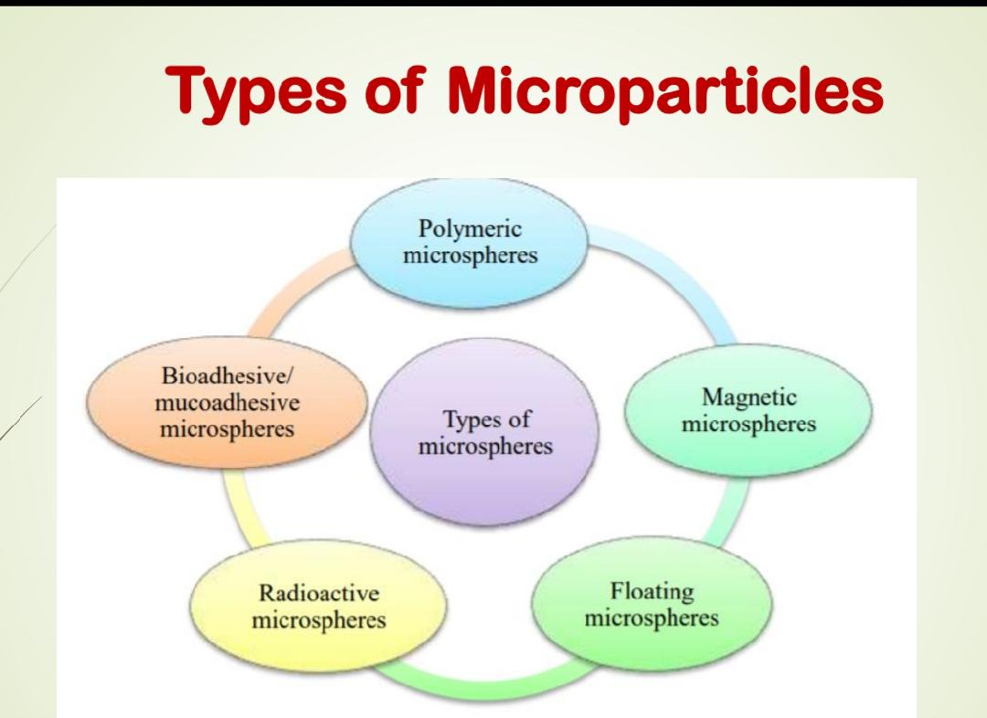

**Advantages**

* As a result of adhesion and intimate contact, the formulation stays longer at the delivery site improving API bioavailability using lower API concentrations for disease treatment
* The use of specific bioadhesive molecules allows For possible targeting of particularsites or Tissues, for example the gastrointestinal (GI) Tract.
* Offers an excellent route, for the systemic Delivery of drugs with high first-pass Metabolism, there by offering a greater Bioavailability
* Prolonged and sustained release of drug.

**Disadvantages**

* The release rate may vary from a variety of factors like food and the rate of transit though gut, mucin turnover rate etc.
* Any loss of integrity in release pattern of the dosage form may lead to potential toxicity.
* Differences in the release rate can be found from one dose to another.

**1.2 Mechanism of mucoadhesion**

Mucoadhesion or bioadhesion can be defined as the State in which two materials, at least one of which is Biological in nature, are held together for a prolonged Time period by means of interfacial forces.

The mechanism of adhesion of certain macromolecules To the surface of a mucous tissue is not well understood Yet. The mucoadhesive must spread over the substrate to Initiate close contact and increase surface contact, Promoting the diffusion of its chains within the mucus. Attraction and repulsion forces arise and, for a Mucoadhesive to be successful, the attraction forces must dominate. Each step can be facilitated by the nature ofThe dosage form and how it is administered. For example, A partially hydrated polymer can be absorbed by the substrate because of the attraction by the surface water.

The mechanism of mucoadhesion is generally divided into two steps: the contact stage and the consolidation Stage. The first stage is characterized by the contact between the mucoadhesive and the mucus membrane, With spreading and swelling of the formulation, initiating Its deep contact with the mucus layer

Mucoadhesion is a complex phenomenon which involves wetting, adsorption and interpenetration of polymer chains.

The mechanism of mucoadhesion is as followed:

The first step is followed by the Intimate contact between a mucoadhesive delivery system and mucosal membrane (where the wetting or swelling Phenomenon takes place)

The second step is finally Penetration of the mucoadhesive delivery system into the tissue or into the surface of the mucous membrane which in turn shows its therapeutic activity.

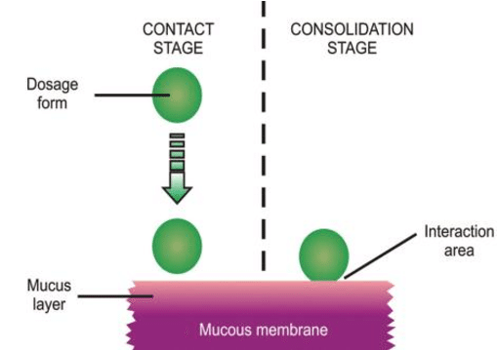

**1.3 THEORIES OF MUCOADHESION**

**Electronic theory:**

Involves the formation of an electric double layer at the mucoadhesive interface by the transfer of Electrons between the mucoadhesive polymer and the mucin glycoprotein network

**Wetting theory:**

States that if the contact angle of liquids on the substrate surface is lower, then there is a greater affinity for the liquid to the substrate surface. If two such substrate surface are brought incontact with Each other in the presence of liquid, the liquid may act As an adhesive amongst the substrate surface.

**Absorption theory:**

According to this theory , after an initial contact Between two surfaces, the material adheres because Surface force acting between the atoms in two Surfaces. Two types of chemical bonds resulting from These forces can be distinguished as primary chemical Bonds of covalent nature and secondary chemical Bonds having many different forces of attraction, Including electrostatic forces, vander wall forces, Hydrogen and hydrophobic bonds.

**Diffusion theory:**

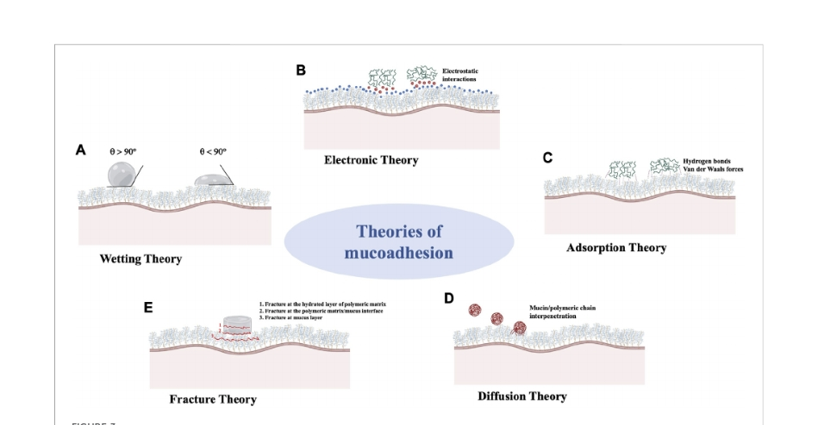 According to this theory, the polymer chains and the Mucus mix to a sufficient depth to create a semi Permanent adhesive bond. The exact depth to which The polymer chain penetrates the mucus depends on The diffusion coefficient and the time of contact

**1.4 Polymers Used In Formulating Mucoadhesive Drug Delivery System**

**First generation mucoadhesive polymers**

First-generation mucoadhesive polymers may be divided into three main sub-categories, namely: Anionic polymers, Cationic polymers and non-ionic polymers. Among these anionic and cationic polymers have been exhibits the greatest mucoadhesive strength.

**Anionic polymers**

Anionic polymers are the most widely employed mucoadhesive polymers within pharmaceutical formulation due to their high mucoadhesive functionality and low toxicity. These include alginates, carrageenan, poly(- acrylic acid) (PAA) and its weakly cross-linked derivatives and sodium carboxymethylcellulose (NaCMC). PAA and NaCMC possess excellent mucoadhesive characteristics due to the formation of strong hydrogen bonding interactions with mucin 23 . Polycarbophil and carbomer (Carbopol, PAA derivatives have been studied extensively as mucoadhesive platforms for drug delivery to the GI tract.

Carbomers are cross-linked with allyl sucrose or allylpentaerythritol, whereas polycarbophil polymers are cross-linked with divinyl glycol. Both compounds have the same acrylic backbone but vary in their cross-link density that is often tailored to suit pharmaceutical or cosmetic performan.

**Cationic polymers**

Chitosan is a cationic polysaccharide, the most abundant polysaccharide in the world, next to cellulose. The most explored mucoadhesive polymers, chitosan is gaining increasing importance due to its good biocompatibility, biodegradability and due to their favourable toxicological 27.The linearity of chitosan molecules also ensures sufficient chain flexibility for interpenetration 28 . Chitosan may provide improved drug delivery via mucoadhesive mechanism; it has also been shown to enhance drug absorption via the paracellular route through neutralization of fixed anionic sites within the tight junctions between mucosal cells.

**Novel second-generation mucoadhesives polymers**

**Second generation includes lectins and thiolated polymers**

**Lectin** these are generally defined as proteins or glycoprotein complexes of non-immune origin that are able to bind sugars selectively in a non-covalent manner. Lectins are capable of attaching themselves to carbohydrates on the mucus or epithelial cell surface and have been extensively studied, notably for drug-targeting applications. These second-generation bioadhesives not only provide for cellular binding, but also for subsequent endo- and transcytosis.

**Thiolated polymers,** also designated thiomers, are hydrophilic macromolecules exhibiting free thiol groups on the polymeric backbone. Due to these functional groups, various features of polyacrylates and cellulose derivatives were strongly improved . The presence of thiol groups in the polymer allows the formation of stable covalents bonds with cysteine-rich subdomains of mucus glycoproteins leading to increased residence time and improved bioavailability. Other advantageous mucoadhesive properties of thiolated polymers include improved tensile strength, rapid swelling, and water uptake behavior. .e.g-various thiolated polymers include chitosan-thioglycolic acid,chitosan-thioethylamidine, alginate-cysteine.

**1.5 Method Of Preparation Of Mucoadhesive Microspheres**

Mucoadhesive microspheres can be prepared by using different techniques like

**Complex Coacervation**

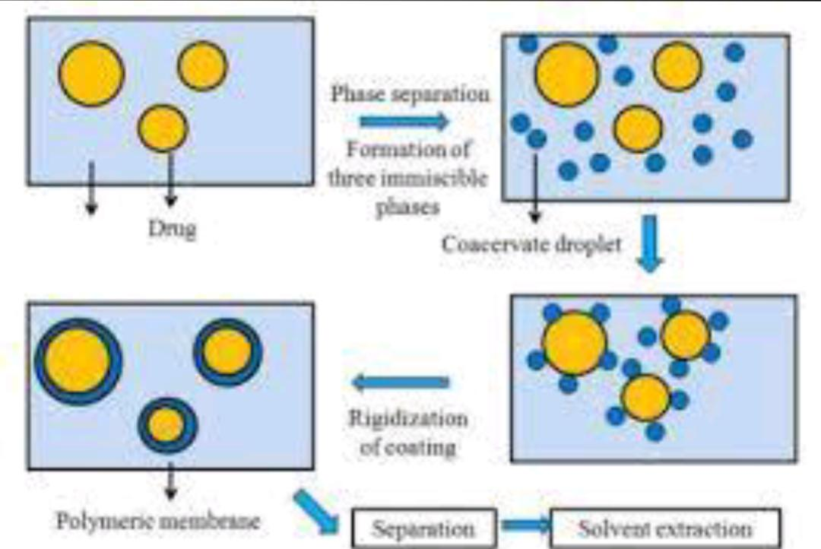Principle of this method is under suitable conditions when solutions of two hydrophilic colloids were mixed, result into a separation of liquid precipitate. In this Method the coating material phase, prepared by dissolving immiscible polymer in a suitable vehicle and the core material is dispersed in a solution of the coatingPolymer under constant stirring. Microencapsulation was achieved by utilizing one of the methods of phase separation, that is, by changing the temperature of the Polymer solution; by changing the pH of the medium, by adding a salt or an incompatible polymer or a non-solvent to the polymer solution; by inducing a Polymer polymer interaction. Generally coating is hardened by thermal cross linking or desolvation techniques, to form a self sustaining microsphere.

**Hot Melt Microencapsulation**

Microspheres of polyanhydride copolymer of poly bis(p-carboxyphenoxy) propane anhydride with sebacic acid were firstly prepared by this method. In this method the polymer is firstly melted and then the solid drug particles are added to it with continuous mixing. The prepared mixture is then suspended in a non-Miscible solvent like silicone oil with stirring and heated at the temperature above the melting point of the polymer with continuous stirring so as to get stabilized Emulsion. The formed emulsion is cooled to solidify polymer particles followed by filtration and washing of the microspheres with petroleum ether.

**Single Emulsion Technique**

The microspheres of natural polymers are prepared by single emulsion technique. The polymers and drug are dissolved or dispersed in aqueous medium followed By dispersion in organic medium e.g. oil, results in formation of globules, and then the dispersed globule are cross linked by either of heat or by using the Chemical cross-linkers. The chemical cross-linkers used are formaldehyde, glutaraldehyde, diacid chloride etc.

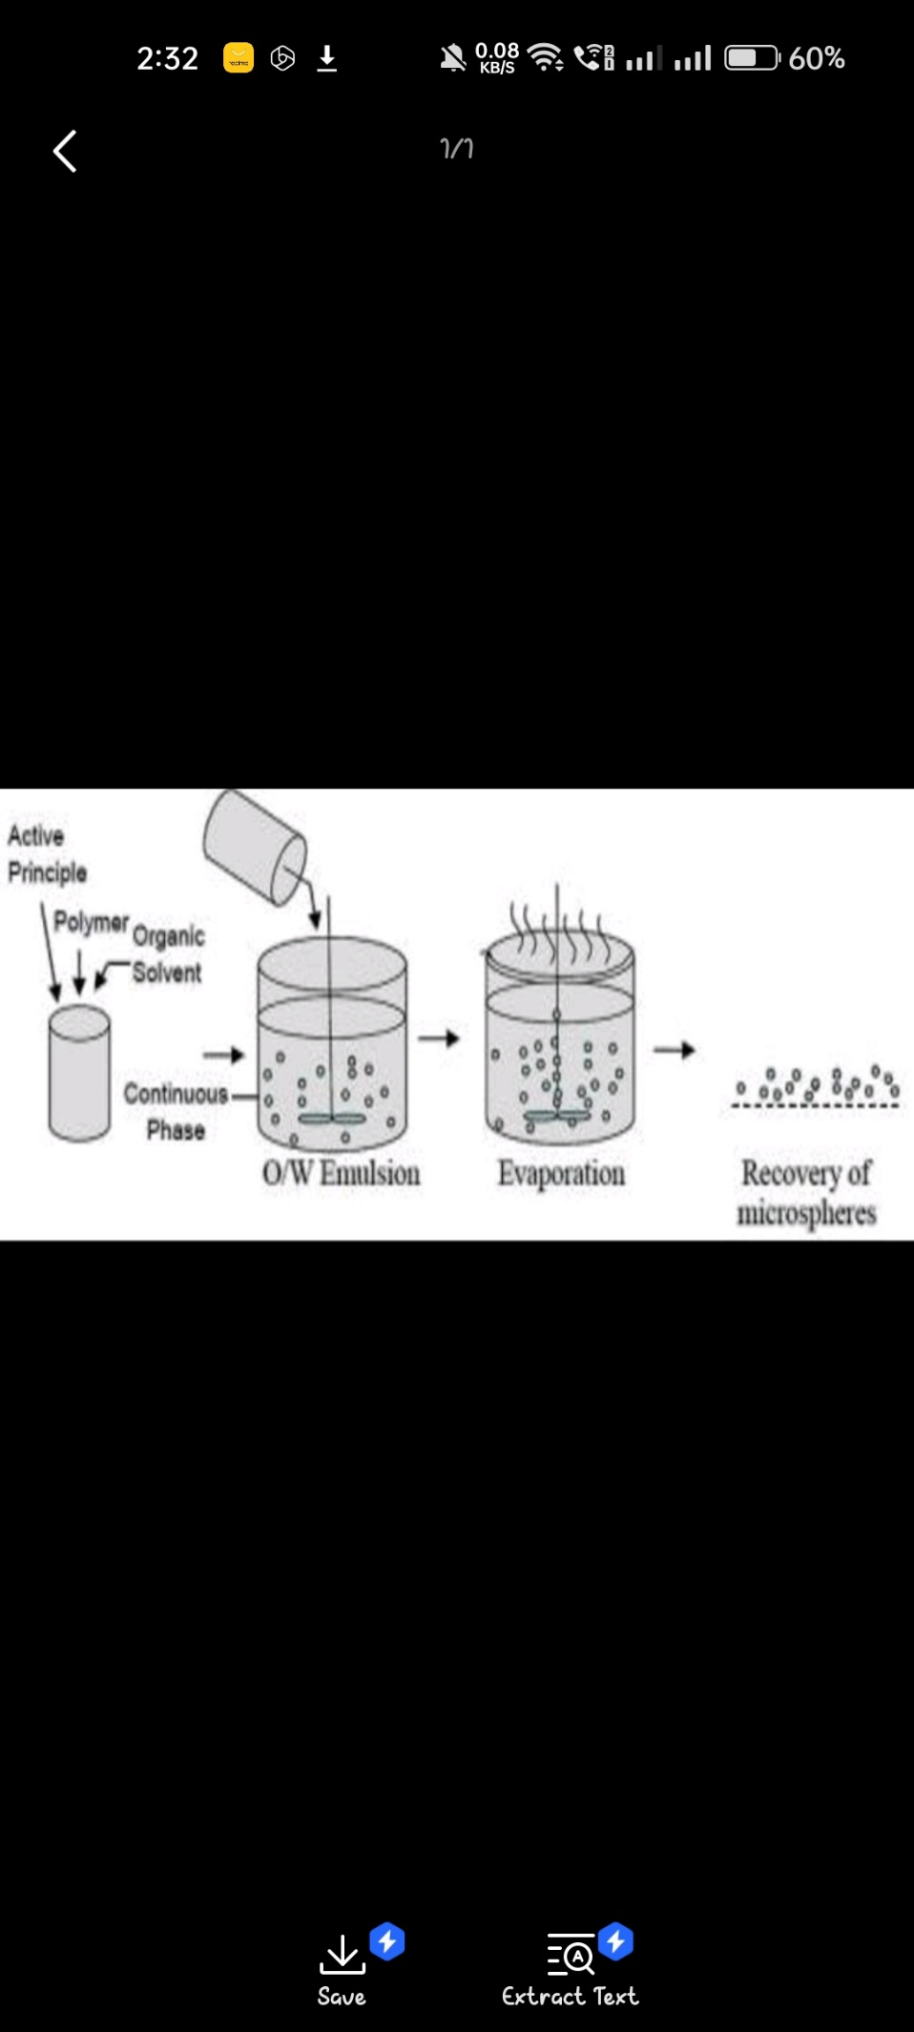

**Double Emulsion Method**

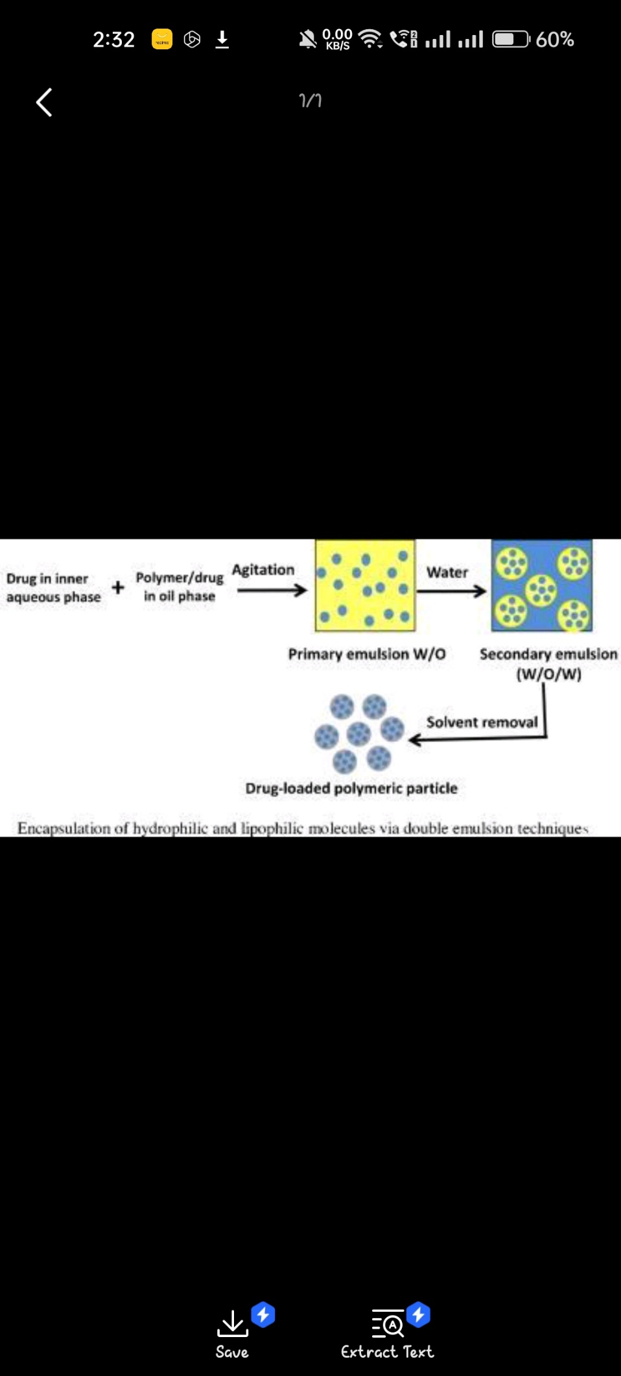This method is firstly described by Ogawa Y et al. In year 1988, and is the most widely used method of microencapsulation 11. In this method an aqueous solutionOf drug and polymer is added to the organic phase with vigorous stirring to get primary water-in-oil emulsion. This emulsion was then poured to a large volume Of water containing an emulsifier like polyvinyl alcohol or polyvinylpyrrolidone, under stirring, to get the multiple emulsions (w/o/w); and stirring was continued Until most of the organic solvent evaporates, leaving solid microspheres. The microspheres are then washed and dried.

**Solvent evaporation technique**

In this technique the drug is dissolved in polymer which was previously dissolved in chloroform and the resulting solution is added to aqueous phase containing 0.2 % sodium of PVP as emulsifying agent. The above mixture was agitated at 500 rpm then the drug and polymer (eudragit) was transformed into fine dropletWhich solidified into rigid microspheres by solvent evaporation and then collected by filtration and washed with demineralised water and desiccated at room Temperature for 24 hrs. Aceclofenac microspheres were prepared by this technique.

**Ionotropic Gelation**

This method was developed by Lim F and Moss RD14. Using this method Microspheres are formed by dissolving the gel-type polymers, such as alginate, in an Aqueous solution followed by suspending the active ingredient in the mixture and extruding the solution through needle to produce micro droplets which fall into a hardening solution containing calcium chloride under stirring at low speed. Divalent calcium ions present in the hardening solution crosslink the polymer, forming gelled microspheres.

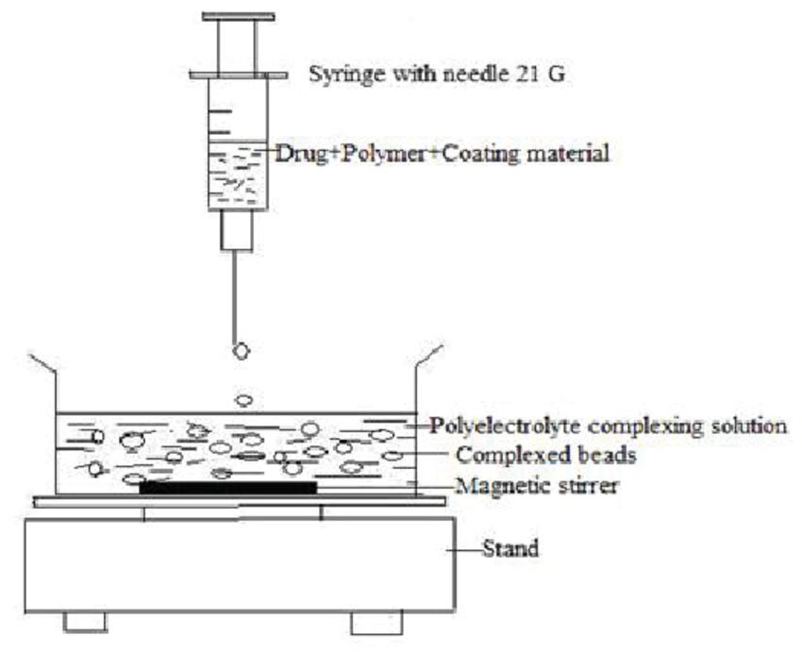

**Phase Inversion Method**

The method involves addition of drug into dilute polymeric solution, in methylene chloride; and resultant mixture is poured intoan unstirred bath of strong non-Solvent, petroleum ether, in a ratio of 1: 100. Microspheres produced are then clarified, washed with petroleum ether and air dried

**Spray Drying**

This method involves dissolving/dispersing of the drug into the polymer solution which is then spray dried. By this method the size of microspheres can be controlled by manipulating the rate of spraying, feeding rate of polymer drug solution, nozzle size, and the drying temperature

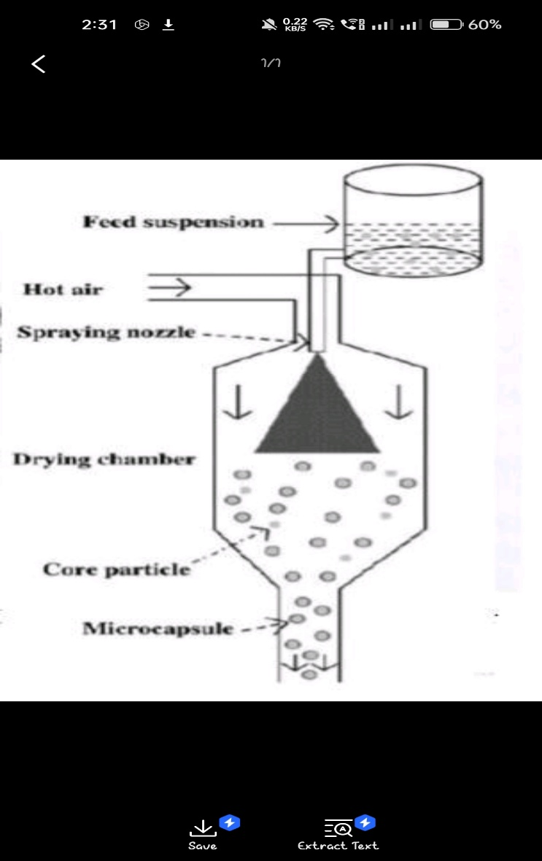

**Evaluation of Mucoadhesive Microspheres**

**Interaction study by TLC/ FTIR.IR spectroscopic studies**

The IR spectra of the free drug and the microspheres are recorded. The identical peaks corresponding tothe functional groups features confirm that neither the Polymer nor the method of preparation has affected the drug stability.

* **Thin layer chromatographic studies**

The drug stability in the prepared microspheres can also be tested by the TLC method. The Rf values of the prepared microspheres can be compared with the Rf value of the pure drug. The values indicate the drug stability.

**Particle size distribution of prepared microspheres:** Carried out using optical microscopy

* **Optical microscopy**

This method is used to determine particle size of microspheres by using optical microscope (MeizerOPTIK) The measurement is done under 45x (10x eye piece And 45x objective) and100 particles are calculated.

**Surface topography by Scanning Electron Microscopy (SEM)**

SEM of the microspheres shows the surface morphology of the microspheres like their shape and size.

* **Scanning electron microscopy (SEM)**

Surface morphology of microspheres is determined by the method SEM. In this method microspheres are mounted directly on the SEM sample slub with the help Of double sided sticking tape and coated with gold film under reduced pressure.

**EntrapmentEfficiency:-**

The entrapment efficiency of the microspheres or the percent entrapment can be determined by keeping the microspheres into the buffer solution and allowing Lysing. The lysate obtained is filtered or centrifuged and then subjected for determination of active constituents as per monograph requirement. The percent

Entrapment efficiency is calculated using following equation

% Entrapment = Actual content/Theoretical content x 100

**Bulk density**

The microspheres fabricated are weighed and transferred to a 10-ml glass graduated cylinder. The cylinder is tapped using an auto trap until the microsphere bed Volume is stabilized. The bulk density is estimated by the ratio of microsphere weight to the final volume of the tapped microsphere bed.

**In vitro drug release studies**

In-vitro release studies can be performed according to USP XXII type 2 dissolution apparatus at suitablepH conditions. The temperature should be maintained at 37±0.5°C and the rotation speed of100 rpm. Then 5 ml of sample should be withdrawn at various time intervals and replenished with an equal volume of fresh Dissolution media. The drug content in the sample can be analyzedspectrophotometrically at specific wavelength (nm).

References:

1. Jain N.K, Controlled and Novel drug delivery, 4th ed .2001.P. 236-237.
2. Chaturvedi G, Saha R, A Review on Microsphere Technology And Its Application, Birla institute of technology and sciences, 2009, 56-58.
3. Sinha V R, Bansal K, Kaushik R, Kumria R, Trehan A, Polycaprolactone Carvalho FC, Bruschi ML, Evangelista RC, Gremio MPD, Mucoadhesive drug delivery system, Brazilian Journal of Pharmaceutical Sciences, 2010, 46(1), 1-17.
4. Parmar H, Bakliwal S, Gujarathi N, Rane B, Pawar S, Different method of formulation and evaluation microspheres and nanospheres, International Journal of Pharmaceutics, 2004, 278(1), 1–23.
5. Mathiowitz E ,Langer R,Polyanhydride microspheres as drug carriers I: Hot-melt microencapsulation, Journal of controlled Release, 1987, 5(1), 13-22.
6. Gabor F, Wirth M, Jurkovich B, Haberl I, Theyer G, Walcher G, Hamilton G, Lectin mediated bioadhesion: Proteolytic stability and binding characteristics of wheat germ agglutinin and Solanum tuberosum lectin on Caco-2, HT-29 and human colonocytes, Journal of Controlled Release, 1997,49,27-37.
7. Haas J, Lehr CM, Developments in the area of bioadhesive drug delivery systems, Expert Opinion on Biological Therapy, 2002,2,287-298.
8. Peppas NA, Buri P, Surface interfacial and molecular aspects of polymer bioadhesion on soft tissue, journal of Controlled Release, 1985,2,257-275.
9. Shaikh R, Singh TRR, Garland MJ, Donnelly RF, Mucoadhesive Drug Delivery Systems, Journal of Pharmacy and Bioallied Sciences, 2011, 3(1),89-100.
10. Alexander A, Tripathi DK, Verma T, Patel S, Mechanism responsible for mucoadhesion of mucoadhesive drug delivery system, International Journal of Applied Biology and Pharmaceutical Technology, 2011, 2(1), 434-445.
11. Mathew ST, Devi GS, Prasanth VV, Vinod B, NSAIDs as microspheres, The International Journal of Pharmacology ,2008,6,1-9.
12. Lee JW, Park JH, Robinson JR, Bioadhesive based dosage forms : The next generation, Journal of Pharmaceutical Sciences 2000,89,850-866.
13. Hagerstrom H, Edsman K, Stromme M,Low-frequency dielectric spectroscopy as a tool for studying the compatibility between pharmaceutical gels and mucus tissue, Journal of Pharmaceutical Sciences,2003,92,1869–1881.