**A STUDY ON FACTORS CONTRIBUTING TO EMPLOYEE MOTIVATION IN ACCESS HEALTHCARE**

1Kaushika R and 2 Manoj Kumar

1MBA student Jerusalem College of Engineering, Chennai

2Professor and, Jerusalem College of Engineering, Chennai

**ABSTRACT**

# Employee motivation plays a crucial role in an organization's success, as motivated employees are more likely to be productive, engaged, and committed to their work. This study titled “A study on factors contributing to employee motivation in AccessHealthcare” aims to explore the factors of motivation among the employees at Access Healthcare Pvt Ltd, allowing for a comprehensive examination of various factors of motivation. A sample size of 111 employees was selected through a rigorous filtering process from an initial pool of 120 employees. Data were collected from both primary and secondary sources, with primary data obtained through a structured questionnaire distributed among employees and secondary data sourced from relevant websites and other sources.

# KEYWORDS: motivation, productive, factors, comprehensive examination.

# INTRODUCTION

# In today's dynamic and competitive business landscape, the significance of employee motivation cannot be overstated. Organizations recognize that fostering a positive work environment and ensuring employee well-being are paramount for sustainable growth and success. "A STUDY ON FACTORS CONTRIBUTING TO EMPLOYEE MOTIVATION" seeks to delve into the intricacies of this crucial aspect by examining the factors that contribute to or detract from employee satisfaction within our organization.

# Motivation, often regarded as the cornerstone of productivity and organizational effectiveness, constitutes a fertile ground for scholarly inquiry and practical application. At its essence, motivation encapsulates the intricate interplay between individual aspirations, organizational culture, managerial practices, and external stimuli. It encompasses a spectrum of psychological, social, and economic factors that drive individuals to initiate, sustain, and channel their efforts toward achieving organizational goals.

# Against the backdrop of burgeoning research in organizational behavior and human resource management, this study embarks on a journey to explore the myriad dimensions of employee motivation. By synthesizing insights from empirical studies, theoretical frameworks, and real-world practices, it seeks to offer a comprehensive understanding of the determinants, mechanisms, and outcomes of motivation in diverse organizational settings.

**REVIEW OF LITERATURE:**

**“The Role of Leadership in Employee Motivation Publication Date: 2023, John Smith.** This study examines the impact of leadership styles on employee motivation. It reviews various leadership theories, such as transformational, transactional, and servant leadership, and their effects on employee motivation levels. The study identifies key leadership behaviors that positively influence motivation, including empowerment, support, and recognition.

**“Employee Motivation and Organizational Culture”, Publication Date-2022, Emily Johnson.** This meta-analysis synthesizes findings from multiple studies on the relationship between organizational culture and employee motivation. It explores how organizational values, norms, and practices shape employee motivation. The study highlights the importance of a supportive and inclusive organizational culture in fostering high levels of motivation among employees.

**“Intrinsic and Extrinsic Motivation: Implications for Employee Engagement” Publication Date-2021, David Brown.** This research paper explores the concepts of intrinsic and extrinsic motivation and their impact on employee engagement. It reviews theories such as self-determination theory and expectancy theory to understand the underlying mechanisms driving employee motivation. The study discusses strategies for leveraging both intrinsic and extrinsic motivators to enhance employee engagement and performance.

**“The Role of Job Design in Enhancing Employee Motivation, Publication Date- 2020, Author, Sarah Lee.** This systematic review examines the relationship between job design factors and employee motivation. It identifies key job characteristics, such as autonomy, variety, and feedback, that influence motivation levels. The study provides insights into how organizations can redesign jobs to enhance employee motivation and satisfaction.

**"Recognition and Rewards: Impact on Employee Motivation and Performance", Publication Date- 2019, Author: Michael Clark.** This study investigates the effects of recognition and rewards programs on employee motivation and performance. It reviews empirical research on the effectiveness of various types of recognition, including monetary incentives, awards, and praise. The study highlights the importance of timely and meaningful recognition in fostering a motivated workforce.

**METHODOLOGY**

# The study “A study on factors contributing to employee motivation in access healthcare” adopts a descriptive research design to investigate various factors of employee job motivation. With a sample size of 120 employees, filtered from an initial pool of 111, the research utilizes stratified random sampling techniques for data collection. Primary data is gathered through structured questionnaires distributed among employees, while secondary data is sourced from the website and other pertinent sources. employing statistical tools REGRESSION (ANOVA), CHI–SQUARE and WEIGHTED AVERAGE, the study aims to achieve several secondary objectives. These objectives include whether the effects of monetary and non-monetary benefits provided by the organization impact employee performance, study the effects of job promotion on employee motivation, and identify the factors contributing to job motivation. Through comprehensive analysis and interpretation of the gathered data, the study endeavors to offer insights vital for enhancing employee satisfaction and organizational performance at Access Healthcare Pvt Ltd.

# ANALYSIS

1. 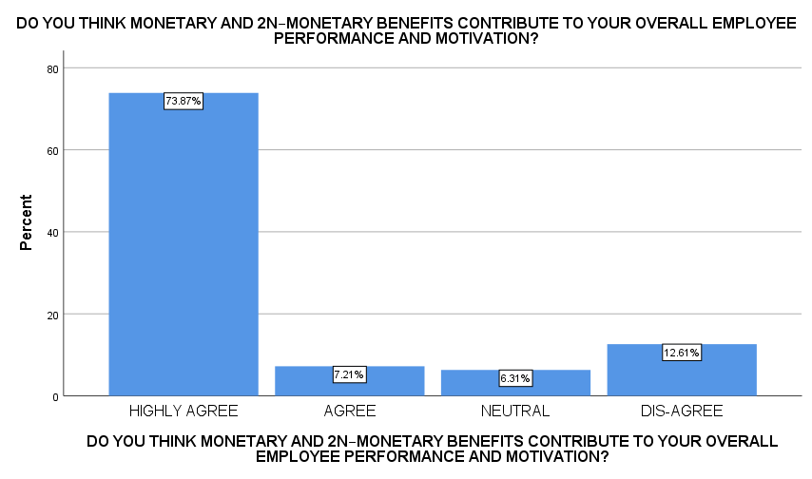PERCENTAGE ANALYSIS OF MONETARY AND NON-MONETARY BENEFITS MOTIVATES THE EMPLOYEE

|  |  |  |
| --- | --- | --- |
|  | Frequency | Percentage |
| HIGHLY AGREE | 82 | 73.9 |
| AGREE | 8 | 7.2 |
| NEUTRAL | 7 | 6.3 |
| DIS-AGREE | 14 | 12.6 |
| Total | 111 | 100 |

INFERENCE: Respondent thinks both monetary and non–monetary benefits contribute to your overall employee performance and motivation, highly agrees with a percentage of 73.87%.

1. 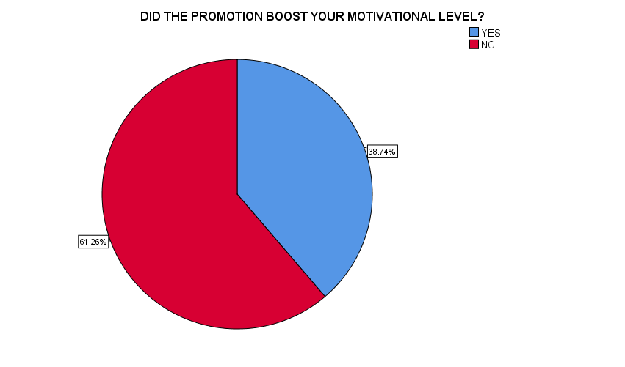PERCENTAGE ANALYSIS FOR WEATHER PROMOTION BOOSTS YOUR MOTIVATION LEVEL

|  |  |  |
| --- | --- | --- |
|  | Frequency | Percentage |
| YES | 43 | 38.7 |
| NO | 68 | 61.3 |
| Total | 111 | 100 |

INFERENCE: With 61.26% of respondents accepted that promotion is interconnected with motivation.

1. 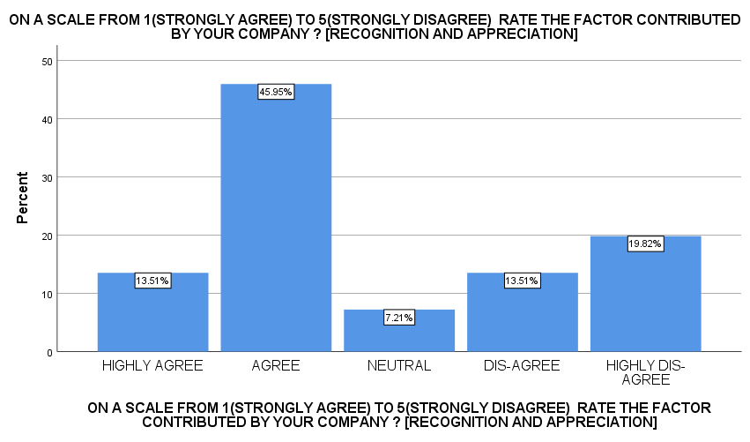PERCENTAGE ANALYSIS OF RECOGNITION AND APPRECIATION IN THE ORGANIZATION

|  |  |  |
| --- | --- | --- |
|  | Frequency | Percentage |
| HIGHLY AGREE | 15 | 13.5 |
| AGREE | 51 | 45.9 |
| NEUTRAL | 8 | 7.2 |
| DIS-AGREE | 15 | 13.5 |
| HIGHLY DIS-AGREE | 22 | 19.8 |
| Total | 111 | 100 |

INFERENCE: With 45.95% most of the respondents accept that they are recognized and appreciated.

|  |  |  |
| --- | --- | --- |
|  | Frequency | Percentage |
| HIGHLY AGREE | 15 | 13.5 |
| AGREE | 59 | 53.2 |
| DISAGREE | 22 | 19.8 |
| HIGHLY DIS-AGREE | 15 | 13.5 |
| Total | 111 | 100 |

1. 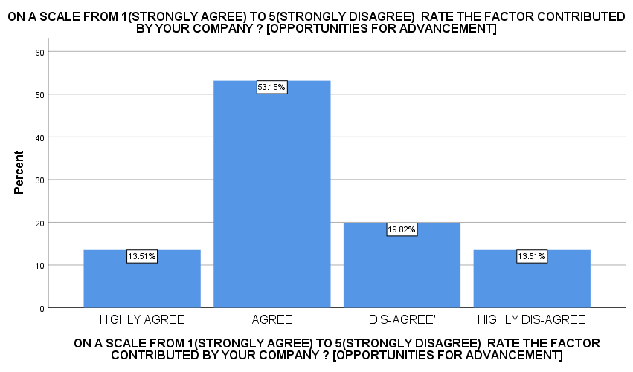PERCENTAGE ANALYSIS OF OPPORTUNITIES FOR ADVANCEMENT IN THE ORGANIZATION

INFERENCE: The organization provides opportunities for advancement agreed to 53.15% of the respondents.

|  |  |  |
| --- | --- | --- |
|  | Frequency | Percentage |
| HIGHLY AGREE | 23 | 20.7 |
| AGREE | 29 | 26.1 |
| NEUTRAL | 29 | 26.1 |
| DIS-AGREE | 15 | 13.5 |
| HIGHLY DIS-AGREE | 15 | 13.5 |
| Total | 111 | 100 |

1. 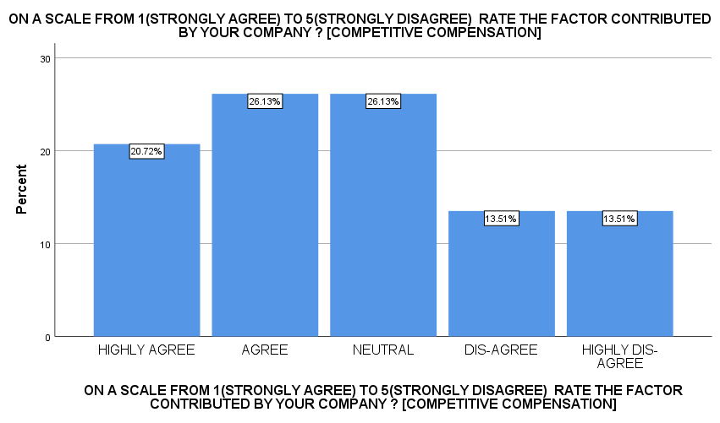PERCENTAGE ANALYSIS OF COMPETITIVE COMPENSATION IN THE ORGANIZATION

INFERENCE: 26.13% agree and neutralize that organizations provide competitive compensation compared to other organizations.

1. REGRESSION ANALYSIS

NULL HYPOTHESIS

H0: There is no impact of monetary and non-monetary benefits on employee motivation ALTERNATIVE HYPOTHESIS

H1: There is an impact of monetary and non-monetary benefits on employee motivation

|  |  |  |  |  |  |  |
| --- | --- | --- | --- | --- | --- | --- |
| **ANOVA** | | | | | | |
| Model | | Sum of Squares | df | Mean Square | F | Sig. |
| 1 | Regression | 32.530 | 2 | 16.265 | 19.292 | .000b |
| Residual | 91.055 | 108 | .843 |  |  |
| Total | 123.586 | 110 |  |  |  |

INTERPRETATION:

From the regression analysis, it is found that the calculated 0.00 is lesser than the table value of 0.05.

Therefore, the alternative hypothesis is accepted.

That there is an impact on monetary and non–monetary benefits for employee motivation.

1. CHI – SQUARE TEST

To find the association between promotion and motivation toward employee

NULL HYPOTHESIS

H0: There is no association between promotion and motivation.

ALTERNATIVE HYPOTHESIS

H1: There is an association between promotion and motivation.

|  |  |  |  |
| --- | --- | --- | --- |
| **promotion boosts your motivation level** | | | |
|  | Observed N | Expected N | Residual |
| YES | 48 | 55.5 | -7.5 |
| NO | 63 | 55.5 | 7.5 |
| Total | 111 |  |  |

|  |  |  |  |
| --- | --- | --- | --- |
| **Promotion within the organization** | | | |
|  | Observed N | Expected N | Residual |
| YES | 48 | 55.5 | -7.5 |
| NO | 63 | 55.5 | 7.5 |
| Total | 111 |  |  |

|  |  |  |  |  |
| --- | --- | --- | --- | --- |
|  |  | Test statistics | |  |
|  |  | Promotion within the organization | promotion boosts your motivation level | |
| Chi-Square |  | 2.027a | 2.027a | |
| df |  | 1 | 1 | |
| Asymp. Sig. |  | 0.155 | 0.155 | |

INFERENCE:

From the CHI-SQUARE test, it is found that the calculated value is 0.155 which is lesser than the table value of 0.05

Therefore, the null hypothesis is, that there is an association between promotion and motivation

1. WEIGHTED AVERAGE

|  |  |  |  |  |  |  |  |
| --- | --- | --- | --- | --- | --- | --- | --- |
| QUESTION/OPTIONS | HIGHLY SATISFIED (5) | SATISFIED (4) | NEUTRAL (3) | DISSATISFIED (4) | HIGHLY DISSATISFIED (5) | TOTAL | WEIGHTED AVERAGE |
| 1) RECOGNITION AND APPRECIATION | 15*1 =15 | 48*2 =96 | 15*3 =45 | 12*4 =48 | 21*5 =105 | 309 | 309/15 = 20.6% |
| 2) OPPORTUNITIES FOR ADVANCEMENT | 14*1 =14 | 56*2 =112 | 0 | 19*4 =76 | 22*5 =110 | 312 | 312/15 = 20.8% |
| 3) COMPETITIVE COMPENSATION | 21*1 =21 | 28*2 =56 | 28*3 =84 | 12*4 =48 | 22*5 =110 | 319 | 319/15 = 21.27% |
| 4) POSITIVE WORK ENVIRONMENT | 42*1 =42 | 28*2 =56 | 15*3 =45 | 26*4 =104 | 0 | 247 | 247/15 = 16.47% |
| 5) WORK-LIFE BALANCE | 49*1 =49 | 21*2 =42 | 21*3 =63 | 20*4 =80 | 0 | 234 | 234/15 = 15.6% |

INFERENCE:

From the above table, the most accepted factor is competitive compensation (21.27%) and the least with work-life balance 15.6%.

**FINDINGS**:

Among 111 respondents, highly agreed with 73.9%, agreed with 7.2%, neutral 6.3%, and disagreed 12.6% that monetary and non-monetary benefits motivated the employee. Among 111 respondents says that yes (38.7%) and no (61.3%) that promotion boosts the motivation level of the employee. Among 111 respondents who highly agree (13.5%), agreed with 45.9%, neutral with 7.2%, disagree with 13.5%, highly disagreed with 19.8% that they are recognized and appreciated in the organization. Among 111 respondents who highly agree 13.5%, agree 53.2%, disagree 19.8%, highly disagree 13.5% that the employees are given the opportunity for advancement in the organization. Among 111 respondents they highly agree that 20.7%, agree 26.1%, neutral 26.1%, disagree that 13.5%, highly disagree 13.5% that the organization gives competitive compensation to the employees. From the regression analysis, it is found that the calculated 0.00 is lesser than the table value of 0.05. Therefore, the alternative hypothesis is accepted. That there is an impact on monetary and non–monetary benefits for employee motivation. From the CHI-SQUARE test, it is found that the calculated value is 0.155 which is lesser than the table value of 0.05 Therefore, the null hypothesis is, that there is an association between promotion and motivation. From the above table, the most accepted factor is competitive compensation (21.27%) and the least with work-life balance 15.6%.

**SUGGESTIONS**

Based on the data collected, it seems that the majority (61.3%) of respondents believe that promotion does not help them get motivated. However, a significant portion (38.7%) feel that promotion does indeed contribute to their motivation. Given this split in opinions, it might be beneficial to explore the reasons behind these responses further. For those who feel that promotion helps with motivation, it could be interesting to delve into what aspects of promotion they find motivating, such as increased responsibility, recognition, or financial rewards. On the other hand, for those who don't feel motivated by promotion, understanding their perspective could provide insights into potential areas for improvement in the promotion process or alternative methods of motivation within the workplace.

Some of the other factors that take into consideration Meaningful Work Employees are motivated when they find their work meaningful and aligned with their values and goals. Autonomy and Empowerment Providing employees with autonomy to make decisions and empowering them to take ownership of their work can boost motivation. Inclusive Culture Fostering an inclusive workplace where diversity is celebrated and all voices are heard can enhance motivation by creating a sense of belonging among employees.

**REFERENCE**

* "Recent Trends in Employee Motivation Research: A Critical Review". Authors, Garcia, S., & Martinez, R. Journal - Review of Organizational Psychology on 2024.
* "Employee Motivation: The Key to Effective Organizational Management in the 21st Century", Authors, Smith, J., & Johnson, A. Journal, International Journal of Business Management on 2023.
* "The Impact of Recognition and Appreciation on Employee Motivation and Performance"-Lee, H., & Chen, L. Journal, Journal of Applied Psychology on 2023.
* "Enhancing Employee Motivation: Strategies and Practices", Author, Brown, M. Book, Advances in Human Resource Management on 2022.
* “The Role of Opportunities for Advancement in Employee Motivation". Author, Wilson, K. “Advances in Organizational Behavior” on 2022.