**Solving 1D Steady State Linear Heat Conduction using Finite Element Method: A Case Study**

**Rupak Sen1, Avik Mali1**

1Student, Asansol Engineering College, Kolkata, West Bengal 700071, India

**ABSTRACT**

The finite element method is a reliable computational technique to solve a range of complicated phenomena that would have been impossible to solve using analytical methods. The finite element method can be applied to any arbitrary shape in one, two, and three dimensions to observe the internal change due to applied boundary conditions. In this paper, we studied a steady-state linear heat conduction problem using the finite element method (FEM) for a simple 1D rod for a variable number of elements and linear and quadratic shape functions. We finally validated our results using analytical results and found an excellent match between the computational and analytical models.

**Keywords:** Finite Element Method, Steady stead 1D heat conduction, Linear FEM

1. **INTRODUCTION**

The finite element method (FEM) is one of the most powerful tools in the computation study to generate solutions to physical phenomena. Due to its efficacy in solving complex physical behavior, it is widely used in structural engineering[1], [2], heat and thermal analysis[3], [4], computational fluid dynamics[5], [6], biofluid simulation[7], [8], and electromagnetism[9]. Among all these applications, FEM’s ability to solve heat transfer problems is groundbreaking in numerous fields. Due to the capability of FEM, we have used a simple FEM code to solve a fundamental 1D heat conduction problem.

The introduction of FEM has given engineers and scientists multiple degrees of freedom to analyze any physical phenomena just from the governing equation. The most important aspect is the geometrical independence of FEM. Most of the time, analytical solutions work only on specific geometrical shapes that are very simple. In contrast, FEM is a way of solving the problem which is highly capable of approximating the real solution based on some initial parameters. The inclusion of FEM eliminates the need for complex analytical solutions. FEM solves any phenomena by constructing matrix and solving iteratively, allowing scope to get insight easily.

FEM is a framework to solve governing equation of the intended physical phenomena, in our case, which is linear heat conduction. FEM starts by making the weak form of governing equation, then discretizing the domain into the smaller domain, calculating the shape function, applying boundary conditions, etc. Details of our method will be described in the method section, focusing on our goal.

In this study, we will solve a steady-state linear 1D heat conduction problem with specific boundary conditions. Though it is a simple model, it gives the starting point for approaching a more complex model in the future. Moreover, we will discuss the results from changing parameters and evaluate the performance of the FEM model from the analytical model.

1. **METHODOLOGY**

Method of FEM used in this study is described below[10], [11]:

1. Discretizing the domain by generating mesh
2. Generating connectivity matrix
3. Calculating Shape function, its derivative and Jacobian
4. Calculate elemental stiffness matrix and force vector
5. Generating global stiffness matrix
6. Applying boundary condition
7. Solving for temperature at every node

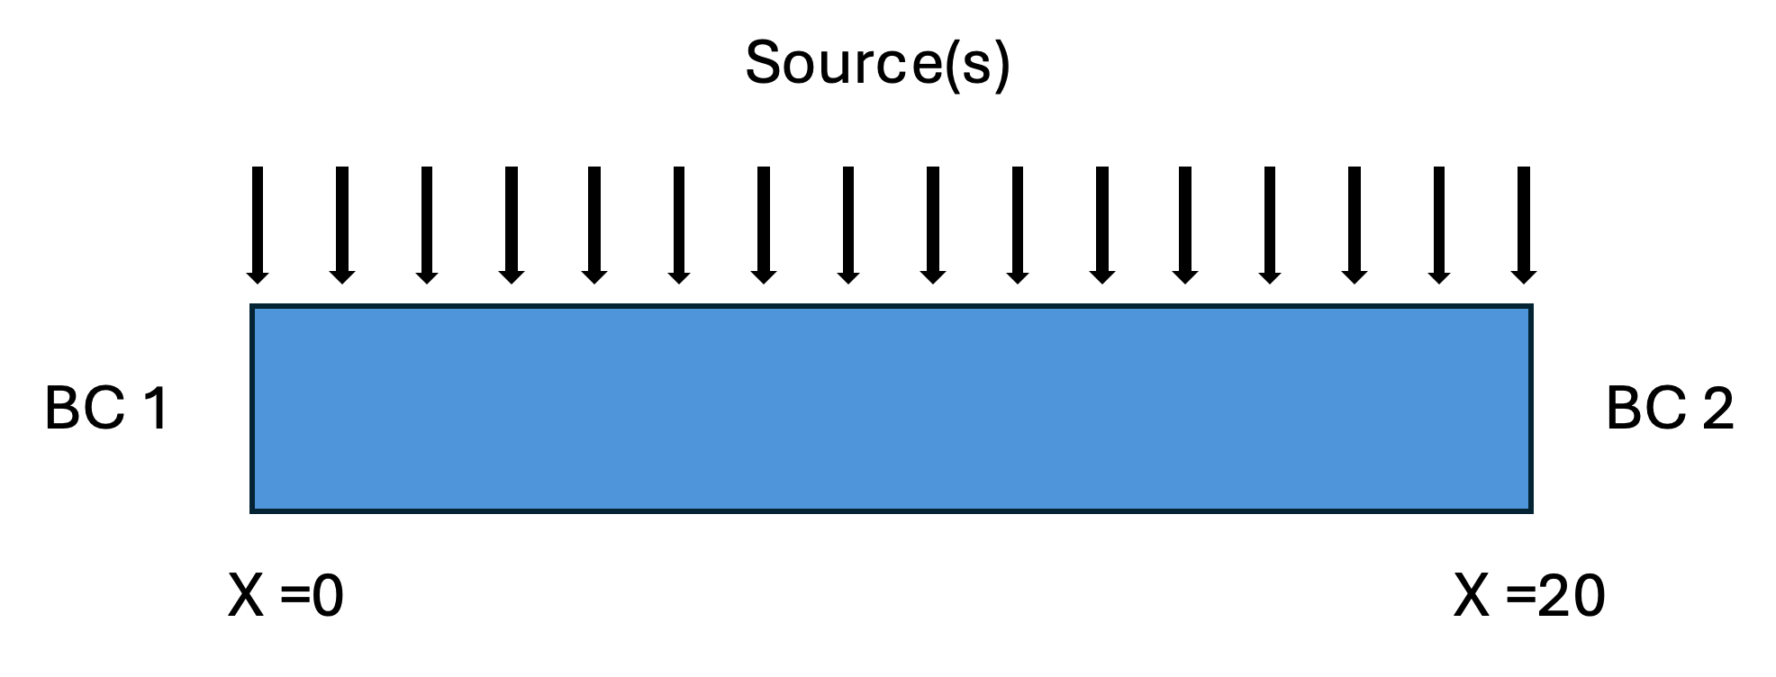

**Figure 1**: Representation of 1D rod domain for solving using FEM

In this problem, we considered Length 20m, cross-sectional area 1 m2, thermal conductivity 5 W/m°C, the constant heat source is 100 W/m, Boundary condition is BC 1= 0°C and heat flux in right side 0 W/m2.

First step is to declare number of elements for discretization and defining shape function. In our study we declared a variable for number of elements so that we can change according to our need. For shape function we considered quadratic and linear shape function. Formula for both shape functions are given below[10], [11]:

|  |  |
| --- | --- |
| For quadratic,  [N]= [ - $\frac{1}{2}ξ\left(ξ-1\right) \left(1-ξ\right)\left(1+ξ\right) \frac{1}{2}ξ(ξ+1)]$ [B]= [ $\frac{2ξ-1}{2} 1-2ξ \frac{2ξ+1}{2}$] | For linear,  [N]= [ $\frac{1}{2}\left(1-ξ\right) \frac{1}{2}(ξ+1)]$ [B]= [-0.5 0.5] |

Here, N is the shape function and B is derivative of shape function.

Next step is to calculate stiffness matrix and force vector at the element level which is done by using Gaussian quadrature. The formula for stiffness matrix and force vector is given below[10], [11]:

|  |  |
| --- | --- |
| Ke= $\int_{Le1}^{Le2}{[}{\left[B^{e}\right]}^{T} Aκ \left[B^{e}\right]dx]$ | Fe= $\int_{Le1}^{Le2}{[}{[N^{e}]}^{T} S dx-{\left[N^{e}\right]}^{T} A \overline{q}(at last node)$ |

Here, A is the cross-sectional area and κ is the thermal conductivity. Integration can be done in several methods. However, we have used gaussian quadrature formula which is I = $\sum_{1}^{Ngp}{f\left(ξ_{i}\right)} w_{i} J$. So, the above equations become [10], [11]:

|  |  |
| --- | --- |
| Ke= ${\left[B^{e}\right]}^{T}*A*κ *\left[B^{e}\right]$*W * Jacobian | Fe= ${[N^{e}]}^{T}*S*W*Jacobian-{\left[N^{e}\right]}^{T} A \overline{q } (at last node)$ |

After obtaining element wise stiffness matrix and force vector using those the global matrix is created. Finally applying boundary condition global matrices are solved.

1. **RESULTS AND DISCUSSIONChart, line chart

   Description automatically generatedChart, line chart

   Description automatically generated**  
   Finally, after solving the given case using the described FEM, we have compared against the exact solution which is given in the Figure-2. We see temperature is placed against the length of the domain. It is observed that solution with 5

(B)

(A)

**Figure 2:** Solution using FEM is compared against exact solution for -

(A) linear element and (B) quadratic element.

linear elements solution nicely matches with the exact solution while solution with 2 linear element fails to capture exact solution. However, in case of quadratic element, it takes only 3 elements to predict the exact results while single element is unable to predict exact solution. So quadratic shape function takes less element to predict results comparing to linear elements.

1. **CONCLUSION**

The finite element method is a reliable tool for solving a wide range of complex phenomena computationally. Due to its acceptability and advantages, this method is used in numerous fields. In this paper, we solved a 1D steady-state heat equation using the finite element method and found that three quadratic elements or five linear elements can predict the exact results.

However, it is essential to note that not any random number of elements is able to produce accurate results. We observed that one quadratic element or 2 linear elements failed to predict the exact solution accurately. This discrepancy highlights that FEM is sensitive to the number of elements, and the correctness of the solution depends on several elements. These findings strengthen the importance and optimization of element numbers for solving heat transfer problems. However, problems from other domains show similar types of sensitivity, according to our knowledge.

Overall, valuable insight is provided by our FEM study focusing on 1D steady heat conduction equations, and we believe this will give guidance for FEM for more complex cases.

1. **REFERENCES**

[1] V. Plevris and G. C. Tsiatas, “Computational structural engineering: Past achievements and future challenges,” *Front Built Environ*, vol. 4, p. 372413, Mar. 2018, doi: 10.3389/FBUIL.2018.00021/BIBTEX.

[2] H. Benaroya and M. Rehak, “Finite Element Methods in Probabilistic Structural Analysis: A Selective Review,” *Appl Mech Rev*, vol. 41, no. 5, pp. 201–213, May 1988, doi: 10.1115/1.3151892.

[3] J. Zhang, C. Lü, X. Zhang, Y. Huang, and X. Meng, “FEM-based thermal analysis of IGBT,” *PrimeAsia 2010 - 2nd Asia Pacific Conference on Postgraduate Research in Microelectronics and Electronics*, pp. 321–324, 2010, doi: 10.1109/PRIMEASIA.2010.5604896.

[4] P. V Krishnakanth *et al.*, “Structural & Thermal Analysis of Gas Turbine Blade by Using F.E.M,” *International Journal of Scientific Research Engineering & Technology (IJSRET*, vol. 2, pp. 2–060, 2013, Accessed: Mar. 29, 2024. [Online]. Available: www.ijsret.org

[5] A. Kulshreshtha, S. K. Gupta, and P. Singhal, “FEM/CFD analysis of wings at different angle of attack,” *Mater Today Proc*, vol. 26, pp. 1638–1643, Jan. 2020, doi: 10.1016/J.MATPR.2020.02.342.

[6] R. Löhner, “Finite elements in CFD: What lies ahead,” *Int J Numer Methods Eng*, vol. 24, no. 9, pp. 1741–1756, Sep. 1987, doi: 10.1002/NME.1620240910.

[7] M. M. N. Hossain, N. W. Hu, M. Abdelhamid, S. Singh, W. L. Murfee, and P. Balogh, “Angiogenic Microvascular Wall Shear Stress Patterns Revealed Through Three-dimensional Red Blood Cell Resolved Modeling,” *Function*, vol. 4, no. 6, Sep. 2023, doi: 10.1093/FUNCTION/ZQAD046.

[8] M. M. N. Hossain, N.-W. Hu, W. Murfee, and P. Balogh, “Three-Dimensional Shear Stress Characteristics in Angiogenic Microvascular Networks Revealed Through Red Blood Cell-Resolved Modeling Based on Real Image Data,” *https://doi.org/10.1152/physiol.2023.38.S1.5733149*, vol. 38, no. S1, May 2023, doi: 10.1152/PHYSIOL.2023.38.S1.5733149.

[9] “The Finite Element Method for Electromagnetic Modeling - Google Books.” Accessed: Mar. 29, 2024. [Online]. Available: https://books.google.com/books?hl=en&lr=&id=WdiEo7DEIIUC&oi=fnd&pg=PR5&dq=FEM+in+electromagnetic&ots=dNa_G1-Ty6&sig=SZQ5reKc-vJ2mYeVGMXduiVDo30#v=onepage&q=FEM%20in%20electromagnetic&f=false

[10] “The Finite Element Method: Its Basis and Fundamentals - Olek C Zienkiewicz, Robert L. Taylor, J.Z. Zhu - Google Books.” Accessed: Mar. 29, 2024. [Online]. Available: https://books.google.com/books?hl=en&lr=&id=YocoaH8lnx8C&oi=fnd&pg=PP1&dq=finite+element+method&ots=idUs6xQYkH&sig=G70rNGFzzVi8CnBuVuct1k0wEu0#v=onepage&q=finite%20element%20method&f=false

[11] “Finite Element Method - Gouri Dhatt, Emmanuel Lefrançois, Gilbert Touzot - Google Books.” Accessed: Mar. 29, 2024. [Online]. Available: https://books.google.com/books?hl=en&lr=&id=wvE1ClcHq5IC&oi=fnd&pg=PT6&dq=Finite+element+method&ots=jml8G8q1YZ&sig=ijaZGPTI_znOvii4MhYk7PWpV68#v=onepage&q=Finite%20element%20method&f=false