**SOLAR COOKERS, AN ALTERNATIVE TO REDUCE THE TIMBER RESOURCE EXTRACTION THROUGH THE USE OF RENEWABLE ENERGY SOURCES**

**Trupti Navathale1, Bhavna Ingole2.**

1Assistant Professor, Mechanical Engineering Department, Datta Meghe College of Engineering, Airoli, Navi Mumbai

2Assistant Professor, Mechanical Engineering Department, Datta Meghe College of Engineering, Airoli, Navi Mumbai

**ABSTRACT**

In this paper, it’s presented an integral project of technology transfer. Based in the development of several prototypes of solar cookers, all of them with our own design and construction, whose functionality is to compound parabolic concentrators of revolution, this project performed how to implement this Eco technology. The prototype implemented uses mirror polished aluminum reflectors, aluminum pressure cooker manual tracking device and solar tilt. With the help of social programs, 50 solar cookers were implemented in community in previously it was implemented a diagnostic of timber resources consumption to each beneficiary family. Also, firing tests were performed with various prototypes plots to select the best one with thermal and ergonomic characteristics. The project expects to reduce the consumption of timber as fuel used for cooking by 30%; to encourage the use of renewable energy, to mitigate respiratory diseases caused by the inhalation of combustion smoke and help the family’s economy. Currently we are working with the monitoring to quantify the improvements achieved in consumption-appropriation. There is already an user manual of maintenance and construction of solar cookers in the indigenous language and the project wants to be the basis for future Eco technologies’ implementations of new technology.

**Keywords:** Solar cooker revolution compound parabolic concentrator, technology transfer and appropriation.

1. **INTRODUCTION**

The use of conventional fuels (hydrocarbons), to meet the daily various needs is inevitable in every home. The gas, for example, is extremely necessary for cooking in urban and rural areas, lesser use is due, due to the total or partial use of wood as fuel. The use of timber resources in rural areas, used for as cooking fuel, has caused respiratory diseases in family members, large emissions of carbon dioxide and deforestation in the forest, which along with forest fires and illegal logging, is an environmental degradation in many cases irreversible. Therefore, alternatives are required to improve the quality of people’s life, mitigate the use of conventional fuels, reduce carbon dioxide emissions and contribute to family and economic savings. Solar cookers are a complementary alternative to meet the basic energy needs in a cooking matter, they can to mitigate to a lesser or greater the problems described above; favoring the rural sector, environment, social and economic welfare.

1. **METHODOLOGY**

Methods are used to developed solar cooker with compound Parabolic Concentrators of revolution and Construction and evaluation of solar cookers with CPC of revolution.

* 1. **Development of solar cookers with Compound Parabolic Concentrators of revolution.**

The solar cookers have been used for several years to cook using sun energy. Although there are many designs in the world, the fact is that there is still a lot to investigate. Until now it had not used the compound parabolic concentrator (CPC) in three dimensions with non-imaging optics for the construction of solar cookers. This proves a field that until now has not been worked with great benefits. A CPC is an efficient means of solar concentration used for several years, in addition to be an application of the non-imaging optics, offers the user several advantages: no emission of light flashes that can damage eyesight, good performance in rainy season, because they use diffuse radiation, and they not require too much time for cooking.

**2.2 Construction and evaluation of solar cookers with CPC of revolution**

Applications of the CPC of revolution in three dimensions [1] show an increased thermal and optical performance that CPC in two dimensions used as compound parabolic channel. This justifies the construction of solar cookers with CPC features of revolution; based in the curves used in 2002 to the solar oven Tolokatsin [2], but considering its rotation with respect to the symmetry axis was obtained one surface of revolution in three dimensions, which of course is a different surface of a paraboloid of revolution. And whose equations are shown below:

1. **MODELING AND ANALYSIS**

By forming the curves CPC of revolution described above and with the benefits of the use of non-imaging optics, the solar cookers construction represents a scarce area explored to perform some research

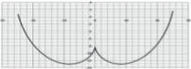

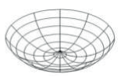

**Figure 1:**.CPC of revolution.

Using metal sections was formed the CPC of revolution to give rise three prototypes of solar cookers that, gradually, they improved thermal and functionality.

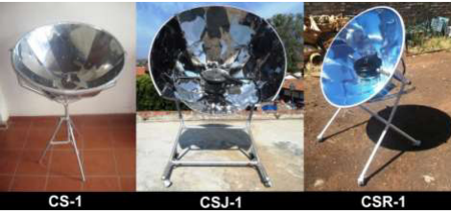

**Figure 2:**.Solar Cookers CPC of revolution

The Solar Cooker 1 (CS-1) was built with reflectors of stainless steel sheet mirror finish, additionally, used a basis of three sticks to sustain the CPC; its solar collection area was 0.47 m2 . With a cooking container of 2 liters has the cooking power reached 19 watts [3] and the cost of the prototype was of approximately $40 dollars. The Solar Cooker "cook with sun", used the CS-1, reflectors stainless steel sheet mirror finish, its solar collection area was 0.73 m2 , its base included a tilt manual device and tracking solar, additionally, included a 5 liter black pot capacity [4]. Its cooking power was 95 watts [5] and had a cost of approximately Rs. 5000. The Solar Cooker Rural 1 (CSR-1) was built using the basis of the CSJ, it included an express black pot of 6 liters of capacity, its reflectors were of anodized aluminum sheet mirror finish and its catchment area was 0.67m2 . Its cooking power was 130 watts and the cost was approximately Rs.2000[6]

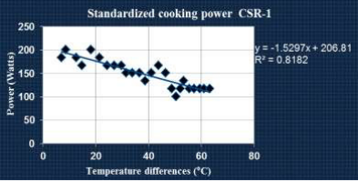

**Figure 3:** Cooking Power of CSR-1.

The Cooking power was calculated based on standard ASAE S580 [7], which establish a procedure for testing solar thermal for solar cookers and provides a framework for the setting of "Cooking Power normalized" to an uniform insolation [8]. The objective of this test is to produce a simple but significant measure of performance for solar cookers. Also the average thermal efficiency, [9] was calculated (Figure 4) of the CSR, which was obtained in 30%

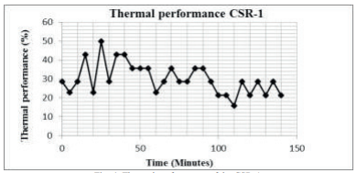

**Figure 4:**.Solar Cookers Thermal Performance.

The constructions of three solar prototypes was based in find one with better thermal performance and ergonomics. The CSR-1 was the solar cooker with the best features suitable to be implemented in any community.

1. **RESULTS AND DISCUSSION**

As a first step we selected the community a town. A sample of approximately 10% of all families in the community, 150 families were chosen by the community according to the scarcity of economic resources. The 150 families were surveyed with the intention of making the diagnosis of timber resources in terms of use, consumption, extraction and buying fuel wood.

Evaluation of extraction and consumption of fuel wood. Of all the families surveyed the results showed that the annual consumption of fuel wood for household is 6.9 tons .

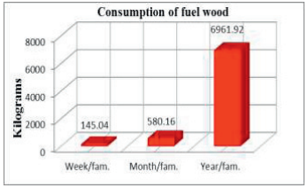

**Figure 4:** Gradual consumption of fuel wood per family

Hence, consumption is significant. However, in the majority of families (62%), fuel wood extraction performed once for week, while only 1% is most often weekly. On average, five extractions are performed of fuel wood every month.

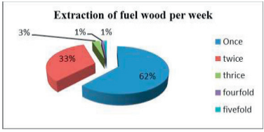

**Figure 5:** Number of extractions per week per family.

When you can’t remove the wood for various reasons, including the rainy season, the population is forced to buy the fuel wood to an average cost of approximately $8 dollars for weekly consumption. This represents a high cost in the case of households receiving weekly approximately $48 dollars.

Consumption of fuel wood could be reduced by 30% if cooked daily, at least to medium day, because every family in the community eats three times a day. After diagnosis of fuel wood, based on indicators: number of persons per household, timber resource consumption, resource extraction and timber purchasing, selection was made from 75 families benefited with one solar cooker. For the construction 75 of the devices were trained 5 people in the community. Moreover, to achieve the transfer and appropriation of technology, is considered perform a training to beneficiaries on solar cookers. In a bilingual form to the beneficiaries were taught a workshop on the use, maintenance and construction of solar cookers. Simultaneously with the workshop training was developed a bilingual manual to achieve transfer and appropriation these solar thermal technologies in more places. It is expected the book to be translated into more indigenous languages and implementation project to be replicated in different latitudes, in rural and urban areas, with the aim of generating profits in the quality of life of people

The evaluation based on interviews with beneficiaries, showed that 85% of the beneficiaries have used the solar cooker, while only 15% not used for various reasons among which are: change of address and family separation. The results of the first monitoring are not so bad, because it sees the acceptance and appropriation of this new solar thermal technology is good. The 85% of users of solar cookers, said that the timing with which they use solar cooking more often is in April and May, spring in Mexico. The use for solar cooker has been varied, from the cooking of vegetables, peppers, tomatoes, chicken, until water heating reflected part of the acceptance of the new eco-technology. Moreover, the beneficiaries expressed interest in receiving a second solar cookers training, in order to optimize its use, as well as the interest of having a tabulator cooking of the solar cooking. Among the improvements suggested in the view of users, expressed interest in to use solar cookers to fry foods and warming tortillas. Due that the CSR-1 is designed to achieve the cooking the food and not can fry.

1. **CONCLUSION**

Solar cookers have been an alternative that generates benefits in rural communities. It takes more research in order to accelerate and encourage the transfer and appropriation of new technologies in indigenous areas. However, the willingness of the population to insert new eco-technologies to their everyday lifestyle is great. The fuel wood saving locally representing the use of solar cookers is significant, therefore, very beneficial for the care of the environment. Also, the benefit economic and public health, are proof that the use of alternative sources of energy generates sustainable projects for the benefit of the poor people, and encourage ways of good living in rural areas and indigenous

.

1. **REFERENCES**

[1] S. Senthilkumar, K. Perumal, & P.S. Srinivasan. Optical and thermal performance of a threedimensional compound parabolic concentrator for spherical absorber.Sadhana, Vol. 34 (3) (2009) pp 369- 380.

[2] Rincón Mejía, E. A. Cocinas solares, a la vanguardia en México. Revista Solar, 2008, Consejo XIV, year 27, Núm. 65, (2008), págs. 2-10.

[3] L.B. López Sosa, D. González Pérez, D., A. López Villa & M. González-Avilés. Diseño, construcción e implementación de la cocina solar Jorhejpataranskua. Memories of the 36th National Solar Energy Week. ANES. 2012. Energía Sostenible para todos. ISBN: 978-607-95019-5-2, (2012) pp 466-470.

[4] M. Gonzalez-Aviles, H. Servin Campuzano, L.B. Lopez Sosa, D. Gonzalez Perez & D.J. Perez Cordova. Memories of the XVIII Congreso Internacional Anual de la Sociedad Mexicana de Ingenieria Mecanica (SOMIM), ISBN 978-607-95309-6-9, (2012) pp 1321-132.

[5] H. Servín Campuzano, M. González-Avilés, L.B. López Sosa, D.J. Pérez Córdova. Estimación de la potencia de cocción de la estufa solar Jorhejpataranskua. Memories of the 36th National Solar Energy Week. ANES. Cuernavaca. Energía Sostenible para todos. ISBN: 978-607-95019-5-2, (2012) pp 472-475.

[6] L. B, López Sosa & M. Gonzalez-Aviles. Memories in extense of the Primer Congreso Sustentabilidad e interculturalidad: paradigmas entre la relación cultura y naturaleza (2013) en prensa.

[7] ASAE S580, Testing and Resporting Solar Cooker Performance. American Society of Agricultural Engineers, ASAES580 JAN03, (2003) 824-826

[8] Funk, P. Evaluating the International Standard Procedure for Testing Solar Cookers and Reporting Performances, Solar Energy Vol. 68, N◦ 1, (2000), págs 1-7.