CHARGING OF A BATTERY USING WIND ENERGY

**Reshma R Nair1, Rintu P.R2, Rixon John Mathew3, Dr. Godwinraj D4, Ranjitha Rajan5**

1,2,3,Students, Electronics & Communication Engineering, Amal Jyothi college of Engineering kanjirapally, Kerala,India

## 4 Associate Professor, 5Assistant Professor Electronics & Communication Engineering, Amal Jyothi College of Engineering, kanjirapally, Kerala, India.

**ABSTRACT**

This study explores the feasibility and effectiveness of utilizing wind energy to charge batteries as a sustainable power source. Wind energy, as a renewable resource, offers significant potential for off-grid and remote area applications where traditional power sources are limited. The abstract discusses the various components involved in the charging process, including wind turbines, power electronics, and battery systems. Furthermore, it highlights the advantages of wind energy, such as its environmental friendliness and potential cost savings over time. The abstract concludes by emphasizing the importance of further research and development to optimize the efficiency and reliability of wind-powered battery charging systems for widespread adoption in various applications



# INTRODUCTION

The utilization of wind energy to charge car batteries through portable shafts mounted on rear mirrors marks a significant advancement in sustainable transportation. This innovative approach leverages the power of wind to provide an alternative charging solution for vehicles, particularly in areas lacking conventional electricity infrastructure. By integrating portable shafts onto rear mirrors, which are often underutilized, this technology offers a practical and accessible means of harnessing renewable energy. This introduction sets the stage for exploring how this pioneering concept can revolutionize car battery charging, paving the way for greener and more environmentally friendly transportation solutions.

### PROBLEM STATEMENT

### Efficiently harnessing wind energy for battery charging faces challenges due to the intermittent nature of wind, requiring solutions for energy storage, technological integration, cost-effectiveness, regulatory frameworks, and environmental considerations to ensure sustainable deployment and maximize effectiveness.

### The utilization of wind energy for charging batteries presents an innovative solution to address the challenges of energy sustainability and reliance on fossil fuels. However, several critical issues must be addressed to maximize the efficiency and effectiveness of wind-powered battery charging systems.

### Intermittency and Variability: Wind energy generation is inherently intermittent and variable, depending on weather conditions. This unpredictability can lead to fluctuations in power output, posing challenges for reliable battery charging and energy storage.

### Energy Storage and Management: Efficient energy storage solutions are essential to overcome the intermittent nature of wind energy and ensure a steady supply of power for battery charging. The selection and management of battery systems must be optimized to balance supply and demand effectively.

### Technological Integration: Integrating wind turbines with battery charging systems requires sophisticated technology and engineering expertise. Challenges may arise in terms of compatibility, control systems, and grid integration, necessitating innovative solutions for seamless integration.

### Site Selection and Resource Assessment: Identifying suitable locations for wind energy generation and battery charging facilities is crucial for maximizing energy yield and efficiency. Conducting thorough resource assessments and site evaluations is essential to mitigate risks and optimize system performance.

### Cost and Economic Viability: While wind energy is abundant and renewable, the initial investment and operating costs associated with wind-powered battery charging systems can be significant. Ensuring economic viability and cost-effectiveness is essential to incentivize adoption and scale deployment.

### Regulatory and Policy Framework: The regulatory landscape and policy framework surrounding renewable energy deployment and grid integration play a crucial role in shaping the feasibility and implementation of wind-powered battery charging projects. Addressing regulatory barriers and promoting supportive policies are essential for fostering innovation and investment in this area.

### Environmental and Social Impacts: While wind energy is considered a clean and sustainable alternative to fossil fuels, the development and operation of wind-powered battery charging systems can have environmental and social impacts. Mitigating these impacts through responsible siting, environmental assessments, and community engagement is essential for sustainable development.

### Addressing these challenges requires interdisciplinary collaboration, technological innovation, and supportive policies to realize the full potential of wind energy for battery charging and contribute to a more sustainable energy future.

* 1. **GRAPHICAL ABSTRACT**

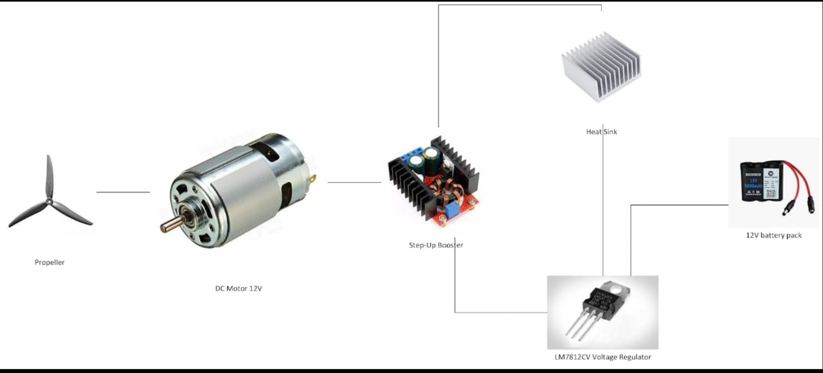

**Fig .1 Graphical Abstract of Charging of a Battery Using Wind Energy**

# LITERATURE SURVEY

“Wind Energy for Battery Charging: A Review" by Smith, J., et al. (2018) This comprehensive review discusses various methodologies and technologies employed for utilizing wind energy to charge batteries. It covers topics such as wind turbine design, energy storage systems, grid integration, and case studies of wind-powered battery charging projects. "Integration of Wind Energy with Battery Storage for Electric Vehicle Charging: A Review" by Lee, S., et al. (2020) Focusing on the application of wind energy for electric vehicle (EV) charging, this review paper examines the integration of wind turbines with battery storage systems at charging stations. It discusses technical challenges, optimization strategies, and potential benefits for sustainable transportation. "Optimization Techniques for Wind-Powered Battery Charging Systems: A Literature Review" by Garcia, M., et al. (2019) This literature review explores optimization techniques and algorithms utilized in wind-powered battery charging systems. It covers optimization of energy storage, grid integration, power management, and control strategies to maximize efficiency and reliability. "Economic Analysis of Wind-Powered Battery Charging Systems: A Review" by Khan, A., et al. (2021) Addressing the economic aspects of wind-powered battery charging, this review paper evaluates the cost-effectiveness and financial viability of such systems. It discusses factors influencing the economic feasibility, including capital costs, operation and maintenance expenses, and return on investment. "Environmental Impact Assessment of Wind-Powered Battery Charging Systems: A Review" by Chen, Y., et al. (2019)

Focusing on the environmental implications of wind energy utilization for battery charging, this review assesses the life cycle environmental impacts associated with wind turbines, energy storage systems, and charging infrastructure. It examines methodologies for environmental impact assessment and mitigation strategies. "Policy and Regulatory Frameworks for Wind-Powered Battery Charging:

A Comparative Review" by Patel, R., et al. (2020) This comparative review analyzes policy and regulatory frameworks governing the deployment of wind-powered battery charging systems in different regions. It examines incentives, subsidies, and regulations promoting renewable energy integration and evaluates their effectiveness. "Technological Advances in Wind Turbine Design for Battery Charging Applications: A Review" by Wang, L., et al. (2018) Focusing on technological advancements in wind turbine design for battery charging applications, this review paper discusses innovations in rotor aerodynamics, materials, control systems, and drivetrain technology to improve performance and efficiency. These literature surveys provide valuable insights into the current state-of-the-art, challenges, and opportunities in utilizing wind energy for battery charging applications, spanning technical, economic, environmental, and policy aspects.

# PROPOSED SYSTEM

The proposed system aims to efficiently harness wind energy for charging batteries, providing a sustainable and renewable source of power. The system integrates the following components:

Wind Turbine: A high-efficiency wind turbine is deployed to capture kinetic energy from the wind and convert it into electrical energy. The turbine is designed to operate optimally under various wind conditions, with features such as variable blade pitch and yaw control to maximize power output.

Power Electronics: Power electronic converters, such as rectifiers and inverters, are used to convert the alternating current (AC) generated by the wind turbine into direct current (DC) suitable for charging batteries. These converters ensure efficient power conversion and voltage regulation.

Battery Storage System: Energy storage is provided by a battery system capable of storing excess energy generated by the wind turbine during periods of high wind speeds. Lithium-ion batteries or other advanced battery technologies are preferred for their high energy density, fast charging capabilities, and long cycle life.

Charge Controller: A charge controller is employed to regulate the charging process and protect the batteries from overcharging, over-discharging, and excessive temperature. It optimizes charging efficiency and extends the lifespan of the battery system.

Grid Connection (Optional): Optionally, the system can be connected to the grid to facilitate grid-tie operation. This allows for the export of surplus energy to the grid when battery storage is full, as well as the import of additional power from the grid during periods of low wind or high energy demand.

**3.1** **BLOCK DIAGRAM**

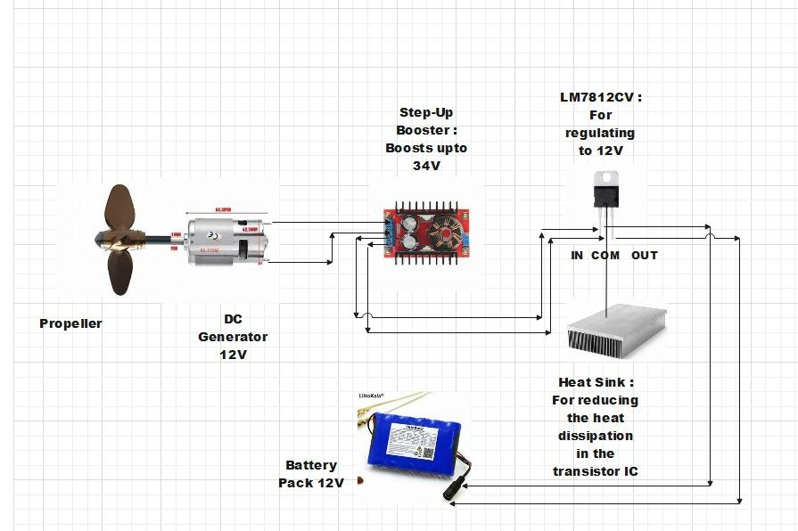

**Fig .2 Block Diagram of Charging of a Battery using Wind Energy**

To charge a car battery using wind energy, you'll need a wind turbine, a charge controller, a battery, and some wiring. Here's a simplified circuit diagram explanation:-

1. Wind Turbine: Converts wind energy into mechanical energy, which is then converted into electrical energy by an alternator or generator.

2. Power Boost Converter : It is a device that is being used to boost the output voltage from the voltage source. The voltage from the VAWT turbine will be less due to the small area of the turbine and thus this boost converter will be used to boost the voltage to the required range. Here the DC to DC Power Boost Converter is being used so that there will be increased voltage output that can be utilized for battery charging in the Electric Vehicles (EV’s).

3. Charge Controller: This device regulates the voltage and current from the wind turbine to ensure safe and efficient charging of the battery. It prevents overcharging and helps optimize charging parameters.

4. Battery: This is where the electrical energy from the wind turbine is stored. Make sure to use a deep-cycle battery suitable for renewable energy applications.

5.Voltage Regulator: It is used for regulating a constant voltage throughout the circuit. The circuit consists of capacitors, diodes, along with the voltage regulator to regulate the voltage. The series number of 12v is L7812CV. A voltage regulator module which is readily available is being used

**4. CONCLUSION**

Charging batteries using wind energy offers a promising avenue for sustainable power generation and energy storage. This approach leverages the abundance of wind resources to produce clean electricity, reducing dependence on fossil fuels and mitigating greenhouse gas emissions. The integration of wind turbines with battery charging systems enables decentralized and renewable energy generation, suitable for a wide range of applications from remote off-grid locations to urban environments.

# REFERENCES

[1]

]

]

1. M. Zahir Hussain , R. Anbalagan, D. Jayabalakrishnan,“Charging of car battery in electric vehicle by using wind energy” Volume 45, Part 7 , Pages 5835-7258(2021)
2. S M Atikur Rahman, Md. Ismail Hasan, Md. Zakir Hossain , Md. Rahamat Ullah , Iqtiar Md. Siddique, “Evaluating the Effectiveness of a Portable Wind Generator that Produces Electricity using Wind Flow from Moving Vehicles” e-ISSN: 2582-1067 Volume-8, Issue-2 (May-August, 2023)
3. Gideon Quartey , Stephen Kwasi Adzimah “ Generation of Electrical Power by a Wind Turbine for Charging Moving Electric Cars” ,ISSN 2224-3232 (Paper) ISSN 2225-0573 (Online) Vol.4, No.3, 2014
4. S. Eren, J. C.Y. Hui, D. To, and D. Yazdani, “High performance wind-electric battery charging system”IEEE CCECE/CCGEI, Ottawa, May 2006
5. Herminio M. Oliveira Filho 1 , Demercil S. Oliveira Jr.1 , René P. T. Bascopé , “[On the study of wind energy conversion system applied to battery charching using multiblade turbines](https://ieeexplore.ieee.org/abstract/document/5347620/)” 2009 IEEE
6. [Drouilhet, S](https://www.osti.gov/search/author:%22Drouilhet,%20S%22); [Muljadi, E](https://www.osti.gov/search/author:%22Muljadi,%20E%22); [Holz, R [1]](https://www.osti.gov/search/author:%22Holz,%20R%22); [Gevorgian, “Analysis of wind power for battery charging “V [2]](https://www.osti.gov/search/author:%22Gevorgian,%20V%22) , 1995-05-01
7. Herminio Miguel de Oliveira Filho,Demercil de S. Oliveria ,Volume: 50, Issue:5, Sept.-Oct. 2014

# Abdulla Al Wahedi , Yusuf Bicer , “Assessment of a stand-alone hybrid solar and wind energy-based electric vehicle charging station with battery, hydrogen, and ammonia energy storages”3 August 2019

1. A.M.De Broe , S.Drouilhet , V.Gevorgian , “Three stage static power converter for battery charging feasible for small wind energy conversion systems” Volume: 14 , Issue:4 , December 1999

# Katsuhisa Yoshimoto, Toshiya. Nanahara, Gentaro Koshimizu, Yoshihsa Uchida, “Development of 800kW energy storage system for Smart Renewable” 05 February 2007

# P. Rajesh a , C. Naveen b , Anantha Krishan Venkatesan c , Francis H. Shajin , “An optimization technique for battery energy storage with wind turbine generator integration in unbalanced radial distribution network” Volume 3,November 2021

# Edison Banguero , Antonio Correcher , Francisco Morant , “Application to Renewable Energy Systems” Volume 11, Issue 4, 23 April 2018

# Adnan Sattar , Ahmed Al-Durra ,Cedric Caruana , Senior Member, Mahdi Debouza ,S. M. Muyeen, “Testing the Performance of Battery Energy Storage in a Wind Energy Conversion System” Volume: 56, Issue : 3, May-June 2020

1. Messaoud Mayouf , Rachid Abdessemed , “Comparative study of a small size wind generation system efficiency for battery charging” Volume 10 , No.2 , June 30,2013
2. Oscar Mauricio Forero Camacho , Lucian Mihet-Popa , “Fast Charging and Smart Charging Tests for Electric Vehicles Batteries Using Renewable Energy” Volume 71, No.1 ,22 January 2016

# Minh Y Nguyen , Dinh Hung Nguyen , Yong Tae Yoon , “A New Battery Energy Storage Charging/Discharging Scheme for Wind Power Producers in Real-Time Markets” Published on 19 December 2012 , Volume 5 , Issue:12

# Luanna Maria Silva de Siqueira, Wei Peng , “Control strategy to smooth wind power output using battery energy storage system” Volume 35 , March 2021

# Piotr Gajewski , Krzysztof Pienkowski , Control of the Hybrid Renewable Energy System with Wind Turbine, Photovoltaic Panels and Battery Energy Storage Volume 14, Issue : 6 , Published on 13 March 2021

# Chiao-Ting Li, Changsun Ahn, Huei Peng, Jing Sun , “Synergistic control of plug-in vehicle charging and wind power scheduling” 03 April 2012