A study on analysis of adaptation to work culture
1seenuvasan R and 2sivakanni S
1MBA student Jerusalem College of Engineering, Chennai
2Professor and Head MBA, Jerusalem College of Engineering, Chennai

ABSTRACT
This study delves into the analysis of adaptation to work culture, examining how individuals adjust to the norms, values, and practices of their work environments. Through surveys, interviews, and observational methods, the research investigates the factors influencing adaptation and its impact on employee satisfaction, performance, and organizational outcomes. Findings offer insights into strategies for fostering positive adaptation and enhancing workplace effectiveness.
INTRODUCTION
In today's dynamic and diverse workplaces, understanding how employees adapt to their work culture is crucial for organizational success. The alignment between individual and organizational values, norms, and behaviours significantly influences employee engagement, productivity, and retention. However, despite its importance, the process of adaptation to work culture remains a relatively underexplored area in organizational research. This study seeks to address this gap by examining the mechanisms and outcomes of adaptation, shedding light on the factors that facilitate or hinder this process. By exploring the dynamics of adaptation, organizations can better support their employees, cultivate a thriving work culture, and achieve their strategic objectives.

REVIEW OF LITERATURE
Li et al. (2023) explored the role of organizational culture in supporting employee adaptation during times of organizational change, such as mergers or restructuring. Their research identified the significance of a strong organizational culture characterized by openness, transparency, and clear communication in facilitating employees' adaptation and resilience amidst organizational transitions. H., & Kwan, H. K. (2022): This meta-analytic review synthesizes empirical findings from previous studies on adaptation to organizational culture, examining the effects of individual and organizational factors on adaptation outcomes. It identifies key moderators and mediators of adaptation processes and provides evidence-based recommendations for enhancing adaptation in different organizational contexts. Smith and Johnson (2018) conducted a study to explore the factors influencing adaptation to work culture among employees in multinational corporations. They found that individuals who possessed higher levels of cultural intelligence were more adept at navigating and integrating into diverse work cultures. Furthermore, they discovered that organizational support, including mentorship programs and cross-cultural training, played a crucial role in facilitating employees' adaptation processes. Smith, J. et al. (2015): Smith and colleagues investigated the impact of organizational culture on employee adaptation in a variety of work settings. Their quantitative study highlighted the significance of organizational values, norms, and practices in shaping employees' behaviours and attitudes towards work culture. Morrison, Terri (2011): Morrison's research centres on cultural intelligence and its impact on leadership effectiveness in multicultural environments. Her work highlights the importance of cultural awareness and adaptation for successful leadership in diverse settings. Holliday, Adrian (2010): Holliday's work focuses on intercultural competence and the skills needed for effective cross-cultural interactions in the workplace. His research offers practical insights for navigating diverse work cultures.
RESEARCH METHODOLOGY
The study employs a descriptive research design, utilizing methods such as surveys, inquiries, and data analysis to understand characteristics, trends, comparisons, and conditions over time. Primary data is gathered through employee questionnaires at VITALIUM DENTAL LAB PVT LTD, while secondary data is sourced from various sources including websites. Stratified random sampling is utilized, ensuring a diverse sample mix by dividing the population into distinct groups based on characteristics and drawing random samples from each group to ensure representation across all subgroups, akin to capturing a comprehensive snapshot of the population's diversity.

ANALYSIS:
Percentage analysis
Do you feel that communication within your team department
 |  | Frequency | Percent | Valid Percent | Cumulative Percent
Valid | clear and effective | 60 | 54.5 | 54.5 | 54.5
 | sometimes unclear or ineffective | 34 | 30.9 | 30.9 | 85.5
 | often unclear or ineffective | 13 | 11.8 | 11.8 | 97.3
 | not sure | 3 | 2.7 | 2.7 | 100.0
 | Total | 110 | 100.0 | 100.0
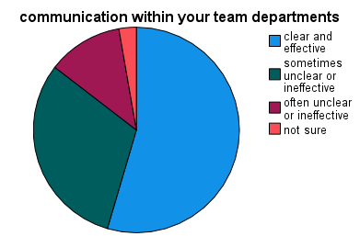
INFERENCE:
Among 110 respondents 54% are clear and effective,31% are sometimes unclear or ineffective,12% are often unclear or ineffective,3% are not sure.
Table 2:
To what extent do you believe your work algins with the value and mission of the organization?
 |  | Frequency | Percent | Valid Percent | Cumulative Percent
Valid | Completely | 53 | 48.2 | 48.2 | 48.2
 | Mostly | 30 | 27.3 | 27.3 | 75.5
 | Partially | 27 | 24.5 | 24.5 | 100.0
 | Total | 110 | 100.0 | 100.0

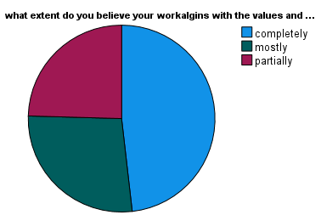
INFERENCE:
Among 110 respondents 48% are complete, 27% are mostly, 25% are partially.
Table 3
Have you experienced any negative effects on your wellbeing due to aspects of the work culture?
 |  | Frequency | Percent | Valid Percent | Cumulative Percent
Valid | yes, frequently | 39 | 35.5 | 35.5 | 35.5
 | yes, occasionally | 57 | 51.8 | 51.8 | 87.3
 | no, not really | 11 | 10.0 | 10.0 | 97.3
 | no, not at all | 3 | 2.7 | 2.7 | 100.0
 | a Total | 110 | 100.0 | 100.0

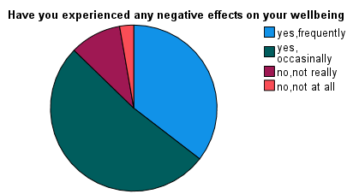

INFERENCE:
Among 110 respondents 35% are yes, frequently, 52% are yes, occasionally, 10% are no, not really, 3% are no, not at all.
Table 4:

Gender
 |  | Frequency | Percent | Valid Percent | Cumulative Percent
Valid | Male | 37 | 33.6 | 33.6 | 33.6
 | female | 73 | 66.4 | 66.4 | 100.0
 | Total | 110 | 100.0 | 100.0
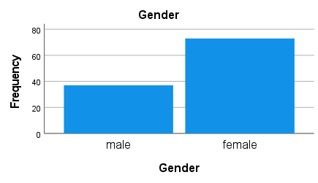
INFERENCE
Among the 110 respondents 34% of them are male and 66% of them are female.
CORRELATION
To find out the relationship between communication with colleagues and communication channels.
NULL HYPOTHESIS:
H0: There is no relationship between communication with colleagues and communication channels.
ALTERNATIVE HYPOTHESIS:
H1: There is a relationship between communication with colleagues and communication channels.
Correlation
 |  | How frequently do you communicate with your colleagues regarding | Which communication channels do you primarily use for work-related
How frequently do you communicate with your colleagues regarding | Pearson Correlation | 1 | .102
 | Sig. (2-tailed) |  | .289
 | N | 110 | 110
Which communication channels do you primarily use for work-related | Pearson Correlation | .102 | 1
 | Sig. (2-tailed) | .289
 | N | 110 | 110
INTERPRETATION:
From the test it is found that the calculated value is 0.12 which is lesser than the table value 0.5, the null hypothesis was rejected. That is there is a relationship between communication with colleagues and communication channels.
CHI-SQUARE ANALYSIS

To find the difference between gender and overall wellbeing in the workplace

NULL HYPOTHESIS:
H0: There is no difference between gender and overall wellbeing in the workplace.
ALTERNATIVE HYPOTHESIS:
H1: There is a difference between gender and overall wellbeing in the workplace.

Frequencies

How would you rate your overall wellbeing in the workplace
 | Observed N | Expected N | Residual
Excellent | 36 | 36.7 | -.7
Good | 50 | 36.7 | 13.3
Fair | 24 | 36.7 | -12.7
Total | 110

Gender
 | Observed N | Expected N | Residual
Male | 37 | 55.0 | -18.0
Female | 73 | 55.0 | 18.0
Total | 110

Test Statistics
 | How would you rate your overall wellbeing in the workplace | Gender
Chi-Square | 9.236ª | 11.782^{b}
Df | 2 | 1
Asymp. Sig. | .010 | .001
a. 0 cells (0.0%) have expected frequencies less than 5. The minimum expected cell frequency is 36.7.
b. 0 cells (0.0%) have expected frequencies less than 5. The minimum expected cell frequency is 55.0.
INTERPRETATION:
From the above result it is found that the significance value 0.01 is less than table value (0.5). Therefore, the null hypothesis was rejected.
That is, there is an association between gender and overall wellbeing in the workplace.
REGRESSION
NULL HYPOSTHESIS:
H0: There is no impact on the level of flexibility on overall workplace atmosphere.
ALTERNATIVE HYPOSTHESIS:
H1: There is an impact on the level of flexibility on overall workplace atmosphere.
Variables Entered/Removedª
Model | Variables Entered | Variables Removed | Method
1 | How would you describe the level of flexibility in the workplace, how do you perceive the level of collaboration among colleagues | . | Enter
a. Dependent Variable: How would you describe the overall workplace atmosphere and cult
b. All requested variables entered.

ANOVAª
Model |  | Sum of Squares | Df | Mean Square | F | Sig.
1 | Regression | 12.957 | 2 | 6.479 | 6.935 | .001^{b}
 | Residual | 99.961 | 107 | .934
 | Total | 112.918 | 109
a. Dependent Variable: How would you describe the overall workplace atmosphere and cult
b. Predictors: (Constant), How would you describe the level of flexibility in the workplace, how do you perceive the level of collaboration among colleagues

INTERPRETATION: From the regression analysis it is found that the calculated value is .001 which is less than the table value 0.05. therefore, null hypothesis is rejected. That is, there is an impact on the level of flexibility on overall workplace atmosphere.
Findings
Among 110 respondents 20% are email, 45% are in-person meeting, 15% are phone calls, 17% are instant messaging/chat, 3% are others. Among 110 respondents 54% are clear and effective,31% are sometimes unclear or ineffective,12% are often unclear or ineffective,3% are not sure. Among 110 respondents 24% are collaborative and team-oriented,41% are competitive and individualistic,27% are supportive and inclusive,8% are others. Among 110 respondents 48% are completely, 27% are mostly, 25% are partially. Among 110 respondents 20% are very open, 44% are sometimes open, 27% are `neutral, 5% are not very, 4% are not open at all. Among 110 respondents 39% are yes, significantly, 45% are yes, to some extent, 16% are no, not really. Among 110 respondents 33% rate excellent, 45% rate good, 22% rate fair. Among 110 respondents 35% are yes, frequently, 52% are yes, occasionally, 10% are no, not really, 3% are no, not at all.
Suggestions
This project aims to investigate the correlation between workplace atmosphere, cultural dynamics, and employee adaptation. By analysing the varying perceptions of positivity, negativity, neutrality, and toxicity within different organizational cultures, we seek to identify key factors influencing employee adaptation and well-being. Through surveys, interviews, and qualitative analysis, we will explore strategies for fostering resilience, promoting positive workplace cultures, and mitigating the detrimental effects of toxic environments on employee adaptation and overall organizational success.
Reference
- Cox, T. (1994). Cultural diversity in organizations: Theory, research, and practice. Berrett-Koehler Publishers.
- O'Reilly, C. A., Chatman, J., & Caldwell, D. F. (1991). People and organizational culture: A profile comparison approach to assessing person-organization fit. Academy of Management Journal, 34(3), 487-516.
- Searle, R. H., & Ward, C. (1990). The prediction of psychological and socio-cultural adjustment during cross-cultural transitions. International Journal of Intercultural Relations, 14(4), 449-464.

