***Harmonizing Sustainable Transportation: A Comprehensive Hybrid Vehicle Integrating CNG, In-Wheel Motors, and Rooftop Solar Panels for Environmental Excellence.***

***MURI VENKATESWARA KARTHIK \****

***Undergraduate at Gayatri Vidya Parishad College of Engineering pursuing Mechanical Engineering, Visakhapatnam-530048, India.***

*\*Corresponding author Email: mvkt.research@gmail.com*

***Abstract:***

*This research paper presents a novel approach to sustainable transportation by proposing a hybrid vehicle that integrates a compressed natural gas (CNG) engine with a battery-powered plug-in electric vehicle (BEV). The hybrid system incorporates in-wheel motors for enhanced efficiency and maneuverability, coupled with a rooftop solar panel system to supplement energy supply. The integration of CNG and electric power addresses range anxiety associated with electric vehicles, reduces emissions, and promotes cleaner air quality. In-wheel motors optimize torque control and regenerative braking, while the rooftop solar panels extend the vehicle's driving range, reducing dependence on the grid. This comprehensive approach offers a promising solution for sustainable transportation, aligning with environmental goals and advancing clean energy technologies in the automotive sector.*

***Keywords:*** *Sustainable transportation, Hybrid vehicle, Compressed natural gas (CNG), Plug-in electric vehicle (BEV), In-wheel motors, Rooftop solar panels, Range anxiety, Emissions reduction, Clean energy technologies, Environmental sustainability, Electric propulsion, Regenerative braking, Traction battery pack, Bi-directional inverter, DC-DC converter, Renewable energy integration, Technological advancements, Comprehensive sustainability, Vehicle efficiency, Automotive industry transformation.*

**1. Literature Survey:**

*The literature survey spanning across* ***[1],[2],[3],[4],[5]*** *reveals a significant body of research addressing the pressing issues of fuel economy, emissions reduction, and sustainable transportation.* ***[1]*** *highlights the importance of hybrid electric vehicles (HEVs) in enhancing fuel efficiency and reducing emissions, emphasizing the challenges in developing control strategies that balance conflicting constraints.* ***[2]*** *underscores the need for alternative fuels and evaluates various options, aligning with the environmental goals crucial for sustainable transportation. Building on this foundation,* ***[3]*** *contributes to the discourse by exploring the advancements in energy management for HEVs, recognizing the complexities in optimizing power sources. In* ***[4]****, a detailed review of HEV control strategies, configurations, and modeling techniques is presented, offering valuable insights into the current state of research in the field.* ***[5]*** *assesses alternative transportation options, advocating for a portfolio of fuels and technologies to achieve societal goals, reinforcing the importance of comprehensive approaches. Finally this paper introduces a groundbreaking concept of a hybrid vehicle integrating a compressed natural gas (CNG) engine with a battery-powered plug-in electric vehicle (BEV), supported by in-wheel motors and rooftop solar panels. This innovative approach, combining various technologies to address range anxiety and reduce emissions, aligns seamlessly with the overarching themes found in the literature survey, providing a promising solution for sustainable transportation.*

**2. Introduction:**

*The evolving landscape of the automotive industry reflects an urgent need for sustainable transportation solutions, prompted by environmental concerns and the finite nature of traditional fossil fuels. This research paper endeavors to contribute to this paradigm shift by introducing a novel concept: a hybrid vehicle integrating a compressed natural gas (CNG) engine with a battery-powered plug-in electric vehicle (BEV), leveraging the advantages of in-wheel motors and rooftop solar panels.*

*The fusion of CNG and electric propulsion systems presents a synergistic approach, strategically addressing the limitations of each technology. The CNG engine acts as a pivotal range extender, alleviating the ubiquitous issue of range anxiety in electric vehicles while significantly reducing emissions compared to conventional gasoline engines. Concurrently, the integration of in-wheel motors revolutionizes vehicle efficiency and maneuverability by eliminating traditional drivetrain components, enabling precise torque control and regenerative braking.*

*Central to the research is the incorporation of rooftop solar panels, providing a sustainable and supplementary energy source. Harnessing renewable solar energy diminishes the vehicle's reliance on grid electricity, extending its driving range while minimizing its carbon footprint. This holistic integration of CNG propulsion, electric power, in-wheel motors, and solar energy epitomizes a comprehensive approach to sustainable transportation, advancing the automotive sector's adoption of clean and renewable technologies.*

*In exploring this innovative hybrid vehicle platform, the paper delves into key components such as in-wheel motors, bi-directional inverters, and DC-DC converters, elucidating their functions and impact on the vehicle's performance. The discussion extends to the operational dynamics of the hybrid system, detailing the power flow during electric and engine modes, and emphasizing the vehicle's adaptability to diverse driving conditions.*

*Furthermore, the research paper highlights the synergies achieved through the integration of CNG and electric power, the efficiency gains facilitated by in-wheel motors, and the environmental benefits derived from the rooftop solar panel system. By presenting a comprehensive approach to sustainability, the paper contributes to the ongoing discourse on cleaner and more efficient transportation.*

*In conclusion, this research paper underscores the viability and benefits of a hybrid vehicle that seamlessly integrates CNG and electric technologies with in-wheel motors and rooftop solar panels. The proposed platform not only addresses current environmental challenges but also anticipates future advancements in sustainable transportation. As the automotive industry navigates towards a greener future, this research positions itself at the forefront of transformative change, advocating for a holistic approach that harmonizes cutting-edge technologies for a more sustainable and efficient tomorrow.*

**3. Diagram Representing Plug In Hybrid Electric Vehicle Technology:**

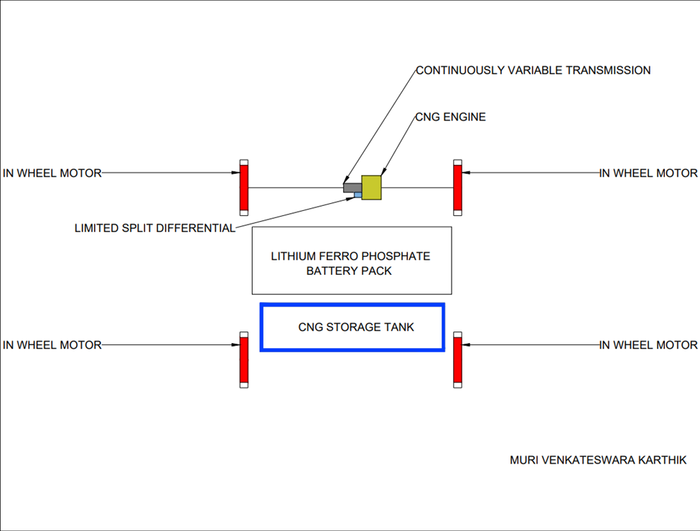

**4.Main Components of Plug In Hybrid Electric Vehicle:**

* ***Motor****- Brushless Direct Current Motor mounted in wheel. This type of motor is referred to as In-Wheel Motor. Total four in-wheel motors are used. Each wheel consists of an in-wheel motor.*
* ***Transmission****- Continuously Variable Transmission*
* ***Differential****- Limited Slip Differential*
* ***Steering****- Electric Power Steering*
* ***Engine****- Four Stroke Four Cylinder Compressed Natural Gas Engine*
* ***Battery****- Lithium Ferro Phosphate*
* ***Inverter****- Bi-Directional Inverter*
* ***Controller****- Bi-Directional Controller*
* ***DC-DC Converter***
* ***Rooftop Solar Panel(s)***
* ***Fuel Tank***
* ***Charge Port***
* ***Charger***

**5.Description of Several Key Components:**

* ***In-Wheel Motor:***

***Definition:***

*An In-Wheel motor, also known as a hub motor, is an electric motor seamlessly integrated into the wheel hub of a vehicle, commonly found in electric or hybrid vehicles.*

***Advantages:***

*- Space Efficiency: Eliminates the need for a separate drivetrain, saving space and providing design flexibility.*

*- Improved Handling and Stability: Optimizes weight distribution, enhancing traction, cornering, and overall stability.*

*- Regenerative Braking: Facilitates efficient conversion of kinetic energy into electrical energy, enhancing efficiency and driving range.*

*- All-Wheel Drive Capability: Enables precise traction control and advanced all-wheel-drive systems without complex linkages.*

*- Reduction in Energy Losses: Direct power delivery to wheels minimizes energy losses associated with traditional drivetrains.*

***Disadvantages:***

*- Unsprung Weight: Increases unsprung weight, impacting ride comfort and handling, especially on rough terrain.*

*- Complexity and Maintenance: Adds complexity to design and maintenance, requiring specialized components and potentially more challenging servicing.*

*- Heat Dissipation: Faces challenges in heat dissipation, potentially affecting performance and reliability.*

*- Cost: Can be more expensive to manufacture and integrate, contributing to the overall vehicle cost.*

*- Limited Compatibility: Retrofitting existing vehicles may pose challenges due to compatibility issues.*

* ***Bi-Directional Inverter:***

***Function:***

*The primary role of the inverter is to convert DC power from the traction battery into AC power for the electric motor. Additionally, it reverses this process during regenerative braking, converting AC back to DC to recharge the battery.*

***Efficiency and Performance:***

*Inverters are crucial for optimizing EV powertrain efficiency. High-efficiency inverters minimize energy losses during power conversion, maximizing driving range and battery life.*

* ***Bi-Directional Controller:***

***A Bi-Directional Controller:***

*Alters the frequency of AC power received from the inverter and directs it to the motor. During regenerative braking, kinetic energy is converted to AC power, regulated by the controller and inverter, and then converted to DC power.*

* ***DC-DC Converter:***

***Function:***

*The DC-DC converter steps down the high-voltage DC output from the traction battery pack to a lower voltage suitable for powering auxiliary systems, such as lights, air conditioning, and infotainment.*

***Efficiency and Performance:***

*High-efficiency DC-DC converters are essential to minimize energy losses, maximizing overall vehicle energy efficiency and optimizing driving range.*

* ***Traction Battery Pack:***

***Definition:***

*The traction battery pack, composed of Lithium Ferro Phosphate cells, stands as a pivotal component in electric and hybrid vehicles, storing electrical energy to power the vehicle's electric motor(s).*

***Functionality:***

*Managed by a battery management system (BMS), the pack's capacity determines the vehicle's range. It boasts versatility in charging methods, including external power supply, regenerative braking, engine mode, where the motors act as generators, and an innovative feature – rooftop solar panel(s). This cutting-edge addition allows the battery to harness solar energy, contributing to sustainability and further enhancing the vehicle's eco-friendly profile.*

*Advancements in the battery pack drive improvements in vehicle performance and range, fostering the adoption of electric transportation.*

**6.Working:**

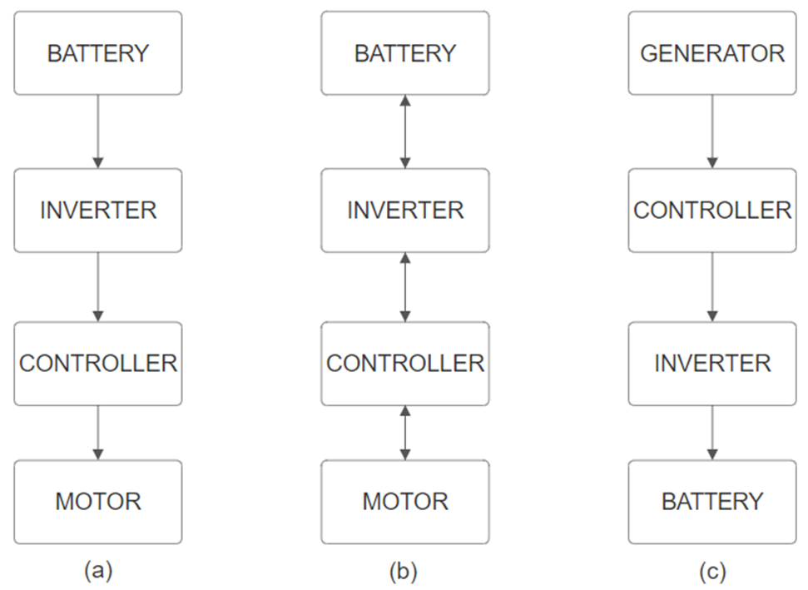

***Diagram (a)*** *shows how the battery powers the motor when the car is in electric mode and not using brakes.*

*In* ***Diagram (b)****, we illustrate how things change during electric mode when you hit the brakes. Here, the motor becomes a generator, sending some power back to the battery in a process called regenerative braking.*

***Diagram (c)*** *simplifies the power transfer when the vehicle runs solely on the engine. Here, the generator sends power to the battery. These diagrams help us understand how power moves around in different driving situations.*

***Electric Mode:***

*When the accelerator pedal is pressed, the battery directs power to the controller, which governs vehicle speed by adjusting the alternating current output from the inverter to the in-wheel motor. During braking, the in-wheel motor transforms into an alternator, capturing kinetic energy to generate electricity through Regenerative Braking. This harvested energy is then redirected to the battery, boosting overall energy efficiency. Traction control is precisely managed by adjusting power distribution among individual in-wheel motors, enhancing stability and performance across diverse road conditions. The rooftop solar panel system actively produces electricity, offering an eco-friendly and supplementary source for charging the traction battery pack, reducing dependence on external power sources and extending the driving range. As a plug-in hybrid electric vehicle (PHEV), the battery can also be recharged using an external power source, providing additional flexibility and convenience for recharging.*

***Engine Mode:***

*During engine-powered operation, the wheel rotation propels the in-wheel motors to function as alternators, generating electrical power. This generated electricity is then used to recharge the traction battery pack, ensuring a continuous power supply. Automatic transition to engine-based propulsion occurs when the traction battery pack reaches full charge, optimizing energy use and seamlessly switching between power sources. The use of Continuously Variable Transmission (CVT) is crucial to the vehicle's design, offering benefits such as lightweight construction, the ability to achieve infinite gear ratios, and smooth operational characteristics. Additionally, its automatic functionality eases the driver's workload, enhancing the overall driving experience and efficiency. Furthermore, the incorporation of Limited Slip Differential improves traction and stability, especially during acceleration and cornering, contributing to the enhanced performance and safety characteristics of the vehicle.*

**7. Results:**

***Synergistic Approach:***

*The integration of a Compressed Natural Gas (CNG) engine with a battery-powered Plug-In Electric Vehicle (BEV) showcases a synergistic approach, harnessing the advantages of both technologies. The CNG engine serves as a range extender, alleviating concerns related to electric vehicle range anxiety, and concurrently delivers lower emissions compared to conventional gasoline engines.*

***Efficiency and Maneuverability:***

*The incorporation of in-wheel motors enhances vehicle efficiency and maneuverability by eliminating the need for traditional drivetrain components. This distributed propulsion system allows for precise torque control and regenerative braking, optimizing energy utilization and improving driving dynamics.*

***Renewable Energy Integration:***

*The addition of a rooftop solar panel system supplements the vehicle's energy supply by tapping into renewable solar energy. This reduces reliance on grid electricity, extending the driving range and contributing to overall sustainability.*

**8. Conclusion:**

***Comprehensive Approach to Sustainability:***

*The proposed hybrid vehicle concept offers a holistic approach to sustainable transportation. By amalgamating advanced technologies, including the CNG engine, electric propulsion, in-wheel motors, and rooftop solar panels, the vehicle mitigates environmental impact, reduces dependence on fossil fuels, and promotes the adoption of renewable energy in the automotive sector.*

***Environmental Benefits:***

*The combination of CNG and electric power results in lower emissions and improved air quality, aligning with environmental sustainability goals. Additionally, the integration of renewable solar energy further enhances the vehicle's eco-friendly profile.*

***Technological Advancements:***

*This research paper underscores the pivotal role of technological advancements in shaping the future of transportation. Leveraging innovations such as in-wheel motors and rooftop solar panels, the proposed hybrid vehicle exemplifies the potential for transformative change in the automotive industry.*

*In summary, this research paper emphasizes the viability and benefits of integrating a CNG engine, electric propulsion, in-wheel motors, and rooftop solar panels into a hybrid vehicle platform. This comprehensive approach provides a promising solution for sustainable transportation, addressing environmental concerns and advancing the adoption of clean energy technologies in the automotive sector.*

**9.References:**

**[1]** Siang Fui Tie, Chee Wei Tan,. A review of energy sources and energy management system in electric vehicles,.Renewable and Sustainable Energy Reviews,.Volume 20 [2013] Pages 82-102,ISSN 1364-0321,<https://doi.org/10.1016/j.rser.2012.11.077>.

**[2]** Hawkins, T.R., Gausen, O.M. & Strømman, A.H. Environmental impacts of hybrid and electric vehicles—a review. *Int J Life Cycle Assess* 17, 997–1014 (2012).<https://doi.org/10.1007/s11367-012-0440-9>

**[3]** M.A. Hannan, F.A. Azidin, A. Mohamed,. Hybrid electric vehicles and their challenges: A review,.Renewable and Sustainable Energy Reviews,.Volume 29[2014]Pages 135-150,ISSN 1364-0321,<https://doi.org/10.1016/j.rser.2013.08.097>.

**[4]** Wisdom Enang, Chris Bannister,. Modelling and control of hybrid electric vehicles (A comprehensive review),.Renewable and Sustainable Energy Reviews,.Volume 74 [2017] Pages 1210-1239, ISSN 1364-0321,<https://doi.org/10.1016/j.rser.2017.01.075>.

**[5]** C.E. Thomas,. Fuel cell and battery electric vehicles compared,.International Journal of Hydrogen Energy,.Volume 34,Issue 15 [2009] Pages 6005-6020, ISSN 0360-3199,<https://doi.org/10.1016/j.ijhydene.2009.06.003>.