**A Study of Bilateral Trade Affiliation Among top economies of Asia (India and United Arab Emirates).**

**Prof M MAnjum Parwej:** Assistant professor in chamali Devi group of Intuitions Indore.

**Dr Sajad Ahmad Mir:** Assistant professor NG at Govt degree college Baramulla.

**Dr Amreen Khan:** Assistant professor in chamali Devi group of Intuitions Indore.

**ABSTRACT**:

The relations between India and United Arab Emirates (UAE) have been marred since their existence as Independent States in 1947. Therefore, the main objective of the proposed study is to describe and analyze the causes, nature, and implications of relations between India and Pakistan in a historical and geo-strategic perspective. It would also explain and evaluate the efforts made for establishing bilateral trade relationship and the out-come of these efforts highlighting the Complexities and Complications of the problem. Ultimately it would attempt to suggest possible solutions to resolve trade problems between both the Countries. These trade problems have put a heavy burden on their economies, and obstructed their social and infrastructural development to a great extent. The question is how long this situation will continue. The volatility of their mutual relations has become all the better.

Keywords: ***India, UAE, Business, MoU. Future planning.***

**INTRODUCTION:**

Despite the fact that the United Arab Emirates (UAE) has one of the largest and most diversified economies in the Gulf region, there exists in the literature virtually no data or research findings relating to the training and development strategies and practices of Emirati companies. The aim of this article is to fill this gap in the literature by providing some basic data about various training and development issues that might be of use to researchers wanting to do comparative work or further research in the UAE. The author attempts to explain the findings of the survey by investigating various elements of the national context such as the national culture, religion, government policy, education and the economic environment. It is intended that the survey results and the subsequent explanations and elaboration will be of use and interest both to researchers and training/development professionals taking up their first position in the UAE, or to the human resource managers within multinational organisations. India and the UAE have been trading partners for several decades. However, a significant shift in the economic relations between the two nations happened post-1990s. India exported several minerals, gems, jewellery, machinery, equipment, and chemicals to UAE and is the third-largest crude petroleum importer.

**INDIA-UAE TRADE**

* India is UAE’s second-largest trading partner accounting for 9% of its total foreign trade and 14% of non-oil exports. Also, the UAE is India’s third biggest trade partner.
* India-UAE trade increased from US$ 180 million per year in the 1970s to US$ 72.8 billion in FY21.
* It is expected that the value of UAE’s non-oil trade with India will increase from the current US$ 60 billion to over US$ 100 billion over the next five years.
* India and UAE bilateral trade worth US$ 84.84 billion during 2022-23. After the USA and China, UAE became India’s third largest trading partner.
* UAE is the 7th largest investor in India with cumulative FDI inflows of US$ 15.57 billion from April 2000-March 2023.
* The UAE is home to 3.5 million Indians (30% of the Emirate’s population). Indians are the largest expatriate community in the UAE, and their remittances are a significant source of foreign earnings.
* Bilateral trade between India and the UAE stood at US$ 43.3 billion in FY21. India exported goods worth US$ 16.7 billion to the Gulf state, while imports aggregated at US$ 26.7 billion during the fiscal.

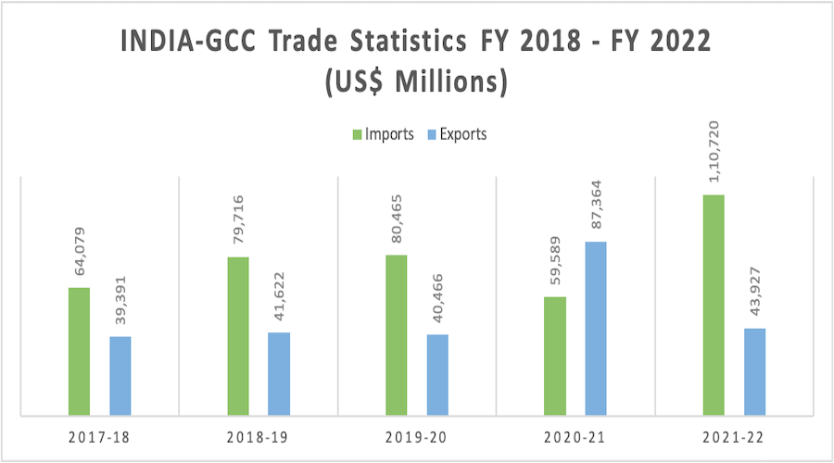

**SCOPE OF THE STUDY:**

In this proposed research work the researcher will try to build the theoretical framework of the Trade relations between India and United Arab Emirates (UAE), to identify and investigate the effectiveness of bilateral talks, and to critically understand the applicable rules, both legal and non-legal. She will also attempt the implementation of the rules and agreements as carried out and what might be its future. The analysis will combine various political economic and social etc aspects of the both the countries. The proposed research work also analyzes the effectiveness and the responsibility of the international community on the Trade relations between India and United Arab Emirates (UAE).Defining the Factors and describing their role in the Trade relations between India and United Arab Emirates (UAE) is another important issue. Hence a discussion of the role of personalities involved will also be included in the work.

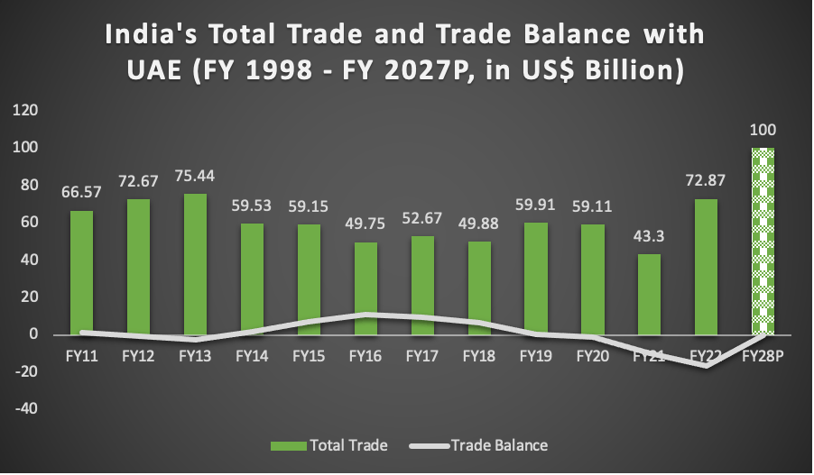

**OBJECTIVES OF STUDY:**

The study is conducted with the following objectives:

* To study India trade relationship with the United Arab Emirates (UAE) during the post liberalization period.
* To examine the socio-economic profile of United Arab Emirates (UAE) and India for growing trade dimensions between the two countries.
* To analyse the structural dimensions of India’s export trade with United Arab Emirates (UAE) during the last ten years and to assess the future growth trends during the coming decade.
* To appraise structural dimensions of India’s import trade with United Arab Emirates (UAE) during last ten years to estimates the future import growth from United Arab Emirates.
* To identify the areas of concern and to suggest suitable measures for promoting India and United Arab Emirates (UAE) trade relationship.

**INDIA AND UAE BUSINESS RELATION:**

India primarily imports mineral oil and fuels from UAE, however also exports natural pearls and precious stones. India and UAE has durable international business relation. India has trade surplus with UAE by 7.4 billion USD in financial year 2017-18. India and the UAE signed a currency pact on Tuesday that allows both the countries to conduct trade in their own currencies by eliminating a third benchmark currency like the U.S Dollars. Now, India will trade in Rupees while UAE in dirham for businesses. Indian External Affairs Minister Sushma Swaraj as part of her two day visit to the middle east held exhaustive discussions with her counterpart Abdullah bin Zayed Al Nahyan to step up cooperation in areas like trade, security and defence and World merchandise trade growth is expected to remain strong in 2018 and 2019 after posting its largest increase in six years in 2017, but continued expansion depends on robust global economic growth and governments pursuing appropriate monetary, fiscal and especially trade policies, as per WTO economists

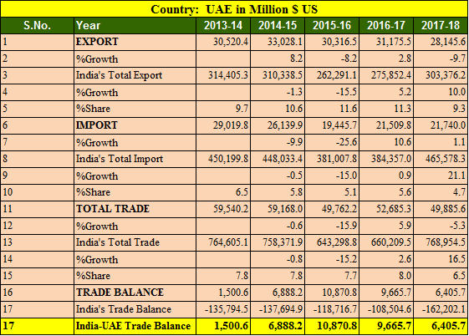

**KEY POINTS OF INDIA UAE TRADE BALANCE IN 5 YEARS**

* Export to UAE decreased by 9.7% in FY 2017-18
* Import from UAE increased by 1.1%
* India’s export to UAE in 5 years is highest in 2014-15 at 33.02 billions USD.
* India’s import from UAE is highest in 2013-14 at 29.01 billions USD.
* Trade balance is in favor of India in tune of 6.40 billions USD.[1]
* India’s total export was highest in 2013-14 at 314 billion USD in last 5 years.
* India’s import from UAE is falling and it has been decreased 30% since 2013-14 due to crude oil pricing

**MAJOR IMPORTED ITEMS BY INDIA FROM UAE WITH AMOUNT & QUANTITY**

* India imported 4,064 commodities from UAE in 2022-23.
* India’s imports to UAE during 2022-23 stood at US$ 53.23 billion.
* Major items imported by India from UAE include petroleum crude (US$ 16.84 billion), petroleum products (US$ 10.20 billion), pearl, precious and semi-precious stones (US$ 10.14 billion), gold (US$ 3.08 billion), aircraft, spacecraft and parts (US$ 1.88 billion), plastic raw materials (US$ 1.66 billion), other precious and base metals (US$ 1.17 billion), etc. during 2022-23.
* Imports from UAE to India were valued at US$ 6.66 billion during April-May 2023-24.
* Major imported items by India from UAE include pearl, precious and semi-precious stones (US$ 1.63 billion), petroleum products (US$ 1.41 billion), petroleum; crude (US$ 1.26 billion), gold (US$ 0.52 billion), plastic raw materials (US$ 0.28 billion), aircraft, spacecraft and parts (US$ 0.26 billion), bulk minerals and ores (US$ 0.16 billion), iron and steel (US$ 0.15 billion), etc. during April-May 2023-24.

**India and UAE have shared trade links through the centuries**.

The trade, which was dominated by traditional items such as dates, pearl and fishes, underwent a sharp change after the discovery of oil in UAE (oil exports begun from Abu Dhabi in 1962).  With the emergence of UAE as a unified entity in 1971, exports from India started growing gradually over the years. The real impetus, however, started after Dubai positioned itself as a regional trading hub by early 1990s and about the same time, the economic liberalization process started in India.

**Growing India-UAE economic and commercial relations contribute** to the stability and strength of a rapidly diversifying and deepening bilateral relationship between the two countries. Both sides are striving to further strengthen these ties for mutual benefits. India-UAE trade, valued at US$ 180 million per annum in the 1970s, is today around US$ 73 billion making UAE, India's third largest trading partner for the year 2021-22 after US and China.  Moreover, UAE is the second largest export destination of India (after US) with an amount of over US$ 28 billion for the year 2021-22.  For UAE, India is the second largest trading partner for the year 2021 with an amount of around US$ 45 billion (non-oil trade).

Both nations have signed Comprehensive Economic Partnership Agreement (CEPA) on 18th February 2022 during the Virtual Summit between Hon’ble Prime Minister Shri Narendra Modi and H.H. President Sheikh Mohamed bin Zayed al Nahyan. The agreement entered into force from 1st May 2022. CEPA will unlock new opportunities in bilateral trade and it is expected to increase the bilateral trade in goods to US$ 100 bn within five years and trade in services to US $ 15 bn.

**CONCLUSION**:

India and the United Arab Emirates enjoy strong bonds of friendship based on age-old cultural, religious and economic ties between the two nations. The ranking of India’s share in world trade 2017 is 14 (imports) and 20 (exports), while UAE rank 17 (imports) and 16 (exports). In the last 67 years, India and United Arab Emirates (UAE) had been able to resolved their trade, bilateral and cultural relationship develop a normal good neighbourly relationship, which could had been betterment people on both sides of the country. Even this is concluded from the research that all objectives of the study or research have been fully achieved.

**REFERENCE**:

* Macroeconomics and Elementary Statistics. FK Publications. ISBN 9788187140900.
* Total Trade".Commerce.nic.in. Department of Commerce. 2015–1. Retrieved 29Jan17.
* India economy and policy 2016-2017.
* # Sardana M Evolution of E-commerce in India part3.2018.
* #TRAI (2017) Highlights of Telecom Subscription data as on 28th Feb
* World trade report
* Times of India.
* www.businessworld.com

1.