**Investigation of Mechanical Strength of AISI 1010 Mild Steel using Tungsten Inert Gas (TIG) Welding**

1Kanhaiya Kumar Choudhary, 2Pawan Kumar Tiwari

1M.Tech Student, Department of Mechanical Engineering,Patel College of Science and Technology, MP,Bhopal,India

2Assistant Professor, Department of Mechanical Engineering,Patel College of Science and Technology, MP,Bhopal,India

**Abstract:**

Tungsten Inert Gas welding is also known as Gas Tungsten Arc Welding (GTAW), is an advance arc welding process become a popular choice when a high level of weld quality or considerable precision welding is required. However, the major problems of TIG welding process are its slow welding speed and limited to lower thickness material in single pass. In this work, autogenous TIG welding has been performed on 5 mm thick AISI 1010 mild steel plate without using any filler material. Wide range of welding current and scan speed has been tested for obtaining a full penetration welding. Activated flux has also been used to improve the weld depth. After performing welding by maintaining different gap between the plates to be welded, weld bead geometry and tensile strength of the weld has been investigated. It is observed that, by maintaining an appropriate gap full penetration welding of plate is possible which gives strength almost similar to base material.

**Keywords** - Tungsten Inert Gas welding, Activated flux, Tensile test, Hardness test and A - TIG welding process.

## 1.1 Introduction

Welding is a process of joining two similar or dissimilar metals by fusion, with or without application of pressure and with or without use of filler metal. Weldability of the material depends upon various factors like the metallurgical changes that occur due to welding, change in hardness of material, in and around the weld and the extent of cracking tendency of the joint. A range of welding processes have been developed so far using single or combination of factors like pressure, heat and filler material used.

### Classification of Welding processes

* + 1. Homogeneous welding
    2. Heterogeneous welding
    3. Autogenous welding

1. Homogeneous welding – Welding of thick plates using filler metal used as per needs according to thickness of plate. The filler material used to provide better strength to the joint. In this process filler material is same as base metal. Different types of homogeneous welding process commonly used are:
   1. Arc welding – Filler material generally used as consumable electrode for manual arc welding and metal inert gas welding.
   2. Gas welding – An external filler rod is required for gas welding.
   3. Plasma arc welding – In case of Plasma arc welding also an external filler rod is necessary for welding.
   4. Thermit welding – In case of thermit welding a molten material from some chemical reaction is added.

In case of homogeneous welding solidification occurs directly by growth mechanism without nucleation stage.

1. Heterogeneous welding – A filler material different from the base material is used for welding. The solidification in heterogeneous weld takes place in two stages *i.e.* nucleation and growth.

Since, Homogeneous and Heterogeneous welding process required external filler material therefore an arrangement for this filler rod feeding (in case of automated system) make the process complex and costly.

1. Autogenous welding – A weld joint can be developed just by melting of edges of plates or sheets. This type of welding used especially if plate thickness is less than 5 mm. No filler is added during autogenous welding. All types of solid phase welding, resistance welding and fusion welding without filler rod corresponding thin category of welding are examples of this category. Following are the some specific advantages of autogenous welding process:

* Suitable for high production rate.
* Heating of the workpiece is confined to very small parts which results in less distortion.
* Possible to weld dissimilar metals as well metal plates of different thickness.
* High speed welding is possible.
* Since no external material is used, the process is very economical.
* Since no filler rod is used, process can be automated easily.

Various types of Autogenous welding process

* 1. Resistance welding – Among these process resistance welding is limited for specific application and not useful for thick plate and complicated shape. Further for welding different thickness plate different diameter electrode is required.
  2. Laser beam welding – Laser Beam Welding process is very expensive process not for small industry.
  3. Electron Beam Welding – Similar to Laser Beam Welding process, Electron Beam Welding process is also very expensive process.
  4. Friction Stir Welding – Friction Stir Welding is mainly limited to low melting temperature and soft material.
  5. Gas welding without filler rod
  6. TIG welding without filler rod

### Tungsten Inert Gas welding

Tungsten Inert Gas welding is also known as Gas tungsten arc welding (GTAW), is an arc welding process that uses a non-consumable tungsten electrode to produce arc. The

welded area is protected from atmospheric contamination by an inert shielding gas (argon or helium), and a filler is normally used to weld thick plate. The electrode is no consumable since its melting point is about 3400oC. In tungsten electrode 1 to 2% thorium and zirconium are added to improve electron emission, arc stability and current carrying capacity. A constant current welding power supply produces energy which is conducted across the arc through a column of highly ionized gas and metal vapors known as plasma. Heat input in GTAW does not depend on the filler material rate. Consequently, the process allows a precise control of heat addiction and the production of superior quality welds, with low distortion and free of spatter.

### Principle of TIG welding

In TIG welding process, the electrode is non consumable and purpose of it only to create an arc. The heat-affected zone, molten metal and tungsten electrode are all shielded room atmospheric contamination by a blanket of inert gas fed through the GTAW torch. Fig. 1 shows schematic diagram of the working principle of TIG welding process. Welding torch consist of light weight handle, with provision for holding a stationary tungsten electrode. In the welding torch, the shielding gas flows by or along the electrode through a nozzle into arc region. An electric arc is created between electrode and the workpiece material using a constant current welding power source to produce energy and conducted across the arc through a column of highly ionized gas and metal vapors. The electric arc produce high temperature and heat can be focused to malt and join two different parts of workpiece.

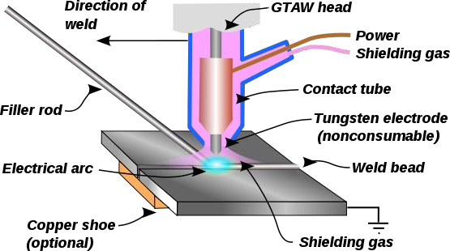

Fig. 1 Schematic diagram of working principle of TIG welding [Ref. 1]

### Different types of welding current

Both the direct current (DC) and alternating current (AC) may be used for TIG welding. When the work is connected to the positive terminal of DC welding machine and the negative terminal to an electrode the welding set up is said to have straight polarity. When work is connected to negative and electrode to positive terminal then the welding set up is said to have reversed polarity.

Table 1 Comparison of different welding current polarities [Ref. 3]

|  |  |  |  |  |
| --- | --- | --- | --- | --- |
| Sl.  No. | Property | DC, electrode  positive | DC, electrode negative | AC |
| 1 | Penetration | shallow | Deep | Intermediate |
| 2 | Heat generation | 2/3rd at electrode,  1/3rd at workpiece | 1/3rd at electrode, 2/3rd  at workpiece | 50% on both |
| 3 | Metal deposition  rate | High | Low | Intermediate |
| 4 | Thickness of  work | Thin sheets | Thick sheets | Intermediate |
| 5 | Stable smaller arc | Easier | Easier | Difficult |
| 6 | Arc blow | serve | Serve | Intermediate |

### Advantages of TIG welding process

* + - * Concentrated arc produced for control heat input to the workpiece. It resulting in a narrow heat-affected zone.
      * This process is done without use of flux, therefore no slag formation during welding process.
      * No Sparks or Spatter because of no transfer of metal across the arc during TIG welding.
      * Compared to other arc welding processes like flux cored welding, fewer amounts of fumes or smokes are produced.
      * Welding of thin material is possible.
      * Welding dissimilar type material is possible.
      * Welding of different types of metal and metal alloys are possible by proper control
      * Welding of different types of metal and metal alloys is possible.

### Disadvantages of TIG welding process

* + - * Low travel speeds than other welding processes to make the process slow.
      * Low filler material deposition during welding compare to other arc welding process.
      * High skills are required for manual welding process.
      * Welding equipment cost is higher than other arc welding process.

### Areas of application of TIG welding

TIG welding is often used for jobs that demand high quality welding such as for instance.

* + - * The offshore industry
      * The petrochemical industry
      * Power plants
      * The chemical industry
      * The food industry
      * The nuclear industry
      * Automobile
      * Aerospace

## 1.2 Experimental planning and procedure

For the present work total experiments were performed in three different phases

In first phase autogenous TIG welding of 5 mm thick mild steel plates were performed without using any filler rod at different welding current and scan speed condition to see the effect of welding & speed and to obtain a current and speed range for approximate welding.

In second phase TIG welding of 5 mm thick mild steel plate was performed after applying a layer of TiO2 flux and compared the weld properties with the welding done without flux.

In third phase, TIG welding was performed by maintaining different gap between the workpieces to be welded and study the effect of this gap on the welding performance mainly weld bead geometry and tensile strength of the weld.

### Experimental setup

For the present project work an autogenous welding set up has been developed to perform welding with a fixed velocity without the application of filler material. A movable vehicle is used to hold TIG torch. The distance between workpiece and torch tip will remain constant the welding process. The speed of movable vehicle is controllable and can be varied according to the requirement of the welding speed and amount of heat required. Figure 3 shows experimental setup for present work. The welding setup for autogenous TIG welding process consists following components:

* + 1. Welding torch
    2. Electrode
    3. Power supply
    4. Inert gas supply unit
    5. Work holding device
    6. Movable vehicle holding the welding torch
    7. Rail Track

## 1.3 Results and discussion

### Welded specimen performed by conventional autogenous TIG welding

Figure 2 shows TIG welded specimens performed with three different welding current and welding speeds.

|  |  |  |
| --- | --- | --- |
| Sl. No. | Welding current | Welded sample at different speed |
| 1 | 170 A | C:\Users\pank\Downloads\3.png |
| 2 | 190 A | C:\Users\pank\Downloads\3.png |
| 3 | 210 A | C:\Users\pank\Downloads\4.png |

Fig. 2 Welded specimens performed with 3 different speed and current setting by conventional autogenous TIG welding process

Macroscopic inspection of the samples produced from 9 experiment clearly reveal that weld joints formed with 170 A current for different welding speed didn’t satisfy the requirements of the welding. Therefore, these particular samples were discarded for further study. The remaining samples were considered for further testing, which has been described below.

### Optical Image at weld zone by conventional autogenous TIG welding process

Fig. 3 shows optical microscopic image at cross section of weld zone by autogenous conventional TIG welding process performed with 190 A and 210 A welding current and three different speeds. The images show that, melting of the weld zone is not fully done for all different current and scan speed combination. Further, it is seen that, weld melt pool depth is larger for higher current (210 A). It is also seen that, as scan speed increase for a particular current value, melt depth reduce.

|  |  |  |  |  |  |
| --- | --- | --- | --- | --- | --- |
| Current | | |  | 190 A | 210 A |
|  |  | |  |
| Speed (mm/s) | |  |
|  | |  | G:\notes\M.tech. project\optical_MS welding\9.1.2015\190.23.1.5.jpg | | G:\notes\M.tech. project\optical image\11.jpg |
| 2.33  mm/s | | |
| 2.96  mm/s | | | G:\notes\M.tech. project\optical_MS welding\9.1.2015\190.29.1.5.jpg | | G:\notes\M.tech. project\optical image\12.jpg |
| 3.5  mm/s | | | G:\notes\M.tech. project\optical_MS welding\9.1.2015\190.35.jpg | | G:\notes\M.tech. project\optical image\13.jpg |

Fig. 3 Optical microscopic Image at cross section of weld by conventional autogenous TIG welding process

### Weld bead geometry at cross section of weld zone by conventional autogenous TIG welding

Table 10 Width and depth of weld zone of TIG welded sample by conventional TIG welding

|  |  |  |  |  |
| --- | --- | --- | --- | --- |
| Sl. No. | Current (A) | Speed (mm/s) | Width (mm) | Depth (mm) |
| 1 | 190 | 2.33 | 6.3 | 2.34 |
| 2 | 190 | 2.96 | 5.75 | 1.28 |
| 3 | 190 | 3.5 | 5.88 | 1.59 |
| 4 | 210 | 2.33 | 7 | 2.47 |
| 5 | 210 | 2.96 | 5.85 | 2.09 |
| 6 | 210 | 3.5 | 6.17 | 1.91 |

7.7

190 A

210 A

7.0

Weld bead width (mm)

6.3

5.6

2.4 3.0 3.6

scan speed (mm/s)

Fig. 4 Variation of weld bead width against scan speed for different welding current

Figure 4 shows the variation of weld bead width against scan speed for 190 A and 210 A welding current of welded specimen. The maximum welding width obtained at minimum welding speed and maximum current. It was normally observed that weld bead width increases as current increases but decreases with increment in welding speed.

2.4

190 A

210 A

1.8

Weld pool depth (mm)

1.2

2.4 3.0 3.6

scan speed (mm/s)

Fig. 5 Variation of weld pool depth against scan speed for different welding current

Figure 5 shows the variation of weld pool depth against scan speed for different welding current of TIG welded specimen. Low welding speed and high current provide high heat input to the workpiece, so the depth of penetration was maximum at this condition. The maximum weld pool depth was 2.47 mm, obtained at 210 A welding current and 2.33 mm/s scan speed.

Depth of penetration obtained in the above experiment was still small for proper applicability of the welding technique. Hence, more literature was studied and it was established that, depth of penetration can be further improved if activated flux is used during the welding process. Based on this, experiments were conducted again with an addition of activation flux utilization.

### Welded specimens performed by activated TIG welding process

It was clearly observed from first set of experiment and results, that combination of maximum welding current and minimum speed provide high heat input to the workpiece material. However, maximum depth of penetration was obtained at this condition. Second set of experiment performed with the use of TiO2 flux and 210 A welding current for three different welding speeds.TiO2 activated TIG welding process performed with 210 A current and three different speeds shown in figure 6.

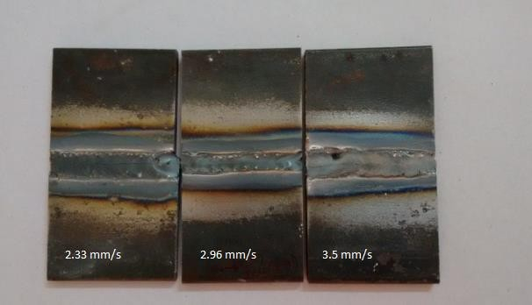

Fig. 6 TIG welded specimen with TiO2 flux at 210 A current

### Optical Image at weld zone of specimen performed by activated TIG welding process

Figure 7 shows optical microscopic image at weld zone performed by TiO2 flux coated autogenous TIG welding process with 210 A current and different scan speed.

|  |  |  |
| --- | --- | --- |
| G:\notes\M.tech. project\optical image\14.jpg | G:\notes\M.tech. project\optical image\15.jpg | G:\notes\M.tech. project\optical image\16.jpg |

(a) 2.33 mm/s (b) 2.96 mm/s (c) 3.5 mm/s

Fig. 7 Optical microscopic Image at weld zone of TIG welded specimen with use of TiO2 flux

From the optical image it is observed that, melt pool depth is relatively larger for using TiO2flux, but still full penetration welding was not obtained. Further, for using TiO2 flux on the melt pool zone some crack has been form. This crack may reduce the strength of the welding. Similar observation was done by some other researcher for using activated flux in welding of different type of steel in TIG welding [11, 12, 13].

### Weld bead geometry at cross section of weld zone by TIG welding with TiO2 flux

Table 11 Width and depth of weld zone of TIG welding with TiO2 flux

|  |  |  |  |  |
| --- | --- | --- | --- | --- |
| Sl. no. | Current (A) | Speed (mm/s) | Width (mm) | Depth (mm) |
| 1 | 210 | 2.33 | 7.16 | 2.65 |
| 2 | 210 | 2.96 | 5.52 | 3.09 |
| 3 | 210 | 3.5 | 6.28 | 2.95 |

210 A

8

7

Weld bead width (mm)

6

5

2.4 3.0 3.6

speed (mm/s)

Fig. 8 Variation of weld bead width against scan speed for 210 A welding current

210 A

3.3

3.0

Weld pool depth (mm)

2.7

2.4

2.4 3.0 3.6

scan speed (mm/s)

Fig. 9 Variation of weld pool depth against scan speed for 210 A welding current

Fig. 8 shows the variation weld bead width against scan speed for 210 A welding current of TiO2 flux coated weld specimen. It was observed that welding width decreases with increment in welding current. The maximum weld bead width obtained at minimum welding speed.

Fig. 9 shows the variation of weld pool depth against scan speed for 210 A welding current of TiO2 flux coated weld specimen. At minimum welding speed high heat input provided to the workpiece material, so the depth of penetration is inversely proportional to the scan speed. The depth of penetration of workpiece decreases with increment in welding speed.

In normal welding condition generally at lower scan speed depth of penetration is increases due to high heat input, but for using activated flux (TiO2) add the upper surface of the plate most of the heat absorbed by the surface and at lower scan speed a wider melt pool is formed. As a result welding depth is reduced.

Table 12 indicates measurement value of depth of penetration for both without using flux and with using flux TIG welded sample. It was observed that the higher depth of penetration obtained for flux coated sample.

Table 12 Comparison of depth of penetration between without flux weld and with flux weld sample

|  |  |  |  |  |
| --- | --- | --- | --- | --- |
| Sl. No. | Current (A) | Speed  (mm/s) | Depth (mm)  without flux | Depth (mm)  with flux |
| 1 | 210 | 2.33 | 2.47 | 2.65 |
| 2 | 210 | 2.96 | 2.09 | 3.09 |
| 3 | 210 | 3.5 | 1.19 | 2.95 |

With the application of flux, desirable results, i.e. increase in depth of penetration was obtained. However, it was seen that material was unable to flow and weld properly as no gap was maintained between the components to be welded. To further improve the welding technique and facilitate optimum flow of the material, it was decided to maintain a suitable gap between the components. Taking this condition into account, more experiments were conducted to study the effect of welding gap kept between the welding sub-parts on the output response. In this regard, it is relevant to mention that, no study was reported on the

effect of gap maintained between the workpieces to be welded by autogenous TIG welding process.

### Welded specimens performed welding by varying gap between workpiece

In this set of experiment, suitable gap between workpiece was maintained for proper flow of material towards the bottom of the joint. Figure 10 shows welded specimens of mild steel performed by three different current and gap between workpiece to be welded. No flux is used for this set of experiment to avoid any crack on the weld zone.

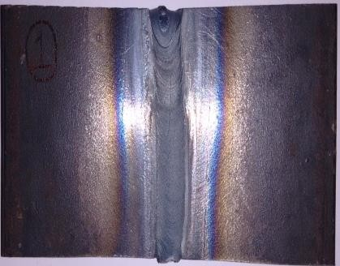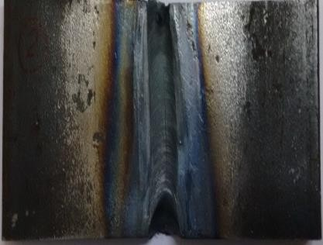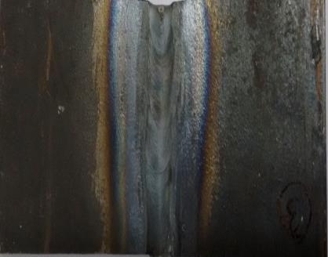

Welding

current

180 A current

Gap between work piece

1 mm

0.75 mm

0.5 mm

200 A Current

190 A Current

Fig. 10 TIG welded specimens by varying gap between workpiece

### Optical microscopic Image at weld zone performed welding by varying gap between workpieces

Figure 11 shows the optical microscopic image at weld zone of TIG welding done with different welding current and gap between workpiece. From the cross-sectional view, it becomes easier to understand the effect of welding parameters on the depth of penetration. It highlights the condition in which most efficient weld is obtained. For gap 0.5 mm melting is not done fully but when gap is maintained 0.75 mm, it has is seen that for using 200 A current full penetration welding was obtained. Again for using 1 mm gap full penetration welding was obtained for the sample processed with 190 A and 200 A welding current.

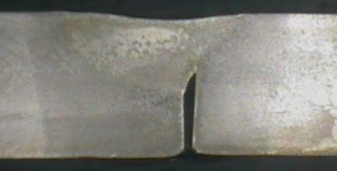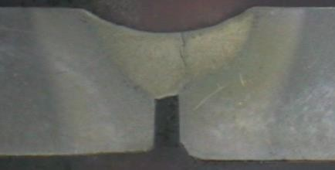

|  |  |  |  |  |  |
| --- | --- | --- | --- | --- | --- |
| Welding current | |  | 180 A current | 190 A Current | 200 A Current |
|  |  |  |
| Gap |  |
| 0.5 mm |  | G:\notes\M.tech. project\optical image\1.jpg | |  |  |
|  | |
| 0.75 mm | | G:\notes\M.tech. project\optical image\8.jpg | |  |  |
| 1 mm | |  | |  |  |

Fig.11 Optical microscopic Image at weld zone of TIG welding done with different welding current and gap between workpiece

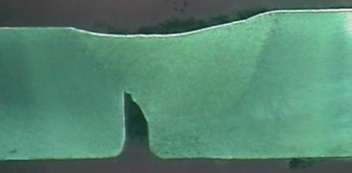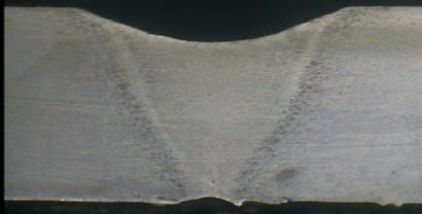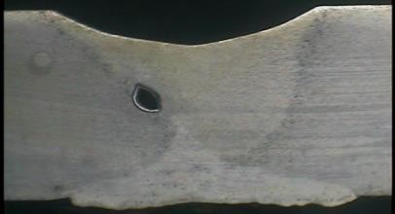

### Weld bead geometry of weld zone

Measurement value of weld width, weld pool depth and crater form of welded sample at weld zone processed with different welding current and gap maintain between workpiece

Table 13 Measurement of width, depth and crater of welded sample at weld zone for different current and gap maintain between workpiece

|  |  |  |  |  |  |
| --- | --- | --- | --- | --- | --- |
| Sl. no. | Current (A) | Gap (mm) | Width (mm) | Depth (mm) | Crater (mm) |
| 1 | 180 | 0.5 | 5.85 | 2.26 | 0.29 |
| 2 | 180 | 0.75 | 6.05 | 2.83 | 0.4 |
| 3 | 180 | 1 | 6.2 | 4.21 | 0.51 |
| 4 | 190 | 0.5 | 6.37 | 2.47 | 0.42 |
| 5 | 190 | 0.75 | 6.13 | 3.05 | 0.76 |
| 6 | 190 | 1 | 6.5 | 4.88 | 0.9 |
| 7 | 200 | 0.5 | 6.52 | 3.46 | 0.71 |
| 8 | 200 | 0.75 | 6.34 | 4.61 | 0.86 |
| 9 | 200 | 1 | 6.94 | 4.98 | 0.98 |

6



0.5 mm gap

0.75 mm gap 1 mm gap

5

4

Weld pool depth (mm)

3

2

180 190 200

current (A)

Fig. 12 Variation of weld pool depth against welding current for different gap between workpiece to be welded

Figure 12 indicates the variation of weld pool depth against welding current for different gap between workpiece to be welded. It has been observed that with the increase in current, weld pool depth increases. Current is directly proportional to the heat input according to relation

H=I2RT. So when current increases heat input increase and it melts the material and flows down in the gap, leading to the melting of adjacent layer of material thereby increasing the depth of penetration. The maximum depth of penetration was observed at 200A current in all the three gap condition.

5

180 A

190 A

200 A

4

Weld pool depth (mm)

3

2

0.4 0.6 0.8 1.0

Gap between workpiece (mm)

Fig. 13 Variation of weld pool depth against gap between workpiece to be welded for different welding current

Fig. 13 represents the variation of weld pool depth against gap between workpiece to be welded for different welding current. To enhance proper welding operation, the gap between two metals should be neither too small nor too large. When welding was done without any gap the molten material did not get any space to flow and only convective metal flow within the melt pool occurred, that restrict the depth of penetration. However, molten material can flow within the gap and reach to bottom portion when a proper gap was maintained. The maximum depth of penetration is observed at 1 mm gap between workpiece to be welded.

7



0.5 mm gap

0.75 mm gap 1 mm gap

6

Weld pool width (mm)

180 190 200

Welding current (A)

Fig. 14 Variation of weld bead width against welding current for different gap between workpiece to be welded

Fig. 14 shows the variation of weld bead width against welding current for different gap between workpiece to be welded. From the figure it can be seen that the value of welding width is increased with increment in applied welding current. Because of high current, crater was formed and welding width was large. The maximum welding width in this experiment was 6.94 mm at 200 A current.

Fig. 15 shows the Variation of weld bead width against gap between workpiece to be welded for different welding current. From the graph it can be clearly seen that width increases as the gap increase. As gap was varied in this experiment ( 0.5 mm, 0.75 mm and 1 mm), this gap value is also contribute in the increment of width of the welded zone.

7.5



180 A

190 A

200 A

7.0

6.5

Weld pool width (mm)

6.0

5.5

0.4 0.6 0.8 1.0

Gap between workpiece (mm)

Fig. 15 Variation of weld bead width against gap between workpiece to be welded for different welding current

1.2

0.5 mm gap

0.75 mm gap 1 mm gap

0.8

Weld crater (mm)

0.4

180 190 200

current (A)

Fig. 16 Variation of weld crater against welding current for different gap between workpiece to be welded

Fig. 16 shows the Variation of weld crater against welding current for different gap between workpiece to be welded. It was observed that with the increase in current, crater increases at

constant gap. At high current due to high heat input to the workpiece some amount of material from the top surface evaporated. Further flow of material within the gap make a concave surface on the workpiece. This is called crater in welding. As current increase this crater depth increases.

0.9



180 A

190 A

200 A

0.6

Weld crater (mm)

0.3

0.4 0.6 0.8 1.0

Gap between workpiece (mm)

Fig. 17 Variation of weld crater against gap between workpiece to be welded for different welding current

Fig. 17 shows variation of weld crater against gap between workpiece to be welded for different welding current. In present work no filler material has been used and also maintained gap between workpiece. When the material melts, it fills up the gap between the workpiece. It was observed that with the increases in gap volume of void space between two welding workpiece also increases.

### Tensile testing

In order to compare the strength of the welding joint at different welding conditions, tensile testing of welded specimen was performed using UTM. From previous two set of experiments it was established that higher depth of penetration was obtained at maximum current and minimum welding speed. Keeping this in mind, specimens with high current were more suitable for further analysis. Neither conventional TIG welded specimen nor activated

TIG welded specimen provide better strength. The results of the test suggest that weld joint obtained are not strong enough which motivated the third set of experiments.

Fig. 18 shows specimen for tensile testing and Table 14 shows the maximum tensile strength value of weld with welding condition.

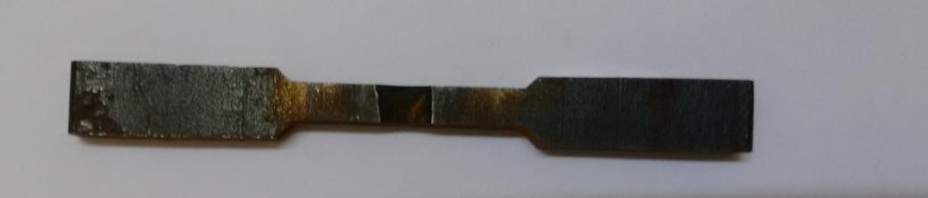

Fig. 18 Tensile testing specimen

Table 14 Tensile strength at weld joint by TIG welding of varying gap between workpiece

|  |  |  |  |
| --- | --- | --- | --- |
| Sl. No. | Welding current  (A) | Gap between  workpiece (mm) | Tensile strength (MPa) |
| 1 | 180 | 0.5 | 115.95 |
| 2 | 180 | 0.75 | 225.21 |
| 3 | 180 | 1 | 264.54 |
| 4 | 190 | 0.5 | 319.10 |
| 5 | 190 | 0.75 | 346.38 |
| 6 | 190 | 1 | 501.173 |
| 7 | 200 | 0.5 | 442.98 |
| 8 | 200 | 0.75 | 395.45 |
| 9 | 200 | 1 | 617.22 |

Fig. 19 shows the variation of tensile strength against gap between workpiece to be welded for different welding current of weld sample. It has been observed that the increase in gap between workpiece to be welded, tensile strength of weld workpiece increases. This is mainly due to the higher penetration of welding for higher welding gap maintain between workpiece.

600

180 A

190 A

200 A

400

Tensile strength (MPa)

200

0

0.4 0.6 0.8 1.0

Gap between workpiece (mm)

Fig. 19 Variation of tensile strength against gap between workpiece to be welded for different welding current

600

0.5 mm gap

0.75 mm gap 1 mm gap

400

Tensile strength (MPa)

200

0

180 190 200

Welding current (A)

Fig. 20 Variation of tensile strength against welding current for different gap between workpiece to be welded

Similarly, Fig. 20 shows the variation tensile strength against welding current for different gap between workpiece to be welded. It has been observed that, with the increase in current

tensile strength of weld workpiece increases. In this experiment autogenous for higher value of current heat input must be high. From the optical image it is seen that with the increase of current penetration depth increases. Higher penetration depth contributes for better strength.

### Vickers Hardness test

Hardness of the welded zone was measured for selective specimen at the cross section. Hardness test was performed using Vickers Hardness tester with 0.3 kgf minimum load capacity. Fig. 21 shows the hardness value at the welded zone, heat affected zone and base material for the sample processed with 200 A current and 0.75 mm gap. Table 15 shows Hardness value for some representative samples.

Table 15 Hardness value for sample

|  |  |  |  |  |  |  |
| --- | --- | --- | --- | --- | --- | --- |
| Sample No. | Welding current (A) | Welding speed (mm/s) | Gap between workpiece  (mm) | Hardness value at molten metal  zone | Hardness value at heat affected  zone | Hardness value at base material  zone |
| 1 | 190 | 2.33 | 0.5 | 192.6 HV | 158.5 HV | 149 HV |
| 2 | 200 | 2.33 | 0.75 | 198.5 HV | 176.8 HV | 146.4 HV |

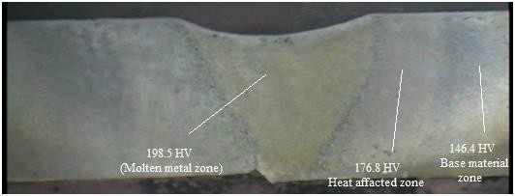

Fig. 21 Hardness value of sample at weld zone processed with 200 A current and 0.75 mm gap

It is observed from figure that hardness value decrease towards the base material zone. Average hardness values at molten metal zone for 190 A and 200 A current are 192.6 HV and 198.5 HV respectively. So it can say that approximate range of micro-hardness is 190 HV to 200 HV at molten metal zone for TIG welded samples.

## Conclusions

Findings of the present investigation can be summarized into following points

* The results of the conventional TIG welding process performed show that, maximum depth of penetration was obtained with parametric combination of minimum welding speed and maximum current.
* When the same procedure is repeated with additional utilization of TiO2 flux, depth of penetration increases in comparison to the conventional welding, but some crack on the weld zone was observed for using flux.
* With constant welding speed, another set of experiments were done by maintaining a gap between workpiece to be welded. It is observed that, with a gap of 1 mm, defect- free welding with proper material flow obtained throughout the joint for higher welding current.
* Comparing the three methods of TIG welding, depth of penetration and tensile strength of weld joint is maximum when adequate gap is maintained between the components to be welded.
* From the graphs plotted, it can be inferred that welding width and depth increases with increase in welding current and gap maintained between the components to be welded.

## REFERENCES

1. en.wikipedia.org/wiki/GTAW
2. Sharma P.C., Manufacturing Technology – I, S. Chand, 2008.
3. Singh S., Production Engineering, LNEC publication, 2010.
4. American Association State, 2012. Standard test method for Tension Testing of metallic materials E8/E8M – 11, pp 3.
5. <http://www.efuda.com/materials/alloys/carbon_steel>
6. Krishna R., Raman R.K., Varatharanjan K., Tyagi A.K. (2014), Microstructure and oxidation resistance of different region in the welding of mild steel, Journal of Material Science vol. 18, pp 1618 – 1621.
7. Raj A., Varghese J., Determination of distortion developed during TIG welding of low carbon steel plate, Journal of engineering Research and General Science vol. 2, pp 756 - 767.
8. Abhulimen I.U., Achebo J.I. (2014), Prediction of Weld quality of a Tungsten inert gas welded steel pipe joint using response surface methodology, Journal of Engineering Research and Application vol. 4, pp 31 – 40
9. Mishra R., Tiwari V., Rajesha S. (2014), A study of tensile strength of MIG and TIG welded dissimilar joints of mild steel and stainless steel, Journal of material science & Engineering vol. 3, pp 23 - 32.
10. Fujii H., Sato T., Lua S.*,*Nogi K. (2008), Development of an advanced A-TIG welding method by control of Marangoni convection, Journal of material science & Engineering vol. 495, pp 296 - 303.
11. Kuo C., Tseng K., Chou C. (2011), Effect of activated TIG flux on performance of dissimilar welds between mild steel and stainless steel, Journal of Engineering materials vol. 479, pp 74-80.
12. Vikesh, Randhawa J., Suri N.M. (2013), Effect of A TIG welding process parameters on penetration in mild steel plate, Journal of Mechanical and Industrial Engineering vol. 3, pp 27 -30.
13. Pal K., Kumar V. (2014), Effect of Activated TIG welding on wear properties and dilution percentage in medium carbon steel welds, journal Emerging Technology and advanced Engineering vol. 4, pp 175 - 182.
14. Nayee G., Badheka V. (2014), Effect of oxide based fluxes on mechanical and metallurgical properties of dissimilar activating flux assisted Tungsten Inert Gas

welds, Journal of manufacturing process vol. 16, pp 137-143.

1. Ruckert G., Perry N., Sire S., Marya S. (2014), Enhanced Weld Penetrations In GTA Welding with Activating Fluxes Case studies: Plain Carbon and Stainless Steels, Titanium and Aluminum, Journal of Science Arts and Metiers, pp 202.
2. Dhandha K.H., Badheka V.J. (2014), Effect of activating fluxes on weld bead morphology Of P91 steel bead-on-plate welds by ﬂux assisted Tungsten Inert Gas welding process, Journal of Manufacturing Processes vol. 17, pp 48 – 57.
3. Zuber M., Chaudhri V., Suri V.K., Patil S.B. (2014), Effect of flux coated Gas Tungsten Arc Welding on 304L, Journal of Engineering and Technologies vol. 6, pp 3.
4. Fujii N., Suzuki H., Yasuda K., Takahashi J (2006), Comparison of strength characteristics of cast iron/mild steel welds produced by various process, Journal of Japan Welding Society vol. 2, pp 302 – 310.
5. Mahajan S., Biradar N.S., Raman R., Mishra S. (2012), Effect of Mechanical Arc Oscillation on the Grain Structureof Mild Steel Weld Metal, a Journal of Indian Institute of Metals, pp 171 – 177.
6. Pasupathy J., Ravisankar V. (2013), Parametric optimization of TIG welding parameters using Taguchi method for dissimilar joint (low carbon steel and AA1050), Journal of Scientific & Engineering Research vol. 4, pp 25 - 28.
7. Dye D., Stone H.J., Watson M., Rogge R.B., Characterization of Phase Transformations and Stresses Duringthe Welding of a Ferritic Mild Steel, Journal of Minerals, Metals and Materials Society vol. 45, pp 2038 – 2044.
8. Nasiri M.B., Behzadinejad M., Latifi H., Martikainen J. (2014), Investigation on the influence of various welding parameters on the arc thermal efficiency of the GTAW process by calorimetric method, Journal of Mechanical Science and Technology vol.8, pp 3255 – 3261.
9. Meng X., Qin G., Zhang Y., Fu B., Zou Z. (2014), High speed TIG-MIG hybrid arc welding of mild steel plate, Journal of Materials Processing Technology vol. 214, pp 2417 – 2424.