**BAGASSE-BASED HYDROGEL NANOBANDAGES FOR ENHANCED WOUND HEALING**

Reena Antony, Alexia Varghese, Alfiya Raqeeb, Sushmita Roy

Department of Microbiology Career College, BHEL Govindpura, Bhopal, M.P, India

__________________________________________________________________________________

**ABSTRACT**

Wound healing is a critical physiological process that involves complex cellular and molecular interactions. Hydrogel-based nanobandages have emerged as promising result for wound care due to their biocompatibility, moisture-retention capacity, and tunable mechanical properties. This article focuses on the development and characterization of bagasse-based hydrogel nanobandages as innovative wound dressings. Bagasse, a byproduct of sugarcane processing, is rich in cellulose and can serve as an eco-friendly and cost-effective source for hydrogel synthesis. Accumulation of large quantities of sugarcane bagasse as agriculture waste leads to complex waste problems which had been a challenge in the synthesis of cellulose hydrogel. Burns and skin wounds require special care and treatment because the body skin is the first defense barrier against pathogens therefore quick and suitable treatment of wound is very important. Using nanotechnology wound dressing can be developed for types of wounds in the present scenario the bandages manufactured are a product of plastic causing various side effects on skin and body causing damages and infections and it even is not environment friendly so to overcome all these challenges using nanotechnology a new bagasse based hydrogel nano bandages are produced which are ecofriendly has polyherbal drug which rapids the speed of wound healing gives cooling effect as hydrogel is used.

**Keywords**: Hydrogel, Nanotechnology, Polyherbal drug, Bagasse, Wounds, Cellulose

__________________________________________________________________________________

**1.INTRODUCTION**

Wound healing, a complex biological process, necessitates innovative approaches to meet the growing demand for effective therapies. Hydrogel-based nanobandages have emerged as a promising solution due to their biocompatibility, moisture retention, and customizable properties. This study focuses on the development and characterization of hydrogel nanobandages derived from bagasse, a byproduct of sugarcane processing. Wound repair is a complicated and staged process with known cell types (e.g., neutrophils, macrophages, fibroblasts, and keratinocytes) and microenvironment conditions (e.g., extracellular matrix (ECM) components, cytokines, and growth factors (GFs) (Childs et. al. 2017, Junnuthula et. al.2022, Paulami et.al. 2023). Bagasse, rich in cellulose, presents a sustainable and cost-effective source for hydrogel synthesis, addressing both environmental concerns and economic feasibility. The accumulation of sugarcane bagasse poses environmental challenges, emphasizing the need for repurposing it in value-added applications like wound healing. Various types of nanomaterials, including metal NPs (e.g., silver, gold, copper, zinc oxide, titanium dioxide, etc.), ceramic NPs, synthetic polymeric NPs (e.g., PET, PLGA, PLLA, etc.), natural polymeric NPs (e.g., chitosan, gelatin, silk, fibrin, collagen, etc), self-assembled NPs, and composite NPs have been used for acute or chronic wound healing. Nanoparticle-based materials are preferred due to their antibacterial activity, biocompatibility, and increased mechanical strength in wound healing. Metal NPs like silver, gold, and zinc are the main options for wound dressing's development because of their antibacterial capabilities and low toxicity (Tyavambiza et. al. 2022).

The occurrence of a wound arises from disruptions in the integrity of skin, mucosal surfaces, or organ tissues (Young et.al. 2011). These diverse types of skin injuries all share a common mechanism of repair. Wound healing, while a natural process in the human body, involves a complex cascade of physiological events (Strodtbeck et. al. 2001). The fact that this process often unfolds without complications is quite remarkable (Young et.al. 2011).

However, the success of this intrinsic healing ability is contingent upon several well-known factors, including the patient's underlying health and nutritional status (Groeber et. al. 2011). Specific conditions, such as diabetes, non-healing ulcers, extensive skin loss, and deep burns, can compromise this natural healing process (Gua et. al. 2010, Groeber et. al. 2011). Inadequate healing can result in the formation of chronic wounds, which elevate the risk of infections and detrimentally impact the patient's overall health and quality of life (Periera et.al. 2016). Additionally, chronic wounds are associated with potential morbidity and mortality, as well as suboptimal cosmetic outcomes (Young et.al. 2011, Periera et.al. 2016, Gua et. al. 2010, Strodtbeck et. al. 2001, Groeber et. al. 2011, Abdelrahman et. al. 2011, Antony et.al. 2019).

In this context, our research aims to harness the potential of bagasse-derived hydrogels for wound management. By utilizing bagasse as a renewable resource, we contribute to sustainability efforts while exploring its efficacy in wound care. The development of hydrogel nanobandages from bagasse involves innovative processing techniques to optimize their structural and functional properties.

upon subsequently.

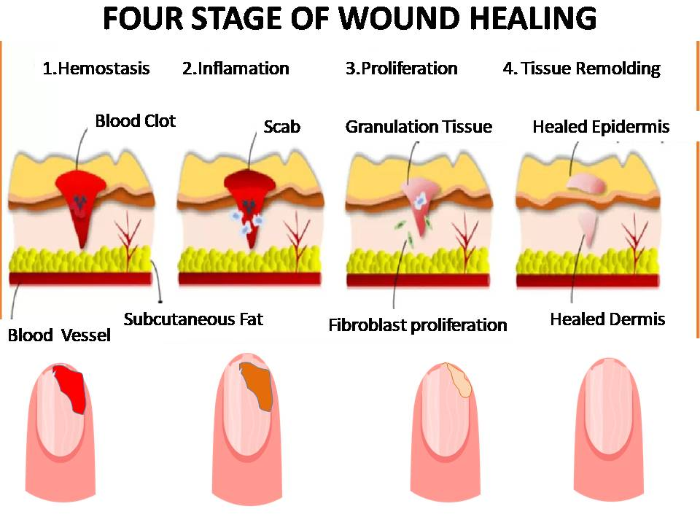

Figure 1-Four Stages of wound healing process

Characterization studies encompass various analytical techniques to evaluate their morphology, composition, and performance. Our investigation extends beyond material development to address broader implications, such as environmental sustainability and resource utilization. By repurposing agricultural waste like bagasse, we mitigate waste disposal challenges and reduce reliance on traditional wound dressing materials. The utilization of bagasse-derived hydrogels not only offers a sustainable alternative but also contributes to the circular economy by transforming waste into valuable products. Overall, this study underscores the potential of bagasse-based hydrogel nanobandages as a sustainable solution for wound healing. By integrating biocompatible materials with eco-friendly production processes, we aim to advance wound care technologies while promoting environmental stewardship. Through interdisciplinary collaboration and innovative research approaches, we strive to address critical healthcare needs while fostering sustainable practices in materials science and biomedical engineering.

In the realm of wound management, hydrogels exhibit a crucial characteristic in replicating the extracellular matrix (ECM), essential for cellular adhesion, tissue anchorage, signaling, and recruitment. Comprising polysaccharides, proteins, and water, the ECM can suffer damage in acute or chronic injury scenarios. Hydrogels, composed primarily of water and polymers, emulate the ECM's rigidity and functions, facilitating cell incorporation and macromolecule integration. Applied to wounded areas, hydrogels act as dermal matrices, mimicking the structure and function of unwounded skin, potentially mitigating scarring by approximating tensile contraction and elastic retraction of intact dermis. This fosters cell development, ECM deposition, and tissue regeneration, augmenting wound healing. Notably, hyaluronic acid, collagen, and alginate hydrogels excel in constructing ECM matrices.

Moreover, in burn therapy, hydrogels play a pivotal role as primary dressings for first aid, particularly within the initial 15 minutes of thermal burns. The water content aids in cooling the burn site, maintaining stable wound temperature, and alleviating pain while safeguarding against infection. Hydrogels, like Carbomer 940, enhance blood flow and tissue recovery, outperforming paraffin dressings in speed and safety, especially for pediatric patients and during ambulance transportation. Ambulances globally equip hydrogel sheets for emergency burn treatment due to their efficacy and water-rich composition.

Hydrogel wound dressings leverage a variety of natural (e.g., chitosan, gelatin, hyaluronic acid, alginate) and synthetic polymers (e.g., polyethylene glycol, polyvinyl pyrrolidone, polyethylene oxide, polyvinyl alcohol) (Negut et.al. 2018). Combinations of natural and synthetic polymers enhance mechanical strength and absorption capabilities, propelling advancements in hydrogel technology. This progress encompasses novel formulations such as sprayable hydrogels, "smart hydrogels," nanogels, aerogels, and cryogels, harnessing polymer attributes for tailored wound care solutions.

**Harnessing Nanotechnology in Wound Dressings**

In most instances, nanotechnology-based dressings serve as a vehicle for delivering therapeutic agents to the wound site, and the mechanism through which wound healing is expedited hinges on the specific properties and actions of these agents (Rajendran et. al. 2018, Stoica et al. 2020, Kalshnikova et. al. 2015). Nonetheless, the size reduction of materials to the nanoscale introduces alterations in their physicochemical characteristics, which can exert an influential role in accelerating the healing process. Some of these attributes that can impact wound healing encompass biocompatibility, biodegradability, stability, size, as well as surface functionalization and charge (Stoica et al. 2020). In addition to these factors, there are various other potential mechanisms through which nanotechnology-based dressings can enhance and expedite wound healing.[Figure 2]

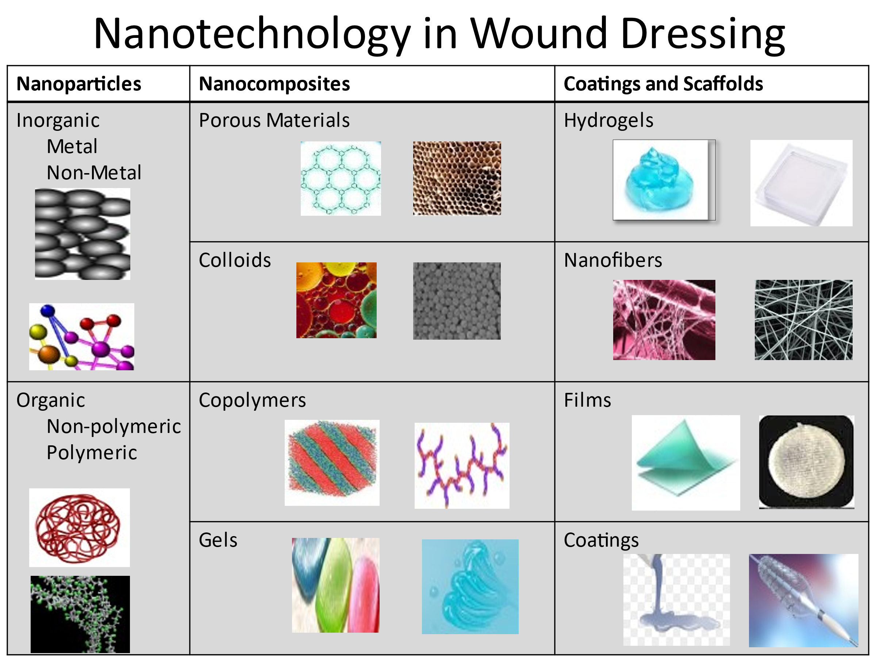

Figure 2: Few dimensions of using Nanotechnology in wound dressing

Top of Form

**2.MATERIALS AND METHODS:**

Utilizing a tailored methodology, we synthesized bagasse-derived hydrogel nanobandages, harnessing the cellulose extracted from bagasse as the primary constituent. A thorough characterization of these nanobandages ensued, employing diverse analytical techniques such as scanning electron microscopy (SEM) for morphological assessment and mechanical testing to gauge structural integrity.

Beyond biocompatibility and moisture retention, the antimicrobial efficacy of the nanobandages was meticulously scrutinized against prevalent wound pathogens. This assessment sought to validate their potential as effective wound dressings by inhibiting microbial proliferation, a critical aspect in preventing infections and promoting healing. Through rigorous experimentation and analysis, our study presents a multifaceted evaluation of bagasse-derived hydrogel nanobandages, elucidating their promising attributes for wound care applications. These findings not only contribute to the expanding repertoire of sustainable biomaterials but also offer insights into the development of advanced wound dressing solutions with enhanced biocompatibility, moisture retention, and antimicrobial properties,

* Preparation of ployherbal drug infusion

Fresh eucalyptus leaves were collected from botanical garden, and were washed thoroughly. Then the eucalyptus leaves were dried and crushed slightly, 50g of crushed leaves were subjected to Soxhlet extraction (50:50) of aqueous solution and (70:30) of ethanolic solution. The extracted solution was filtered with Whatman no.1 filter paper, the honey sample utilized was procured from a local store, 25ml of honey was added to the extracted solution and mixed, subjected to vortex mixer at 50°Cfor 2 hours then the infusion was stored in beaker and was refrigerated.

* Green Synthesis of nanoparticles from the drug infusion prepared: Synthesis done through method mentioned by solution mentioned by Huston et al. 2021.
* SEM Analysis of the SNPs synthesized: The SNPs synthesized were tested through UV-Vis spectrophotometer (Systronic) and SEM(Zeiss)
* Hydrogel synthesis: Hydrogel was syntghesized using Baggase from sugarcane by method devised by Zimele Nikosivele et.al.2023.
* Antimicrobial studies on wound infecting microorganisms

**3.RESULTS**

**Hydrogel synthesized from Baggase:**

Cellulose was extracted from baggase collected and processed in the laboratory.

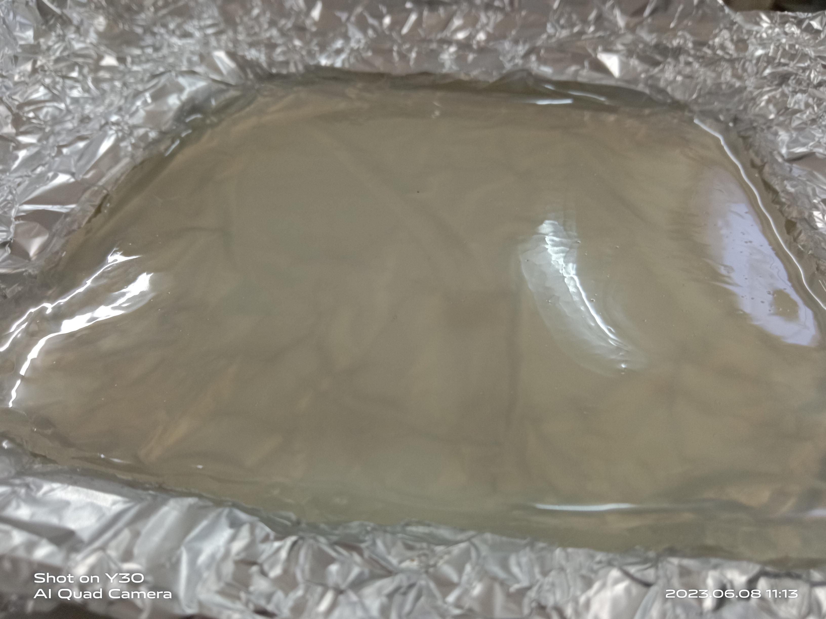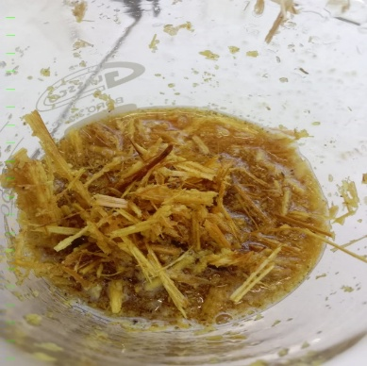

**Fig 3: Baggase and cellulose hydrogel isolated**

**Green Synthesis of Silver Nanoparticles from eucalyptus and honey infusion**

The herbal infusion prepared was subjected to green synthesis of Silver nanoparticles using Silver nitrate solution.

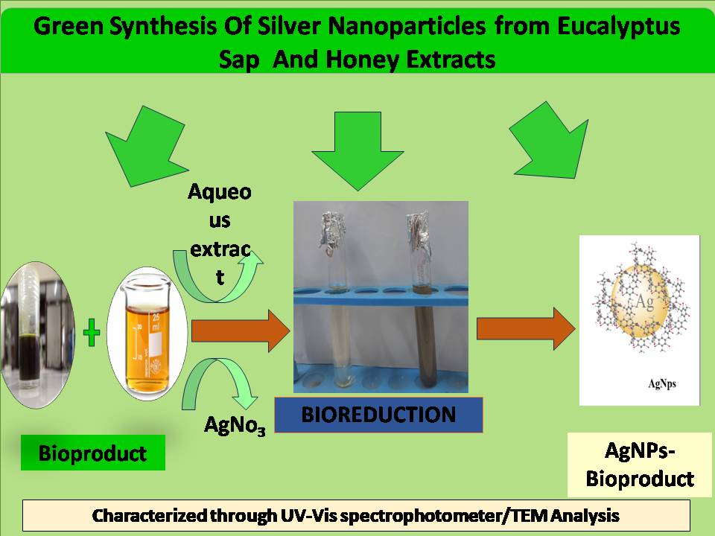

**Figure 4: Ilustration of green synthesis employed for SNPs synthesis**

**Hydrogel mechanical testing**

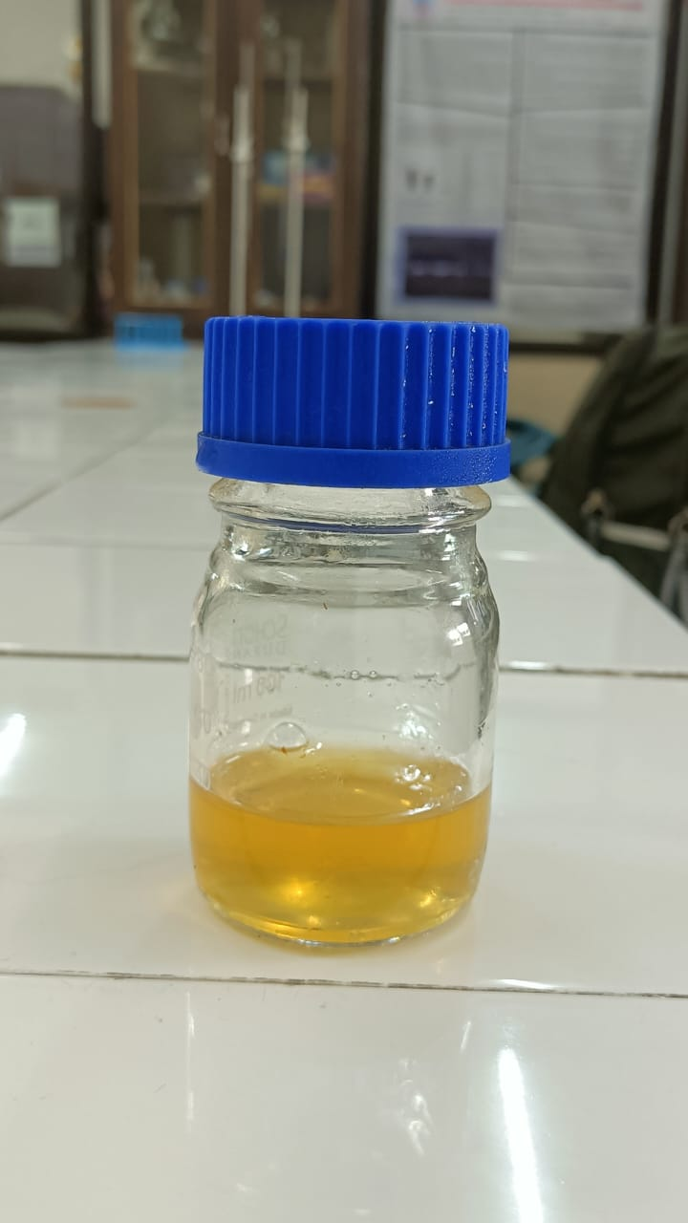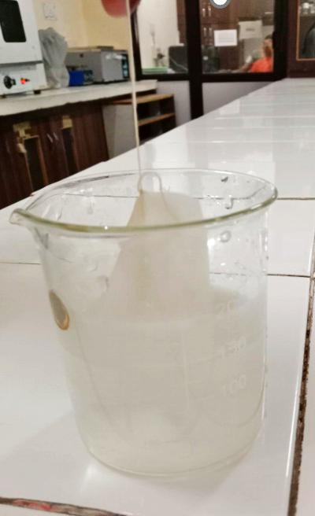

**Figure 5 Photo illustration of Swelling test and Viscosity test of hydrogel synthesized**

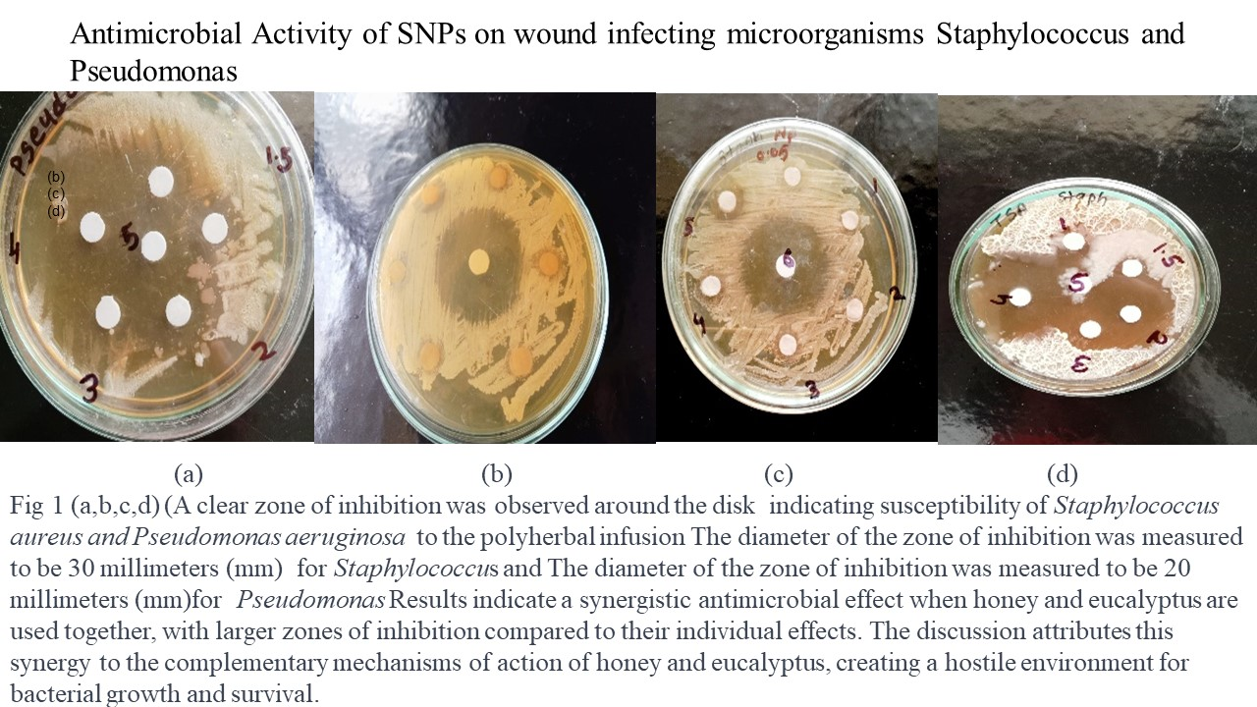

Figure 6: Illustration showing antimicrobial test of the SNPs synthesized

SEM analysis revealed the nanostructured morphology of the hydrogel bandages, with a porous network conducive to cellular infiltration and nutrient exchange.



Figure 7: SEM analysis result showing Nanoparticles synthesis

**4.CONCLUSION**

Bagasse-derived hydrogel nanobandages offer a promising solution for advanced wound care management. Leveraging the abundance of sugarcane bagasse as a sustainable resource, these nanobandages exhibit desirable properties, including biocompatibility, moisture retention, and antimicrobial activity. The eco-friendly nature of the hydrogel addresses concerns regarding plastic-based wound dressings, offering a greener alternative. Future studies may focus on optimizing the formulation and exploring additional functionalities, paving the way for their clinical translation and widespread adoption in wound care practice. The utilization of bagasse as a precursor for hydrogel synthesis presents a sustainable approach to address both environmental and healthcare challenges. The successful fabrication and characterization of bagasse-based nanobandages underscore the feasibility of repurposing agricultural waste for biomedical applications. The tunable mechanical properties of the hydrogel offer versatility in catering to diverse wound types, from superficial abrasions to deep burns. Furthermore, the inherent biocompatibility and antimicrobial activity of cellulose-based hydrogels enhance their therapeutic efficacy while minimizing the risk of adverse reactions or secondary infections. Collaborative efforts between researchers, industries, and policymakers are essential to scale up production and ensure accessibility of these innovative wound dressings to populations worldwide.

**4.** **ACKNOWLEDGEMENT**

The authors would like to extend our sincere thanks for the funding of this project by DBT- BIRAC Eyuva fellow project Reference no. – BT/EF0022/01/22.

**5.REFERENCES**

[1]Paulami Dam, Merve Celik, Merve Ustun.(2023) Wound healing strategies based on nanoparticles incorporated in hydrogel wounds patches. RSC Adv.,13(31): 21345–21364.

[2]Junnuthula V. Kolimi P. Nyavanandi D. Sampathi S. Vora L. K. Dyawanapelly S(2022). Polymeric Micelles for Breast Cancer Therapy: Recent Updates, Clinical Translation and Regulatory Considerations. Pharmaceutics. 2022 Sep 3;14(9):1860.

[3] Childs D. R. Murthy A. S. (2017) Overview of Wound Healing and Management. Surg. Clin. North Am.97:189–207.

[4]Tyavambiza C. Meyer M. Meyer.(2022) Cellular and Molecular Events of Wound Healing and the Potential of Silver Based Nanoformulations as Wound Healing Agents S. Bioeng., 9:712.

[5]Negut I. Grumezescu V. Grumezescu A. M.(2018)Treatment Strategies for Infected Wounds.Molecules. 23:2392.

[6]Young,A.;McNaught, C.-E.(2011) The physiology of wound healing. Surgery. 29, 475–479.

[7]Pereira, R.F.;Bártolo,P.J.(2016) Traditional Therapies for Skin Wound Healing. Adv. Wound Care. 5,208–229.

[8]Guo,S.;DiPietro,L.A.(2010) Factors Affecting Wound Healing. J.Dent. Res.,89,219–229.

[9]Strodtbeck,F.(2001) Physiology of wound healing. New born Infant Nurs. Rev.1,43–52.

[10]Beldon,P. (2010) Basic science of wound healing. Surgery., 28, 409–412.

[11]Groeber,F. Holeiter,M. Hampel,M. Hinderer,S. Schenke-Layland, K. (2011) Skin tissue engineering—Invivo and invitro applications. Adv. Drug Deliv. Rev., 63, 352–366.

[12]Abdelrahman,T.; Newton, H. (2011)Wound dressings: Principles and practice. Surgery. 29,491–495.

[13]Reena Antony(2019). Wound Healing Nano-Bandages. Int. J. for Res. in Appl. Sci.& Eng. Tech. (IJRASET) Volume 7 Issue VI, 283-285.

[14] Rajendran,N.K., Kumar,S.S.D., Houreld,N.N., Abrahamse,H. (2018)A review on nanoparticle based treatment for wound healing. J. Drug Deliv. Sci. Technol., 44,421–430.

[15]Stoica,A.E.;Chircov,C.;Grumezescu,A.M.(2020) Nanomaterials for Wound Dressings: An Up-to-Date Overview. Molecules, 25,2699.

[16]Kalashnikova,I.;Das,S.;Seal,S.(2015) Nanomaterials for wound healing: Scope and advancement. Nanomedicine. 10,2593–2612.

[17] Zimele Nikosivele Treasure Mzimela , linda Zikhona Linganiso , Neerish Revaprasadu , Tshwafo Elias Motaung.A comparison of cellulose extraction from sugarcane bagasse through akali , department of chemistry ,university of Zululand private bag X 1001 ,3886 south Africa September 28 2023.

[18] Matthew Huston, Melissa DeBella, Maria DiBella, and Anisha Gupta(2021)Green Synthesis of Nanomaterials Nanomaterials (Basel). 11(8): 2130.