**A Review on a single-phase grid connected transformer less photo voltaic inverter**

Chintu Kumar1, Prakash Narayan Tiwari2

1M. Tech Scholar, Department of Electrical &Electronics Engg. RNTU Bhopal (India)

2Assistant Professor, Department of Electrical &Electronics Engg. RNTU Bhopal (India)

**Abstract**

A single-phase grid connected transformer less photo voltaic (PV) inverter which can operate either in buck or in boost mode, and can extract maximum power simultaneously from two serially connected sub arrays while each of the sub array is facing different environmental conditions, is presented in this paper. As the inverter can operate in buck as well as in boost mode depending on the requirement, the constraint on the minimum number of serially connected solar PV modules that is required to form a subarray is greatly reduced.

Key words: PV Array, MPPT, Buck-Boost Converter, phase lock loop, single Phase inverter, PI controller, fuzzy logic controller, MATLAB

**1. INTRODUCTION**

Power electronics is the technology associated with efficient conversion, control and conditioning of electric power by static means from its available input form into the desired electrical output form. The goal of power electronics is to control the flow of energy from an electrical source to an electrical load

With high efficiency, high availability, and

high reliability using small size, light weight and low-cost devices.

**1.1General Introduction**

In recent years, there has been growing interest in power electronics systems one reason for this is the increasing utilization of electrical and electronics equipment, not only for industrial, but also for commercial and residential applications. Another reason is interest in improving the system efficiency, besides the expansion of the application of renewable energies. This growing demand has favored the development of new power electronics devices, as well as novel power converter topologies, some of the areas where power electronics used:

GENERATION (Thermal, hydro, Nuclear, wind, solar and other)

INDUSTRIAL

DOMESTIC

TRANSPORT

Power electronics application broadly includes converters’, inverters, choppers etc. The AC to DC converter (rectifier) is one of the most popular power electronics devices which are an efficient and convenient source of DC power.

A great portion of electrical and electronic devices currently in use is designed to operate using direct current (DC) power while, for reasons of distribution efficiency, most power is ultimately delivered to such devices as alternating current (AC) power. Therefore, the AC-DC front-end converter is needed to converter the AC power to the DC power in many electrical and electronic devices. Two-stage approach is widely used in the AC-DC front-end converters for high power application. Because of its continuous input current and simplicity, Continuous Conduction Mode (CCM) boost topology is the most popular for the power factor correction (PFC) stage. The major concern of a photo voltaic (PV) system is to ensure optimum performance of individual PV modules in a PV array while the modules are exposed to different environmental conditions arising due to difference in insolation level and/or difference in operating temperature. The presence of mismatch in operating condition of modules signiﬁcantly reduces the power output from the PV array [1]. The problem with the mismatched environmental conditions (MEC) becomes signiﬁcant if the number of modules connected

in series in a PV array is large. In order to achieve desired magnitude for the input dc link voltage of the inverter of a grid connected transformer less PV system, the requirement of series connected modules becomes high. Therefore, the power output from a grid connected transformer less (GCT) PV system such as single phase GCT (SPGCT) inverter-based systems derived from H-bridge and neutral point clamp (NPC) inverter-based systems [4], get affected signiﬁcantly during MEC. In order to address the problem arising out of MEC in a

PV system, various solutions are reported in the literature. An exhaustive investigation of such techniques has been presented in. Power extraction during MEC can be increased by choosing proper interconnection between PV modules [6], or by tracking global maximum power point (MPP) of PV array by employing complex MPP tracking (MPPT) algorithm. However, these techniques are not effective for low power SPGCT PV system. Similarly, reconﬁguration of the PV modules in a PV array by changing the electrical connection of PV modules is not effective for SPGCT PV system due to the considerable increment in component count and escalation in operating complexity. In order to extract maximum power from each PV module during MEC, attempts have been made to control each PV module in a PV array either by having a power electronic equalizer or by interfacing a dc to dc converter Schemes utilizing power electronic equalizer require large component count thereby increasing the cost and operation complexity of the system. The scheme presented in uses generation control circuit (GCC) to operate each PV module at their respective MPP wherein the difference in power between each module is only processed through the GCC. Scheme presented in uses shunt current compensation of each module as well as series voltage compensation of each PV string in a PV array to enhance power yield during MEC. The schemes based on module integrated converter use dedicated dc to dc converter integrated with each PV module. However, the efﬁciency of the aforesaid schemes are low due to the involvement of large number of converter stages, and further in these schemes the component count is high and hence they face similar limitations as that of power electronic equalizer based scheme. Instead of ensuring MPP operation of each and every module, certain number of modules are connected in series to form a string and the so formed strings are then made to operate under MPP in . Even then there is not much reduction in overall component count and control complexity In order to simplify the control conﬁguration and to reduce the component count, schemes reported in combine all the PV modules into two sub arrays, and then each of the sub array is made to operate at their respective MPP. However, the reported overall efﬁciency of both the schemes are poor. By introducing a buck and boost stage in SPGCT PV inverter, power extraction during MEC is improved in Further, as a consequence of the presence of the intermediate boost stage, the requirement of series connected PV modules in a PV array has become less. In the schemes presented in the switches of either the dc-to-dc converter stage or inverter stage operate at high frequency; as a result there is a considerable reduction in the size of the passive element count, thereby improving the operating efﬁciency of these schemes. Further, the reported efﬁciency of and higher than that of. An effort has been made in this paper to divide the PV modules into two serially connected sub arrays and controlling each of the sub arrays by means of a buck and boost based inverter so that optimum power evacuation from the sub arrays is ascertained during MEC. This process of segregation of input PV array into two sub arrays reduces the number of series connected modules in a sub array almost by half compared to that of the schemes proposed in. The topological structure and control strategy of the proposed inverter ensure that the magnitude of leakage current associated with the PV arrays remains within the permissible limit. Further, the voltage stress across the active devices is reduced almost by half compared to that of the schemes. Hence very high frequency operation without increasing the switching loss is ensured. High frequency operation also leads to the reduction

in the size of the passive elements.

## 1.1 INTRODUCTION TO PV CELLS

The primary photovoltaic cells were formed in the late 1950s, and throughout the 1960s were basically used to give electrical capacity to earth circling satellites. In the 1970s, various upgrades in delivering, execution and nature of PV modules reduced costs and paved way for range of chances for fuelling remote earthbound applications, along with battery charging for bearing guides, signals, broadcast communications instrumentation and various basic, low control requirements. During 1980s, photo voltaic emerged as a favored power supply for electronic gadgets, adding machines, lights, watches, radios and diverse little battery-charging applications. Following the 1970s emergency, there was rise in creation of PV control frameworks for private and business utilities and applications. The energy crises of the 1970s, led to the development of PV power systems for residential and business uses. Globally the application of photovoltaic systems to power rural health clinics, refrigeration, water pumping, telecommunications, and off grid households increased significantly, and accounts for a major portion of the current world marketplace for PV product.

### 1.2 PV CELL CONCEPT

A basic Si PV cell comprises of a thin wafer of an ultra-thin layer of phosphorus-doped (N-type) Si on top of a thicker layer of boron-doped (P-type) Si. An electrical field is produced at the surface contact of these two. When sunlight strikes the surface of a PV cell, this electrical field gives energy and excites light-animated electrons, prompting a stream of current through the cell and thereby providing it to the electrical load. Regardless of size, even a small semiconductor PV cell produces about 0.5 – 0.6 volt DC under open-circuit, no-heap conditions. The power yield of a PV cell depends on its proficiency and size and is relative to the force of sunlight falling on the surface of the cell. For example, below peak sunlight conditions, a typical industrial PV cell with an extent of 160 cm2 can turn out regarding a pair of watts peak power.

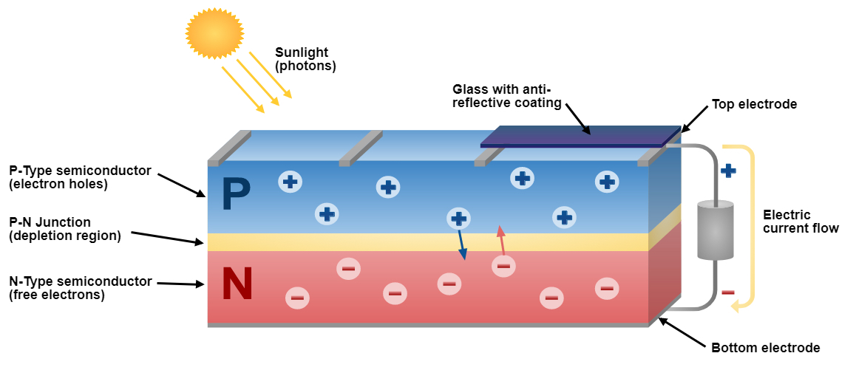

Figure 1 A photovoltaic cell

## 2. LITERATURE REVIEW

Power Electronics has already found an important place in modern technology and has revolutionized control of power and energy. As the voltage and current ratings and switching characteristics of power semiconductor devices keep improving, the range of applications continues to expand in areas such as lamp controls, power supplies to motion control, factory automation, transportation, energy storage, multi megawatt industrial drives, and electric power transmission and distribution.

The greater efficiency and tighter control features of power electronics are becoming attractive for applications in motion control by replacing the earlier electro-mechanical and electronic systems. Applications in power transmission include high-voltage dc (VHDC) converter stations, flexible ac transmission system (FACTS), and static-var compensators. In power distribution these include DC to AC conversion, dynamic filters, frequency conversion, and Custom Power System

**T. Shimizu, O. Hashimoto, and G. Kimura et.al. [1]** This paper shows a novel photovoltaic inverter that can't just synchronize a sinusoidal AC output current with an utility line voltage, yet in addition control the power age of each photovoltaic module in an exhibit. The proposed inverter system is made out of a half-connect inverter at the utility interface and a novel age control circuit which makes up for decreases in the output power of the system that are owing to varieties in the age states of individual photovoltaic modules.

**A. Bidram, A. Davoudi, and R. S. Balog et.al. [6]** “Incomplete concealing in photovoltaic (PV) exhibits renders traditional maximum power point tracking (MPPT) systems insufficient. The diminished productivity of concealed PV exhibits is a critical obstacle in the fast development of the sunlight-based power systems. Consequently, tending to the output power crisscross and fractional concealing impacts is of vital worth. Extracting the maximum power of halfway concealed PV exhibits has been broadly examined in the writing. The proposed arrangements can be classified into four fundamental gatherings. The main gathering incorporates adjusted MPPT systems that appropriately recognize the worldwide MPP. They incorporate power bend slant, load-line MPPT, separating square shapes procedures, the power increase strategy, quick working power enhancement, Fibonacci search, neural systems, and molecule swarm improvement.

**D. Nguyen, and B. Lehman et.al. [9]** This paper proposes a versatile reconfiguration plan to lessen the impact of shadows on sun powered boards. An exchanging lattice associates a sunlight based versatile bank to a fixed piece of a sun based photovoltaic (PV) exhibit, according to a model-based control calculation that expands the power output of the sun powered PV cluster. Control calculations are actualized continuously. A test reconfiguration PV system with a resistive load is displayed and is appeared to confirm the proposed reconfigurations.

**L. F. L. Villa, T.-P. Ho, J.-C. Crebier, and B. Raison et. Al. [11]** This paper ponders a photovoltaic (PV)- module-implanted power-hardware topology got from a battery equalizer. The proposed topology dispenses with the different maximum power point tops regular to fractional concealing in PV modules. The topology does as such by evening out the general energy of the PV module using just a single inductive stockpiling component. A hypothetical report is completed to depict the physical conditions of the topology. In view of it, a model is planned and assembled. It is tried with a mostly concealed PV module, raising its power output by about 40%, best case scenario. The outcomes are contrasted with comparative topologies devoted to alleviate incomplete concealing in PV applications.

**N. Femia, G. Lisi, G. Petrone, G. Spagnuolo, and M. Vitelli et.al. [13]** One of the significant drawbacks of photovoltaic (PV) systems is spoken to by the impact of module confusing and of fractional concealing of the PV field. Distributed maximum power point tracking (DMPPT) is an exceptionally encouraging procedure that permits the expansion of productivity and dependability of such systems. Displaying and structuring a PV system with DMPPT is amazingly more perplexing than actualizing a standard MPPT method. In this paper, a DMPPT system for PV exhibits is proposed and broke down. A dc and small-signal ac model is determined to break down consistent state conduct, just as elements and soundness, of the entire system. At last, reenactment results are accounted for and talked about.

**E. Karatepe, T. Hiyama, M. Boztepe, and M. C. olak, et.al. et,al. [15]** In part concealed photovoltaic (PV) modules commonly show extra challenges in tracking the maximum power point since their power–voltage characteristics are mind boggling and may have different nearby maxima. Therefore, customary methods neglect to track the maximum power point viably if the PV exhibit is mostly concealed or a portion of its cells are harmed. This paper displays a novel power remuneration system for PV clusters for muddled non-uniform insolation conditions. The proposed system depends on recouping the power of non-concealed PV modules into the system again totally by forward biasing a detour diode of the concealed PV modules. For this reason, the proposed system utilizes dc–dc converters outfitted with each PV string in the PV cluster. For distinguishing which concealed PV modules ought to be deactivated, the working voltage of the PV modules are checked and thought about. The proposed system empowers the non-concealed PV modules to work successfully at their ordinary maximum power point. The adequacy of the proposed system is explored and affirmed for convoluted mostly concealed PV array.

**3. CONTROL STRATEGY**

**3.1 DESIGN OF****PHOTO VOLTAIC ARRAY**

For effective boundless power age PVA is connected to make control from sunshine essentially based gentle. since the heap solicitation is growing gradually the quality age furthermore ought to be expanded, anyway on account of the regular strategy for power age is causing an unnatural climate change, due to this the capability of the PVA should be raised through alongside silicon surface the board and in addition, use the MPPT procedures to follow most extreme serious quality in the midst of any light and cools. The blueprint of PVA is finished in MATLAB with Simulink.

Voltage of PVA thoroughly depends on sunlight based orientated enlightenment (Sx) and encompassing temperature (Tx). PVA (picture voltaic grandstand) is a blend of affiliation and parallel solar cells arranged in a group to deliver the ideal voltage and contemporary. every affiliation blend of cells might be cons

idered as photo voltaic module. Addition in affiliation cells extends the voltage and augmentation in parallel cells manufactures as far as possible. Itemizing for voltage of every cell is given beneath

*Vc= ln ($\frac{I_{ph}+I_{o}-I_{c}}{I_{o}}$)-RsIc*(1)

Where, k = Boltzmann constant (1.38 × 10-23 J/K).

Ic = cell output current, Amp.

Iph= photocurrent

Io = reverse saturation current of diode 18601207777

Rs= series resistance of cell

Tc= reference cell operating temperature

Vc= cell voltage, V.

The DC-DC converter used as a piece of the MPPT can be either a Cuk converter or a buck boost converter. The voltage yield of the PVA both should be quickened or blurred with respect to the delivered intensity of the PVA. The converter makes the voltage consistently with the alteration inside the temperature or the light. The control structure can give a commitment cycle regard which is appeared differently in relation to the triangular waveform and heartbeat is created encouraged to the exchange gave. The duty cycle is made by method for using the underneath computation.

**3.1.1 Maximum Power Point Tracking Algorithms**

MPPT algorithms are necessary in PV applications because the MPP of a solar panel varies with the irradiation and temperature, so the use of MPPT algorithms is required in order to obtain the maximum power from a solar array.

**3.1.1.1 Perturb and Obseve Method**

There are different type of MPPT technique using for solar pv .Perturb and observe The P&O algorithm is also called “hill-climbing”, but both names refer to the same algorithm depending on how it is implemented. Hill-climbing involves a perturbation on the duty cycle of the power converter and P&O a perturbation in the operating voltage of the DC link between the PV array and the power converter [8]. In the case of the Hill-climbing, perturbing the duty cycle of the power converter implies modifying the voltage of the DC link between the PV array and the power converter, so both names refer to the same technique. In this method, the sign of the last perturbation and the sign of the last increment in the power are used to decide what the next perturbation should be. As can be seen in Figure 2 on the left of the MPP incrementing the voltage increases the power whereas on the right decrementing the voltage increases the power.

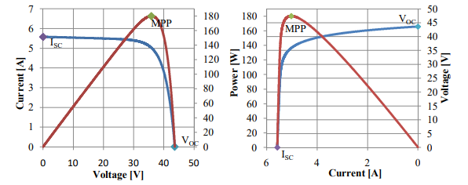

**Figure 2 PV panel characteristic curves.**

If there is an increment in the power, the perturbation should be kept in the same direction and if the power decreases, then the next perturbation should be in the opposite direction. Based on these facts, the algorithm is implemented [8]. The process is repeated until the MPP is reached. Then the operating point oscillates around the MPP. This problem is common also to the InCond method, as was mention earlier. A scheme of the algorithm is shown in Figure 3.2.

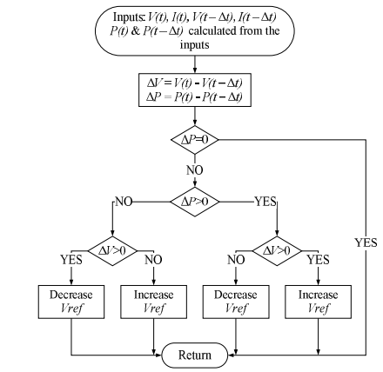

**Figure 3 The flowchart of the P&O**

**3.1.2 Incremental conductance**

The incremental conductance algorithm is based on the fact that the slope of the curve power vs. voltage (current) of the PV module is zero at the MPP, positive (negative) on the left of it and negative (positive) on the right. By comparing the increment of the power vs. the increment of the voltage (current) between two consecutives samples, the change in the MPP voltage can be determined.

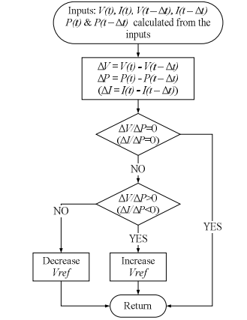

**Figure 4 Incremental Conductance**

**4.PROPOSED METHODLOGY**

**4.1 DUAL BUCK-BOOST INVERTER AND ITS OPERATION**

The schematic of the proposed Dual Buck & Boost based Inverter (DBBI) which is depicted in Fig.4.1 V is comprising of a dc-to-dc converter stage followed by an inverting stage. The dc-to-dc converter stage has two dc to dc converter segments, CONV1 and CONV2 to service the two subarrays, PV1 and PV2 of the solar PV array. The segment, CONV1 is consisting of the self-commutated switches, S1 along with its anti-parallel body diode, D1, S3 along with its anti-parallel body diode, D3, the freewheeling diodes, Df1, Df3 and the ﬁlter inductors and capacitors, L1, Cf1, and Co1. Similarly, the segment, CONV2 is consisting of the self-commutated switches, S2 along with its anti-parallel body diode, D2, S4 along with its anti-parallel body diode, D4, the freewheeling diodes, Df2, Df4 and the ﬁlter inductors and capacitors, L2, Cf2, and Co2. The inverting stage is consisting of the self-commutated switches, S5, S6, S7, S8, and their corresponding body diodes, D5, D6, D7 and D8 respectively. The inverter stage is interfaced with the grid through the ﬁlter inductor, Lg. The PV array to the ground parasitic capacitance is modeled by the two capacitors, Cpv1 and Cpv2.

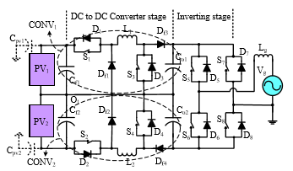

**Fig. 5 Dual Buck & Boost based Inverter (DBBI)**

**4.2 FUZZY LOGIC CONTROLLER**

The fuzzy controller has four main components: The rule-base, that holds the knowledge in the pattern of a set of rules that, describes the finest way to control a system. The membership functions are used to quantify knowledge. The inference mechanism states which control rules are relevant next to the current time and then decides which input of the plant should be enabled. The fuzzification interface modifies the inputs, such a way that they can be interpreted and compared to the rules in the rule-base. The defuzzification interface transforms the conclusions reached by the inference mechanism into the inputs of the plant. Fig. 4 is shows the schematic diagram of fuzzy logic controller.

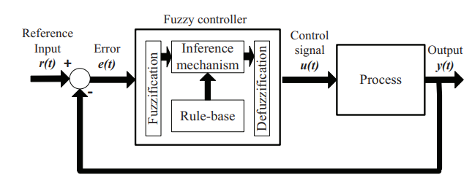 **Figure 6 Scheme of a fuzzy logic controller**

**4.3 Description of fuzzy logic tools**

Unlike Boolean or crisp logic Fuzzy logic, deal with vague, imprecise and uncertain problems and uses membership functions whose values vary between 0 and 1. Figure 5.3 shows a schematic block diagram of fuzzy inference system or fuzzy controller. It consists of following working blocks: -

• Fuzzification Interface

• Knowledge base

• Decision making logic

• Defuzzification

Since it is a two-dimensional fuzzy control, a fuzzy logic controller must possess proportional integral control effects. An integral action is usually needed to achieve the best performance in practical situation.

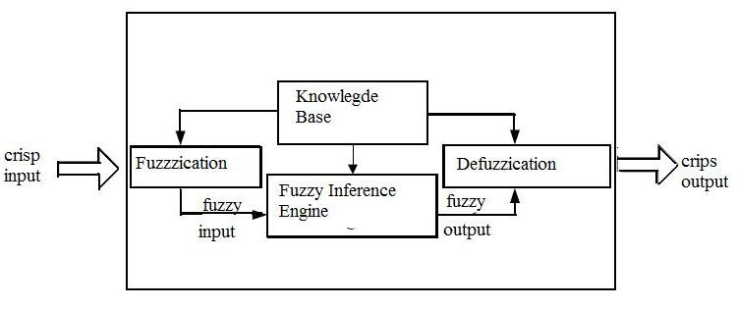

**Figure 7 Fuzzy Inference System**

**5.CONCLUSION**

A single-phase grid connected transformer less buck and boost based PV inverter which can operate two sub arrays at their respective MPPT was proposed in my paper. Here two pv sub array are two different located so that output should be maintain at any cases. The attractive features of his inverter were effect of mismatched environmental conditions on the PV array single phase inverter with pi control is more stable compared to single phase inverter with fuzzy logic control .

**REFERENCES:**

[1] T. Shimizu, O. Hashimoto, and G. Kimura, “A novel high-performance utility-interactive photovoltaic inverter system,” IEEE Trans. Power Electron., vol. 18, no. 2, pp. 704-711, Mar. 2003.

[2] S. V. Araujo, P. Zacharias, and R. Mallwitz, “Highly efﬁcient single-phase transformerless inverters for grid-connected photovoltaic systems,” IEEE Trans. Ind. Electron., vol. 57, no. 9, pp. 3118-3128, Sep. 2010.

[3] B. Ji, J. Wang, and J. Zhao, “High-efﬁciency single-phase transformerless PV H6 inverter with hybrid modulation method,” IEEE Trans. Ind. Electron., vol. 60, no. 5, pp. 2104-2115, May 2013.

[4] R. Gonzalez, E. Gubia, J. Lopez, and L. Marroyo, “Transformerless single phase multilevel-based photovoltaic inverter,” IEEE Trans. Ind. Electron., vol. 55, no. 7, pp. 2694-2702, Jul. 2008.

[5] H. Xiao and S. Xie, “Transformerless split-inductor neutral point clamped three-level PV grid-connected inverter,” IEEE Trans. Power Electron., vol. 27, no. 4, pp. 1799-1808, Apr. 2012.

[6] A. Bidram, A. Davoudi, and R. S. Balog, “Control and circuit techniques to mitigate partial shading effects in photo voltaic arrays,” IEEE J. Photovolt., vol. 2, no. 4, pp. 532-546, Oct. 2012.

[7] N. D. Kaushika, and N. K. Gautam, “Energy yield simulations of interconnected solar PV arrays,” IEEE Trans. Energy Convers., vol. 18, no. 1, pp. 127-134, Mar. 2003.

[8] H. Patel, and V. Agarwal, “Maximum power point tracking scheme for PV systems operating under partially shaded conditions,” IEEE Trans. Ind. Electron., vol. 55, no. 4, pp. 1689-1698, Apr. 2008.

[9] D. Nguyen, and B. Lehman, “An adaptive solar photovoltaic array using model-based reconﬁguration algorithm,” IEEE Trans. Ind. Electron., vol. 55, no. 7, pp. 2644-2654, Jul. 2008.

[10] G. V.-Quesada, F. G.-Gispert, R. P.-Lopez, M. R.-Lumbreras, and A. C.-Roca, “Electrical PV array reconﬁguration strategy for energy extraction improvement in grid-connected PV systems,” IEEE Trans. Ind. Electron., vol. 56, no. 11, pp. 4319-4331, Nov. 2009.

[11] L. F. L. Villa, T.-P. Ho, J.-C. Crebier, and B. Raison, “A power electronics equalizer application for partially shaded photovoltaic modules,” IEEE Trans. Ind. Electron., vol. 60, no. 3, pp. 1179-1190, Mar. 2013.

[12] P. Sharma, and V. Agarwal, “Maximum power extraction from a partially shaded PV array using shunt-series compensation,” IEEE J. Photovolt., vol. 4, no. 4, pp. 1128-1137, Jul. 2014.

[13] N. Femia, G. Lisi, G. Petrone, G. Spagnuolo, and M. Vitelli, “Distributed maximum power point tracking of photovoltaic arrays: novel approach and system analysis,” IEEE Trans. Ind. Electron., vol. 55, no. 7, pp. 2610-2621, Jul. 2008.

[14] C. Olalla, C. Deline, D. Clement, Y. Levron, M. Rodriguez, and D. Maksimovic, “Performance of power-limited differential power processing architectures in mismatched PV systems,” IEEE Trans. Power Electron., vol. 30, no. 2, pp. 618-630, Feb. 2015.

[15] E. Karatepe, T. Hiyama, M. Boztepe, and M. C. olak, “Voltage based power compensation system for photo voltaic generation system under partially shaded insolation conditions,” Energy Convers.and Manage., vol. 49, pp. 2307-2316, Aug. 2008.

[16] A. A. Elserougi, M. S. Diab, A. M. Massoud, A. S. Abdel-Khalik, andS. Ahmed, “A switched PV approach for extracted maximum power enhancement of PV arrays during partial shading,” IEEE Trans. Sustain. Energy, vol. 6, no. 3, pp. 767-772, Jul. 2015.

[17] I. Patrao, G. Garcera, E. Figueres, and R. Gonzalez-Medina, “Grid-tie inverter topology with maximum power extraction from two photovoltaic arrays,” IET Renewable Power Gener., vol. 8, no. 6, pp. 638-648, 2014.

[18] D. Debnath and K. Chatterjee, “Maximising power yield in a trans-formerless single phase grid connected inverter servicing two separate photovoltaic panels,” IET Renewable Power Gener., vol. 10, no. 8, pp. 1087-1095, 2016.

[19] N. A. Ahmed, H. W. Lee, and M. Nakaoka, “Dual-mode time-sharing sine wave-modulation soft switching boost full-bridge one-stage power conditioner without electrolytic capacitor DC link,” IEEE Trans. Ind. Appl., vol. 43, no. 3, pp. 805-813, May/Jun. 2007.

[20] Z. Zhao, M. Xu, Q. Chen, J. S. Lai, and Y. Cho, “Derivation, analysis, and implementation of a Boost–Buck converter-based high-efﬁciency PV inverter,” IEEE Trans. Power Electron., vol. 27, no. 3, pp. 1304-1313, Mar. 2012.

[21] W. Wu, J. Ji, and F. Blaabjerg, “Aalborg inverter a new type of buck in buck, boost in boost grid-tied inverter,” IEEE Trans. Power Electron., vol. 30, no. 9, pp. 4784-4793, Sept. 2015.

[22] R. Teodorescu, M. Liserre and P. Rodriguez, Grid converters for photovoltaic and wind power systems, John Wiley & Sons Ltd., 2011, ISBN: 978-0-470-05751-3.

[23] W. Li, Y. Gu, H. Luo, W. Cui, X. He, and C. Xia, “Topology review and derivation methodology of single phase transformerless photovoltaic inverters for leakage current suppression,” IEEE Trans. Ind. Electron., vol. 62, no. 7, pp. 4537-4551, Jul. 2015.

[24] W. Wu, Y. He, and F. Blaabjerg, “An LLCL power ﬁlter for single-phase grid-tied inverter,” IEEE Trans. Power Electron., vol. 27, no. 2, pp. 782-789, Feb. 2012.

[25] D. Debnath and K. Chatterjee, “Maximising power yield in a transformerless single phase grid connected inverter servicing two separate photovoltaic panels,” IET Renewable Power Generation, vol. 10, no. 8, pp. 1087-1095, 2016