ASSESMENT OF THE INTZE WATER TANK FOR VARIOUS CONICAL DOME ANGLES
MUHAMMAD AZIJ¹, RAKESH SAKALE², HIRENDRA PRATAP SINGH³
PG Student¹, Prof.², Prof.³
School of Research & Technology, People’s University Bhopal (M.P.)

ABSTRACT
A professional engineering subject known as Civil Engineering is concerned with the planning, development, and upkeep of the built environment, including structures like buildings, roads, bridges, canals, dams, and bridges. Within the field of civil engineering, structural engineering deals with the analysis and design of structures that are intended to support or withstand loads. Municipalities and enterprises utilise liquid storage tanks extensively for firefighting and water delivery systems. Water tanks, with their primary function of guaranteeing a steady flow of water from a greater distance with a suitable static head to the intended place under the influence of gravitational force, are therefore essential to public utilities as well as industrial structures.
In this research we analyze the 1000 m³ Intze tank and then modifies the conical dome angle from 45⁰, 51⁰ and 56⁰ to modify the Tan K configuration. Staad Pro is software used for developing, evaluating, and modelling structural parts. Models are run both with and without data. In wind zone 2, comparisons are made between the analytical results for bending moment displacement of joints, axial and shear force, hoop tension, meridional thrust, etc.
CHAPTER-1
INTRODUCTION
  - GENERAL
The source of all concepts is water. In day-to-day existence, water is essential. The most effective storage option for residential or even commercial use is an overhead liquid storage tank. Depending on where the water tank is located, the tanks may be referred to as overhead, on-ground, or underground water tanks. Rectangular, round, and Intze types can be used to create the tanks in a variety of shapes. The elevated water tanks are usually smaller in capacity and are constructed by gravity to directly carry water. The public can reach elevated water tanks both nearby and far away. In India, Intze type tanks are widely utilised. Currently, a lot of overhead water tanks are available for public usage. The purpose of water tanks is to store water for various purposes such as drinking water, water systems, fires, forestry, farming, plants and animals, chemical assembly, food preparation, and many more. Water tanks have been around for almost as long as human progress. The cost, size, shape, and construction of the materials used to manufacture water tanks are all impacted by the water tank limit. The examination of the several RCC water tanks that were built in the past and were situated at different heights between low and high found evidence of damage from wind, earthquakes, and water pressure. An crucial step towards developing a long-term awareness of the particular risks and hazards to the public was the finding of the wind impacts. Strong bonded tanks were used to increase most water supply frameworks in developing nations like India. The main goal of this review is to improve knowledge about wind forces' effects on structures like the Intze tank and its many conical wind domes.

1.2 REINFORCED CONCRETE WATER TANK

Reinforced concrete is used to build water tanks for storage. An IS 3370: 2009 (Parts I–IV) water tank is designed with reinforced concrete. The layout of the tanks is determined by their location, whether they are underground, above ground, or both. The tanks are mostly used in various forms and are often constructed in circular or rectangular designs. Reinforced concrete or steel can be used to make the tanks. Usually, the overhead tanks are elevated from the roof through the base. The tanks are positioned on the foundation on the other side.

1.3 INTZE TANK
With a horizontal or flat floor slab and a maximum storage capacity of 200,000 litres, circular tanks with diameters between 5 and 8 metres are a cost-effective option. Generally, the storage is between three and four metres deep. Since the side walls are fixed to the floor slab at the junction, they are intended to withstand bending moment and circumferential hoop tension. Through the use of coefficients suggested in IS: 3370 (part IV), the design forces are calculated. When the diameter is large
Higher circular tanks necessitate thicker floor slabs, which makes dome construction unfeasible. An affordable alternative in these situations is an Intze type tank with bottom spherical dome and conical dome. As everyone knows, the best civil engineering construction is determined by its economic design. The following proportioning of various structural parts of an Intze type tank top spherical dome makes up the notion of an Intze tank.
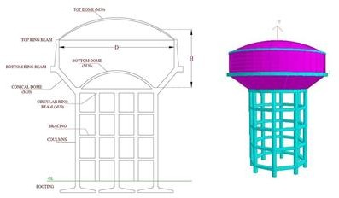
The top ring beam, the conical dome, the bottom spherical dome, the bottom circular girder, the columns and braces, and the foundations are all pictured.
Figure1 Intze Water Tank
1.4 WIND LOAD

Since wind strength is the primary cause of wind disasters for diverse structures, a detailed examination of various structures in wind load activity is necessary. Wind pressure becomes a crucial load factor when researching and building tanks because of the height and form of the water tanks, which causes lateral movement. Because of the wind load, lateral movement in the tank results in water slip and extra vibrations. It is necessary to look into how the high water tank reacts to varying wind pressure in various terrain types.

Code Based Wind Analysis: • Designed using IS-875 part-III as a basis: Analysing raised cement concrete water tanks correctly against horizontal forces is crucial. The goal of the current investigation is to determine the degree of wind load on the upper roof of raised water tanks throughout different regions of India.

CHAPTER-2

LITERATURE REVIEW
2.1 REVIEW OF RELATED RESEARCH
In view of being critical element for storing large amount of water for an area, large number of studies on previous literature have been made for looking into various aspects of Intze tanks and comparing it with other alternatives.
Shivprasad Dundage¹ and Prof. N.P. Phadtare², 2023 explain about overhead water tank is a water storage facility supported by a tower and constructed at an elevation to provide useful storage and pressure for a water distribution system. Safety as well as working of such structures is considered as very crucial during earthquakes, since they put up for necessities like drinking water, firefighting during fire accidents, etc. Such structures should stay in operating condition even after several earthquakes. This RC overhead water tanks involves huge water mass supported on the top of tank supporting system known as staging. This investigation is basically to discover the seismic behavior of RC overhead water tanks. In this study, a FEM based model is used for finding out the nonlinear seismic performance of RC overhead water tanks with several staging variations. The staging that is different bracing patterns considered in this study in lateral and vertical direction, which relatively increases the strength and stiffness of tank in supporting system. Staad models are prepared and analyze for different seismic zones as well as for cyclonic regions and observed the parameters such as base shear, base moment and lateral displacement. The commercial software STAAD.Pro is used for structural analysis. Since the seismic response of water tank structure depends on its dynamic properties and frequency of ground motion. This seismic analysis of overhead water tank structure cannot be carried out on the basis of maximum value of ground acceleration because of nonavailability of ground acceleration data at every location. Hence for seismic analysis of overhead water tank, earthquake response spectrum analysis is widely used. While using this method, smooth design spectra is used to determine the value of displacement and forces in members at every mode of vibration. Octagonal, Radial, Cross, Alternate tie , Diagonal and X- type bracings are used to analyze the structure under all the seismic zones viz. II, III, IV & V. Also observed the behavior of tank for cyclonic region where wind load is increased by 30%. Analysed the overhead water tanks of same capacity for different bottom dome deviation angles and concluded.
Tarun and Mrs. Monika, 2023 According to their shocking findings of the past, several elevated water tanks made of reinforced concrete have collapsed or been severely damaged as a result of earthquakes in different parts of the world. The breakdown of the supporting system was due to the causes that have been generally observed, which demonstrates that the supporting system of raised tanks has a more vital relevance than the supporting systems of other structural types of tanks. The majority of the damage that is seen as a result of seismic activity is caused by factors such as inappropriate and unsuitable design of supporting system, errors made during selection of supporting system, improper arrangement of supporting parts, underestimated demand or exaggerated strength, etc. Therefore, the purpose of this study is to determine the efficacy of various supporting systems of elevated tanks that have undergone various modifications, such as using a variety of different types of bracing systems for intze tanks. In this study, a time history analysis of the tank was performed while taking into account the dual mass system in sap2000. A comparison was then made between the results of base shear, base moment, and displacement. Finally, the study revealed how important it is to have a suitable supporting configuration in order for elevated water tanks to remain resistant to heavy damage or failure during seismic events.
Adilakshmi Bugatha (2016)¹ et al. - Presented that, overhead tanks and Storage archives are utilized to keep water. Each tank is made out of part free structures to discard any spillage. In this wander, working weight methodology is used to diagram an Intze tank and Elements of the Intze tank are created by restricting state system. When in doubt, for a given point of confinement, a circuitous shape is supported in light of the way that tensions are uniform and lower diverged from various shapes. Smaller tensions suggest diminished measures of the material imperative for improvement that chops down the advancement cost of water tanks. The key focus of this paper is to give best measures of the required measure of bond and steel for a given water holding limit. Setting up the arrangement, estimation, costing, examination of frameworks and cost connection of yield outlines for various information sources are fused into this report.
Ahmed Musa (2015)² et al. - Presented that, Steel fluid stockpiling tanks inside the state of truncated cones are regularly used as regulation vessels for water conveyance or putting away compound substances. Various disappointments were recorded in the past couple of decades for metallic fluid tanks and storehouses underneath wind stacking. A steel cone-shaped tank vessel can have an unmistakably lesser thickness making it defenceless to locking beneath twist stacks specifically when they're not completely filled. In this examination, a breeze burrow weight investigates is executed on an extended funnel-shaped tank with the goal that you can assess the outside breeze weights when submerged in a limit layer. The tried tank setup speaks to mixed cone-shaped tanks wherein the cone is topped with a barrel. What's more, the effect of territory attention and twist speed on the weight esteems and wind powers are classed. The propose and rms weight coefficients are provided for phenomenal test occurrences further to the recommend and rms general drag powers which can be procured by means of incorporating the weight coefficient over the tank model's surface. Its found that the aggregate recommend and rms drag powers are very reliant on Reynolds wide assortment that is a normal for wind speed and that they have the greatest cost at mid-top for the diminishing barrel, at the best for the tapered component, and at the base for the upper round and hollow part .
B. Dean Kumar and B.L.P. Swam (2010)⁴ - Presented that, Wind streams with respect to the surface of the ground and produces the stack on the frameworks status at the ground. The impact of the breeze on the structures is of prime significance. The vast majority of the creators remember the static effect of twist on the structure. In any case, for tall frameworks the breeze interfaces with the structure progressively. The Indian across the board code IS 875 (Part- 3) 1987 offers with the breeze impacts at the structures. Water towers are basic structures from the purpose of the breeze impact. Towers of stature 16 m, 20 m, 24 m and 28 m are considered in the present investigation. Essential recurrence is calculated through methods for the system given in Indian general IS 1893- 1984. In the calculation of basic recurrence conditions (a) Tank purge and (b) Tank full of water are contemplated. It's found from the analysis that static weights are less in contrast with the ones given by means of the blast adequacy thing procedure (GEFM). Dynamic interchange in the midst of the fluctuating breeze perspective and the shape are considered in GEFM and comparable static breeze weights are developed. GEFM is more level headed and reasonable and suggested for wind stack plan of water towers.
Deepa Dubey (2017)⁵ et al. - Overhead Intze type tank is a form of expanded water tank resting on staging. Bottom part of circular tank of Intze tank is abounding in flat structure, thus in flat bottom, the thickness and reinforcement is set up to be high. This work aims to study the performance of the Overhead water tank of Intze type under the action of basic wind loads in different terrain category. Commonly water tank is analysed as in step with the code IS 875 (element 3) and layout of water tank dome is executed as consistent with IS code 3370-1987 in working stress approach and the staging (column and beams) are designed as per IS code 456-2000 in limit state method. In addition the present work deals with the Wind analysis of elevated Intze type water tank using Staad-Pro Software package. Wind study of reinforced concrete Intze tank is finished at one of a kind staging heights of tank with the aid of assuming to be located in exclusive wind zones in India of different terrain categories. Different parameters like as Design wind forces, displacements because of wind forces at unique heights of water tank are in comparison in one of a kind wind zones
Nitesh J Singh and Mohammad Ishtiyaque (2015)¹⁴ - The Water Tanks outline that subjected to Live Load, Dead Load and Seismic Load or Wind Load as indicated by IS codes of Practices. Greatest time's tanks are intended for Wind Forces and now not, in any case, checked for Earthquake Load assuming which the tanks will be protected underneath seismic powers once got ready for wind powers. In this have an investigation of wind Forces and Seismic Forces following up on an Intze Type Water tank for Indian conditions are the examination. The result of the twist on the hoisted frameworks is of most elevated importance as Wind stream moves to the ground surface and makes loads at the status of the framework on the ground. The majority of the planners keep in mind the breeze impact and disregard the seismic impact at the shape. The Indian Standard Code IS 875(Part-3) 2003 and IS 1893-2000 for Wind and Seismic impact is utilized as a part of this investigation. The Elevated Structure
is intended for different Wind powers i.e. 39 m/s, 44 m/s, 47 m/s and 50 m/s and the same is cross-checked with various Seismic Zones i.e. Zone-II, Zone-III, Zone-IV, and Zone-V by 'Reaction Spectrum Method and the most extreme administering condition from both the powers is additionally utilized for plan and examination of arranging. Its saw from the examination that the Entire load, Entire minutes and Reinforcement in organizing i.e. Columns, Braces and additionally for Raft establishment shifts for Case-1, Case-2, Case-3 and Case-4 Rajesh Cherukupally (2015)¹⁵ et al. - Presented that, in locales with most elevated catastrophic events likelihood, living ability frameworks to oppose fiasco related harms is a huge structural building challenge. Hoisted water tanks are important living structures. A sizeable computational investigation has been led to look the quickened general execution of water tank under breeze pressure. Since these structures have immense mass gathered at the upper of the thin supporting building, these structures are exceptionally vulnerable to even powers in view of wind. Limited variables models of 24 raised water tanks have been examined. Lifted water tanks are contemplated with various parameters to investigation the rooftop relocations, base minutes and base shears. Inquiry of the leaving study might lead us to a better comprehension of the raised water tank conduct under breeze stack and more secure outline of such structure .

CHAPTER-3

RESEARCH METHODOLOGY
  - GENERAL
This study analyses an Intze tank by creating a model of the tank under both full and empty situations, using varying conical dome angles. Various models are studied in relation to wind load. Various inferences are formed by comparing the outcomes of the models.
Analysis of the Models
Full tank Condition
Empty tank Condition
Results
Comparison of Result and discussion
Figure 2 Flow Chart
Conclusion

Using Staad Pro V8i (SS6) software, the study analyses the Intze tank with various conical dome angles and compares them in terms of axial force, shear force, bending moment, displacement, hoop tension, and meridional thrust.

PROBLEM IDENTIFICATION

Industrial and public water tanks are vital infrastructure. The physics of the material, climate, and current building practices all influence the design and construction techniques used in reinforced concrete. Prior to beginning the design, the designer needs to choose the best kind of staging tanks. Correct assessment of loads, including static balancing of structure, is necessary, especially for overturning the overhanging members. When the tank is both full and empty, the model should be based on the worst-case load combination and shears caused by both vertical and horizontal loads operating in any direction. These days, water conservation is of utmost importance since, as humanity grows, water becomes more and more necessary for survival. Water storage needs to be adequately treated because it is used for drinking, irrigation, industrial generation, fighting fires, and other purposes. The Water Tank is a huge water storage tank. The water tanks are intended to be used for rainwater tank storage, emergency storage, product manufacture, and ground storage of water for daily consumption. In human society, the water tank is a crucial structure for civil engineering. Water storage tanks come in a variety of forms to help advance human civilization. When building a concrete structure for the purpose of storing liquids, such as water, the impermeability of the material is crucial. The water cement ratio is the primary determinant of the permeability of all conventional, stiff, and compacted concrete with certain mixed ratios. More permeability is a result of the water cement ratio rising. As a result, it is ideal for the water cement ratio to fall; however, a much lower water cement ratio may result in compaction issues and also show to be detrimental. In order to maximise its tensile strength, the fluid retention system's design must be centred on preventing cement cracks. Cracks can be avoided by using thick wood shutters that block the simple passage of heat caused by the weight of the concrete. One can prevent cracks. The chance of a crack can also be reduced by lowering limitations on the structure's ability to expand or contract freely. It's been stated that poorly constructed buildings, not natural calamities, are the true source of human mortality. The primary cause of fatalities is building collapse. As a result, the construction must be appropriately inspected for a variety of natural disasters, including typhoons, floods, cyclones, and earthquakes.
Table 1 TANK DETAILS
S.  No | Particulars | Size/value | Size/value | Size/value
1 | Angle Conical dome (degrees) | 45⁰ | 51⁰ | 56⁰
2 | Capacity of tank (m³) | 1000 | 1000 | 1000
3 | Unit weight of concrete (kN/ m³) | 25 | 25 | 25
4 | Grade of concrete (Mpa) | M30 | M30 | M30
5 | Grade of steel (Mpa) | Fe415 | Fe415 | Fe415
6 | Thickness of top dome(mm) | 100 | 100 | 100
7 | Rise of top dome ( m) | 2 | 2 | 2
8 | Diameter of tank ( m) | 14 | 15 | 16
9 | Height of cylindrical wall (m) | 5.5 | 5 | 4
10 | Thickness of cylindrical top mm | 200 | 200 | 200
11 | Thickness of cylindrical bottom ( mm) | 300 | 300 | 300
12 | Section of Top ring beam ( m) | 0.4x 0.4 | 0.4x 0.4 | 0.4x 0.4
13 | Rise of conical dome ( m) | 2 | 2 | 2
14 | Thickness of conical dome (mm) | 500 | 500 | 500
15 | Rise of bottom dome (m) | 1.8 | 1.8 | 1.8
16 | Thickness of bottom dome (mm) | 250 | 250 | 250
17 | Number of columns | 8 | 8 | 8
18 | Section of bottom ring beam ( m) | 1.2x0.6 | 1.2x 0.6 | 1.2x 0.6
19 | Total height of staging ( m) | 18 | 18 | 18
20 | Diameter of columns ( m) | 0.75 | 0.75 | 0.75
21 | Section of bracing (m) | 0.5 x 0.5 | 0.5 x 0.5 | 0.5 x 0.5
22 | Section of bottom circular beam (m) | 1.2x0.75 | 1.2x0.75 | 1.2x0.75
  - LOADS

Dead Load
Water pressure and self-weight are taken into account

Live Load
Live load = 1.5 KN/m²

Wind Load
Basic wind speed = 39 m/s

CHAPTER-4

RESULTS AND DISCUSSION
The current study compares several characteristics for different angles of the Intze tank's conical dome, including axial force, shear force, displacement, bending moment, hoop tension, and meridional thrust. Results from the study of the Intze tank can be compared both graphically and tabularly.

AXIAL FORCE
If an axial load or force that acts through the centric or geometric axis of the structure is applied to the structure along a length or perpendicular to the cross- section of the component.

Table 2 Axial force for different angles of conical dome
Angle of Conical Dome | Axial force (KN)
Angle of Conical Dome | Empty Tank | Full Tank
45 degree | 1415.62 | 4141
51 degree | 1478.79 | 4208.59
56 degree | 1557.05 | 4328.46

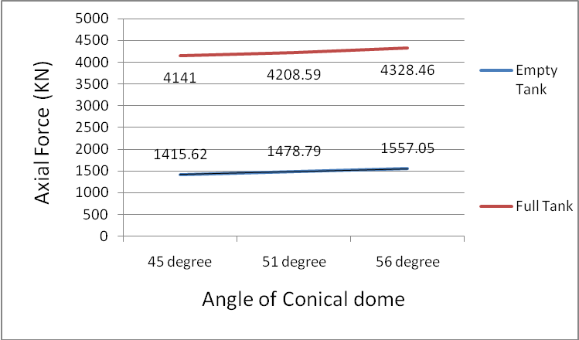
Graph 1 Variation of axial force with conical dome angles
After examining a number of models, we can sum up the findings as follows:
1. In the case of an empty Intze tank, the axial force is greatest at an angle of 56 degrees and lowest at 45 degrees for the conical dome. The shift in the tank's geometry results in an increase in the value of axial force.
2. When the Intze tank is fully charged, the axial force reaches its maximum at an angle of 56 degrees and its minimum at 45 degrees. The shift in the tank's geometry results in an increase in the value of axial force.
3. Because water exerts hydrostatic pressure, values of axial force are significantly higher in tank full conditions than in empty ones when compared to empty conditions.

SHEAR FORCE

Unaligned pressures called shear forces push one portion of a body in one direction and another in a different direction.

Table 3 Shear force for different angles of conical dome
Angle of Conical Dome | Shear force (KN)
Angle of Conical Dome | Empty tank | Full tank
45 degree | 166.1 | 554.61
51 degree | 185.96 | 633.44
56 degree | 205.78 | 643.81

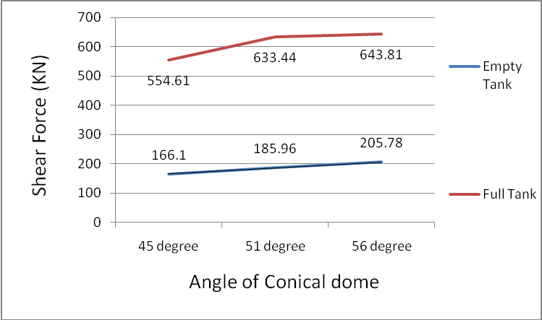
Graph 2 Variation of shear force with angle of conical dome
After examining different models, the outcomes can be summed up as follows:
1.Shear force for an empty Intze tank is greatest at 56 degrees of conical dome angle and lowest at 45 degrees of dome angle. The shift in the tank's shape results in an increase in shear force.
2. In the case of an Intze tank in full condition, shear force is greatest at an angle of 56 degrees and lowest at an angle of 45 degrees of the conical dome. The shift in the tank's shape results in an increase in shear force.
3. Because water exerts hydrostatic pressure, shear force values are significantly higher in full tanks than in empty ones as compared to empty ones.

5.3BENDING MOMENT

The bending moment is the result of an external force or moment acting on an element to cause it to bend. A beam is the simplest and most fundamental component of a construction that is subject to curvature.

Table 4 Bending moment for different angles of conical dome
Angle of Conical Dome | Bending moment(kNm)
Angle of Conical Dome | Empty tank | Tank full
45 degree | 328.6 | 1228.55
51 degree | 388.4 | 1412.6
56 degree | 409.8 | 1722.29

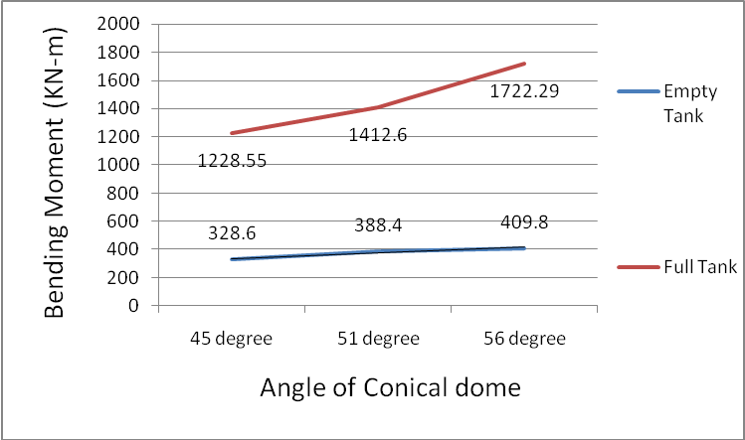
Graph 3 Variation of bending moment with angle of conical dome
After examining a number of models, we can sum up the findings as follows:
1. For an empty Intze tank, the bending moment is greatest at an angle of 56 degrees and lowest at an angle of 45 degrees for the conical dome. The shift in the tank's geometry results in an increase in the bending moment value.
2. In the case of an Intze tank in full condition, the bending moment is greatest at an angle of 56 degrees and lowest at an angle of 45 degrees of the conical dome. The shift in the tank's geometry results in an increase in the bending moment value.
3. Due to the water's hydrostatic pressure application, bending moment values are significantly higher in full tanks than in empty ones as compared to empty ones.The maximum bending moment of an intze tank under both filled and empty conditions increases as the angle of the conical dome increases. The same is consistent with Shubham Gautam's (2017)19 findings.

4.3 MERIDIONAL THRUST

The orientation along the longitudinal axis of a solid revolution is referred to as meridional. The longitudinal thrust is another name for meridian thrust.

The conical dome's meridional thrust results from weights or other vertical forces acting on its base. The thickness across the wall on the curve's radius is referred to as the radial. The top dome weight, the cylinder wall, and so forth make up the entire load.

Table 5 Meridional Thrust for different angles of conical dome
Angle Conical dome | Empty tank |  | Full tank
Angle Conical dome | Meridional Thrust (Bottom dome) KN | Meridional Thrust (Conical dome)  KN | Meridional Thrust (Bottom dome) KN | Meridional Thrust (Conical dome)  KN
45  Degree | 81.75 | 221.05 | 738.75 | 421.5
51  Degree | 90.5 | 242.5 | 684.25 | 473.62
56  Degree | 102.25 | 262.5 | 625.25 | 554.25

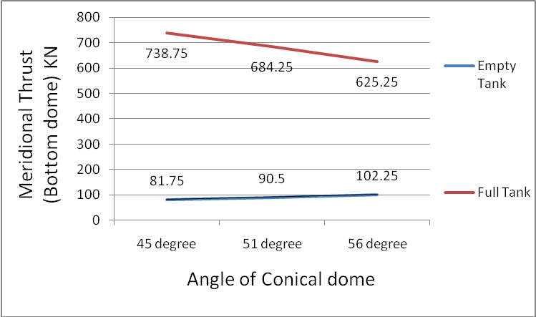
Graph 4 Variation of meridoinal thrust (Bottom Dome) in empty and full tank with angle of conical dome
After examining a number of models, we can sum up the findings as follows:
1. For an empty Intze tank, the meridional push in the bottom dome is greatest at an angle of 56 degrees, then 51 degrees, and lowest at an angle of 45 degrees. The shift in the tank's geometry results in an increase in the value of hoop tension.
2. When the Intze tank is empty, the meridional push in the conical dome reaches its maximum at an angle of 56 degrees, then 51 degrees, and its minimum at an angle of 45 degrees. As the conical dome's angle increases, the value rises as a result of the geometrical change in the dome.
It is discovered that the results of meridional thrust on bottom and conical domes are similar to those found in the standard book "Advanced Reinforced Concrete Vol.2, 7th Edition." Written by H.J. Shah (2014)7
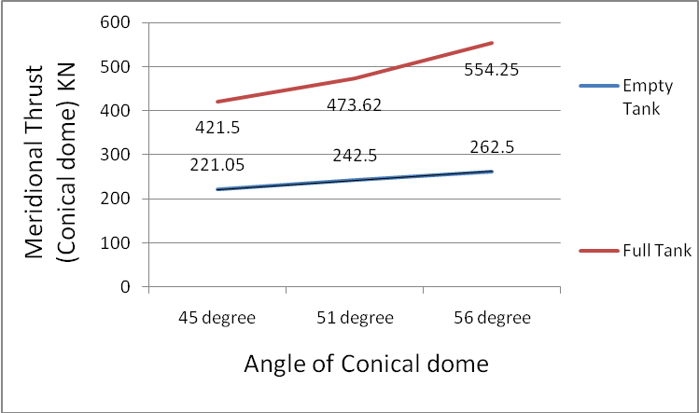

Figure 5 Varition of Meridional Thrust in empty and full tankwith angle of conical dome
After examining a number of models, we can sum up the findings as follows:
1. For an Intze tank in full condition, the meridional thrust in the bottom dome is greatest at 45 degrees, minimum at 51 degrees, and minimal at 56 degrees for the conical dome angle. The meridional push on the bottom dome is dependent on the weight of the water lying above it, and the value of hoop tension drops as the angle of the conical dome increases due to this change in geometry.
2. In the case of an Intze tank operating at full capacity, meridional push within the conical dome occurs at its minimum angle of 45 degrees and at its maximum angle of 56 degrees, followed by 51 degrees. The conical dome's altered geometry and the hydrostatic pressure exerted by water both contribute to the value's growth.
Similar findings are discovered for the meridional thrust results on the conical and bottom domes, as reported in the standard book "Advanced Reinforced Concrete Vol.2, 7th Edition} by Dr. H.J. Shah (2014)7

CHAPTER-5

CONCLUSION AND FUTURE SCOPE
  - CONCLUSION
The following results are reached after numerous Intze tank models were analysed for both empty and full tank conditions using a variety of factors.
1. It has been discovered that as the conical dome's angle increases from 45 to 56 degrees, shear force, bending moment, and node displacement likewise rise under both full and empty tank situations. Additionally, full tank conditions yield higher values of axial force, shear force, bending moment, and node displacement at all dome angles than empty tank conditions. Thus, it can be said that the conical dome's angle significantly affects the node displacement, axial force, shear force, and bending moment.
- For all three angles, the values of hoop tension in the conical dome, cylindrical wall, and bottom dome are greater. Tank full conditions yield higher values (45⁰, 51⁰, and 56⁰) than empty conditions.
3. When the tank is full, the bottom dome has the maximum hoop tension.
4. When the angle of the conical dome is altered from 45 degrees to 56 degrees when the tank is full, the loop tension in the bottom dome drops; in the empty tank condition, the opposite behaviour is seen.
5. When the angle of the conical dome is altered from 45 degrees to 56 degrees, both in the full and empty tank conditions, the hoops tension in the cylinder wall and conical dome increase dramatically.
6. When the tank is full, the bottom dome and conical dome have the maximum value of longitudinal thrust.
7. When the conical dome angle is altered from 45 degrees to 56 degrees when the tank is fully charged, the lateral thrust in both the bottom dome and the conical dome reduces.
8. When the angle of the conical dome is altered from 45 degrees to 56 degrees when the tank is empty, the longitudinal thrust in both the bottom dome and the conical dome increases dramatically.
9. At a conical dome angle of 45 degrees, the minimal values of axial force, shear force, bending moment, and node displacement are obtained. From a design perspective, the less bending moment, the less reinforcing that will be needed, making the construction more cost-effective.
10. A 45-degree conical dome results in the lowest amounts of hoops tension and meridional thrust. The concrete section thickness and the need for reinforcement to make the construction cost-effective must be smaller than the minimum values of hoop tension and meridional thrust.
11. The maximum values of hoop tension and meridional thrust in the bottom dome of a tank in full condition are obtained at a 45-degree angle to the conical dome; this will have a minor impact on the structure's economy.

FUTURE SCOPE
1. For the same capacity, the same analysis can be conducted for conical dome angles less than 45 degrees and greater than 56 degrees.
2. Studies can also be conducted by altering the bottom dome's diameter, top dome's rise, and bottom dome's diameter.

REFERENCES
- Adilakshmi Bugatha, Suribabu Paliki, Ramesh Reddi (2016), “Design, Analysis and Optimization of Intze Type Water Tank For Different Parameters As Per Indian Codes”, 5th International Conference On Recent Trends In Engineering Science & Management‖, December 2016, ISBN 978-81-932074-1-3.
- Ahmad Musa, Boshosha Haithama (2016), Ashraf Damatty, “Effect Of Wind Speed And Terrain Exposure On The Wind Pressures For Elevated Steel Conical Tanks” NDM-536-1, Resilient Infrastructure, june 1-6-2016
- Ankatesh Morvy, Varsha More (2017), “Comparative Study On Dynamic Analysis Of Elevated Water Tank Frame Staging And Concrete Shaft Supported”, IOSR Journal Of Mechanical And Civil Engineering, Jan - Feb. 2017. p-ISSN 2320-334X, Volume 14, Issue 1 Ver. I, pp 38-46,
- B. Dean Kumar And B.L.P Swami (2010), “Wind Effects On Water Towers-Influence of Various Dynamic Parameters”, Indian Journal Of Science And Technology, Aug 2010.ISSN 0974- 6846, Vol. 3 No.8.
- Deepa Dubey, Satyendra Dubey, Y. K. Bajpai (2017), “Wind Force Analysis of Intze Type Water Tank in Various Wind Zones Using Staad-Pro”, IJAERD June 2017, e-ISSN (O) 2348-4470, p-ISSN (P) 2348-6406, Volume 4, Issue 6.
- G.P Deshmukh, Ankush Patekhede (2015), ―Analysis Of Elevated Water Storage Structure Using Different Stagging System‖, IJRET Apr-2015, eISSN2319-116, p-ISSN 2321-7308, Volume 04, Issue 04.
- H.J Shah {Advanced reinforced concrete vol-2, 7th Edition:2014} ISBN:978-81-928692-2-3}. IS 875 (Part -2) 1987, Code Of Practice For Design Loads For Building and Structure Imposed Load (Second Revision), Udc 624.042.3:006.76
- IS 875 (Part-3) 1987, Code Of Practice For Design Loads For Building And Structure Wind Load (Second Revision), Udc 624.042.41.
- IS 3370 (Part I-IV) 2009, General Requirements, Code of Practice for Concrete Structures for the Storage of Liquid.
- IS 456-2000, Plain and Reinforced Concrete - Code of Practice (Fourth Revision), ICS 91.100.30
- Jay Lakhanakiya, Hemal J Shah (2015), ―A Parametric Study of an Intze Tank Supported on Different Stagings‖, International Journal For Scientific Research & Development 2015, ISSN(Online) 2321- 0613,Vol. 3, Issue 09.
- K. Hirdesuchita, Asmita Bajare, Manoj Hedaoo (2011), “Performance of Elevated Water Tanks Subjected To Wind Forces”, IJAET April-June, 2011, e-ISSN 0976-3945, Vol.II, Issue II.
- Nitesh J Singh, Mohammad Ishtiyaque (2015), “Design Analysis & Comparison of Intze Type Water Tank for Different Wind Speed and Seismic Zones as Per Indian Codes”, IJRET, 2015,e-ISSN 2319-1163, p-ISSN 2321-7308, Volume 04, Issue 09.
- Rajesh Cherukupally, Sudip jha, P.Srilakshmi (2015), “Behaviour of an Elevated Water Tank for Different Staging Patterns and Different Staging Heights”, International Journal & Magazine Of Engineering, Technology, Management and Research August 2015. ISSN No 2348- 4845, Volume No 2, Issue No 8.
- Reshma Kulkarni, Mangulkar (2015), “Dynamic Analysis Of Elevated Intze Water Tank” , ICATEST 2015, e-ISSN 2321-9637,
- Saikala Kondepudi, K. S. K Reddy , Harshakaviti Karthik (2015),”Analysis and Design of Elevated Intze water tank and its Comparative Study in Different Wind Zones - Using SAP2000” International Journal Of Science Technology & Engineering, August 2015, ISSN (Online): 2349-784X, Volume 2, Issue 2.
- Schintha Ravichandra, R.K. Ingle (2015), “Analysis Of Cylindrical Water Tanks Wind Or Earthquak”, IJESRT 10th may, ISBN: 978-93- 85465-11-6.
- Shivprasad Dundage and Prof. N.P. Phadtare “Comparative Study of Intze Type of Water Tank for Different Bracing Pattern under Wind and Seismic Load” IJRASET ISSN: 2321-9653; IC Value: 45.98; SJ Impact Factor: 7.538 Volume 11 Issue V May 2023- Available at www.ijraset.com
- Shubham Gautam, Shubham Yadav, Susanta Kumar Sethy (2017), “Seismic Analysis of Intze Water Tank for Different Bottom Dome Deviation Angle & Bracing” , IJAERD December 2017, e-ISSN (O) 2348-4470, p- ISSN (P) 2348-6406 Volume 4, Issue 12.
- Tarun and Mrs. Monika (2023) “Analysis of Elevated Water Tank With Different Bracing System” International Research Journal of Modernization in Engineering Technology and Science (Peer-Reviewed, Open Access, Fully Refereed International Journal) Volume:05/Issue:07/July-2023.
- V. L. Swarupa, R. Ramkrishna (2017), “Performance of Elevated Circular Water Tank in Different Wind Zones”, IJSETR March 2017, ISSN 2319-8885,Volume 06, Issue11, pp 2252-2257.
- Yogesh Thorat, Yogesh Kadam, Sagar Kute & Sanchit Kashid (2017), “Analysis of Water Tank on Sloping Ground”, International Journal Of Engineering Sciences & Management, January-March 2017,ISSN2277 – 5528 7(1).

