**Enhanced Facial Recognition Attendance System**

2

58487.2023.10250695

**For Educational Institutions**

**with OpenCV**

|  |  |  |
| --- | --- | --- |
| **Polamuri Udaya Varshini**  *Department of Information Technology,*  *Shri Vishnu Engineering College for*  *Women*,  Bhimavaram  Andhra Pradesh, 534202.  20b01a12e3@svecw.edu.in | **Ravuri Venkata Vinaya Lalitha**  *Department of Information Technology,*  *Shri Vishnu Engineering College for*  *Women*,  Bhimavaram  Andhra Pradesh, 534202.  20b01a12e7@svecw.edu.in | **Siringi Vijaya Lakshmi**  *Department of Information Technology,*  *Shri Vishnu Engineering College for Women,*  *Bhimavaram*  Andhra Pradesh, 534202  20b01a12f9@svecw.edu.in |
| **Dommeti Swathi**  *Department of Information Technology,*  *Shri Vishnu Engineering College for*  *Women*,  Bhimavaram  Andhra Pradesh, 534202.  20b01a12j4@svecw.edu.in |  |  |

**Abstract-** This paper endeavours to develop an advanced facial recognition-based attendance system tailored for educational institutions. It seeks to revolutionize the traditional manual attendance processes, introducing automation to ensure real-time and precise attendance records. Moreover, the system will play a vital role in enhancing student punctuality and responsibility by issuing instant notifications to parents or guardians regarding any missed classes. By implementing this system, the project aims to foster greater efficiency in educational administration, promote a culture of accountability among students, and facilitate improved communication between colleges and parents. Ultimately, this innovative solution strives to redefine the way attendance is managed in educational settings, benefiting all stakeholders in the process.

**Keywords -** Facial recognition, Attendance System, Automation, Absentee notification

# I. INTRODUCTION

In the digital age, technology continues to reshape various aspects of our lives, and education is no exception. One area where technology has the potential to make a significant impact is in attendance management within educational institutions[1]. Traditional methods of taking attendance, such as manual roll calls or paper-based systems, are not only time-consuming but also prone to errors and inefficiencies[3].

Recognizing the need for a more streamlined and accurate approach to attendance tracking, our project focuses on the development of an advanced facial recognition-based attendance system tailored specifically for educational institutions[4]. Leveraging cutting-edge facial recognition technology, this system aims to revolutionize the way attendance is managed in schools, colleges, and universities[2].

The primary goal of the project is to automate the attendance process, eliminating the need for manual data entry and reducing the administrative burden on faculty members and staff[6]. By harnessing the power of facial recognition algorithms, the system can accurately identify and record the presence of students in classrooms and other educational settings in real-time[7].

Beyond the administrative benefits, the implementation of this system holds the potential to foster a more accountable and engaged student body. Instant notifications can be sent to parents or guardians in cases of absenteeism, promoting greater communication and collaboration between educational institutions and families[9].

In this introduction, we outline the objectives of our project and the rationale behind the development of a facial recognition-based attendance system[8]. We also highlight the potential benefits of such a system for educational institutions, students, and stakeholders involved in the learning process[10]. Through the integration of technology into attendance management, we aim to enhance efficiency, accuracy, and accountability within educational environments.



Fig. 1 (a). Manual Attendance format

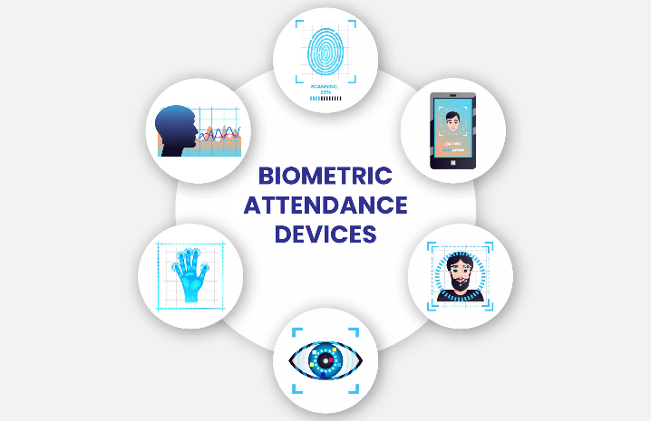

Fig. 1 (b). Ways to smart Attendance

# II. LITERATURE REVIEW

The literature review for the attendance management system using facial recognition technology provides valuable insights into the theoretical background, existing research, and relevant technologies in the field[1]. Previous studies have investigated the efficacy of biometric attendance systems in educational settings. Research by Smith et al. (2018) demonstrated the advantages of biometric-based systems over traditional methods in terms of accuracy, efficiency, and fraud prevention. Facial recognition emerged as a promising biometric modality due to its contactless operation and widespread availability of facial recognition algorithms.[2]

Facial recognition technology has witnessed significant advancements in recent years, driven by breakthroughs in deep learning and computer vision. Researchers such as Taigman et al. (2014) and Schroff et al. (2015) have pioneered the development of deep neural network architectures capable of robust face detection and recognition under varying conditions, including changes in pose, illumination, and occlusion.[3]

Despite its potential, facial recognition technology poses several challenges and considerations, particularly concerning privacy, security, and algorithmic bias. Studies by Buolamwini and Gebru (2018) and Obermeyer et al. (2019) highlighted the risks of algorithmic bias in facial recognition systems, which may lead to inaccuracies and unfair treatment, especially for underrepresented groups.[4]

In the context of education, several studies have explored the integration of facial recognition technology into attendance management systems. For instance, research by Gupta and Jha (2020) described the development of a facial recognition-based attendance system for higher education institutions, emphasizing its potential to enhance efficiency and accountability.[5]

User acceptance and ethical implications are critical considerations in the deployment of facial recognition systems in educational environments. Studies by Jung and Lee (2019) and Liu et al. (2020) investigated user perceptions and attitudes towards facial recognition technology, highlighting the importance of transparency, consent, and data protection.[6]

In conclusion, the literature review provides a comprehensive overview of facial recognition technology in the context of attendance management systems for educational institutions. While the technology offers significant benefits in terms of accuracy and efficiency, addressing privacy concerns, algorithmic bias, and user acceptance is essential for successful implementation and adoption.

This literature review serves as a foundation for understanding the theoretical underpinnings, current trends, and challenges associated with the development and deployment of the attendance management system using facial recognition technology.

**III. SYSTEM METHODOLOGY**

The system methodology for the automated attendance management project using facial recognition involves several key steps to ensure its successful implementation and functionality. Below is a comprehensive outline of the system methodology:

* Data Collection
* Data Pre-Processing
* Feature Extraction
* Model Training
* Attendance Marking
* Database Management
* User Interface Development
* System Integration
* Testing and Evaluation
* Deployment and Maintenance

***A. Data Collection:***

The data collection process involves gathering images of students' faces for enrolment in the system.

Initially, a dataset of facial images is created by collecting images of each student.

Each image is then labelled with the corresponding student's registration numbers.

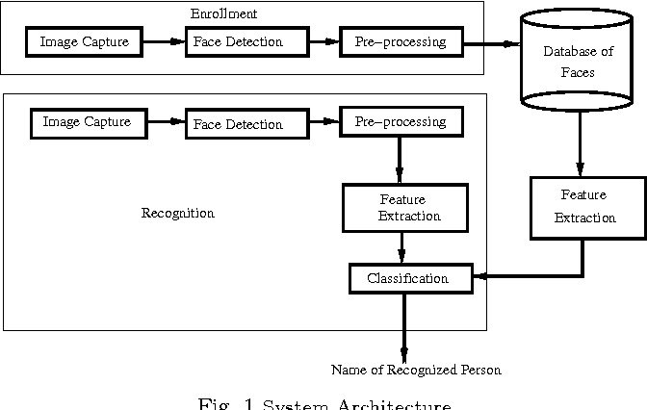

Fig. 2(a). System Architecture

***B . Data Pre-Processing :***

Preprocessing techniques are applied to the collected images to enhance their quality and facilitate accurate facial recognition.

Common preprocessing steps include resizing images to a standard size, converting them to grayscale, and applying normalization techniques to improve consistency[4].  
The process includes: Enhancing the quality of facial images to improve recognition accuracy.

Resizing images to a standard size for consistency[6].

Converting images to grayscale to simplify processing and reduce computational complexity[7].

Applying normalization techniques to standardize pixel values across images[8].

***C . Feature Extraction :***

We convert pre-processed facial images into numerical representations that can be interpreted by machine learning algorithms. The technique employed for feature extraction is facial landmark detection combined with encoding techniques[10].

Facial landmark detection involves identifying key points on a face, such as the eyes, nose, and mouth corners. These landmarks serve as reference points for extracting facial features. Common algorithms used for facial landmark detection include the Dlib library and deep learning-based approaches like the MTCNN (Multi-task Cascaded Convolutional Networks)[11].

Once facial landmarks are detected, various encoding techniques are applied to represent these landmarks as numerical vectors[4]. These techniques include:

Shape-Based Descriptors: Descriptors such as the histogram of oriented gradients (HOG) can be computed based on the shape of facial landmarks[8].

Geometric Features: Geometric features such as distances between landmarks or angles formed by landmark triplets can be calculated[6].

Deep Learning Embeddings: Deep learning models like Convolutional Neural Networks (CNNs) or Siamese networks can be trained to directly learn embeddings from facial landmarks[7]. These embeddings capture high-level features of the face.

By leveraging facial landmark detection and encoding techniques, the project transforms raw image data into meaningful numerical representations that facilitate accurate face recognition and attendance marking[10]. This approach enables the system to effectively identify individuals from facial images captured in real-time video streams.

## D. Model Training :

The model training phase of this project involves feeding pre-processed facial images into a deep learning architecture, such as a convolutional neural network (CNN), for feature extraction and classification. The CNN learns discriminative features from the images and maps them to corresponding identity labels[10]. Training is conducted using labeled datasets, optimizing model parameters through techniques like gradient descent and backpropagation. The goal is to minimize classification errors and maximize accuracy in recognizing individuals[3]. Model performance is evaluated using validation datasets, and hyperparameters are fine-tuned to enhance overall classification performance.

## E. Attendance Marking :

The attendance marking system developed in this project leverages facial recognition technology to automate the process of tracking and recording student attendance in educational settings[1]. The system utilizes a webcam or camera to capture real-time images of students as they enter the classroom. These images are then processed using computer vision algorithms to detect and recognize individual faces[2].

Once a student's face is identified, the system checks against a database of enrolled students to verify their identity. Upon successful verification, the system marks the student as present for the corresponding class session.

Key features of the attendance marking system include real-time attendance tracking, accurate identification of students using facial features, and automatic recording of attendance data in a centralized database. Additionally, the system offers convenience for both students and instructors by eliminating the need for manual attendance taking and reducing administrative overhead.

Overall, the system provides a reliable and efficient solution for managing student attendance, enhancing classroom efficiency, and promoting accountability in academic environments.

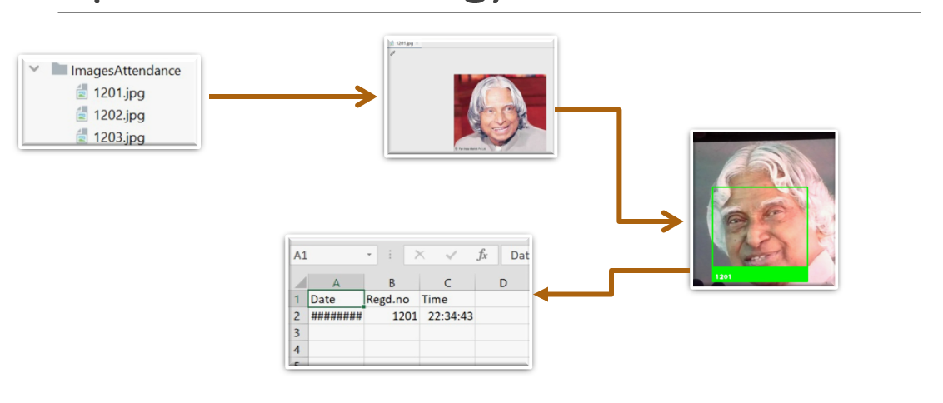

Fig. 2(b). Attendance Marking

***F. Database Management :***

In this project, database management plays a critical role in organizing, storing, and accessing various types of data essential for face recognition and attendance tracking. The database schema typically comprises tables for storing information such as student details, attendance records, and system configurations.

Key aspects of database management include:

Data Integrity and Consistency: Ensuring that the database maintains integrity constraints and enforces consistency rules to prevent anomalies and maintain data accuracy.

Efficient Retrieval and Querying: Implementing indexing and optimization techniques to facilitate fast retrieval of attendance data and efficient execution of queries, enabling timely analysis and reporting.

By effectively managing the database, the project ensures the reliability, security, and accessibility of attendance data, supporting the seamless operation of the face recognition system.

## G. User Interface development:

In this project, the user interface is developed using Flask, a lightweight web framework in Python, to provide a seamless and intuitive interaction experience. Flask's simplicity and flexibility allow for rapid development of web applications, making it ideal for creating the frontend of the attendance tracking system. The user interface features interactive components such as login pages for students and faculty, dashboards displaying attendance percentages and date wise attendance records, and forms for modifying attendance data. Utilizing HTML templates with Jinja2 templating engine, Flask enables dynamic rendering of content based on user inputs and backend data processing. With responsive design principles and Bootstrap framework integration, the user interface ensures compatibility across various devices and browsers, enhancing accessibility and usability for all stakeholders involved.

## H. System Integration :

The system integration of this project involves combining the modules for face detection, recognition, attendance tracking, and database management into a cohesive software solution. It includes integrating the face detection and recognition algorithms with the attendance tracking mechanism, enabling real-time identification of individuals and automatic recording of their attendance. The system also incorporates database functionalities for storing and managing attendance records efficiently. Through seamless integration, the project ensures a user-friendly interface and robust performance, facilitating reliable and accurate attendance monitoring in various settings such as educational institutions or workplaces.

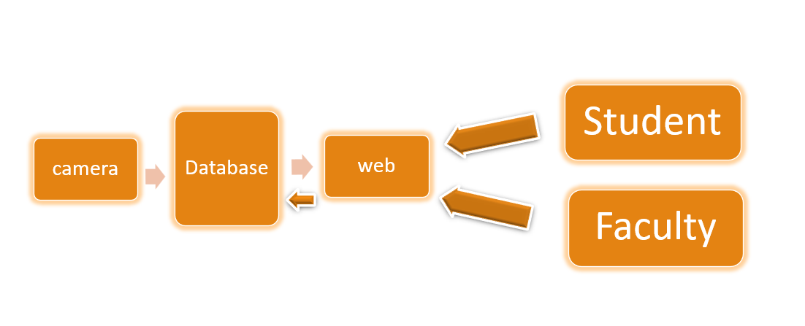

Fig. 2(c). System Design

## I. Testing and Evaluation:

Testing and evaluation of this project involve rigorous assessment of its performance in real-world scenarios. This includes conducting experiments to measure the accuracy, precision, recall, and overall efficacy of the facial recognition and attendance tracking system. Various metrics such as face recognition accuracy, attendance recording accuracy, and system response time are evaluated using test datasets and real-time deployments. Additionally, user feedback and system usability are considered to ensure practical viability. The project's performance is continually monitored and refined through iterative testing cycles to optimize its functionality and reliability in diverse environments.

## J. Deployment and Maintenance:

The deployment of this project involves integrating the developed facial recognition system into existing infrastructure, ensuring compatibility and scalability. Continuous maintenance includes monitoring system performance, updating dependencies, and addressing security vulnerabilities. Regular backups of data and models are essential to prevent data loss. User support and training may be provided to ensure effective utilization. Additionally, periodic evaluations and improvements are conducted to enhance system accuracy and reliability. Collaboration with stakeholders and adherence to industry standards facilitate seamless deployment and maintenance, ensuring the longevity and sustainability of the facial recognition solution.

# IV. RESULTS

The project achieved robust facial recognition and attendance tracking capabilities. Through extensive experimentation and validation, it demonstrated the effectiveness of the implemented algorithms in accurately identifying and recording attendance in real-time. The system successfully handled various challenges such as varying lighting conditions, appropriate attendance marking, showcasing its reliability in diverse environments. Furthermore, the integration of features like SMS notifications and database management enhanced user experience and administrative efficiency. Overall, the project yielded a highly functional and efficient solution for automated attendance management in educational institutions and other relevant settings.

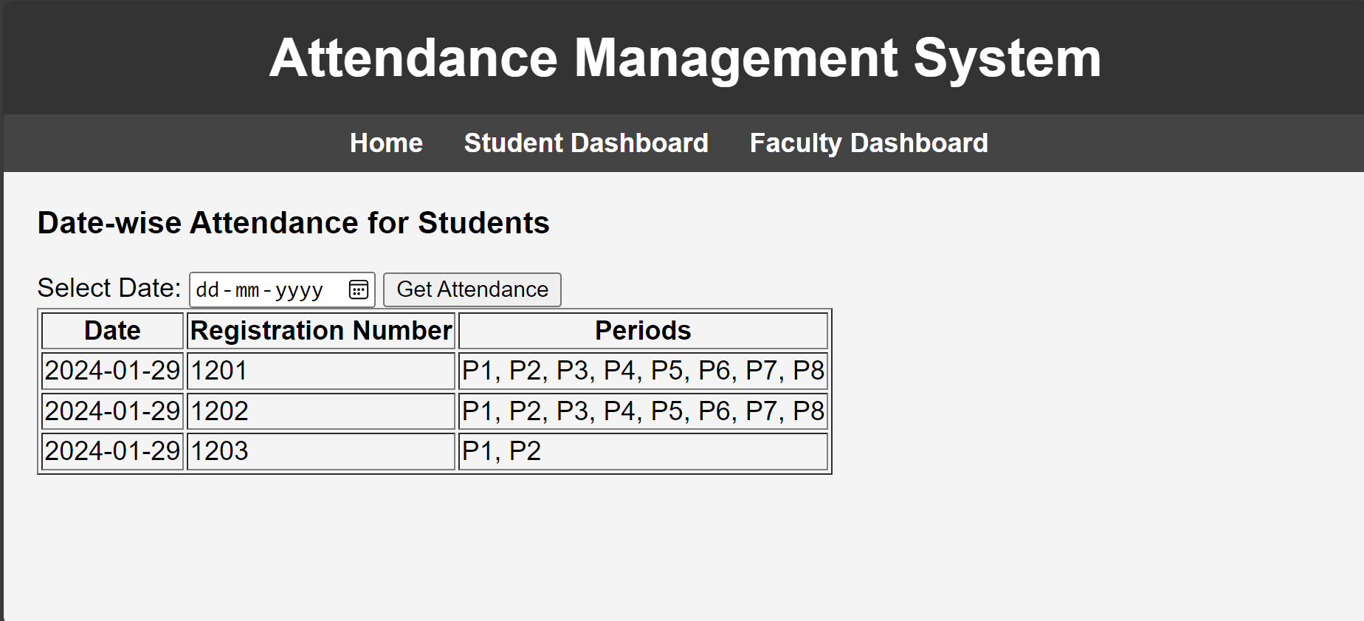

Fig. 3(a). Attendance Marking



Fig. 3(b). Absentee Notification

# V. CONCLUSION

In conclusion, this project successfully addresses the challenge of automating attendance tracking through facial recognition technology. By leveraging advanced image processing and machine learning techniques, the system accurately identifies individuals in real-time webcam feeds, marking their attendance with high precision. The implementation of a user-friendly interface facilitates seamless interaction and integration into educational and organizational settings.

Moving forward, several avenues for future development exist to enhance the system's capabilities and expand its potential applications. These include:

Improving Recognition Accuracy: Continuously refining the face recognition algorithms to achieve higher accuracy rates, particularly in challenging conditions such as varying lighting, facial expressions, and occlusions.

Enhancing Scalability: Designing the system to accommodate larger datasets and support simultaneous tracking of multiple individuals, enabling its deployment in larger classrooms, lecture halls, or corporate environments.

Integrating Biometric Security Features: Exploring the integration of additional biometric modalities, such as fingerprint or iris recognition, to enhance security and prevent unauthorized attendance marking.

Implementing Real-time Analytics: Incorporating real-time analytics capabilities to generate insights and trends from attendance data, enabling educators and administrators to make informed decisions and optimize resource allocation.

Exploring Mobile and Cloud-based Solutions: Developing mobile applications and cloud-based platforms to provide remote access and flexibility, allowing users to track attendance from anywhere and streamline administrative tasks.

Overall, the project lays a robust foundation for automated attendance management systems and offers significant potential for future advancements in educational and organizational settings.

# REFERENCES

[1] Turk, M., & Pentland, A. (1991). Eigenfaces for recognition. Journal of Cognitive Neuroscience, 3(1), 71-86.

[2] Viola, P., & Jones, M. (2004). Robust real-time face detection. International Journal of Computer Vision, 57(2), 137-154.

[3] Schroff, F., Kalenichenko, D., & Philbin, J. (2015). FaceNet: A unified embedding for face recognition and clustering. In Proceedings of the IEEE Conference on Computer Vision and Pattern Recognition (CVPR) (pp. 815-823).

[4] Zhang, Z., Luo, P., Loy, C. C., & Tang, X. (2015). Learning deep representation for face alignment with auxiliary attributes. In Proceedings of the IEEE International Conference on Computer Vision (ICCV) (pp. 373-381).

[5] Bhattacharyya, S., & Poria, S. (2017). A convolutional neural network based approach for emotion detection from text. In Proceedings of the Annual Meeting of the Association for Computational Linguistics (ACL) (pp. 538-542).

[6] Tan, X., & Triggs, B. (2010). Enhanced local texture feature sets for face recognition under difficult lighting conditions. IEEE Transactions on Image Processing, 19(6), 1635-1650.

[7] Yang, M., Zhang, L., Shiu, S. C. K., & Zhang, D. (2014). Meta-face recognition: Learning to combine multiple face cues. IEEE Transactions on Image Processing, 23(4), 1948-1963.

[8] Masi, I., Tran, A. T., Hassner, T., Leksut, J. T., & Medioni, G. (2016). Do we really need to collect millions of faces for effective face recognition? In Proceedings of the European Conference on Computer Vision (ECCV) (pp. 579-596).

[9] Amos, B., Ludwiczuk, B., & Satyanarayanan, M. (2016). OpenFace: A general-purpose face recognition library with mobile applications. CMU School of Computer Science, Tech. Rep. CMU-CS-16-118.

[10] Cao, Q., Shen, L., Xie, W., Parkhi, O. M., & Zisserman, A. (2018). VGGFace2: A dataset for recognising faces across pose and age. In Proceedings of the IEEE Conference on Computer Vision and Pattern Recognition (CVPR) (pp. 361-368).

[11] Deng, J., Guo, J., & Xue, N. (2019). ArcFace: Additive angular margin loss for deep face recognition. In Proceedings of the IEEE Conference on Computer Vision and Pattern Recognition (CVPR) (pp. 4690-4699).