**A REVIEW ARTICLE ON PATIENT MEDICATION HISTORY INTERVIEW**

**Dr.M.SPHURTHY MITRA1, SHAIK TABUSSUM HASMI 2**

1Associate Professor, Department of Pharmacy Practice, Dr.K.V.Subba Reddy Institute Of Pharmacy. Kurnool.

2Student, Department of Pharmacy Practice, Dr.K.V.Subba Reddy Institute Of Pharmacy. Kurnool.

**ABSTRACT**

Goal of Medication Review goal of medication review is to optimize therapy a drug identifying and solving drug relate problems, and ensuring that all therapeutic objectives are being achieved. Daily review of patients' drug therapy enables the pharmacist to .Assess whether desired therapeutic outcomes are being achieved, .Monitor for drug-related problems/ toxicity, Ensure rational and quality use of medicines, Assess patient compliance (medication adherence) , Assess the completeness of medication charts. The routine review of drug therapy for a specific patient or a specific condition includes a number of components Medication order review (MOR)/Treatment chart review (TCR), Clinical review/ Daily progress review, Detection and management of adverse drug reactions (ADRs).

1. **INTRODUCTION**

The Medication history is a part of pharmaceutical consultation that identifies and document allergies or other serious adverse medication events as well as information about how medicines are taken currently and have been taken in the past. Starting point for medication reconciliation and medication review. Part of medical history which focuses on medication therapy. Interviewing a patient for collection of data related to medical history is called medication history interview.It is a detailed, accurate and complete account of all prescribed and non-prescribed medications, that a patient had taken or is currently taking. It provides information of patient allergic tendencies, adherence to pharmacological and non-pharmacological treatments, self-medication with and alternative medicines. Medication history is a detailed, accurate and complete account of all prescribed and non-prescribed medications that a patient had taken or is currently taking prior to a newly initiated institutionalized or ambulatory care. The documentation of medication history has historically been undertaken mainly by physicians and sometimes nurses. The patient in the documentation of medication history has been shown to result in significant improvement in its accuracy and comprehensiveness. It also includes information on the current and past considerations about medicines. It is a beginning for medicines reconciliation and review. A positive effect on patient care is observed when accurate and complete medication histories are taken. Medication history interview involves interviewing a patient for collecting the medical history. The history attained by the medical team and the pharmacist may differ and fall into two categories, i.e., intentional (when medical team makes a decision of changing the regimen) or unintentional (when complete record was not available). Differences should be clarified with the prescribes or the senior pharmacist. Firstly the pharmacist should get familiarize with the patient charts to know the present medical status and background particulars of the patient. The interview should be started with introduction and the reason for interview. The patient’s name, address, age, and past medication history should be jotted down.

1. **GOALS OF MEDICATION HISTORY :**

* To gain information on Prescription and nonprescription medications Perceived benefit or adverse effects of the therapy, Identification of potential medication problems.
* To develop more through assessment and pharmaceutical care plan.
* Better patient outcomes.

**Types of Data**

* Collection
* Information provided by the patient
* Cannot confirmed/observed/measured

**Objective:**

* Measurable and observe
* Not influenced by the opinion/perception of the patient

**SOURCES OF PATIENT DATA:**

* Patient interview Medical records
* Pharmacy dispensing records Health care providers
* Care giver/family members Sources of Patient Data

**Components of Patient Drug History:**

* Demographic and patient financial insurance information
* Medication allergies and intolerance
* Immunizations
* Medications
* Additional home monitoring and compliance aids
* Barriers to compliance
* Additional information for patient history
* Social history
* Acute/chronic medical problems

**Aspects of medication use obtained from medication history interview:**

* History of previous allergies/ADR
* Perceived efficacy
* Perceived side effects
* Adherence to medication
* Medication administration techniques
* Specific problems related to medicine us
* Possibility of pregnancy in women of child bearing age.

**Steps involved in Medication History Interview:**

* Patient Selection
* Self-preparation
* Privacy and confidentiality
* Purpose of interview
* Conduct interview
* Conclusion
* Document and follow-up

**Patient Selection :**

* Ideally all Patient
* If not possible priority should be given to those who are more likely to get benefit Eg: Patient with poly pharmacy, Multiple and chronic diseases.
* Certain diseases it is not possible to take medication history interview like psychiatric disorders, impaired cognition etc.
* Consider family members or relatives
* Collect all the data including co- morbid conditions
* Make use of various sources of data
* Provisional list of medications can be made through medical notes
* Preparation of list of questions can be helpful

**Privacy and Confidentiality:**

* Consider privacy and confidentiality of the patient
* Hospital setting – difficult to maintain because interviews are taken at bedside Patient unable to communicate – family members can be involved
* Must maintain confidentiality of the data except for exchange of information with other health care professionals.

**Purpose of interview:**

* Introduce him/herself and explain the purpose of interview
* Possible benefits should also be explained
* Respect patient right to decline the interview

**Conduct Interview**

* Use proper communication skills during interview
* Where possible ask open ended questions
* Close ended questions may be useful to confirm details
* All the questions asked appropriately

**Conclusion Check whether:**

* All important and relevant details obtained ask patient if he/she has any questions relating to the medications.

1. **MEDICATION HISTORY INTERVIEW:**

A Medication history is a detailed, accurate and complete account of all prescribed and non-prescribed medications that a patient had taken or is currently taking prior to a initially institutionalized or ambulatory care. It provides valuable insights in to patient’s allergic tendencies, adherence to pharmacological and non-pharmacological treatments and self medication with complementary and alternative medicines. Interviewing a patient in collecting the data medical history is called medication history interview.

**Importance of accurate drug history;**

Preventing prescription errors and consequent risk to patients.Useful in detecting drug related pathology or changes in clinical signs that may be the result of drug therapy.It should encompass all currently and recently prescribed drugs, previous adverse drug reactions including herbal or alternative medicines and adherence to therapy for better care plan.

Goals: The goal of education history interview is to obtain information on aspects of drug use that may assist of patient. The information collect can be utilized to Compare medication profile with the medication administration record and investigate the discrepancies. Verify medication history taken by other staffs and provide additional information where appropriate.

**The following information is commonly recorded:**

* Currently or recently prescribed medicines
* OTC medication
* Vaccinations
* Alternative or traditional remedies
* Description of reactions and allergies to medicine
* Medicines found to be ineffective
* Adherence to past treatment and the use of adherence aids

**Information sources:**

* Patient
* Family or caregiver
* Medication vials / bubble packs
* Medication list
* Community pharmacy
* DPIN (Drug programs information network)

**Question to ask:**

* Which community pharmacy
* do you use?
* Any allergies to medications and what was there reaction?
* Which medications are you currently taking:
* The name of the medication
* The dosage form
* The amount (specifically the dose)
* How are the taking it by which route)
* How many times a day
* For what reason
* What prescription medications are you taking on a regular basis or as needed basis?
* What over the counter medications are you taking on a regular or as needed basis?
* What herbal or natural medicines are you taking on a regular or as needed basis?
* What vitamins or supplement are you taking?
* Have you recently started any new medicines?
* Did a doctor change the dose or stop any of your medications recently?
* Did you change the dose or stopped any of your medications recently?
* Are any of the medications causing side effects
* Have you change the dose or stopped any medications because of unwanted effects?
* Do you sometimes stop taking your medicine whenever you feel better?
* Do you stop taking your medicine if it makes you feel worse?

**Patient counseling :**

PATIENT COUNSELING is defined as providing medication information orally or in written form to the patient or their representatives on direction of use, advice on side effects, precautions, storage, diet and life style modifications.

**Objectives of Patient Counseling:**

* Patient should recognize the importance of medication for his well being
* Patient’s understanding of strategies to deal with medication side effects and drug interactions should be improved.
* Patient becomes an informed, efficient and active participant in disease treatment and selfcare management
* Drug interactions and adverse drug reactions should be prevented.
* Should ensure better patient compliance

**Patient counseling consist of 3 stages:**

* Introduction
* Process content and issue regarding
* Conclusion

**Introduction:**

* Review the patient’s record
* Introduce yourself [pharmacist]
* Explain the purpose of counseling
* Obtain drug related information such as allergies, use of herbals etc.

**Functions of Patient Counseling:**

* Effective patient counseling aims to produce the following results
* Better patient’s understanding of their illness and the role of medication in its treatment
* Improved medication adherence
* More effective drug treatment
* Reduce incidence of adverse effects and unnecessary healthcare cost
* Improved quality of life for the patient
* Better coping strategies to deal with medication related adverse effects

**Counseling area:**

The patient should be counseled in a semiprivate area away from the other people and distractions. The patient perceive the counseling area as confidential, secure and conducive to learning. This helps ensure both parties are focused on the discussion and minimizes interruptions and distractions. It provides an opportunity for patients to ask questions they may be hesitant to ask in public.

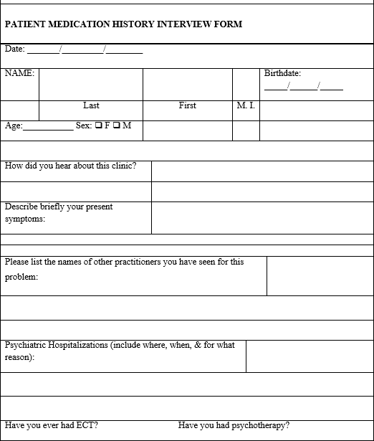

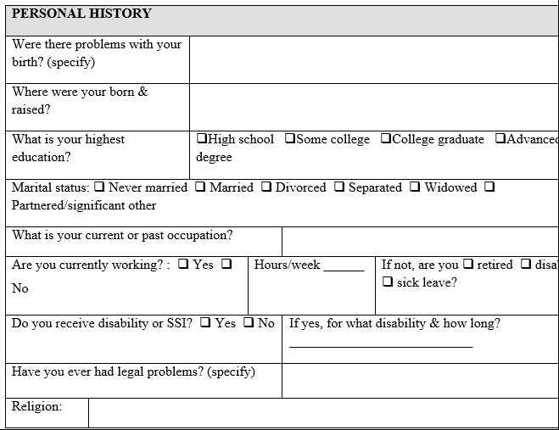

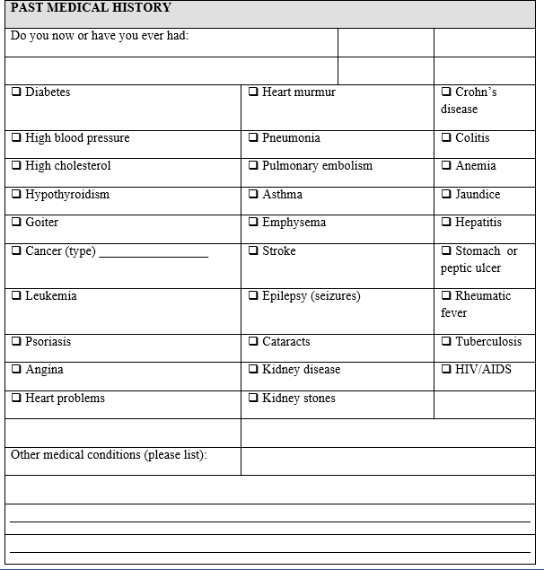

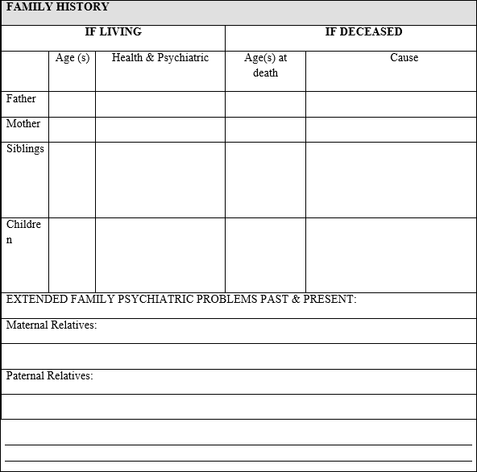

1. **MEDICATION REVIEW:**

Medication review involves the review of a patient's medication regimen to ensure that therapy is appropriate, safe, efficacious and cost effective. This can be achieved by pharmacists attending ward rounds on a day-to-day basis and applying their knowledge of therapeutics in the management of specific diseases or conditions. Daily review is desirable to keep up with any changes to drug therapy. Ideally, the a pharmacist should follow the patient from the day of admission until the day of discharge. During each ward visit, the pharmacist should engage in clinical activities including identification of patient factors affecting medication management, assessment of drug therapy, monitoring outcome, intervening to prevent or resolve drug-related problems and education of the patient or career.

**Collection and interpretation of patient specific information :**

Pharmacists need to collect information that will assist them to determine the appropriateness of drug therapy. This includes the patient's demographic details such as age, sex and body weight, social history, presenting complaints, past medical history, allergy and sensitivity status, current and recent medication, and results of relevant laboratory tests and other investigation. This enables the pharmacist to understand the patient's disease condition, the reason why certain drugs are being administered and the patient's daily clinical progress. This understanding is the foundation for medication review. Relevant information can be obtained from a variety of sources including the patient, case notes, the medication chart, nursing notes, observational charts, laboratory results and through discussions with medical and nursing staff. When a patient is admitted to hospital, medical staff document relevant information regarding the admission in the patient's case notes. This usually includes a list of medications which the patient is currently taking. This list may be inaccurate or incomplete, particularly in situations where medical staff are over-burdened with a high patient load. By speaking personally to patients about their medications, pharmacist can obtain further information which may be of importance to the ongoing medical management of the patient. This process is sometimes referred to as a medication history interview (MHI).

The goal of the medication history interview is to obtain a complete and accurate summary of the Indications that a patient has been using, together with other information which tray usefully contribute to pharmaceutical care. The patient's medication history should be obtained at the beginning of the hospital admission so as to provide any additional useful information to the prescribe that may positively influence drug therapy selection. The nature of the medication history interview will depend on the patient's condition. The pharmacist must determine the specific goals of the interview and tailor the questions accordingly. The medication history interview provides an ideal opportunity for pharmacists to apply their expertise as 'medication managers'. It enables the pharmacist to:

* Establish a rapport with the patient Explain their role in patient management
* Conduct preliminary medication counselling
* Plan ongoing patient management/ pharmaceutical care
* The steps involved in taking a medication history are summarized in Appendix IL Pharmacists should tailor their questions and discussions according to the information that is needed and the patient's ability provide this information.

1. **ASSESSMENT OF MEDICATION THERAPY :**

In order to determine the appropriateness of drug therapy, it is essential to understand the therapeutic goals for the individual patient. These may include one or more of the following:

* Reduction/elimination of signs and symptoms
* Arresting or slowing disease progression
* Preventing disease/symptoms

These goals should be tailored to the patient's individual circumstances, and may differ from patient to patient based on their age, co-morbidity and the nature and severity of their illness. For example, for a 40-year-old patient with diabetes and hypertension, the goal may be to reduce blood pressure below 130/85 mmHg. However, in a 75-yearold patient with diabetes, hypertension and a history of postural hypertension, the goal may be to reduce blood pressure to no lower than 150/90 mmHg in order to minimize the risk of symptomatic hypertension

**Identification of drug related problems :**

when reviewing a patient’s drug therapy, one of the main objectives is to identify and resolve any drug related problems. A drug related problem is any event or circumstance involving drug treatment that interferes or potentially interferes with the patient achieving an outcome of medical care. Eight categories of drug related problems [DRPs] were outline by Charles Helper and Linda Strand in their landmark paper in 1990.

**Drug related problems :**

* Untreated indication
* Improper drug selection
* Sub therapeutic dose
* Over dosage
* Adverse drug reactions
* Failure to receive drugs
* Drug interactions
* Drug use without indication

**Untreated indication:**

Does the patient have an untreated medical condition or indication which may benefit from drug therapy? when reviewing the indication for the drug therapy, it is important to consider whether the indications may be an unrecognized ADR. For example ,a patient who complains of may be taking antibiotics or other drugs contribute to this problem.some untreated indications may not be obvious if the patient has no associated signs or symptoms.

**Improper drug selection:**

Does the patient have a medical condition Cor which the wrong drug is being taken? It is important to ensure that the 1110St appropriate drug has been chosen to treat the patient's medical condition. For example, a short course of a non-steroidal anti-inflammatory agent is the usual first-line treatment for acute gout. However, if the patient concerned also has renal impairment, a short course of prednisone may be a more appropriate choice depending on the clinical situation. It is important to ensure that the drugs prescribed are able to achieve the therapeutic objectives (the purpose for which the drug is prescribed). However, the possibility of non-adherence to drug therapy or failure to receive drugs should be considered before deciding that a given drug is ineffective.

**Sub therapeutic dose:**

Does the patient have a medical condition for which too little of the correct drug is being taken? The dose and dosing regimen should be individualized based on the patient's medical condition• Knowledge of clinical pharmacokinetics is useful in understanding when a maxim response is likely to occur after commencing drug treatment. For some drugs with a narrow therapeutic index and where there is an established relationship between serum concentration and therapeutic effect therapeutic drug monitoring (TDM) be a useful aid, many factors need to patient considered when interpreting serum drug Concentrations including co-existing diseases, concomitant drug therapy and the timing of blood sampling.

**Over dosage:**

Does the patient have a medical problem which too much of the drugs. Over dosage may also occur if a patient takes a drug for a longer period than necessary. For example, medication if antibiotic treatment is continued after infection has resolved, it may expose the agent patient to the unnecessary risk of developing ADRs and also increase the treatment cost concerned Over dosage can also occur if the same t con: generic drug has been prescribed twice under different brand names. Both individual doses actuation and the total daily dose should be assessed.

**Adverse drug reactions:**

Does the patient have a medical condition which is the result of an ADR? The detection of an ADR is crucial in the management of any patient a since failure to recognize an ADR may a result in continuing patient morbidity. As a D first step, the pharmacist should check that the patient is not allergic to the prescribed for the drug, or has had an adverse reaction to the c drug in the past. Secondly, it is important to assess the patient for the presence of and new symptom, increased severity of baseline symptoms, abrupt cessation of medications or addition of anti-allergic medicines and/or steroids All patients, especially those who most should be susceptible to develop an ADR, re monitored on a daily basis for any possible ADR. It is, therefore, essential that the clinical pharmacist has a thorough knowledge of the detection, monitoring and management of ADRs.

Failure to receive drugs: Does the patient have a medical condition that is the result of him or her not receiving a drug? This may be due to many factors including non- adherence, poor administration technique, missed doses due to medication errors, sub- standard drugs, non-availability of the prescribed drug or the patient's inability to pay for the medication. For example, a patient with newly diagnosed hypertension who has been prescribed an angioplasty converting enzyme inhibitor continues to have high blood pressure. On speaking to e the patient, the pharmacist discovers that the or patient has not been taking the drug because s of its high cost. If the patient has no relevant contraindications, a low-dose thioridazine or a beta blocker will be more affordable and at t least equally effective. Its Drug interactions: Does the patient have t a medical condition that is the result of y a drug-drug or drug -food interaction?

Drug interactions vary in their clinical t significance, and the pharmacist needs to make a professional judgement whether a change in drug therapy is necessary. For example, a patient who has been prescribed Prulifloxacin and iron tablets may not absorb Prulifloxacin if these drugs are taken at the same time. This problem can be resolved by giving the doses of these drugs several hours o apart. The pharmacist should identify and R, resolve drug—drug interactions of clinical or significance to avoid adverse consequence any possible ADR. It is, therefore, essential that the clinical pharmacist has a thorough knowledge of the detection, monitoring and management of ADRs.

1. **MONITORING OF TREATMENT OUTCOME :**

* Monitoring of treatment outcome is the key to assessing whether the therapeutic goals of d drug treatment have been achieved. It is an ongoing process and involves a review of the s patient's clinical status, laboratory data and t other markers of drug therapy response. In hospitals, monitoring of treatment outcome is usually carried out on a daily basis by the attending doctors as part of their overall clinical review of the patient's progress and clinical status.
* When evaluating a patient's response to drug therapy, the pharmacist may need to review information and data from a number of sources. For monitoring of the effects of antibiotic treatment usually involves examining data patient's temperature chart, laboratory (changes to indices such as white cell ESR count all CRP) and case note entries which describe changes in the signs and symptoms go patient's infection. Useful information to patient also be obtained by speaking evaluations undertaken by other healthcare therapeutic professional’s goals require long-term for example, a response to anti-follow-up. depressants may take up to 4-6 weeks If the therapeutic goals are achieved the expected time frame, pharmacists should try to identify possible causes such as medication non-adherence before considering the need for a change in therapy. This may involve dose adjustment, cessation of a drug and commencement of another drug or the addition of a second agent.

1. **DOCUMENTATION :**

The pharmaceutical care provided to a patient should be an integral part of the patient's medical record. The documentation of pharmaceutical care provided can be made either in the medication chart or in case notes with a clear title (for example, clinical pharmacy) with the pharmacist's signature. Documentation of services in the patient's medical record is then accessible to all other healthcare professionals.

1. **REFERENCES**
2. Budhrani, R. Usman, M Sharma, P Kumar. Concise Course in Pharmacy Practice. S. Vikas and Company.
3. A Text book of Pharmacy Practice by the author Sourabh Kosey Nirali Prakashan. Page No.9.1-9.9 2. A Text book of Pharmacy Practice by the author Dr. Sachin V. Tembhurne, Dr. Ashwini R. Madgulkar, Dr. Virendra S. Ligade Nirali Prakashan. Page No.9.1-9.4
4. A Text book of clinical pharmacy practice Essential concepts and skills second edition Hepler CD and Strand LM. 1990. Opportunities and responsibilities in pharmaceutical care. Am J HospPharm 47:533–43. SHPA Standard of Practice for the Provision of Medication Reconciliation. 2007.
5. J Pharm Pract Res37(3):231–3 (also available on The Society of Hospital Pharmacists of Australia. Stebbins MR, Cutler TW and Parker PL. 2009.
6. Assessment of therapy and medication therapy management. In: Koda-Kimble MA, Yee Young LY, Alldredge BK, Corelli RL, Guglielmo BJ, Kradjan WA and Williams BR. (ed)s. Applied Therapeutics - The Clinical Use of Drugs. 9th ed. Lippincott Williams & Wilkins - A Wolters Kluwer Company, Baltimore, Maryland, USA.Wilcox C and Duguid MJ. 2001.
7. The medication chart as an integral tool in the pharmaceutical care plan.Aust J Hosp Pharm 31(40): 268–274.
8. Wingate D, Phillips SF, Lewis SJ, Malagelada JR, Speelman P, Steen R,et al. Guidelines for adults on self-medication for the treatmentof acutediarrhoea. Alimentary Pharmacology & therapeutics. 2001;15(6):773–782. Available from.
9. Horn JR, Philip DH. Loperamide: Danger of Elevated PlasmaConcentrations. 2016.
10. Mehran ZMD, Maryam RMD. Loperamide Dependency: A CaseReport.
11. Addict Health. 2017;9(1):59–63.4) National Institute on Drug Abuse, Advancing Addiction Science, Over-theCounter Medicines Antidiarrheal medication.Loperamide Healthects. .
12. Wagner GA, de Andrade AG. Pharmacist professionals in theprevention of drug abuse: updating roles, and opportunities.
13. Brazilian Journal of Pharmaceutical Sciences. 2010;46(1):19–27.
14. Chris EMA. Substance abuse Counseling Techniques.
15. 2018.Healthday: Some addicts abusing diarrhea drug Imodium, Addicts areturning to Imodium for its key ingredient, loperamide. Article no.156..
16. Daniulaityte R, Carlson R, Falck R, Cameron D, Perera S, Chen L,et al. “I just wanted to tell you that loperamide WILL WORK”:Aweb-based study of extra-medical use of loperamide.Drug and Alcohol Dependence.013;130(1-:241–244.
17. Lavin MR, Marraa JM, Holland MG, Sullivan RW, Morgan BW,Oakes JA, et al. Cardiac conduction disturbance are loperamideabuse. Depress Anxiety. 1996;4(5):952–959.
18. Prescription vs. OTC: Loperamide Information/ FDA label.
19. Rajanandh MG. Medication History Interview And Communication Skills. SRM University,Chennai.
20. Parthasarathi G, Hansen KN. A textbook of clinical pharmacy practice.2nd ed. India.universitypresspublication.p.190-210.
21. T. Mohana Priya, Dr. M. Punithavalli & Dr. R. Rajesh Kanna, Machine Learning Algorithm for Development of Enhanced Support Vector Machine Technique to Predict Stress, Global Journal of Computer Science and Technology: C Software & Data Engineering, Volume 20, Issue 2, No. 2020, pp 12-20
22. Ganesh Kumar and P.Vasanth Sena, “Novel Artificial Neural Networks and Logistic Approach for Detecting Credit Card Deceit,” International Journal of Computer Science and Network Security, Vol. 15, issue 9, Sep. 2015, pp. 222-234
23. Gyusoo Kim and Seulgi Lee, “2014 Payment Research”, Bank of Korea, Vol. 2015, No. 1, Jan. 2015.
24. Chengwei Liu, Yixiang Chan, Syed Hasnain Alam Kazmi, Hao Fu, “Financial Fraud Detection Fluid: Based on Random Forest,” International Journal of Economics and Finance, Vol. 7, Issue. 7, pp. 178-188, 2015.
25. Hitesh D. Bambhava, Prof. Jayeshkumar Pitroda, Prof. Jaydev J. Bhavsar (2013), “A Comparative Study on Bamboo Scaffolding And Metal Scaffolding in Construction Industry Using Statistical Methods”, International Journal of Engineering Trends and Technology (IJETT) – Volume 4, Issue 6, June 2013, Pg.2330-2337.