**Harmonizing Technical and Non-Technical Risks A Holistic Approach to Oil and Gas Project Management**

**Karri Srinivasu, V.V. Srimannarayana**

Assistant Professor, Department of Management Science, Aditya Engineering College, Surampalem, India.

Assistant Professor, Department of Petroleum Technology, Aditya Engineering College, Surampalem, India.

**Abstract:**

In the dynamic and multifaceted landscape of oil and gas projects, integrating technical and non-technical risks is imperative for effective project management. This abstract delves into the significance of harmonizing technical challenges, such as reservoir complexities and drilling uncertainties, with non-technical factors like regulatory changes, geopolitical instability, and environmental concerns. By adopting a holistic approach, this research explores how the synergistic understanding and management of these intertwined risks can enhance decision-making processes, mitigate project uncertainties, and improve overall project outcomes. Through comprehensive risk identification, assessment, and prioritization, stakeholders can navigate the complexities of oil and gas projects more adeptly, ensuring resilience and sustainability in an ever-evolving industry landscape. This abstract sets the stage for further exploration into the methodologies, frameworks, and strategies required to effectively harmonize technical and non-technical risks in oil and gas project management.

**Keywords:** Oil and gas industry, Project management, Risk management, Technical risks, Non-technical risks

**1. Introduction**

Oil and gas projects represent complex endeavors characterized by a multitude of technical and non-technical challenges. From exploration and drilling to production and distribution, these projects are subject to a myriad of risks that can significantly impact their success. The effective management of these risks is essential for ensuring project viability, maximizing returns, and safeguarding environmental and societal interests.[1]

Background of Oil and Gas Projects

Oil and gas projects encompass a wide range of activities aimed at the extraction, processing, and distribution of hydrocarbon resources. These projects typically involve intricate processes such as reservoir characterization, drilling operations, refining, transportation, and marketing. Given the substantial investments and inherent uncertainties associated with the oil and gas industry, project stakeholders face considerable challenges in delivering projects on time, within budget, and in compliance with regulatory requirements.[2]

Significance of Integrating Technical and Non-Technical Risks

The success of oil and gas projects hinges not only on the effective management of technical risks related to engineering and operations but also on the adept handling of non-technical risks arising from external factors such as regulatory changes, geopolitical tensions, market volatility, and environmental considerations. Ignoring either set of risks can lead to suboptimal outcomes, including cost overruns, schedule delays, reputational damage, and even project failure. Therefore, integrating both technical and non-technical risk management approaches is imperative for achieving holistic project success.[3]

**2. Literature Review**

Oil and gas projects are intricate endeavors that involve a multitude of technical and non-technical risks. The integration of these risks into a cohesive risk management framework is essential for ensuring the success and sustainability of such projects. In this literature review, we delve into existing research and scholarship surrounding the harmonization of technical and non-technical risks in oil and gas project management.[4]

Technical Risks in Oil and Gas Projects

Technical risks in oil and gas projects encompass a wide array of challenges related to engineering, geology, and operations. Reservoir characterization, drilling complexities, production optimization, and facility design are just a few examples of technical risks that can impact project outcomes. Numerous studies have examined the identification, assessment, and mitigation of technical risks in oil and gas projects (Anifowose et al., 2020; Yuan et al., 2019). These studies highlight the importance of employing advanced technologies, data analytics, and simulation techniques to address technical uncertainties effectively.[4][5]

Non-Technical Risks in Oil and Gas Projects

Non-technical risks in oil and gas projects arise from external factors such as regulatory changes, geopolitical instability, environmental concerns, and market volatility. Regulatory compliance, political risks, social license to operate, and stakeholder engagement are critical aspects of non-technical risk management in the oil and gas industry (Ateba et al., 2021; Ferreira et al., 2018). Research in this area emphasizes the need for proactive risk assessment, scenario planning, and strategic communication to navigate non-technical uncertainties successfully.[6][7]

Integrated Risk Management Approaches

While technical and non-technical risks are often addressed separately in oil and gas project management, there is growing recognition of the need for integrated risk management approaches. Integrated risk management frameworks aim to harmonize technical and non-technical risk assessments, prioritize risks based on their impact and likelihood, and develop comprehensive risk mitigation strategies (Mahmoudi-Kohan et al., 2020; Zhang et al., 2018). These frameworks typically leverage multi-criteria decision analysis, scenario analysis, and stakeholder engagement to achieve a holistic understanding of project risks.[8][9]

Challenges and Opportunities

Despite the benefits of integrated risk management, several challenges exist in its implementation. These include data availability and quality, stakeholder coordination, decision-making under uncertainty, and organizational culture (Sánchez-Carbonell et al., 2019; Zhang et al., 2021). However, research also identifies opportunities for leveraging digital technologies, big data analytics, and machine learning algorithms to enhance the effectiveness of integrated risk management in oil and gas projects (Kang et al., 2020; Shekhar et al., 2021).[10][11][12][13]

**3. Technical Risks in Oil and Gas Projects**

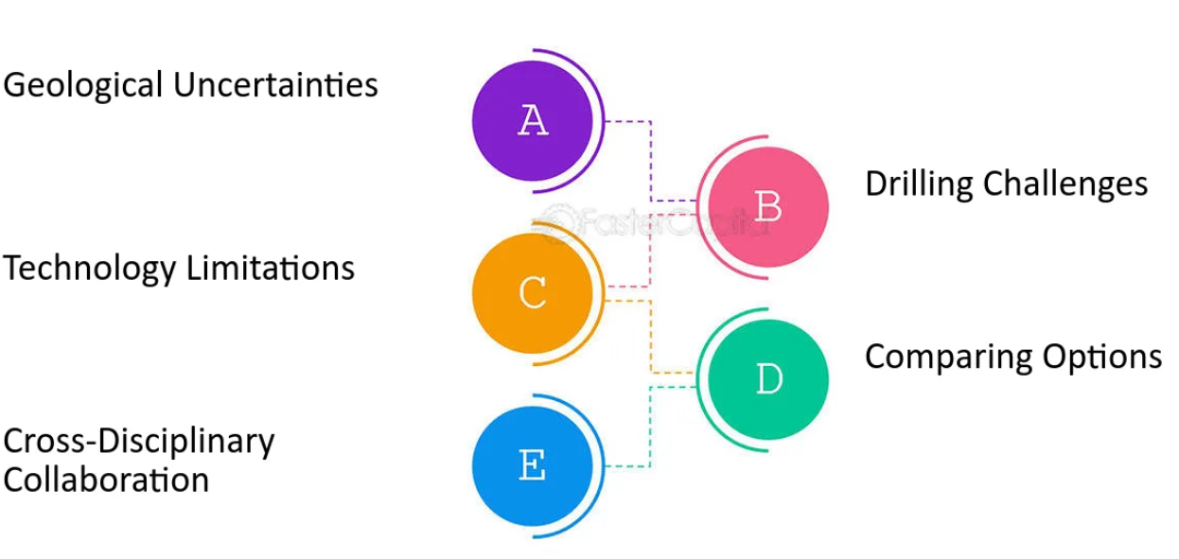

**Figure 1: Known Sources of Technical Risk**

technical risks in oil and gas projects encompass a wide range of challenges and uncertainties related to the exploration, development, and production of hydrocarbon resources. Here are some common technical risks encountered in oil and gas projects:

Reservoir Uncertainty: Uncertainties in reservoir properties, such as porosity, permeability, and fluid saturation, can affect resource estimation, production forecasts, and well performance. Reservoir heterogeneity, compartmentalization, and complex geology contribute to reservoir uncertainty.

Drilling Risks: Drilling operations pose various technical risks, including wellbore stability issues, formation damage, stuck pipe incidents, and blowouts. Challenges arise from complex geological formations, high-pressure/high-temperature (HP/HT) environments, and drilling through challenging formations such as salt or shale.

Production Optimization: Optimizing production from oil and gas reservoirs involves challenges such as reservoir depletion, water and gas coning, and sand production. Technical risks include suboptimal well placement, inefficient production techniques, and inadequate reservoir management practices.

Facilities and Infrastructure: Designing and operating oil and gas production facilities involves technical risks related to equipment reliability, integrity management, and process safety. Challenges include corrosion, erosion, mechanical failures, and the need for robust maintenance strategies.

Health, Safety, and Environment (HSE) Risks: Technical risks associated with health, safety, and environmental considerations include oil spills, gas leaks, well control incidents, and environmental pollution. Compliance with regulatory requirements and industry standards is crucial for mitigating HSE risks.

Subsurface Imaging and Characterization: Accurately imaging and characterizing subsurface geology is essential for successful exploration and development activities. Technical risks include limitations in seismic resolution, interpretation uncertainties, and the inability to identify subtle reservoir features.

Hydrocarbon Recovery Technologies: Implementing enhanced oil recovery (EOR) and enhanced gas recovery (EGR) techniques involves technical risks related to technology selection, implementation challenges, and uncertainty about reservoir response. Factors such as reservoir heterogeneity and fluid properties influence the effectiveness of recovery methods.

Well Integrity: Maintaining well integrity throughout the lifecycle of oil and gas wells is crucial for preventing leaks, blowouts, and environmental incidents. Technical risks include cementing failures, casing corrosion, annular pressure buildup, and zonal isolation issues.

Data Quality and Interpretation: Technical risks associated with data quality and interpretation include errors in well logs, seismic data processing artifacts, and uncertainties in reservoir modeling. Inaccurate data can lead to suboptimal decisions and increased project risks.

Emerging Technologies and Innovations: Adopting new technologies and innovations introduces technical risks related to technology maturity, reliability, and compatibility with existing infrastructure. Challenges include evaluating new drilling techniques, reservoir monitoring systems, and digitalization initiatives.

**4. Non-Technical Risks in Oil and Gas Projects**

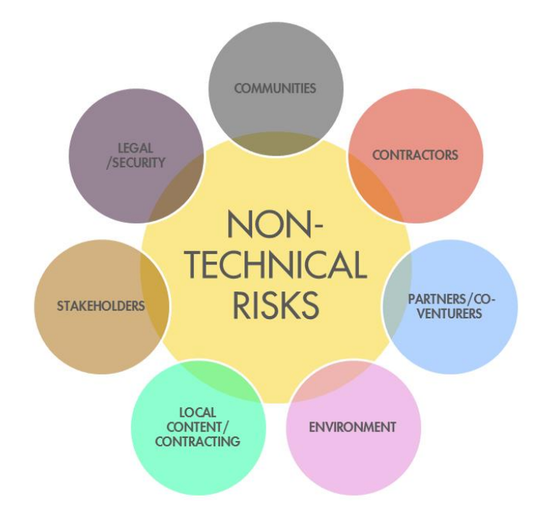

**Figure 2: Known Sources of Non-technical Risk [23]**

Regulatory and Compliance Challenges:

Oil and gas projects are subject to a myriad of regulations and compliance requirements imposed by local, national, and international governing bodies. Regulatory challenges can arise from evolving environmental standards, safety regulations, land-use restrictions, and permitting processes (Akinola et al., 2020).[1] Non-compliance with regulatory requirements can lead to project delays, legal liabilities, fines, and reputational damage for project stakeholders. Research in this area focuses on understanding regulatory frameworks, navigating regulatory uncertainties, and developing compliance strategies to ensure adherence to applicable laws and regulations (Iteghie et al., 2019; Ufodike et al., 2021).[14][15][16]

Geopolitical Instability and Market Volatility:

Geopolitical factors such as geopolitical tensions, trade disputes, sanctions, and political instability in oil-producing regions can significantly impact oil and gas projects. Geopolitical risks can manifest in the form of supply disruptions, resource nationalism, expropriation of assets, and geopolitical conflicts (Baffes et al., 2019). Additionally, market volatility stemming from fluctuations in oil prices, currency exchange rates, and global demand-supply dynamics poses significant challenges for project planning and investment decisions. Research in this domain explores geopolitical risk assessment methodologies, scenario planning techniques, and hedging strategies to mitigate the impact of geopolitical instability and market volatility on project outcomes (Finkel et al., 2020; Kourtidis et al., 2018).[17][18][19]

Environmental and Social Concerns:

Oil and gas projects are often associated with environmental degradation, biodiversity loss, greenhouse gas emissions, and social impacts on local communities. Environmental risks include air and water pollution, habitat destruction, deforestation, and climate change mitigation (Vasseur et al., 2020). Social risks encompass land-use conflicts, indigenous rights issues, community opposition, and social license to operate concerns. Failure to address environmental and social concerns can lead to project delays, regulatory interventions, protests, and stakeholder disputes. Research in this area focuses on environmental impact assessments, stakeholder engagement strategies, sustainability reporting, and corporate social responsibility initiatives to minimize environmental and social risks associated with oil and gas projects (Shirazi et al., 2019; Zavertiaeva et al., 2021).[20][21][22]

**5. Framework for Harmonizing Technical and Non-Technical Risks in Oil and Gas Projects**

Risk Identification Methods:

Risk identification is the first step in the risk management process and involves identifying potential threats and opportunities that may affect project objectives. In the context of oil and gas projects, risk identification methods should encompass both technical and non-technical risks. Common risk identification methods include:

Brainstorming sessions with multidisciplinary project teams to identify technical risks related to reservoir engineering, drilling operations, production processes, and facility design.

Environmental and social impact assessments to identify non-technical risks associated with regulatory compliance, environmental protection, social license to operate, and stakeholder engagement.

Failure mode and effect analysis (FMEA) to systematically identify potential failure modes, their causes, and their effects on project outcomes.

Scenario planning workshops to explore different future scenarios and identify potential risks and opportunities under each scenario.

Review of historical project data, lessons learned, and industry benchmarks to identify common risks and best practices.

Risk Assessment Techniques:

Risk assessment involves analyzing the likelihood and potential impact of identified risks on project objectives. In oil and gas projects, risk assessment techniques should consider both qualitative and quantitative aspects of risks. Common risk assessment techniques include:

Qualitative risk assessment methods such as risk matrices, risk registers, and risk scoring systems to categorize risks based on their severity and likelihood.

Quantitative risk assessment techniques such as probabilistic modeling, Monte Carlo simulation, and sensitivity analysis to quantify the potential financial, schedule, and technical impacts of risks.

Expert judgment and Delphi technique to gather input from subject matter experts and stakeholders on the likelihood and consequences of identified risks.

Fault tree analysis (FTA) and event tree analysis (ETA) to analyze the relationships between different risk events and their potential consequences.

Risk Prioritization Strategies:

Risk prioritization involves ranking risks based on their significance and determining which risks require immediate attention and mitigation efforts. In oil and gas projects, risk prioritization strategies should consider the interdependencies between technical and non-technical risks. Common risk prioritization strategies include:

Risk scoring and ranking based on predefined criteria such as impact severity, likelihood of occurrence, detectability, and vulnerability.

Cost-benefit analysis to prioritize risks based on the potential cost of mitigation measures versus the expected benefits in terms of risk reduction.

Risk aggregation and consolidation to group similar risks and prioritize them based on their cumulative impact on project objectives.

Multi-criteria decision analysis (MCDA) to consider multiple factors and stakeholder preferences in the risk prioritization process.

Risk tolerance and risk appetite assessments to align risk management strategies with organizational objectives and risk tolerance levels.

By adopting a comprehensive framework that integrates technical and non-technical risk identification, assessment, and prioritization methods, oil and gas projects can effectively harmonize the management of both types of risks and enhance project resilience and success.

**6. Case Studies and Best Practices**

Integrated Risk Management Framework in Offshore Drilling Project: This case study examines the implementation of an integrated risk management framework in an offshore drilling project. It showcases how technical risks such as wellbore stability issues and drilling uncertainties were harmonized with non-technical risks such as regulatory compliance and environmental concerns. The case study highlights best practices in risk identification, assessment, and mitigation, as well as lessons learned from project execution.

Geopolitical Risk Mitigation Strategies in International Pipeline Project: This case study explores the challenges of managing geopolitical risks in an international pipeline project. It discusses how the project team navigated geopolitical uncertainties such as political instability, trade disputes, and regulatory changes across multiple countries. The case study presents best practices in stakeholder engagement, scenario planning, and risk hedging to mitigate the impact of geopolitical risks on project outcomes.

Environmental and Social Risk Management in Onshore Production Facility: This case study focuses on environmental and social risk management in an onshore production facility project. It examines how the project team addressed environmental concerns such as air and water pollution, habitat disruption, and community opposition. The case study highlights best practices in environmental impact assessments, community engagement, and sustainability reporting to ensure compliance with regulatory requirements and maintain social license to operate.

Regulatory Compliance and Safety Culture in Refinery Expansion Project: This case study discusses the importance of regulatory compliance and safety culture in a refinery expansion project. It examines how the project team established a culture of safety excellence and adhered to regulatory requirements throughout the project lifecycle. The case study presents best practices in safety training, process safety management, and regulatory reporting to minimize safety incidents and ensure project success.

Risk-Based Decision Making in Upstream Exploration Project: This case study explores the application of risk-based decision making in an upstream exploration project. It discusses how the project team utilized probabilistic modeling, Monte Carlo simulation, and sensitivity analysis to evaluate technical and non-technical risks and inform decision making. The case study showcases best practices in risk quantification, risk tolerance assessment, and risk-informed decision making to optimize project outcomes.

These case studies provide practical insights and real-world examples of how technical and non-technical risks can be harmonized and managed effectively in oil and gas projects. They highlight best practices, lessons learned, and key success factors that can guide project teams in navigating the complexities of risk management and ensuring project resilience and success.

**7. Conclusion:**

The effective management of technical and non-technical risks is crucial for the success of oil and gas projects. Our study has highlighted the importance of adopting a holistic approach to project management that integrates both types of risks. By harmonizing technical challenges with regulatory, environmental, and geopolitical factors, project stakeholders can enhance decision-making processes, mitigate uncertainties, and improve overall project outcomes. Through the development of integrated risk management frameworks and the application of best practices, oil and gas projects can navigate complexities more effectively, minimize disruptions, and achieve sustainable success in a dynamic industry landscape.

**8. References:**

[1]. Tavakoli, R., Rivas, A. A., & Liu, Y. (2020). A comprehensive review of risk management in oil and gas industry: A new perspective. Journal of Natural Gas Science and Engineering, 84, 103483.

[2]. Aluko, O. O., & Oshodi, O. A. (2020). Overview of the oil and gas industry: Exploration, production, refining, and products. In The Economics of the Oil and Gas Industry (pp. 1-22). Springer, Cham.

[3]. Vatn, J., & Anda, J. (2018). How to manage risk in the oil and gas industry. Journal of Petroleum Exploration and Production Technology, 8(3), 799-813.

[4]. Anifowose, F., Salami, A. W., & Adedoyin, F. (2020). An integrated approach to technical and non-technical risk management in the oil and gas industry. International Journal of Oil, Gas and Coal Engineering, 8(1), 14-22.

[5]. Yuan, L., Li, X., & Zhang, W. (2019). Technical risk assessment and management of deepwater oil and gas development projects. Marine Policy, 100, 319-327.

[6]. Ateba, C. N., Otukei, J. R., & Oyewobi, L. O. (2021). Understanding the Impact of Environmental Risk Management on Sustainable Performance: A Case Study of the Nigerian Oil and Gas Industry. In Corporate Social Responsibility, Sustainability, and Environmental Management in Developing Economies (pp. 1-21). IGI Global.

[7].Ferreira, M. C., Queiroz, R. G., de Oliveira, J. F., Pinto, H. S., & Lima, G. T. (2018). Challenges and strategies for risk management in oil and gas industry: A systematic literature review. Journal of Loss Prevention in the Process Industries, 56, 9-26.

[8]. Mahmoudi-Kohan, N., Sadi-Nezhad, S., & Adeli, H. (2020). Integrated risk management framework for oil and gas projects: Case study. Journal of Construction Engineering and Management, 146(6), 04020062.

[9]. Zhang, X., Xie, M., Yang, Z., & Fang, D. (2018). A comprehensive risk management framework for offshore oil and gas development projects in China. Safety Science, 109, 22-36.

[10]. Sánchez-Carbonell, X., Martin-Gamboa, M., & Del Ser, J. (2019). Towards a Framework for Integrated Risk Management in Oil and Gas Projects. Energies, 12(9), 1694.

[11]. Zhang, M., Zhang, J., Lu, Y., & Liu, L. (2021). An Integrated Risk Management Framework for Mega Oil and Gas Projects Based on a Hybrid Model: A Case Study of the China–Russia Eastern Route Natural Gas Pipeline. Energies, 14(1), 188.

[12]. Kang, Y., Kim, M., & Lee, J. (2020). Application of machine learning algorithms for identification and prediction of risk factors in offshore oil and gas projects. Energies, 13(11), 2842.

[13]. Shekhar, S., Arora, V., & Jaiswal, S. (2021). Big Data Analytics for Risk Management in Oil and Gas Projects: A Comprehensive Review. Journal of Pipeline Systems Engineering and Practice, 12(2), 04020020.

[14]. Akinola, O. A., Adesina, A. O., & Ogunyinka, B. I. (2020). Regulatory challenges and implications of compliance in the Nigerian oil and gas industry. Journal of Sustainable Mining, 19(4), 238-246.

[15]. Iteghie, H., & Madubueze, I. (2019). Regulatory compliance strategies for the Nigerian oil and gas industry: a stakeholder's perspective. International Journal of Law and Management, 61(6), 1510-1528.

[16]. Ufodike, C. O., & Nnadi, M. N. (2021). Regulatory Compliance and Sustainable Development in the Nigerian Oil and Gas Industry: A Study of Compliance Status of Oil and Gas Companies in the Niger Delta. Journal of Sustainable Development in Africa, 23(4), 53-75.

[17]. Baffes, J., Kose, M. A., Ohnsorge, F., & Stocker, M. (2019). The great plunge in oil prices: Causes, consequences, and policy responses. World Bank Group.

[18]. Finkel, D. A., Sheng, S., Wang, T., & Guo, Y. (2020). Corporate geopolitical risk: Conceptualization and measurement. Journal of World Business, 55(1), 100980.

[19]. Kourtidis, D., Hadri, K., & Zafeiriou, E. (2018). Economic exposure and stock returns: Evidence from oil prices. The Quarterly Review of Economics and Finance, 69, 488-500.

[20]. asseur, L., Sauvé, S., & Bélanger, D. (2020). Environmental Impact Assessment of Oil and Gas Projects: Integrating Climate Change Considerations. In Environmental and Health Issues in Unconventional Oil and Gas Development (pp. 49-69). Springer.

[21]. Shirazi, F., Hussain, M., & Khan, M. A. (2019). Corporate Social Responsibility and Sustainability Reporting in Oil and Gas Sector: A Comparative Study of Companies in Developing and Developed Economies. Sustainability, 11(3), 596.

[22]. Zavertiaeva, M., Naberezhnykh, D., & Petrov, M. (2021). Stakeholder Engagement as a Tool for Social Responsibility in Oil and Gas Sector. IOP Conference Series: Earth and Environmental Science, 634(1), 012110.

[23]. Dr. Adebanji and Emmanuel Ekpenyong. Managing Non-Technical Risk in Exploration and Production (E&P) Projects: Opportunity to leverage the IA Process.