**DESIGN OF HOLLOW R.C.C BEAM**

Pradeep Vithalrao Mote, Priyanka Dubey

PG Scholar, CED, Dr. APJ Abdul Kalam University Indore, M.P., India E mail -pradeepmote@gmail.com

Assistant Professor, CED, Dr. APJ Abdul Kalam University Indore, M.P., India E mail - priyankadubey1105@gmail.com

**ABSTRACT**

The objective of this project is to develop a formulated Excel sheet for the design of simple and hollow R.C.C. beams, aiming to provide a user-friendly tool for engineers and designers to efficiently perform beam design calculations. The Excel sheet comprises three sheets, with Sheet 1 for the calculation and formulation of simple beams, Sheet 2 for the calculation and formulation of hollow beams, and Sheet 3 for taking inputs from the user and displaying the results obtained from Sheet 1 and Sheet 2.

The formulated Excel sheet allows users to input design parameters such as beam span, beam depth, beam width, concrete grade, steel grade, loads, and other relevant parameters in Sheet 3, which are then automatically referenced and used in the calculations in Sheet 1 and Sheet 2. The design results, including effective length of the beam, effective depth of the beam, dead load, total and ultimate load, bending stress, shear stress, area of steel required, number of steel bars required, and other parameters, are displayed in tabular form in Sheet 3 based on the input values provided by the user.

The advantages of this formulated Excel sheet include its user-friendly interface, automated calculations based on input values, quick and efficient design result generation, and flexibility to design both simple and hollow R.C.C. beams. The Excel sheet serves as a valuable tool for engineers and designers in the design process, providing accurate and reliable results for beam design, and potentially saving time and effort in the design process.

The future scope of this project includes further refinement and enhancement of the Excel sheet based on feedback and requirements from users, incorporation of additional design codes and specifications, extension to other types of structural elements, and potential integration with other software or tools for comprehensive structural design and analysis.

**INTRODUCTION**

In the previour report we tried to design three different simple beam and three different hollow R.C.C. beams of same dimentions and load as of designed simple beam to see the difference in the resultant output and see wheather the use of Hollow R.C.C. beam is useful for us or not. But as we know the number of attains matter in any field to finitely say that it is superior on paper or not. Therefore in this report we come with a solution that we will create a formulated sheet in Microsoft Excel which will design both the beam as per our value inputs and process the result as per our formulation. he results are compared and analyzed to assess the relative performance of the different beam types. Additionally, sensitivity analysis may be conducted to study the effects of varying design parameters on the beam performance.

Overall, this report provides a comprehensive comparison of simple beams and hollow beams, utilizing a formulated sheet in Microsoft Excel to analyze and evaluate their respective performance. The findings of this report can be valuable for engineers, architects, and other professionals involved in structural design and analysis, helping them make informed decisions in selecting appropriate beam types for their specific applications.

Using Excel for comparing simple beams and hollow beams allows you to perform calculations and analyze results in a structured and organized manner, making it a useful tool for engineering and structural analysis purposes. However, it's important to note that the accuracy of the results depends on the accuracy of the input values and assumptions made during the calculations. It's always recommended to consult relevant engineering codes, standards, and professionals for accurate and reliable results in real-world applications.

# OBJECTIVE OF THE WORK

The objective of our project is to make a formulated sheet of Microsoft excel and perform comparision between Simple beam with Hollow R.C.C. Beam. The objective of this project is to develop a comprehensive and user-friendly formulated sheet for the design of hollow and simple reinforced concrete (R.C.C.) beams using Microsoft Excel. The formulated sheet will incorporate mathematical formulas and functions to calculate key beam properties such as Bending moment moment of inertia, bending stress, based on user-inputted design parameters and material properties.

* + - Developing a user-friendly and efficient formulated sheet in Microsoft Excel for the design of hollow and simple R.C.C. beams.
    - Incorporating mathematical formulas and functions to calculate moment of inertia, section modulus, and bending stress based on user-inputted design parameters and material properties.
    - Ensuring accuracy and reliability of the calculated results by validating the formulated sheet against established engineering codes, standards, and best practices.
    - Providing a tool that allows for easy comparison between different beam configurations, aiding in the selection of appropriate beam types for specific applications.
    - Creating a comprehensive and organized sheet that can be used as a reference for beam design calculations, with clear documentation and instructions for ease of use.

Overall, the objective of this project is to develop a formulated sheet in Microsoft Excel that simplifies the design process for hollow and simple R.C.C. beams, making it a valuable tool for professionals in the field of structural engineering.

**Result:-**

Following shows the value of the resultant output of design done in MS Excel as Simple Beam( Type 1) and Hollow beam (Type1).

Both the beam was of 4000mm clear length and have same Live load of 10 kN/m.

From the below we can clearly see that the defference between both the beam at various parameters. From the alaysis of the table we can see that the hollow beam is giving us the better result as compared to simple beam on following parameters:-

* + - Dead load of hollow beam is less than simple beam
    - Total load of hollow beam is less than simple beam
    - Ultimate load of hollow beam is less than simple beam
    - Area of steel (Required) of hollow beam is less than simple beam
    - It also passing all three checks of Bending, Shear and Deflection

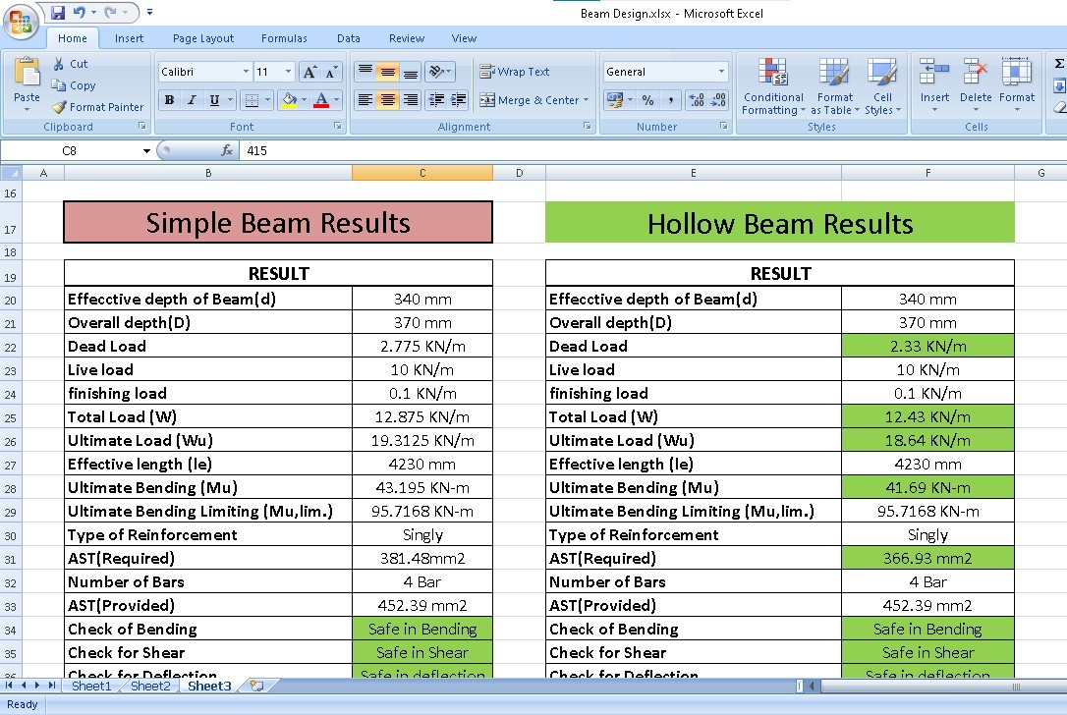

**Fig. 1 Result of Beams Type 1**

## Comparision between Simple Beam (2) and Hollow Beam(2)

Following shows the value of the resultant output of design done in MS Excel as Simple Beam (Type 2) and Hollow beam (Type 2). Both the beam was of 5000mm clear length and have same Live load of 12 kN/m.

From the below we can clearly see that the defference between both the beam at various parameters. From the alaysis of the table we can see that the hollow beam is giving us the better result as compared to simple beam on following parameters:-

* + - Dead load of hollow beam is less than simple beam
    - Total load of hollow beam is less than simple beam
    - Ultimate load of hollow beam is less than simple beam
    - Area of steel (Required) of hollow beam is less than simple beam
    - Number of Steel Bars used is less in Hollow beam as compared to simple beam.
    - Area of Steel (Provided) is less in hollow beam as compared to simple beam.
    - It also passing all three checks of Bending, Shear and Deflection

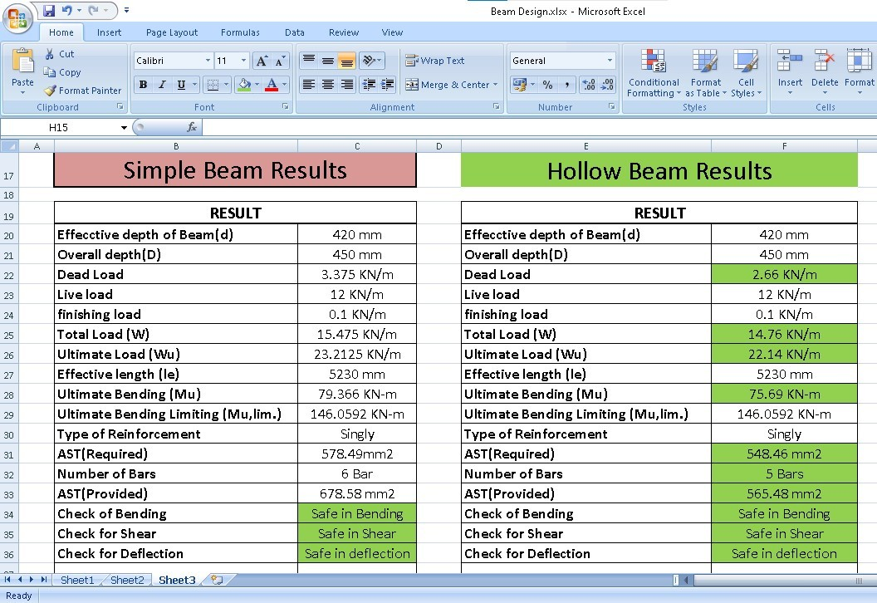

**Fig. 2 Result of Beam Type 2**

## Comparision between Simple Beam (3) and Hollow Beam(3)

Following shows the value of the resultant output of design done in MS Excel as Simple Beam( Type 1) and Hollow beam (Type1).

Both the beam was of 3000mm clear length and have same Live load of 8 kN/m.

From the below we can clearly see that the defference between both the beam at various parameters. From the alaysis of the table we can see that the hollow beam is giving us the better result as compared to simple beam on following parameters:-

* + - Dead load of hollow beam is less than simple beam
    - Total load of hollow beam is less than simple beam
    - Ultimate load of hollow beam is less than simple beam
    - Area of steel (Required) of hollow beam is less than simple beam
    - It also passing all three checks of Bending, Shear and Deflection

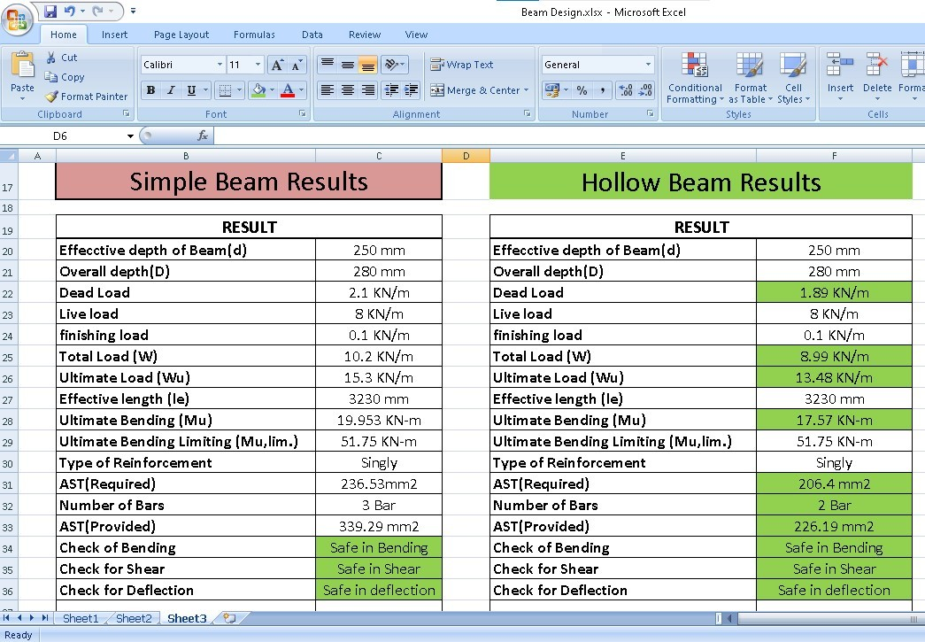

**Fig. 3 Result of Beam Type 3**

**Conclusion-**

The formulated sheet for the design of hollow and simple R.C.C. beams in Microsoft Excel offers several advantages, including:

* + - **Efficiency and Time-Saving**: The formulated sheet automates the calculation of key beam properties, such as moment of inertia, section modulus, and bending stress, based on user-inputted design parameters and material properties. This can significantly reduce the time and effort required for manual calculations, leading to increased efficiency in the beam design process.
    - **Accuracy and Reliability**: The formulated sheet utilizes established engineering formulas and functions, validated against relevant codes and standards, to ensure accurate and reliable results. This can help minimize the risk of errors and ensure that the designed beams meet the required performance and safety criteria.
    - **User-Friendliness**: The formulated sheet is designed with a user-friendly interface, including clear instructions and input fields, making it easy for engineers, architects, and other professionals to use, even if they are not experts in beam design. This can help streamline the design process and reduce the learning curve for users.
    - **Flexibility and Comparison**: The formulated sheet allows for easy input of different design parameters and material properties, enabling users to quickly compare and evaluate different beam configurations. This can facilitate the selection of appropriate beam types for specific applications and optimize the design based on project requirements.
    - **Sensitivity Analysis**: The formulated sheet can be used for sensitivity analysis, allowing users to study the effects of varying design parameters and material properties on the beam performance. This can provide insights into the sensitivity of the design to different factors and help users make informed decisions during the beam design process.
    - **Documentation and Reporting**: The formulated sheet typically includes clear documentation and instructions within the sheet, making it a comprehensive reference for beam design calculations. This can be useful for documentation purposes and can serve as a basis for reporting and communication with project stakeholders.
    - **Customization**: The formulated sheet can be customized to suit specific project requirements, such as local design codes, material properties, and design standards. This flexibility allows users to adapt the sheet to their specific needs, making it a versatile tool for different projects.
    - **Cost-effective**: Developing a formulated sheet in Microsoft Excel can be a cost- effective solution compared to purchasing specialized software for beam design. Excel is a widely used and easily accessible software that is readily available to most professionals, making the formulated sheet a cost-effective option for beam design calculations.

# REFERENCES

1. Ankur Dubey, D. S. (2017, 5), "Comparative analysis of a 50 Storey RCC Frame with shear wall for conventional loading and construction sequence loading", International Research Journal of Engineering and Technology, 4, 6.
2. Chang-Koon Choi, H.-K. C.-G. (1992),"Simplified Building Analysis with Sequential Dead Loads", CFM. ASCE, 11.
3. Chang-Koon Choi, M. A.-D. (1985), "Multistorey Frames Under Sequential Gravity Loads". ASCE, 12.
4. Jayasena, M. T. (2004),"Effects of Axial Shortening of Columns on Design and Construction of Tall Reinforced Concrete Buildings", ASCE, 9.
5. Kiran Y. Naxane, P. M. (2017), "Construction Sequence Analysis of Multistoried RCC Building", International Research Journal of Engineering and Technology, 6.
6. Lee, T. H. (2013),"Advanced Construction Stage Analysis of High-rise Building", ASEM, 9.
7. Mahajan, S. R. (2015, 4 2),"Analysis of Multi Storied RCC Building for Construction Sequence Loading", International Journal of Modern Trends in Engineering and Research, 6.
8. Murthy, M. B. (2016, 11 7),"Comparison of Linear Static Analysis and Construction Sequence Analysis on Multi-storey Building with RC Floating Column Resting on RC and Composite Transfer Girders", International Journal of Engineering Trends and Technology, 36.
9. Santosh Panigrahi, D. V. (2019, 4 6),"Importance of Construction Sequence Analysis in design of High Rise Building", International Journal of Innovative Science, Engineering & Technology.