Vision Based Spy Robot System using IoT

**HONEY RAJPUT*1, ASHOK SANJAY DANGA*2, NIKHIL VITTHAL NANDEKAR*3, PRAJAKTA VARDHAN CHAWRE*4  , PRANALI ANANT KHACHANE*5  , MRS. SUSHMA TELRANDHE *6**

1,2,3,4,5,6 Department of Electronics and Tele Communication Engineering, Guru Nanak Institute of Engineering and Technology

**Abstract:** Surveillance literally means to watch from a distance. Surveillance cameras and facial recognition are used to monitor public and private spaces and to identify people. The effectiveness of this technology is up for debate, but it is nevertheless becoming both more pervasive and more invasive. So, this paper proposes a surveillance robot which can move and has multi-sensory capabilities inbuilt. The main motive of the paper is the surveillance of human activities in remote areas where human intervention is difficult or risky. The robot is used to collect information from the remote terrain and monitor that information at a far secure place with the help of IoT technology.

**Keywords:** Raspberry Pi 3, PIR Sensor, IR Sensor, Webpage, DC Motor, Python, IoT, HTML, PHP.

# INTRODUCTION

Surveillance literally means to watch from a distance, while surveillance robots are used to monitor the behavior, activities, and other changing information that is gathered for the general purpose of managing, directing, or protecting one's assets or position.[21]

Surveillance cameras and facial recognition are used to monitor public and private spaces and to identify people. The city of the future is likely to place a lot of emphasis on security. So, robots may well be performing dangerous jobs normally done by the police, and automated incident detection cameras will be used to enable fast intervention by security personnel.[22]

Robots have also started to be used for surveillance purposes in the private sector as well and robot guards are currently being tested all over the world. US-based Gamma 2 Robotics has developed Ramsee, a machine resembling a small cosmonaut that does the security patrol rounds at sensitive sites.[23]

Surveillance cameras in trains, metro stations and other public places have become widespread in many cities. However, current systems suffer from a serious weakness since they require constant monitoring by a human agent. It is known that a person’s attention falls away rapidly after twenty minutes, so it can be seen that there is substantial room for improvement in this type of system, as a crime or offence being committed might easily escape the agent’s attention. As a result, video surveillance is mainly used as a means of dissuasion or to shed extra light on a crime or offence, and only very rarely as a real-time crime detection tool. The proposed paper is the kind of system that ought to help the authorities avoid the crime happenings in and around the area under surveillance.

# LITERATURE REVIEW

[2]Juan G. Parada-Salado, Luis E. Ortega-García, Luis F. Ayala-Ramírez, Francisco J. Pérez Pinal [2018] presented a concept on design and construction of a land wheeled autonomous mini-robot (LWAMR) for in-door surveillance. The LWAMR can be autonomous by using a position, speed and distance sensor. In addition, it is capable of sending images and video in real-time by using a spycam, which is controlled by a servomechanism. Details of the design, control algorithm, communication, and human-machine interface (HMI) are given. HMI was implemented in LabVIEW and it is used for monitoring remotely the LWAMR health and surveillance. Communication between the HMI and the LWAMR system was carried out by means of RF transceivers. Results show the effective implementation of this kind of LWAMR system. Advantages of the presented LWAMR are low cost, versatility, modularity, robustness and remote (or not) operation by using a mobile device HMI.

[3]S M Ashish, Madhurya Manjunath, Ravindra L, Mohammed Nadeem, Neelaja K [2018] proposed a concept about a Raspberry Pi based automated robot which fulfils the purpose of surveillance. The robot provides autonomous movement around the facility where it is deployed and will move around the obstacles in its way by detecting them. It detects any kind of human emotions in the facility and alerts the registered users through SMS alert. It also captures the image of the commotion by using a Pi camera.

[4]T. Saravanakumar, D. Keerthana, D. Santhiya, J. Sneka, D. Sowmiya [2018] The main objective of this paper is to develop a virtual environment for detecting suspicious and targeted places for the user without any loss of human life. It is based on the development of a robot vehicle for observing/spying suspicious objects. It can continuously monitor the objects. The robot can move in every direction (left, right, forward and backward). It is used for video surveillance and remotely controls the particular place using Wi-Fi as a medium. The webcam which is placed on the robotic unit will capture the video and it transmits lively to the remote end. The major application of this paper can be analyzed using an HTML web page which can be used to control the movement of the robot. L293D is a quadruple dual H-Bridge motor- driven IC.

[5]Harshitha R, Muhammad Hameem Safwat Hussain [2018] By means of this paper, the author puts forward a surveillance robot which can be integrated into any kind of household. The base controller of the bot will be the powerful Raspberry Pi 3 Model B. A webcam attached to the Pi monitors the area and sends a notification when any trespassing or obtrusion is detected. The camera also possesses a face recognition algorithm which will possess the ability to identify the person responsible for the motion triggering. If it is authorized personnel, the on-board voice assistant will start talking with the person. The notification will be sent only when it’s unauthorized personnel and will contain pictures clicked of the trespasser and also activate live streaming of the webcam feed. The live streaming ability of the Pi allows the camera feed to be analyzed from any location using the internet. With such a system, every user will feel more sheltered while they’re not at their place of residence or when they’ve left their children and old ones alone at home.

[1]Muhammad Hamza, M Atique-ur-Rehman, Hamza Shafqat, Subhan Bin Khalid [2019] proposed an idea about a platform to remotely control a surveillance robot over the internet. It will enable us to monitor the activities in the remote and sensitive areas. In traditional security systems, fixed locations are used for monitoring and spying purposes. For such cases, our robotic system is mobile and it can go into those areas where human access is risky, impossible or not suitable and provide us with the footage of those locations. The camera mounted on the robot keeps on capturing the video. This live video from the robot will be streamed on the webpage and it will be used for both surveillance and controlling the robot movement accordingly. The movement algorithm of the robot is implemented using CGI scripts and the monitoring is done by utilizing the MJPG video streamer. The aim is to control the robot from anywhere in the world via webpage and to make the delay time as little as possible.

# BLOCK DIAGRAM

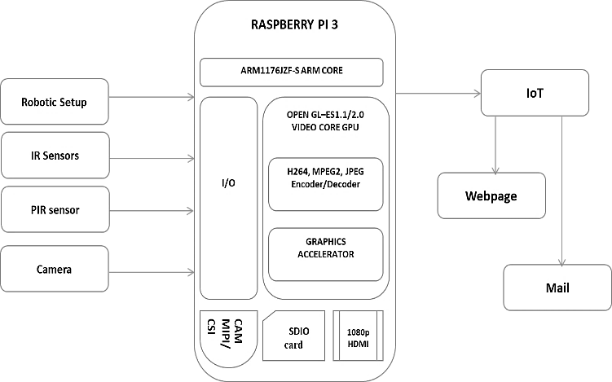

**Raspberry Pi 3:**

The Raspberry Pi 3 Model B is the latest version of the Raspberry Pi computer. The Raspberry Pi is the cheapest board, it doesn't have a case, and is simply a credit-card sized electronic board of the type which might be inside a PC or laptop but much smaller. It acts as the controlling core of the system.

# Robotic Setup:

The Robotic setup is a casing that houses the microcontroller board, various sensors, mounted on wheels used for navigation which is driven by DC motors.

# IR Sensors:

IR (Infrared) Sensor works by emitting infrared signal/radiation and receiving the signal when the signal bounces back from any obstacle. In other words, the IR Sensor works by continuously sending a signal (in a direction) and continuing receiving the signal, it comes back by bouncing on any obstacle in the way.

# PIR Sensors:

PIR (passive infrared) motion sensor detects any movement of objects, human or animals. Every object with a temperature above absolute zero emits heat in the form of infrared radiation. PIR motion sensor detects a change in the infrared radiation impinging on it. When any object or human passes in the front of the PIR sensor, the temperature in the sensor’s field of view will rise from ambient temperature to object temperature and then back again to ambient temperature. PIR sensor converts this temperature change into the change in output voltage and that change in voltage is considered as motion detected.

# Pi Camera:

The Raspberry Pi Camera v2 is the new camera board released by the Raspberry Pi Foundation. The Raspberry Pi Camera Module v2 is a high quality 8 megapixel Sony IMX219 image sensor custom designed add-on board for Raspberry Pi, featuring a fixed focus lens. It is used for the acquisition of images and videos from the surveillance area.

# SDIO Card:

Secure Digital I/O Card is a version of the SD Memory Card that adds wireless transmission to any compatible device. Introduced in 2001, the first SDIO card on the market was a Bluetooth card. Wi-Fi and ZigBee cards followed them.

# Graphics Accelerator:

A graphics accelerator is a piece of dedicated hardware designed and used to rapidly process visual data. It is a chipset attached to a video board to which a computer program can offload the sending and refreshing of images to the display monitor and the computation of special effects of common images and videos.

# Web Page:

A web page is a document that is suitable to act as a web resource on the World Wide Web. In order to graphically display a web page, a web browser is needed. This is a type of software that can retrieve web pages from the Internet. When accessed by a web browser it may be displayed as a web page on a monitor or mobile device. The webpage has necessary buttons to facilitate the manual remote control of the system. It also enables the user to view the received images or videos.

# IMPLEMENTATION

This paper involves the implementation of a surveillance system using a robot which is IoT enabled. The whole system is divided into two parts: Hardware and Software. The hardware is the moving robotic prototype which is used for sensing, capturing and transmitting the captured data through IoT. The software consists of a webpage with the required user interface to manually control the robotic movements, to receive the data from the hardware module and to notify the user of any intrusions. The hardware is mainly controlled by the Raspberry Pi 3 microcontroller.

It is the brain of the robotic module that takes care of all its functions such as sensing, movements (both autonomous and manual movements), data transmission, camera control and communication between the module and the user. It acts as a wireless computer with LAN, Bluetooth, GSM and internet connectivity for data transmission. The movements of the robot are controlled by two DC motors which in turn is interfaced to the Raspberry Pi 3 board. The module is powered by a battery.

The robotic base module is also implemented using, webpage and an android application through which the robot can be controlled. The robot is controlled by the buttons available on the webpage. Also, the live streaming and auto-pilot facilities are available on the webpage. The webpage is built using two different languages namely, HTML and PHP. HTML is used for frontend components and PHP is used for backend operation.

The captured image via the camera in the robotic setup is delivered to the user as an image attachment with email. The SMTP module programmed in the raspberry pi automatically signs-in to the given mail id. It attaches the captured image and sends it to the required user. This part is established by IoT. The results are captured and the required data is presented.

The hardware specifications of the Raspberry PI 3 are:

* Quad-Core 1.2GHz Broadcom BCM2837 64bit CPU
* 1GB RAM
* BCM43438 wireless LAN and Bluetooth Low Energy (BLE) on board
* 100 Base Ethernet
* 40-pin extended GPIO
* Four USB 2 ports
* 4 Pole stereo output and composite video port
* Full-size HDMI (1080)
* CSI camera port for connecting a Raspberry Pi camera
* DSI display port for connecting a Raspberry Pi touchscreen display
* Micro SD port for loading operating system and storing data
* Upgraded switched Micro USB power source up to 2.5A

# Advantages of Raspberry Pi over other Microcontroller:

There are three main benefits to the Raspberry Pi 3. It has Bluetooth, Wi-Fi and it has a more powerful CPU/GPU pair. The Broadcom BCM2837 is a 64-bit CPU. The main benefit is that this chip is more efficient and far more powerful which is a quad-core Cortex-A7 Broadcom BCM2836. The difference in power is much greater than the move from a 900MHz quad-core processor to a 1.2GHz quad-core.

# RESULTS

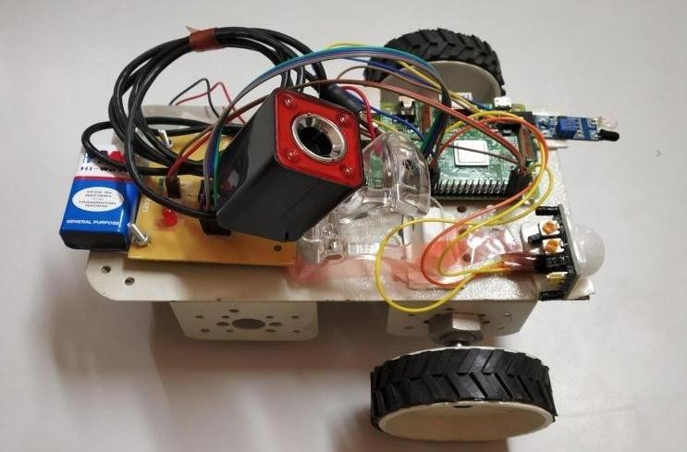

Fig 1: Top View of the Hardware

The above picture gives us the top view of the hardware where the sensors mounted on the robotic module can be viewed.

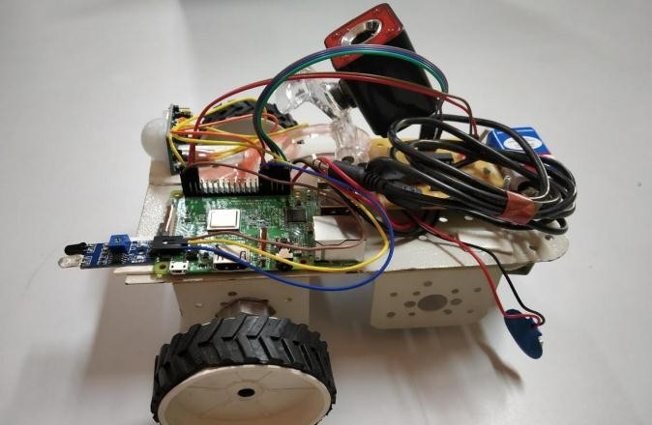

Fig 2: Side View of the hardware

The picture presents the side view of the hardware which shows the connections and other details.

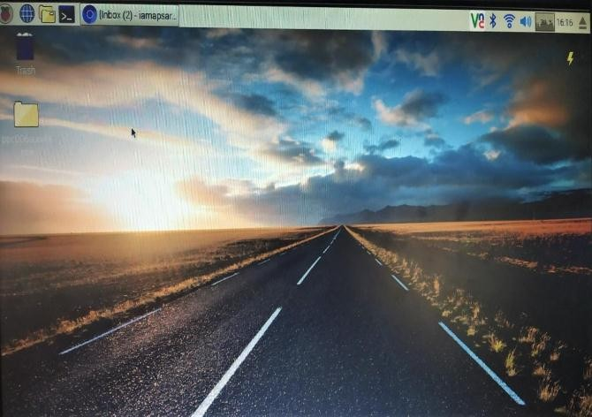

Fig 3: Raspbian OS

Raspbian is a Debian-based (32 bit) computer operating system for Raspberry Pi. Raspbian is highly optimized for the Raspberry Pi line's low-performance ARM CPUs.

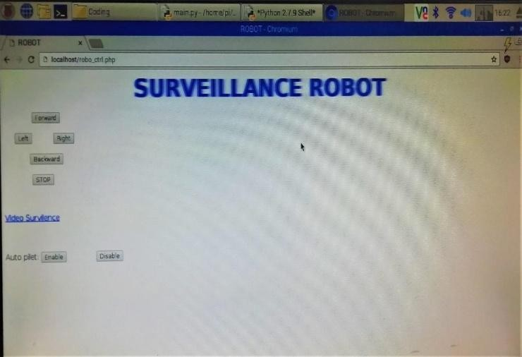

Fig 4: Webpage

This gives a glimpse of the developed webpage. It has buttons for controlling the robot either manually or automatically. It also has an option for viewing the live video.

# CONCLUSION

The conclusion is that the proposed system is completed successfully. The motion of the robot is being controlled manually using a webpage. According to the movement, we could control the wheel and hence the movement of the robot through the webpage by using IoT. The input given to the webpage is sent through the internet and desired movement occurs at the robot end.

# REFERENCES

1. Muhammad Hamza, M Atique-ur-Rehman, Hamza Shafqat, Subhan Bin Khalid, “CGI SCRIPT AND MJPG VIDEO STREAMER BASED SURVEILLANCE ROBOT USING RASPBERRY PI” in 16th International Bhurban Conference on Applied Sciences & Technology (IBCAST) Islamabad, Pakistan, 8th – 12th January, 2019, IEEE 2019.
2. Juan G. Parada-Salado, Luis E. Ortega-García, Luis F. Ayala-Ramírez, Francisco J. Pérez Pinal, “A Low-Cost Land Wheeled Autonomous Mini- Robot For In-Door Surveillance” In Ieee Latin America Transactions, Vol. 16, No. 5, May 2018.
3. S M Ashish, Madhurya Manjunath, Ravindra L, Mohammed Nadeem, Neelaja K, “Automated Hybrid Surveillance Robot” In International Journal Of Innovations In Engineering Research And Technology [Ijiert], Issn: 2394-3696; Volume 5, Issue 5, May-2018.
4. T. Saravanakumar, D. Keerthana, D. Santhiya, J. Sneka, D. Sowmiya, “Surveillance Robot Using Raspberry Pi-IoT” in International Journal of Electronics, Electrical and Computational System(IJEECS);ISSN 2348-117X; Volume 7, Issue 3, March 2018.
5. Harshitha R, Muhammad Hameem Safwat Hussain, “SURVEILLANCE ROBOT USING RASPBERRY PI AND IOT” in 2018 IEEE - DOI 10.1109/ICDI3C.2018.00018; International Conference on Design Innovations for 3Cs Compute Communicate Control.
6. Gaurav S Bagul, Vikram C Udawant, Kalpana V Kapade and Jayesh M Zope, “IOT BASED SURVEILLANCE ROBOT” in International Journal of Trend in Research and Development, Mar - Apr 2018; Volume 5(2), ISSN: 2394-9333.
7. Rutuja. R. Bachhav, Priyanka. S. Bhavsar, Devyani. K. Dambhare, “Spy Robot For Video Surveillance And Metal Detection” In International Journal For Research In Applied Science & Engineering Technology (Ijraset); Issn: 2321-9653; Volume 6 Issue V, May 2018.
8. Neha Joisher, Sonaljain, Tejas Malviya, Vaishali Gaikwad (Mohite), “Surveillance System Using Robotic Car” In International Conference On Control, Automation And Systems, Ieee 2018.
9. Fatma Salih, Mysoon S.A. Omer, “Raspberry Pi As A Video Server” In The International Conference On Computer, Control, Electrical, And Electronics Engineering (Iccceee) 2018.
10. Sweeta Deshmukh, Priyadarshini, Mamta, Madhura Deshmukh, Dr.Md. Bakhar, “Iot Based Surveillance Robot” In International Journal Of Innovative Research In Computer And Communication Engineering; Vol.5, Special Issue 4, June 2017
11. Ghanem Osman Elhaj Abdalla, T. Veeramanikandasamy, “Implementation Of Spy Robot For A Surveillance System Using Internet Protocol Of Raspberry Pi” In 2nd Ieee International Conf On Recent Trends In Electronics Information & Communication Technology, May 19-20, 2017.
12. Souvik Saha, Arko Singh, Palash Bera, Murshed Nawaz Kamal, Soumya Dutta, Uttam Gorian, Sayak Pramanik, Angshuman Khan, Surajit Sur, “Gps Based Smart Spy Surveillance Robotic System Using Raspberry Pi For Security Application And Remote Sensing” In Ieee , 978-1-5386- 3371-7/17,2017.
13. Zeeshan Shaikh, Priyanka Gaikwad, Nikhil Kare, Swapnali Kapade, M.V. Korade , “An Implementation On – Surveillance Robot Using Raspberry-Pi Technology” In International Research Journal Of Engineering And Technology (Irjet); Volume: 04 Issue: 04; April 2017.
14. Priya B. Patel, Viraj M. Choksi, Swapna Jadhav, M.B. Potdar, “Smart Motion Detection System Using Raspberry Pi” In International Journal Of Applied Information Systems (Ijais);Foundation Of Computer Science Fcs, New York, Usa; Volume 10 – No.5, February 2016.

[15]M.Balakrishnan,S.P.Jayakumaran,S.Gowthaman,G.Rathanasabhapathy, “A Smart Spy Robot Charged And Controlled By Wireless Systems” In Ieee Sponsored 2nd International Conference On Innovations In Information Embedded And Communication Systems Iciiecs’15.

1. Ketan Dumbre, Snehal Ganeshkar, Ajinkya Dhekne, “Robotic Vehicle Control Using Internet Via Webpage And Keyboard” In International Journal Of Computer Applications; Volume 114 – No. 17, March 2015.
2. V. Meenakshi, Ch. Lakshmi Saketh, K. Kalyankumar, “Secured Spy Ip Control Robot Using Raspberry” In International Journal Of Emerging Technology And Advanced Engineering; Volume 5, Issue 2, February 2015.
3. Chun-Hua Chang, Shao-Chen Wang, And Chieh-Chih Wang, “Exploiting Moving Objects: Multi-Robot Simultaneous Localization And Tracking” In Ieee Transactions On Automation Science And Engineering 2016.
4. K. Prema, N. Senthil Kumar, S.S. Dash, S. Siva Chandran, “Online Control Of Fuzzy Based Mine Detecting Robot Using Virtual Instrumentation” In Ieee Transactions 2012.
5. Javaid Khurshid, Hong Bing-Rong, “Military Robots - A Glimpse From Today And Tomorrow” In 8th International Conference On Control, Automation, Robotics And Vision, Kunming, China, 6 - 9th December 2004.
6. https://en.wikipedia.org/wiki/Surveillance
7. https://[www.cio.com/article/2463903/5-uses-for-the-surveillance-robot-of-tomorrow.html](http://www.cio.com/article/2463903/5-uses-for-the-surveillance-robot-of-tomorrow.html)
8. https://roboticsandautomationnews.com/2016/06/15/fully-autonomous-security-robot-prepares-to-terrify-intruders/5179/