**Comparative Study of Construction Sequence Analysis with Conventional Analysis of RC Structures with Floating Columns Using Etabs**

Gautami Balasaheb Gosavi, Priyanka Dubey

PG Scholar, CED, Dr. APJ Abdul Kalam University Indore, M.P., India E mail -gosavigautami.gg4@gmail.com

Assistant Professor, CED, Dr. APJ Abdul Kalam University Indore, M.P., India E mail - priyankadubey1105@gmail.com

**ABSTRACT**

Increasing incidents of failure of structures during the creation phase is a rising concern in India. The failure of various structural elements like slabs, beams, columns, and shear walls is significant. While analyzing a multi storey building frame, conventionally all the probable loads are applied after modelling the entire building frame. But in practice the frame is constructed in various stages. Accordingly, the stability of frame varies at every construction stage. Even during construction freshly placed concrete floor is supported by previously cast floor by formwork. Construction sequence analysis (CSA) helps in analysing the building in a new manner. The aim of this study is to investigate the change in values of numerous structural parameters namely axial force, shear force, and bending moment during and after construction and after a life of 50 years with creep effect. Using construction sequence analysis, this study analysed the behaviour of structural parameters of a G+10 storied building located in low prone earthquake zone with floating columns resting on transfer girder and measured these results against the response spectrum analysis of the building. In previous studies, the values of deflection and shear forces found in CSA are more than dynamic analysis. This study gives an idea regarding the failure of buildings during the construction phase. The present study provides a comparison of conventional analysis with construction stage analysis for RC building after the construction and the life of 50 years using ETABS software.

***Keywords****: Construction Sequence Analysis (CSA), Conventional Analysis, RC Structure, Displacement, Shear, ETabs*

**INTRODUCTION**

# Conventionally buildings are analysed by assuming that the building has already been constructed and the loads are applied only after the completion of the building, which is not the case in reality. In reality, the building is constructed in stages. Therefore, the results generated by the conventional analysis method are markedly different from the actual results. Which may lead to the failure of the building during the construction phase. To overcome this assumption a method called ‘Construction sequence analysis (CSA)’is developed. CSA helps in analysing the building in a staged fashion. The structural parameters are markedly different in the case of CSA when compared to conventional analysis. This happens primarily due to the incomplete action of the truss in the building frame. Due to this, there is irregular load transfer in the building frame. And some members are subjected to higher loads in CSA than in conventional analysis.

# Multi storied buildings have been analysed for years on the assumption that whole of the load is applied on the complete frame. Looking in to the mode of incidence of the load, it is evident that part of the load is applied in stages as the construction of the frame proceeds, whereas the remaining part of it is imposed on completion of the frame. The main factors affecting the limit state of serviceability of building are

# • Creep and shrinkage

# • Span and cross section of the structural members

# • Cycle time for floor to floor construction and strength of concrete

# In present study the main factor which we are considering is Cycle time for floor to floor construction and strength of concrete. Due to architectural requirements some of the columns are designed as floating columns which rests on the transfer girder which intern rests on the shear walls in the multi-storeyed building. Two cases have been considered for the study and comparison. Whereas in Case 1 the building will be analysed as a whole for the subjected loading (DL, LL, WL, SL) by using ETABS software and in Case 2 the building will be analysed with reference to the construction sequence or staged construction for the subjected loading by using ETABS software.

# OBJECTIVE OF THE WORK

The aim of this study is to investigate the change in values of numerous structural parameters namely axial force, shear force, and bending moment during and after construction and after a life of 50 years with creep effect. Using construction sequence analysis, this study analysed the behaviour of structural parameters of a G+10 storied building located in low prone earthquake zone with floating columns resting on transfer girder and measured these results against the response spectrum analysis of the building. In previous studies, the values of deflection and shear forces found in CSA are more than dynamic analysis. This study gives an idea regarding the failure of buildings during the construction phase. The present study provides a comparison of conventional analysis with construction stage analysis for RC building after the construction and the life of 50 years using ETABS software.

**Result:-**

Result will be done on the basis of following points –

1. Deformation in Transverse Beam in Vertical Direction
2. Shear Force in Transverse Beam
3. Bending Moment in Transverse Beam
4. Axial Force in Columns
5. Long Term Deflection in Case of Slab
6. Stress in Slab

MODEL 1

MODEL 2

MODEL 3

**Deformation in Transverse Beam**

45

40

35

30

25

20

15

10

5

CA

CSA (Stage 1)

CSA (Stage 2)

CSA (Stage 3)

CSA (Stage 4)

0

**MODEL DETAILS**

2500

#### Bending Moment in Transverse Beam

2000

MODEL 1

MODEL 2

MODEL 3

1500

**Bending Moment in KN-m.**

1000

CA

CSA (Stage 1)

CSA (Stage 2)

CSA (Stage 3)

CSA (Stage 4)

500

0

**MODEL DETAILS**

1800

#### Shear Force in Transverse Beam

1600

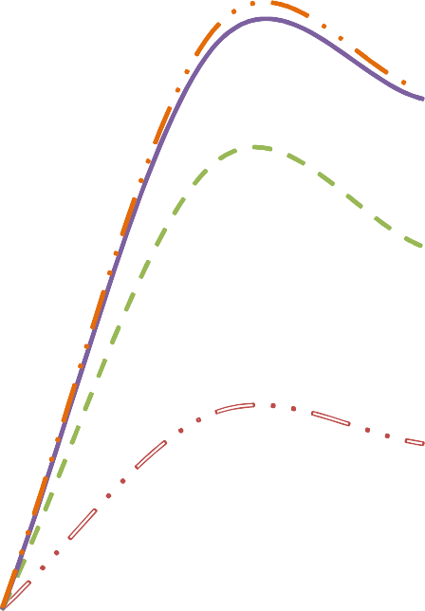

MODEL 1

MODEL 2

MODEL 3

1400

1200

1000

**Shear Force in KN**

800

600

CA

CSA (Stage 1)

CSA (Stage 2)

CSA (Stage 3)

CSA (Stage 4)

400

200

0

**MODEL DETAILS**

7000

#### Axial Force in Columns

6000

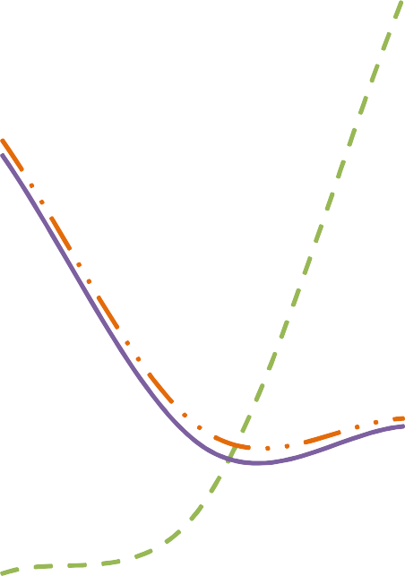

MODEL 1

MODEL 2

MODEL 3

5000

4000

**Axial Force in KN**

3000

2000

CA

CSA (Stage 1)

CSA (Stage 2)

CSA (Stage 3)

CSA (Stage 4)

1000

0

**MODEL DETAILS**

CSA (Stage 4)

4313.2

2568

2636

#### Deformation of Slab

35

MODEL 1

MODEL 2

MODEL 3

30

25

20

**DIsplacment in mm.**

CA

15 CSA (Stage 1)

CSA (Stage 2)

CSA (Stage 3)

CSA (Stage 4)

10

5

0

**MODEL DETAILS**

**Stress Results in Slab –**

Model 1 (CONVETIONAL ANALYSIS) –

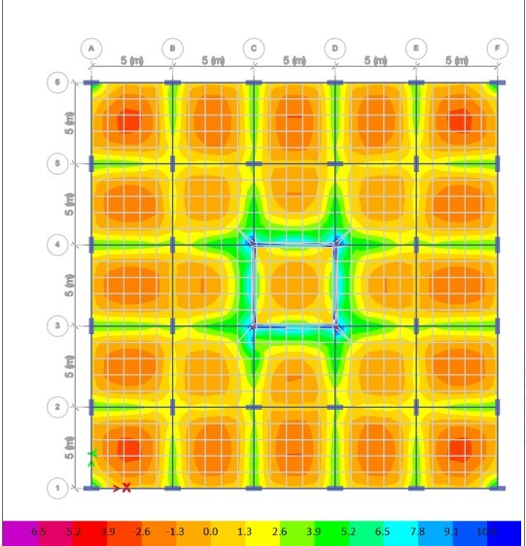

MODEL 1 (CONSTRUCTION SEQUENCE ANALYSIS) AFTER CONSTRUCTION (STAGE 1) –

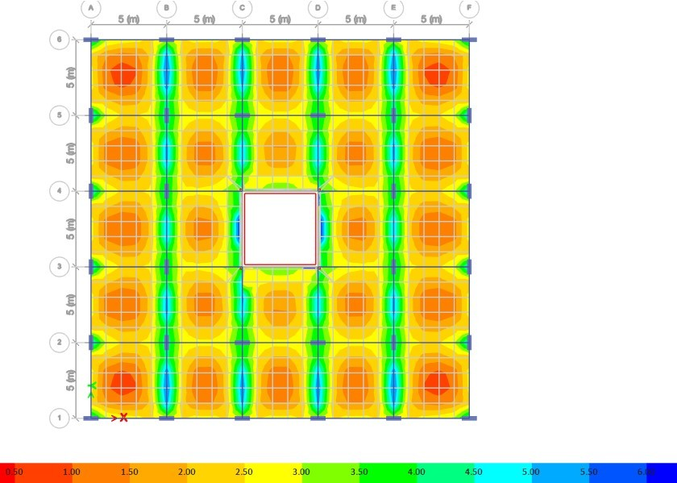

MODEL 1 (CONSTRUCTION SEQUENCE ANALYSIS) AFTER CONSTRUCTION (STAGE 2) –

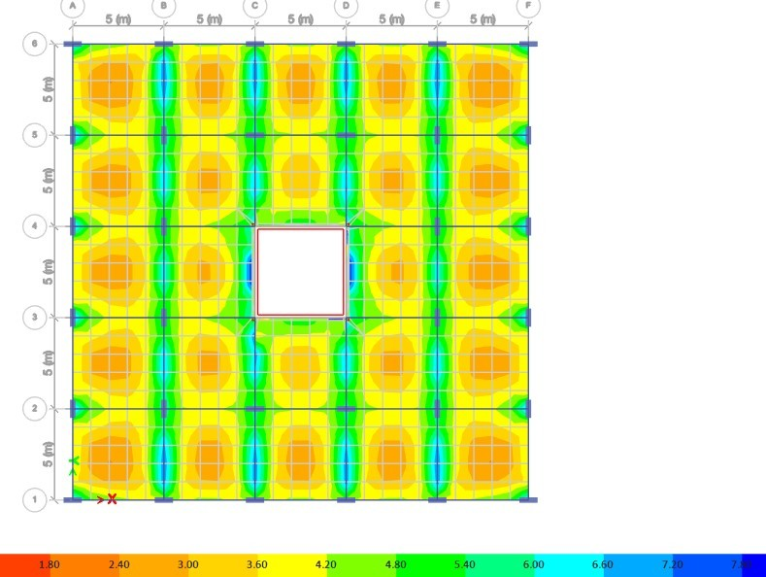

MODEL 1 (CONSTRUCTION SEQUENCE ANALYSIS) AFTER CONSTRUCTION (STAGE 3) –

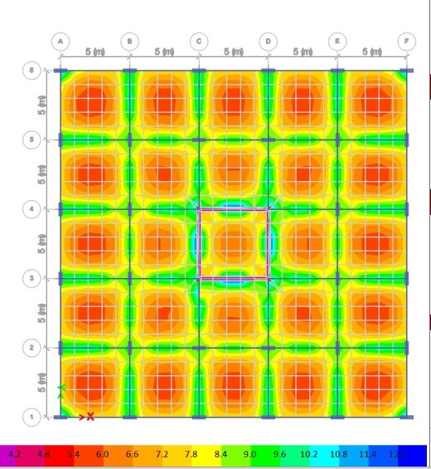

MODEL 1 – (CONSTRUCTION SEQUENCE ANALYSIS) AFTER 50 YEARS (STAGE 4) –

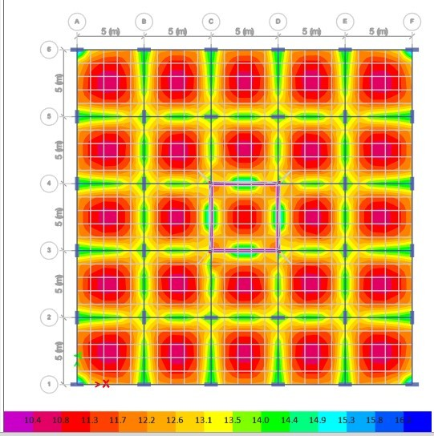

MODEL 2 CONVENTIONAL ANALYSIS–

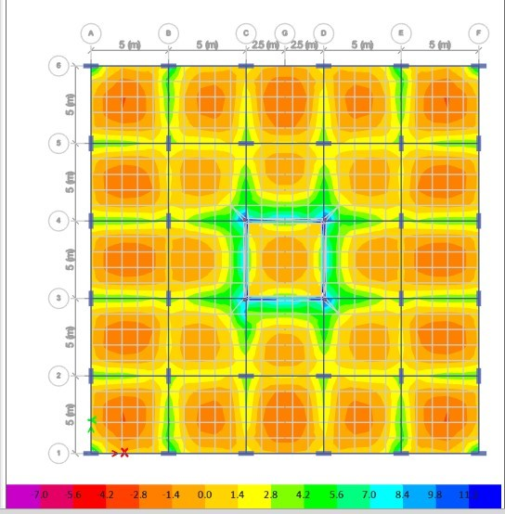

MODEL2 (CONSTRUCTION SEQUENCE ANALYSIS) AFTER CONSTRUCTION (STAGE 1) –

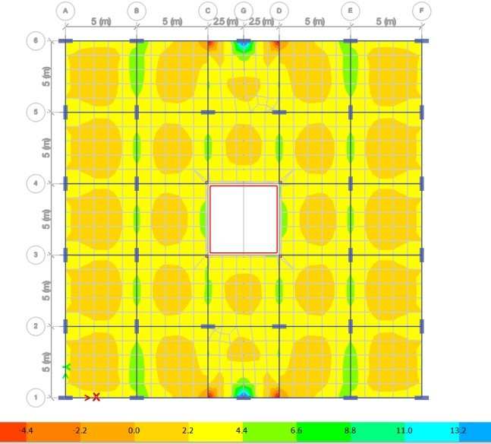

MODEL2 (CONSTRUCTION SEQUENCE ANALYSIS) AFTER CONSTRUCTION (STAGE 2) –

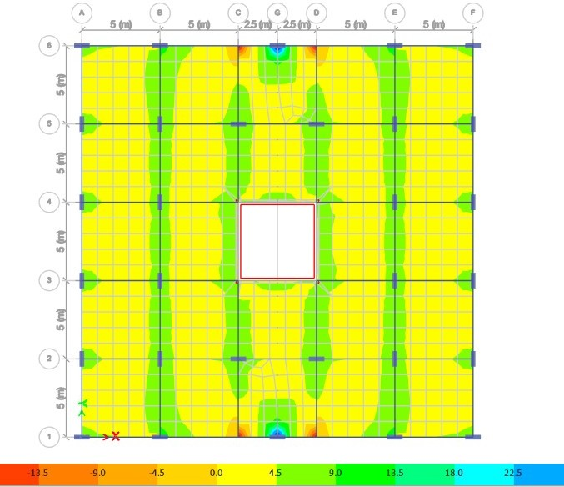

MODEL2 (CONSTRUCTION SEQUENCE ANALYSIS) AFTER CONSTRUCTION (STAGE 3) –

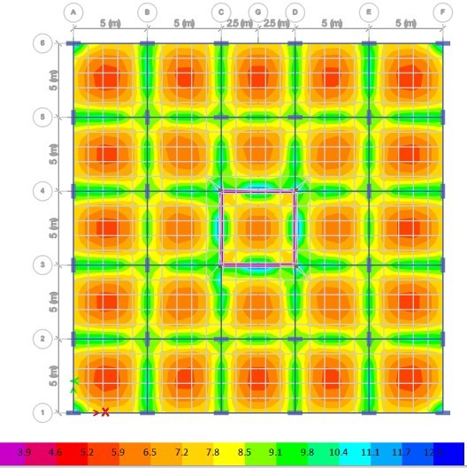

MODEL 2 – (CONSTRUCTION SEQUENCE ANALYSIS) AFTER 50 YEARS (STAGE 4) –

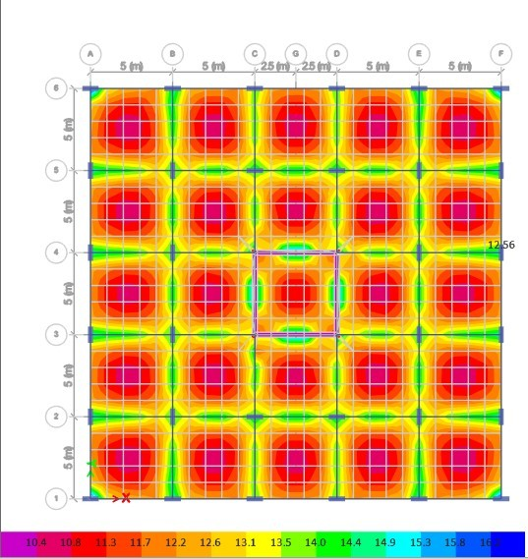

MODEL 3 CONVENTIONAL ANALYSIS –

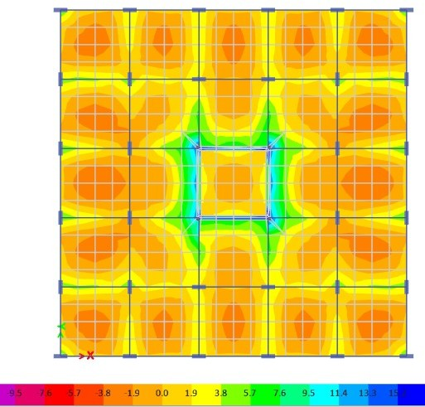

MODEL 3 – (CONSTRUCTION SEQUENCE ANALYSIS) AFTER CONSTRUCTION (STAGE 1) –

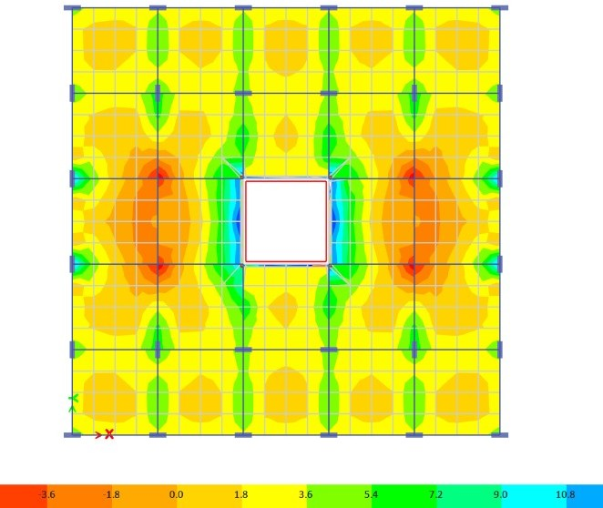

MODEL 3 – (CONSTRUCTION SEQUENCE ANALYSIS) AFTER CONSTRUCTION (STAGE 2) –

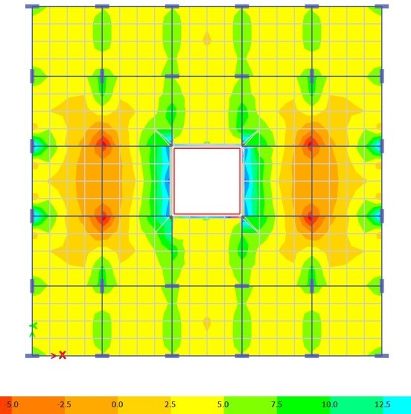

MODEL 3 – (CONSTRUCTION SEQUENCE ANALYSIS) AFTER CONSTRUCTION (STAGE 3) –

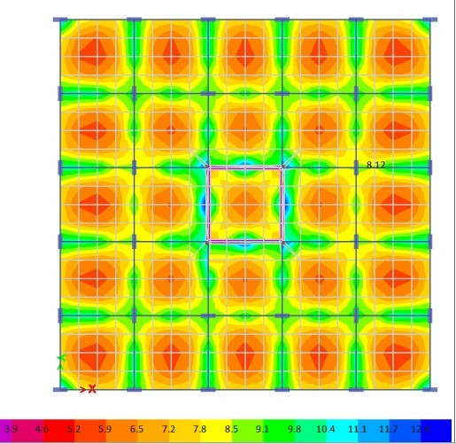

MODEL 9 – (CONSTRUCTION SEQUENCE ANALYSIS) AFTER 50 YEARS (STAGE 4) –

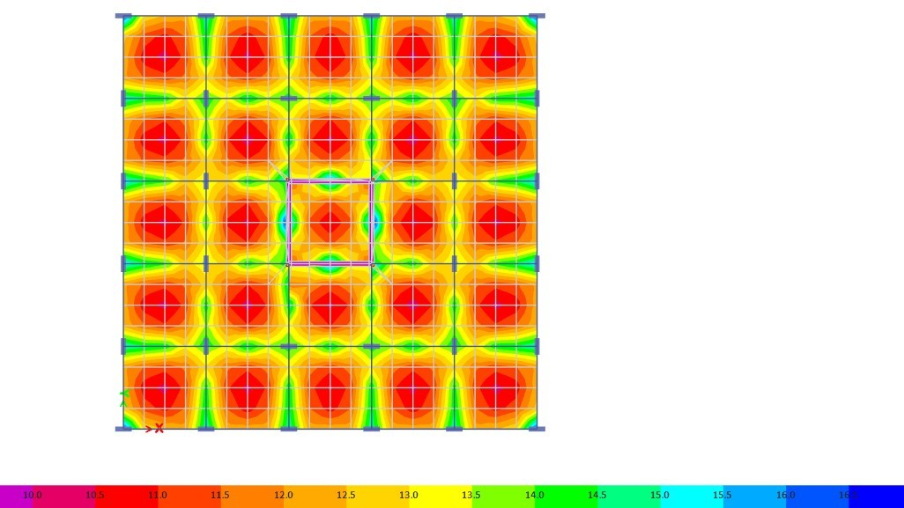

**Conclusion-**

Following points have been concluded on this -

* + - The values of shear force and bending moment are markedly different in conventional and construction sequence analysis for the structures having floating columns. The bending moment increases up to 7% in CSA as compared to conventional analysis while the axial force also decreases up to 20% for floating column case. Hence, the results also clearly state that in high-rise buildings CSA is necessary due to considerable difference in the values for slabs, beams and columns.
    - It is found that the change in values of structural parameters is caused due to the incomplete truss, which causes uneven load transfer for the concept of floating columns.
    - The deformation in slab shows 15% higher values for construction sequence analysis. In this manner, column shortening for exterior and interior columns for a particular section is also considered for conventional analysis and construction stage analysis.
    - The stresses in the slab also increases up to 10 % with respect to time which one needs to considered for the actual behaviour of structure for its entire life of design.
    - In conventional analysis, the staging of construction is neglected due to which the values are different from real-world values.
    - Beams are more vulnerable to sequential loading as compared to columns.
    - The structural members must be designed for the higher values of axial force, shear force, and bending moment between the two methods.

# REFERENCES

1. Ankur Dubey, D. S. (2017, 5), "Comparative analysis of a 50 Storey RCC Frame with shear wall for conventional loading and construction sequence loading", International Research Journal of Engineering and Technology, 4, 6.
2. Chang-Koon Choi, H.-K. C.-G. (1992),"Simplified Building Analysis with Sequential Dead Loads", CFM. ASCE, 11.
3. Chang-Koon Choi, M. A.-D. (1985), "Multistorey Frames Under Sequential Gravity Loads". ASCE, 12.
4. Jayasena, M. T. (2004),"Effects of Axial Shortening of Columns on Design and Construction of Tall Reinforced Concrete Buildings", ASCE, 9.
5. Kiran Y. Naxane, P. M. (2017), "Construction Sequence Analysis of Multistoried RCC Building", International Research Journal of Engineering and Technology, 6.
6. Lee, T. H. (2013),"Advanced Construction Stage Analysis of High-rise Building", ASEM, 9.
7. Mahajan, S. R. (2015, 4 2),"Analysis of Multi Storied RCC Building for Construction Sequence Loading", International Journal of Modern Trends in Engineering and Research, 6.
8. Murthy, M. B. (2016, 11 7),"Comparison of Linear Static Analysis and Construction Sequence Analysis on Multi-storey Building with RC Floating Column Resting on RC and Composite Transfer Girders", International Journal of Engineering Trends and Technology, 36.
9. Santosh Panigrahi, D. V. (2019, 4 6),"Importance of Construction Sequence Analysis in design of High Rise Building", International Journal of Innovative Science, Engineering & Technology.