**USING ARDUINO TO CONTROL THE PIEZOELECTRIC ACTUATOR AND IR SENSOR**

N.Tamiloli1, J. Sudhakar2, Anil Kumar1, RM Sathiyamoorthy1, P Dhilip Kumar1,

G Loganathan1, V Sountharasu1, M Vignesh Kumar1

1. Department of Mechanical Engineering, PERI Institute of Technology, Mannivakkam, Chennai-48, Email:tamiloligg@gmail.com
2. Department of Mechanical Engineering, Jeppiaar Institute of Technology, Kunnam, Sriperumbudur-631604. Email Id:- sudhakarpje@gmail.com

**Abstract:**

In this review, utilizations of the Arduino stage in the business were checked on. Arduino, delegate and well known open-source equipment, can gain data from different sensors; send information utilizing correspondence innovation, and control gadgets through actuators. The examination was led with ep of tinker CADD programming. Arduino can be a valuable instrument as an underlying model for independent businesses frameworks. Arduino enjoys benefits in that it tends to be joined with different electronic items and is savvy. In this way, albeit many examinations have been directed in the field tests, Arduino applications can be additionally extended in the ventures field from here on out. The actual layer is the most nitty gritty degree of reflection in IoT. It predominantly comprises of sensors that secure data for the framework and actuators that do activities in light of directions from the framework. Sensors and actuators are thoughtfully presented and discussed in this paper. Sensors can be read, and actuators can be written. Additionally, various regulators utilized in IoT are talked about with its modifying techniques.

**Key words**: Arduino, IoT, Industries, Layer, Information, etc.

1. **Introduction**

### A sensor is a gadget that delivers a result signal to detect an actual peculiarity. In the broadest definition, a sensor is a gadget, module, machine, or subsystem that distinguishes occasions or changes in its current circumstance and sends the data to other hardware, oftentimes a PC processor.

### An actuator is a machine component that converts an electrical, pneumatic, or hydraulic input signal into the required form of mechanical energy and produces force, torque, or displacement, typically in a controlled manner, in an actuating system [1]. It is referred to as a mover and is a type of transducer[2]. An actuator requires a control gadget (constrained by control signal) and a wellspring of energy. The control signal is moderately low energy and might be electric voltage or flow, pneumatic, or water driven liquid strain, or even human power.[3] In the electric, water driven, and pneumatic sense, it is a type of computerization or programmed control.

### Piezoelectric actuators are transducers that convert electrical energy into a mechanical relocation or stress in light of a piezoelectric impact, or the other way around. They have been utilized broadly as a high accuracy situating instrument since it have some control over a little mechanical uprooting at high velocity, with the benefits of enormous created force, stable dislodging, and usability. Nonetheless, issues incorporate insufficient relocation and the huge voltage up to two or three hundred volts, which is required [4] [5]. Piezoelectric actuators can be planned either as piezoelectric bimorph actuators or as straight actuators utilizing a switch component [6].

### Arduino is an Italian open-source equipment and programming organization, task, and client local area that plans and produces single-board microcontrollers and microcontroller packs for building computerized gadgets. Its equipment items are authorized under a CC BY-SA permit, while the product is authorized under the GNU Lesser Overall population Permit (LGPL) or the GNU Overall population Permit (GPL),[7] allowing the assembling of Arduino sheets and programming conveyance by anybody. Arduino sheets are accessible monetarily from the authority site or through approved distributors[8]. There are any applications utilizing in the Arduino especially.

### IoT

Among the many applications of Arduino, the Internet of Things (IoT) relies heavily on it. Its similarity with different sensors, availability modules, and cloud administrations makes it an optimal stage for building IoT arrangements. Arduino sheets can gather information from sensors, process it, and communicate it to the cloud for investigation and activity. It is a popular choice for IoT prototyping and development due to its adaptability, affordability, and extensive community support. You can enroll in an Arduino course to learn how to create additional Arduino applications.

**Data Logging**

Information logging is another application where Arduino succeeds because of its capacity to store a lot of data on microSD cards or other stockpiling gadgets. Users are able to monitor temperature, humidity, light levels, and other environmental conditions over time thanks to this feature. This information could then be imparted to others through the Web or investigated utilizing programming like MATLAB or Succeed, which would permit clients to recognize examples or patterns inside the informational collection that might not have been apparent previously.

**IR sensor:**

1. An infrared sensor is an electronic instrument which is used to sense certain characteristics of its surroundings by their emitting and/or detecting infrared radiation.

2. Infrared sensors are also capable of measuring the heat being emitted by an object and detecting motion.

3. Infrared waves are not visible to the human eye. In the electromagnetic spectrum, infrared radiation can be found between the visible and microwave regions.

4. The infrared waves typically have wavelengths between 0.75 and 1000 µm

**Actuators:**

Actuators convert an electrical signal to the corresponding physical quantity such as movement, force, sound, display etc. The actuator is a part of any machine which is responsible for mechanical rotation or controlling.

**Piezoelectric actuators**: Piezoelectric actuators are devices that produce a small displacement with a high force capability when voltage is applied. There are many applications where a piezoelectric actuator may be used, such as ultra-precise positioning and in the generation and handling of high forces or pressures in static or dynamic situations. Actuator configuration can vary greatly, depending on application.

**Pneumatic actuators:** A pneumatic actuator uses energy formed by vacuum or compressed air at high pressure to convert into either linear or rotary motion. Pneumatic actuators are notable in their use for applications where the opening and closing of valves takes place.

**2. EXPERIMENTAL STUDY AND WORKING CODE**

The experiment conducted with hep of Tinker cad software. This circuit involve in different steps. The figure 1 and figure 2 showing the circuit diagram.

Step 1: Step 1: Build the Circuit

Step 2: Code with Blocks

Step 3: PIR Motion Sensor Arduino Code

Step 4: PIR Motion Sensor Setup.

Step 5: Build a Physical Arduino Circuit (Optional).

Step 6: PIR Motion Sensor Adjustments.

Step 7: Results

**IR Sensor& Piezoelectric Actuator**

IOT Kit : Arduino

Sensor: PIR Sensor

Motor: Micro Servo

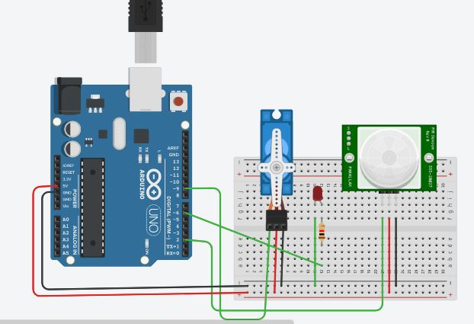

Figure 1: IR Sensor& Piezoelectric Actuator circuit

**3. Programme Code**

Code:

#include <Servo.h>

Servo myservo;

int led=6;

intpir=2;

void setup()

{

pinMode(pir,INPUT);

pinMode(led,OUTPUT);

myservo.attach(9);

Serial.begin(9600);

}

void loop()

{

intval = digitalRead(pir);

Serial.println(val);

if(val==HIGH){

digitalWrite(led,HIGH);

myservo.write(70);

}

else{

digitalWrite(led,LOW);

myservo.write(10);

}

delay(10);

}

OutPut : ( PIR Sensor Detected object , Servo Motor Will rotate, Serial Monitor Change from 0 -🡪1 .. ie object detected using sensor )

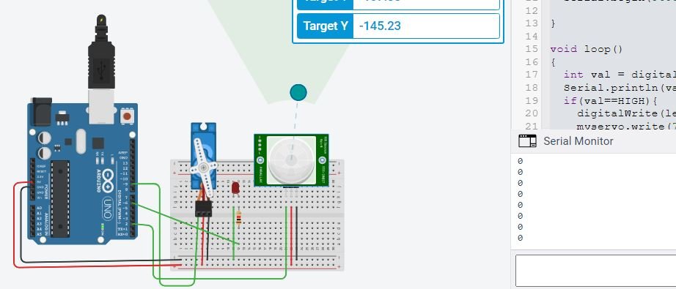

Figure 2. IR Sensor& Piezoelectric Actuator output circuit

**Conclusions**

In this various examinations using open-source equipment Arduino stages in the business. For the purpose of the preliminary study, a number of recently published articles were identified and their in-depth contents regarding Arduino applications were analyzed. It was affirmed that a considerable lot of the examinations surveyed in this paper were led in non-industrial nations as opposed to created nations. This pattern might be credited to the expense viability of Arduino. In the mining business, the usage of microcontrollers, like Arduinos, has expanded quickly lately. These investigations will act as the reason for the advancement of businesses future.

**References**

1. *Escudier, Marcel; Atkins, Tony (2019).*[*"A Dictionary of Mechanical Engineering"*](https://dx.doi.org/10.1093/acref/9780198832102.001.0001)*.*[*doi*](https://en.wikipedia.org/wiki/Doi_(identifier))*:*[*10.1093/acref/9780198832102.001.0001*](https://doi.org/10.1093%2Facref%2F9780198832102.001.0001)*.* {{[cite journal](https://en.wikipedia.org/wiki/Template:Cite_journal)}}: Cite journal requires |journal= ([help](https://en.wikipedia.org/wiki/Help:CS1_errors#missing_periodical))
2. *Butterfield, Andrew J.; Szymanski, John, eds. (2018).*[*"A Dictionary of Electronics and Electrical Engineering"*](https://dx.doi.org/10.1093/acref/9780198725725.001.0001)*. Oxford Reference.*[*doi*](https://en.wikipedia.org/wiki/Doi_(identifier))*:*[*10.1093/acref/9780198725725.001.0001*](https://doi.org/10.1093%2Facref%2F9780198725725.001.0001)*.*
3. *Nesbitt, B. (2011).*[*Handbook of Valves and Actuators: Valves Manual International*](https://books.google.com/books?id=mzsF34JBXGoC)*. Elsevier Science. p. 2.*[*ISBN*](https://en.wikipedia.org/wiki/ISBN_(identifier))[*978-0-08-054928-6*](https://en.wikipedia.org/wiki/Special:BookSources/978-0-08-054928-6)*. Retrieved 2021-11-11.*
4. M. C. Carrozza, A. Eisinberg, A. Menciassi, D. Campolo, S. Micera, and P. Dario, “Towards a force-controlled microgripper for assembling biomedical microdevices,” J. Micromech. Microeng., vol. 10, no. 2, pp. 271–276, 2000.
5. Nah, S. K., and Z. W. Zhong. "A microgripper using piezoelectric actuation for micro-object manipulation." *Sensors and Actuators A: Physical* 133.1 (2007): 218-224.
6. K. S. Mohamed, “IoT physical layer: Sensors, actuators, controllers and programming,” in The Era of Internet of Things, Cham: Springer International Publishing, 2019, pp. 21–47.
7. ["Getting Started: FOUNDATION > Introduction"](https://web.archive.org/web/20170829015201/https:/www.arduino.cc/en/Guide/Introduction). arduino.cc. Archived from [the original](https://www.arduino.cc/en/guide/introduction) on 2017-08-29. Retrieved 2017-05-23.
8. ["Arduino - Home"](https://www.arduino.cc/). www.arduino.cc. Retrieved 2022-10-27.