# A Review article on Pancreatic Cancer along with pharmacological use of Fluorouracil (5-FU)

# Miss. Priyanka Borude (Student)1, Miss. Kishori Raut (Student) 1, Mrs. Pawar Madhuri (Lecturer)2,

# Miss. Shital Khandagale (Lecturer) 2, Dr. Yogesh Bafana (Principal)3

# Arihant College of Pharmacy 2. Arihant College of Pharmacy 3. Arihant college of Pharmacy

# Abstract:-

One of the most deadly cancers is pancreatic cancer (PC). Delays in diagnosis and early metastases are major contributors to PC's high fatality rate. Consequently, in order to increase survival rates, it is imperative to develop novel treatment targets for PC patients. a significant bar

The existence of a hypoxic tumor microenvironment, which is linked to a poor prognosis, treatment resistance, increased invasion, and metastasis, is rier to effective PC treatment.

It may be possible to create new therapeutic approaches to prevent PC from developing and metastasizing as a result of the identification of several unique chemicals and pathways in PC cells that promote the growth of cancer cells in hypoxic environments. This paper gives an outline of the most recent findings about hypoxia in PCs and describes how the available treatments work.[1]

# Introduction:-

With a 5-year survivor rate of 9%, pancreatic cancer (PC) is one of the most aggressive and deadly cancers [2]. Ninety percent of PC types are pancreatic ductal adenocarcinomas, a prototype of a tumor with a prominent inflammatory milieu where immune and stromal cells make up the majority of the tumor mass [3]. Fibroblasts, extracellular matrix, and immune cells make up the PC microenvironment, which leads to severe stromal desmoplasia and angiogenesis to facilitate invasion, metastasis, and resistance to treatment [4]. There is hypoxia in the pancreatic tumor microenvironment (TME) and PC is a hypo-vascular malignancy [5]. An imbalance in the generation and consumption of oxygen results in a hypoxic tumor microenvironment (TME), a distinctive feature of cancer that is essential to the growth of tumors.Studies have demonstrated a strong correlation between tumor growth and metastasis and the expression of hypoxia-inducible factor (HIF)-1α [6]. PCs have an overexpression of HIF-1, a crucial regulator of the response to hypoxia.

Prior research has demonstrated that as compared to normal cells, cancer cells have higher energetic demands. In order to adjust to the hypoxic environment in the TME, tumors change their metabolism.[7]

Transcription factors known as HIFs are essential for the way cells react to hypoxia. To help cells adapt to hypoxia, the transcription factor HIF-1α directly binds to hypoxia-response elements (HREs) in gene promoters, activating its downstream target in the process. HIF-1 is a heterodimer consisting of two subunits: α and β. Cellular oxygen concentration regulates HIF-1α activity; in normoxic settings, the ubiquitin-proteasome pathway constitutively degrades HIF-1α, while in hypoxic conditions, HIF-1α stabilizes.[8] The incidence and mortality in Asia are expected to rise by 190532 and 182127 in 2040, respectively, based on China and India, two Asian countries with populations over one billion[8]. This represents the biggest growth in terms of numbers. Furthermore, the standardized death rate for pancreatic cancer in China increased from 1.30 per 100,000 to 3.32 per 100,000 between 1991 and 2014; it may peak in the next five years. The mortality rate was higher for older adults and those living in urban and northeastern regions than for younger adults and those living in rural and middle-western regions[8]. According to predictions, the incidence of pancreatic cancer will rise from 12.1 per 100,000 in 2010 to 15.1 and 18.6 per 100,000 in 2030 and

2050, respectively.

The complex TME with hypoxia, which results from PC's rapid development and metastasis, is a significant obstacle to the effective treatment of PC. Therefore, understanding the molecular mechanisms behind the connection between hypoxia and metastasis is essential to creating new

tactics that will enhance the prognosis of PC patients. Therefore, improving the prognosis of PC patients requires identifying the molecular pathways driving the disease's progression and creating appropriate targeted therapeutics. The most recent findings on hypoxia in PC are compiled in this review, which also offers a synopsis of the existing therapeutic options and possible targets for future hypoxia in metastatic PC therapy.[8]

Pancreas:-

Anatomy of the pancreas

# Defination:- The pancreas is a long, flat gland that lies in the abdomen behind the stomach.

The pancreas is an elongated, tapered organ located across the back of the belly, behind the stomach. The right side of the organ—called the head—is the widest part of the organ and lies in the curve of the duodenum, the first division of the small intestine. The tapered left side extends slightly upward—called the body of the pancreas—and ends near the spleen—called the tail.

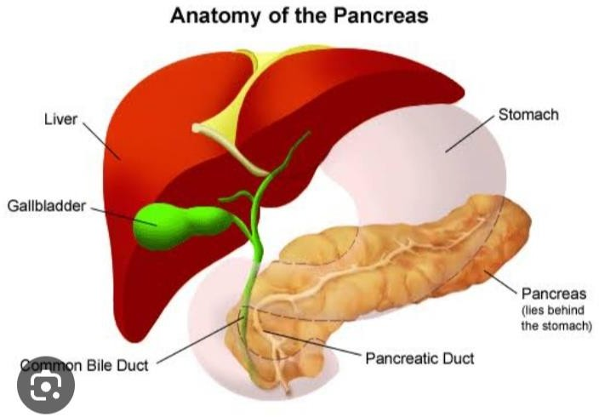Dig. Anatomy of pancreas

https://[www.stanfordchildrens.org/en/topic/](http://www.stanfordchildrens.org/en/topic/) default?id=pancreas-anatomy-and-functions- 85-P00682.(9)

# The pancreas is made up of 2 types of glands:-

**Exocrine:-** The exocrine gland secretes digestive enzymes. These enzymes are secreted into a network of ducts that join the main pancreatic duct. This runs the length of the pancreas.

**Endocrine:-** The endocrine gland, which consists of the islets of Langerhans, secretes hormones into the bloodstream.

# Functions of the pancreas

**The pancreas has digestive and hormonal functions:-** The enzymes secreted by the exocrine gland in the pancreas help break down carbohydrates, fats, proteins, and acids in the duodenum. These enzymes travel down the pancreatic duct into the bile duct in an inactive form. When they enter the duodenum, they are activated. The exocrine tissue also secretes a bicarbonate to neutralize stomach acid in the duodenum. This is the first section of the small intestine**.**

The main hormones secreted by the endocrine gland in the pancreas are insulin and glucagon, which regulate the level of glucose in the blood, and somatostatin, which prevents the release of insulin and glucagon.(10)

# Cancer

**The Definition of Cancer :-** Cancer is a disease in which some of the body’s cells grow uncontrollably and spread to other parts of the body. Cancer can start almost anywhere in the human body, which is made up of trillions of cells. Normally, human cells grow and multiply (through a process called cell division) to form new cells as the body needs them. When cells grow old or become damaged, they die, and new cells take their place. Sometimes this orderly process breaks down, and abnormal or damaged cells grow and multiply when they shouldn’t. These cells may form tumors, which are lumps of tissue. Tumors can be cancerous or not cancerous (benign).

Cancerous tumors spread into, or invade, nearby tissues and can travel to distant places in the body to form new tumors (a process called metastasis). Cancerous tumors may also be called malignant tumors. Many cancers form solid tumors, but cancers of the blood, such as leukemias, generally do not. Benign tumors do not spread into, or invade, nearby tissues. When removed, benign tumors usually don’t grow back, whereas cancerous tumors sometimes do. Benign tumors can sometimes be quite large, however. Some can cause serious symptoms or be life threatening, such as benign tumors in the brain. Benign tumors do not spread into, or invade, nearby tissues. When removed, benign tumors usually don’t grow back, whereas cancerous tumors sometimes do. Benign tumors can sometimes be quite large, however. Some can cause serious symptoms or be life threatening, such as benign tumors in the brain.

# Difference between normal cell and cancer cells:-

grow in the absence of signals telling them to grow. Normal cells only grow when they receive such signals. ignore signals that normally tell cells to stop dividing or to die (a process known as programmed cell death, or apoptosis). invade into nearby areas and spread to other areas of the body. Normal cells stop growing when they encounter other cells, and most normal cells do not move around the body.

tell blood vessels to grow toward tumors. These blood vessels supply tumors with oxygen and nutrients and remove waste products from tumors. hide from the immune system. The immune system normally eliminates damaged or abnormal cells.

trick the immune system into helping cancer cells stay alive and grow. For instance, some cancer cells convince immune cells to protect the tumor instead of attacking it.

accumulate multiple changes in their chromosomes, such as duplications and deletions of chromosome parts. Some cancer cells have double the normal number of chromosomes.

rely on different kinds of nutrients than normal cells. In addition, some cancer cells make energy from nutrients in a different way than most normal cells. This lets cancer cells grow more quickly. Many times, cancer cells rely so heavily on these abnormal behaviors that they can’t survive without them. Researchers have taken advantage of this fact, developing therapies that target the abnormal features of cancer cells. For example, some cancer therapies prevent blood vessels from growing toward tumors, essentially starving the tumor of needed nutrients.

# How does Cancer develop:-

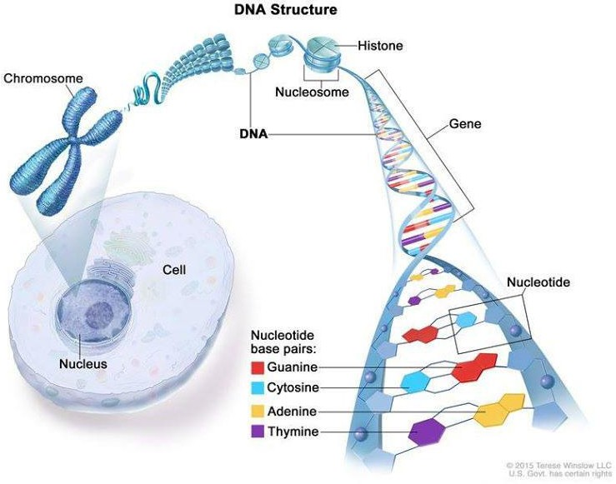

Cancer is caused by certain changes to genes, the basic physical units of inheritance. Genes are arranged in long strands of tightly packed DNA called chromosomes.

Credit: © Terese Winslow

Cancer is a genetic disease—that is, it is caused by changes to genes that control the way our cells function, especially how they grow and divide.

Genetic changes that cause cancer can happen because: of errors that occur as cells divide.

of damage to DNA caused by harmful substances in the environment, such as the chemicals in tobacco smoke and ultraviolet rays from the sun. (Our Cancer Causes and Prevention section has more information.) they were inherited from our parents they were inherited from our parents. The body normally eliminates cells with damaged DNA before they turn cancerous. But the body’s ability to do so goes down as we age. This is part of the reason why there is a higher risk of cancer later in life. Each person’s cancer has a unique combination of genetic changes. As the cancer continues to grow, additional changes will occur. Even within the same tumor, different cells may have different genetic changes.

# Fundamentals of Cancer:-

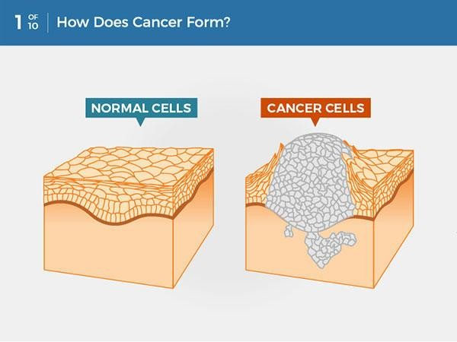

Cancer is a disease caused when cells divide uncontrollably and spread into surrounding tissues.

**Types of Genes that Cause Cancer:-** The genetic changes that contribute to cancer tend to affect three main types of genes—proto-oncogenes, tumor suppressor genes, and DNA repair genes. These changes are sometimes called “drivers” of cancer.

Proto-oncogenes are involved in normal cell growth and division. However, when these genes are altered in certain ways or are more active than normal, they may become cancer-causing genes (or oncogenes), allowing cells to grow and survive when they should not Tumor suppressor genes are also involved in controlling cell growth and division. Cells with certain alterations in tumor suppressor genes may divide in an uncontrolled manner.

DNA repair genes are involved in fixing damaged DNA. Cells with mutations in these genes tend to develop additional mutations in other genes and changes in their chromosomes, such as duplications and deletions of chromosome parts. Together, these mutations may cause the cells to become cancerous.

# When Cancer Spreads:-

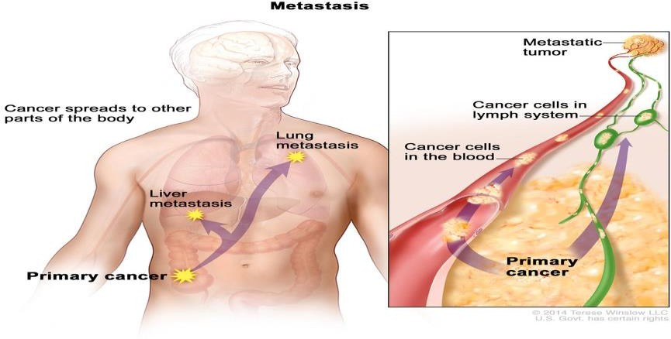

In metastasis, cancer cells break away from where they first formed and form new tumors in other parts of the body.

Credit: © Terese Winslow

As scientists have learned more about the molecular changes that lead to cancer, they have found that certain mutations commonly occur in many types of cancer. Now there are many cancer treatments available that target gene mutations found in cancer. A few of these treatments can be used by anyone with a cancer that has the targeted mutation, no matter where the cancer started growing.

A cancer that has spread from the place where it first formed to another place in the body is called metastatic cancer. The process by which cancer cells spread to other parts of the body is called metastasis.

Metastatic cancer has the same name and the same type of cancer cells as the original, or primary, cancer. For example, breast cancer that forms a metastatic tumor in the lung is metastatic breast cancer, not lung cancer. Under a microscope, metastatic cancer cells generally look the same as cells of the original cancer. Moreover, metastatic cancer cells and cells of the original cancer usually have some molecular features in common, such as the presence of specific chromosome changes.

In some cases, treatment may help prolong the lives of people with metastatic cancer. In other cases, the primary goal of treatment for metastatic cancer is to control the growth of the cancer or to relieve symptoms it is causing. Metastatic tumors can cause severe damage to how the body functions, and most people who die of cancer die of metastatic disease.

**Tissue Changes that Are Not Cancer:-** Not every change in the body’s tissues is cancer. Some tissue changes may develop into cancer if they are not treated, however. Here are some examples of tissue changes that are not cancer but, in some cases, are monitored because they could become cancer. Hyperplasia occurs when cells within a tissue multiply faster than normal and extra cells build up. However, the cells and the way the tissue is organized still look normal under a microscope. Hyperplasia can be caused by several factors or conditions, including chronic irritation.

Dysplasia is a more advanced condition than hyperplasia. In dysplasia, there is also a buildup of extra cells. But the cells look abnormal and there are changes in how the tissue is organized. In general, the more abnormal the cells and tissue look, the greater the chance that cancer will form. Some types of dysplasia may need to be monitored or treated, but others do not. An example of dysplasia is an abnormal mole (called a dysplastic nevus) that forms on the skin. A dysplastic nevus can turn into melanoma, although most do not.

Carcinoma in situ is an even more advanced condition. Although it is sometimes called stage 0 cancer, it is not cancer because the abnormal cells do not invade nearby tissue the way that cancer cells do. But because some carcinomas in situ may become cancer, they are usually treated.

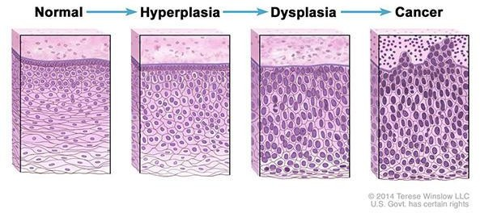

Normal cells may become cancer cells. Before cancer cells form in tissues of the body, the cells go through abnormal changes called hyperplasia and dysplasia. In hyperplasia, there is an increase in the number of cells in an organ or tissue that appear normal under a microscope. In dysplasia, the cells look abnormal under a microscope but are not cancer. Hyperplasia and dysplasia may or may not become cancer.

Credit: © Terese Winslow [11,12,13,14,]

# PANCREATIC CANCER TRENDS:-

Estimated new cases and fatalities from pancreatic cancer have been rising annually in the United States during the past 20 years, from 2001 to 2020. Men and women have also shown this tendency.

ladies, as depicted in Figure 2. Age-adjusted rates of pancreatic cancer deaths in the United States increased by an average of 0.3% year from 2009 to 2018, but age-adjusted rates of new cases remained steady from 2008 to 2017[15]. These data were analyzed using statistical models.

According to estimates of the incidence burden of pancreatic cancer from the 28 EU member states and a few additional carefully chosen countries, in 2025, 2030, 2035, and 2040, the incidence will be 557688, 639030, 726740, and Reasons and Risk Elements for Colorectal Cancer

The three types of pancreatic intraepithelial neoplasias (PanINs) are low-grade PanIN-1, intermediate-grade PanIN-2, and high-grade PanIN-3 noninvasive epithelial proliferations in smaller pancreatic ducts.

The process of developing from normal epithelium to PanIN-1/PanIN-2 and ultimately to PanIN- 3/invasive pancreatic cancer takes a significant amount of time [16]However, the stage of development preceding high-grade PanIN-3 and invasive pancreatic cancer is the ideal window of opportunity for pancreatic cancer prevention through efficient interventions. Consequently, preventing pancreatic cancer requires a deep and comprehensive understanding of the risk factors associated with the disease. Although the precise origin of pancreatic cancer is unknown, there are a number of modifiable and non-modifiable risk factors linked to its development. of carcinoma of the pancreas. Age, gender, ethnicity, ABO blood type, microbiota, diabetes mellitus (DM), family history, genetic susceptibility, and smoking are examples of non-modifiable risk factors. Modifiable risk factors include dietary factors, pancreatitis, obesity, infection, and socioeconomic status and insurance. The impact of these variables on the development, invasion, and occurrence of pancreatic cancer is examined and condensed as follows[17]

# Issue and potential course of action:-

One of the main factors in the TME that causes pancreatic tumor malignancy is hypoxia. While current approaches have demonstrated efficacy in treating PC, comparatively few clinical trials have completed. Many studies have shown that hypoxia in PC drives several pathways that result in invasiveness, EMT induction, and metastasis. Future research is necessary to confirm that hyperpoxia is a significant therapeutic target in PC, despite all of these findings.

Ideally, this assessment of unique methodologies might help steer future research and explorations toward increasing the efficacy and decreasing the toxicity of chemotherapy drugs. s. For instance, myo-inositoltrisphosphate (ITPP, OXY111A) and the novel antihypoxic chemical evofosfamide target tumor hypoxia and are used to[18,19]

# Epidemiology:-

Evaluating the most recent epidemiologic trends in pancreatic cancer is essential due to its significant impact on clinical care and preventive actions [20]. As a result, we provide an overview of the most recent pancreatic cancer epidemiology.

When it comes to patient prognoses, pancreatic cancer regularly has the worst results of all malignancies. In certain areas, it is even expected to overtake other tumors as the second biggest cause of cancer-related deaths [21]

In a research involving 84275 patients who had at least five years of follow-up, the real 5-year survival rate for patients with pancreatic cancer increased from 0.9% in 1975 to 4.2% in 2011 at all stages of the disease. However, in patients who had surgery, this percentage decreased to 2.9% in 2011.

From 1.5% to 17.4%, it rose[22]. The actual 5-year survival rate for non-resected patients was 0.8% in 1975 and 0.9% in 2011, indicating a relatively stable rate between 1975 and 2011[22]. China has the lowest 5-year relative survival rate of any cancer, at 7.2% for pancreatic cancer[23] Based on data from Surveillance, Epidemiology, and End Results Program 18 between 2010 and 2016, Cancer Stat Facts revealed that the 5-year survival rate in the United States at the time of diagnosis is almost 10%[24]. The 5-year survival rate for pancreatic cancer is low, varying between 2% and 9% with little variation.

Hence between high-income and middle-class and low-income nations[21,25]. Consequently, the five-year survival rate for pancreatic cancer varies worldwide among various nations and areas, although it never goes above 10%. Additionally, it is anticipated that the 5-year survival rate for individuals with nonoperative pancreatic cancer will be lower. Pancreatic cancer ranks third in the US behind lung and bronchus cancer and colorectal cancer, with the American Cancer Society reporting about 60430 new cases and 48220 deaths in the US in Cancer Statistics 2021[26]. It was anticipated that within the 28 member states of the European Union (EU), around

By 2025, approximately 111500 people (55000 men and 56500 women) will have died from pancreatic cancer. The number of cancer-related deaths recorded in 2010 will rise by nearly 50% (45% men and 49% women), and it has been predicted that pancreatic cancer may overtake lung and colorectal cancers as the third most common cause of cancer-related deaths in the European Union[27] According to the 2018 Global Cancer Statistics, deaths from pancreatic cancer account for around 94.2% of new cases, with incidence and mortality figures of 458918 and 432242 worldwide, respectively, in 2018[28]. Pancreatic cancer continues to be the

Global Cancer Statistics 2020 revealed that pancreatic cancer was the seventh most common cause of cancer-related death worldwide in 2020, accounting for 466003 associated deaths and 495773 new cases overall, with about equal numbers of fatalities and incidence[29] The number of incident cases and fatalities from pancreatic cancer in both genders increased 2.3-fold from 195000 incident cases and 196000 deaths in 1990 to 448000 incident cases and deaths, according to the systematic analysis for the 2017 Global Burden of Disease Study.

441000 fatalities worldwide in 2017[25]. According to these studies, the number of incident cases and pancreatic cancer-related deaths has been gradually rising. Globally, there is a significant variation in the average age-standardized rates (ASRs) of pancreatic cancer incidence and death [29]. With 9.9 cases per 100,000, Eastern Europe had the highest incidence rate (ASR). Western Europe (9.8), Northern America (9.3), Southern Europe (8.4), and Northern Europe (8.3) followed.

Micronesia/Polynesia (7.7), Australia/New Zealand (7.9), and Western and Eastern Asia (7.0)[29].

Western Europe had the greatest ASR of death (7.4 per 100000), followed by Northern Europe (6.7), Australia/New Zealand (6.7), Southern Europe (8.4), Eastern Europe (5.6), and North America (6.9). (4.8) Eastern Asia and (4.4) Western Asia [29]. Three dimensions are measured by the Human Development Index (HDI), a composite index: life expectancy, length of education, and availability of resources necessary for a suitable and reasonable existence[30]. Compared to medium- or low-HDI regions, the ASRs of pancreatic cancer incidence and death were considerably greater in very high HDI regions[29]. The regions with the lowest ASRs of incidence and death were predominantly in South-Central Asia (1.5 and 0.9 per 100,000), Eastern

Melanesia (2.9, 1.7), South-Eastern Asia (2.9, 1.8), Africa (2.0, 1.7), Middle Africa (2.0, 1.2), Western Africa (2.2, 1.8), and Melanesia (2.9, 1.7) are all classified as medium to low HDI regions[29].

Hungary (ASR, 11.2), Uruguay (ASR, 10.7), Japan (ASR, 9.9), Slovakia (ASR, 9.6), Czechia (ASR, 9.5), and Austria (ASR, 9.0) were the top six countries with pancreatic cancer incidence, with 9.0 and greater per 100000. Twenty-one countries, including the United States (ASR, 8.2), had an [31], the ASR of pancreatic cancer mortality was 10.2 per 100000 in Hungary and 10.2 in Uruguay. Of the 26 nations, the US had the lowest ASR (6.6) with an incidence of 8.6 to 7.2 per 100000. The ratio In comparison to lower HDI countries, the age-standardized rates of pancreatic cancer were three to four times higher in higher HDI countries[28]. There have been reports of greater incidence and fatality rates of pancreatic cancer in nations and regions with higher GDP and HDI per capita levels also had higher coefficients of determination (R) for both GDP and HDI per capita in terms of incidence and mortality[32]. With clear regional differences, the predicted number of new cases of pancreatic cancer in China was comparably low in Central China (5.2), Southwest (4.3), and South China (3.6), and relatively high in East China (9.4 per 100000), Northeast (9.4), Northwest (6.8), and North China (5.3)[23]. The increased incidence and mortality rates of pancreatic cancer in nations with higher HDIs highlight the need for increased attention and the implementation of suitable risk factor reduction programs as an effective means of reducing the cancer's incidence and mortality[33].

# Risk factors with flow chart :-

[**https://images.app.goo.gl/jXJeziYE7cBWoYrA9**](https://images.app.goo.gl/jxjeziye7cbwoyra9) **[34]**

# Causes and risk factors of pancreatic cancer :-

Consequently, a complete and in-depth comprehension of the risk factors for pancreatic cancer factors has significant application in preventing pancreatic cancer. Although the precise origin of pancreatic cancer is unknown, there are a number of modifiable and non-modifiable risk factors linked to its development.

of carcinoma of the pancreas. Age, gender, ethnicity, ABO blood type, microbiota, diabetes mellitus (DM), family history, genetic susceptibility, and smoking are examples of non-modifiable risk factors.

1.Reasons and Risk Elements for Colorectal Cancer:-

The three types of pancreatic intraepithelial neoplasias (PanINs) are low-grade PanIN-1, intermediate-grade PanIN-2, and high-grade PanIN-3 noninvasive epithelial proliferations in smaller pancreatic ducts.

The process of developing from normal epithelium to PanIN-1/PanIN-2 and ultimately to PanIN- 3/invasive pancreatic cancer takes a significant amount of time [35]. However, the stage of development preceding high-grade PanIN-3 and invasive pancreatic cancer is the ideal window of opportunity for pancreatic cancer prevention through efficient interventions. Modifiable risk factors include dietary factors, pancreatitis, obesity, infection, and socioeconomic status and insurance. The impact of these variables on the development, invasion, and occurrence of pancreatic cancer is examined and summarized as follows.

Age is a non-modifiable risk factor.:-

Elderly people are often affected by pancreatic cancer. It is quite uncommon for people to receive a diagnosis of 90% of newly diagnosed patients are over 55, with the majority being in their seventh or

eighth decade of life, and 90% are younger than 30[36,37]. Each country has a different peak age for the occurrence.

For instance, the peak incidence occurs in patients' sixth decade of life in India, but the peak occurs in patients' seventh decade of life in the United States[36].

Sexual:- Males are more likely than females to have pancreatic cancer globally (age-standardized . Sexual Males are more likely than females to develop pancreatic cancer globally (age-standardized rate of 5.5 in men to females ratio of 4.0)[38]. Higher development index nations seem to have more of this discrepancy[39]. Despite the gender disparity, reproductive factors were not linked to pancreatic cancer in women, according to a comprehensive assessment of 15 studies[40]. These results suggest that there are other possible causes for the male preponderance, such as varying exposures to environmental or genetic factors. .

# Blood group:-

There is evidence linking several ABO factors to the chance of developing pancreatic cancer. blood types in numerous extensive epidemiological investigations. After combining data from the

well-known United States Nurse Health Study and the Health Professionals Follow-up Study, Wolpin et al. [41]discovered that patients with blood groups A (HR: 1.32, 95%CI: 1.02-1.72), AB (HR: 1.51, 95%CI: 1.02-2.23), or B (HR: 1.72, 95%CI: 1.25-2.38) had a significantly higher risk of developing pancreatic adenocarcinoma when compared to blood patients with blood group O. These conclusions were supported by data from the Pancreatic Cancer Cohort Consortium, which pooled information from 12 prospective cohort studies[42].

Changes in the host inflammatory state and glycosyltransferase specificity among the various ABO blood groups are the hypothesized mechanisms behind this[41]

# ancestry and genetic vulnerability:-

Pancreatic cancer, which affects 5%–10% of newly diagnosed cases, is deemed familial if two or more first-degree relatives had been previously diagnosed with the illness[43]. Individuals having risk factors in their families

individuals without a family history are nine times more likely to acquire pancreatic cancer, and this risk increases to thirty-two times greater if three or more first-degree relatives have already received a diagnosis[44] The risk of getting pancreatic adenocarcinoma (RR: 1.8, 95%CI: 1.48-2.12) is 80% higher in people with a family history of pancreatic cancer, even if only one first-degree relative has been diagnosed with the disease, according to a meta-analysis of nine studies. with people who don't have any documented family history[45] This suggests that a subset of afflicted people have a high hereditary predisposition to pancreatic cancer.

The number of first-degree relatives who are afflicted with familial pancreatic cancer increases the risk dramatically, and the most often implicated mutations in this cohort are BRCA2 and PALB Particular syn Compared to the general population, those with syndromes are also linked to a higher chance of developing pancreatic cancer. Table 2 provides a summary of these [46,47]

# Diabetes:-

One known risk factor for pancreatic cancer is diabetes. Patients with type 1 diabetes had a doubling of the risk of pancreatic cancer, according to a meta-analysis by Stevens et al. [48]

in contrast to individuals who do not have this illness (RR: 2.00, 95%CI: 1.37-3.01). A comparable magnitude of increased risk of pancreatic cancer in patients with type-2 diabetes was also shown by another thorough meta-analysis of 36 trials (OR: 1.82, 95%CI: 1.66-1.89)[49] It is important to remember that while diabetes is a risk factor, pancreatic cancer can also present as a recent

development of diabetes. HbA1c has gained attention as a possible biomarker for early pancreatic cancer diagnosis as a result of this [50]

# Variable risk factors (Modify risk factors)

Consuming tobacco:- In pancreatic cancer, cigarette smoking is thought to be the most significant modifiable risk factor, as multiple individual and combined studies have shown a strong positive correlation. Panc4 research online.

combined information from 12 case-control studies, comprising 12890 controls and 6507 cancer cases. The findings showed that ever-smokers had a dose-responsively elevated risk of pancreatic cancer[51] There is a 74% greater risk of pancreatic cancer in current smokers (OR: 1.74, 95%CI: 1.61-1.87) and a 20% increased risk in past smokers (OR: 1.20, 95%CI: 1.11-1.29) compared to never smokers, according to a meta-analysis of 82 published studies[52]. Additionally, this study discovered that the probability of relapse after quitting smoking mains for a minimum of ten years[52], but other research indicates that it could take up to twenty years for the risk to return to baseline after quitting smoking [54]. Similar results have been published by the Pancreatic Cancer Cohort Consortium, which also discovered that the risk rose with the length of smoking (> 50 years OR: 2.13, 95%CI: 1.25-3.62) and the quantity of cigarettes smoked (> 30 cigarettes/d, OR: 1.75, 95%CI: 1.27-2.42)[53]

Regarding e-cigarettes and pancreas health, there are still unsolved questions in a unique field for further investigation. E-cigarettes are promoted as safer (but not always safe) substitutes for regular cigarettes, as they provide heated nicotine with less chemicals than tobacco smoking[55]. More research is necessary.

to assess the risk/benefit ratio of e-cigarettes as a potentially carcinogenic exposure or as a useful smoking cessation aid that helps avoid pancreatic cancer [55].

# Booze:-

The relationship between alcohol intake and the onset of pancreatic cancer has been the subject of numerous research, with varying degrees of success[54,57,56]. Combined data from 14 cohort studies, totaling 2187

Patients who drank more than 30 grams of alcohol a day had a higher chance of developing pancreatic cancer (RR:1.22, 95%CI: 1.03-1.45)[58]

According to the most current meta-analysis, there was a 15% increased risk of pancreatic cancer in those with heavy alcohol use (RR: 1.15, 95%CI: 1.06-1.25; P = 0.001) compared to low and moderate alcohol consumption.[59].

Male heavy drinkers and high spirits drinkers were most at risk for this elevated risk[59] In this context, alcohol is a risk factor for pancreatic cancer because it is also the primary cause of chronic pancreatitis, a condition that is known to increase the risk of pancreatic cancer[60].

**persistent pancreatitis:-** A progressive inflammatory disease of the pancreas that results in fibrosis and the loss of islet and acinar cells is known as chronic pancreatitis. The reported incidence of this condition varies significantly, from 2 to 14/100000 of Americans are citizens [61]. .. In their lives, about 5% of these people will get pancreatic cancer [62]. A combined analysis of data from seven different studies on chronic pancreatitis revealed that these patients had a 13-fold increased risk of pancreatic cancer (RR: 13.3, 95%CI: 6.1-28.9). tients, in contrast to controls or the broader population[62] .. If a reliable test can be developed and the lengthy latency time is taken into

consideration, people with chronic pancreatitis may be a suitable target group for pancreas cancer screening due to their higher risk and relatively low incidence.

**Being overweight:-** With 338 million children and adolescents and 1.97 billion adults worldwide being classified as overweight or obese in 2016[63], the incidence of obesity is rising globally. The Global Cancer.

Research Fund found 23 research that examined the potential link between a higher body mass index (BMI) and pancreatic cancer in their 2012 pancreatic cancer report.

There was a 10% greater risk of pancreatic cancer for every 5 BMI units in the meta-analysis of these individual studies, 19 of which found that obese patients had an increased risk of the disease (RR: 1.10, 95%CI:

1.07–1.14) with no gender-specific differences in the results[63] The growing prevalence of obesity is probably a significant contributing factor to the increased incidence of pancreatic cancer in the industrialized world, given the quality of the evidence linking obesity to the disease. Large-scale public health campaigns have been launched against some of the other major lifestyle choices, and the ensuing damage declines in the use of cigarettes and alcohol. Similar initiatives must emphasize informing the public about the dangers obesity poses to their health.

**dietary components:-** The World Cancer Research Fund global report offers a succinct overview of the effects of nutrition and diet on the risk of pancreatic cancer in Table 1. There is scant evidence to show that red and eating processed meat are linked to the development of pancreatic cancer. Given that eating too much red and processed meat has been linked to DNA damage and the production of carcinogens like N-nitroso compounds, this makes biological sense.[63]

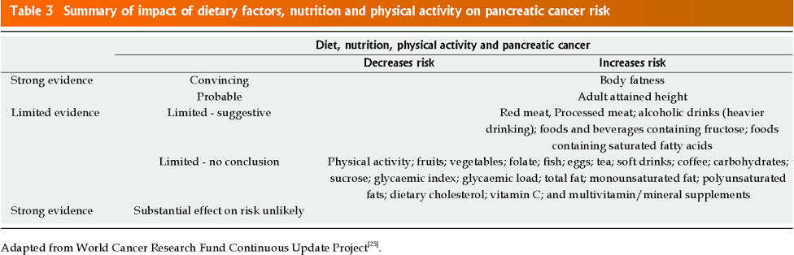

<https://images.app.goo.gl/s1g8iJdtcBPK1eHE6>[64]

There is insufficient data to draw conclusions on the role of other dietary variables, such as foods and beverages containing fructose or foods high in saturated fatty acids, in the aetiology of pancreatic cancer.

additional food exposures. This illustrates the challenges associated with dietary epidemiology and suitable study design indicators for examining the risk of pancreatic cancer.

**Virus Infection:-** Numerous infections and pancreatic cancer have also been studied; individuals with Helicobacter pylori (H-pylori)[65] or hepatitis C infections[66] showed elevated risks.

To support these conclusions, more research is required[65]. As has been observed for oesophageal adenocarcinoma trends, the possible relationship for H-pylori offers intriguing conjecture regarding H-pylori removal (designed to minimize gastric cancer risk) potentially having negative repercussions for rising pancreas cancer incidence[67]

# Pathophysiology :-

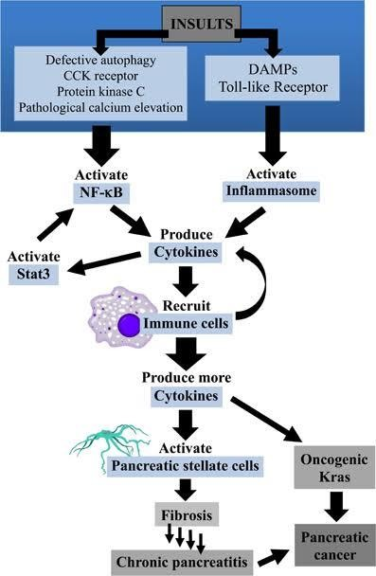

[https://images.app.goo.gl/m2Aw64fbyx6jGuCw9](https://images.app.goo.gl/m2aw64fbyx6jgucw9) [68]

# Symptoms:-

Signs and symptoms:- Symptoms of pancreatic cancer frequently appear later in the disease's progression. Signs and symptoms of pancreatic cancer can include the following when they occur: back or sides accompanied with stomach ache.appetite decline.Reduced weight.Jaundice is the term for a yellowing of the skin and the whites of the eyes. floating or light-colored stools.urine with dark hue.It's burning.Diabetes that is newly diagnosed or that is becoming more difficult to manage. Arm or leg pain and edema that could be brought on by a blood clot. Weakness or fatigue

floating or light-colored stool Diabetes that is newly diagnosed or that is becoming more difficult to manage. Arm or leg pain and edema that could be brought on by a blood clot. Weakness or fatigue [69]

# Diagnostic test:-

Tests used to diagnose pancreatic cancer include: Imaging tests. Imaging tests take pictures that show the inside of the body. Imaging tests used to diagnose pancreatic cancer include ultrasound, CT scans, MRI scans and, sometimes, positron emission tomography scans, also called PET scans. A scope with ultrasound. Endoscopic ultrasound, also called EUS, is a test to make pictures of the digestive tract and nearby organs and tissues. EUS uses a long, thin tube with a camera, called an endoscope. The endoscope passes down the throat and into the stomach. An ultrasound device on the endoscope uses sound waves to create images of nearby tissues. It can be used to make pictures of the pancreas.

Removing a tissue sample for testing. A biopsy is a procedure to remove a small sample of tissue for testing in a lab. Most often, a health professional gets the sample during EUS. During EUS, special tools are passed through the endoscope to take some tissue from the pancreas. Less often, a sample of tissue is collected from the pancreas by inserting a needle through the skin and into the pancreas. This is called fine-needle aspiration.

The sample goes to the lab for testing to see if its cancer. Other specialized tests can show what DNA changes are present in the cancer cells. The results help your health care team create your treatment plan.

Blood tests. Blood tests might show proteins called tumor markers that pancreatic cancer cells make. One tumor marker test used in pancreatic cancer is called CA19-9. Doctors often repeat this test during and after treatment to understand how the cancer is responding. Some pancreatic cancers don't make extra CA19-9, so this test isn't helpful for everyone.

Genetic testing. If you're diagnosed with pancreatic cancer, talk with your health care team about genetic testing. Genetic testing uses a sample of blood or saliva to look for inherited DNA changes that increase the risk of cancer. Results of genetic testing might help guide your treatment. The results also can show whether family members might have an increased risk of pancreatic cancer.

**Staging**:-

After confirming a diagnosis of pancreatic cancer, your health care team works to find the extent of the cancer. This is called the stage of the cancer. Your health care team uses your cancer's stage to understand your prognosis and create a treatment plan.

The stages of pancreatic cancer use the numbers 0 to 4. In the lowest stages, the cancer is only in the pancreas. As the cancer grows, the stage increases. By stage 4, the cancer has spread to other parts of the body.[70]

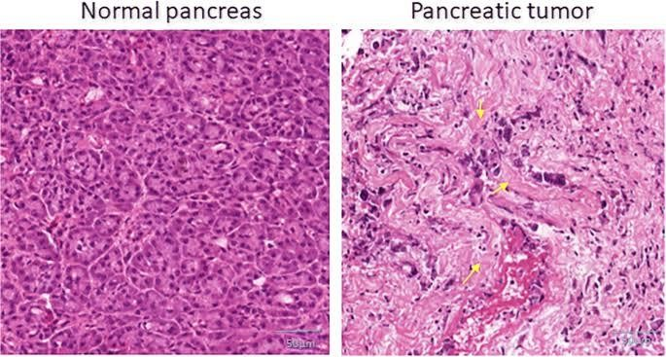

[**https://images.app.goo.gl/tqyJT9SpbxCoYqBP8 [71**](https://images.app.goo.gl/tqyJT9SpbxCoYqBP8%20%5b71)**]**

**Pharmacology treatment**

# Drug name:- Fluorouracil (5-FU)

Pyrimidine antagonists:-

Pyrimidine analogues have varied applications as antineoplastic, antifungal and antipsoriatic agents.

# Fluorouracil (5-FU) :-

It is converted in the body te the corresponding nucleotide 5-fluoro- 2-deexyuridine monophosphate (FdUMP), which forms a covalent ternary complex with methyl THFA and tymidylate synthase (TS) resulting in irreversible inhibition of TS. Consequently con version of deoxyuridilic acid to deoxythymidylic acid is blocked. Selective failure of DNA symhesis occurs due to non-availability of thymidylate, Accordingly, thymidine can partially reverse S-FU toxicity. The triphosphate of 5-FU (FUTP) gets incorporated into RNA, interferes with RNA synthesis as well as RNA function, contribut ing to its cytotoxicity. Even resting cells are affected, though rapidly multiplying ones are more susceptible. Since inhibition of TS by 5-FU is dependednt on the presence of THFA, concurrent infusion of leucovorin enhances the efficacy of S-FU. Cisplatin and oxaliplatin also synergise with 5- FU. Most protocols now employ 5-FU along with leucovorin and cisplatin/ exaliplatin, e.g. leucovorin

+ 5FU+ oxaliplatinis (FOLFOX) protocol.

Currently, 5-FU is a commonly used anticancer drug for many solid malignancies, especially of colon, rectum, stomach, pancreas, liver, urinary bladder, head and neck. Oral absorption of S-FU is

unreliable. It is mostly used by iv infusion. 5-FU is rapidly metabolized by dihydro- pyrimidine dehydrogenase (DPD) resulting in a plasma t½ of 15-20 min after iv. infusion. Genetic deficiency of DPD predisposes to severe 5-FU toxicity, Major toxicity of 5-FU is exerted on the bone marrow and git causing

myclosuppression, menitis, dire, and vomiting. Peripheral neuropathy (hand-foot syndrome) also occursal verhours werkt for weeks 11 magideyis in for 4 In attemere days, 34 doses 4 days lollowed by

FLURACH, FIVE FLUORO FIVOCI

A 1% topical solution applied twice daily for 3-6 weeks has yielded gratifying results in superficial basal cell carcinoma, and in actinic keratosis.

# Conclusion:

This review provides a comprehensive account of the epidemiology and management of pancreatic ductal adenocarcinoma. Significant gaps (as highlighted in the summary section above) remain in the understanding of this disease and treatment options although continually evolving continue to have limited success. There has been a recent drive to fund large consortia and specialist research into pancreatic ductal adenocarcinoma but there is much work to be done to enable similar breakthroughs as seen for other cancer sites.

# Reference:-

1. Novel theropies targeting hyporia mechanism to treat pancreatic cancer.
2. Siegel RL, miller KD, Jermal A cancer statistics, 2019 CA cancer J clin 2019; 69:7-34, dol: 10.33221 caac 21551. [pubmed C cross ref [Google scholar]
3. National health commission of the people’s Republic of china Chinese, guidelines far diangnosis and treatment of pancreatic cancer 2018 (English version) chin J cancer Res 2019:31 : 278.94.dol 10.21147 /J issan.1000_9604.2019.02.03 [Google scholar]
4. dougan sk the pancreatic cancer microenvironment cancer j. 2017,20:321-5.dol:10.1097/ ppo.0000. 000000000.288[Google scholar]
5. Erkan m.kurtanglu M.kleeff J the role of hypoxia in pancreatic cancer a potential therapeutic target? Expert Rev Gastroenterol Hepato.2016:10:301-16.dol:10.1586. [Google scholar]
6. Zimma A, kurpisz m hypoxia-Inducible factor-1 in physiological & pathgphysiological ahgiogensesis: Application and therapies. Biomed Res int.2015;2015:549412.dol:10.1155./2015| 549412[Google scholar]
7. Hwang HK. Wado k,Kim HY, et.al A momogram to peroperatively predictin riesected pancreatic cancer following neoadjuvant chemaradiation theoapy chin J cnacer Res 2020;32.105-14.

Dol:10.2147|J. issn 1000;9604:2020.01.12[Google scholar]

1. Novel theropies targeting hyporia mechanism to treat pancreatic cancer.
2. http://www.standfordchrldren. org|len|topic|default?. Id-pancreas- anatomy-and-functions-85- P00682
3. [http://www.hopkinsmedicine.org](http://www.hopkinsmedicine.org/)|health|conditions-and-disease|the-pancreas||:~: text-The% pancreas% 20 has % 20 digestive % 20 and, The %20 duadenum %2c%they%20 are % 20 activated.
4. <http://www.cancer.gov/types/metastcc-cancer> 12[.htt](http://www.cancer.gov/about-cancer/diagnosis-staging/diagnosis/tumor-/grade)p[://www.cancer.gov/about-cancer/diagnosis-staging/diagnosis/tumor-/grade](http://www.cancer.gov/about-cancer/diagnosis-staging/diagnosis/tumor-/grade)

13.[http://www.cancer.gov/about-cancer/diagnosis-staging/diagnosis/pathology-reports-fact-sheet.](http://www.cancer.gov/about-cancer/diagnosis-staging/diagnosis/pathology-reports-fact-sheet) 14[.htt](http://www.cancer.gov/about-cancer/causes-prevention/risk/myths)p[://www.cancer.gov/about-cancer/causes-prevention/risk/myths.](http://www.cancer.gov/about-cancer/causes-prevention/risk/myths)

1. 1[.htt](http://seer.cancer.gov/statfocts)p[://seer.cancer.gov/statfocts](http://seer.cancer.gov/statfocts)|html/pancreas html.
   1. maisnneuve p. epidemiology & burden of pancreatic cancer presse med. 2019;48.e113-e123 [pubmed] [google scholar]
   2. Rawla p. Sunkarat. Graduputiv. Epidemiology of pancreatic cancer: Global Trends, Etioloy and risk factor World I oncol 2019, 10;10-27 [pmc free article] [pubmed] [Google scholar]
2. Jiax,Dup,Wuk,Xuz, fang J. xux link pancreatic cancer mortality in china: characteristics & prediction, pancreas 2018;47:233-237.[pubmed] [Google scholar]. ChoJ, petrov M.S. pancreatitcs, pancreatic cancer and their metabolic sequence projected burden to 2050 clin Transl Gastroenterol. 2020;11:e00251 [PMC free article] [pubmed] [Google Scholar]
3. pancreatic cancer: A review of epidemiology, trend and risk factors
4. pourmortezo M, Rahman Z.U, Young M evafosfamide, a new horizon in the treatment of Pancreatic cancer anticancer Drugs, 2016;27:723-5.dol:10.1097/cad.0000000000000386; [pubmed][Cross reference][Google scholar]
5. Limani p. Linecker M, kr on P, etal development of oxv ||| A, a novel hypoxia modifier as a potential wit hepao-pancreatic biology neoplasms-protocol of a first-Ib [1] a clinical trial. BMC cancer 2016;16.812.dol.10,1186/3.2885-016-2855-3 [PMC free article] [pubmed][google scholar]
6. oHuang J, Lak V, ngai CH, Zhang L, Yuan J, Lao xq, ng k, chang C, zheng zj, wang MCS, worldwide burden of, Risk Factors for and trends in pancreatic cancer gastroenterology 2021;160;744-754 [PMC free article] [pubmed] [Google scholar]
7. mcGuigan A, Kelly P, turkington RC, Jones C, caleman HG, McCain Rs-pancreatic cancer; A review of clinical diagnosis, epidemiology treatment & outcomes world j, gastroenterol, 2018;24;4846,4861[PMC free article] [pubmed] [google scholar]
8. Bengtssan A, Andersson R. Ansari D, The actual 5-year Survivors of pancreatic ductual adenocarcinoma based on real-world data Sci Rep 2020;10;16425. [PMC free article] [pubmed] [google scholar]
9. Zhao C, Gao F, LiQ, LiuQ, LinX, The distribution characterstics and Growing trend of pancreatic cancer in china. Pancreas 2019;48:309-314, [pubmed] [google scholar]
10. Surveillance, Epidemiology, and end results program cancer stat facts. Pancreatic cancer [cited 20 Jan 2021] in:National cancer institute [internet] available from: https://seer.cancer

.gov/staffacts/html/pancreas html.

1. BD 2017 pancreatic cancer collaborators The global regional & national burden of pancreatic cancer & its attributable. Risk factors in 195 countries and territaries 1990.2017, a systematic analysis for the Global Burden or disease study 2017 lancet Gastroenterol Hepatol 2019:4:934-947 [PMC free article] [pubmed] [Google scholar]
2. Siegel RL Miller KD, fuchs He, jemal A, cancer statistics 2021 CA cnacer J clin. 2021:71:7-33 [pubmed] [Google scholar].
3. Ferlay J. partensky C, Bray F, more deaths from pancreatic cancer than breast cancer in the EU by 2017, acta oncol. 2016;55:1158-1160 [pubmed] [Google scholar].
4. Bray F Ferlay J Scerjamajorom Siegel RL. Torre LA. Jemal A global Cancer statistics 2018 estimates of 2018 GLOBOCAN by world wide for incidence & mortality. 36 Cancers in 185 countries: CA Conce J-clin, 2018 68:394-424. [PubMed] [Google scholar]
5. Sung H Ferlay Ⅰ. Siegel RL. Lavensonne M.Soerjomataram I Jemol A, Bray Soerja mataram I Global Cancer Statistics 2020 GLOBACAN estimates of Incidence and Mortality worldwide for 36 cancers in 185 countries CA cancer Jaclin 2021:71:209-249 [pubmed] [Google Scolar]
6. Conceição Human Development Repert 2020 [Cited 10 max2021]. In united nations Development programme (UNDP) [Internet Available from http:// hdr undp.org/en/2020 report
7. Ferlay J. Ervik M. LamF,Colombet M. Mery L. Pineros M, ZnaorA Soerjemotaram I, Bray F Global Cancer observatory Cancer Today [cited 20 Jan 2021] In International Agency for Research an cancer Available from http://gco.iarc,fr/today
8. wang MCS, jiang JY, liang M Fang Y. yeung ms, sung jjv Global temparal patterns of pancreatic cancer and association with socioeconomic development Sci Rep 2017;7:3165 [PMC free article][pubmed] [Google scholar]
9. Goodarzi E, Dehkordi AH, Beiranvand R, Naemi H, khazaei Z, epidemiology of the incidence and mortality of pancreas cancer & its relationship with the human development incex (HDI) in the world an Ecological study in 2018 curr pharm Des, 2020;26:5163-5173 [pubmed] [Google scholar]
10. https://images app google|/jxje2i,VE|CBWoYrAg
11. Zhao C, Gao F, wang S, liu Q, pancreatic cancer & associated exosomes, cancer biomark 2017;20;357-367[pubmed] [Google scholar]
12. Midhas chawal S, Garg Pk modifiable & non-modifaible risk factors far pancreatic cancer a review cancer left 2016;381:269-277 [pubmed] [Google scholar]
13. Wood HE, Gupta S, kang JY, Quinn MJ, Maxwell JD, mudans majeed A, pancreatic cancer in England & wales 1975-2000:patterns trends in incidence survival & mortality aliment pharmacol| the 2006;23:1205-1214 [pubmed] [Google scholar]
14. International Agency for Research on cancer world health organization Global cancer observatory 2018 available from: [URL:https://gco](https://gco/) iarc fr/
15. IARC:Globacan 2012: available from URL : [https://globacan](https://globacan/) iarc fr/pages/fact-sheet-cancer.aspx
16. Wahi MM. Shah N. Schrock CE, Rosemursy As 2nd goldinSB reproductive factors & risk of pancreatic cancer women, a review of the literature and epidemiol 2009;19:103-111.[pubmed] [Google scholar]
17. Wolpin BM, chan AT Hartage P, chanock SJ, Kraft P. hunter DJ, giovannucci EL, fuchs CS, ABO blood group & the risk of pancreatic cancer J Natt cnacer Inst 2009;101:424-431 [PMC free article][pubmed] [Google scholar]
18. Wolpin Bm Kraftt P, Gross M, helzlsouer K, Buenode-mesquita HB, steplowski E, stolzenberg- solomon RZ, Arslan AA, Jacabs EJ, lacraix A etal pancreatic cancer risk & ABO blood group alleles results from the pancreatic co hort consortium cancer Res 2010;70;1015-1023[PMC free article] [pubmed] [Google scholar]
19. Hruban RH, canto MI, goggins M, schulick R, Klein AP update on familial pancreatic caner Adv surg 2010;44;293-311 [PMC free article] [pubmed] [Google scholar]
20. Becker AE, Hernandez YG, Fruch| H, Lucas AL, pancreatic ductal adenocarcinamo;Risk factors screening & early detection world J gastroenterol 2014;20;11182-11198 [PMC free article] [pubmed] [Google scholar]
21. permuth-Wey J, Egan KM, family history is a significant risk factor for pancreatic cancer result from a systematic review & meta-analysis fam cancer 2009;8;109-117 [PMC free article] [pubmed] [Google scholar]
22. Chen F, Roberts NJ, Klein AP, Inherited pancreatic cancer chin clin oncol 2017;6;58 [PMC free article] [pubmed] [Google scholar]
23. Del chiaro M, segersvard R, Lohr M, Verbeke C, Early delection & prevention of pancreatic cancer is it really possible today? World J, grastroenterol 2014;20;12118-12131 [PMC free article] [pubmed] [Google scholar]
24. Stevens RJ, Roddam AW, Beral V. pancreatic cancer in type 1 & young-onset diabetes systematic review & meta analysis BR J, cancer 2007;96;507-509 [PMC free article] [pubmed] [Google scholar]
25. Huxley R, Ansary-moghaddam A, Berrington de Gonzalez A, Barzi F, woodward M, type 2nd diabetes & pancreatic cancer a meta- analysis of 36 studies Br J, cancer 2005;92;2076-2083 [PMC free article] [pubmed] [Google scholar]
26. Grote VA, Rohrmann S, niesters A, Dossus L. tjnneland A,Halkjaer J, overVad K, fagherazzi G, boutron-ruault MC, morois s, etal diabetes mellitus, glycated heamoglobin c-peptide levels in relation to pancreatic cancer risk a study with the European prospective investigation into cancer & nutrition [Efile] cohort diabetalagia, 2011;54:3037-3040 [pubmed] [Google scholar]
27. Boestti C. Lucenteforte E, silverman DT Petersen G, bracci PM, JiBT, Nergi E, Lid, Risch HA, olson SH etal cigarette smoking & pancreatic cancer on analysis from the international pancreatic cancer case-control consortium (panc4) Ann oncol 2012;23;1880-1888 [PMC free article] [pubmed] [Google scholar]
28. Iodice S, Gandini S, Maisonneuve P, Lowenfels AB, tobacco & the risk of pancreatic cancer a review and meta-analysis langen-becks Arch surg. 2008;393;535-545 [pubmed] [Google scholar]
29. Lynch SM, Vrieling A, Lubin JH, kraft P, Mendelsohn JB, hartage p, canzian Fm steplowski E, Arslan AA gross M, etal cigarette smoking & pancreatic cancer a pooled analysis from the pancreatic cancer cohort consortium AMJ Epidemiol 2009;170;403-413 [PMC free article] [pubmed] [Google scholar]
30. Midha S, chawala S, Garg PKm modifiable & non-modifiable risk factors for pancreatic cancer a review cancer let. 2016;381;269-277 [pubmed] [Google scholar]
31. Cummings KM, Dresler CM, field JK fox J, Gritz ER, Hanna NH,ikedaN, JassemJ, Mulshine JL, peters MI etal E-cigarttes & cancer patients J thorac oncol 2014;9;438-441 [PMC free article] [pubmed] [Google scholar]
32. Rohrmann S, Linseisen J, vrieling A, boffetta p, stolzenberg-solomen RZ, Lowenfels AB, Jensen MK, overvad K, Olsen A, Tjanneland A, etal ethanol intake & the risk of pancreatic cancer in the European prospective investigation into cancer & nutrition [Epic] cancer causes control 2009;20;785-794 [PMC free article] [pubmed] [Google scholar]
33. Lin Y, Tamakoshi A, kawamura T, INabay, Kikuchi S, motohashi V, kurosawa M, ashno Y, risk of pancreatic cancer in relation to alcohols drinking coffee consumption & medical history findings from the japan collaborative cohort study for evaluation of cancer risk int J, cancer 2002;99;742-746 [pubmed] [Google scholar]
34. Genkinger JM, spiegelman D, Anderson KE, Bergkvist L, bernstein L, van den Brandt PA, English DR, freudenheimjl, fuchs CS, Giles GG, etal alcohol intake & pancreatic cancer risk: a pooled analysis of fourteen cohort studies cancer epidemicol biomarkers Prev 2009;18;765-776[PMC free article] [pubmed] [Google scholar]
35. Wang VT, Grou YW, Jin WW, xiao M, Fang HY association between alcohol intake & the risk of pancreatic cancer a dose-response meta-analysis of cohort studies BMC cancer 2016;16;212 [PMC free article] [pubmed] [Google scholar]
36. samakhvalov AV, Rehm J, Roerecke M, alcohol consumption as a risk factor for acuto & chronic pancreatitis a systematic review & a series of meto-analysis EBio medicine 2015;2;1996-2002 [PMC free article] [pubmed] [Google scholar]
37. Machicado JD, REboursv, Yadav D, epideomiology of chronic pancreatics pancreapedia 2016;1-15 [Google scholar]
38. Raimondi S, Lowenfels AB, MOrselli-labate AM. Maisonneuve P, pezzilli R. pancreatitis. Aetiology incidence & early deletion best pract Res clin Gastroenteral 2010;24;349-358 [pubmed] [Google scholar]

63.2015 WCRFI pancreatic cancer statistics | world cancer research fund international available from: URL : https://www.WCRT. Org /int/cancer-facts-figure/data-specific-cancers/pancreatic cancer

-statistics [Google scholar] 64.https://images.app.google/s198 i JdtCBPK1ehe6

1. Gua V, Liu W, I helicobacter pylori infection & pancreatic cancer risk : A meta-analysis cancer Res ther. 2016;12;C229-C232 [pubmed] [Google scholar]
2. El-Serag HB, engles EA, Landgren. O, chiao E, Henderson L, Amaratange FIC, Giordano TP. Risk of hepatobiliary & pancreatic cancer after hepatobiliary C virus infection A population based study of US veterans hepatology 2009;49;116-123 [PMC free article] [pubmed] [Google scholar]
3. Walker MM. Talley NJ, review article bacteria & pathologeneis of disease in the upper gastrointestinal tract—beyond the era of helocobacter pylori aliment pharmacol the 20 14;39;767- 769 [pubmed] [Google scholar]
4. https://[www.images.app.google/M2Aw64fbyx6jGuCw9](http://www.images.app.google/M2Aw64fbyx6jGuCw9)
5. https://[www.mayoclinic.org/disease-conditions/pancreatic](http://www.mayoclinic.org/disease-conditions/pancreatic) cancers/symptoms-causes/syc- 20355421
6. https://[www.mayoclinic.org.disease-conditions/pancreatic](http://www.mayoclinic.org.disease-conditions/pancreatic) cancer/diagnosis-treatment/drc- 20355427.
7. https://images/app. Google./tqyJt9spbxcovqBP8
8. Book-> Essentials of medical pharmacology, 8th edition

-K.D. Tripathi(MD) page no-923.