**Multifaceted approach to mucormycotic skull base osteomyelitis: A case study**

**Dr Preeti Singh, Dr Harsh Patel, Dr Abhaya kumar**

**Department of Neurosurgery**

**Kokilaben Dhirubhai Ambani Hospital & Research Institute**

**Mumbai**

Mucormycosis is a deadly opportunistic fungal infection. Caused by fungus of class zygomycetes and order mucorales. Cranium bone can be affected due to mucormycosis via transosseus, perineural or haematogenous spread which is unprecedented and postures both a diagnostic and challenge. It commonly affects immunocompromised individual. Owing to uncommon event of mucormycotic skull base osteomyelitis in immunocompetent person, high mortality rate and diagnostic difficulty following case study will center on significance of multifaceted approach in prompt diagnosis and early treatment of this disease.

Case : A 64 year old male patient presented with chief complaints of hemifacial pain with unilateral headache on right side from 25 days for which patient consulted a neurologist who started him on tab pregablin 75 mg post which facial pain improved but headache progressed to left side of face. On examination there was paresthesia of the right side upper lip and angle of the mouth. There was no signs of oral infection and mouth opening was full. His medical history was non significant. Patients haematological investigations were inside ordinary limits. On the premise of history and clinical examination conclusion of trigeminal neuralgia was made. Magnetic resonance imaging (MRI ) of the brain showed patchy heterogeneously enhancing marrow signal alteration is noted in the clivus [right more than left] and the adjacent sphenoid bone around the sella with irregular non-enhancing osteolytic areas. Mild accentuated enhancement of the dura along the posterior aspect of clivus, bilateral Meckel's caves and medial aspects of the temporal lobes. Mild accentuated enhancement extending along the bilateral foramen ovale and rotundum along the V3 and V2 segments of trigeminal nerve on either side, respectively.

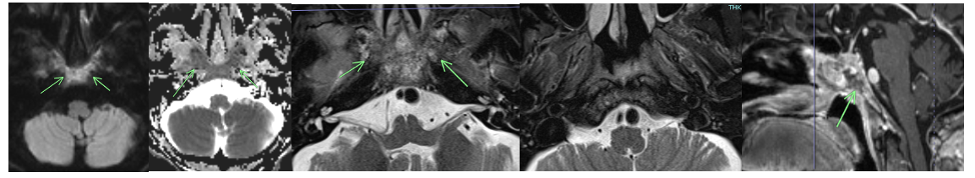

Computerized tomography of the paranasal sinus ( CT ) PNS showed Irregular osteolysis and permeative destruction involving the clivus. Moderate mucosal thickening in both halves of sphenoid sinus with focal erosion / osteolytic bone defect along the floor of sphenoid sinus.Variable erosions of the floor of sella turcica. Similar subtle erosions of the postero-lateral walls of both sphenoid sinuses and the intersphenoid septum. Irregular erosions of the bilateral pterygoid plates. Mild edematous thickening of the pre-clival and nasopharyngeal soft tissue.

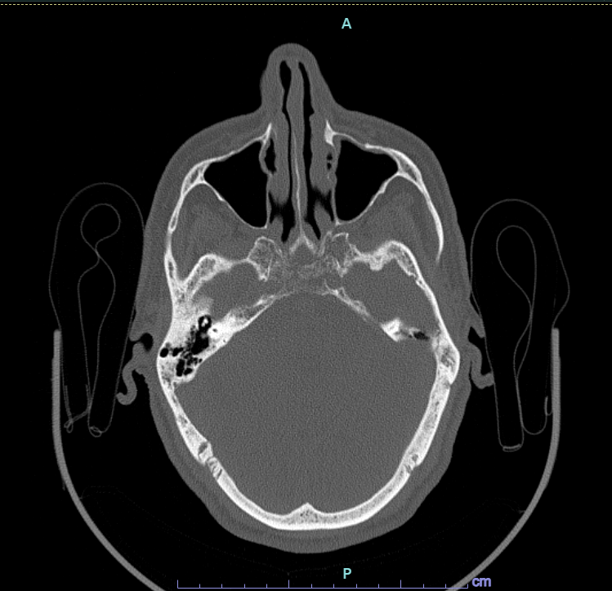

Although these imaging features are seen in infective / inflammatory etiology like skull base osteomyelitis, in view of absence of constitutional symptoms an low clinical suspicion of infection, possibility of neoplastic etiology such as hematological infiltrative disease process or metastasis was considered.

Whole body PET CT negative except for metabolically active lucent and permeative lesion is seen involving clivus, sella turcica, body of sphenoid bone, bilateral lesser wing and bilateral pterygoid plates likely suggestive of infective pathology.

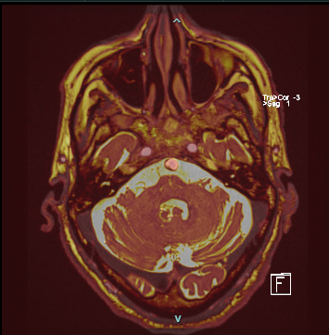

Patient underwent endoscopic guided debridement and biopsy of the lesion biopsy of a skull base lesion. Tissue sample was sent for gram stain, histopathological examination and fungal culture test.

Gram stain showed narrow and acute aseptate fungal hyphae with 90 branching.

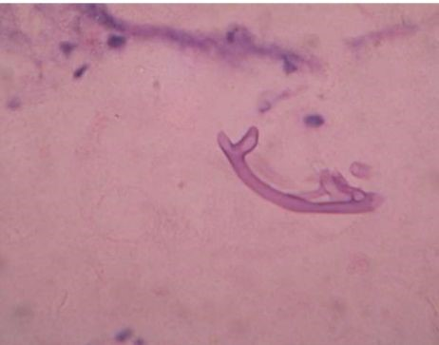

Histopathological examination showed broad aseptate hyphae with right angle branching

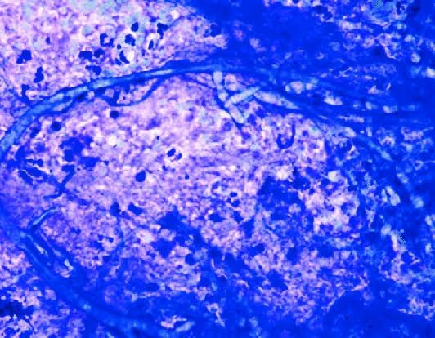

Diagnosis of mucormycosis was made and patient was started on tab posconazole 300 mg. Fungal culture remained negative for 2 weeks making it difficult to diagnose fungal species thereby tissue sample was sent further PCR sequencing which showed growth of mucor species.

Discussion

Early biopsy of the lesion followed by histopathological examination and molecular method such as PCR sequencing should be used in parallel as fragile non septated growth of these fungi make them prone to mechanical damage giving negative culture making it difficult to identify species and start appropriate antibiotics. Treatment involves combination of surgical debridement and antibiotic therapy. Surgical debridement should be used prior to medical treatment because it allows better penetration of antifungal agents to the site of infection.